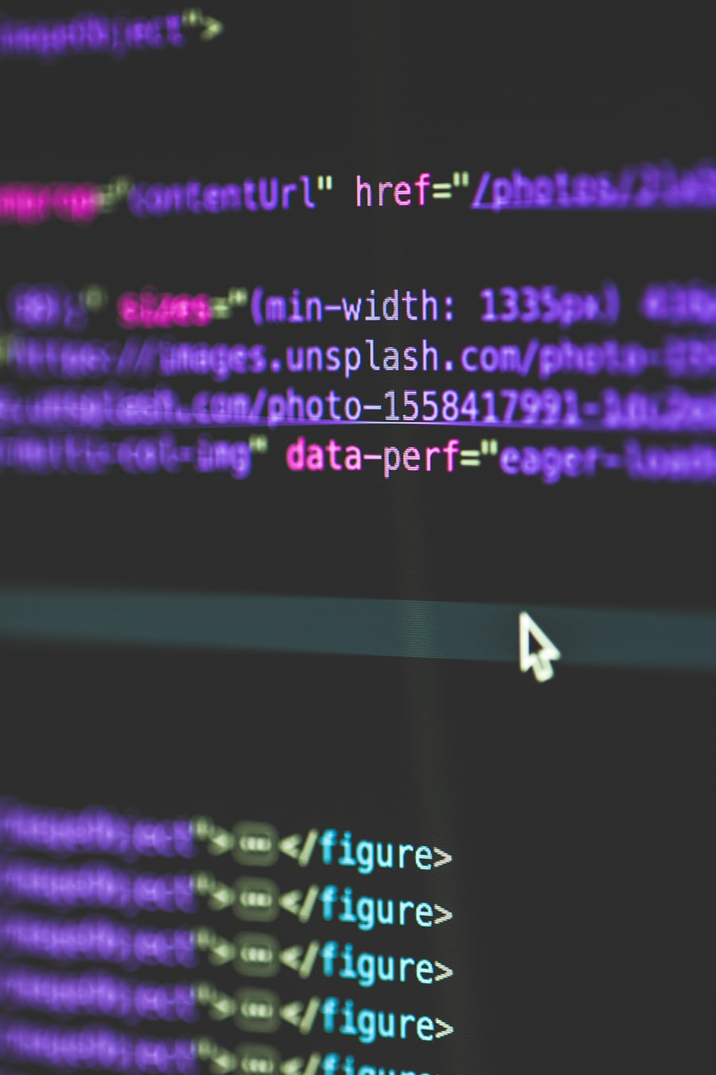
MODOU
PENE
1810381

SOFTWARE DEVELOPMENT

ASSESSMENT 1
SECTION I

LECTURE NAME

JOY BOTU

SUMMARY

PART A

INTRODUCTION……………………………………………………………1
VARIABLE……………………………………………………………………2
CONSTANT……………………………………………………………………3
DATA TYPE…………………………………………………………………...4
DECIMAL AND FLOAT TYPES…………………………………………4.1
STRING TYPES……………………………………………………………4.2
CONTROL STRUCTURE……………………………………………………5
- SEQUENTIAL…………………………………………………………
- CONDITIONAL………………………………………………………
- ITERATIVE…………………………………………………………..

PART B

HOW APPLICATION WORKS……………………………………………6
FLOWCHART……………………………………………………………….7
EXERCISE_1…………………………………………………………………8
EXERCISE_2…………………………………………………………………9
EXERCISE_3…………………………………………………………………10
EXERCISE_4…………………………………………………………………11

REFERENCES………………………………………………………………12

INTRODUCTION
C # is a new object-oriented programming language and is pronounced C Sharp.
It is a simple, modern programming language that will be very simple for everyone who already knows C ++ and Java. The C # language combines the high productivity of languages ​​for rapid application development (Rapid Application Development, RAD) with the potential of C ++. "
Apart from a few terms, the explanation of which is now premature, I would add that C # is a language suitable even for beginners who are only now entering the world of programming. It is also true that those who have already had experiences with other languages ​​will find it easy to understand the constructs of C #. Is a language that does not work directly in the standard environment in which programs are compiled into machine code, but, like Java, needs a virtual execution environment. In the case of Java, there is a need for the famous Java Virtual Machine that allows programs (which have a .class extension) to be able to run. The C # instead needs the installation of the so-called
.NET FRAMEWORK
downloadable from the Microsoft website.
The .NET Framework is a new computer platform that simplifies application development in the highly distributed Internet environment. The .NET Framework is designed to achieve the following goals:
Provide a coherent object-oriented programming environment, whether the object code is stored and executed locally, executed locally but distributed on the Internet or executed remotely.
Provide a code execution environment that minimizes software distribution and version conflicts.
Provide a code execution environment that ensures secure execution even of codes created by unknown or semi-trusted vendors.
Provide a code execution environment that eliminates performance problems in scripted or interpreted environments.
Make the developer experience consistent across very different types of applications, such as Windows-based applications and web-based applications.
Generate all communications according to industry standards to ensure that the .NET Framework-based code can integrate with any other code.
The .NET Framework has two main components: the common language runtime and the .NET Framework class library. Common Language Runtime is the basis of the .NET Framework and can be considered as an agent that manages the code at runtime, providing basic services such as memory management, thread management and remote services, while activating a rigid independence of the types and other forms of code accuracy that ensure protection and efficiency. The concept of code management is indeed a fundamental runtime principle. The runtime code is called managed code, while the non-runtime code is called unmanaged code. The class library, the other main component of the .NET Framework, is a complete object-oriented set of reusable types that can be used in application development, from the traditional command line or graphical user interface (GUI, Graphical User Interface) to those based on the most recent innovations provided by ASP.NET, such as Web Forms and XLM Web services

VARIABLE

A variable can be compared to a warehouse and is essential for the programmer. In C #, a variable is declared like this:
<data type> <name>;
This is the simplest version, but the variable has no value yet. You can assign one at a later time or at the same time as you declare it, like this:
<data type> <name> = <value>;\
So far, only local variables have been used, which are variables declared and used within the same method. The syntax of the C # language provides that a variable, declared within a method, cannot be used outside the method itself (which is why it is called "local"). If you are familiar with other programming languages, you will know of the existence of global variables, which can be accessed from multiple points. In the case of C # the concept of global variable is not supported. However, it is possible to define within a class a field that is accessible by all the methods of the class. Allow me to show you what I said with an example:
using System;
namespace VariableScop
{
class Program
{
private static string worldClass = "world, class!";
static void Main(string[] args)
{
string worldLocal = "worLd, local!";
Console.WriteLine(worldLocal);
Console.WriteLine(Program.WorldClass);
staff();
}
static void staff()
{
Console.WriteLine("Message from the staff: " + Program.worldClass);
}
}
}

The variables allow you to store data of various types, eg text strings, numbers or objects. There are local variables that are accessible within the method where they were defined, then there are the fields of the class that can be accessed from all the methods of the class and even outside of it, if visibility permits.

CONSTANT
The const qualifier in C # has many uses and declensions, depending on whether it is applied to a variable, to a method of a class, to arguments or to the return value of a function. As the name suggests, const makes the entity to which it is applied immutable (in the case, for example, of a variable), or indicates that the entity itself cannot apply changes (as in the case of the methods of a class). The most obvious use is the definition of constant values that remain unchanged for the entire execution of the program, for example numerical constants:
CONST DOUBLE NUMBER= 2;
Given the immutability of a const variable, its initialization must be contextual to the declaration. For example, the following fragment will generate a compilation error:
CONST DOUBLE NUMBER;
NUMBER=2 // ERROR
Note that the concept of "constant variable" is not an oxymoron: remember that a variable, in the context of programming languages, is only a memory location to which a name is associated, regardless of the fact that its content changes during program execution.

DATA TYPE
C# is an object-oriented language and is halfway between java and C ++, so we have variables of type value x = 2, variables of type reference using new to create a new object x = new X () directly in the heap (the memory dynamic) and finally pointer-type variables like those of C ++, but in this case the code must be managed as an unsafe. In practice, the pointer is a variable that points to the first memory cell of the variable. The data types in C # are:

Sbyte | Form 128 to 127
Short | From 32768 to 32767
Int | From 2147483648 to 2147483647
Long | From 92233720368.. to 9223372036..
Byte | From 0 to 255
Ushort | From 0 to 65535
Uint | From 0 to 4294967295
Ulong | From 0 to 18446744073709551615
Float | From +-1.5x10-45 to +-3.4x1038
Double | From +-5.0x10-324 to +-1.7x10308
Decimal | From +-1.0x10-28 to 7.9x1028
Char | Unicode character
Bool | True or False

Decimal and float types
To represent real numbers, we can use floating and decimal types. If we want to use a comma number with 7 decimal places precision, we use the float type. If instead we want to manage numbers with commas to 15 - 16 digits we use the type double; for numbers with digits after the comma of 28 - 29 digits we use the decimal type, which is the one that occupies the most memory (128 bits).

String types

To handle strings in C # we use the string type. This contains consecutive text characters simply enclosed in double quotes. Let's look at an example:
string Mystring = "Hello world";
If we want, we can use special characters inside our string, just use the backslash (), followed by the character. For example, we can decide to wrap up with "n":
string Mystring = "This is my country\n Africa.";

CONTROL STRUCTURES
The control structures are special instructions, typical of imperative languages, which allow instructions to be executed under certain conditions.
Bohm-Jacopini's Theorem In 1966 the computer scientists Corrado Bohm and Giuseppe Jacopini enunciated the following theorem: Each algorithm can be implemented using only three structures

- Sequential: blocks of procedural code whose instructions are executed in the same sequence as they were written in the source code. These may contain conditional and / or iterative control structures.
- Conditional: allow you to specify two branches or blocks (one of the true and one of the false) of code, of which only one will be executed based on the Boolean result of the conditional expression (true / false).
- Iterative: they execute the same block of code, in a repetitive way, until the conditional expression is true.

Expressions like y = 5 or i ++ become statements when they are followed by a semicolon. In C, the semicolon is an instruction terminator and not, as in Pascal, a simple separator.

In C# we can use the curly braces {and} to group multiple statements in a block, which is seen syntactically as a single statement. The parentheses enclosing the function statements, those after an if or after a while are the most obvious example. Very important to remember is that after the closing brace of a block you do not have to put a semicolon (even if this is not considered a syntax error).
statement1;
statement2;
statement3;
Therefore, it can never happen that the instruction2 is executed after the instruction3. This also applies to the assignment and reading instructions of the variables, for which attention must be paid to the irreversibility of the writing operation.
CONDITIONAL STRUCTURES

- IF
If(condition){ // if the condition is true
Instruction 1; compile the instruction (if false it leaves the block)
.
.
Instruction n;
}
This structure works as follows: the condition of the if statement is checked. If it is true, the immediately following instructions are executed, otherwise, if it is false, the if blocking is skipped (therefore the instructions inside the if are not executed) and the immediately following instructions are executed.

- IF -ELSE
If(condition 1) { // if the condition 1 is true
Instruction 1; compile the instruction

}else if (condition 2) { //otherwise if the condition 2 is true

Instruction 2; compile the instruction
}else{ //otherwise

Instruction 3 compile instruction 3
}

- Switch(value){ // select the value
Case 1: compare with 1
Instruction 1;
Break;
Case 2:
Instruction 2;
Break;
.
.
Case n;
Instruction n;
Default: // acquires all other values other than those of the selection (case)
Instruction;
}

Very similar to the logic of the if ... else statement, the switch is used when it is necessary to compare the different values (case1 to casen) and a variable or expression (switch (value)) can assume and therefore in based on them perform distinct actions. The break instruction is used to exit the switch block, in fact it would not make sense (in many cases) to continue to compare (but this does not mean that, in some situations, the break should always be there).

ITERATIVE STRUCTURES

The iteration commands allow you to repeatedly execute certain instructions until a certain condition remains true.

- WHILE
While(condition) { // compile the instruction until the condition is true
Instruction 1;
}

Structure used when a prior inspection is required.

- DO-WHILE
Do{
instructions
}while(condition);

The do-while is very similar to the while, with the only difference being that the check is done at the end and therefore the instructions inside the block are executed at least once, regardless of whether the condition in the while is true or false.

- For(initialization; condition; increase or decrease ){
Instructions
}
The logic of the for command is very similar to the while, in fact they could very well be used for the same purposes. The fact remains that the for is much more concise than the while and is used when we already know the number of iterations that must be performed.

- BOOLEAN
Bool a; //declare variable
If(condition){
a=true;
}else{
a= false
}
A Boolean variable is a binary variable capable of assuming only two Boolean values: true (true) or false (false). Boolean variables are the basis of Boolean algebra (Boolean algebra) and of the functioning of computer
devices

HOW APPLICATION WORKS
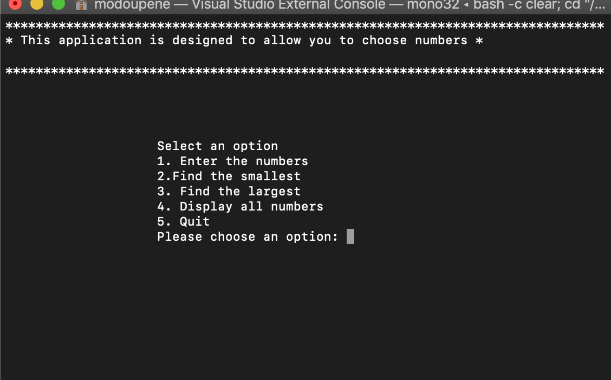
The present figure illustrates our application which was developed with one of the most used software in the programming world. As we can see in the first figure when the user opens the application is displayed the first layer that allows the user to choose option
When choosing an option, you cannot enter variable string like text because it is not recognise in the system

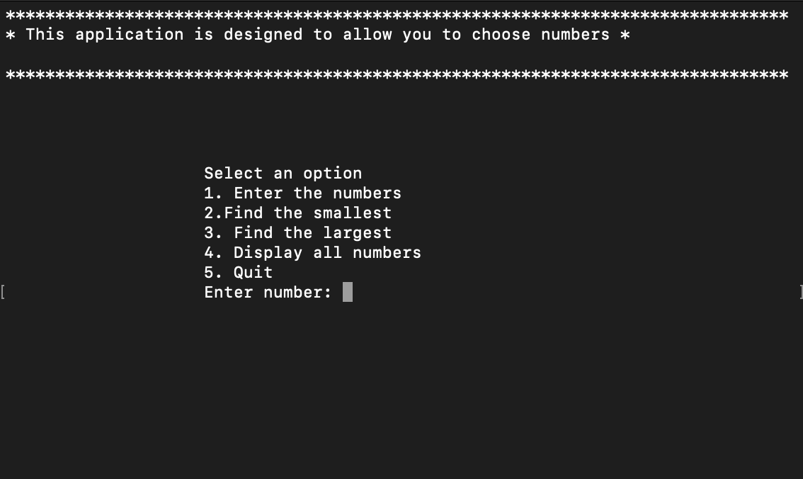

When the user enter option 1 "Enter number" is displayed
That only allows him to enter 3 numbers in the vector. Once the three numbers are entered, it is redirected to the main menu, which allows it to choose another option

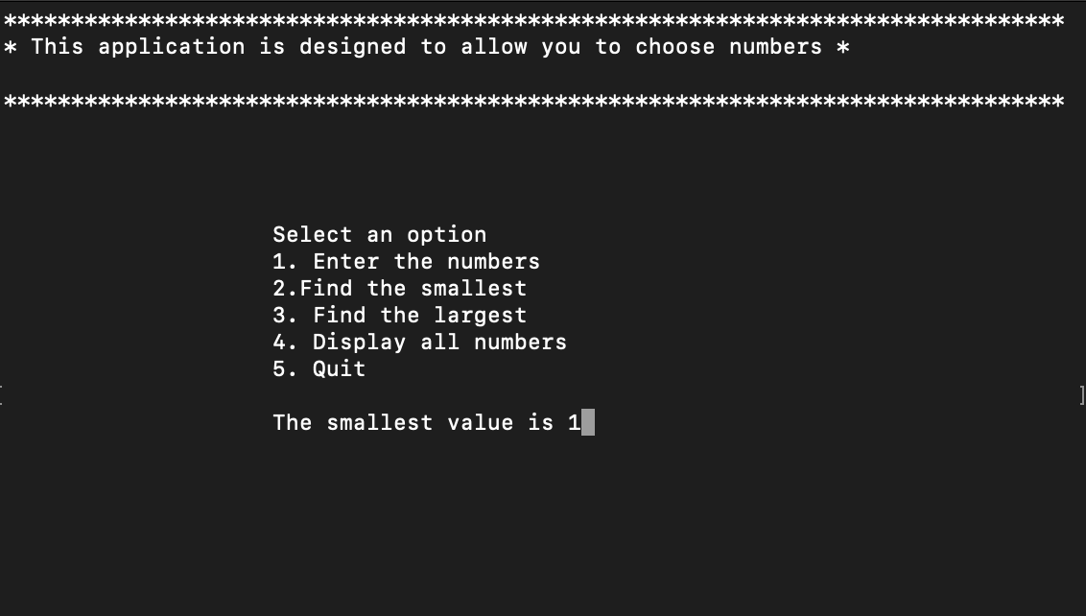
Once the user inserts
“1-2-3”
In the vector and uses the option "2" is displayed the smallest number and click on send is redirected in the main menu

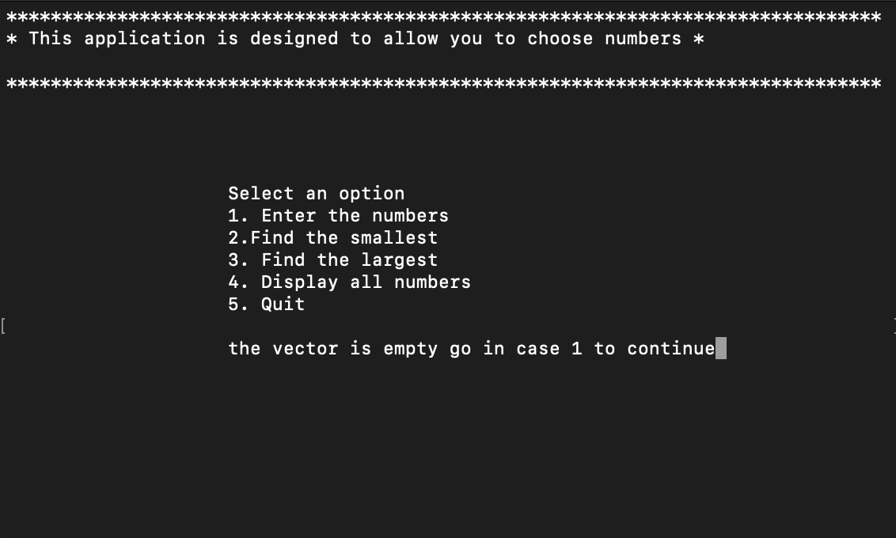
thanks to the implementation that we made on the program when the user inserts another option before option 1 then it is remembered that the vector is empty, and you have to go in case 1 to be able to continue also applies to cases

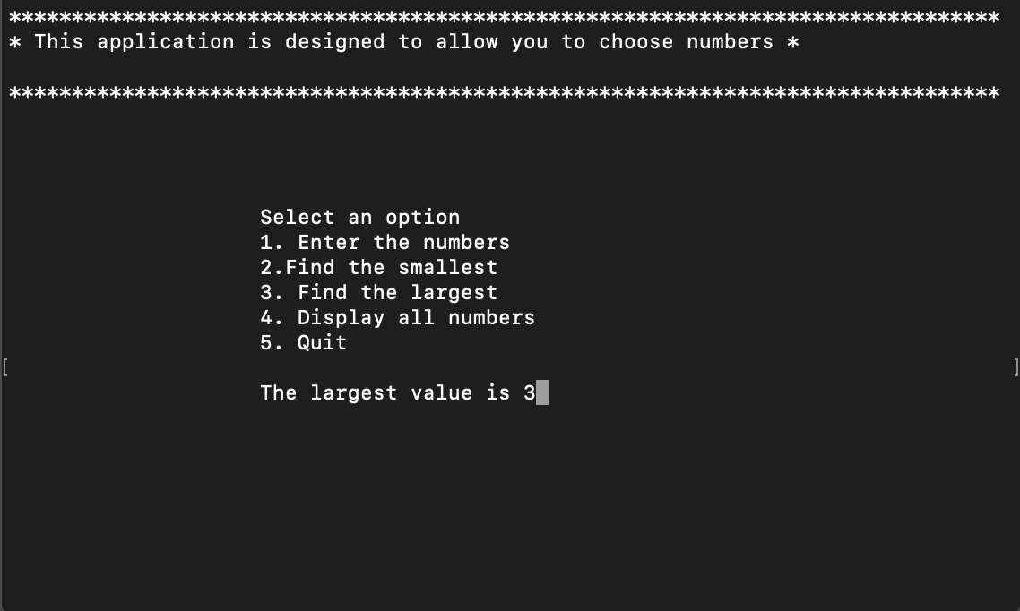

When the user uses the "3" option, the largest number that is on the carrier is displayed and also clicking on the send is sent back to the main menu

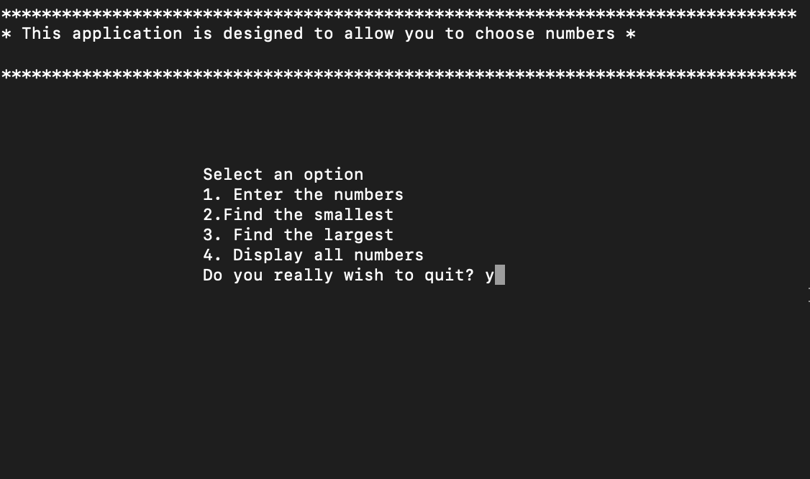
When the user wants to exit the application, he takes advantage of the "5" option which then displays a message if he wants to exit the program and how he inserts "yes or y or YES or Y" the application closes
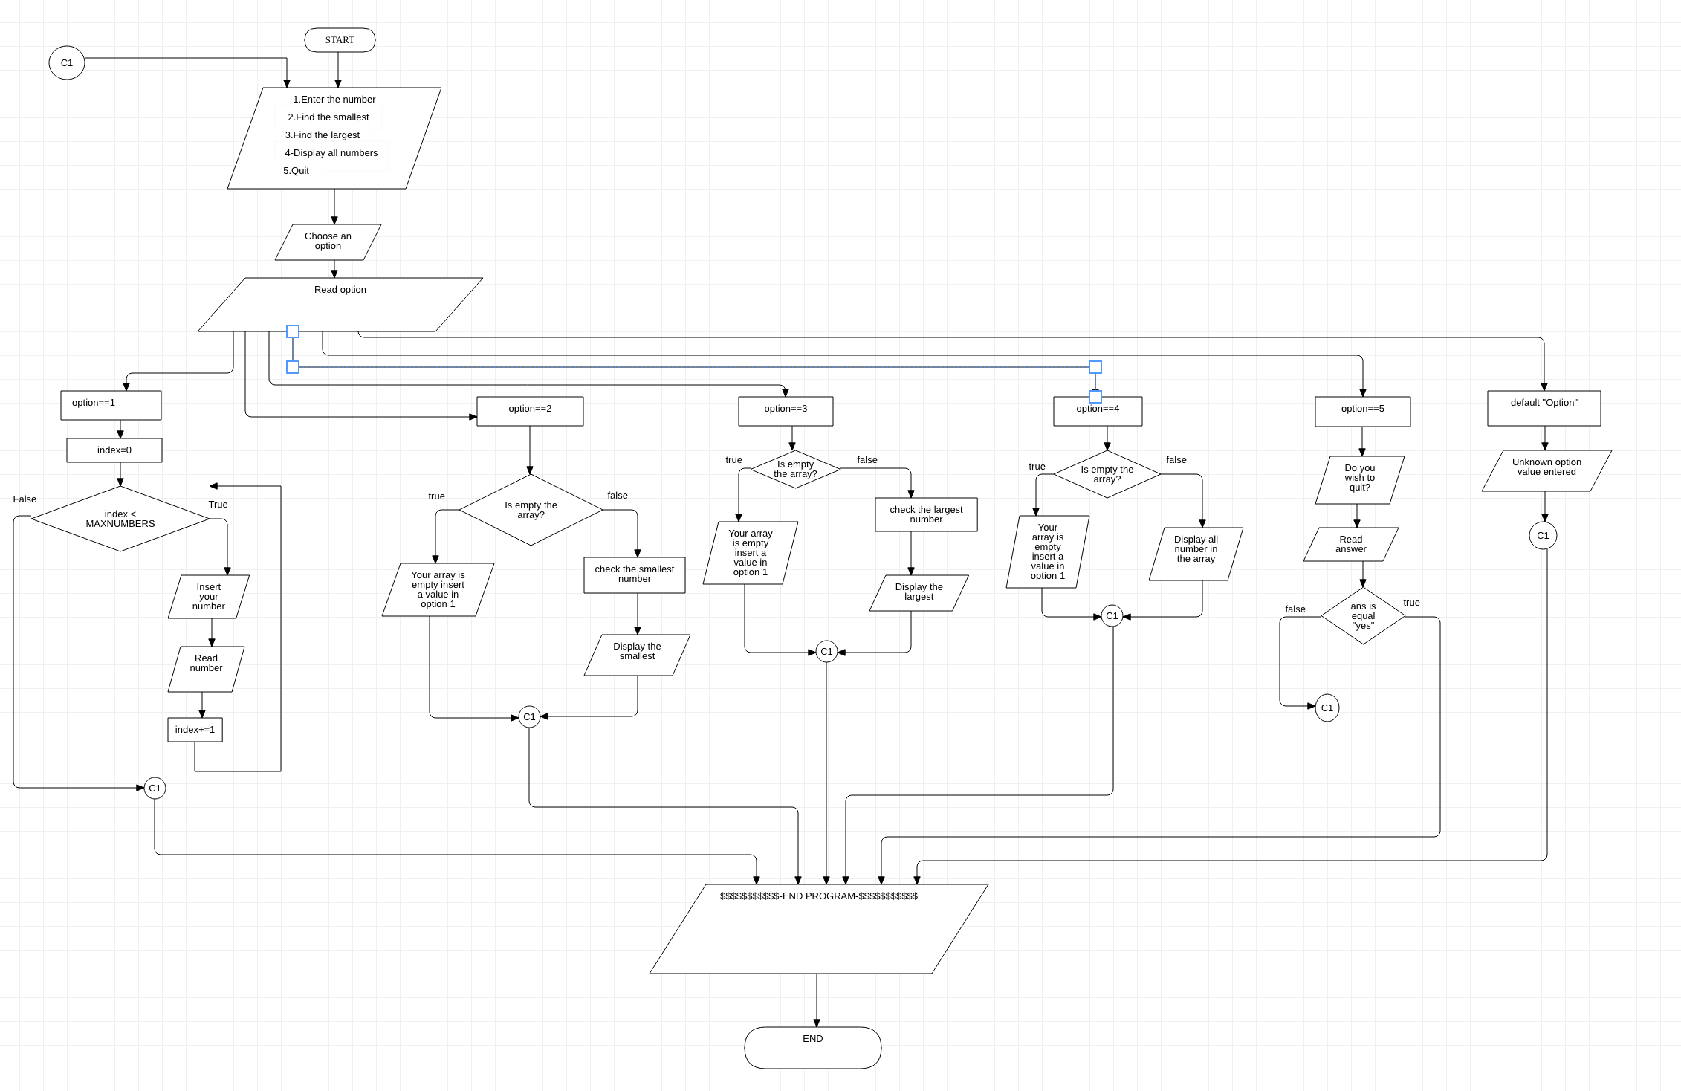
FLOWCHART

using System; //library
using
System.Collections.Generic;
using System.Linq;
using
System.Text;
using
System.Threading.Tasks;
namespace Assignmen2014_15
{
class Program
{
const int MAXNUMBERS = 3; //declare constant
static void Main(string[] args)
{
int[] theNumbers = new int[MAXNUMBERS]; //initialize the vectore
int chosenOption = 0;
bool quit = false;
InitialiseNumbers(theNumbers); // active under-program to insert a numbers
while (quit == false) // control structure to display the menu until the condition is true
{
DisplayHeader(); //methode who display the header
DisplayMenu(); // methode to dsiplay the menu
chosenOption = ReadNumber("Please choose an option: "); //methode to choose an option in menu but it can be only number
quit = ProcessMenu(chosenOption, theNumbers);
Console.Clear();
}
}
static void InitialiseNumbers(int[] numbers)
{
for (int index = 0; index < MAXNUMBERS; index++)
{
numbers[index] = 0;
}
}
static void DisplayHeader()
{
WriteText("*******************************************************************************", 0, 0); // Top left hand corner of screen is x = 0, y = 0;
WriteText("* This application is designed to allow you to choose numbers *", 0, 1); // Next line down is x = 0, y = 1, etc WriteText("* and finds the biggest and the smallest value *", 0, 2);
WriteText("*******************************************************************************", 0, 3);
}
static void DisplayMenu() // fuction display the menu
{
WriteText("Select an option", 20, 8); // Display menu at at x = 20, y = 8
WriteText("1. Enter the numbers", 20, 9);
WriteText("2.Find the smallest", 20, 10);
WriteText("3. Find the largest", 20, 11);
WriteText("4. Display all numbers", 20, 12);
WriteText("5. Quit", 20, 13);
}
static void WriteText(string text, int x, int y) //function to able writetext
{
Console.CursorLeft = x;
Console.CursorTop = y;
Console.Write(text);
}
static int ReadNumber(string prompt)
{
string text; int
number;
WriteText(prompt, 20, 14); //display
text = Console.ReadLine(); // read
number = int.Parse(text); // insert variable integer
ClearText(20, 14, prompt.Length + text.Length); // Clear the text at this line
return number;// return the varisble
}
static void ClearText(int x, int y, int length)
{
// Write space ' ' characters starting at x, y for 'length' times
WriteText(new String(' ', length), x, y);
}
static bool ProcessMenu(int option, int[] numbers) //function to choose an option and also insert a number
{
bool quit = false;
switch (option) // int who allow you to insert an option
{
case 1:
GetNumbers(numbers); // function insert numbers
break; // Pause the system and go back in the menu
case 2:
if (FindSmallest(numbers) == 0) // condition when the array is empty
{
WriteText("the vector is empty go in case 1 to continue", 20, 15); //<<<-display
}
else {
WriteText(string.Format("The smallest value is {0}", FindSmallest(numbers)), 20, 15); // methode to display smallest numbers
}

Console.ReadKey(); // Pause
break; // end of the process and go back
case 3:
if (FindLargest(numbers) == 0)
{
WriteText("the vector is empty go in case 1 to continue", 20, 15);
}
else {
WriteText(string.Format("The largest value is {0}", FindLargest(numbers)), 20, 15); //methode to display largest number
}

Console.ReadKey(); // Pause
break;
case 4:

Console.WriteLine("All numbers are \n",20,15); // display a string of letters
for (int index = 0; index < MAXNUMBERS; index++) // loop to find out all number
{
if (numbers[index] == 0)
{
WriteText("the vector is empty go in case 1 to continue", 20, 15);
}
else {
Console.Write(numbers[index] + "" + 20, 15); //display all number insert in the vector
}

}

break;

case 5:

quit = IsQuitting(); // function to quit the programm
break;
default: //
WriteText("Unknown option value entered", 20, 15);
Console.ReadKey(); // Pause break;
break;
}
return quit; //return in the variable quit to check to function
}
static void GetNumbers(int[] numbers) //methode to insert number in the vector
{
for (int index = 0; index < MAXNUMBERS; index++) // cicle to insert the numbers
{
numbers[index] = ReadNumber("Enter number: "); // read in the keyboar the number you insert
}
}
static int FindSmallest(int[] numbers) // methode to find the smallest number
{
int smallest = numbers[0];

for (int index = 0; index < MAXNUMBERS - 1; index++) // <-- subtract 1
{
if (numbers[index + 1] < smallest)
{
smallest = numbers[index + 1];
}

}

return smallest; // return variable smallest
}
static int FindLargest(int[] numbers) // function to find the big number
{
int largest = numbers[0];
for (int index = 0; index < MAXNUMBERS - 1; index++) // <-- subtract 1
{
if (numbers[index + 1] > largest) // condition to find the smallest number
{
largest = numbers[index + 1];
}
}
return largest; // return in the variable largest
}
static bool IsQuitting() //function to exit in the programm
{
string response; //declare variable
bool quit; //declare boolean
quit = false; // assign false in the boolean

WriteText("Do you really wish to quit? ", 20, 13); //display the message
response = Console.ReadLine(); //read the message
quit |= (response == "YES" || response == "Y" || response == "yes" || response == "y");
//quit |= (response == "YES" || response == "Y" || response == "yes" || response == "y");
return quit;
}

}
}

EXERCISE 1
using System;

namespace Exercise_1
{
class MainClass
{
public static void Main(string[] args)
{
string name; //name of the customer
float price; // declare variable price
int quantity; // declare quantity
float sum = 0;
string ans;

Console.WriteLine("Insert Customer name");
name = Console.ReadLine();
Console.WriteLine("Price of the product");
price = float.Parse(Console.ReadLine());
Console.WriteLine("The Quantity");
quantity = int.Parse(Console.ReadLine());

sum = price * quantity;
Console.WriteLine("The sum is: " +sum);

Console.WriteLine("Print invoice\n"+"Yes or NO");
ans = Console.ReadLine();
if (ans == "yes") {
Console.WriteLine("Name: "+name+"\n"+ "Total price order: "+sum);

}

}
}
}
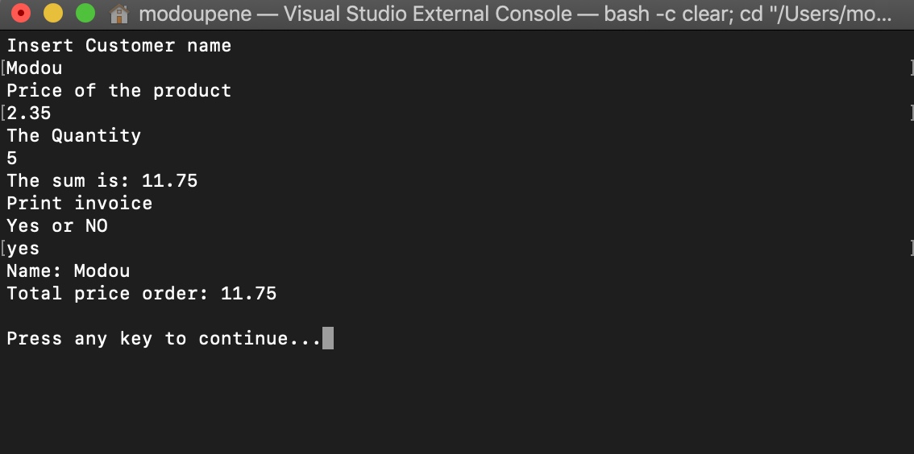

EXERCISE 2
using System;

namespace Exercise_2_
{
class MainClass
{
public static void Main(string[] args)
{
float x = 0;
float y=0;
float area=0;
Console.WriteLine("Insert X");
x = float.Parse(Console.ReadLine());
Console.WriteLine("Insert Y");
y = float.Parse(Console.ReadLine());
area = (3 * x) - (2 * 2) + ((y + 3) * (x - 7));
Console.WriteLine("The sape area is " + area);

}
}
}
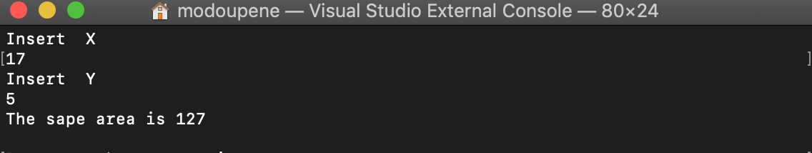

EXERCISE 3
using System;
using System.Collections.Generic;
using System.Linq;
using System.Text;

namespace slootmachine
{
class MainClass
{
public static void Main(string[] args)
{
Random randNumGen = new Random();
int credits = 0;
bool ans;
string answer;

Console.WriteLine("******************************************");
Console.WriteLine("------------------------------------------");
Console.WriteLine("Welcome Slot Machine!");
Console.WriteLine("------------------------------------------");
Console.WriteLine("Press Spacebar !");
Console.WriteLine("------------------------------------------");

Console.WriteLine("******************************************");
ConsoleKeyInfo keyInfo = Console.ReadKey(true);
do
{

ans = true;
int randNum1 = randNumGen.Next(0, 9);
int randNum2 = randNumGen.Next(0, 9);
int randNum3 = randNumGen.Next(0, 9);
Console.WriteLine("First Random Number: " + randNum1);
Console.WriteLine("Second Random Number: " + randNum2);
Console.WriteLine("Third Random Number: " + randNum3);

if (randNum1 == randNum2 || randNum1 == randNum3 || randNum2 == randNum3)
{
credits += 5;
Console.WriteLine("You win, your points\n " + credits + " Spin?");

}
else

if ((randNum1 == randNum2) && (randNum2 == randNum3))
{
credits += 15;
Console.WriteLine("You win, your points\n " + credits + " Spin?");
}
else

if ((randNum1 == 9) && (randNum2 == 9) || (randNum1 == 9) && (randNum3 == 9) || (randNum2 == 9) && (randNum3 == 9))
{
credits += 200;
}
else

if ((randNum1 == 9) && (randNum2 == 9) && (randNum3 == 9))
{
credits += 2000;
Console.WriteLine("You win, your points\n " + credits + " Spin?");
ans = false;
}
else
{
Console.WriteLine("You lose, your points are " + credits + " Spin?");
}

answer = Console.ReadLine();
if (answer == "no")
{
ans = false;
}

} while (ans);

Console.WriteLine("Your points are " + credits );

}
}
}
9
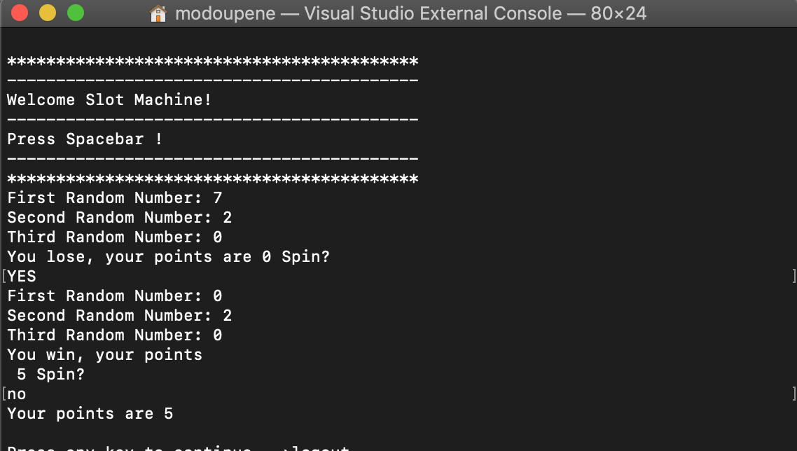

EXERCISE 4
using System;
using System.Collections.Generic;
using System.Linq;
using System.Text;
using System.Windows.Forms;
using System.Drawing;

namespace Snake_and_Ladder
{
class PlayerLocation
{
public static void Play_1Location(int Play_1location, PictureBox Play_1)
{

switch (Play_1location)
{
case 0:
Play_1.Location = new Point(36, 510);
break;
case 1:
Play_1.Location = new Point(129, 510);
break;
case 2:
Play_1.Location = new Point(216, 510);
break;
case 3:
Play_1.Location = new Point(306, 510);
break;
case 4:
Play_1.Location = new Point(394, 510);
break;
case 5:
Play_1.Location = new Point(483, 510);
break;
case 6:
Play_1.Location = new Point(572, 510);
break;
case 7:
Play_1.Location = new Point(663, 510);
break;
case 8:
Play_1.Location = new Point(663, 432);
break;
case 9:
Play_1.Location = new Point(572, 432);
break;
case 10:
Play_1.Location = new Point(483, 432);
break;
case 11:
Play_1.Location = new Point(394, 432);
break;
case 12:
Play_1.Location = new Point(306, 432);
break;
case 13:
Play_1.Location = new Point(216, 432);
break;
case 14:
Play_1.Location = new Point(129, 432);
break;
case 15:
Play_1.Location = new Point(36, 432);
break;
case 16:
Play_1.Location = new Point(36, 353);
break;
case 17:
Play_1.Location = new Point(129, 353);
break;
case 18:
Play_1.Location = new Point(216, 353);
break;
case 19:
Play_1.Location = new Point(306, 353);
break;
case 20:
Play_1.Location = new Point(394, 353);

break;
case 21:
Play_1.Location = new Point(483, 353);
break;
case 22:
Play_1.Location = new Point(572, 353);
break;
case 23:
Play_1.Location = new Point(663, 353);
break;
case 24:
Play_1.Location = new Point(663, 272);
break;
case 25:
Play_1.Location = new Point(572, 272);
break;
case 26:
Play_1.Location = new Point(483, 272);
break;
case 27:
Play_1.Location = new Point(394, 272);
break;
case 28:
Play_1.Location = new Point(306, 272);
break;
case 29:
Play_1.Location = new Point(216, 272);
break;
case 30:
Play_1.Location = new Point(129, 272);
break;
case 31:
Play_1.Location = new Point(36, 272);
break;
case 32:
Play_1.Location = new Point(36, 193);
break;
case 33:
Play_1.Location = new Point(129, 193);
break;
case 34:
Play_1.Location = new Point(216, 193);
break;
case 35:
Play_1.Location = new Point(306, 193);
break;
case 36:
Play_1.Location = new Point(394, 193);
break;
case 37:
Play_1.Location = new Point(483, 193);
break;
case 38:
Play_1.Location = new Point(572, 193);
break;
case 39:
Play_1.Location = new Point(663, 193);
break;
case 40:
Play_1.Location = new Point(663, 113);
break;
case 41:
Play_1.Location = new Point(572, 113);
break;
case 42:
Play_1.Location = new Point(483, 113);
break;
case 43:
Play_1.Location = new Point(394, 113);
break;
case 44:
Play_1.Location = new Point(306, 113);
break;
case 45:
Play_1.Location = new Point(216, 113);
break;
case 46:
Play_1.Location = new Point(129, 113);
break;
case 47:
Play_1.Location = new Point(36, 113);
break;
case 48:
Play_1.Location = new Point(36, 33);
break;
case 49:
Play_1.Location = new Point(129, 33);
break;
case 50:
Play_1.Location = new Point(216, 33);
break;
case 51:
Play_1.Location = new Point(306, 33);
break;
case 52:
Play_1.Location = new Point(394, 33);
break;
case 53:
Play_1.Location = new Point(483, 33);
break;
case 54:
Play_1.Location = new Point(572, 33);
break;
case 55:
Play_1.Location = new Point(663, 33);
break;
default:
Play_1.Location = new Point(663, 33);
break;

}
}
public static void Play_2Location(int Play_2location, PictureBox Play_2)
{
switch (Play_2location)
{
case 0:
Play_2.Location = new Point(36, 510+46);
break;
case 1:
Play_2.Location = new Point(129, 510 + 46);
break;
case 2:
Play_2.Location = new Point(216, 510 + 46);
break;
case 3:
Play_2.Location = new Point(306, 510 + 46);
break;
case 4:
Play_2.Location = new Point(394, 510 + 46);
break;
case 5:
Play_2.Location = new Point(483, 510 + 46);
break;
case 6:
Play_2.Location = new Point(572, 510 + 46);
break;
case 7:
Play_2.Location = new Point(663, 510 + 46);
break;
case 8:
Play_2.Location = new Point(663, 432 + 46);
break;
case 9:
Play_2.Location = new Point(572, 432 + 46);
break;
case 10:
Play_2.Location = new Point(483, 432 + 46);
break;
case 11:
Play_2.Location = new Point(394, 432 + 46);
break;
case 12:
Play_2.Location = new Point(306, 432 + 46);
break;
case 13:
Play_2.Location = new Point(216, 432 + 46);
break;
case 14:
Play_2.Location = new Point(129, 432 + 46);
break;
case 15:
Play_2.Location = new Point(36, 432 +46);
break;
case 16:
Play_2.Location = new Point(36, 353 + 46);
break;
case 17:
Play_2.Location = new Point(129, 353+ 46);
break;
case 18:
Play_2.Location = new Point(216, 353 + 46);
break;
case 19:
Play_2.Location = new Point(306, 353 + 46);
break;
case 20:
Play_2.Location = new Point(394, 353 + 46);
break;
case 21:
Play_2.Location = new Point(483, 353 + 46);
break;
case 22:
Play_2.Location = new Point(572, 353 + 46);
break;
case 23:
Play_2.Location = new Point(663, 353 + 46);
break;
case 24:
Play_2.Location = new Point(663, 272 + 46);
break;
case 25:
Play_2.Location = new Point(572, 272 + 46);
break;
case 26:
Play_2.Location = new Point(483, 272 + 46);
break;
case 27:
Play_2.Location = new Point(394, 272 + 46);
break;
case 28:
Play_2.Location = new Point(306, 272 + 46);
break;
case 29:
Play_2.Location = new Point(216, 272 + 46);
break;
case 30:
Play_2.Location = new Point(129, 272 + 46);
break;
case 31:
Play_2.Location = new Point(36, 272 + 46);
break;
case 32:
Play_2.Location = new Point(36, 193 + 46);
break;
case 33:
Play_2.Location = new Point(129, 193 + 46);
break;
case 34:
Play_2.Location = new Point(216, 193 + 46);
break;
case 35:
Play_2.Location = new Point(306, 193 + 46);
break;
case 36:
Play_2.Location = new Point(394, 193 + 46);
break;
case 37:
Play_2.Location = new Point(483, 193 + 46);
break;
case 38:
Play_2.Location = new Point(572, 193 + 46);
break;
case 39:
Play_2.Location = new Point(663, 193 + 46);
break;
case 40:
Play_2.Location = new Point(663, 113 + 46);
break;
case 41:
Play_2.Location = new Point(572, 113 + 46);
break;
case 42:
Play_2.Location = new Point(483, 113 + 46);
break;
case 43:
Play_2.Location = new Point(394, 113 + 46);
break;
case 44:
Play_2.Location = new Point(306, 113 + 46);
break;
case 45:
Play_2.Location = new Point(216, 113 + 46);
break;
case 46:
Play_2.Location = new Point(129, 113 + 46);
break;
case 47:
Play_2.Location = new Point(36, 113 + 46);
break;
case 48:
Play_2.Location = new Point(36, 33 + 46);
break;
case 49:
Play_2.Location = new Point(129, 33 + 46);
break;
case 50:
Play_2.Location = new Point(216, 33 + 46);
break;
case 51:
Play_2.Location = new Point(306, 33 + 46);
break;
case 52:
Play_2.Location = new Point(394, 33 + 46);
break;
case 53:
Play_2.Location = new Point(483, 33 + 46);
break;
case 54:
Play_2.Location = new Point(572, 33 + 46);
break;
case 55:
Play_2.Location = new Point(663, 33 + 46);
break;
default:
Play_2.Location = new Point(663, 33 + 46);
break;

}
}
}
}

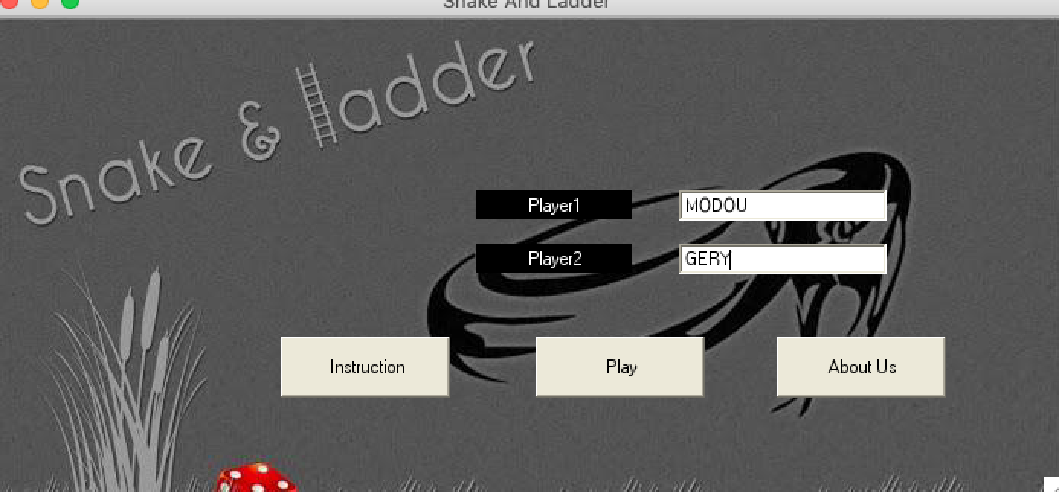
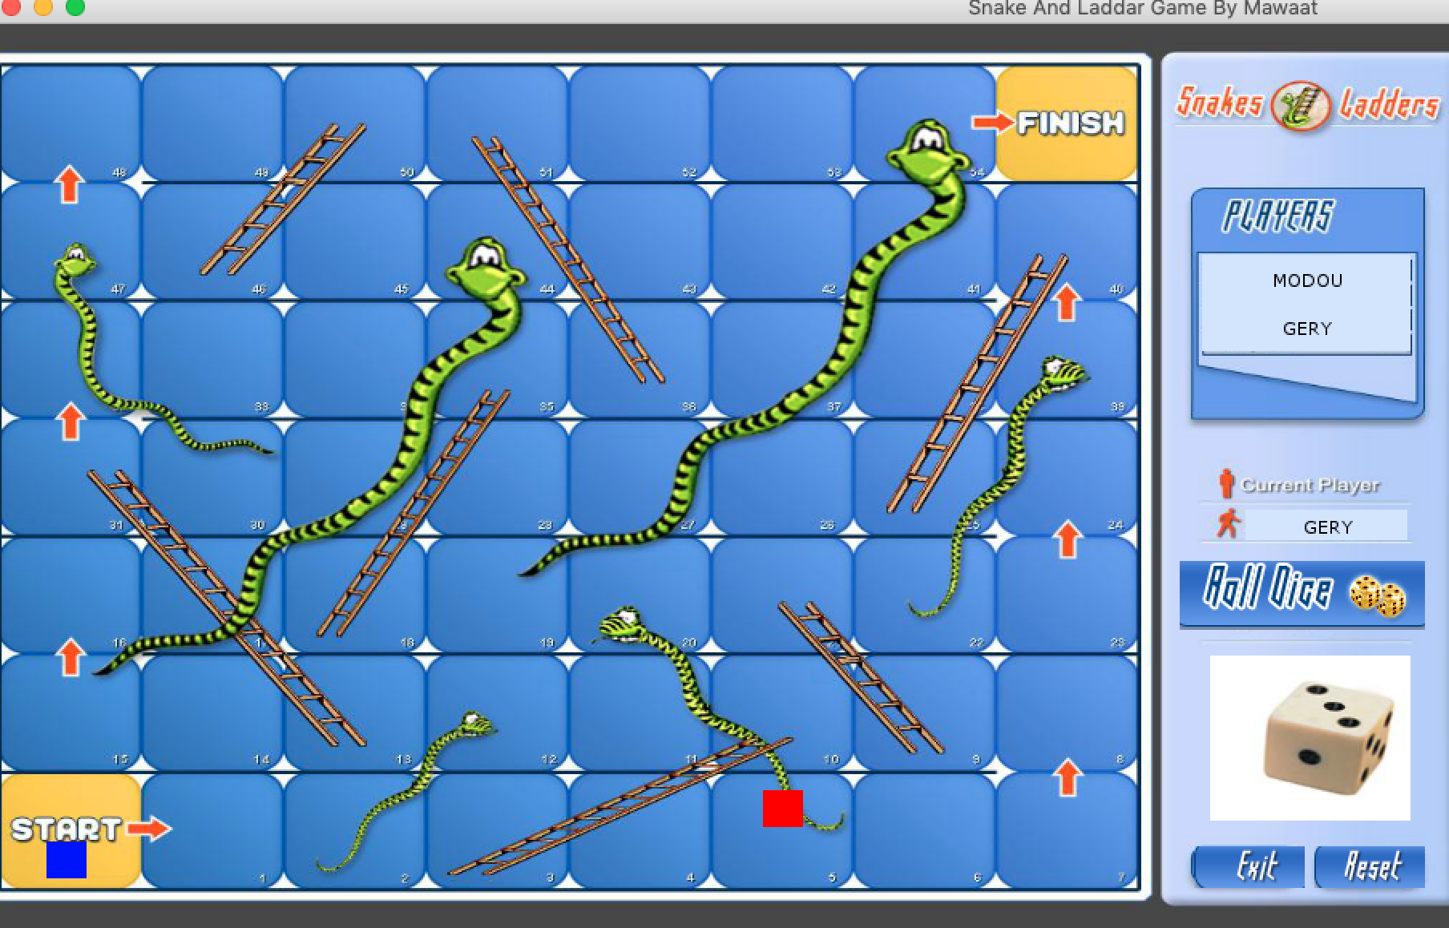
REFERENCE

Docs.microsoft.com. (2019). C# Guide. [online] Available at: https://docs.microsoft.com/en-us/dotnet/csharp/ [Accessed 1 Sep. 2019].

C# sharp. Microsoft. Archived from the original on February 14, 2006. Retrieved March 25, 2008.

C# language . Ecma International. June 2006. Retrieved January 26, 2012.

Archer, Tom (2001). Chapter 4: The Type System. Inside C#. Redmond

