Critical Review
Luke Rees
2100874

Contents
Showreel 3
Business Card 4
Bibliography 5

Showreel
https://www.youtube.com/watch?v=HpW0eYq_jRU
Showreel can be found on YouTube using the above link.

Business Card
Front
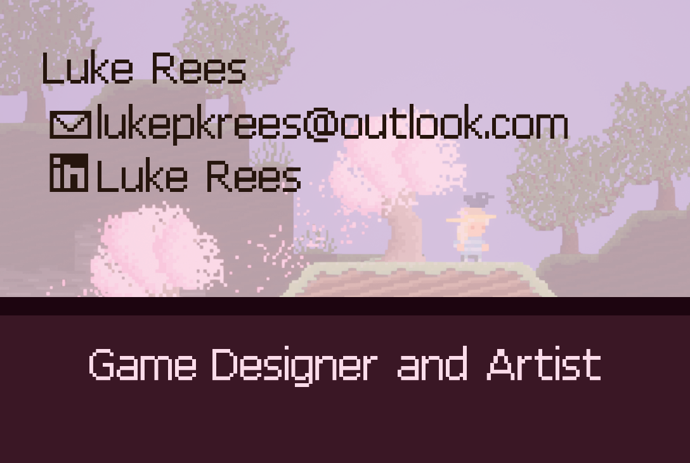
https://uowtsd-my.sharepoint.com/:i:/g/personal/2100874_student_uwtsd_ac_uk/EXlT-NmbuehGvF1Tr24Lr20B87buaGp2ORPZnJVkjynvJQ?e=WpBXv7
Back
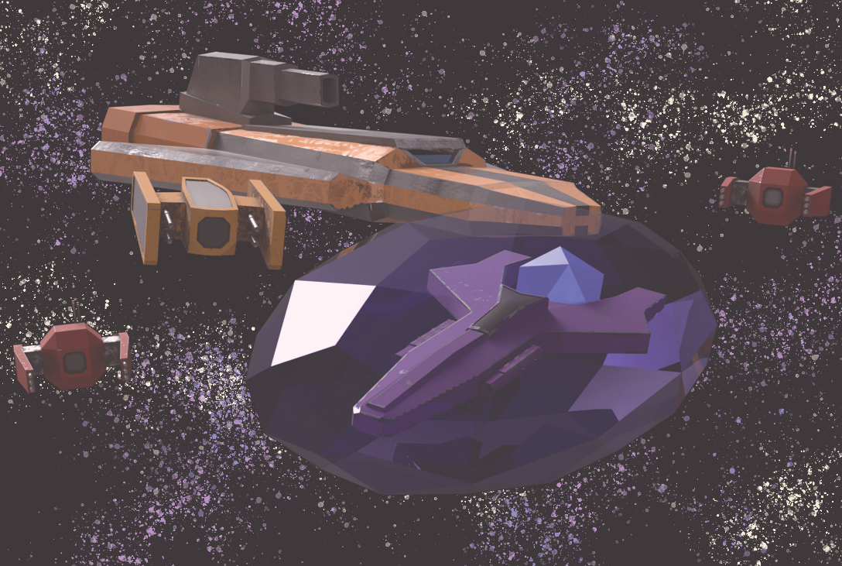
https://uowtsd-my.sharepoint.com/:i:/g/personal/2100874_student_uwtsd_ac_uk/EasLiiu-7SNNvW9yiMKiVlEB5BMaiWg9TTjXwir_-UKc0w?e=FasTPA

Bibliography
S. Lanier, 'How To Design a Good Business Card', Hubspot, Mar. 2, 2023, [Online], Available: https://blog.hubspot.com/sales/how-to-design-business-card, [Accessed: Apr. 9, 2024].
Visme, 'How to Design a Business Card | Do's and Don'ts for Business Card Design', Youtube, Jul. 2, 2020, [Online], Available: https://www.youtube.com/watch?v=4p_JVwpmf7U, [Accessed: Apr. 9, 2024].
M. Waziullah, 'Creating the Perfect Business Card: A Guide to Dos and Don'ts', Linkedin, Sept. 25, 2023, [Online], Available: https://www.linkedin.com/pulse/creating-perfect-business-card-guide-dos-donts-mohammed-waziullah/, [Accessed: Apr. 9, 2024].
Indeed Editorial Team, '22 Tips for Creating Business Cards (Plus Why They Matter)', indeed, Feb. 4, 2023, [Online], Available: https://www.indeed.com/career-advice/career-development/business-card-tips, [Accessed: Apr. 9, 2024].
Sean, 'Game Environment and Prop Artist - Showreel 2018 ', Youtube, Apr. 25, 2018, [Online], Available: https://www.youtube.com/watch?v=3lfYmp3xUkE, [Accessed: Mar. 28, 2024].
B. Russel, 'UE4 - Technical Artist Showreel - BRTechArt', Youtube, Apr. 30, 2018, [Online], Available: https://www.youtube.com/watch?v=3_6mrmMaDTk, [Accessed: Mar. 28, 2024].
S. Singh, 'Game Animation Showreel | Sonali Singh', Youtube, Apr. 18, 2021, [Online], Available: https://www.youtube.com/watch?v=lFo7L1IasZo, [Accessed: Apr. 13, 2024].
M. Graham, 'How to make a standout showreel', Canon, [Online], Available: https://www.canon.co.uk/pro/stories/how-to-make-a-standout-showreel/, [Accessed: Apr. 13, 2024].
V. Vishwaksena, 'Showreel Tips VFX,Animation,Gaming', Linkedin, Sept. 24, 2023, [Online], Available: https://www.linkedin.com/pulse/showreel-tips-vfxanimationgaming-venkata-vishwaksena/, [Accessed: Apr. 13, 2024].
Royalty Free Music – No Copyright Music, ‘Chill With Me - tubebackr | @RFM_NCM’, Youtube, Dec. 22, 2023, [Online], Available: https://www.youtube.com/watch?v=nEZj-ZKqgUw, [Accessed: Apr. 29, 2024].

