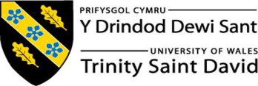
Applied Leadership and Management in the Workplace
Module Assignment Submission
Student Name: | Tanya regan.
Student Number: | 2319051
Module No: | BMSK 5010
Module Title: | Developing a learning organisation

Statement of Confirmation of Authenticity
By the act of making this submission, the student declares that this is the work of the student named above. The work has not, in whole or in part, been knowingly presented elsewhere for assessment, or where assessment has been built on a previous assessment, this has been identified. Where materials have been used from other sources it has been properly acknowledged. If this statement is untrue, the student acknowledges that an assessment offence has been committed.
Attention is drawn to the plagiarism and unfair practice policies of both the University and of ILM.

Introduction 3
Benefits of developing individuals in the workplace 3
Innovation 3
Cost savings 3
Knowledge 3
Alignment with vision, mission and strategy 4
The Michigan model 5
Improved workplace culture 5
Manage an individual's expectations in respect of personal development. 6
Wants and needs 6
Opportunities 7
Costs 7
Time 8
Critical assessment of DVLA’s development vehicles 8
DVLA examples of development vehicles 8
Mentoring 8
Courses 9
Best suited development vehicles for DVLA 10
Department visits 11
Action plan tools to identify development needs 12
GAP Analysis 12
SMART action plan 13
Mind map 14
Summary 15
References 16
References 16

Introduction
Developing and maintaining a learning culture is essential for organisations that want to improve performance and support employee development. A learning culture encourages continuous learning, knowledge sharing, and improvement, helping employees adapt to change and perform effectively in their roles. By investing in development opportunities such as training, mentoring, and workplace learning, organisations can build a skilled and engaged workforce

Benefits of developing individuals in the workplace

Innovation
Developing a high-performing culture encourages innovation by creating an environment of trust, motivation, and continuous improvement. When workplaces set clear goals, support employee development, and reward high performance, employees are more willing to take risks and experiment with new ideas (Edmondson, 2019) creating a culture of collaboration and emotional safety, which are critical for knowledge sharing and encourgaing creative problem-solving (Schein, 2010).
Additionally, when a workplace focuses on learning and taking accountability, it enables organizations to adapt and create innovative ideas or solutions that create long-term high performance (Denison, 1997).

Cost savings
Developing a learning organisation helps improve cost efficiency by enabling improvement across all areas of the workplace, encouraging knowledge sharing, and better decision-making. When employees regularly review and give feedback on practices and share learning, organizations can highlight things which are not working and ways to improve efficiency, reduce errors, and streamline processes, leading to lower running costs (Argyris & Schön, 1978). Creating the culture of a learning orgainisation also improves problem-solving skills, allowing issues to be addressed early before they escalate into failures (Senge, 1990) in addition to this, continuous learning supports innovation in processes and technologies, which can reduce waste and improve productivity, resulting in lowering costs while maintaining quality (Robbins & Judge, 2022).

Knowledge
Developing a learning organisation improves knowledge by allowing creation, transfer, and sharing of knowledge throughout the organisation. When learning is part of everyday practices, staff are encouraged to gain new skills and share expertise, turning individual knowledge into workplace knowledge (Nonaka & Takeuchi, 1995). This process reduces knowledge being withheld and enhances collective understanding, leading to better decision-making and performance.
Additionally, learning organisations spend time on structures and systems, such as training, communities of sharing best practice, and feedback processes—that support knowledge retention and continuous development (Chun Wei Choo, 2016). By encouraging reflection and the sharing of knowledge, organisations are better able to focus on lessons learned and apply them across different areas, strengthening their overall knowledge and adaptability.

Alignment with vision, mission and strategy
Developing a learning organisation supports a company’s vision, mission, and strategy by ensuring employees develop the skills and knowledge needed to achieve long-term company goals. When learning is part of daily work, employees better understand the organisation’s direction and can align their actions with strategic priorities, improving overall performance and adaptability (Senge, 2006)
A learning organisation helps achieve a company’s vision by preparing employees for future challenges and encouraging innovation. For example, Google’s vision of organizing the world’s information is supported by a strong learning and experimentation culture. Google invests heavily in employee learning, data-driven decision-making, and innovation practices, which allows continuous development of new products and services aligned with its long-term vision (Alphabet Inc., 2023).
Showing how this develops a company's mission is an example of Toyota. Toyota's mission, which focuses on delivering high-quality vehicles through continuous improvement, is supported by its learning-based Toyota Production System. Practices such as Kaizen encourage employees at all levels to identify problems, share knowledge, and implement improvements, demonstrating how learning directly supports operational excellence (Liker, 2004)
From a strategic perspective, learning organisations enable companies to adapt to changes in technology and the market. IBM, for example, aligns its learning culture with its digital transformation strategy by investing in large-scale employee learning initiatives to build skills in areas such as cloud computing and artificial intelligence. This ensures that employee capabilities remain aligned with strategic goals and future business needs (IBM, 2022).

The Michigan model
The Michigan Model of Human Resource Management (HRM) supports improved organisational strategy by ensuring that people's management is directly aligned with business objectives. The model, argues that HR practices should be designed to fit and reinforce an organisation’s strategy, structure, and systems (Fombrun, Tichy, & Devanna, 1984)
The Michigan Model also improves strategy by promoting consistency and control. Because HR practices are tightly linked to strategic objectives, employees clearly understand expectations and how their performance links to organisational success. (Boxall & Purcell, 2016).
Overall, the Michigan Model fits well with improved strategy because it treats employees as strategic resources and ensures HR systems are deliberately created to support organisational goals.
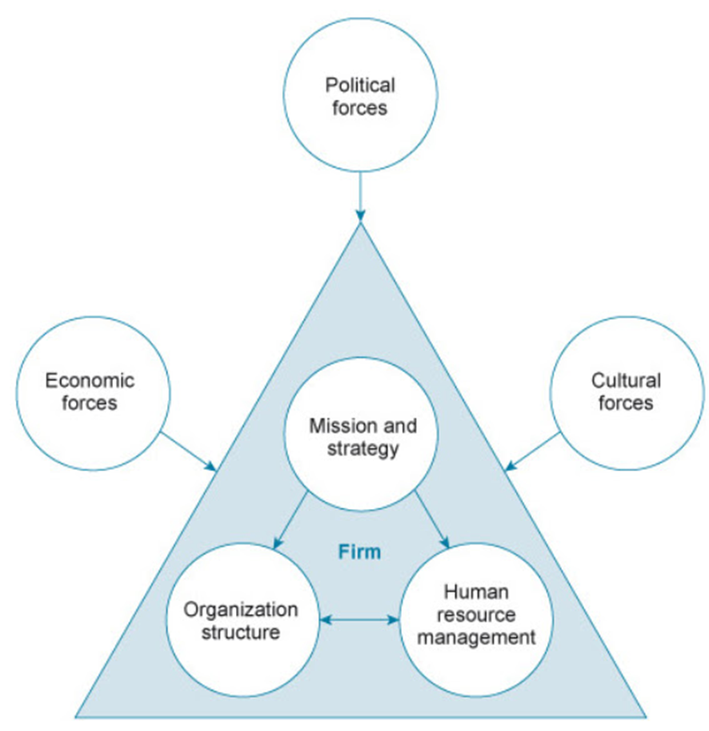

Overall, developing a learning organisation ensures that learning is closely linked to a company’s vision, mission, and strategy.

Improved workplace culture
Developing a learning organisation has a strong positive impact on workplace culture by creating an environment based on trust, collaboration, and continuous improvement. When learning is encouraged, employees feel valued and supported, which improves morale and engagement. A culture that promotes learning communicates that mistakes are seen as opportunities to improve rather than failures, increasing safety and openness (Edmondson, 1999).
Learning organisations also improve communication and collaboration. Knowledge sharing across teams reduces gaps and encourages employees to work together to solve problems. This shared learning builds stronger relationships , which strengthens workplace culture and teamwork (Senge, 1990).
In Black Box Thinking, (Syed, 2016) Matthew Syed uses the example of a study of nurses to show how learning from mistakes can improve performance.
The study found that nurses who felt safe to speak up about errors were able to learn from them and improve patient care. Instead of hiding mistakes out of fear of blame, these nurses discussed what went wrong and how to prevent it happening again. This open approach led to better learning, fewer repeat errors, and improved outcomes.
Syed uses this example to show that organisations that treat mistakes as learning opportunities, rather than failures, are more likely to improve performance. It highlights the importance of a supportive culture where people feel confident reporting problems and learn from them.

Overall, developing a learning organisation improves workplace culture by fostering trust, collaboration, engagement, and continuous improvement, all of which contribute to a more positive and productive working environment.

Manage an individual's expectations in respect of personal development.

Wants and needs
Using the Wants and Needs Model, employees are likely to expect their workplace to meet both basic needs and higher-level wants. At a basic level, employees expect fair pay, job security, and safe working conditions. For example, an employee expects to be paid on time, have clear working hours, and work in a safe environment. If these needs are not met, motivation and performance are likely to decline (Maslow, 1943)
Employees also expect their social needs to be met, such as positive relationships and teamwork. In the workplace, this could include supportive managers, respectful colleagues, and opportunities to work in teams. For example, regular team meetings and open communication help employees feel included and valued.
At a higher level, some employees expect opportunities for growth and recognition. This may include access to training, career progression, and praise for good performance. For example, offering development courses or recognising achievements through 1;1’s meets employees’ wants for personal development and achievement, increasing motivation and engagement (Armstrong & Taylor, 2023)
Overall, when organisations meet both employees’ needs and wants, employees are more satisfied, motivated, and committed to their work

Opportunities
Managing an individual’s expectations about personal development involves being clear and realistic about the opportunities available. Organisations can offer development opportunities such as training courses, mentoring, coaching, job shadowing, development assignments, or temporary positions like promotions. These opportunities help employees build new skills and gain experience that supports their career goals. For example, an employee may attend a training course to improve certain skills or be given additional responsibilities to prepare for future roles. This employee may then go on to share their knowledge with colleagues, further developing others.
It is important for managers to communicate about what development opportunities are available and what is required to access them. Regular performance reviews and development discussions help manage employee expectations with realistic career pathways. When employees understand how development opportunities work and what is achievable, they are more motivated, engaged, and satisfied with their role.

Costs
Managing employee expectations is important when looking at the costs of development in the workplace. Development helps employees improve skills, but it also costs money, time, and resources.
Training courses and qualifications can be expensive, so organisations cannot always offer development straight away or to everyone. Employees may expect quick promotion or pay increases after training, so managers need to clearly explain what development can and cannot offer.
Development also takes time away from normal work, which can affect productivity. Employees need to understand that training must fit business needs and may be spread over time.
By setting clear expectations about development opportunities, timescales, and outcomes, organisations can manage expectations, control costs, and keep employees motivated.

Time
Managing expectations around time is important when supporting employee development. Development activities such as training or mentoring take time away from day-to-day work, so employees need to understand that learning cannot always happen immediately. In busy workplaces, development must be planned around customer demands and may take place gradually. Employees may also expect quick results from development, such as promotion or improved performance, but learning often takes time to show results. Clear communication about timescales helps employees remain patient, motivated, and realistic about their development journey.

Critical assessment of DVLA’s development vehicles
Development vehicles are simple ways a workplace helps employees learn and progress and grow. They are used within the guidelines of an employee's role and requirement.
They include things like training courses, job learning coaching or mentoring, and taking on new tasks or projects. For example, an employee might attend a short course, learn from an experienced colleague, or be given extra responsibilities or temporary step up in a role to build new skills.
These development vehicles help employees improve their skills and prepare for future roles, while also helping the organization perform better.

DVLA examples of development vehicles

Mentoring
DVLA uses mentoring to support employee development by pairing with a less experienced employee with a more experienced colleague. The mentor provides guidance, advice, and support, helping the employee develop skills, confidence, and knowledge. This is usually in the form of a higher grade or senior management.
Through mentoring, employees can learn from real workplace experience, receive feedback, and gain insight into career progression. For example, a mentor may help an employee improve communication skills, understand workplace expectations, or prepare for future roles.
Mentoring benefits the organization by developing talent, improving performance, and supporting employee engagement and retention.
However, mentoring can be difficult to manage effectively. Scheduling is often a challenge, as both have busy workloads, which can lead to cancelled or infrequent meetings. Especially in the Contact Centre, as call demand takes priority over development. Typically, the meetings get moved due to the higher managers' priorities and commitments as these sessions do not benefit them as much as the mentee.
Another issue is finding the right mentor–mentee match. If personalities, communication styles, or goals do not align, the mentoring relationship may not be productive and can lead to frustration for both parties.
Additionally, a lack of structure can cause mentoring sessions to become inconsistent. Without clear goals, timelines, or guidance, meetings may lose focus and vary in quality, limiting the overall development benefit for the employee.
In conclusion, mentoring helps employees learn and grow with support from experienced colleagues. However, it only works well when meetings are regular, the right people are matched, and sessions are well organized.

Courses
Development courses support a learning culture by encouraging employees to build new skills and knowledge. Given training opportunities, employees feel supported and are more willing to learn and improve.
These courses help employees share new ideas, improve performance, and apply what they learn to their jobs. They also educate employees on policies and procedures. Over time, this creates a culture where learning is valued, confidence increases, and employees are motivated to develop themselves, helping the organization grow and adapt.
Development courses can be costly and time-consuming, especially if employees are taken away from their regular work. If courses are not well planned or relevant, employees may struggle to apply what they have learned, reducing their value. Scheduling requires accurate scheduling for the contact center as there are high customer demand and targets to achieve.
Another issue is that learning from courses may be inconsistent, as not all employees learn in the same way. Without follow-up support or opportunities to practice new skills, the benefits to the learning culture can be limited.
Development courses help build a learning culture by improving skills and encouraging continuous learning. However, they can be expensive and less effective if the training is not relevant or supported in the workplace.
In conclusion, mentoring and development courses are important development vehicles at the DVLA and have the potential to support employee growth and performance. Mentoring provides personalised support, knowledge sharing, and insight into career progression, while development courses help build essential skills, knowledge of policies, and consistent ways of working across the organisation.
The effectiveness of these development vehicles is strongly influenced by operational and management factors. In high-demand environments such as the Contact Centre, competing priorities, workload pressures, and staffing issues often limit the time available for development activities. This reduces consistency and can weaken the overall impact of mentoring and training. Mentoring relationships suffer when meetings are frequently rescheduled, poorly matched, or lack clear structure and objectives.
While development courses add positively to a learning culture, it can be reduced if training is not role-specific, followed up, or by opportunities to apply learning in the workplace. Without reinforcement through coaching, feedback, or experience, learning may not lead to improved performance. It could be used as an opportunity to take a break from a demanding role.
Overall, for mentoring and development courses to be effective at DVLA, they must be planned, resourced, and supported by management. Protecting time for development, improving structure, and linking learning outcomes to performance objectives would improve their efficiency and be a worthwhile expense.

Best suited development vehicles for DVLA
Training courses best suit DVLA as they are designed around the company’s vision, mission, and strategy. Employees learn the skills and behaviors that directly support what the company is trying to achieve. A lot of the training is in education around data protection, inclusivity and the organisations values and goals. For example, induction and ongoing training can show employees how their roles link to wider business goals. Every new employee is required to complete mandatory induction training when joining the agency. When employees understand the organisation’s strategy (especially from the start), they are more able to make decisions and work in ways that support long-term success.
Training courses improve employee knowledge by helping employees learn new skills and understand their jobs better. They give clear guidance on how to do tasks correctly and introduce new information that helps employees work more confidently.
Training also helps employees understand why tasks are done in certain ways. This makes it easier for them to use what they have learned in different situations and share knowledge with others at work.

Department visits
Department visits help employees at the DVLA understand how different parts of the organisation work and how their own job fits into the bigger picture. By visiting areas such as the mail room, keying teams, printing, and the contact centre, employees can see how work moves through the organisation from start to finish.
For example, seeing how the mail room handles post helps employees understand where customer applications begin. Learning about keying shows how important accurate data entry is. Visiting printing shows how documents are produced, and the contact centre shows how customer questions and problems are dealt with. This helps employees understand the purpose of each department.
When employees understand how all departments link together, they are more aware of how their work affects others. This encourages better quality, fewer mistakes, and more responsibility for their role. It also helps employees work better as a team, respect other departments, and communicate more effectively.
Overall, department visits support high performance and teamwork by helping employees see that everyone plays an important part in delivering services and achieving shared goals.

Action plan tools to identify development needs

GAP Analysis
This gap analysis is for a call center worker. It compares the skills needed to do the job well with the employee’s current skills. This helps identify where training and development are needed to improve performance.

Skill / Area | Required Standard | Current Level | Gap Identified | Development Action
Communication skills | Clear, confident, and professional communication | Clear communication but lacks confidence on difficult calls | Low confidence handling difficult queries | Communication skills training and call role-play
Product knowledge | Strong understanding of products and services | Basic product knowledge | Unable to answer detailed customer questions | Product knowledge training
Customer handling | Calm, empathetic handling of complaints | Struggles with upset customers | Difficulty managing complaints | Customer service and complaint-handling training
Systems use | Efficient use of call-handling systems | Slow system navigation | Longer call handling times | On-the-job system coaching with experienced colleague
Performance targets | Consistently meets call time and quality targets | Targets often missed | Time management issues | Time management training and mentoring. Ensuring correct modes are used for off call work

This gap analysis shows where the employee needs to improve to meet the job requirements. Identifying these gaps helps the organisation choose the right training and support to improve performance.

SMART action plan
This SMART action plan is for an administrative employee who enters drivers' records into a system. It sets clear goals to improve accuracy and speed and outlines how progress will be supported and reviewed.
SMART Area | Plan
Specific | Improve accuracy and speed when keying records into the system
Measurable | Reduce data entry errors to fewer than 2 per week and increase records completed by 5 per week.
Achievable | Complete refresher training and regular practice with manager support.  Shadow experienced keyer on team  Have regular spot checks on completed work  Biweekly check points or when needed.
Relevant | Accurate records reduce errors and improve efficiency. Achieve performance objective
Time-bound | Targets to be achieved within 8 weeks (specific date to be entered here)
The action plan sets clear goals to improve the employee’s accuracy and speed when entering records. It explains what actions are needed, how progress will be measured, and when goals should be achieved.
Using an action plan helps employees understand expectations, stay focused, and track progress. It also benefits the organisation by improving performance, reducing errors, and supporting employee development. This is also a tool to use performance management is required when targets are not improved. It can be used as evidence if a case needs to be built- protecting the organisation

Mind map
This mind map outlines the key areas someone needs to focus on when developing towards a management position in DVLA. It highlights the skills, experience, training, behavior, and planning needed to support career progression into management.
Main Goal:
Become a Manager
Key Areas:
Skills
- Communication
- Leadership
- Problem-solving
- Decision-making
- Time management
Knowledge & Experience
- Understanding company policies
- Knowing how the organisation works
- Supervising or supporting others
- Meeting targets and objectives
Training & Learning
- Management training courses
- Coaching and mentoring
- Learning on the job
- Shadowing managers
Behavior & Attitude
- Taking responsibility
- Showing initiative
- Being reliable
- Supporting team members
Performance & Feedback
- Achieving work targets
- Receiving feedback
- Acting on feedback
- Attending reviews
Career Planning
- Setting career goals
- Creating a development plan
- Appy for positions and gain feedback
The mind map shows that developing into a management position requires building the right skills, gaining experience, and continuing to learn. It also highlights the importance of positive behavior, good performance, regular feedback, and clear career planning to support progression into a management role.

Summary
Developing a learning culture is important because it helps employees continuously improve their skills, knowledge, and confidence. When learning is encouraged, employees feel supported, motivated, and more engaged in their work. A strong learning culture also helps organisations adapt to change, improve performance, and reduce mistakes by learning from experience. It encourages teamwork, open communication, and knowledge sharing across departments. Overall, a learning culture benefits both employees and the organisation by supporting personal development, improving efficiency, and helping the organisation achieve long-term success.

References

References
Argyris, C., & Schön, D. A. (1978). Organizational Learning. Addison-Wesley.
Armstrong, M., & Taylor, S. (2023). Armstrong’s Handbook of Human Resource Management Practice (16th ed.). Kogan Page.
Boxall, P. F., & Purcell, J. (2016). Strategy and Human Resource Management (4th ed.). Palgrave Macmillan.
Chun Wei Choo. (2016). The inquiring organization : how organizations acquire knowledge and seek information. Oxford University Press.
Denison, D. R. (1997). Corporate Culture and Organizational Effectiveness.
Edmondson, A. C. (2019). The fearless organization: Creating psychological safety in the workplace for learning, innovation, and growth. John Wiley & Sons, Inc.
IBM. (2022). Let’s Create 2022 Annual Report. https://www.ibm.com/investor/att/pdf/IBM_Annual_Report_2022.pdf
Liker, J. K. (2004). The Toyota Way: 14 Management Principles from the World’s Greatest Manufacturer. New York Mcgraw Hill Professional.
Mark Fenton O'creevy, & Gooderham, P. (2005). Diffusion of HRM to Europe and the Role of US MNCs. Hampp.
Maslow, A. H. (1943). A theory of human motivation. Psychological Review. Eyrolles, Dl , Cop.
Nonaka, I., & Takeuchi, H. (1995). The knowledge-creating company: How Japanese Companies Create the Dynamics of Innovation. Oxford University Press.
Robbins, S. P., & Judge, T. A. (2022). Organisational Behaviour : Global and Southern African Perspectives. Pinelands, Cape Town Pearson Education.
Schein, E. H. (2010). Organizational culture and leadership (4th ed.). Jossey-Bass.
Senge, P. M. (1990). The Fifth Discipline. The Crown Publishing Group.
Senge, P. M. (2006). The fifth discipline: The art and practice of the learning organization. Doubleday/Currency.
Syed, M. (2016). Black Box Thinking. Hodder & Stoughton.

