

Student name: Tulba Oksana
Student ID: 2513894
Module name: Introduction to Health and Social Care
Module code: LCHS4003
Lecturer name: Oluwadamilola Tayo

Table of Contents
1 Poster 3
2 Element 2 4
2.1 Dentistry Service. Introduction 4
2.2 Critical Evaluation of Modern Functioning 4
2.3 Significance in Enhancing Quality of Life Services 5
5 Reference List 6

Recommendation:
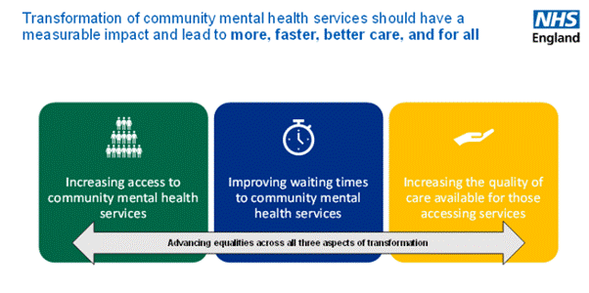

Current functioning of the service:

Today, Community Mental Health Services (CMHS) operate through a transformed model of "Integrated Care Systems" (ICS). Rather than being isolated units, services are now organised via Integrated Care Boards (ICBs), which aim to bridge the gap between primary care (GPs) and specialist psychiatric teams. Modern functioning relies on multidisciplinary hubs where clinicians, social workers, and peer support specialists collaborate to manage caseloads within the community. Also, under the NHS Long Term Plan, the focus has shifted toward "open access," allowing patients to move more fluidly between different levels of support without the rigid barriers of traditional referral thresholds. This proactive approach prioritises early intervention and crisis prevention to keep individuals stable within their home environments.

Some of the challenges facing community mental health services (CMHS) in the UK include staff shortages, limited funding, long waiting times, and difficulties with access:

1.Workforce Shortages and High Turnover: A primary obstacle is the chronic shortage of qualified mental health professionals, including psychiatric nurses and clinical psychologists. High caseloads and burnout have led to significant retention issues, which directly impacts the continuity of care for service users and puts immense pressure on remaining multidisciplinary teams.

2.Increased Demand and Waiting Times: Despite the goals of the NHS Long Term Plan, the surge in referrals post-pandemic has outpaced service capacity. This "referral gap" means that many individuals with non-crisis but serious conditions face extensive waiting lists, often leading to a deterioration in their mental health before they receive specialist community intervention.

Community Mental Health Services

History of the service:
The evolution of UK mental health services from institutional settings to local community care was a prolonged process. Early steps toward outpatient care began in the 1930s, with voluntary admissions and outpatient clinics. The founding of the NHS in 1948 made psychiatric care free, but it remained largely hospital-based. The Mental Health Act 1959 signalled the beginning of deinstitutionalisation. In 1961, Enoch Powell’s “Water Tower” speech highlighted the need to close large asylums and reduce beds. By the 1980s, the Care in the Community policy was introduced, leading to the closure of large psychiatric hospitals in favour of local support. The service was modernised by the 1999 National Service Framework, which established multidisciplinary Community Mental Health Teams (CMHTs) used today to integrate clinical and social care.

Community Mental Health Services (CMHS):
Community Mental Health Services (CMHS) in the UK provide integrated care for individuals with complex mental health conditions that require more specialist support than primary care can offer. Managed by the NHS, these services are delivered through multidisciplinary Community Mental Health Teams (CMHTs), which include psychiatrists, mental health nurses, and social workers. Beyond clinical treatment, CMHS focus on "person-centered" recovery, helping service users manage their daily lives, housing, and social inclusion. This model often includes 24/7 crisis resolution and home treatment teams (CRHTTs)to provide urgent intervention, effectively serving as a vital alternative to acute hospital admission for those experiencing severe mental distress. Overall, CMHS play a crucial role in promoting long-term stability and independence within the community.

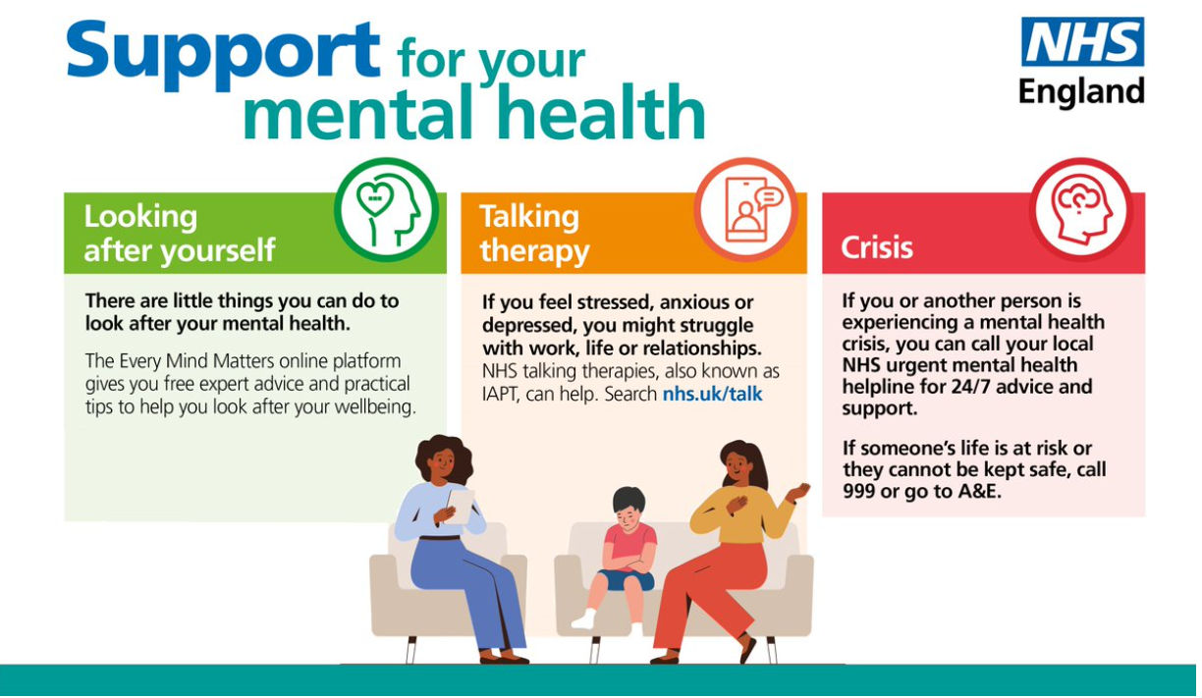
Element 2
Dentistry services
1. Introduction
The way dental care is provided in the UK has changed significantly over the last two centuries. Before any official regulation was introduced, dental work was often basic and risky. It was typically carried out by travelling tradesmen with no formal medical training or professional oversight. A key step towards regulating the profession came with the 1878 Dentists Act, which introduced a formal register of qualified practitioners and allowed patients to identify properly trained dentists (General Dental Council, 2023). This marked the beginning of a more structured and safer dental system.
A major turning point occurred on 5 July 1948 with the creation of the National Health Service. The introduction of the NHS meant that dental care was no longer limited to those who could afford private treatment, but became part of a wider system of publicly funded healthcare available to the population (NHS England, 2023). As a result, access to dental services increased significantly, changing the overall approach to oral healthcare in the UK.
However, demand for treatment quickly exceeded government expectations. In the first nine months alone, the NHS provided over 7 million sets of dentures to people who had previously avoided treatment due to cost. Although NHS dental care was initially free at the point of use, the high cost of providing services soon became a concern for policymakers. As a result, in 1951 the government introduced charges for certain treatments, including dentures, marking the beginning of a co-payment system within NHS dentistry (House of Commons Library, 2024). This development highlights the ongoing challenge of balancing public demand with available funding, which remains a key issue for the profession today (British Dental Association, 2024).

2. Critical Evaluation of Modern Functioning
Today, NHS dentistry operates in a way that is quite different from other healthcare services. It is based on a specific and often criticised contract model known as Units of Dental Activity (UDAs). Since 2006, dental services in England have been delivered through this system, which determines how dentists are paid for their work (House of Commons Library, 2024). Unlike GP surgeries, most dental practices are independent businesses that hold contracts with the NHS to provide publicly funded care. This structure shapes how dental services are delivered and funded.
One of the major current issues is that NHS funding does not fully cover the level of dental care needed by the population. This has contributed to what are often described as “dental deserts” – areas where few or no dentists are able to take on new NHS patients. The Nuffield Trust (2023) notes that access to NHS dentistry has become increasingly difficult in many parts of England in recent years. This is partly because the UDA system is considered restrictive and financially challenging, leading some dentists to reduce their NHS work or move towards private practice. As a result, access to care has declined.
This situation has raised concerns about the development of a “two-tier” system. Patients who can afford private treatment are often able to access care more quickly, while those relying on NHS services may face long waiting times or difficulty finding a dentist accepting new patients. The British Dental Association (2024) argues that without further reform to funding and contracts, access problems are likely to continue. This highlights the ongoing impact of structural and financial limitations within NHS dentistry.
3. Significance in Enhancing Quality of Life Services
The importance of dental services for a person’s quality of life is often underestimated. It is not only about relieving toothache; dental care is a key part of overall health. There are well-established links between poor oral health and serious conditions such as heart disease, diabetes, and complications during pregnancy (WHO, 2022). There is also a significant economic impact. When people experience dental pain and cannot access treatment, they may need to take time off work. In some cases, they attend Accident and Emergency (A&E) departments instead (NHS England, 2023). However, as A&E staff are not trained dentists, they are usually unable to treat the underlying problem, which places unnecessary pressure on hospital services. This demonstrates the wider impact of limited access to dental care.
Beyond physical health, the social and psychological effects are also considerable. Oral health influences how people speak, what they can eat, and how they feel about themselves. Missing or painful teeth can damage self-esteem, making it more difficult to attend job interviews or engage in social activities (Oral Health Foundation, 2021). In addition, regular check-ups play a crucial role in the early detection of oral cancer, as dentists can identify warning signs at an early stage (NHS, 2022). As highlighted by the House of Commons Library (2024), the true value of dental services lies in their ability to reduce health inequalities between different socioeconomic groups. However, current access issues are limiting this potential. Ultimately, ensuring equal access to dental care is not only a medical concern but also a matter of fairness and social justice in the UK.

References:

  - British Dental Association (2024) About the BDA. Available at: https://www.bda.org/about-us/ (Accessed: 8 March 2026).
  - General Dental Council (2023) Our role and legislation. Available at: https://www.gdc-uk.org/about-us/our-organisation/how-we-are-governed/legislative-framework (Accessed: 8 March 2026).
  - House of Commons Library (2024) NHS dentistry in England. Available at: https://commonslibrary.parliament.uk/research-briefings/cbp-9597/ (Accessed: 8 March 2026).
  - NICE (2019) Service user experience in adult mental health services: history and context. Available at: https://www.nice.org.uk/guidance/qs14 (Accessed: 7 March 2024).
  - NHS (2022) Mouth cancer. Available at: https://www.nhs.uk/conditions/mouth-cancer/ (Accessed: 8 March 2026).
  - NHS England (2019) The Community Mental Health Framework for Adults and Older Adults. Available at: https://www.england.nhs.uk/wp-content/uploads/2019/09/community-mental-health-framework-for-adults-and-older-adults.pdf (Accessed: 7 March 2024).
  - NHS England (2023) Accident and emergency services. Available at: https://www.england.nhs.uk/urgent-emergency-care/services/a-e/ (Accessed: 8 March 2026).
  - NHS England (2024) Our plan to recover and reform NHS dentistry. Available at: https://www.england.nhs.uk/long-read/our-plan-to-recover-and-reform-nhs-dentistry/ (Accessed: 8 March 2026).
  - Nuffield Trust (2023) NHS dental services in England. Available at: https://www.nuffieldtrust.org.uk/resource/nhs-dental-services (Accessed: 8 March 2026).
  - World Health Organization (2022) Oral health. Available at: https://www.who.int/news-room/fact-sheets/detail/oral-health (Accessed: 8 March 2026).

