Pentest Report

Name: Geng Li
Student ID: 104973180
Date: 20/04/2020
Module：Network Security
目录
Introduction： 2
Penetration testing framework 3
Penetration testing tools 3
Identified vulnerabilities 3
Vulnerability utilization and Solutions 4
Vulnerability name: Missing X-Frame-Options Header 4
Vulnerability name: Invalid SSL Certificate 6
Vulnerability name: HTTP Strict Transport Security (HSTS) Policy Not Enabled 6
Vulnerability name: SSL Medium Strength Cipher Suites Supported (SWEET32) 8
Vulnerability name: SSL RC4 Cipher Suites Supported (Bar Mitzvah) 9
Vulnerability name: TLS Version 1.1 Protocol Detection 9
Vulnerability name: TLS Version 1.0 Protocol Detection 10
Vulnerability name: DNS Server Cache Snooping Remote Information Disclosure 11
Vulnerability name: DNS Server Spoofed Request Amplification DDoS 12
Vulnerability name: POP3 Cleartext Logins Permitted 12
Vulnerability name: SSL Anonymous Cipher Suites Supported 12
Timetable for execution of solution 13

Introduction：
This is a black box test for https://tevelcyber.com/, which aims at learning and teaching and tries to learn the methods and skills of penetration test in real environment. The Tevel Cyber Corps Private Limited gave their consent for students to carryout live Pen Testing on their website，Rules / guidelines for testing are provided as follows
- Do not modify any contents in the website as this is in production status (Encouraging to report the vulnerability)
- Provide details of the vulnerability and exploit methodology, including information needed to reproduce and validate the vulnerability and a Proof of Concept (POC).
- Make a good faith effort to avoid privacy violations, destruction of data, and interruption or degradation of our services.
- Do not modify or access data that does not belong to you.
- Do not use vulnerabilities (reported or not-yet-reported) to pivot and discover further vulnerabilities.
This Pentest strictly follows the above rules / guidelines and strives to achieve the ultimate goal of teaching Contingency policy
The following Contingency policy should be strictly followed in this Pentest
1. Once the normal operation of the web page, stop the test immediately
2. In case of any leakage of user data, report to the company immediately
3. If damage is caused to the server of the web page, report to the company immediately
4. If there is any change to the web page data or display content, immediately change back to the original data or content
5. If the web page is unable to run and other serious results are caused, contact the company immediately to start the standby scheme
6. Back up all data involved in the meeting in advance
7. Predict all errors or improper operations that will occur in the test process, and plan solutions

Penetration testing framework

Vulnerability
exploitation
Vulnerability scanning
Information gathering
Pre interaction

Write report

Penetration testing tools
The following tools were used in this penetration test
Information collection：Nmap(kali),Metasploit(kali)
Vulnerability scanning: Nessus(kali), Netsparker(windows)
Vulnerability exploitation: Metasploit (kali)

Identified vulnerabilities
Severity | Count
Critical | 0
High | 0
Medium | 29
Low | 4

Vulnerability | Severity | Port
Missing X-Frame-Options Header | Low | 80
Invalid SSL Certificate | Medium | 443
HTTP Strict Transport Security (HSTS) Policy Not Enabled | Low | 443
SSL Medium Strength Cipher Suites Supported (SWEET32) | Medium | 2078，2080，2087，2083，2096
SSL RC4 Cipher Suites Supported (Bar Mitzvah) | Medium | 21
POP3 Cleartext Logins Permitted | Low | 110
DNS Server Spoofed Request Amplification DDoS | Medium | 53
SSL Anonymous Cipher Suites Supported | Low | 21
DNS Server Cache Snooping Remote Information Disclosure | Medium | 53
TLS Version 1.0 Protocol Detection | Medium | 2078，2080，2087，110，143，993，2083，995，2096
TLS Version 1.1 Protocol Detection | Medium | 2078，2080，2096，2083，143，993，110，996，21，2087

Vulnerability utilization and Solutions
All attacks are carried out using modules in Metasploit, and similar steps are used
1. Search the exploitable attack module of the vulnerability
2. Check the module parameters and set the parameters, where RHOST is set to 192.185.39.52 and RPORT is set to the corresponding port
3. Search available payloads
4. Set payloads parameters
5. Execute attack

Vulnerability name: Missing X-Frame-Options Header
Description: Netsparker detected a missing X-Frame-Options header which means that this website could be at risk of a clickjacking attack.
The X-Frame-Options HTTP header field indicates a policy that specifies whether the browser should render the transmitted resource within a frame or an iframe. Servers can declare this policy in the header of their HTTP responses to prevent clickjacking attacks, which ensures that their content is not embedded into other pages or frames.
Clickjacking is when an attacker uses multiple transparent or opaque layers to trick a user into clicking on a button or link on a framed page when they were intending to click on the top level page. Thus, the attacker is "hijacking" clicks meant for their page and routing them to other another page, most likely owned by another application, domain, or both.
Using a similar technique, keystrokes can also be hijacked. With a carefully crafted combination of stylesheets, iframes, and text boxes, a user can be led to believe they are typing in the password to their email or bank account, but are instead typing into an invisible frame controlled by the attacker.
Attack tool used: Metasploit
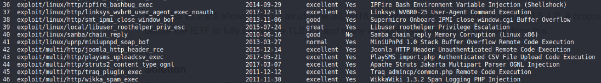
Protocols involved: HTTP
Success or not:
Module number | Success or not
36 | Yes
37 | Yes
38 | No
39 | No
40 | No
41 | No
42 | Yes
43 | Yes
44 | No
45 | Yes
46 | Yes

Solution: Sending the proper X-Frame-Options in HTTP response headers that instruct the browser to not allow framing from other domains.
X-Frame-Options: DENY It completely denies to be loaded in frame/iframe.
X-Frame-Options: SAMEORIGIN It allows only if the site which wants to load has a same origin.
X-Frame-Options: ALLOW-FROM URL It grants a specific URL to load itself in a iframe. However please pay attention to that, not all browsers support this.
Employing defensive code in the UI to ensure that the current frame is the most top level window.
Solution cost：No new software or hardware needs to be purchased. It takes an hour to modify the code

Vulnerability name: Invalid SSL Certificate
Description: Netsparker identified an invalid SSL certificate.
An SSL certificate can be created and signed by anyone. You should have a valid SSL certificate to make your visitors sure about the secure communication between your website and them. If you have an invalid certificate, your visitors will have trouble distinguishing between your certificate and those of attackers
Attack tool used: Metasploit
Protocols involved: HTTP,SQL
Success or not:
Module Number | Success or not
45 | Yes
46 | Yes
47 | No
48 | No
49 | Yes
50 | No

Solution: Fix the problem with your SSL certificate to provide secure communication between your website and its visitors.
Solution cost：No new software or hardware needs to be purchased. It takes several hours to modify the code

Vulnerability name: HTTP Strict Transport Security (HSTS) Policy Not Enabled
Description: Netsparker identified that HTTP Strict Transport Security (HSTS) policy is not enabled.
The target website is being served from not only HTTP but also HTTPS and it lacks of HSTS policy implementation.
HTTP Strict Transport Security (HSTS) is a web security policy mechanism whereby a web server declares that complying user agents (such as a web browser) are to interact with it using only secure HTTP (HTTPS) connections. The HSTS Policy is communicated by the server to the user agent via a HTTP response header field named "Strict-Transport-Security". HSTS Policy specifies a period of time during which the user agent shall access the server in only secure fashion.
When a web application issues HSTS Policy to user agents, conformant user agents behave as follows:
Automatically turn any insecure links referencing the web application into secure links. (For instance,http://example.com/some/page/will be modified to https://example.com/some/page/ before accessing the server.)
If the security of the connection cannot be ensured (e.g. the server's TLS certificate is self-signed), show an error message and do not allow the user to access the web application.
Protocols involved: HTTP
Attack tool used: Metasploit
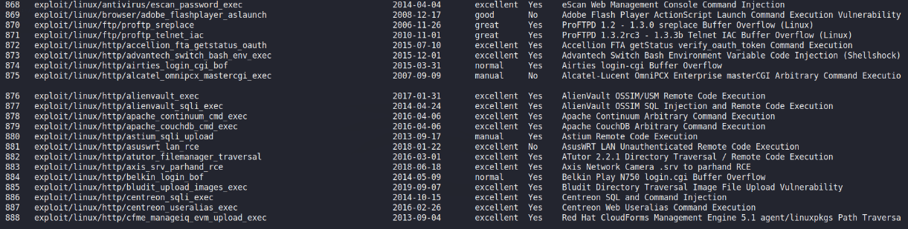
Success or not:
Module Number | Success or not
868 | Yes
869 | Yes
870 | No
871 | No
872 | No
873 | No
874 | No
875 | No
876 | No
877 | No
878 | No
873 | No
880 | Yes
881 | Yes
882 | No
883 | No
884 | No
885 | No
886 | No
887 | No
888 | No

Solution: Configure your webserver to redirect HTTP requests to HTTPS.
For Apache, you should have modification in the httpd.conf.
# load module
LoadModule headers_module modules/mod_headers.so
# redirect all HTTP to HTTPS (optional)
<VirtualHost *:80>
ServerAlias *
RewriteEngine On
RewriteRule ^(.*)$ https://%{HTTP_HOST}$1 [redirect=301]
</VirtualHost>

# HTTPS-Host-Configuration
<VirtualHost *:443>
# Use HTTP Strict Transport Security to force client to use secure connections only
Header always set Strict-Transport-Security "max-age=31536000; includeSubDomains"

# Further Configuration goes here
[...]
</VirtualHost>
No new software or hardware needs to be purchased. It takes an hour to modify the code

Vulnerability name: SSL Medium Strength Cipher Suites Supported (SWEET32)
Description: The remote host supports the use of SSL ciphers that offer medium strength encryption. Nessus regards medium strength as any encryption that uses key lengths at least 64 bits and less than 112 bits, or else that uses the 3DES encryption suite.
Note that it is considerably easier to circumvent medium strength encryption if the attacker is on the same physical network.
Protocols involved: HTTP，SQL，TCP/IP
Attack tool used: Metasploit
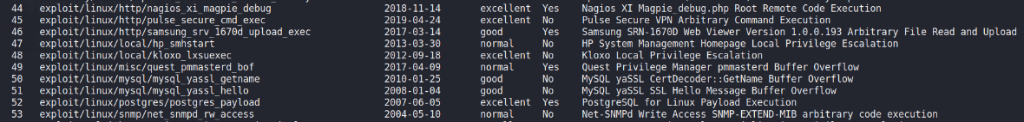
Success or not:
Module Number | Success or not
44 | Yes
45 | Yes
46 | Yes
47 | No
48 | No
49 | No
50 | No
51 | No
52 | Yes
53 | no

Solution: Reconfigure the affected application if possible to avoid use of medium strength ciphers.
Solution cost : No new software or hardware needs to be purchased. It may take several hours to modify the software configuration

Vulnerability name: SSL RC4 Cipher Suites Supported (Bar Mitzvah)
Description: The remote host supports the use of RC4 in one or more cipher suites.
The RC4 cipher is flawed in its generation of a pseudo-random stream of bytes so that a wide variety of small biases are introduced into the stream, decreasing its randomness.
If plaintext is repeatedly encrypted (e.g., HTTP cookies), and an attacker is able to obtain many (i.e., tens of millions) ciphertexts, the attacker may be able to derive the plaintext.
Protocols involved: HTTP,TCP/IP,SNMP,
Attack tool used: Metasploit
Success or not:
Module Number | Success or not
45 | Yes
46 | No
47 | No
48 | No
49 | No
50 | No
51 | No
52 | No

Solution: Reconfigure the affected application, if possible, to avoid use of RC4 ciphers. Consider using TLS 1.2 with AES-GCM suites subject to browser and web server support.
Solution cost : No new software or hardware needs to be purchased. It may take several hours to modify the software configuration

Vulnerability name: TLS Version 1.1 Protocol Detection
Description: The remote service accepts connections encrypted using TLS 1.1.
TLS 1.1 lacks support for current and recommended cipher suites.
Ciphers that support encryption before MAC computation, and authenticated encryption modes such as GCM cannot be used with TLS 1.1
As of March 31, 2020, Endpoints that are not enabled for TLS 1.2 and higher will no longer function properly with major web browsers and major vendors.
PCI DSS v3.2 still allows TLS 1.1 as of June 30, 2018, but strongly recommends the use of TLS 1.2. A proposal is currently before the IETF to fully deprecate TLS 1.1 and many vendors have already proactively done this.
Protocols involved: TLS,HTTP
Attack tool used: Metasploit
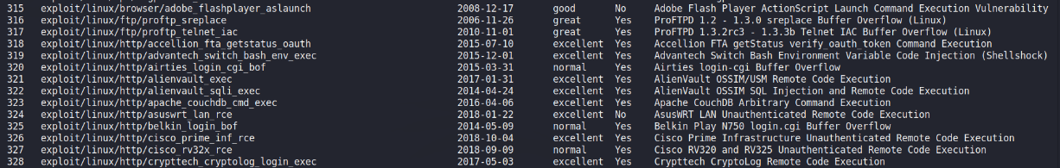
Success or not:
Vulnerability Number | Success or not
315 | No
316 | No
317 | No
318 | Yes
319 | Yes
320 | No
321 | No
322 | No
323 | No
324 | No
325 | No
326 | No
327 | No
328 | No

Solution: Enable support for TLS 1.2 and/or 1.3, and disable support for TLS 1.1.
Solution cost : No new software or hardware needs to be purchased. It may take an hour to modify the settings

Vulnerability name: TLS Version 1.0 Protocol Detection
Description: The remote service accepts connections encrypted using TLS 1.0. TLS 1.0 has a number of cryptographic design flaws. Modern implementations of TLS 1.0 mitigate these problems, but newer versions of TLS like 1.2 and 1.3 are designed against these flaws and should be used whenever possible.
As of March 31, 2020, Endpoints that aren’t enabled for TLS 1.2 and higher will no longer function properly with major web browsers and major vendors.
PCI DSS v3.2 requires that TLS 1.0 be disabled entirely by June 30, 2018, except for POS POI terminals (and the SSL/TLS termination points to which they connect) that can be verified as not being susceptible to any known exploits.
Solution: Enable support for TLS 1.2 and 1.3, and disable support for TLS 1.0.
Solution cost : No new software or hardware needs to be purchased. It may take an hour to modify the settings

Vulnerability name: DNS Server Cache Snooping Remote Information Disclosure
Description: The remote DNS server responds to queries for third-party domains that do not have the recursion bit set.
This may allow a remote attacker to determine which domains have recently been resolved via this name server, and therefore which hosts have been recently visited.
For instance, if an attacker was interested in whether your company utilizes the online services of a particular financial institution, they would be able to use this attack to build a statistical model regarding company usage of that financial institution. Of course, the attack can also be used to find B2B partners, web-surfing patterns, external mail servers, and more.
Note: If this is an internal DNS server not accessible to outside networks, attacks would be limited to the internal network. This may include employees, consultants and potentially users on a guest network or WiFi connection if supported.
Protocols involved: SSH,SMB
Attack tool used: Metasploit
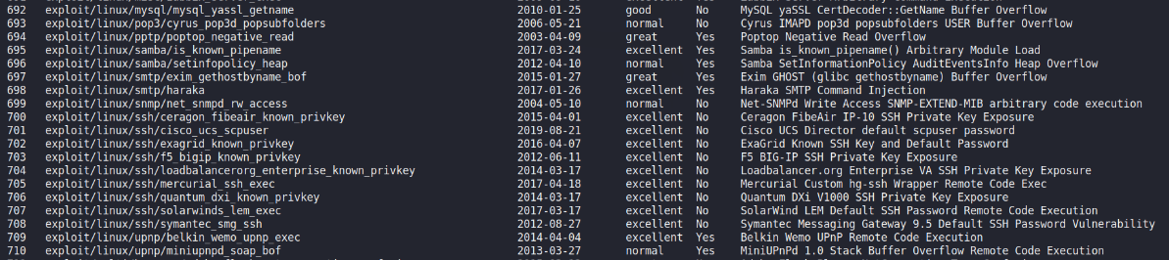
Success or not:
Module Number | Success or not
692 | No
693 | No
694 | No
695 | No
696 | No
697 | No
698 | Yes
699 | Yes
700 | Yes
701 | No
702 | No
703 | No
704 | No
705 | No
706 | Yes
707 | No
708 | No
709 | No
710 | No

Solution: Contact the vendor of the DNS software for a fix.
Solution cost : New DNS software needs to be purchased, which may cost tens of thousands of Y

Vulnerability name: DNS Server Spoofed Request Amplification DDoS
Description: The remote DNS server answers to any request. It is possible to query the name servers (NS) of the root zone ('.') and get an answer that is bigger than the original request. By spoofing the source IP address, a remote attacker can leverage this 'amplification' to launch a denial of service attack against a third-party host using the remote DNS server.
Success or not: This vulnerability may cause DDoS attacks on a web page that is in a service state and therefore cannot be tested for DDoS
Solution: Restrict access to your DNS server from public network or reconfigure it to reject such queries.
Solution cost : No new software or hardware needs to be purchased. It may take an hour to modify the settings

Vulnerability name: POP3 Cleartext Logins Permitted
Description: The remote host is running a POP3 daemon that allows cleartext logins over unencrypted connections. An attacker can uncover user names and passwords by sniffing traffic to the POP3 daemon if a less secure authentication mechanism (eg, USER command, AUTH PLAIN, AUTH LOGIN) is used.
The vulnerability with low risk can not be tested and is acceptable
Solution: Contact your vendor for a fix or encrypt traffic with SSL / TLS using stunnel.
Solution cost : Need to contact the vnedor to provide services, which may cost thousands of pounds, and a few days of work

Vulnerability name: SSL Anonymous Cipher Suites Supported
Description: The remote host supports the use of anonymous SSL ciphers. While this enables an administrator to set up a service that encrypts traffic without having to generate and configure SSL certificates, it offers no way to verify the remote host's identity and renders the service vulnerable to a man-in-the-middle attack.
Note: This is considerably easier to exploit if the attacker is on the same physical network.
The vulnerability with low risk can not be tested and is acceptable
Solution: Reconfigure the affected application if possible to avoid use of weak ciphers.
Solution cost : No new software or hardware needs to be purchased. It may take an hour to change the configuration of application.

Timetable for execution of solution
Vulnerability name | Urgency | Suggested resolution period
SSL Anonymous Cipher Suites Supported | Low | Within six months
POP3 Cleartext Logins Permitted | Low | Within six months
DNS Server Cache Snooping Remote Information Disclosure | Medium | As soon as possible
TLS Version 1.0 Protocol Detection | Medium | Within three months
TLS Version 1.1 Protocol Detection | Medium | Within three months
SSL RC4 Cipher Suites Supported (Bar Mitzvah) | Medium | Within three months
SSL Medium Strength Cipher Suites Supported (SWEET32) | Medium | Within three months
HTTP Strict Transport Security (HSTS) Policy Not Enabled | Low | Within six months
Invalid SSL Certificate | Medium | Within three months
Missing X-Frame-Options Header | low | Within six months

