Course: BA Business Management

Module name: The Global Business Environment

Module code: LCBB4005

Lecture name: Alfred Mensah

Title of report: Environmental Analysis Of An Industry

Student name: Daniela Krasteva


Student number: 2124368

TESLA MOTORS, I.N.C.

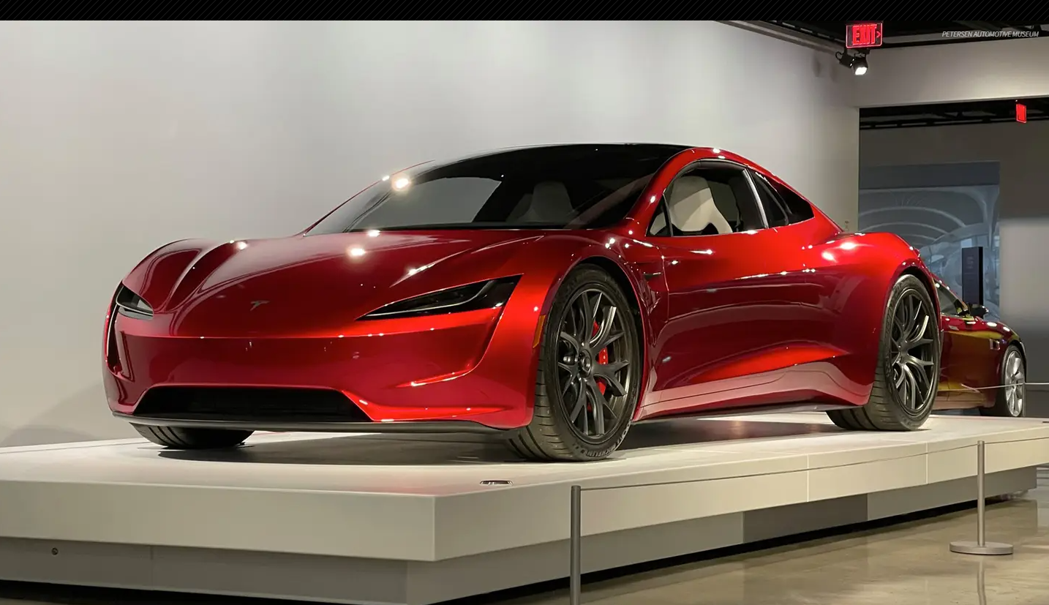

TESLA MOTORS, I.N.C.

.

The Table of Contents
The executive summary…..……………………………………………………………4
The introduction to global business environments…………………..……………….…..5
Purpose of assignment…………………….………………….……………….………...6
Critical analysis……………………………………………………..…………………..7
The Internal businesses environments……………………………..…………………….8
The external business environments………….………………….…………………..….9
Tesla Pestles analysis ......................................................................................................10
Conclusion statements……….………………….……………………………….….….11
The reference list………………………………………………………………………12

Executive Summary
As a result of globalization and technological advancements, the electric automobile industry is changing significantly compared to fuel-powered automobile vehicles. Tesla Motors, Inc. has been chosen to examine significant driving forces in the internal and external environment. The phrase "global business environment" has been established in this study. A critical assessment has been made utilizing the primary driving force – Pestle. The report reflects on obstacles experienced while Tesla Motors, Inc. is trading globally.
Introduction To Global Business Environment
Tesla is a company for electric automobiles with specific cutting-edge battery technology and electric powertrain n. A group of technicians formed in 2003 and founded the company y. One of the primary objectives is to provide users with infinitely scalable generating power and potent goods that minimize the risk of environmental pollution.
Report Plan Structure
The report structure plan includes the cover page, the executive synopsis, contents table, an overview of the global business environment, Tesla Motors Inc introduction, critical analysis, challenges in trading across the globe, summary, conclusion, and references.
Introduction of Tesla Motors, Inc.
Tesla is a rechargeable automobile and green power firm headquartered in Austin. Tesla makes electrical automobiles, residence storing batteries, solar panels, and rooftop solar tiles, among other things. With a fair value of about $1 trillion, Tesla is among the wealthiest businesses and richest carmakers. According to the most recent data assessment in 2021, the group has done 930,422 automobiles (2021), 3.999 GWh battery storage systems (2021), and 345 MW solar projects (202). America, Europe, the Pacific region, and Asia are the regions served globally. America, Europe, the Pacific region, and Asia are the global regions. At a reduced price, unlike many high-performance sports cars, it has become easier to improvise an extremely fast-powered electric car that is good, manages better, and is joyous to drive as according to Jiang (2022). Despite this, this vehicle would be the most gasoline and least polluted aircar. You have the option of having it all." Martin Eberhard and Tarpenning wrote the document "The twenty-first - century Fully Electric Tesla Motors

C.E.O and Chairperson

Elon Musk, an originator, is the chairperson and executive officer. And the company's largest shareholder since 2008.
The Importance of the Business Environment
It is crucial to be aware of your competitors' strategies and actions. In a commercial setting, businesses can study their competitors' tactics and behavior s. They may also devise their methods in this regard d. Identifying growth areas, building a solid brand image, remaining in sync with rivals, and determining dangers are some of the essential benefits of a business environment (Saxena and Vibhandik, 2021). The assignment report focuses on critically evaluating the external and internal business environment of a specific brand considered in the automobile industry and reflection on the encounter in global international trading.
External Business Environment
Tesla Motors should deal with hardships like the current economy, industry, industry dynamics, regulations imposed, and social-economic increased pressure to run its enterprise. According to Saxena and Vibhandik (2021), "The global economic crisis of 2007-2009 sparked a great fight for three key vehicle industries in the United Nations, with many of them on the verge of bankrupt y. On the other hand, Tesla Motors reaped the benefits of the automobiles industry's economic difficult s. For example, following the acquisition of an idle institution in Fullerton, California, partly sponsored by General Electric and Toyota, the company successfully moved all New Vehicle automakers back to the U.S.A.," according to the data analysis essay "Tesla Motors Company's analyzed based.".
Source: http://fernfortuniversity.com/term-papers/pestel/nyse4/862-tesla--inc-.php

Critical Evaluation

Rising prices for a low-carbon way of life and sustainable sources are social variables influencing Tesla Motors' operations. Tesla, for example, tailors its reduced marketing to clients' wants for reduced lifestyles. Sustainable buildings affect Tesla motors' exterior environment due to steadily increasing waste disposal regulations and growing concern about climate change. The zero-emission capabilities of electric vehicles increase their commercial acceptance. Indeed, California requires auto dealers to provide a certain percentage of zero-emission vehicles in their total sales volume. According to Bao and Wang (2022), dealer rules jeopardize the procedures of Tesla in U.S.A states, the U.K cities, and others. The primary dealer industry pressured legislative bodies to pass rules requiring carmakers to sell only through independent recognized dealers rather than corporation dealerships.
Source: https://www.jstor.org/stable/26488657
Internal business environment
An intrinsic study of the organization aids in identifying the primary resources and competencies in various aspects of the organization, such as operations, funding, and marketing.

Advantages of the Corporation
As per Saxena and Vibhandik, (2021), advantages of the corporations include strength which has a well-known, strong brand founded on excellent performance and dependability features. Operational skills are well-established with a naturally gifted design, sales, and marketing team and have standing firm commitments to the company's future development in terms of innovation and creativity.

Weaknesses of the Corporation

Concerns have been raised about the effectiveness of electric vehicles in contrast to gasoline engines and negative stereotypes about their achievement. Negative operational margins are reported. The brand's global market is undeveloped; it sells only in three locations: Europe, the East, and the United States.
According to Saxena and Vibhandik,(2021), I.C. automakers market brands with levels similar to luxury, coziness, and speed. I.C. automakers market brands with levels similar to luxury, coziness, and speed.
Source: https://ieeexplore.ieee.org/abstract/document/7273032

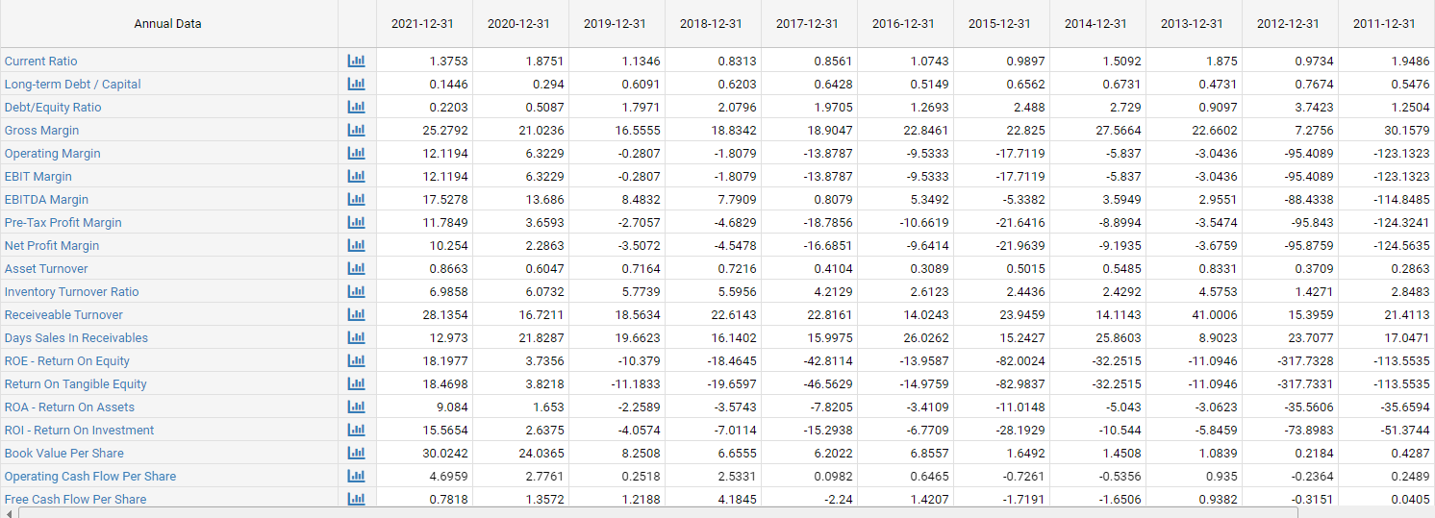
A Graphic Example of Tesla’s Financial Ratios for Analysis 2009- 2022 TESLA

Tesla's net profitability was negative in 2016 and 20 7. however, it does not imply a lack of financial resources because Tesla is a new company. It spends a fortune on business to drive sales, and its planning and engineering approach contribute to critical operating profits and net earnings, which weakens its relative competitive advantage.

Pestel Analysis of Tesla Motors, Inc.

Tesla Inc. went live in 2010 and quickly gained international attention n. Tesla vehicles require electricity instead of gasoline, significantly reducing their carbon footprint t. Cars and trucks are also categorized as a luxury item because they are generally out of reach for people with middle- and lower incomes as according to Sousa and Castañeda (2022).

Key drivers | External Factors to Consider
The Political | You could be subject to tax breaks if you buy a Tesla automobile.  Moreover, state enticement has enhanced its financial recital of its focus on conservational sympathy. Tesla prepares, have a global presence and is entering new markets, such as China, which has a shipping hub, and the Netherlands, which has an organizational cent r. It may also face difficulties due to political upheaval in the countries it operates, which could disrupt the distribution network and lead to financial loss s. It also has many sourcing collaborators whose stock is contingent on each country's political stability and international ties with America as according to Sousa and Castañeda (2022).
The Economical | Current interest rates, currency exchange rates used to calculate consumer revenue, rising prices, rates of economic growth, and other variables all affect a business s. It also takes into account the unemployment rate. The vehicle is classified mainly as a luxury seed. The sale of electric vehicles has proven to be helpful to the world Ecton y. In 2016 and 2017, the global automotive industry expanded at a breakneck pa e. This same prospect of creating expense vehicles in the long term has emerged due to increased sales. The local economy determines growth in a county. In the long run, making affordable cars accessible to ordinary patrons will advantage the corporate entity in two ways. To commence with and contend with other players in marketplace as supported in Sousa and Castañeda (2022).
The Social | The environmental factor of Tesla Inc. directly affects its economic and political elements as in Sousa and Castañeda (2022). Tesla vehicles are better for the environment because they are powered by electricity instead of gasoline. Consequently, customers who drive an electrical automobile may be competent for just a unusual tax credit.  Besides, the management's motivation has greater its financial recital because of its focus on conservational sympathy.  Party-political issues have aided Tesla's growth, allowing it to grow in different countries.
Technological | Tesla automobiles are front-line in terms of knowledge. These elevated vehicles equipped with cutting-edge new tech are the future, and buyers flock to them. The fuel-efficiency feature reinterprets the term "sustainability."  Furthermore, cutting-edge technology adds other wings to the c p. Innovation, on either hand, is ever-changing as evidenced in Sousa and Castañeda (2022).
Legal one | Like the political aspects, the legal element considers the country's legislation and rule. It monitors how different laws and legal changes, like those governing safety and health, consumer rights, equality of opportunity, and ethical guidelines, impact Tesla's growth as in Sousa and Castañeda (2022). It may also choose to sell its vigour resolutions in other countries. In addition to the limitations obligatory by various jurisdictions on shortest selling, Tesla's minor international sales process may be a foundation of concern.
The Environmental | Automobiles which run on electricity rather than gasoline are marketed as environmentally friendly. Tesla automobiles adhere to numerous environmental regulations, and carbon pollution is kept to a minim m. Tesla has made a name for itself by focusing on the surroundings that few can match. Tesla is well-positioned to cope with the pandemic. Tesla Motors consistently delivers vehicles directly to customers, even though carparks will fill with unsold vehicles and dealers are eager to sell vehicles. According to Sousa and Castañeda (2022), the progress toward a keyless automobile buying proposal was discussed on the earnings call, claiming that a motor could be bought in 5 minutes using a smartphone app. Amid 2016 and 2017, the global motorized industry expanded at a quick speed. The likelihood of developing cost-effective automobiles in the long term has resulted in the emergence of auctions revenue.

Challenges in Trading Across the Globe
The battery-powered carmaker's significant accomplishments in 2018 were negated by plenty of difficulties and scandals, including a securities and exchange board (S.E.C.) court case against C.E.O. Elon Musk, overloaded service canters, and occupational safety worries. Thus far in 2019, even so, almost nothing has changed. Even joyful news, such as introducing a $35,000 Model 3 and the Model Y S.U.V., has met with reservations about its implications. Tesla does have a lot on its tray as it enters the second period, with multiple rounds of layoffs, new issues with S.E.C., and a consumer reports score lo s. (2019)
Tesla launched in February that this will expropriate so many of its shops and convert the remainders into exhibitions and resource centers as it transitions to an internet sales mod l. Musk stated throughout a teleconference following the launch that the transition would lead to layoffs. (2019) Tesla launched in February. Will expropriate so many of its shops and convert the remainders into exhibitions and resource canters as it transitions to an internet sales mod l. Musk stated throughout a teleconference following the launch that the transition would lead to layoffs. (2019) In March 2019, China temporarily stopped Model 3 sales due to "several anomalies" in vehicles destined for Chinese buyers, such as a lack of labels on hydraulic fluid reservoirs and incorrect motor capacity. As per a Tesla spokesperson, the ability to print the issue causing the label problems has been addressed. According to Business insider, China has since lifted the sales ban on Model 3. As per company influencer, throughout March, Tesla senior director Sanjay Shah sent an email to employees asking for assistance with vehicle consignment s. During the international production recession, Tesla coped compared to traditional automobile manufacturers, yet C.E.O. Elon Musk had also alerted of challenges acquiring semiconductor devices and other equipment. as per Saxena and Vibhandik, (2021). Due to Tesla's exposure to the fluctuation of the virtual currency, all eyelids are now on its 2nd income to see whether recent drops in bitcoin prices will harm the organization's bottom boundary.
Conclusion
Conclusively, Tesla Motors was founded by carving out an uncontested niche market for affluent sports car enthusiasts who shared the company's goal for sustainability and the use of fossil fuels. The Model S, which competes well in the battery and hybrid electric vehicle industries and the luxury sedan market, has now been added to the company's product line. The company has demonstrated great technical innovation and operational resiliency, demonstrating its capacity to remain profitable beyond 2014.

References
Jiang, T. (2022, March). A Business Model to Analyze the Tesla Based on SWOT Analysis and POCD. In 2022 7th International Conference on Financial Innovation and Economic Development (ICFIED 2022) (pp. 2896-2899). Atlantis Press.Electric Cars, Solar & Clean Energy (no date) Tes a. Available at: https://www.tesla.com/ (Accessed: 2 April de
Sousa, G. C., & Castañeda-Ayarza, J. A. (2022). PESTEL analysis and the macro-environmental factors that influence the development of the electric and hybrid vehicles industry in Brazil. Case Studies on Transport Policy, 10(1), 686-699.
Saxena, N., & Vibhandik, S. (2021). Tesla's Competitive Strategies and Emerging Markets Challenges. IUP Journal of Brand Management, 18(3).
Bao, Y., & Wang, H. (2022). Numerical study on flow and heat transfer characteristics of a novel Tesla valve with improved evaluation method. International Journal of Heat and Mass Transfer, 187, 122540.
Tesla Motors Company’s Environment Analysis | Business Paper Example (no date) Business-Essay.com. Available at: https://business-essay.com/tesla-motors-companys- environment-analysis/ (Accessed: 2 April 2022).

