A Comparison of The Marketing Methods of Two Multinational Hotel Brands

Student Name: Mohammad Assadujjaman
Student ID Number: 2207975

Module Title: Marketing Essentials BMIH4005
Lecturer Name: Luciana Suardi

Introduction
Marketing is simply the value-creation process of organizations through which they take monetary value from their customers in return. Using appropriate methods of marketing often benefits an organization in many ways. Focusing on two multinational hotel brands, this essay will discuss their marketing methods using various theories and models. Various other marketing-related discussions of the brands will be presented in this essay. How the brands create value for their customers and how their current market positions will also be a part of the discussion (Ferrell et al, 2021).

Chosen Brands
The selected two multinational brands are the Ritz-Carlton Hotel Company and Premier Inn Limited. Ritz-Carlton is a US-based limited liability company that operates its hotel businesses with 108 hotels worldwide. The company was founded in 1983 by William B. Johnson and its parent organization is Marriott International though the business was started by Swiss hotelier César Ritz (Shah, 2022). This hotel brand has 113 properties in North America, Europe, the Middle East, Africa, Asia-Pacific region, and Caribbean Latin America and 30031 rooms in 2021. On the other hand, the leader of UK hotel chains, Premier Inn is an England-based multinational hotel chain which has operations in the UK, the UAE, the Republic of Ireland, Qatar, Germany, the Isle of Man, and so forth. Being founded in 1987 as Travel Inn, this hotel chain has transformed into the largest hotel chain in the United Kingdom. Whitbread plc is the parent organization of Premier Inn and this hotel chain is responsible for generating 70% of the earnings of the parent organization (David, 2022).

Marketing Choices
The Ritz-Carlton Hotel Company and Premier Inn Limited have made a handful of marketing choices that are driving them to their mission and vision. For instance, Premier Inn has adopted marketing choices to use the advancement of technology for ensuring online promotions of their services, online booking system, digital key systems for hotel check-ins and outs, and even the television of the rooms can be connected with the customers' smart devices, and so forth. On the other hand, Ritz-Carlton has made a marketing choice of ‘mouth-of-word’ which promotes their products and services to their customers. As this direction generates a vocal chain for Ritz-Carlton, the hotel chain is benefitting from this marketing choice in transforming the potential customers into profitable and sustainable customers for the business (George, 2021).

Current Market Position
Both of these brands are the leaders of their respective business industries. Ritz-Carlton has been successful to position itself as a US luxury hotel chain. In the perpetual map for understanding the market position of a brand, this US brand has placed itself in a high price and quality position though it offers some midrange rooms for its customers in different locations (Iyer et al, 2019). They believe that they create sweet memories for their customers during their stays and that will bring them back to be sustainable and profitable customers for the brand. On the other hand, according to Gilliland (2017), Premier Inn has topped the industry with a BSI score of 88.7 which is fair enough for the customers to make their decision to stay in the hotel. One of the strengths of Premier that is helping its market position is this brand has branches in almost every region of the United Kingdom that psychologically attracts customers not to switch to other brands (Wagh, 2022).

Marketing Strategies They Use
To understand the marketing strategies used by Ritz-Carlton, understanding their marketing mix will be helpful. The organization uses their marketing mix and designs its marketing strategies according to its product and services, pricing strategies, placement of its services, and promotions (Morgan et al, 2019). The company ensures the quality of their products and services along with a fair price as they offer budget stays for cost-savvy tourists. And it understands the customers' psychology of choosing the place for visiting. Then the company segments the customers and targets the most profitable customers for ensuring profitability. For promotions, the organization uses many promotional channels such as online marketing platforms, social media marketing, and traditional marketing campaigns as well. On the other hand, Premier Inn, for ensuring the best marketing approach for the growth, and segmentation of their customers and hotels and targets the appropriate customers for the appropriate positions with the price that will attract them. They communicate with their target audiences using their websites, various booking sites, social media platforms, and many more. Premier Inn markets its products as the best service in the United Kingdom for both internal and external tourists at a fair price (Mothersbaugh et al, 2020).

The Use of Segmentation Targeting and Positioning as well as Marketing Communications with Their Target Audiences
Ritz-Carlton and Premier Inn segment their customers and choose their target customers for positioning and conducting marketing communication of their brands. Both of these brands conduct research on the customers, divide them based on the amount of disposable income that they can spend on their stays, and target the suitable product offerings to them according to their price preferences. Here, Ritz-Carlton uses digital and print media for their promotions and they have spent $100 million on their advertising in 2021 for ensuring marketing communications with their customers (Khas, 2022). On the other hand, Premier Inn spends more on its digital promotional campaigns for communicating with its customers. They spend on search engine optimization and other forms of digital marketing like social media marketing for ensuring marketing communications with their target audiences to turn potential customers into sustainable and profitable customers.

The Use of Segmentation Targeting and Positioning as well as Marketing Communications with Their Target Audiences
Ritz-Carlton and Premier Inn segment their customers and choose their target customers for positioning and conducting marketing communication of their brands. Both of these brands conduct research on the customers, divide them based on the amount of disposable income that they can spend on their stays, and target the suitable product offerings to them according to their price preferences. Here, Ritz-Carlton uses digital and print media for their promotions and they have spent $100 million on their advertising in 2021 for ensuring marketing communications with their customers (Khas, 2022). On the other hand, Premier Inn spends more on its digital promotional campaigns for communicating with its customers. They spend on search engine optimization and other forms of digital marketing like social media marketing for ensuring marketing communications with their target audiences to turn potential customers into sustainable and profitable customers.

Premier Inn Segmentation Targeting, Positioning, & Marketing Communications
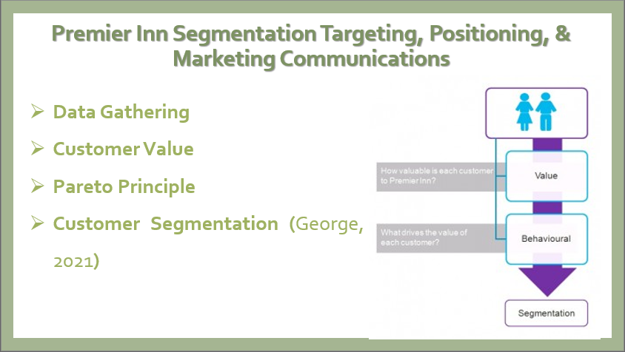
Data Gathering: Premier Inn gathers customer data from their existing customers using feedback and from potential customers on their websites and other digital forms of marketing.
Customer Value: SCV or single customer value is important to Premier Inn and they care about their millions of customers. Cost-savvy customers and business stayers are not the same and do not provide the same value by which Premier Inn divides its customers.
Pareto Principle: The customer value shows a Pareto factor for Premier Inn that the cost-savvy customers and business stayers have different customer behaviour and expected value that Premier Inn follows.
Customer Segmentation (George, 2021): Using the data used in the previous three sections, Premier Inn puts the collected data together and uses them for segmenting its customers. And according to the customer behaviour of different customer bases, they offer marketing communication using a different marketing and promotional systems.

Ritz-Carlton Segmentation Targeting, Positioning, & Marketing Communications
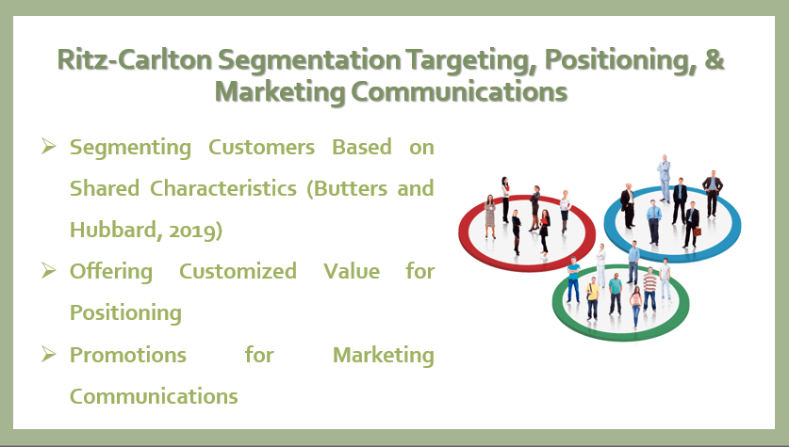
Ritz-Carlton segments their customers based on their customer behaviour and some other common characteristics like disposable income, lifestyle, and many more.
Segmenting Customers Based on Shared Characteristics (Butters and Hubbard, 2019): Ritz-Carlton differentiates its customers based on their characteristics such as millennials, baby boomers, Gen Z, family travellers, business travellers, etc.
Offering Customized Value for Positioning: Ritz-Carlton tailors its different types of customer expectations and provides service according to their needs, wants, and demands.
Promotions for Marketing Communications: Ritz-Carlton uses both digital marketing approaches and traditional promotional mediums for ensuring marketing communications with its target customers.

Sustainability and Green Messaging Considerations
Premier Inn has undertaken a mission to ensure net zero carbon emissions as their sustainable and green messaging campaign. This UK brand is the first brand in the United Kingdom to declare this green message to its customers publicly. According to Kwarteng (2021), Premier Inn is focusing on renewable energy sources and the organization is promised to earn this sustainability by 2040 and ensure green marketing to their business operations. It will work on reducing the gas used in its hotels, reducing carbon emissions from its cars and vehicles that are used for distribution, using solar panels for supporting renewable energy, and many other sustainable and green messaging. And the other one, Ritz-Carlton, as their proof of sustainability and green messaging, reduced their carbon emissions by a thousand tonnes, used 96% LED lights for ensuring low usage of electricity, reduced water and gas consumption by 10%, and many more for improving sustainability (Khan, 2021).

Impacts of Contemporary Issues on Their Marketing
The COVID-19 pandemic has influenced the market position of the Ritz-Carlton hotel negatively. It had put a downfall to the business as the pandemic has decreased the number of customers, focus more on employment safety laws due to the pandemic, increase the expense of hotel health and safety issues, and many more (Ozdemir et al, 2021). As COVID-19 is a macro environmental factor, Ritz-Carlton had no control over it but it had to go with the flow as did other businesses. The profit margin of this hotel company has decreased and it had to maintain employee cut-off, and many other operations to ensure the business ran. On the other hand, the pandemic and the Brexit issue have reshaped the hospitability industry of the United Kingdom which had a major impact on the market position of Premier Inn. The quarantine laws of the UK, the loss of customer during the pandemic, the increment of expenses in health and safety, the loss of profits, and many more issues generated by COVID-19 has decreased the market size of the hospitability industry of the United Kingdom (Spanaki et al, 2021). Markova and King (2022) mentioned that the British Exit from the European Union has forced the government of the UK to change the employment laws which caused a major reduction in the employee number of Premier Inn along with other businesses of the industry as well.

Recommendations
For both of these brands, the first recommendation goes to the usage of digital marketing activities for their promotions. The brands can use social media platforms and ensure proper promotional campaigns by social media influencers, celebrities, and other public figures by social media contents. They can also focus on their existing customers and ensure email marketing and other forms of one-to-one marketing activities for ensuring a sustainable and profitable relationship with them. For increasing their future growth of them, Ritz-Carlton and Premier Inn can automate their staffs and use search engine optimization marketing for the major tourist attractions. As the COVID-19 pandemic has taught them to be conscious of their customer's health, both of them should maintain proper safety and health measures for their customers and employees as well (Smith, 2022).

Conclusion
Ritz-Carlton and Premier Inn are two market leaders in the US and the UK hospitality industry. These two businesses are responsible for generating a mentionable percentage of contribution to their respective country’s gross domestic products. As COVID-19 and Brexit have hit them recently, they should be tricky to cope with the situation and increase their productivity by ensuring the proper utilization of their marketing plans and use of technology for their brand promotions to ensure future growth and sustainable development of their businesses.

References
Butters, R.A. and Hubbard, T.N., 2019. Industry Structure, Segmentation, and Competition in the US Hotel Industry (No. w26579). National Bureau of Economic Research.
David, S. (2022) About Us, Premier Inn. Available at: https://www.premierinn.com/gb/en/why.html (Accessed: October 22, 2022).
Ferrell, O.C., Hartline, M. and Hochstein, B.W., 2021. Marketing strategy. Cengage Learning.
George, R., 2021. Market Segmentation, Targeting, and Positioning. In Marketing Tourism and Hospitality (pp. 221-246). Palgrave Macmillan, Cham.
George, R., 2021. Tourism and Hospitality Marketing Principles. In Marketing Tourism and Hospitality (pp. 3-31). Palgrave Macmillan, Cham.
Gilliland, N. (2017) What makes Premier Inn the World's strongest hotel chain?, Econsultancy. Available at: https://econsultancy.com/what-makes-premier-inn-the-world-s-strongest-hotel-chain/ (Accessed: October 22, 2022).
Iyer, P., Davari, A., Zolfagharian, M. and Paswan, A., 2019. Market orientation, positioning strategy and brand performance. Industrial Marketing Management, 81, pp.16-29.
Khan, H. (2021) Green policy: The Ritz Carlton Hotel. Available at: https://www.ritzcarlton.com/en/about-the-ritz-carlton/green-policy/ (Accessed: October 22, 2022).
Khas, W. (2022) Ritz-Carlton Hotel, MediaRadar. MediaRadar 252 West 37th Street New York, NY 10018 855-723-2788. Available at: https://advertisers.mediaradar.com/ritz-carlton-hotel-advertising-profile (Accessed: October 23, 2022).
Kwarteng, K. (2021) Net zero carbon emissions | News | 2021 | Premier Inn. Available at: https://www.premierinn.com/gb/en/news/2021/net-zero-carbon-emissions.html (Accessed: October 22, 2022).
Markova, E. and King, R., 2022. Brexit, Covid and Bulgarian migrants in the UK: stay or return?. Southeast European and Black Sea Studies, pp.1-21.
Morgan, N.A., Whitler, K.A., Feng, H. and Chari, S., 2019. Research in marketing strategy. Journal of the Academy of Marketing Science, 47(1), pp.4-29.
Mothersbaugh, D.L., Hawkins, D.I., Kleiser, S.B., Mothersbaugh, L.L. and Watson, C.F., 2020. Consumer behavior: Building marketing strategy. New York, NY, USA: McGraw-Hill Education.
Ozdemir, O., Dogru, T., Kizildag, M., Mody, M. and Suess, C., 2021. Quantifying the economic impact of COVID-19 on the US hotel industry: Examination of hotel segments and operational structures. Tourism Management Perspectives, 39, p.100864.
Shah, D. (2022) Luxury Hotels & Resorts: The Ritz, RitzCarlton.com. Available at: https://www.ritzcarlton.com/en/about (Accessed: October 22, 2022).
Smith, A. (2022) Travel & Tourism Industry, International Trade Administration | Trade.gov. Available at: https://www.trade.gov/travel-tourism-industry (Accessed: October 22, 2022).
Spanaki, M.Z., Papatheodorou, A. and Pappas, N., 2021. Tourism in the post COVID-19 era: evidence from hotels in the North East of England. Worldwide Hospitality and Tourism Themes, 13(3), pp.357-368.
Wagh, H. (2022) Travel and tourism in the United Kingdom (UK), Statista. Statista Research Department. Available at: https://www.statista.com/topics/3269/travel-and-tourism-in-the-united-kingdom-uk/#topicHeader__wrapper (Accessed: October 22, 2022).

