ACADEMIC & EMPLOYABILITY SKILLS

Andrei-Daniel Mihai
1912494

Table of Contents
Introduction 3
Section 1 3
A personal overview of myself 3
Screen grabs 3
Key points for delivering a successful PowerPoint presentation 5
Section 2 5
Identifying key skills that are required for successful 5
1. HE learning 5
2. Employability 6
The self-evaluation exercise to discover the strength and weaknesses, personality type, suitable career suggestion 7
Compare and contrast the results of myself from an initial description 8
Section 3 9
Short term and long term goals 9
Action plan for the academic and personal/professional skills that I need to improve 10
Section 4 12
Analysing the data 12
Time management and organization 12
Conclusion 13
References 14

Introduction
This study deals with key skills that are required for successful employability for an individual. It has a major impact on an individual to develop personal and professional skills for the future. A vital role has been played by the key skills that help achieve significant goals and that is essential. It has also discussed self-evaluation exercises for me and that has an impact to find out strengths, weaknesses, and suitable career suggestions. Short and long term goals are analysed in this study as it is helpful for me to crack a suitable job. An appropriate action plan has been discussed in this study that is important for developing the skill as well.

Section 1

A personal overview of myself
My name is Andrei-Daniel Mihai and I was born in Romania in a city named Ploiesti , who is the main city in the county of Prahova which is very close to Bucharest, the capital of the country. I moved to United Kingdom in August 2015, seeking for a job. At the beginning, I lived in Maidstone, close to London, but I did not liked it there so I moved to Cambridge. Cambridge is very nice city, not to big but not to small, has great parks, restaurants and pubs. When it comes to night life is not that great, but we can’t have it all, right?
In Cambridge, I had my first job as a first-line technical support for a small company but it wasn’t that great. I like to be more active and to interact more with people so after that, I get a job in Addenbrooke’s Hospital or Cambridge University Hospital NHS Trust. I can tell is a massive hospital with lots of opportunities. At one point I was thinking moving my attention towards medicine or nursing but something happened and all my attention turned to IT and Technology. Probably because, we use so many medical equipment that involves programming like Alaris infusion pumps who has integrated a software which will dose the amount of medication that the patient need’s it without killing the patient, or the anaesthetic machine which will monitor the patient during a surgical procedure and the list is endless. All of those things and many more requires technology and evolution, which I will like to take part create it to help all those in need.
That is why I decided to become a software developer. I have a few reasons why software developer.
First of all, I want to create a program/app that will help the human kind.
Second will be the salary; in this job field the salary is high and you are well paid for your effort. According to PayScale, a software developer can earn in an average annual of 71.218$.(PayScale Average Software Developer Salary)
The demanding is still high in the IT sector so that means it is very easy to find a job. According to the US Bureau of Labour Statistics, software developers jobs are predicted to grow by 17% from 2014-2024. (U.S Bureau of Labour Statistics – software developers).
As a software developer you can work remotely (from which corner of the world you want, if you have a good internet connection and a computer/laptop available).
In the IT sector there is no age limit which means is never late for you to learn something new and try to improve it. In 2018, according to Stack Overflow Developer report, who made a survey over 100000 developers, 25% of programmers were over the age of 35. (Stack Overflow Report )
For an overview, there are a lot a pros. factors for this job, some of them we’ve listed them above but there is also some cons. factors like stress ( a major project is not ready on the dead line), in this field like in medicine you always have to learn new things. Is not a bad thing in learning new skills but sometimes we don’t have enough time to stay and study. As we know the IT market is in continuing “booming” and growth, with high demand and of course the technology needs to improve.
I am pursuing my graduation at the University of Wales Trinity Saint David where I am also focusing on the development of significant key skills for obtaining success in my career. I am developing such skills by following significant processes along with my studies. It is helpful for me to choose the right career option and that is essential for my bright future as well.

Screen grabs
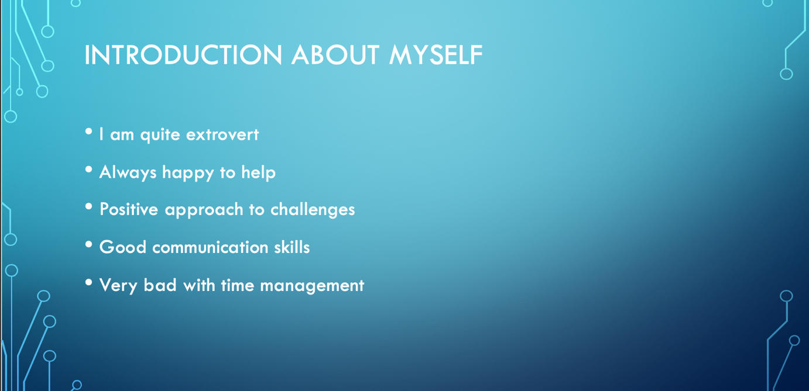

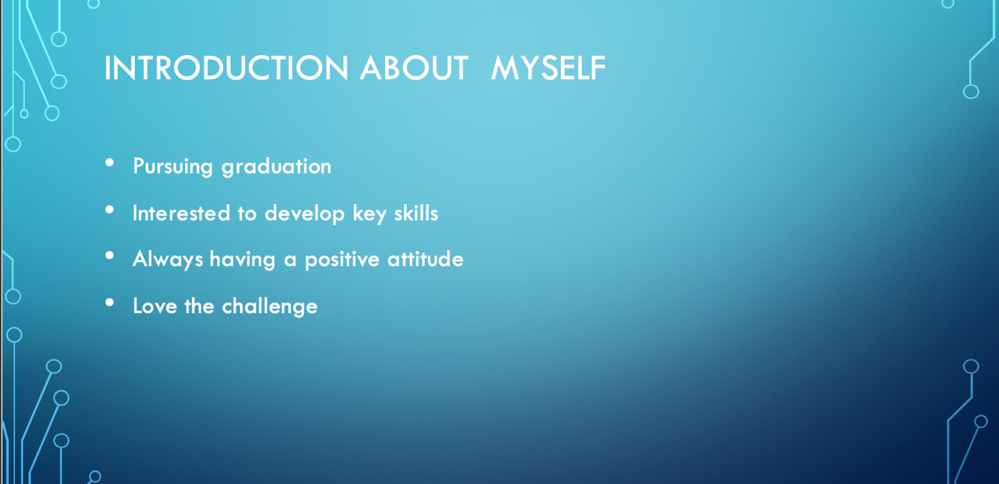

Figure 1: Screen Grabs from the initial introduction
(Source: Created by author)

Key points for delivering a successful PowerPoint presentation
- It is important to give importance to audiences needs
- It has a major impact to make the thing simple and concentrate on the actual message in order to make things understandable (Abas and Imam, 2016). It plays a vital role in delivering a successful PowerPoint presentation.
- A good start is helpful to attract the audiences and that creates a positive impact on the presentation.
- Effective voice plays a great role in making the presentation successful and that is important.

Section 2

Identifying key skills that are required for successful

1. HE learning
- Critical thinking
It is an essential skill regarding the learning that needs to improve for achieving success in the long run. My basic reasoning may indeed have appeared to be specific for my work. The ability of transforming issues into circumstances is not lost when adding to code. The experience picked up while spending long days and evenings reconsidering enlistment procedures will be important when forming calculations and innovative methods for conveying information (Baumeister and Vohs, 2018). Keep on encouraging enthusiasm for taking care of issues, and I will not experience any difficulty turning into a proficient and able designer.
- Research
It has a major impact to shorten my inquiry into the thought I am looking for and that is essential for an advanced education proficient. It has been seen that staff are focusing on coping with the issues in a characterized procedure for developing the output in different sectors. It plays a vital role to develop my logical brain and that is significant while giving programming arrangements. My examination abilities likewise open doors for stretching into information science and AI these days.
- Summary
I have had the option to cheer up in knowing my experience as an instructor and a director has not gone futile. It is helpful for me to be supported in realizing these transferable aptitudes. Additionally, some of those fall into delicate abilities and different classes (Brooks and Seipel, 2018).

2. Employability
- Communication
It is considered as a vital factor that is essential to increase employability for an individual. It is important to increase the fluency in speaking and increase the listening power as well. It will be helpful for to attract the interviewer and understand them as well (Hiemstra, Van Yperen and Timmerman, 2019). Initiatives need to be taken by me in order to increase communication skills as it is the first and foremost criterion for developing employability. It plays a vital role to make the message clear and concise and that is essential to get the attention of the audience.
- Teamwork
It will be a key skill for me that needs to improve for getting a quality job and work as a team. It is essential to prove that I am a team player and that it is helpful for me to get attention. Significant steps that are there that are helpful to increase the skill and that need to be followed for better performance. It is helpful to create a positive working relationship that is important to achieve goals and objectives for everyone (Li et al. 2019). As a team player I will be capable of managing others and controlling critical situations and that is important.
- Problem-solving skill
It has been seen that significant problems are there that need to be solved for better performance. Additionally, it has a major impact on reaching the goals by coping with several challenges. Employability can be increased with the help of problem-solving skills and that is helpful for future development as well (Marneros et al. 2020). It proves that I am efficient and hardworking as well and that creates a positive impact for me in my professional life. Additionally, this skill is able to prove that I can solve any problem from different angles in different situations.
- Leadership
Employability skills can be triggered with the help of leadership skills. It is helpful for me to get a suitable job for me shortly and that is important. It is important as a graduate to show the potential to motivate team members and encourage them. It has a major impact to cope with different situations (Messum et al. 2017). Additionally, it can be helpful to face different challenges in different situations in order to achieve success. Setting goals, objectives, and leading by good is the best example of a good leader. I need to follow such things in order to increase good leadership skills and that is essential for future development.
- Organizing skill
This skill influences me to finish a task efficiently and avoid mistakes for me. It is essential to organize a work before approaching it and that is important to achieve success by showing efficiency. This skill plays a major role for me to reach my goals and achieve success by coping with challenges.

The self-evaluation exercise to discover the strength and weaknesses, personality type, suitable career suggestion
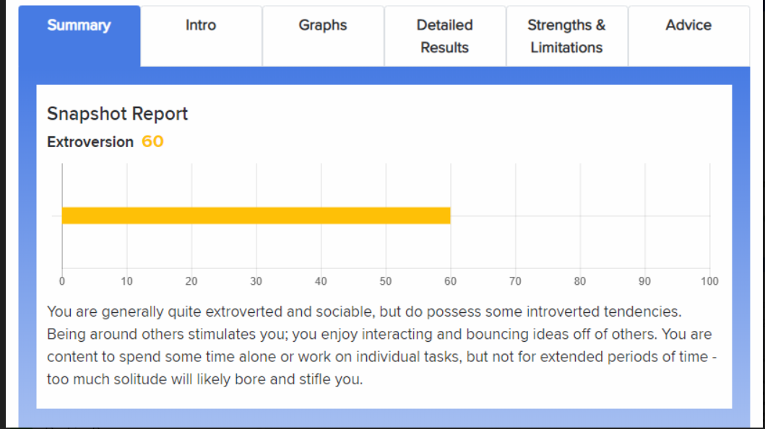
Figure 2: Self Evaluation Result
(Source: https://psychologytoday.tests.psychtests.com/bin/transfer)
It is possible to find out the strengths and weaknesses of the given exercise that is given in the result of the self-evaluation test. It has shown that I am quite extroverted and sociable and that is considered as my strongest point. The quality of extroverts is indeed helpful to attract others and that is necessary for achieving the goals and objectives. It has created a major impact on my professional life by increasing my interacting skills with others as well. It is essential to be successful to interact with other people and make them comfortable and that is important. Extrovert quality helps me to work as a team member that is important to get success in a short period. Additionally, I can share my ideas and views with others for solving a problem and approach with that. It is essential for increasing sustainability in professional life by competition with other people. Sociable is another significant strength and that helps to attract people who have a major impact to increase communication (Messum et al. 2016). Communication skill is indeed important to reach the goals and gain success as well. Based on this I can say those extroverts are my strongest strength and that is important to achieve success in the long run.
On the other hand, work on individual tasks is considered my weakness as it is tough to reach the goals and objectives by working alone. Different members of a team can indeed share different strategic plans for achieving an objective and that is helpful to gain success as well (Rubens et al. 2018). I need to interact with more people to cope with significant challenges by utilizing the extrovert quality of mine.

Compare and contrast the results of myself from an initial description
Significant issues are there that have lagged me behind to achieve success according to my initial description. Now the result has shown that I have developed in such areas and that is essential for increasing the possibility of getting success.
- Communication: I have described that I am quite weak in my communication skill but I have increased my communication skills by following significant procedures. It is helping people to interact with the people and understand their point of view as well (Suleman, 2016). Based on the result, I can say that I have improved my interaction skills in order to get attention and that it is helpful to establish my point of view.
- Extroverts: According to the result, I can compare my extrovertism skill and it has improved significantly. This quality has indeed made me more social as I can easily interact with people and share my plans and point of view. It has a major impact to increase the probability to get success and that is important for me. It has developed the mentality to work as a team to achieve a goal by facing different problems (Woolley and Fishbach, 2017). I can face significant challenges as well at present by increasing my extrovertism and that is essential.
- Organizing skills: I have increased my organizing skills to perform a task more efficiently and perfectly. It has a major impact to make a good impression and attention that is helpful to be successful (Rubens et al. 2018). Self-evaluation exercise has shown me that I have developed this skill significantly to perform tasks more effectively and that is mandatory to be successful for me.
- Problem-solving skills: It is another important sector that I have improved for getting success. According to the Self-evaluation exercise I can bring solutions to different problems efficiently while performing a task.

Section 3

Short term and long term goals
Short term goals
- To improve my communication skill is considered as my short term goal. It will be helpful for me to gain success efficiently and that has a major impact.
- To learn a new set of skills regarding problem-solving is another short term goal for me as it is helpful to be successful in the long run. Additionally, it has a major impact to cope with significant challenges.
- To gain experience regarding leadership as it plays a vital role to lead a team in future and that is helpful to take me towards success.
- To become an authority in my industry is another impact short term goal that needs to be achieved for achieving a long term goal.
Long term goal
- My long term goal will be to increase my extrovertism as it has a major impact on interacting with people.
- To avoid the mentality of doing individual task will be my long term goal in order to cope with my team member and that is essential

Action plan for the academic and personal/professional skills that I need to improve
Activity | Description | Time
Reduce introvertism (long term goal) | It creates a negative impact on being successful in the long run as it can lead me to get alone from society. It is not expected for performing as a team and that is considered an obstacle for getting success in the long run (Messum et al. 2016). I have tried to interact with more and more people to increase my extroverts as it plays a major role in achieving goals and objectives for me. It has also a major impact to cope with significant challenges while approaching a task that is not expected. Based on this, I have influenced myself to get involved in different activities with unknown people for a long time. At present, I have performed the Self-evaluation exercise to check my performance and that is increasing. | It has taken 6 months to reduce the introvert mentality.
Avoid doing an individual task (long term goal) | I belonged to the mentality of doing the individual task and that kept me out of doing teamwork and that is not expected for achieving the goals and objectives. Team performance can be helpful to cope with significant challenges in the long run (Li et al. 2019). It has an impact on the development of skills as well for performing a task efficiently and that is important. I have tried to associate with others and started doing teamwork regarding my project as well. It has helped me to deduce the mentality of doing tasks individually. Additionally, I have started to share my plans and point of view with others as well and that helps me to establish my presentation attractive as well. | It has taken 5 months to improve.
Increasing communication skill | It is considered a key skill that needs to be improved within a short period of time. I have started interacting with people and reading journals and books to increase the skill | It has taken 4 weeks to improve.
Leadership skill | It has a great impact to achieve success in the long run and I have started doing a university project with my friends to increase the leadership skill | It has taken 3 tweaks to increase leadership skills.
Table 1: Action Plan
(Source: Created by author)

Section 4

Analyzing the data
It has been observed from the Self-evaluation exercise that my extrovertism quality has increased than before and I have scored 60 out of 100. It is significant and that will be helpful for me to bring out the best output regarding success. It has a major impact on the overall development as well that plays a vital role to cope with significant challenges. It has also seen that communication skill has been improved as I am able to interact with others fluently. It has also helped me to understand their views and bring a sound solution for achieving success.

Time management and organization
Time management quality has a major impact to be successful for me and that is essential for organizing. I have managed time to meet my long term and short term goals as it has a major impact to be successful in the long run. I have organized the time to reduce my introvertism activity and that has taken almost 6 months to improve. Additionally, I have learned to work as a team by organizing the time properly and that is important for me as well to meet my goals. I have also taken initiatives to manage my time to read journals and books as it is important to improve communication skills as well.

Conclusion
It can be concluded from the study that key skills are required for being successful by increasing employability. It is also important to find out significant skills by Self-evaluation exercise for achieving success. Short term and long term goals have been analysed in this study in order to improve my quality and skills that are helpful to do well in the near future. The activity plan has been developed in this study and that is shown the description regarding the activity and taken time to improve these activities. It is essential to focus on these in order to cope with different problems during the time of achieving success. Additionally, time management and organization activity are helpful to improve the tasks efficiently and that is important.

References
PayScale - https://www.payscale.com/research/US/Job=Software_Developer/Salary
U.S Bureau of Labour Statistics - https://www.bls.gov/ooh/computer-and-information-technology/software-developers.htm#tab-6
Stack Over Flow - https://insights.stackoverflow.com/survey/2018/#developer-profile-age

Abas, M.C., and Imam, O.A., 2016. Graduates' Competence in Employability Skills and Job Performance. International Journal of Evaluation and Research in Education, 5(2), pp.119-125.
Baumeister, R.F., and Vohs, K.D., 2018. Strength model of self-regulation as a limited resource: Assessment, controversies, update. In Self-Regulation and Self-Control (pp. 78-128). Routledge.
Brooks, N., and Seipel, S.J., 2018. Grit and the Information Systems Student: A Discipline-Specific Examination of Perseverance and Passion for Long Term Goals. Information Systems Education Journal, 16(1), p.21.
Hiemstra, D., Van Yperen, N.W. and Timmerman, M.E., 2019. Students’ effort allocation to their perceived strengths and weaknesses: The moderating effect of instructional strategy. Learning and Instruction, 60, pp.180-190.
Jackson, T.P. and Oliver, S., 2018. Adaptive Learning Program for Developing Employability Skills. Journal of Pedagogic Development, 8(1).
Li, Y., Sheldon, K.M., Rouder, J.N., Bergin, D.A. and Geary, D.C., 2019. Long-term prospects and college students’ academic performance. Journal of Psychoeducational Assessment, 37(3), pp.358-371.
Marneros, S., Papageorgiou, G. and Efstathiades, A., 2020. Identifying key success competencies for the hospitality industry: the perspectives of professionals. Journal of Teaching in Travel & Tourism, pp.1-25.
Messum, D., Wilkes, L., Peters, C. and Jackson, D., 2017. Senior Managers' and Recent Graduates' Perceptions of Employability Skills for Health Services Management. Asia-Pacific Journal of Cooperative Education, 18(2), pp.115-128.
Messum, D.G., Wilkes, L.M., Jackson, D. and Peters, K., 2016. Employability Skills in Health Services Management: perceptions of recent graduates. Asia-Pacific Journal of Health Management, 11(1), pp.25-34.
Rubens, A., Schoenfeld, G.A., Schaffer, B.S. and Leah, J.S., 2018. Self-awareness and leadership: Developing an individual strategic professional development plan in an MBA leadership course. The International Journal of Management Education, 16(1), pp.1-13.
Suleman, F., 2016. Employability skills of higher education graduates: Little consensus on a much-discussed subject. Procedia-Social and Behavioral Sciences, 228, pp.169-174.
Woolley, K. and Fishbach, A., 2017. Immediate rewards predict adherence to long-term goals. Personality and Social Psychology Bulletin, 43(2), pp.151-162.

