Create a leaflet (with accompanying 2000-word rationale) promoting the welfare of children and young people.

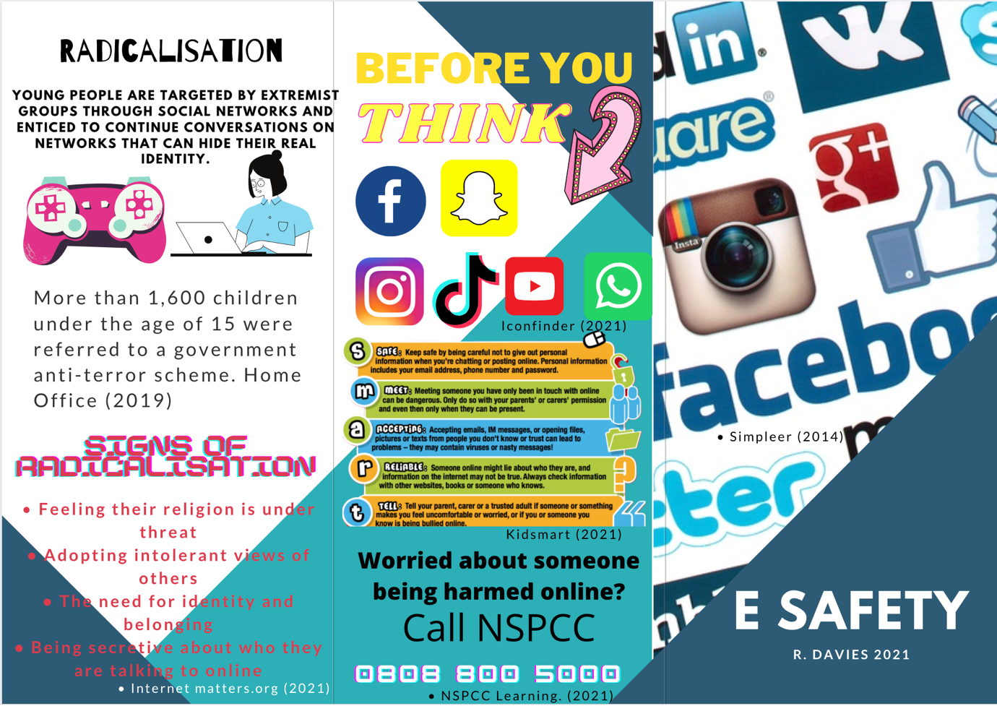
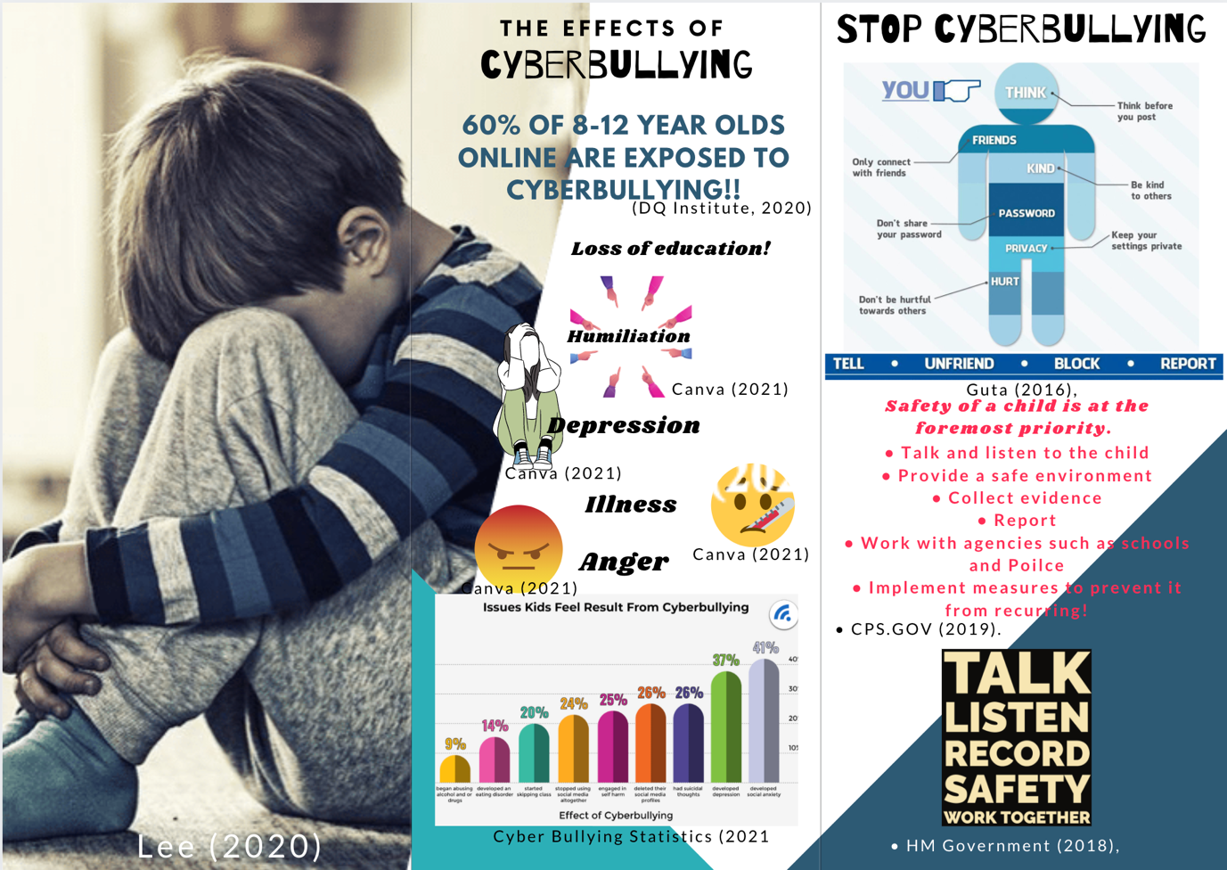

References for leaflet.
- DQ Institute, (2020)​, Nearly two-thirds of children surveyed around the world are exposed to cyber risks, first-ever global Child Online Safety Index reveals. [online] Available at: https://www.dqinstitute.org/press-release/nearly-two-thirds-of-children-surveyed-around-the-world-are-exposed-to-cyber-risks-first-ever-global-child-online-safety-index-reveals/ [Accessed March 15. 2021].
- Canva (2021), image gallery [online] Available at: https://www.canva.com/design/DAEZlBPNLrc/s6soiOH4jAEDxiivhVpupA/edit [Accessed March 15. 2021].
- CPS.GOV (2019). Safeguarding Children as victims and witnesses [online] Available at:https://www.cps.gov.uk/legal-guidance/safeguarding-children-victims-and-witnesses [Accessed March 15. 2021].
- Cyber Bullying Statistics (2021), All the latest Cyber Bullying Statistics and whats it means in 2021. [online] Available at: https://www.broadbandsearch.net/blog/cyber-bullying-statistics [Accessed March 15. 2021].

Guta (2016), Cyber Bullying Pictures and Posters For Your Classroom. [online] Available at:https://edtechreview.in/news/2392-cyber-bullying-posters-pictures [Accessed March 15. 2021].
- HM Government (2018), Working Together to Safeguard Children A guide to inter-agency working to safeguard and promote the welfare of children [online] Available at: https://assets.publishing.service.gov.uk/government/uploads/system/uploads/attachment_data/file/942454/Working_together_to_safeguard_children_inter_agency_guidance.pdf [Accessed March 14. 2021].
- Home Office (2019), Home Office in the media. Factsheet: Provent and channel statistics 2017/2018[online] Available at: https://homeofficemedia.blog.gov.uk/2018/12/13/factsheet-prevent-and-channel-statistics-2017-2018/ [Accessed March 15. 2021].
- Iconfinder (2021). [online] Available at: https://www.iconfinder.com/social-media-icons [Accessed March 15. 2021].
- Internet matters.org (2021), Learn about radicalisation. [online] Available at:https://www.internetmatters.org/issues/radicalisation/learn-about-it/ [Accessed March 15. 2021].
- Kidsmart (2021). [online] Available at: https://www.childnet.com/resources/looking-for-kidsmart [Accessed March 15. 2021].
- Lee (2020), Common Signs of Kindergarten Bullying. [online] available at: https://www.verywellfamily.com/kindergarten-bullying-signs-621007 [Accessed March 15. 2021].
- NSPCC Learning. (2021). E-safety for schools | NSPCC Learning. [online] Available at: https://learning.nspcc.org.uk/research-resources/schools/e-safety-for-schools/ [Accessed March 15. 2021].
- Simpleer (2014). Think of the children: be smart with home tech. [online] Available at:http://www.simpleer.com/think-of-the-children-be-smart-with-home-tech/ [Accessed March 15. 2021].

Rationale
This leaflet is designed to educate children but also all of the various parties around children such as family members and friends. Its purpose is to identify signs of online harm and delving into radicalization and cyberbullying. According to the guidance published by the Government and the NSPCC (2021):

“Across the UK highlights the importance of safeguarding pupils from harmful and inappropriate online material.” (NSPCC, 2021)

Online abuse can take shape in a number of forms such as sexual exploitation, grooming, emotional abuse and cyberbullying. The government made internet safety a compulsory part of the new curriculum for Wales (2020) although according to Youjin (2020) sixty percent of eight to twelve-year-old children having been exposed to cyber risks. With this in mind, online safeguarding cannot only be the responsibility of a school but also any individual who interacts with and cares for a child. The Working Together to Safeguard Children document, HM Government (2018) suggests the importance of all parties around a child to work together to ensure all are able to keep an individual safe but also if anything does inflame the matter can be addressed quickly.

Internet safety for children has become a rising concern all around the world. According to a survey conducted by NHS Glasgow (2021) the average child spends 1-3 hours a day on the internet, 1-2 hours playing video games and 2-3 hours per day watching television, adding to a total of 6.3 hours a day spent in front of a screen. Experts have suggested the number of hours online and in front of a screen to be linked with issues children can have, such as having problems with their sleep, eyesight and addiction because of increased use of digital devices. Having problems with sleeping patterns and health issues can have a detrimental effect on a child’s development. When considering Maslow’s Hierarchy of Needs pyramid, Cherry (2021) suggests for a child to develop and grown their fundamental aspects at the bottom of his table such as safety and health must be established for a child to develop further up his pyramid. The effect of too much online and screen time can hinder the development of a child. Schools are educating children and parents to create and promote a balanced approach to the amount of time spent online to aid a child’s development. Educating children can be regarded as one way in which to safeguard children from online harm. Educators have a statutory duty in regard to safeguarding of children. According to Children’s Commissioner (2018) the use of social media behind closed doors makes it difficult for parents and professionals to supervise while children are online. There are several legal frameworks, laws and procedures for child protection, which are continuously amended and updated. One of these is the Children’s Act 2004, which led to the biggest change in how services dealt with families.

The last fifteen years has seen a number of high-profile reviews of policy into safeguarding children online because of children such as Breck Bednar age 14 being groomed to rebel against his parents and leave his home to meet and be murdered by his predator, Meredith (2019). Professor Byron’s review (2008)underlines the unease about children’s safety online with the professor reviewing their safety online. The professor concluded that everyone plays a role in empowering children to stay safe online whilst allowing children to enjoy the technology. The Lord Lambing Enquiry 2003 into the death of Victoria Climbé concluded that a number of professionals around the family to have inconsistencies and Victoria’s voice had been ignored. Cooper (2005). The Government outlines the failures highlighted within the enquiry and the new legislation of Every Child Matters (2003) was established and a year after the Children’s Act 2004 was updated to ensure all children are being safeguarded.

Since the publication of the Byron Review, internet safety has become an integral part of child safeguarding in the UK. Furthermore, the Government’s Internet Safety Strategy Green Paper is seeking to make Britain the safest place in the world for children and adults to be online, Bradley (2017), by strengthening measures to protect users and improving digital literacy for children and parents. Although the NSPCC (2020) have reported over 10,000 additional grooming offences since a new anti-grooming law has come into force.

A number of factors contribute towards a child’s vulnerability such as children with Additional Learning Needs (ALN) and mental health issues. The Social and environmental barriers as well as low self-esteem are targeted by online predators or their lack of knowledge and understanding of the dangers when online. The ALN reform, Welsh Government (2021) ensures everyone around the child works together from all professions and can be seen to be a key part of the Working Together to Safeguard Children document 2018. Children and young people who are currently experiencing a mental health problem are more than three times more likely to have been bullied online in the last year.

The freedom of the internet attracts individuals, but the lack of rules online makes bullying online more likely. Mishen et al (2009) found when children are unsupervised, cyberbullying is likely to take place with Harrison (2014) reinforcing that the majority of children are using the internet alone. Educational settings can safeguard children from sites and issues online through denying access from online harm whilst following policy and procedure.

The modern term for bullying, Cyberbullying is the act of bullying carried out in using a form of digital device and social media. Digital devices such as mobile phones, tablets and computers enable the bullying to be in the form of sending, sharing and posting negative content, which can be harmful, obscene and mean to their victims be carried out. More and more cases of cyberbullying have also been identified through the use of social media platforms such as Facebook and Snapchat, as it is a way of publicly humiliating a victim as these messages or images can be seen by millions. It has also seen various news outlets such as the BBC (2020) reporting that such platforms have been used to share videos of serious illegal physical and unlawful behaviour, with videos being shared many times before being removed. Cyberbullying can affect an individual’s mental and physical health through creating feelings of anger, frustration and bottling up emotions. An individual who is bullied over time can see affects in their self-esteem, leading the individual to withdraw from family and friends. These signs can be identified by schools, family members and friends. The Working Together to Safeguard Children (HM Government, 2018) document highlights the important of all inter-agencies working together to safeguard all children and young people. The effects of cyberbullying can also influence a child’s education and health with children becoming disinterested in attending school or choosing to skip classes in the attempt to avoid their tormentors. According to a study published by Wegge, Vandelbosch and Eggermont (2014) 13% of young adults reported they had concerns about going to school the next day. The Department of Education (2012) published a clear link between poor attendance and lower academic achievement with pupils less likely to attain at school and stay in education.

All who work in schools are bound to provide a wider duty of care that children and young people are enabled to use the internet and their communication technologies safely. A framework of internet safety policies developed through a whole school approach can provide a safe environment for children to use the internet with all who are involved in a child’s education implementing. The HWB platform (2021) provided access for children to a number of resources free of charge for all individuals within the educational system in Wales. The software provides safe suggested programmes for children to use but also includes a number of educational resources for not only children but also parents to develop and learn how to use the internet safely.

A whole school approach to e-safety can ensure students, staff, parents and governors are able to teach children about being safe online as well as having a no tolerance approach to any form of bullying and a number of other issues that link to online use to ensure children can feel safe online whilst highlighting children know the right and wrongs of being responsible online. One of the outcomes of the new curriculum of Wales highlights the purpose for the curriculum to support a child within the curriculum to become ethical, informed citizens that are valued members of society, Welsh Government (2020).

The invention of the world wide web in 1989 has opened connection for individuals and allowed communication for communities all around the world. The internet has created a number of positive changes in bringing people together and connecting with the wider world, but it also exposes individuals especially children to a number of dangers. Although there are a number of positive technologies available online, they can be misused with malicious intent by predatory individuals who target the vulnerable. According to the Home Office (2019) figures more than 250 people in Wales had been highlighted to be extremism through radicalization. 'Radicalisation' involves a group or individuals spreading or inciting extremist ideas online, and the practice of manipulating someone to gain their trust for the purposes of sexual abuse has become known as 'grooming'. North West Community Services (2021)

According to NSPCC (2021) a number of researchers concluded that radicalisation has no clues or signs of the online abuse being conducted bar from a possible change in behaviour and mood within the victim. Education plays a vital role in educating and safeguarding children of the possible predators that are online. Through educating children from an early age they become equipped with the knowledge and understanding to be online safely. The new curriculum of Wales 2022 allocates schools to have wellbeing and safety lessons to educate and discuss issues such as cyber bullying, radicalisation and Mental Health. The UK Council for Internet Safety (2020) implemented a compulsory framework to equip children for digital life. The curriculum also provides an alternative curriculum for those who are vulnerable where suggested programmes such as the Princes Trust is used to gain qualification through learning about the danger of radicalisation and online line harm. Schools also take responsibility in preventing individuals from being drawn into terrorism through radicalisation by following the Counter-Terrorism and Security Act 2015 , Home Office (2019). Helplines are provided for teachers and governors to raises concerns directly with the Department for Education as well as a number of software intervention schools can invest in such as “My Concern”.
To conclude, the development of child protection laws and procedures must be evaluated and changed before an incident such as the death of Victoria Climbé has triggered the development of the law. Recommendations from the Welsh Government (2016) to ensure online safety stated, “Information about online safety should be more widely available”. The safeguarding of children can not only be the responsibility of professionals. The Welsh Government furthermore stated that “Parents and careers should be more educated on how to keep children safe.” Although there is already access to platforms for parents such the HWB (2013) where resources are regularly available for parents on how to safeguard their child a possible educational requirement that all parents are to undertake a course of how to safeguard their child could be a method of ensuring that all parents are educated of their responsibilities. However, research had suggested that approaches to online safety could have little effect in changing the knowledge and practice of young people (Cornish, 2017) suggesting that the current attempt in safeguarding children from cyberbullying and radicalisation is not having the desired effect.

References

- BBC News (2020), Bullying: ‘They’d spit at me and film it’, 2020. [online] Available at: https://www.bbc.co.uk/news/newsbeat-54931351 [Accessed March 14. 2021].

Bradley (2017). Internet Safety Strategy green paper. [online] Available at: https://www.gov.uk/government/consultations/internet-safety-strategy-green-paper [Accessed March 21. 2021].
- Byron (2008). The Report of the Byron Review. Safer Children in a Digital World. [online] Available at: https://www.iwf.org.uk/sites/default/files/inline-files/Safer%20Children%20in%20a%20Digital%20World%20report.pdf [Accessed March 14. 2021].

Cherry (2021). The 5 Levels of Maslow's Hierarchy of Needs. [online] Available at: https://www.verywellmind.com/what-is-maslows-hierarchy-of-needs-4136760 [Accessed March 15. 2021].

Children’s Commissioner (2018). Children unprepared for social media ‘cliff edge’ as they start secondary school, Children’s Commissioner for England warns in new report. [online] Available at: https://www.childrenscommissioner.gov.uk/2018/01/04/children-unprepared-for-social-media-cliff-edge-as-they-start-secondary-school-childrens-commissioner-for-england-warns-in-new-report/ [Accessed March 18. 2021].

Cooper (2005). Surface and Depth in the Victoria Climbie Inquiry Report. [online] Available at: https://www.researchgate.net/publication/229765816_Surface_and_Depth_in_the_Victoria_Climbie_Inquiry_Report [Accessed March 25. 2021].
- Cornish, K. (2017) Bursting the Bubble: Why Online Safety Education needs to evolve. [online] Available at: https://swgfl.org.uk/magazine/bursting-the-bubble-why-online-safety-education-ne/ [Accessed March 26. 2021].
- Department of Education (2012), Improving attendance at school. [online] Available at: https://www.gov.uk/government/publications/improving-attendance-at-school [Accessed March 22. 2021].
- Harrison, T. (2014). The influence of the Internet on the character virtues of 11–14 year olds. Birmingham: University of Birmingham. [Accessed March 14. 2021].
- HM Government (2018 p6,06), Working Together to Safeguard Children A guide to inter-agency working to safeguard and promote the welfare of children [online] Available at: https://assets.publishing.service.gov.uk/government/uploads/system/uploads/attachment_data/file/942454/Working_together_to_safeguard_children_inter_agency_guidance.pdf [Accessed March 14. 2021].
- Home Office (2019), Individuals referred to and supported through the Prevent programme, England and Wales, April 2018 to March 2019. [online] Available at: https://assets.publishing.service.gov.uk/government/uploads/system/uploads/attachment_data/file/853646/individuals-referred-supported-prevent-programme-apr2018-mar2019-hosb3219.pdf [Accessed March 23. 2021].
- Hwb.gov (2021) [online] available at: https://hwb.gov.wales/repository/discovery?sort=recent&strict=1 [Accessed March 14. 2021].
- Meredith (2019). BBC News, Breck Bednar: Mother shares 'lesson' in online grooming. [online] Available at: https://www.bbc.co.uk/news/uk-northern-ireland-50426449 [Accessed March 23. 2021].
- Mishnan, F., Michael, S., & Solomon, S. (2009). Ongoing and online: Children and youth’s perceptions of cyberbullying. Children and Youth Services Review, 3(12), 1222–1228. [online] Available at: https://www.sciencedirect.com/science/article/abs/pii/S0190740909001200?via%3Dihub [Accessed March 14. 2021].
- NHS Glasgow (2021), Screen Time. [online] Available at: https://www.nhsggc.org.uk/about-us/professional-support-sites/screen-time/# [Accessed March 19. 2021].
- North West Community Services (2021). Keeping Safe: how to spot and prevent online grooming and radicalisation. [online] Available at: https://www.nwcstraining.co.uk/safeguarding/keeping-safe-how-to-spot-and-prevent-online-grooming-and-radicalisation/ [Accessed March 23. 2021].

NSPCC (2020). Online child grooming offences pass 10,000. [online] Available at: https://www.nspcc.org.uk/about-us/news-opinion/2020/Online-child-grooming-offences-pass-10000/ [Accessed March 22. 2021].
- NSPCC (2021), Protecting children from being radicalised. [online] Available at: https://www.nspcc.org.uk/keeping-children-safe/reporting-abuse/dedicated-helplines/protecting-children-from-radicalisation/ [Accessed March 14. 2021].
- The Children Act , (2004). [online] Available at: https://www.legislation.gov.uk/ukpga/1989/41 [Accessed March 14. 2021].
- Uk Council for Internet Safety (2020), Education for a connected World- 2020 edition. [online] Available at: https://assets.publishing.service.gov.uk/government/uploads/system/uploads/attachment_data/file/896323/UKCIS_Education_for_a_Connected_World_.pdf [Accessed March 14. 2021].
- Wegge, Vandelbosch and Eggermont (2014), Popularity Through Online Harm: The Longitudinal Associations Between Cyberbullying and Sociometric Status in Early Adolescence. The Journal of Early Adolescence. [online] Available at: https://journals.sagepub.com/doi/10.1177/0272431614556351 [Accessed March 19. 2021].
- Welsh Government (2020). Curriculum for Wales. [online] Available at: https://gov.wales/curriculum-wales-overview [Accessed March 14. 2021].
- Welsh Government (2021), Additional learning needs (ALN) transformation programme [online] Available at: https://gov.wales/sites/default/files/publications/2018-09/additional-learning-needs-aln-transformation-programme-v2.pdf [Accessed March 14. 2021].
- Youjin (2020), Global study warns of ‘cyber pandemic’ among children; biggest risk for S’porean kids is cyber bullying [online] Available at: https://www.todayonline.com/singapore/global-study-warns-cyber-pandemic-among-children-biggest-risk-sporean-kids-cyberbullying [Accessed March 18. 2021].

