Problem Solving and Decision Making.
(BMSW4004_LON)
(Suneth Fernando)
Monther Al Jaradat ID (2009450)

Introduction.
This report covers the university of Wales trinity saint David, so that I can write about a problem related to my current job, my previous job, or a problem I found from an external source.
Introduction to where I work it is the world’s largest quick-service restaurant chain, serving tens of millions of customers daily worldwide. The type of products they sell are burgers, French fries, milkshakes, and happy meals.
It aims to provide quality food in a friendly and pleasant environment, to be a socially responsible company, to provide good returns to its shareholders, to provide its customers with high quality food, to provide fast service and value for money.
The restaurant was founded by Richard and Morris in 1940 in San Bernardino, California. In 1955 Ray Kroc bought the restaurant and displayed it all over the word.
What business they do running a restaurant a burger restaurant, but in the business word, it is a real estate company. While the brand has sold over billion hamburgers to customers worldwide, 85% of its stores are owned by franchisees. Franchisees pay to use the brand name, ownership operations, and brand menu items, but unlike other franchises, the restaurant owner the land on which the stores are built. Between the burgers and the land, the restaurant makes a lot of its money on the land. The restaurant owns thousands of distinctive real estate pieces around the world. From times square in New York city to red square in Moscow, the restaurant has wandered all over the world, buying up luxury real estate. Franchisees pay a company a portion of their food sales, but a much large portion of the restaurant’s revenue comes from the rent you pay on the properties. After all, rent in times square is not cheap, but burgers are cheap. The restaurant still takes the franchise on franchisor sales but has a much greater revenue stream from the leases of the approximately 33,000 franchisee-owned restaurants.
The different departments in the restaurant or in the company are operations, development, finance, marketing, and human resources.
Operations, the restaurant operations department controls the equipment and franchises of the restaurants. They ensure that franchisees follow the agreements set by the company. They provide support to franchisees in all aspects of the business. All in all, they make sure that the restaurant business runs smoothly.
Development, the development department plans and manufactures products. They ensure that the products manufactured reach the qualities specified by the company. Besides, they are also developing new products for the restaurant.
Finance, the finance department keeps a record of the company’s earnings. They keep all the transactions made by the company. They also pay the salaries of employees. They keep track of how the work is being done.
Marketing, the mine role of the marketing department is to attract new clients. They organize advertisements and promotions. Moreover, they cooperate with the development department to ensure that the design, quality, and price of the product is what the consumer wants.
Hr, the human resources department recruits and hires all new employees. They handle the affairs of all employees which includes retirement, dismissal, etc. they hire quality employees and motivate them to do their best.
As for the department in which the problem occurred, or sometimes it is still challenged, which is (customer service) and I mean serving food to the fanatic or drunk customer, if some of them come and cause big problems in the restaurant, knowing that the restaurant is close to an underground train station and it is a famous restaurant that includes many people who want to eat but some of them are because of staying up late and parties when they come the problem start in the restaurant.
Stakeholders in the business and how they are affected if they face, or we face affected by the customer service problem when they are drunk or because the restaurant is located in a known area and there is a heavy crowd in the restaurant they fight for their food. Or when they come back the same people who caused a problem with people in the restaurant or for food and want to fight.
Strengths, Weaknesses, Opportunities and Threats of the company, the restaurant.
Strengths | Weaknesses | Opportunities | Threats
One of the most valuable brands in the entire word. | Franchise business model. | Launching more items like this according to the geographical conditions. | Risky investments on technology initiatives.
Also, the restaurant or the company has a multi-billion real estate empire. | Interruptions in supply-chain business modal. | Rebuilding the brand image. | Fierce competition from competitors like burger- king.
Also, the restaurant or the company is taking revolutionary technology. | Lack of employee satisfaction. | The company has initiated a partnership with uber eats. | Cultural threat while operating in various countries.
And the restaurant or the company acquisition of ‘dynamic Yield’ is a step towards enhanced personalized marketing and customizations. | The restaurant or the company breakfast menu has lost its charm. | The company expansion in Asian markets. | And the company face immense pressure to improve its practices to minimize the waste.

In terms of solutions, there is more than one solution that the company adopts, restaurant to avoid the problem of angry and drunk customers.
alternative Solution
Solution 01
The guards outside the restaurant or the security.
Solution 02
Talk to them, talk to them and calm them down.

Solution 01-the guards outside the restaurant or the security.
Plus, Points | Minus Points | Interesting Points
He can protect the restaurant +5 | Sometimes if the restaurant is full, he cannot control entering a specific number-5 | The security are strong-willed people+5
He can tell who wants to fight and stop them +5 | Sometimes people crowd the food window, so the guard must leave his place and come to the front of the window to bring them back-5 | He can talk to the police at the station and tell them to come in any problem that may arise+5
And he also has a radio that can tell people in the restaurant about any situation+5 | Sometimes the people in the restaurant must go out and help out as one or two-4
Also, the restaurant is close to an underground train station, that is, there is also a police officer nearby for any case+5
Total Plus Points+20 | Total minus points-14 | Total interesting points+10

Solution 02-talk to them, talk to them, and calm them down.
Plus, points | Minus points | Interesting points
The best way is to talk to them and tell them that their food is ready+4 | Sometimes they do not want to listen-5 | It is some people in speech that understand and calm down+5
Control and calm them+3 | Or that when we talk to them, they want to start a fight-5
Sometimes there is a singer from the same restaurant who sings and the atmosphere calms down+4 | Or sometimes because they are drunk, they come back after we talked to them and ask the same question-4
Total plus points+11 | Total minus points-14 | Total interesting points+5

In relation to the best solution of the two options, which is the first option, as the security helps not only at the door of the restaurant, but advances to the point of food delivery and collections points and keeps some drunk or fanatic people and others away.
As for preparing a plan and how I will implement it.
- Regarding the problem, as people come drunk or angry, but how to solve the problem, as the guard must always be available, as I wrote above, or the guard intervene as soon as possible in any problem.
- In relation to the management of the company, as some of them are strict and others are understanding, but in general, as much as possible, the company tries to provide them they food fast, like as soon as possible in order to avoid problems or to reach the police.
- Regarding the challenges of the company, the same people who come to the restaurant in the shift night, where I work, if there are a large number of people, and the restaurant is always full, the restaurant is asking for more people to protect the restaurant security, inside and outside.
4.
Task | Duration | Resources required
Meeting with the manager to solve the problem | 3 | Laptop, projector, digital screen and a office room
Regular work | 4 | Complete the work that is asked of me
Not making trouble | 5 | Avoid fighting or causing any trouble

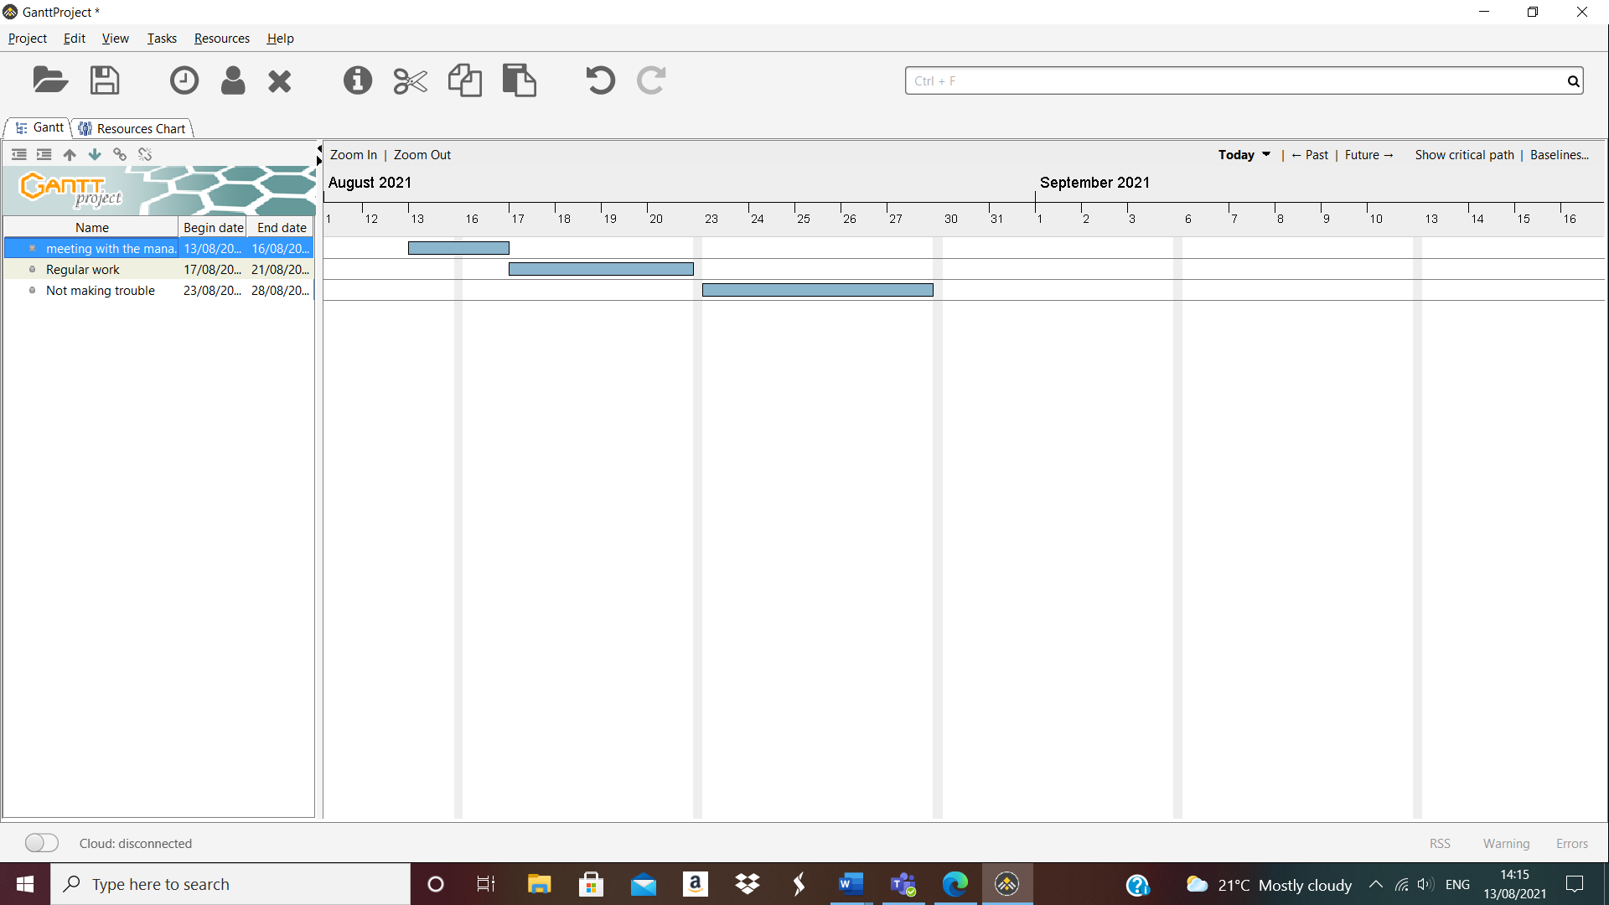

5. guards should be placed regularly in every corner in order to prevent fanatics from approaching the barrier and to calm them as much as possible so that no one get hurt at work.
6. as a plan for implementation or a list, the most important things is that there is security to protect the restaurant with the implementation and coordination of the company responsible for them, as their work starts from a specific hour to another hour, and also the security men must talk with the restaurant management to find a solution in order to coordinate between them because they are more than one in they designated place and they monitor the place because many and many people come to the restaurant and they must be guarded from people who are drunk or who are just looking for problems, not for they food.
7. as a result of the project, all the obligations and orders required must be carried out carefully to avoid any fight or problem in the restaurant, as the plan is for everyone to be aware of what is happening in the place and ready for anything. Happen in the restaurant.
8. for the effectiveness of the solution, it is necessary not to avoid quarrels with them from all parties of the workers who work because some of them and I witnessed what happened started a quarrel, and this is a mistake. Therefore, so should not talk to them in a barbaric manner.
9. specific requirements to meet the right work, communication, work together, allow groups into the restaurant not so much and take them out when the get food. Because the restaurant, fast food only.
10. regarding the draft, it is necessary to do what I said before to avoid angry and drunken people from reckless behaviour in the restaurant. Security must be organized among them, and if anything, dangerous happens, because the restaurant is connected to the trin station, there is police nearby to help and provide a helping hand.

About my implementation process.
Review the process implementation of all the roles assigned to security so that people do not approach the front of the food window and act recklessly in order to get food or try to steal food like some people and each of them must be is they place and the right place and organize among them to make things go smoothly at the end of the night to avoid problems and fights in the restaurant and call the police.
Comments from employers.
Some customers, as me or we are in the restaurant, find this is something that exists and all of us have seen many of them fighting, but what is most important thing is to avoid approaching or interfering in any fight, whatever it is, for our safety at work, and we leave the rest to the security men.
As for the administration, the administration is always ready for any situation or person because we do not know what they will do, especially when they are drunk or otherwise, so we avoid and they avoid fight and when anything happen the security guards and the police if we need them are ready for any problem, and the administration is ready for anything happen inside the restaurant.
Conclusion, it was an enjoyable experience for me learning in this course, as I was able to deduce the information, the problem and solve it in a very good way, as I learned a lot a lot, so that helped me to improve myself for the better, other than that, how to write about topics, deduce solutions and how to implement them, and so on. As I look to my future.
This is the reference from which I extracted some information about the same company and the rest of what I learned; I wrote it by myself.
https://1851franchise.com/why-is-mcdonalds-considered-a-real-estate-company-2715077#stories
https://www.ukessays.com/essays/commerce/business-organisation-and-environment-for-mcdonalds-commerce-essay.php#:~:text=The%20various%20departments%20in%20McDonald's,%2C%20marketing%2C%20and%20human%20resource.
https://www.edrawmax.com/article/mcdonalds-swot-analysis.html

thank you.

