

BSc. Applied Computing. Data Security And Compliance
Securing the Hybrid Workforce and learning from Equifax: A structured approach to Data Security and Compliance

ACCA5034.

Lecturer: Dr Ayman El Hajjar
University of Wales Trinity Saint David
(London Campus)

Student Name: Ataur Rahman
Student Number: 2430256
Group: 01
Team: 01
Date: 11/08/2026

Table of Contents
Task 1: Research in Data Security and Compliance 1
1.1 Introduction 1
1.2 Why the Corporate Perimeter no longer holds 1
1.3 Zero Trust Network Access 2
1.4 Secure Access Service Edge 3
1.5 Data Loss Prevention 3
1.6 Critical Evaluation: Integration, Governance and Limits 4
1.7 Conclusion 6
Task 2: Case Scenario, a Structured Cybersecurity Programme for Equifax 7
2.1 Introduction 7
2.2 Organisational Structure and Accountability 7
2.3 Policies and Procedures 9
2.4 Governance and Strategic Alignment 9
2.5 Risk Management and Assessment 10
2.6 Compliance, Incident Response and Protection Controls 11
2.7 Conclusion 12
References 13
Appendix A: RACI Matrix for Core Security Activities 15

Task 1: Research in Data Security and Compliance

1.1 Introduction
Hybrid working stopped being a temporary arrangement some time ago. Gallup’s May 2024 tracking put 53% of employees in remote-capable roles on a hybrid schedule, with a further 27% working remotely full time, and found the pattern had held steady rather than reversed as many predicted [1]. For a security team, that stability is the problem. A workforce that used to sit inside a small number of offices, behind a small number of firewalls, now authenticates from home routers, co-working spaces, airport longes and personal phones, often to systems that themselves live outside the corporate network in SaaS platforms. The question this paper addresses is how an organization builds an environment that anticipates, protects against, detects and automatically responds to threats under those conditions, using three technologies that are frequently marketed together but rarely examined together: zero-trust network access (ZTNA), secure access service edge (SASE) and data loss prevention (DLP).
The argument development here is that none of the three is a substitute for the others, and that treating any of them as a complete answer to hybrid work risk is a mistake. ZTNA governs who and what is allowed to reach a resource. SASE governs how traffic gets there and lets that governance travel with the user rather than staying fixed to an office network. DLP governs what happens to the data once access has been granted, which is the point ZTNA and SASE are designed to reach. The paper works through each control in turn, then evaluates what they achieve together and where the model still falls short.

1.2 Why the Corporate Perimeter no longer holds

Perimeter security assumes a defensible edge: a network boundary where traffic can be inspected, and an inside that is trusted more than the outside. Virtual Private Networks (VPN) extended that boundary to remote users by tunnelling them into the corporate network, but a VPN authenticates a connection once and then largely gets out of the way, granting broad-network-level reach rather than access scoped to a specific application. The national Institute of Standards and Technology (NIST) Special Publication 800-207 makes the underlying problem explicit: attackers who compromise a single account or endpoint inside a traditionally trusted network segment can often move laterally with little further resistance, because the model was built to keep outsiders out rather than to constrain insiders once they are in [2].
Verizon's 2024 Data Breach Investigations Report gives that concern a current number. Vulnerability exploitation as an initial access vector rose 180% year on year, and exploitation of edge devices and VPNs specifically increased from 3% to 22% of that vector, driven partly by zero-day attacks against the very appliances organisations rely on to extend their perimeter to remote staff [3]. The report also found that it typically takes organisations 55 days to remediate half of their critical vulnerabilities once a patch is available, a gap that is difficult to close when the affected systems sit on infrastructure the security team no longer fully controls, such as a contractor's laptop or a branch office router [3]. A hybrid workforce multiplies the number of network edges an organisation has to defend at exactly the moment attackers are getting faster at finding the weak ones.
The practical shape of that expansion is worth being specific about, because it changes what a security team is actually defending. Bring-your-own-device use means the organisation frequently has no control over the patch level of the machine an employee is typing on. Consumer-grade home routers rarely receive firmware updates and are managed by nobody with security training. Shadow IT, meaning cloud tools and file-sharing services staff adopt on their own to get work done, sits entirely outside whatever visibility the security team has built into sanctioned systems. None of these were significant considerations when most work happened inside a small number of buildings the organisation itself controlled, and none of them are addressed by a firewall configured to defend a network edge that a growing share of daily work never passes through.

1.3 Zero Trust Network Access
NIST SP 800-207 defines zero trust as a set of principles rather than a single product: no implicit trust is granted based on network location or asset ownership, every access request is authenticated and authorised individually, and access is granted per session, at the minimum level of privilege needed for the task [2]. The architecture NIST describes has three logical components working together: a policy engine that decides whether to grant access based on identity, device posture, behavioural signals and other context; a policy administrator that executes that decision by establishing or severing the communication path; and a policy enforcement point that sits between the user and the resource and carries out the administrator's instruction [2].
ZTNA is the practical, deployable form of that model. Instead of placing a user on the network and trusting the network to constrain them, ZTNA brokers each connection to a named application, verifies identity and device posture before granting it, and re-evaluates that decision continuously rather than once at login. In effect it replaces network-level access with application-level access, so that a compromised laptop can reach the one finance application it was authorised for rather than the whole finance subnet. This directly answers the lateral-movement weakness that made the Equifax breach so damaging, a connection this paper returns to in Task 2.
The approach is not free of friction. Continuous verification depends on rich, reliable telemetry about devices and users, which is hard to gather from unmanaged personal devices and legacy systems that were never built to report their own health. Retrofitting per-application access controls onto older, monolithic applications can require re-architecture rather than a configuration change. And a policy engine is only as good as the policies written into it: an organisation that migrates to ZTNA but keeps overly broad access rules out of convenience gains a new access-control layer without gaining the security benefit it was meant to provide. Zero trust, in other words, is a governance discipline before it is a technology purchase, a point developed further in section 6.
Most organisations that succeed with ZTNA do not attempt a single cut-over from network-level trust to per-application brokering. A more realistic path starts by inventorying which applications actually need to be reachable from outside the office, moving the highest-risk of those, typically internet-facing administrative interfaces and anything holding regulated data, behind a policy enforcement point first, and using the access logs that generates to refine policy before extending the same model to lower-risk systems. Micro-segmentation, dividing the internal network into smaller zones so that a credential valid in one zone is not automatically valid in the next, follows the same logic at the network layer and is what would have limited how far the Equifax attackers could travel once inside a single exposed application, a case examined in full in Task 2.

1.4 Secure Access Service Edge
Gartner, which coined the term in 2019, defines SASE as the convergence of network connectivity (chiefly software-defined WAN) with a set of security functions, including secure web gateway, cloud access security broker, firewall-as-a-service and zero trust network access, delivered primarily as a cloud service rather than through hardware at a fixed location [4]. The practical effect for a hybrid workforce is that security policy stops being tied to a physical office network and instead follows the user to whichever point of presence they connect to, whether that is a home office, a client site or a coffee shop. A remote worker's traffic is inspected and policed at a nearby cloud edge node instead of being backhauled across a private network link to a data centre for inspection, which was the traditional way of extending office-grade controls to remote staff and which adds latency in proportion to distance from that data centre.
SASE is best read as the delivery mechanism that makes ZTNA and other controls consistently available regardless of where a user happens to be, rather than as a security control in its own right. That is also its main limitation as an evaluation matter. Because SASE bundles several previously separate products into one platform, an organisation adopting it is making a multi-year commitment to a single vendor's roadmap across networking and security simultaneously, which raises the cost of switching later and makes the maturity of any one component, such as its DLP or CASB module, harder to assess independently. Migrating away from established MPLS wide-area networks and appliance-based firewalls toward a cloud-delivered model is also a significant infrastructure project, not a quick swap, and organisations with heavy investment in legacy networking equipment may find the transition slower and more expensive than vendor marketing implies.
A related evaluation point concerns performance and availability. Once security enforcement moves from an organisation's own data centre to a third-party cloud edge, an outage or latency spike at the provider becomes an outage or latency spike for every remote employee trying to reach every application, which is a different failure mode to a single office losing its own internet connection. Vendor selection therefore has to weigh the breadth of a provider's point-of-presence network and its published availability record alongside the completeness of its security feature set, since a SASE platform that is comprehensive on paper but has thin regional coverage will produce a worse experience for hybrid staff than the office-bound model it replaced.

1.5 Data Loss Prevention
Tahboub and Saleh describe DLP as a set of systems built to identify, monitor and control sensitive data as it moves across an organisation's network, endpoints and storage, using content inspection and contextual analysis to decide whether a given transfer should be allowed, blocked or logged [5]. Where ZTNA decides whether a connection is permitted and SASE decides how that connection is routed and inspected, DLP is concerned with the payload itself: it looks inside a file being uploaded, an email being sent or a document being copied to a USB drive, and applies policy based on content rather than only on who is asking.
That focus is what makes DLP necessary in a hybrid environment rather than optional. A ZTNA policy can correctly authenticate an employee and correctly grant them access to a customer database, because that access is part of their job, and still have no way of stopping that same employee, or an attacker who has stolen their session, from exporting the entire table to a personal cloud drive once access has been granted. Unmanaged personal devices, employees' use of consumer file-sharing and messaging tools, and email sent from home networks all create exfiltration paths that identity and network controls alone do not close. Endpoint DLP agents, cloud-based DLP integrated into a CASB, and network-level content inspection each cover a different point in that chain.
DLP has real limits. Content-inspection rules generate false positives when legitimate business documents happen to match sensitive-data patterns, which over time trains staff to route around the control rather than comply with it. Encrypted traffic is a structural blind spot unless the organisation also decrypts and re-inspects it, which raises its own privacy and performance questions, and unstructured or novel forms of sensitive data, such as a screenshot of a spreadsheet, are harder to classify reliably than a well-formatted credit card number. DLP works best as one layer among several rather than as a standalone control, which is the argument developed in the next section.
DLP is also one of the few controls in this paper aimed squarely at insider risk rather than external attack. A malicious or careless insider with legitimate credentials is not stopped by better authentication, because the authentication was never the problem, and is not stopped by network segmentation if the data they are misusing sits inside the segment they are authorised to reach. Content-aware inspection at the point of transfer is what catches that case, which is why mature DLP deployments increasingly pair content rules with behavioural signals, such as an unusually large export or an unusual destination, rather than relying on static keyword matching alone.

1.6 Critical Evaluation: Integration, Governance and Limits
Read individually, ZTNA, SASE and DLP address different questions: who may connect, how that connection is delivered and inspected, and what may leave once access is granted. Read together, they form a layered model in which a compromise at any single point still leaves the others in place. A stolen credential is constrained by continuous ZTNA verification and least-privilege scoping. A compromised home network is brought under consistent policy by SASE rather than left entirely outside corporate visibility. An authorised user attempting to exfiltrate data, whether carelessly or maliciously, is caught by DLP even though their access was legitimate. This layering is what the task brief's language of anticipating, protecting, detecting and automatically responding actually requires in practice: no single product performs all four functions, and the combination is designed precisely to cover the gaps each individual control leaves open. Figure 1 sets out how the three controls sit relative to one another for a single user session, regardless of the user's physical location.
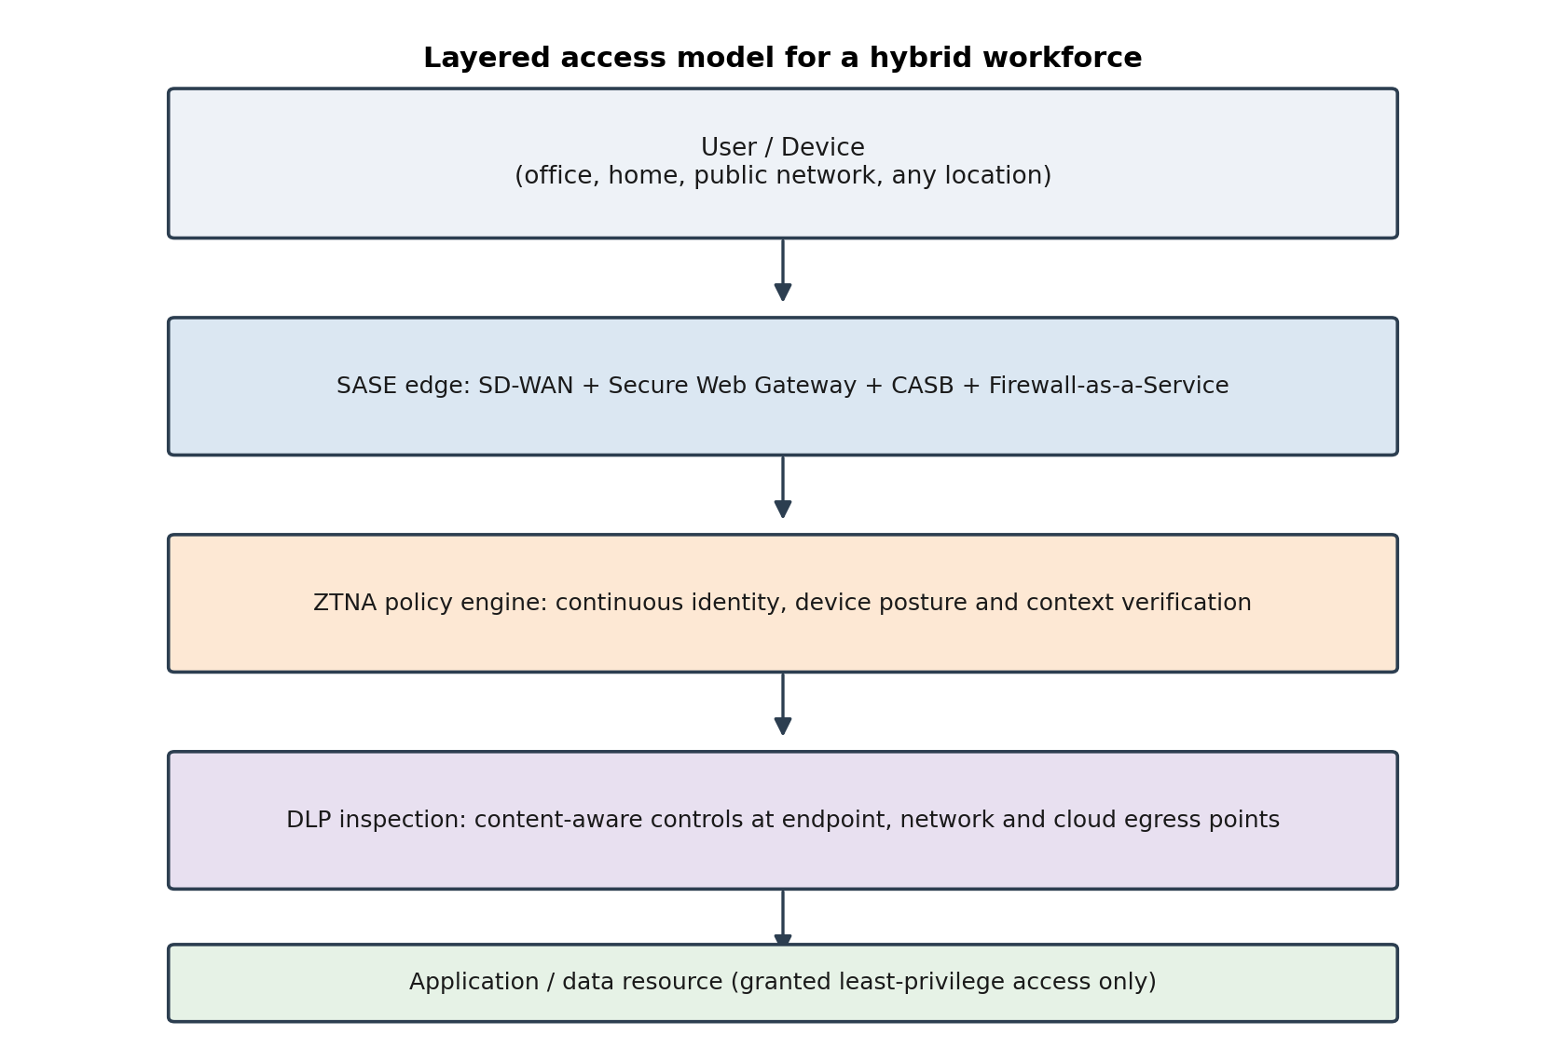
Figure 1: Layered access model combining SASE, ZTNA and DLP for a hybrid workforce.
The limits of this model are organisational as much as technical. IBM's 2024 Cost of a Data Breach Report found that the average time to identify and contain a breach was 258 days, the lowest figure in seven years but still a large window, and that organisations using AI-assisted detection cut that figure by close to 100 days on average, which suggests the tooling matters but is far from sufficient on its own [6]. Deploying ZTNA, SASE and DLP without the staff to tune their policies, investigate their alerts and retire stale access rules produces a security stack that looks comprehensive on a vendor diagram while doing little in practice. Small and medium-sized organisations in particular face a genuine cost and skills barrier to running all three well, and "zero trust" has become enough of a marketing term that a product labelled this way is not a guarantee that the underlying architecture matches NIST's actual definition.
None of this is a one-off project. Access policies drift as staff change roles and projects end, new SaaS applications get adopted faster than the security team can review them, and DLP rules written for last year's most sensitive data category can miss this year's. An organisation that treats a ZTNA, SASE and DLP rollout as complete once the software is installed will find the controls decaying quietly rather than failing loudly, which is a harder problem to notice and a more dangerous one to leave unaddressed. Sustaining the model requires the same recurring review cycle that Task 2 builds into the Equifax remediation programme: a defined owner, a measurable target and a fixed audit interval for each control, rather than a single implementation milestone treated as the end of the work.
Regulation is now a second driver of adoption alongside risk reduction, and the two are converging. The EU's General Data Protection Regulation (GDPR) already requires organisations to apply technical measures appropriate to risk when processing personal data [7]. The Digital Operational Resilience Act (DORA), which entered into application in January 2025, imposes ICT risk-management and resilience-testing obligations on EU financial entities specifically [8], and the NIS2 Directive extends comparable cybersecurity risk-management and incident-reporting duties across eighteen sectors classed as essential or important [9]. None of these instruments mandates ZTNA, SASE or DLP by name, but each expects the kind of continuous risk management, access control and monitoring that those technologies are built to support, and each treats governance failure, not merely technical failure, as a compliance matter. That framing carries directly into Task 2.

1.7 Conclusion
The perimeter that traditional security controls were built to defend has effectively dissolved for any organisation with a hybrid workforce, and patching that perimeter with a VPN is not a substitute for redesigning access around identity and data rather than network location. ZTNA, SASE and DLP address separate parts of that redesign and are strongest when deployed as a coordinated layer rather than as isolated purchases. None of them removes the need for governance: policy quality, staffing and continuous tuning determine whether the layer actually reduces risk or simply adds cost, and an organisation that buys the technology without building that discipline around it will still be caught out by the same class of failure the technology was bought to prevent. The following section applies this reasoning to a real breach, the 2017 Equifax incident, to design a cybersecurity programme that treats these controls as part of a governed system rather than a checklist.

Task 2: Case Scenario, a Structured Cybersecurity Programme for Equifax

2.1 Introduction
On 7 March 2017, Apache disclosed a critical remote-code-execution vulnerability in the Struts web framework, tracked as CVE-2017-5638, and released a patch the same day. The US Department of Homeland Security notified Equifax of the vulnerability the next day, and an internal email instructed administrators to patch affected systems. Equifax's own vulnerability scan, run on 15 March, failed to identify the exposed system, and on 10 March, attackers had already begun exploiting the same flaw against Equifax's online dispute portal. Unauthorised access continued from 13 May to 30 July 2017, undetected in part because a digital certificate used to decrypt and inspect outbound traffic had expired roughly ten months earlier, leaving that channel uninspected for the duration of the intrusion [10] [11]. By the time Equifax discovered the breach, after renewing the expired certificate, attackers had extracted the personal data of approximately 147 million individuals, including Social Security numbers, dates of birth and addresses.
The US Government Accountability Office's (GAO) review and the House Oversight and Government Reform Committee's staff report both concluded that the breach was, in the Committee's words, entirely preventable, and both identified failures across identification of vulnerable assets, detection of intrusion, network segmentation and data governance rather than a single point of technical failure [10] [11]. This section uses that finding as the basis for a forward-looking cybersecurity programme, structured around organisational accountability, policy, strategic governance, risk assessment and compliance controls, and drawing on the ZTNA, SASE and DLP analysis from Task 1 where it applies directly to the gaps the case exposed.
The brief for this task asks for analytical reasoning and justified design decisions rather than a further retelling of the incident, and the structure below is built to answer that instruction directly. Each of the five components that follows, organisational structure, policy, strategic governance, risk assessment and compliance controls, is traced back to a specific finding from the GAO or House investigation rather than presented as generic best practice, so that the reasoning for each design choice is visible and defensible against the facts of the case rather than asserted on authority alone.

2.2 Organisational Structure and Accountability
The House Committee's report attributes part of Equifax's failure to a security function that lacked the authority and visibility to force remediation across the business, with responsibility for patching split across teams and no single accountable owner ensuring the March patch instruction was actually carried out [11]. The structure proposed here answers that finding directly, by giving the Chief Information Security Officer a formal reporting line to a Board Cyber Risk Committee rather than routing security oversight through a general IT or legal reporting chain, so that unresolved risk reaches the board without being filtered by the operational teams whose performance it reflects. Figure 2 sets out the reporting structure.
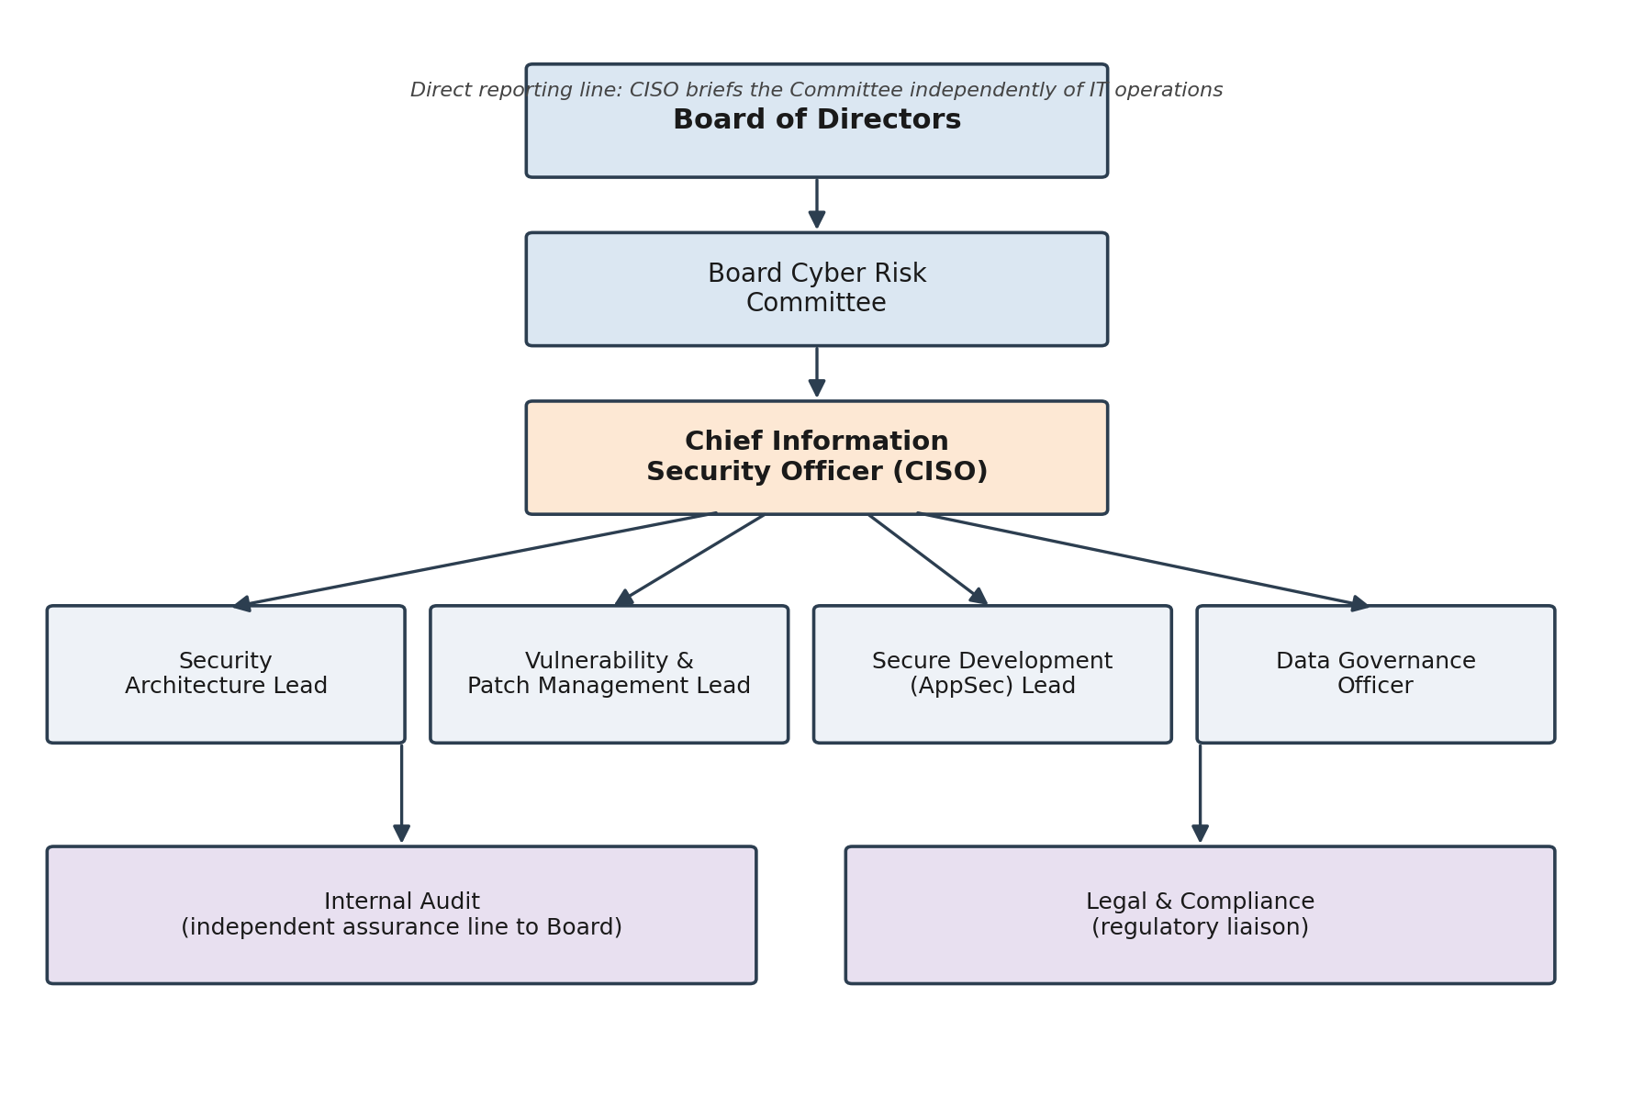
Figure 2: Proposed governance and reporting structure.
Four operational roles report to the CISO. A Security Architecture lead is accountable for the design of network segmentation and access control, including the ZTNA and SASE deployment discussed in Task 1. A Vulnerability and Patch Management lead owns the asset inventory and the patch pipeline, closing the specific gap that let the Struts vulnerability go unpatched for months after a fix existed. A Secure Development lead is responsible for scanning and approving third-party components, such as open-source frameworks like Struts, before and after they enter production. A Data Governance Officer owns data classification and retention, addressing the Committee's finding that Equifax retained more sensitive consumer data, for longer, than its business purpose required [11].
Two further lines are shown separately from the CISO's operational chain: Internal Audit reports independently to the Board, so that the effectiveness of security controls is verified by a function with no stake in the outcome, and Legal and Compliance handles regulatory liaison and breach notification obligations. Separating audit from the CISO's own operational reporting matters because Equifax's internal vulnerability scan was the very control that failed to detect the unpatched system; an audit function positioned to challenge that result, rather than one that reports through the same chain being audited, is more likely to catch a repeat of that specific failure.
Role allocation also carries budget authority, which the House Committee's report treats as a live issue: patching work identified as necessary was not completed even after the vulnerability was flagged internally, which points to a resourcing and prioritisation gap rather than only an awareness gap. Under the structure proposed here, the Vulnerability and Patch Management lead has authority to require downtime windows across business units for critical patching and reports patch-SLA compliance to the CISO monthly, so that a delay of the kind that let CVE-2017-5638 remain unpatched becomes visible to the Board Cyber Risk Committee within weeks rather than only after an incident forces disclosure.

2.3 Policies and Procedures
The policies proposed below map directly onto the causal chain the investigations identified: a known vulnerability, a missed patch, an undetected intrusion and an unsegmented network that let attackers reach far more data than the initial foothold should have allowed. Table 1 sets out five policies, each with a measurable target and an audit cadence, on the view that a policy without a metric is a statement of intent rather than a control.
Policy | Objective | Measurable target | Audit frequency
Vulnerability and patch management | Close known vulnerabilities before they can be exploited | Critical vulnerabilities (CVSS 9.0+) patched or mitigated within 72 hours of a vendor patch being available | Monthly
Asset inventory and discovery | Maintain a complete, current record of internet-facing and internal systems | 100% of internet-facing assets scanned and matched against the inventory weekly | Quarterly
Secure software development lifecycle | Prevent vulnerable third-party components from reaching production | Software composition analysis run on every build; no critical-severity component deployed without a documented exception | Quarterly
Data classification and protection | Limit the volume and retention of sensitive personal data held | All datasets classified within 30 days of creation; retention beyond policy limits requires documented business justification | Semi-annual
Continuous monitoring | Detect intrusion and data exfiltration in near real time | 100% of TLS-inspected egress traffic covered by valid, current certificates; monitoring coverage reviewed against the asset inventory | Monthly
Table 1: Core policies for the proposed programme.
The continuous monitoring policy directly targets the certificate failure that let Equifax's own inspection tools run blind for ten months: a monthly reconciliation between the asset inventory and the list of certificates due for renewal would have flagged the lapse well before it became a two-month blind spot for attacker traffic. Each policy is written to be auditable rather than aspirational, so that Internal Audit, reporting through the line described in section 2, can verify compliance against a defined number rather than a subjective judgement.

2.4 Governance and Strategic Alignment
The NIST Cybersecurity Framework 2.0, published in February 2024, organises cybersecurity activity into six functions: Govern, Identify, Protect, Detect, Respond and Recover [12]. The addition of Govern as a standalone function in the 2.0 revision, sitting above and informing the other five, is directly relevant to Equifax, whose failure the House Committee traced back to governance and accountability gaps as much as to any single missed technical control [11]. Figure 3 maps each function to a specific element of the programme proposed in this report.
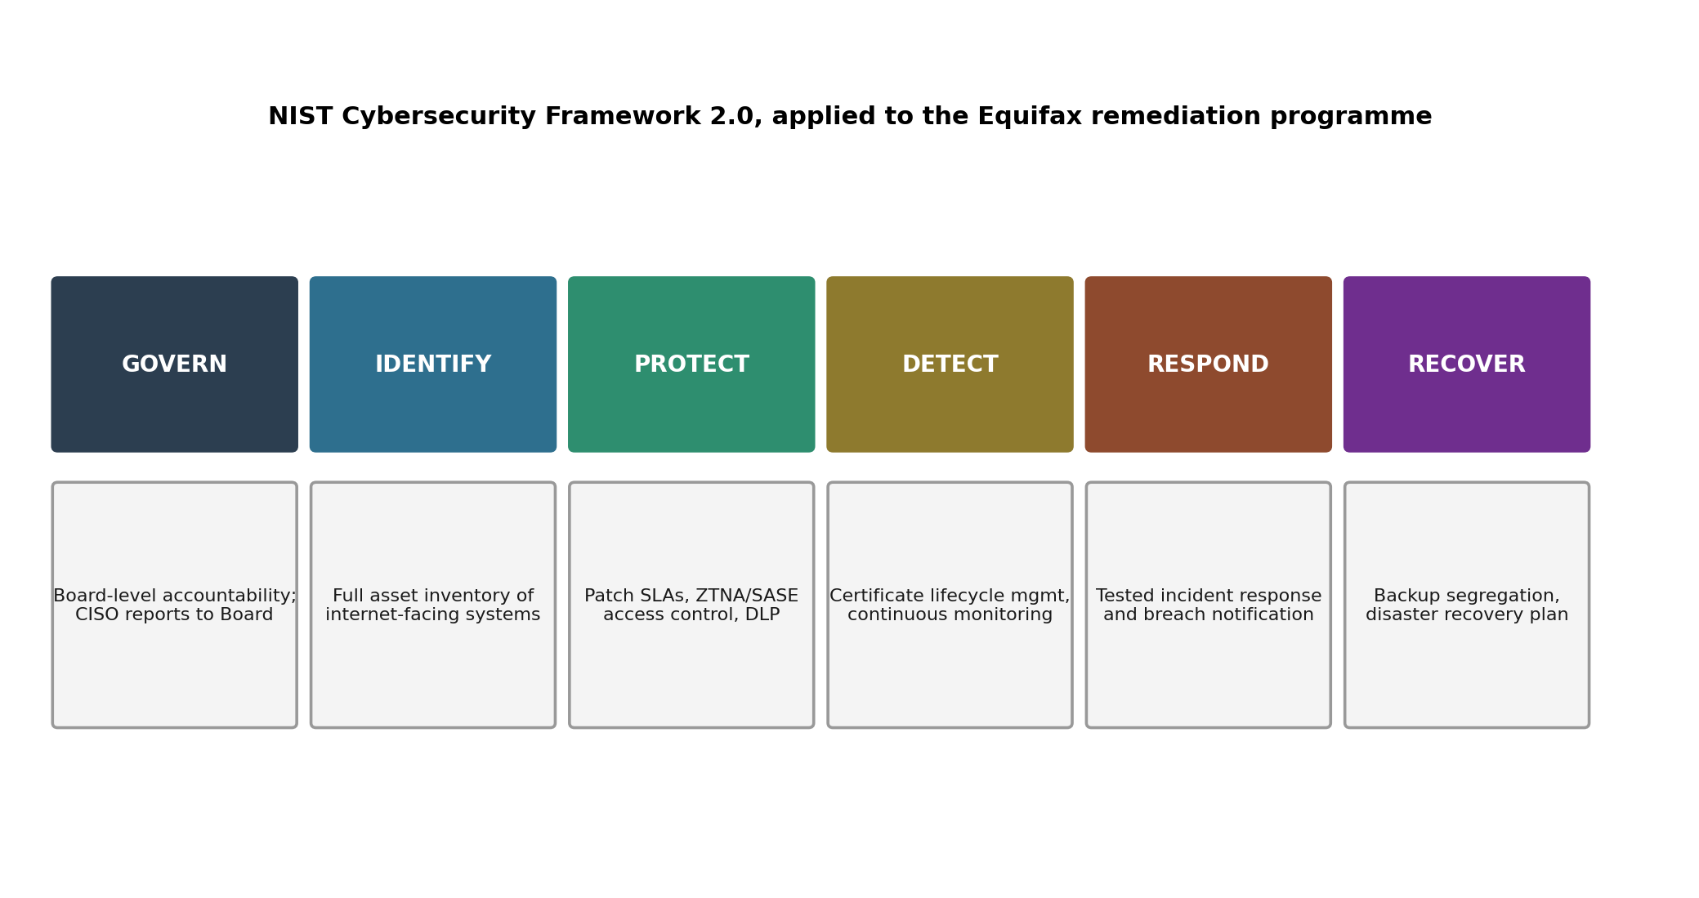
Figure 3: NIST CSF 2.0 functions mapped to the Equifax remediation programme.
Positioning Govern first is a deliberate structural choice, not a formality. It establishes that the Board Cyber Risk Committee and CISO reporting line described in section 2 exist before, and inform, the technical controls under Identify, Protect, Detect, Respond and Recover, rather than being added afterwards to give existing technical work a governance label. Business continuity and long-term resilience follow from that ordering: an organisation that treats security governance as prior to and continuous with strategy is positioned to catch a lapse such as the expired certificate through routine oversight, rather than relying on the breach itself to surface the gap. The financial and reputational stakes are not abstract. Equifax's post-breach settlement and remediation costs ran into the billions of dollars, a scale of loss that strategic alignment with a recognised framework is intended to make far less likely.
Strategic alignment also means the security programme is reviewed on the same cadence as other enterprise risk, rather than treated as a separate technical workstream that only surfaces at Board level when something goes wrong. Under CSF 2.0, the Govern function calls for the organisation's risk management strategy, roles and policy to be reviewed and communicated on a defined schedule, which is why the quarterly risk register review in Appendix A sits under the Board Cyber Risk Committee's direct accountability rather than being delegated entirely to operational staff. Formal certification of the resulting information security management system against ISO/IEC 27001:2022 would add independent, third-party assurance on top of the CSF 2.0 self-assessment, giving the Board external evidence that controls are operating as designed rather than relying solely on internal reporting [13]. Consumer trust, which Equifax's own disclosures show was damaged in a way that outlasted the immediate financial settlement, is rebuilt more by this kind of demonstrable, ongoing oversight than by a one-time remediation exercise.

2.5 Risk Management and Assessment
A high-level risk assessment for the environment described in the case identifies five dominant risk areas, summarised in Table 2 with an indicative likelihood and impact rating and the primary mitigation drawn from the programme above.
Risk | Likelihood | Impact | Primary mitigation
Unpatched internet-facing application (e.g. the dispute portal running Apache Struts) | High | Severe | 72-hour patch SLA for critical vulnerabilities; asset inventory tied to vulnerability scanning
Open-source/third-party component risk introduced through the software supply chain | High | Severe | Software composition analysis in the secure SDLC; documented exception process for unpatched dependencies
Flat network segmentation allowing lateral movement between the initial foothold and multiple sensitive databases | Medium | Severe | ZTNA-based per-application access control and microsegmentation (Task 1, section 3)
Expired or misconfigured TLS inspection certificates blinding monitoring to encrypted exfiltration | Medium | Severe | Certificate lifecycle management under the continuous monitoring policy
Plaintext or weakly protected credentials stored on internal systems, enabling escalation beyond the initial point of entry | Medium | Severe | Credential vaulting and encryption at rest; least-privilege database access enforced through ZTNA policy
Table 2: High-level risk register.
The fifth risk reflects a detail confirmed in the FTC's later settlement with Equifax: once inside the network, attackers located administrative credentials stored in plain text on an internal system and used them to query 51 separate databases over the following weeks [14]. That finding is what turns a single compromised web application into a breach of 147 million records, and it is a risk a patch alone does not touch; even a perfectly maintained patch cycle does not stop an attacker who is already inside from finding a credential left in a readable file. The pattern across all five risks is that each was individually foreseeable and each was addressed by an existing control that had failed operationally rather than one that did not exist: a patch existed but was not applied, a scan ran but produced a false negative, segmentation existed but was not granular enough to contain the intrusion, a monitoring tool existed but was blind due to an expired certificate, and a credential-storage standard existed but was not enforced consistently. Prioritisation therefore favours mitigations that reduce reliance on any single control functioning perfectly, which is the rationale for combining a hard patch SLA with independent asset-inventory reconciliation, network segmentation and credential vaulting, rather than relying on any one of these alone.

2.6 Compliance, Incident Response and Protection Controls
Regulatory alignment for a programme of this kind should follow the breach notification model established by the GDPR, which requires notification of a personal data breach to the relevant supervisory authority within 72 hours of the organisation becoming aware of it [7]. Equifax took over six weeks to publicly disclose the 2017 breach after its internal discovery; a policy committing to a fixed, short notification window, applied consistently regardless of jurisdiction, removes the discretion that produced that delay.
Incident response should be built around a documented plan with defined roles, escalation paths and playbooks for the scenarios most relevant to the risk register in Table 2, tested through tabletop exercises rather than left untested until a real incident forces the first run-through. A realistic testing cadence is at least two exercises a year, one covering an external web-application compromise similar to the actual 2017 event and one covering an insider or credential-misuse scenario, with findings from each exercise fed back into the policy metrics in Table 1 so that the plan improves rather than remains static. Disaster recovery planning should keep backups logically and administratively separate from production systems, so that a compromise of production credentials cannot also compromise the recovery path.
On the technical side, the programme combines the ZTNA and SASE controls from Task 1, which limit how far an intrusion can spread once it begins, with continuous vulnerability scanning that is reconciled against the asset inventory rather than run in isolation, endpoint detection and response tooling, encryption with actively managed certificate lifecycles, and strong authentication, including multi-factor authentication, for all administrative and internet-facing application accounts. The justification for this combination is measurable. IBM's 2024 data places the average breach dwell time at 258 days industry-wide [6], while Equifax's own attackers had roughly 76 days of undetected access, itself long enough to extract data on around 40% of the US adult population; controls that close the detection gap, in particular working certificate-based traffic inspection and an access model that limits lateral movement, address the two specific technical failures that turned an exploited web application into a breach of that scale. Reducing dwell time and constraining lateral reach are the two levers with the clearest link, in this case, between the technical control and the limitation of harm actually observed.

2.7 Conclusion
The five components of this programme, accountable governance, auditable policy, strategic alignment to a recognised framework, an evidence-based risk register and a compliance and control layer built on ZTNA, SASE and DLP, are designed to function as one system rather than as independent workstreams. The Equifax case shows why that matters: nearly every individual technical control that could have prevented or limited the breach already existed inside the organisation in some form, a patch, a scan, a segmentation boundary, a monitoring certificate, a credential-storage standard, and each failed for a governance or process reason rather than a technology gap. A programme that fixes only the technology while leaving accountability, patch discipline and independent audit unaddressed would be exposed to the same failure mode again. Regular independent audit against the metrics in Table 1, reporting through the line shown in Figure 2, is what keeps that from happening quietly, and is the single design choice in this report most directly aimed at preventing a second Equifax rather than only responding to the first.

References
[1] Gallup, "Hybrid Work in Retreat? Barely," Gallup Workplace, Washington, DC, USA, 2025. [Online]. Available: https://www.gallup.com/workplace/694361/hybrid-work-retreat-barely.aspx
[2] S. Rose, O. Borchert, S. Mitchell, and S. Connelly, "Zero Trust Architecture," National Institute of Standards and Technology, Gaithersburg, MD, USA, NIST Special Publication 800-207, Aug. 2020. [Online]. Available: https://doi.org/10.6028/NIST.SP.800-207
[3] Verizon, "2024 Data Breach Investigations Report," Verizon, Basking Ridge, NJ, USA, 2024.
[4] Gartner, "Secure Access Service Edge (SASE)," Gartner Information Technology Glossary. [Online]. Available: https://www.gartner.com/en/information-technology/glossary/secure-access-service-edge-sase
[5] R. Tahboub and Y. Saleh, "Data leakage/loss prevention systems (DLP)," in Proc. 2014 World Congress on Computer Applications and Information Systems (WCCAIS), Hammamet, Tunisia, 2014, doi: 10.1109/WCCAIS.2014.6916624.
[6] IBM Security, "Cost of a Data Breach Report 2024," IBM, Armonk, NY, USA, Jul. 2024.
[7] European Parliament and Council of the European Union, Regulation (EU) 2016/679 of 27 April 2016 on the protection of natural persons with regard to the processing of personal data (General Data Protection Regulation), Official Journal of the European Union, L 119, 4 May 2016.
[8] European Parliament and Council of the European Union, Regulation (EU) 2022/2554 of 14 December 2022 on digital operational resilience for the financial sector (Digital Operational Resilience Act), Official Journal of the European Union, L 333, 27 Dec. 2022.
[9] European Parliament and Council of the European Union, Directive (EU) 2022/2555 of 14 December 2022 on measures for a high common level of cybersecurity across the Union (NIS 2 Directive), Official Journal of the European Union, L 333, 27 Dec. 2022.
[10] U.S. Government Accountability Office, "Data Protection: Actions Taken by Equifax and Federal Agencies in Response to the 2017 Breach," Washington, DC, USA, Rep. GAO-18-559, Aug. 2018.
[11] U.S. House of Representatives, Committee on Oversight and Government Reform, "The Equifax Data Breach," Majority Staff Report, 115th Congress, Washington, DC, USA, Dec. 2018.
[12] National Institute of Standards and Technology, "The NIST Cybersecurity Framework (CSF) 2.0," NIST Cybersecurity White Paper (CSWP) 29, Gaithersburg, MD, USA, Feb. 2024. [Online]. Available: https://doi.org/10.6028/NIST.CSWP.29
[13] International Organization for Standardization, "Information security, cybersecurity and privacy protection, Information security management systems, Requirements," ISO/IEC 27001:2022, Geneva, Switzerland, 2022.
[14] Federal Trade Commission, "$575 million Equifax settlement illustrates security basics for your business," FTC Business Blog, Washington, DC, USA, Jul. 2019. [Online]. Available: https://www.ftc.gov/business-guidance/blog/2019/07/575-million-equifax-settlement-illustrates-security-basics-your-business

Appendix A: RACI Matrix for Core Security Activities
This appendix expands on the governance structure in Task 2, section 2, showing accountability for the activities most relevant to the risk register in Table 2. R = Responsible, A = Accountable, C = Consulted, I = Informed.

Activity | CISO | Vuln. & Patch Lead | Security Architecture Lead | Data Governance Officer | Board Cyber Risk Committee
Critical patch deployment | A | R | C | I | I
Network segmentation design | A | I | R | C | I
Data classification and retention | A | I | C | R | I
Certificate lifecycle management | A | R | C | I | I
Incident response plan testing | R | C | C | C | A
Quarterly risk register review | R | C | C | C | A
Table A1: RACI matrix for core security activities.

