Are Welsh Businesses leading the way in meeting the sustainble development goals ?

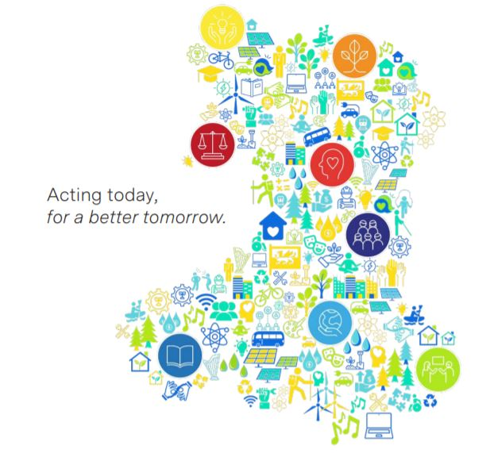

The challenge of Sustainability BMSP7001D
Natalie Emma Male 1702161
Dr Louise Emanuel
Are Welsh Businesses leading the way in meeting the sustainble development goals ?
Natalie Emma Male

It is a brave new world for those organisations who venture into sustainability. How do they start to implement the goals and contribute to a brighter future. Wales may just have the answer.

During the mass production era the sole purpose of business was to practice profit maximisation, resulting in many of the problems that have been highlighted in recent years, issues that are currently being debated at COP26 in Glasgow. Academics and theorists alike have issued stark warnings, and people are starting to ask why we didn’t listen? Even as far back as 1798, Thomas Malthus recognised the limitations of the earth to provide for man’s needs. The linear production model had become commonplace with production and consumption part of everyday life. We did not comprehend that our desire to boost the economy would have devastating consequences.
“The power of population is indefinitely greater than the power in the earth to produce subsistence for man”. (Malthus , 1798)

Sustainability was once considered a new age concept, images spring to mind of protesters chained to trees contesting the latest road construction.

These eco warriors were ridiculed but could now be considered pioneers of change, however it wasn’t enough to make the masses take notice. Then slowly came the realisation that the linear model had become unsustainable, wreaking havoc on the planet, its ecosystems, and inhabitants. Images across the internet and press brought us face to face with the devastating consequences of our actions. As a society we looked to make businesses accountable, suddenly organisations were thrust into the public spotlight. As consumers, were we not equally responsible for not questioning the provenance of the products we purchased. How do businesses adjust to the growing expectations of employee’s, consumers, and stakeholders. How do they begin to reshape their business model, whilst acting ethically and meeting the targets set out?
Far from the linear model dominating operations, now sustainability is starting to shape the economic climate and challenging existing practices. As we faced social economic and environmental challenges something had to change. Developed in 2012, the sustainable development goals were created to tackle some of the most pressing economic, political, and environmental challenges facing the

planet. In 2016 the 17 goals were adopted by 193 member countries”. (The sustainable development agenda , 2021). The SDGs have faced criticism for being somewhat aspirational with a lack of any legally binding agreement. They and are heavily reliant on collaboration and cooperation, encouraging business to solve problems through innovation and creativity. Assumed responsibility is a key theme rather than imposed rules, which is concerning as targets are set for 2030. The world has faced increasing political challenges such as Brexit, continuing catastrophic climate change and the Covid 19 pandemic which have all had an effect on business operations.
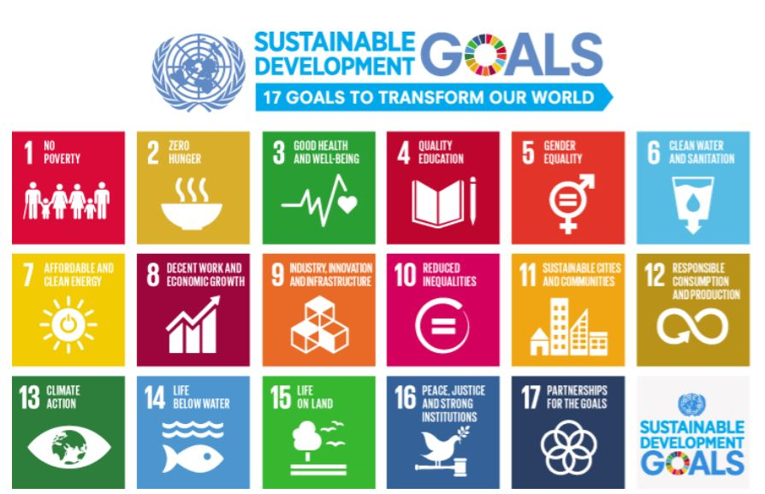
SD Goals (The sustainable development report , 2020)

The Covid 19 pandemic has affected the progress of some of the goals including poverty, hunger from food shortages and decline in global economic growth and manufacturing. (The sustainable development report , 2020). It is more crucial than ever for all sectors to work together to achieve the targets. The goals do set a framework for recovering from the pandemic. Though many organisations globally have successfully embedded sustainability. The SDGs could be considered a broad a framework, with a focus for businesses to develop
innovation and technology. Although, it has been estimated that implementation of the SDGs has the potential to generate new growth opportunities to the value of 12 trillion (Dowd, 2018). Dr David Griggs states that businesses play a pivotal role in advancing sustainability “How do you approach these 17 goals, 169 targets, which when you first look at them, blows your mind a bit? You look where your business is aligned to them. And that goes for whether you're a country, or a business, or a government”. (Griggs & Fryer , 2021) The message from Dr Griggs is keep it simple, start small and tackle something that is achievable. But not all organisations are practising what they preach. One organisation who came to light for appalling practices is Nestle. Social rights groups have exposed ethical violations as far back as 1973. The latest violation saw the company issued with a cease-and-desist order from California’s state water resources control board. Nestle’ have been accused of illegally pumping millions of gallons of water from San Bernardino National Forest. (Spiegelman , 2021). This is in stark contrast to the company’s website that states their SDG pledge “Our global efforts to improve our environmental performance involves stewarding water resources for future generations”. (Nestle', 2021) Nestle’ has continued to promote the goals with evidence to the contrary. Perhaps this is due to legality, the global goals are not enforceable, and many organisations operate in countries that do not have the same laws or legislation. This demonstrates a case of profit maximisation above ethics and an example of SDG-washing. The SDGs promotes human rights above the benefit or costs to businesses. With little sense of responsibility for community or place, it appears some large corporations are still practising the linear model and exploiting finite resources. Nestle’ is an example of a large organisation who has the finances to implement innovation to address their own sustainability issues. They are not alone, there is little empirical research that displays the level of work ongoing to meet the goals at an organisational level. A study of 1370 organisations from 97 countries displayed superficial engagement from their own sustainability reports (Heras‐Saizarbitoria, 2021) Perhaps if countries set out their own individual legislation such as Wales, examples of negative impacts may be reduced, with the positive focus moving to wellbeing.

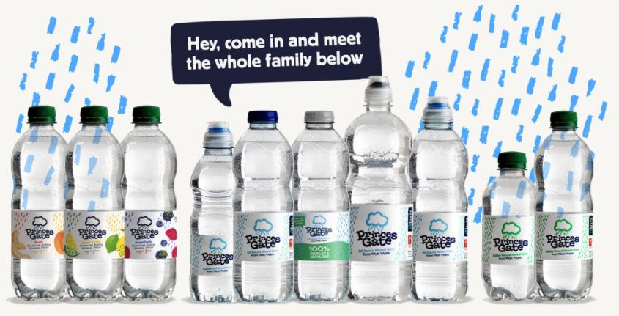
Princess Gate recycled bottles (Our Commitment, 2021)
Pembrokeshire based company Princess Gate may not be in the same league as Nestle’ when it comes to product volume, but when it comes to sustainability the organisation is leaps ahead. Everything at Princess gate is recycled and they have been accredited zero to landfill certified. The range of bottles are 100% recyclable and are made from 51% recycled plastic, they are the first business to start using recycled plastic from within the UK reducing their carbon footprint further. The factory is also powered solely by green energy. When a company has grown in the community there appears to be evidence of respect for place and people. The organisation states that “We’ll continue to take a holistic approach to reducing our environmental impact whilst investing in our friends in the hope that we can use Princess Gate to improve lives and strengthen community”. (Our Commitment, 2021) It appears that those businesses that have grown alongside their community seem to be motivated to embed sustainable practices. Research shows that embedding sustainability has likely been financially beneficial for Princess gate, supporting the hypothesis that doing good can benefit all parties. Recognizing opportunities for value creation is key, it is crucial that organisations understand their negative and positive impacts, identifying the value in their negative impacts can lead to increased profitability. (Olwig, 2021)
Businesses response to sustainability in Wales is mainly due the implementation of the pioneering Wellbeing and Future Generations act 2015.Supporting the SDGs the act outlines sustainable development in Wales incorporating environmental, social, economic, and cultural attributes, this is achieved through 7 goals and five ways of working. The goals have been determined with safeguarding the wellbeing of generations both present and future and is truly unique, The United Nations states that 'What Wales is doing today, the world will do tomorrow." (Howe, 2020-2021)

'What Wales is doing today, the world will do tomorrow." United Nations

The Wellbeing of Future Generations act is a more compact framework in comparison to the SDGs and Welsh businesses can feel less overwhelmed in its implementation. Indeed, the United Nations recognises the significance of the Wellbeing of future generations act and encourages other countries to implement this model. It is completely unique as the only type of its legislation currently in the world. (Promoting Wales to the World, 2021).The Future Generations act is effective due to this reason opposed to moral duty which can be exploited and avoided. Expectation is set out in law, with a clear framework and legal duty on public bodies, rather than political or moral duty. (Well-Being , 2016).

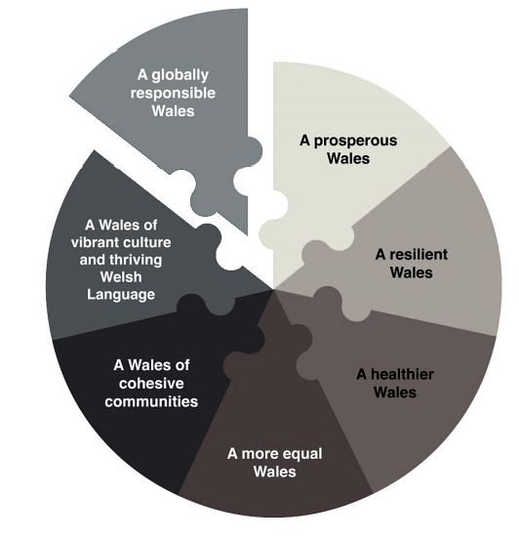
(Ellis , 2019) The WFGA framework
With so much to consider and a wealth of information many businesses feel confused and unsure where current operations fit within the framework. The SDGs represent a political agreement,

and many businesses may have never collaborated with policy makers and the UN, with long term goals this unfamiliar process can be overwhelming for short term focused businesses. (Pedersen, 2018) Can ambitious change become a reality and how can they embed effective sustainability practices? Some SMEs do not have the ability to make dramatic change or have the technology or innovation. Actions however small can contribute collaboratively to the overall goals. Business can start with carrying out a review and determining current sustainability practices. Followed by identifying targets to meet and developing a roadmap to achieve and measure success. There are a number of positive motivations and benefits in identifying opportunities in the value chain. With profit maximisation the main focus of business, saving money will be an appealing factor. Recycling, reducing energy consumption and water conservation can have an impact on profitability. The government has estimated that implementing energy efficiency can save UK businesses approximately £6 billion per year, without the expensive outlay for new equipment. (Banc, 2021) Completive advantage can be gained by acting more ethically, consumers are expecting more from their brands and are becoming more ethically aware. Embedding sustainable practices within an organisation can grow brand reputation and increase stakeholder confidence. Other areas that can be effective, for example introduction of a paperless office. Although it may not be possible to eradicate paper completely, using less paper is good for the environment and the bottom line. One of the most important aspects is that both the SDGs and future generations Act recognise the importance of collaboration. Organisations needs to establish meaningful change and contribute significantly to the goals, working towards a multi stakeholder approach. Working together assists in achieving a common goal sharing rules, structures, risks, resources, and responsibilities. However, collaborations are only effective when businesses raise expectations, make change happen and challenge each other. (Enright & Ogler , 2018) Business Wales recognises collaboration as an opportunity to increase business growth, developments in technology are providing further opportunities. Taping into a wealth of resources and co-creating products can add value for the customer. (Collaboration, 2021). Adidas though a global organisation was not renowned for its sustainable practices, they teamed up with rival competitor New Zealand company Allbirds to create a sustainable shoe. Sharing their knowledge and expertise from supply chain to materials, they have created a running shoe that has a footprint of 2.94kg which is 63% less emissions than traditional production processes

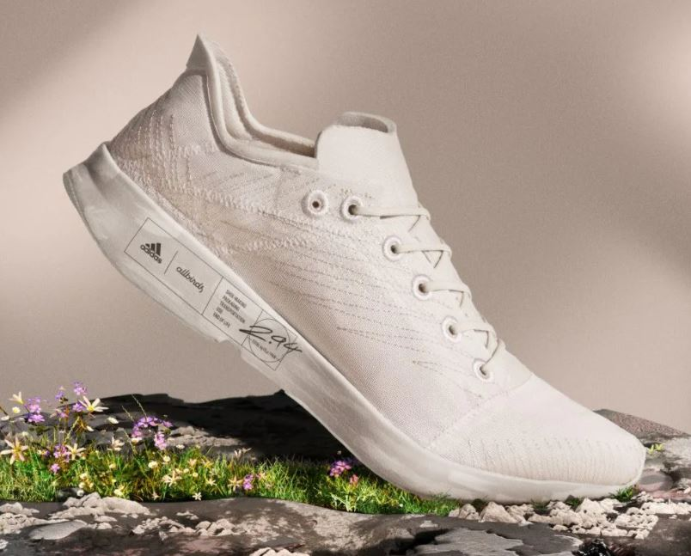
Sustainable footwear (Davey, 2021)
A spokesperson for adidas states “For fashion to become truly sustainable it requires cross-industry collaboration; to find new ways to sell and/or share products and ways to reuse and recycle them”. (Davey, 2021). This is an example of shared resources addressing environmental issues and accomplishing shared goals. Companies wishing to strategically achieve social, economic, and environmental sustainability targets can be achieved by supply chain collaboration. Where two independent parties work together to fulfil mutual benefits and common goals. (Zhao et al, 2017)
Global organisations undoubtedly have a role to play in increasing sustainability practices and decreasing negative outputs. From small SMEs to global corporations the combined impact in meeting the SDGs can be profound. Transparency and honestly in reporting can only assist in measuring the fundamental change. Businesses can benefit from developing a sustainable policy no effort is too small, from implementing a paperless office to changing to energy efficient light bulbs. Larger organisations are able to implement new technologies and innovation to achieve their goals. In order to reach a shared goal businesses must collaborate to achieve a common purpose. The world is depending on a combined effort that transcends business as usual. In the words of Sir David Attenborough at Cop26 “We are, after all, the greatest problem solvers to have ever existed on Earth. If working apart, we are a force powerful enough to destabilize our planet. Surely working together, we are powerful enough to save it” (Indian Express , 2021)
References

Banc. (2021). Why and how to make your business more environmentally sustainable. Retrieved November 4th, 2021, from Development Bank Wales: https://developmentbank.wales/news-and-events/why-and-how-make-your-business-more-environmentally-sustainable
Collaboration. (2021, November 11th ). Retrieved from Business Wales: https://businesswales.gov.wales/collaboration
Davey, H. (2021, June). Adidas and Allbirds: “Fashion brands need to collaborate to accelerate the crucial race to combat climate change”. Retrieved from Stylist: https://www.stylist.co.uk/fashion/sustainable-shopper-allbirds-adidas-trainers/520750
Dowd, L. (2018, May 16th). Risk of 'SDG wash' as 56% of companies fail to measure contribution to SDGs. Retrieved November 10th, 2021, from Reuters Events: https://www.reutersevents.com/sustainability/risk-sdg-wash-56-companies-fail-measure-contribution-sdgs
Ellis , J. (2019, February ). International Impact Report; Wales to the World. cardiff: Future Generations Act. Retrieved November 4th, 2021, from https://www.futuregenerations.wales/wp-content/uploads/2019/07/Wales-to-the-World.pdf
Enright , S., & Ogler , C. (2018). Private-Sector Collaboration for Sustainable Development. BSR. Retrieved November 11th, 2021, from https://www.bsr.org/reports/BSR_Rockefeller_Private-Sector_Collaboration_for_Sustainable_Development.pdf
Griggs , D., & Fryer , M. (2021, September 15th). How to Tackle the Sustainable Development Goals. Retrieved November 1st, 2021, from Network for Business Sustainability: https://www.nbs.net/articles/how-to-tackle-the-sustainable-development-goals
Heras‐Saizarbitoria, I. U. (2021, August 23rd ). Organizations' engagement with sustainable development goals: From cherry‐picking to SDG‐washing?. Corporate Social Responsibility and Environmental Management. doi:https://doi.org/10.1002/csr.2202
Howe, S. (2020-2021). Future Generations Commissioner for Wales Annual Report. Cardiff: Office of the Future Generations Commissioner for Wales. Retrieved November 12th, 2021
Indian Express . (2021, Novemeber 2nd). ‘Either we stop it, or it stops us’: Top quotes from COP26 climate change summit. Retrieved November 11th, 2021, from The Indian Express: https://indianexpress.com/article/world/climate-change/cop26-climate-change-summit-top-quotes-7602912/
Malthus , T. (1798). An Essay on the Principle of the Population. London. Retrieved from http://www.esp.org/books/malthus/population/malthus.pdf
Nestle'. (2021). Contributing to the global goals. Retrieved November 4th, 2021, from Nestle.com: https://www.nestle.com/csv/what-is-csv/contribution-global-goals
Olwig, M. F. (2021, June ). Sustainability superheroes? For-profit narratives of ‘‘doing good” in the era of the SDGs. (Elsevier, Ed.) World Development, 42, 105-427. doi:https://doi.org/10.1016/j.worlddev.2021.105427
Pedersen, C. S. (2018). The UN Sustainable Development Goals are a great gift to businesses. (Elsevier, Ed.) Procedia CIRP, 69, 21-24. Retrieved November 8th, 2021, from https://www.sciencedirect.com/science/article/pii/S2212827118300040
Promoting Wales to the World. (2021). Retrieved November 4th, 2021, from Future Generations Commissioner for Wales: https://www.futuregenerations.wales/making-it-happen/international/
Spiegelman , I. (2021, April 26th). California Authorities Say Nestlé Is Illegally Gulping Up Public Water. Retrieved November 3rd, 2021, from Los Angeles Magazine: https://www.lamag.com/citythinkblog/nestle-water-california-legal-dispute/#:~:text=On%20Friday%2C%20California%27s%20State%20Water,water%20under%20its%20Arrowhead%20brand.
The sustainable development agenda . (2021, November 1st). Retrieved from The United Nations : https://www.un.org/sustainabledevelopment/development-agenda-retired/#:~:text=On%201%20January%202016%2C%20the,Summit%20%E2%80%94%20officially%20came%20into%20force.
(2020). The sustainable development report . United Nations. Retrieved November 10th, 2021, from https://unstats.un.org/sdgs/report/2020/The-Sustainable-Development-Goals-Report-2020.pdf
Well-Being . (2016). Peer reviewd book of proceedings (pp. 1-253). Birmingham: BIRMINGHAM CITY UNIVERSITY.
Zhao et al, X. (2017). Supply chain collaboration for sustainability: A literature review and futureresearch agenda. International Journal of Production Ecconomics, 194. Retrieved November 11th, 2021, from https://reader.elsevier.com/reader/sd/pii/S0925527317301251?token=C30F2CD029AD64CF619A6B3DCBB16F798EBC6507E1235927CA45ABD217F39B201B799BD550BD1451989F52C0C22A8957&originRegion=eu-west-1&originCreation=20211111172656

