Mihaita Viorel Petrache

Student Number 2215055
E-portfolio

1.a) To improve our life we need lo learn every day something new, to become a student had to pass the exam to be accepted at university. I did find myself having some problems with my time management[1], with my capacity of listening or my attention on classes.
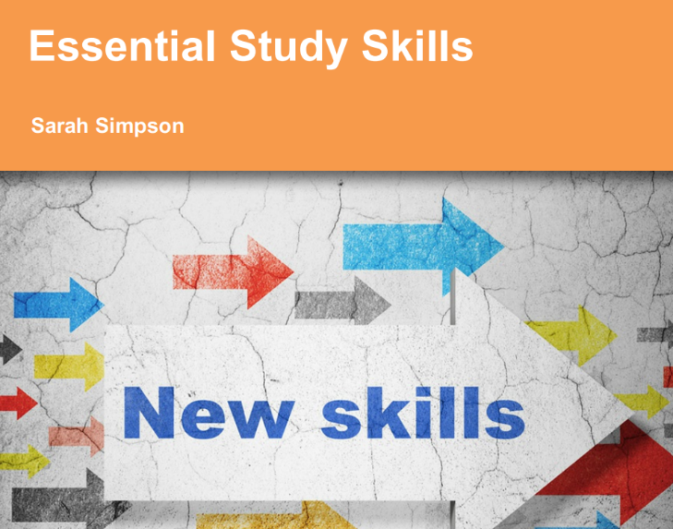[2]
The most difficult for me was to manage my time, so I start to learn about time management and how it can improve my future career which is to be a web developer. When we manage our time in the right way, we become more positive, stressless, productive and improve our communication skills. Some researchers discover that time management is very important, and it may affect individual's overall performance and achievements.[3]

Being able to accumulate knowledge about study skills we cand develop employment skills which are very important to sustain a future career. Being organized and methodical. Able to plan work to meet deadlines and targets. Monitoring progress of work to ensure you are on track to meeting a deadline. Communication is the simple act which transfer information’s from one place to other places. I can be written, vocally , visually or non-verbally[4]. To be able co communicate effectively with your colleagues, superiors no matter which industry you work on. From my experience this are very important skills but are also very often overlooked. If you master them , you can improve you professional and personal life effectively and impressively.[5]
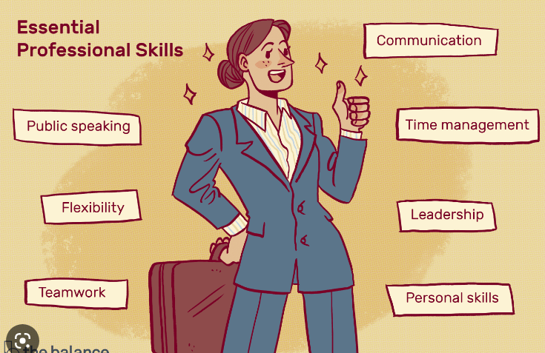

b) By using Turnitin link from module page I get my similarity score which is 30 % which is not a passable score. To improve my score, I have to focus on the researchers that I have done, to be more credible and to be more focus on the topic. Very important is the knowledge of your topic, without it you can mislead other people. Another point where I will have to work is references, to be more devoted to find articles with positive review.

2.
a)https://sway.office.com/Y46q4iSfynH44qzl?ref=Link
b) For creating my online video I used the online video player vimeo. [6]
https://vimeo.com/773077686/947539fa0f

3. In task 3 I will discuss about automatic referencing tools. The one I chose is Mendeley [7]reference tool. I find Mendeley a verry helpful tool to help anyone who want to give references like a professional and is free.
The first to have access on Mendeley, you must navigate on the official site.[8]Go on the right top corner to find the download button. After that you have to select the correct option for your operating system.
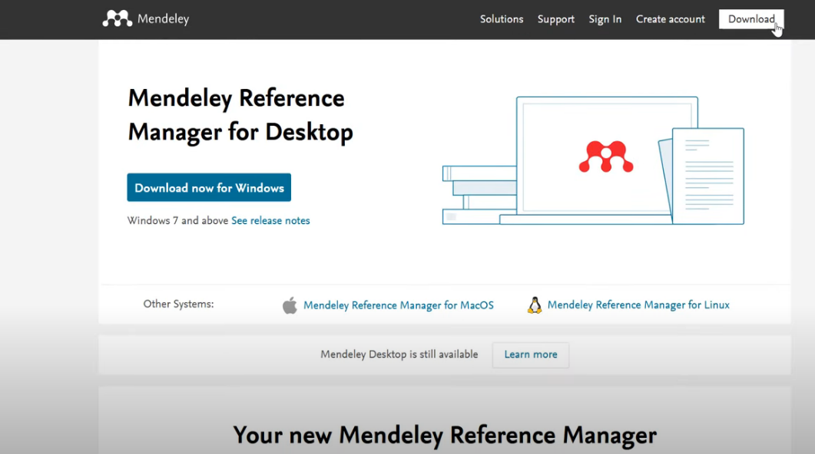
The next step is to install the app by clicking Install button.
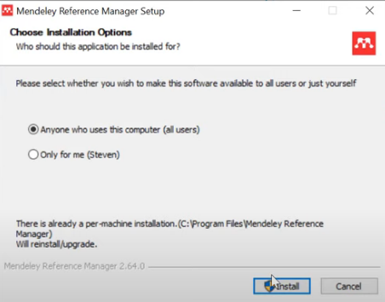

To use the Mendeley reference manager you have to create an account on Elsevier[9]. To do the go back on the Mendeley references managers site and click create account, insert your email address , your name and family name and chose a password and then click register button. After that you will have a Elsevier account which will help you to use Mendeley References Manager.
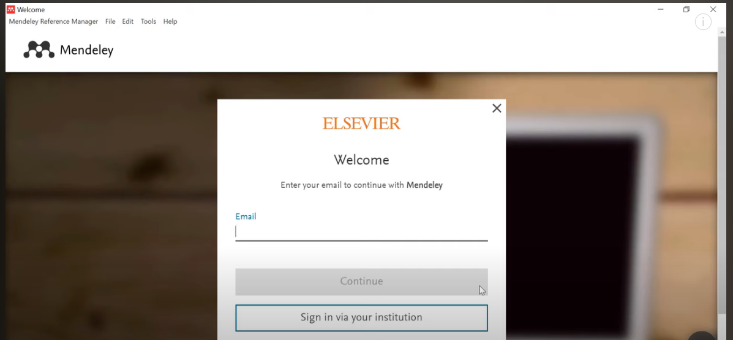
You can also download the Mendeley Web importer which will work on all major internet browsers and it will help you to save your references very easy.
If you want to use the Mendeley on Microsoft word you have to go back on Mendeley site and download the Mendeley Cite. This it will help you to insert the references in a very easy way and you cand chose our desirable referencing style. Here you cand find a video to help you to install and use the Mendeley References Manager.[10]

4.Life Is a Team Sport!
https://express.adobe.com/post/YzuYTVQo46lDU/
I create the poster with Adobe Express program.[11]
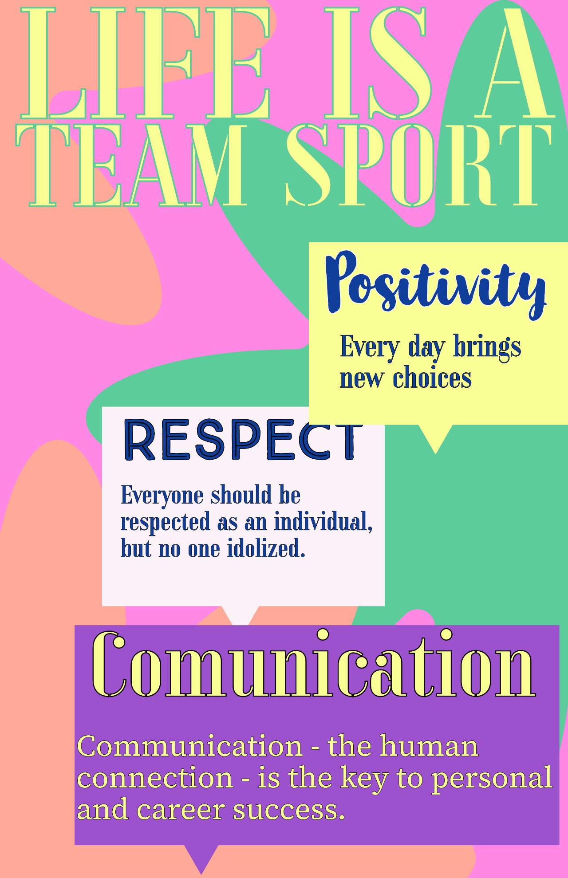[12][13][14]

References:
[1] ‘TIME MANAGEMENT AND ACADEMIC ACHIEVEMENT OF HIGHER SECONDARY STUDENTS’, Accessed: Nov. 20, 2022. [Online]. Available: http://en.wikipedia.org/wiki/
[2] S. Simpson, ‘Essential Study Skills Essential Study Skills 4 Contents’, 2015, Accessed: Nov. 20, 2022. [Online]. Available: www.sylvania.com
[3] G. Goremykina et al., ‘The Impact of Time Management on Students’ Academic Achievement Project portfolio management system, concepts and approach foundations Grid management and air quality of Xi’an city The Impact of Time Management on Students’ Academic Achievement’, IOP Conf. Series: Journal of Physics: Conf. Series, vol. 995, p. 12042, 2018, doi: 10.1088/1742-6596/995/1/012042.
[4] ‘What is Communication? Verbal, Non-Verbal & Written | SkillsYouNeed’. https://www.skillsyouneed.com/ips/what-is-communication.html (accessed Nov. 20, 2022).
[5] ‘Communication - Importance of Good Communication Skills’. https://corporatefinanceinstitute.com/resources/management/communication/ (accessed Nov. 20, 2022).
[6] ‘Videos on Vimeo’. https://vimeo.com/ (accessed Nov. 20, 2022).
[7] ‘What is Mendeley Reference Manager? - Mendeley Support Center’. https://service.elsevier.com/app/answers/detail/a_id/30107/supporthub/mendeley/p/16075/ (accessed Nov. 20, 2022).
[8] ‘Mendeley Reference Manager | Mendeley’. https://www.mendeley.com/reference-management/reference-manager/ (accessed Nov. 20, 2022).
[9] ‘Elsevier | An Information Analytics Company | Empowering Knowledge’. https://www.elsevier.com/en-gb (accessed Nov. 20, 2022).
[10] ‘How To Use Mendeley Reference Manager (Complete Beginner’s Guide) - YouTube’. https://www.youtube.com/watch?v=OzFHGFnAM2Q (accessed Nov. 20, 2022).
[11] ‘Adobe Express’. https://express.adobe.com/sp/ (accessed Nov. 20, 2022).
[12] ‘Paul J. Meyer - Communication - the human connection - is...’ https://www.brainyquote.com/quotes/paul_j_meyer_190945?src=t_communication (accessed Nov. 20, 2022).
[13] ‘Albert Einstein - Everyone should be respected as an...’ https://www.brainyquote.com/quotes/albert_einstein_163169?src=t_respect (accessed Nov. 20, 2022).
[14] ‘Martha Beck - Every day brings new choices.’ https://www.brainyquote.com/quotes/martha_beck_282605?src=t_positive (accessed Nov. 20, 2022).

