Kelvin Kpenosen 1908380 UWTSD

BMSW4001 Academic and Employability skills Task2 (Term 2) Structured academic report

Rita Ukachi-Lois

Table of Contents
INTRODUCTION 3
REFLECTION 4
WHAT I KNOW BEFORE 6
WHAT I HAVE LEARNT 7
WHAT NEEDS IMPROVEMENT? 7
SUMMARY ON IMPROVING THE SKILLS- 8
CONCLUSION 10
REFERENCES 10

INTRODUCTION
This report reflects the lesson and topic discussed during class and my skills developed during the lesson. During our lesson and class exercise, I have learnt Team building skills, paraphrasing skills, communication skills, research skills, reading skills and time management skills. This report will analyse the usefulness of the skills in term 2 that have been learnt during the module from term 1. Kolb's learning cycle will be used to reflect the skills. This will further reflect the learning that I have undertaken outside the classroom. This report will also throw light on my learnings that I have already and what was learnt during class and outside of the classroom. I have also summarised the skills that I need to improve on. At last, a summary will also be covered that will include the ways to improve the skills.

REFLECTION
Morgan (2017) stated that it is very important to reflect own learning you had during an event or process. This is the section where I will reflect my own experience and learning during the class exercise. Various skills are important for the academic and professional journey. During my class exercise of Paraphrasing, I have developed the paraphrasing skill, as before that I only have theoretical knowledge of doing paraphrasing. Apart from paraphrasing skill, I have also learnt about summarising skill. I got to know that I am good at Summarising skills. I am also good at working as a team. Outside my classroom I have worked in various activities where I have worked in a team and I have effectively led the team so that my team objective can be met. Apart from this, I have also worked in a team during my classroom project where I have also dealt with my team members in an effective manner (Sewell, 2017).
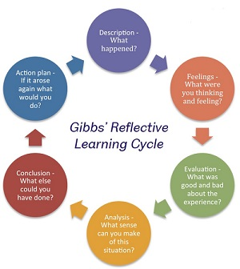

Figure: Gibbs reflective cycle
Source: Cherry, 2019
Kolb's learning cycle would be used to gain a deep understanding of the skills learnt and what I have experienced during my academic journey. Kolb's learning cycle reflects four different stages (McLeod, 2013). The first stage of the Kolb's reflection cycle is reflection of own experience and learning. The second stage reflects the analysing, judging and reviewing the class exercise. The third stage is the main stage where the reflection is made on the learning made during the exercise and conclusion from the exercise. The last stage is active experimentation that involves further planning and to try out the new things that I have learnt. At the time of class activities, I have excelled my skills and learning new skills also like summarising skills, research skills, paraphrasing skills. During the beginning of term 1, I was not confident that I am good at summarising, time management, reading skills (Cherry, 2019). I was not sure about how to summarize the paragraph and use paraphrasing skills. At the time of class activities, my performance was average, I was not able to give excellent performance. Some improvement areas for must be considered by me and I needed to work to improve the skills. I was quite confident that am good at summarising skills. All the mentioned skills would help me in term 2. These skills are very important to my study in achieving good grades. Team building skills would help me to do projects and work in a group. Time management skills would help me to do my work on time and to manage all my assignment and project according to the deadlines. I can also paraphrase very well but I need to work only on the length of my text as discussed from feedback with my lecturer during term 1. Apart from this, I have also learnt in term 2 about the cover letter and CV writing skills. Before term 2, I was aware of the skills. I learnt and refreshed on these skills during the session provided in the class (Cherry, 2019). I need to work on improving my reading skills, time management skills, research skills, cover letter, CV etc.

WHAT I KNOW BEFORE
Academic skills are important constituent for a successful study and for future employability. I know the different skills earlier that I have used in my academic career and it can also be useful in my future employability. Some of the skills that I know earlier are summarising skills, paraphrasing skills, time management skills, reading, presentation skills etc (Williams et al., 2012).
Team working:
Having the attribute to work well as a team player and having the ability to work within a team. Being good at doing works in a team, the ability to complete work in a team and to coordinate with all team members properly so that the team goal can be achieved (Pretorius & Ford, 2016).
Time management:
I also knew that time management skills are very important for academic and employability journey. I already knew that time management is an essential skill and ability that makes the work or task easier. I always try to manage my time with the help of my to-do lists (Smith & Roberts, 2015).
Paraphrasing:
I have also acknowledged the value and worth of paraphrasing and the manner it can contribute to the good and skilled writing. I also knew that working to a deadline is also very important and it can contribute to the academic and employability journey both. I knew how to paraphrase a but I needed to improve paraphrasing without any language errors (Blaxell & Moore, 2012).
Summarising skills:
I also knew that summarising skills is also important in academic skills as it enables to summarise the whole research and paper in a single paragraph. I am good at summarising skills as in the class activities, I got a comment that I am good at summarising a paragraph.

WHAT I HAVE LEARNT
I have learnt many skills during my academic and professional journey. It has helped me to gain an understanding of the basic academic skills that are essential for the success of the academic journey. And during my academics and outside I have learnt various skills that would be useful in my professional and academic path.
Paraphrasing skills:
At some extent, I got to know that the paraphrasing skills are the essential part of the academic journey. I have learnt how to paraphrase a paragraph in a given word limit but I need to work on my language errors according to Lecturers feedback from term1 in class exercise (Smith & Roberts, 2015).
Summarising skills:
I have also learnt summarising paragraphs and cover the word limit But I need to reduce the number of language errors within a paragraph. During my class activities.
Team working:
I have learnt to work in a team and how to cooperate with all team members for the achievement of a particular goal. I have also learnt to work according to meet deadlines.
Research skills:
Apart from this, I have also learnt about the research skills as it helps me to find out the proper answer to my questions. I have learnt research skills during my classes and preparing for the assignments. Example, I have improved my research skills during my term first assignment where I have researched the kinds of literature on the essential academic and employability skills. I have also learnt the reading skills and it has helped me to understand the ideas and texts (Husebø et al, 2015).

WHAT NEEDS IMPROVEMENT?
I got to know that various skills need improvements. With the help of in-class activities, I also got to know that I need to improve on some of the skills that are important for my academic path.

Paraphrasing:
I need to improve paraphrasing skills by working on my language errors and the content of my paraphrase text, which will contribute to skilled writing and improve through grasping, additional research and to understand the method needed for paraphrasing.
Reading skills:
I also need to improve my reading skills as it is needed within academic skills and it is the most important skills for a student. Reading well takes patience, time and practice. It is the ability that helps in understanding the written text and it. I do not enjoy reading at all and I need to improve my reading skills (Husebø et al, 2015).
Time management skills:
I need to improve my time management skills also. I am not able to work with deadlines and there is a need to strengthen and improve time management skills. To work with the deadlines is very important for the academic and professional path (Blaxell & Moore, 2012).
CV and cover letter:
I need to learn to prepare a CV and cover letter. I need to work on the cover letter and CV and this will help me to showcase my academic and professional achievements and to showcase my skills. It is well organised and very easy to understand.

SUMMARY ON IMPROVING THE SKILLS-
Paraphrasing can be improved by regular practice of doing paraphrasing. I must follow some steps to paraphrase a text and for this I must carefully read the text and highlight note or underline the important phrases and terms that must be remembered. Furthermore, I must work on phrases and words to use in the place of the sentence. Thus, this skill can be improved only with the help of regular practice (Paraphrase Example, 2016).
Reading skills must be improved with the help of practising the reading daily. It can be improved with the resources and opportunities available. It can also be improved with the help of different learning styles. So that learning reading skills can be enjoyable. I can improve my reading skills with the help of different techniques. I can use four different reading techniques like skimming. Skimming refers to the process of gist reading as it helps in knowing exactly about the text as its most basic level. This strategy will help in recalling the reading (Jackson, 2015).
Time management skills: I must work on improving the time management skills that will help me to work to meet deadlines. I need to work according to the given period. I must prioritise my work according to emergency and urgency. I must also prepare a to-do list so that I can note down my tasks as per the priority and urgency (Abas & Imam, 2016).
CV can be improved with doing some research and to get tips to prepare a CV. I need to prepare a CV for practice and must take feedback from the teacher. I must choose the right format for my CV. I must mention qualifications and experience that are relevant to the job that I apply for. Leadership experience must also be reflected in the CV. I must also reflect other key skills and important projects (Jobs.ie, 2020).

CONCLUSION
Hereby it can be concluded from the aforementioned report that this assignment has provided the insights into following the essential guideline of in class study, reading, writing and understanding a structured academic report, which was not followed by myself in term 1. It also showed what is academic and employability skills. This assignment has reflected the topic and lesson discussed during the class. And the skills learnt during the class has also been covered. The skills that needs improvement have also been covered. At last, a summary has also been provided on the skills that must be improved.

REFERENCES

Abas, M. C., & Imam, O. A. (2016). Graduates' Competence on Employability Skills and Job Performance. International Journal of Evaluation and Research in Education, 5(2), 119-125.
Blaxell, R., & Moore, C. (2012). Connecting academic and employability skills and attributes.
Cherry, K. (2019). Kolb's Theory of Learning Styles. Available at: https://www.verywellmind.com/kolbs-learning-styles-2795155 (Accessed: April 2020)
Husebø, S. E., O'Regan, S., & Nestel, D. (2015). Reflective practice and its role in simulation. Clinical Simulation in Nursing, 11(8), 368-375.
Jackson, D. (2015). Employability skill development in work-integrated learning: Barriers and best practice. Studies in Higher Education, 40(2), 350-367.
Jobs.ie, (2020). STUDENT CV TEMPLATE. Available at: https://www.jobs.ie/job-talk/student-cv-template/ (Accessed: April 2020)

McLeod, S. A. (2013). Kolb - Learning Styles. Available at: www.simplypsychology.org/learning-kolb.html (Accessed April 2020)
Morgan, P. (2017) The Business Students’ Guide to Study and Employability. London: Sage.
Paraphrase Example, (2016). Improve Your Paraphrasing Skills https://medium.com/@ParaExample/improve-your-paraphrasing-skills-fdc75bb52281 (Accessed: April 2020)
Pretorius, L., & Ford, A. (2016). Reflection for Learning: Teaching Reflective Practice at the Beginning of University Study. International Journal of Teaching and Learning in Higher Education, 28(2), 241-253.
Sewell, C. (2017) Reflective Practice Workshop. Available at: https://www.repository.cam.ac.uk/bitstream/handle/1810/265159/MEM_ReflectivePracticeHandout_V4_20170616.pdf?sequence=1 (Accessed: April 2020)
Smith, J., & Roberts, R. (2015). Reflective practice. Vital Signs for Nurses: An Introduction to Clinical Observations, 222-230.
Williams, K., Woolliams, M., & Spiro, J. (2012). Reflective writing. Macmillan International Higher Education.

Appendix 1: paraphrasing

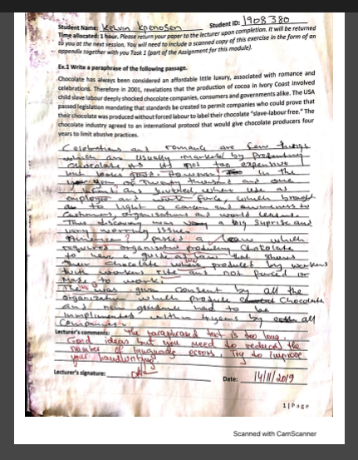

Appendix 2: Summarising

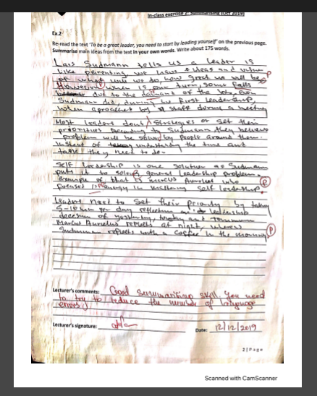

Appendix 3
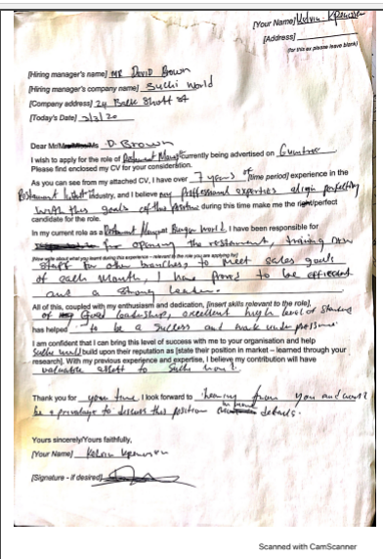

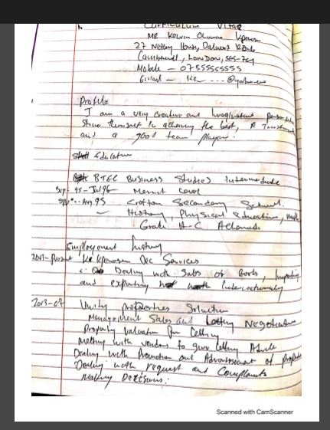
Appendix 4: CV

