

LOCATION: Swansea | LLEOLIAD: abertawe
LEVEL 6 | LEFEL 6
EXAMINATION PERIOD | CYFNOD ARHOLIADAU
May 2018 | MAI 2018

MODULE CODE: M6X1113
Wide Area Networks
TIME: 2 HOURS

answer THREE quESTIONs out of FoUR

Equipment or materials required – None
Adnoddau neu ddefnyddiau sydd eu hangen - Dim

ANSWER THREE QUESTIONS

Q1.

- With reference to Access Control List (ACL):
  - Name and describe the two types of Cisco IPv4 ACL
(5 marks)
  - Although IPV4 and IPV6 ACLs are very similar, there are three significant differenced between them, explain these differences.
(6 marks)
  - Refer to figure 1 configure IPV6 ACL R1:
    - Name the access list
    - Denies all IPV6 packets from 2001:DB8:CAFE:30::/64 destined for any IPV6 network
    - Allow all other IPV6 packets
(5 marks)
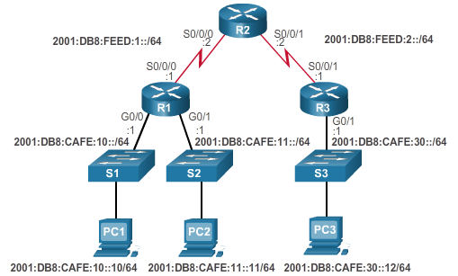
Figure 1: Configuring IPV6 ACLs

  - Match the numbered ACL operation statements in figure 2 below from the provided ACL operation list. Not all answers will be used. The first statement requires two words or phrases to complete it.
(9 marks)
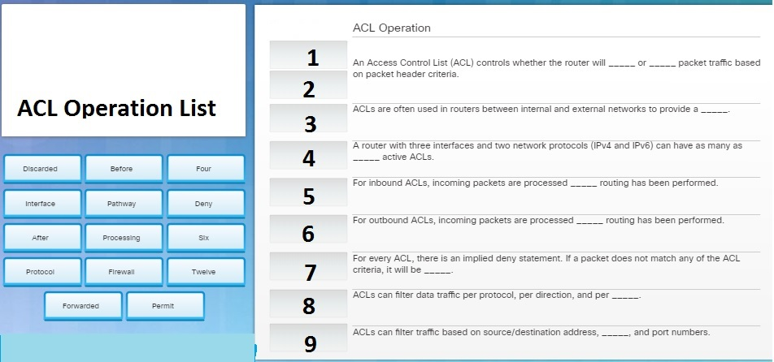
Figure 2: ACL Operation

Q2.

- Point to Point Protocol (PPP) frame consists of six fields. Name and describe them.
(12 marks)

- PPP defines two protocols for authentication. Name and explain them
(6 marks)

- In figure 3 below, determine whether each characteristic describes Link Control Protocol (LCP) or Network Control Protocol (NCP).
(7 marks)
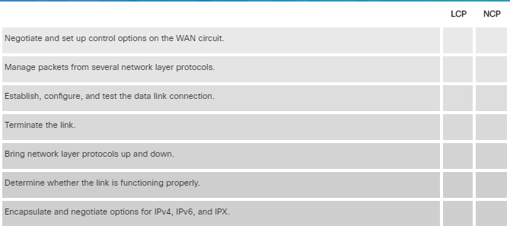
Figure 3: LCP and NCP characteristics

Q3.

- Figure 4 below represent an International Oil Company. The central office is the main site which is connected to the Internet. The refinery, regional and branch offices are all connected to the central office via the Internet. However, there is a direct high-speed link between the regional and central office. Staff in Central and branch offices are allowed remote access and work from home.

    - Choose appropriate WAN technologies for the design and support of this setup to provide fast, reliable and secured connection. The choices of WAN technologies are not limited.
(15 marks)
ii. Upon the completion of the design, evaluate your system, e.g. why you have chosen such a structure, benefits and limitations, etc.
(10 marks)
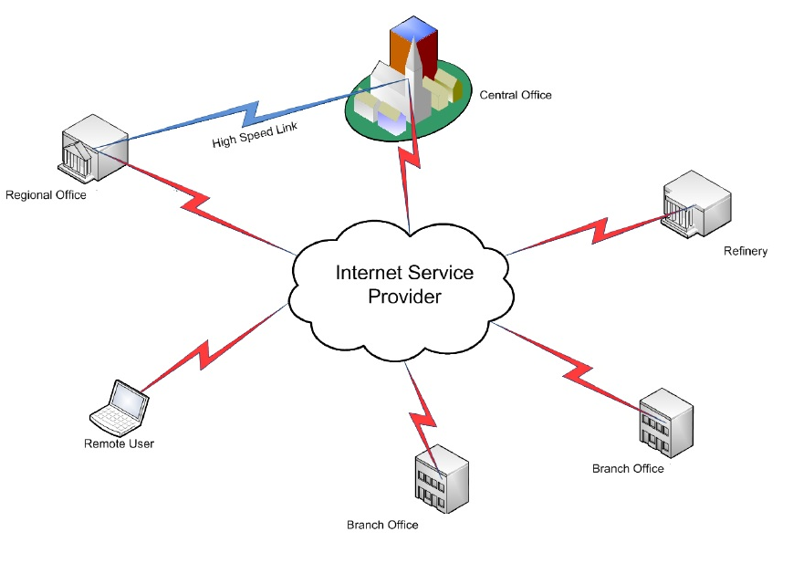
Figure 4: International Oil Company

Q4.

- Technology is constantly changing and network evolving. Discuss the following trends in today’s networks.
  - Internet of things (IoT) (6 marks)
  - Cloud Computing (6 marks)
  - Virtualisation (6 marks)
  - Software Defining Networking (SDN) (7 marks)

Diwedd/End

