Josef Welch
1800724
Product design
Word count: 1645

Death of the Author

In today's postmodernist filled society, one of our greatest dilemmas is that there is never absolute truth. Society is always second guessing itself. In essence the truth is unacceptable and everything is interpretation; no interpretation is final. Although scientists may argue that in fact truths can be definitive through science; beliefs, objects and emotions fashioned by human psychology are not as reliable as atoms and can change how they behave for no apparent reason. This creates the idea that there is no absolute truth outside our own unique perspective.

French philosopher Roland Barthes (1967) would say that due to postmodern attitudes “the birth of the reader must be at the cost of the death of the author”. He suggests that whatever the author is trying to convey is not complete and therefore meaningless until the reader or observer has formed they're unique interpretation. This has led to problems in modern society because everyone has an opinion that cannot be assured as truth or fiction. False truth has emerged as a result. I debate that even though postmodernism has benefited the development of culture; it has also paved the way for false truth ( fake news ) that could lead us into social and political danger.

Through the use of semiotics, my exhibition will highlight how our post modernist culture has influenced popular beliefs and the way it disregards the real inspiration of an artist's work with false truth. ‘ The Death of the Author’.( Barthes 1967)

Exhibition Summary

The exhibition will be split into two separate rooms, Room A and Room B. The both rooms will be filled with the same four exhibits; however Room A will be accompanied by false truths about the items and Room B will have the creators original attended truth. The contrasting Rooms will outline how the reader determines the fate of an exhibit and reasons why our postmodern culture has caused the death of the author.

People will enter the exhibition in pairs; however, viewers will have a unique experience as you will only ever enter one room during your time at the exhibition. Your exhibition partner will enter the counterpart room. The viewers will leave the rooms and will be encouraged to talk to each other about what they have learned about the exhibits. This is where the partners should realise that what they have just learned about the exhibition contradicts each others findings. They will not know which interpretation is true or false. They will have to make that decision themselves. Hopefully by going through this process they will understand the importance of the reader by showing how the author's work is meaningless until finished by the reader's interpretation. The death of the author.

If people choose not to interact with their partner they will only take with them what they have learnt from their room, even if it's false. If they choose to believe what they have learnt, it will show how our cultures need to interpret everything can influence individuals negatively or positively.
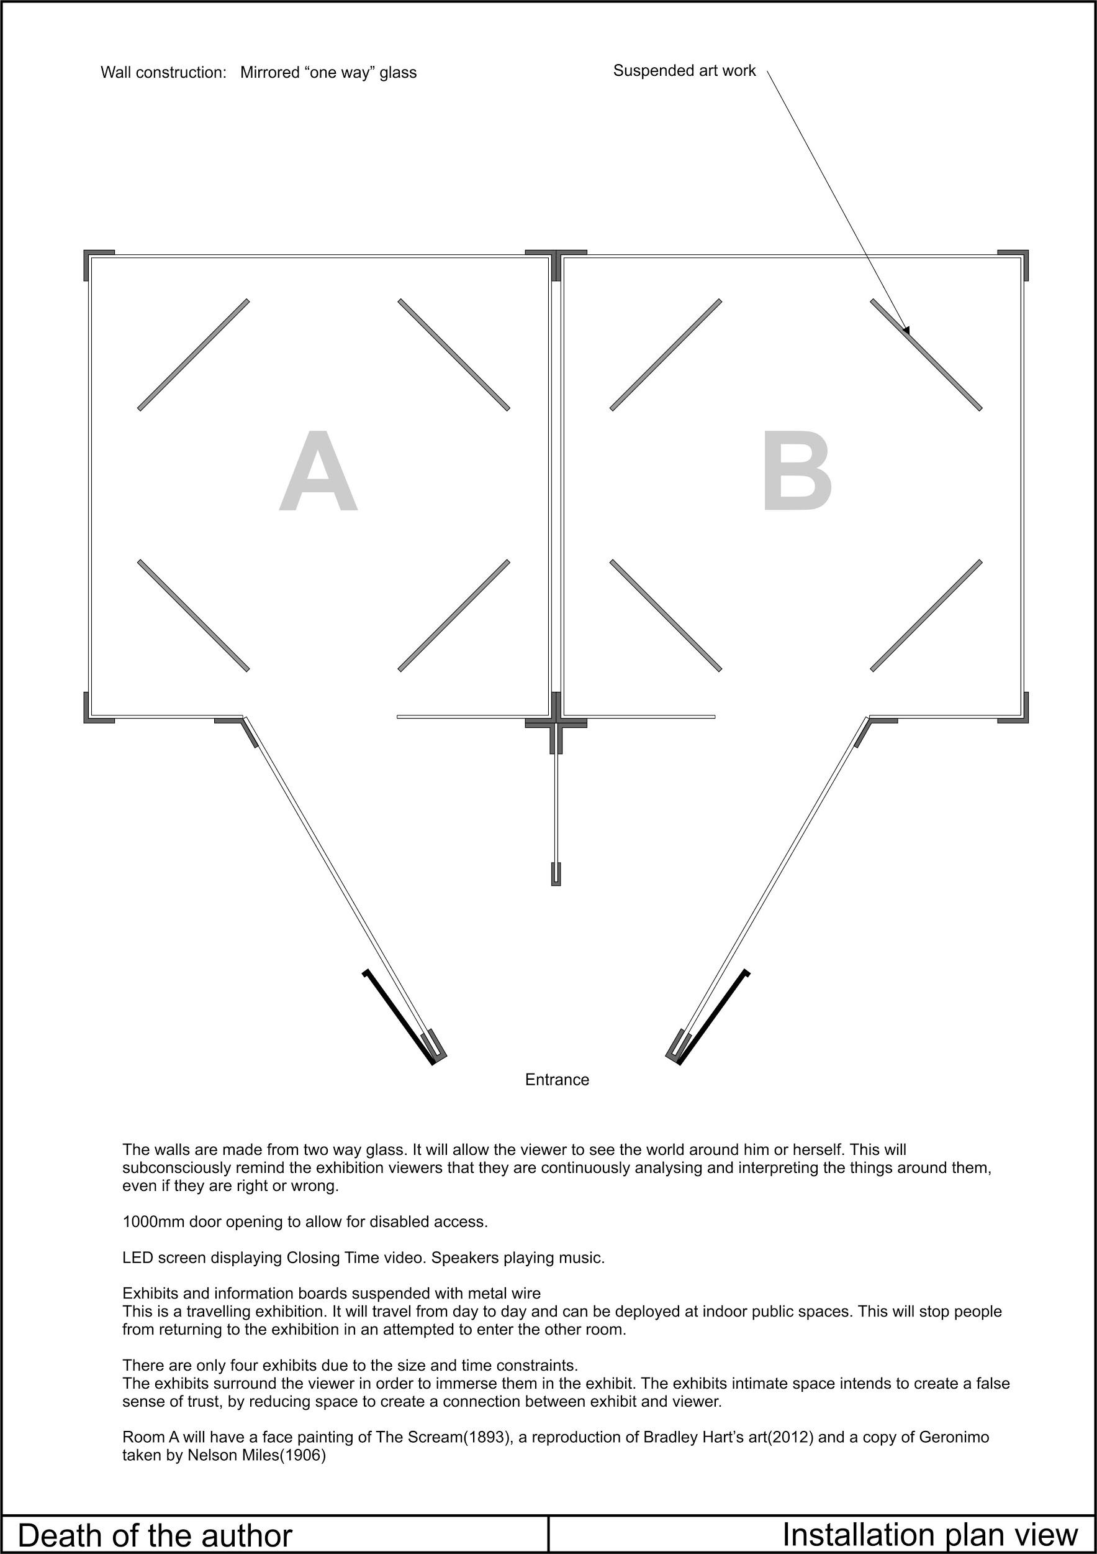

Exhibits

1. Closing Time, Semisonic(1998)

The first installation will be the song Closing Time by Semisonic. It's music video will be shown on a LED screen with the song being repeated through speakers. The song is a fine example of the death of the author, as it's popular perception in contrasting from its creatures original meaning.

When it was originally released fans believe the song was about encouraging a lonely man looking for love to vacate a bar, as it is about to end service for the night. Through popular perception it became societies go-to song for the end of a night out. This interpretation will be presented in Room A. (ref diagram)

However, this interpretation doesn't concor with the songs true meaning. In truth the song is about fatherhood. Semisonic's lead singer, Dan Wilson, explained during a performance at his 25th reunion at Harvard, ‘Millions and millions of people bought the song and heard the song and didn’t get it. They think it’s about being bounced from a bar but it’s about being bounced from the womb’.(2008 ) The exhibition text will further analyse the song, showing its true meaning for example, ‘Closing time, you don’t have to go home but you can’t stay here.’(ref) A definitive nod to the child being bounced from the womb. This interpretation will be presented in Room B. (ref)

2. Der Schrei Der Natural(ref)

Der Schrei Der Natural or otherwise known as The Scream is one of biggest misnomers in popular culture. Painted by Norwegian expressionist artist Edvard Munch, the skeletonised face in the painting is one of the most iconic images of art. Through our societies postmodern culture, popular belief is that the painting is of a figure screaming out. This interpretation has been supported through many years of comical parodies and pop culture. Even many art experts have argued the case. By a majority, it is us the reader who has finished the meaning of the painting. This interpretation will be presented in Room A.

However the true meaning of the painting couldn't be anymore contrasting. The figure in the painting is not screaming but instead blocking his ears while being overwhelmed by his surroundings. Munch recalls his inspiration in his diary. 'I was walking along the road with two friends. The sun set. I felt a tinge of melancholy. Suddenly the sky became a bloody red. I stopped, leaned against the railing, dead tired, and I looked at the flaming clouds that hung like blood and a sword over the blue-black fjord and city. My friends walked on. I stood there, trembling with fright. And I felt a loud, unending scream piercing nature.' (Munch 1892)

Instead , the painting tries to portray the scream of life around the figure. It is a metaphor for the anxiety that Munch was experiencing. As a result, Munch’s painting clearly shows the impact of the reader on a piece of work and is an example of false truth. This interpretation will be presented in Room B(ref), where it will be further analysed.

3. Bubble Wrap

The third item used in the exhibition will be a bubble wrap painting by Bradley Hart (2012). Bubble wrap is a perfect example of how the perception of an object has been changed by the observer. Bubble wrap is universally used around the world as protection to transport products, 'The amount of bubble wrap that is produced annually is enough to wrap around the the equator' (ref). This interpretation will be given in Room A. It will continue to talk about it's impact on our society and environment.

Bubble wrap was invented by engineers Alfred Fielding and Marc Chavannes (1957); and was actually originally intended to be textured wallpaper that insulated homes. It was not until BMI saw its potential as packaging, that the use of bubble wrap changed to what we know it as today. This is a great example of how the Reader's (BMI) interpretation of a product changes how it's perceived. The Authors true intentions are disregarded. This will be shown in Room B.

I chose Bradley Hart's painting (2012) because it gives another perception of bubble wrap. It pays homage to bubble wraps original use. Bradley Hart (2018) said himself he was 'inspired' (ref)when he investigated the history of bubble wrap. I also chose Steve Jobs as the subject as he is perceived in public differently compared to his private personality. This would be explained in more detail.

4. Native Americans

The final exhibit is a celluloid picture of Geronimo taken by Nelson Miles(1906). There is a common misconception that the Native Americans were called Indians by European travelers because they bare a resemblance. This interpretation will shown in Room A. It will be further analysed.

Room B will show the truth behind the misnomer. ‘In 1492, Christopher Columbus landed in the Caribbean, unlocking what Europeans quickly came to call the ‘New World’. Columbus ‘found’ a land with around two million natives. He thought he had found a new route to the East, so he mistakenly called these people ‘Indians’ This shows how interpretation can manipulate the truth. This interpretation will also be examined in more detail.(nationalarchives).

Bibliography

- Barthes. R (1967) The Death of The Author, 1977, Fontana, London
- Wilson. D (1998) Closing Time, Feeling Strangely Fine, MCA recording 1998, Track 1
- Munch. E (1893) Der Schrei Der Nature [Oil], Munch Museum, Oslo, Norway
- Hart. B (2012) [ Acrylic, bubble wrap painting], portrait of Steve Jobs
- Wilson. D (2008), Harvard 25th Reunion, interview,https://www.youtube.com/watch?v=niz9FtJIB2Y
- Miles. N (1906), Human Tiger, [Celluloid], 1906, Library of Congress, https://truewestmagazine.com/american-indian-historical-photos/
- National Archieves, Source 2-7 : CO1/1 : These are extracts from the diaries of one of the Virginia settlers, possibly Captain Gabriel Archer, and show the life of the settlers as well as their interaction with the native Americans. http://www.nationalarchives.gov.uk/education/resources/native-north-americans/

