

‘Are primary schools in Wales doing enough to promote positive mental well-being to pupils during periods of transition?’

1700921
BA (Hons) Primary Education with QTS
University of Wales Trinity Saint David
March 2020

Word count: 6226

Frontispiece

This is to certify that, except where specific reference is made, the work described in this research project is the result of the investigation carried out by myself (the author). The sole purpose of this assignment is for assessment of the authors understanding of the subject matter which contributes towards their overall degree classification, and neither this research project nor any part of it has been presented or is currently being submitted in candidature of any award other than in part for the degree of BA (Hons) in Primary Education with QTS of University of Wales Trinity Saint David.

Acknowledgements

I would like to take this opportunity to express a sincere thank you to the school, teachers and pupils that contributed in this research project. Their contribution, assistance and constant support proved to be invaluable. Thank you to the head teacher of this school for allowing me access to interview the staff and pupils during my placement at the school, and thank you to the school leadership team who made an incredible effort to both include and accommodate me in the day to day running of the school.
I would also like to thank Dr. Sioned Hughes, who provided me with guidance and support throughout this project by providing me with both positivity and enthusiasm and by answering my countless questions and queries.

Contents

Introduction ………………………………………………………………..pg 6
Literature Review:
- What is wellbeing? ……………………………………… pg 7
- What is transition?............................................................. pg 9
Methodology ………………………………………………………………..pg 10
- Obsevation………………………………pg 11
- Questionnaire……………………………pg 11
- Focus Group……………………………..pg 12
- Interview…………………………………pg 12
Results and discussion …………………………………………………….pg13
- Questionnaire…………………………….pg 13
- Focus Group……………………………..pg 15
- Interviews………………………………..pg 16
- Limitations of Research………………….pg 17
Conclusion ………………………………………………………………...pg 18
Reference List ……………………………………………………………..pg 20
Appendices:
- Appendix 1: Ethics form …………………………………………………pg 23
- Appendix 2: Consent forms …………………………………………...…pg 39
- Appendix 3: Example of Questionnaire distributed to Year 3…………...pg 40
- Appendix 4: Example of Questionnaire distributed to Year 6 …………..pg 41
- Appendix 5: Data Analysis of Year 3 Questionnaire Results ……………pg 42
- Appendix 6: Data Analysis of Year 6 Questionnaire Results ……………pg 45
- Appendix 7: Year 3 Focus Group Transcript……………………………..pg 49
- Appendix 8: Year 6 Focus Group Transcription………………………….pg 51
- Appendix 9: Interview with Transition Lead …………………………….pg 54
- Appendix 10: Interview with ALENCO ……………………………..pg 58
- Appendix 11: Interview with Family Liaison Officer ……………….pg 60
- Appendix 12: Report on School A ……………….…………………..pg 64

Introduction

The aim of this research project is to gain an insight into how primary schools in Wales are promoting positive mental well-being to their pupils during periods of transition. Interest in the national wellbeing of children and young people is not a new concept (Fattore et al, 2007). However, there is growing awareness in the importance of maintaining a positive sense of well-being. All pupils deserve to have good well-being and to grow up equipped with the tools that they need in order to understand and support their mental well-being when moving into adulthood. According to the Department for Education (2019), whilst the majority of children and young people report being relatively happy with their lives, there are many that are not. This research project aims to identify what strategies, resources, interventions and approaches primary schools in Wales use to promote and encourage positive mental health as well as positive general well-being. Prior to addressing this aspect, research will be undertaken in order to develop a current and profound understanding of how schools’ approach and deal with matters of health and well-being.
The overall aim of this project is to conduct research to improve knowledge and understanding of the impact that positive emotional and mental well-being has on pupils within primary schools particularly during significant events of change such as that of transitioning from class to class or school to school. This topic has been chosen as pupil well-being is becoming more of a priority within Welsh education, therefore, having an insight into the subject is advantageous for the author.
The first section of the research undertaken by the author focuses on how pupils feel whilst in school and how they view and feel during periods of transition, for example: moving from class to class or in Year 6’s case how they feel on their impending move to secondary school. This information and data will be gathered through informal conversations with the pupils in their classroom setting and through paper questionnaires that will be distributed to a focus group of pupils in Year 3 and Year 6. Using observations and questionnaires the author will be able to gain an insight into the benefits and challenges of School A’s well-being and transition policies and whole-school approaches.
The second area of the research is a small-scale case study focusing on how School A fosters and supports pupils well-being whether it be mentally, emotionally, socially or physically. School A is currently a pioneer school for health and well-being and is working with the Welsh Government and other schools to proceed with developments relating to professional learning. The case study will focus on the opinions of pupils in the year groups of 3 and 6 within the school during focus group interventions. These pupils will also be asked to draw the authors attention to any classroom resources which help the pupils maintain a positive state of mind or to members of staff who aid the pupils during times of distress.
The research methods that will be undertaken during this case study are:
- A review of literature.
- Observations.
- Group interviews with children within a primary school setting.
- Paper Questionnaire distributed to a focus group of pupils.
- Interviews with teachers.

Literature Review
What is well-being?
Well-being is defined by the English Cambridge Dictionary as ‘the state of feeling healthy and happy’. However, it is important to recognise that well-being is, in fact, a much broader concept than moment-to-moment happiness. Tchiki Davis (2019) has defined well-being as being the experience of health, happiness, and prosperity which includes having good mental health, high life satisfaction, a sense of meaning or purpose, and the ability to manage stress. Therefore, whilst well-being does include happiness, it also includes other things previously mentioned by Davis (2019) such as how satisfied people are with their life as a whole, their sense of purpose, and how in control they feel. Well-being emerges from a person's thoughts, actions, and experiences. It is something sought by every individual because it includes so many positive factors such as feeling happy, healthy, socially connected, and purposeful. Unfortunately, well-being appears to be in decline in many countries including Wales and the rest of the UK. In fact, it is estimated that a quarter of a million ten to fifteen-year-olds in the UK are unhappy with their lives (The Children’s Society, 2020). Figures such as this have been proven to correlate with mental health figures. According to recent statistics from the Welsh Government (2019), 1 in 10 children between the ages of five to sixteen in Wales have a mental health problem and many more have behavioural issues. It is also estimated that one in four children will show some evidence of mental ill-health across the UK and that in an average-sized classroom three children will experience some type of mental health problem (National Assembly for Wales, 2018). With these statistics that show three children in every average-sized classroom having a mental health issue, earlier and more effective methods of intervention are needed urgently across the UK.
According to an article written by the BBC in 2018, tackling the emotional and mental health issues in children must become a national priority. The BBC (2018) has also declared that emotional and mental health should be part of the new curriculum and that everyone who cares, volunteers or works with children to be trained in the topic. Fortunately, for Wales, the country will soon be undertaking an educational reform due to the suggestions of Professor Graham Donaldson (Successful Futures, 2015). Donaldson published his independent review titled ‘Successful Futures’ in 2015. This review examined the curriculum and assessment arrangements in Wales as well as informed the process of developing a new curriculum for Wales. This new curriculum will have six Areas of Learning and Experience one of which will focus on Health and Well-being and this will come into full effect in 2022. According to the National Assembly for Wales, a reform of the current curriculum in Wales offers a once-in-a-generation opportunity to embed well-being into the lives of pupils (2018). The National Assembly for Wales published a report in 2018 which looked into the emotional and mental health of children and young people in Wales titled ‘Mind Over Matter’. As part of this report, a survey was carried out which asked children whether they thought they were being suitably supported emotionally in schools and colleges. It was found that over two-thirds of respondents said that they wanted to be taught more about how to look after their emotional well-being and mental health. The BBC reported similar findings to a survey distributed to 3,000 children between the ages of eleven to nineteen. The results showed that 44% of respondents didn’t find support at school helpful and that 48% didn’t know where to go to access support within the school (Mind Cymru, 2019). These two surveys demonstrate the need for more effective intervention strategies as many pupils across the education system do not know how or where to access support and in the instance where support is given to pupils, they do not deem it either effective or useful.
Schools provide an ideal environment for informing and promoting good mental health and emotional well-being to children. Schools are an ideal environment to teach and promote sensitive issues such as mental health to pupils as not only do teachers create a safe learning environment to explore such issues but also because pupils spend a large amount of their time in school. It is estimated that throughout their education, pupils will spend over 7,800 hours at school (Cowburn and Blow, 2018). However, despite the number of time pupils spend in school the education system is at present unbalanced. There appears to be too much emphasis on academic achievement and not enough focus on promoting the well-being of pupils. Schools are often struggling to prioritise well-being due to several factors such as an overcrowded curriculum, funding constraints and the pressure placed on teachers to meet pupil attainment targets. However, the introduction of the area of learning and experience that is Health and Well-being will provide schools across Wales with a holistic structure for understanding health and well-being (Donaldson, 2015). Engagement with this area will help to foster a whole-school approach that enables health and well-being to permeate all aspects of school life. There are many benefits to promoting health and well-being in educational settings. It has been reported that pupils experience improved morale, increased productivity, reduced absenteeism, stronger engagement as well as better teamwork and social networks when informed and taught well-being strategies (Selinger, 2014). Well-being strategies teach pupils how to become resilient learners which aids them in their classwork but also in later life when out in the working world. Furthermore, schools have a crucial role in supporting pupils to make healthy lifestyle choices and to understand the importance of health and well-being. Therefore, schools must make time to promote and teach pupils about issues surrounding the topic of health and well-being as healthy informed pupils are more alert, engaged and better able to concentrate and learn in the classroom.
What is transition?
School transitions are conversions that all children go through as pupils as they change classrooms and schools throughout their educational lives. These transitions play a major role in the development of the pupil’s decisions and can also serve as a milestone that can direct them in many ways. Transitions can occur at a variety of ages and can greatly vary across school districts. Although transitions can occur at many different periods, it is believed that several periods of transition are typical (Anderman et al, Unknown). This statement is supported by Alan Mortiboys (2005) who also identifies several significant transitions that need to be negotiated during a child’s educational life. Transitional events such as starting school, moving school and moving up year by year in school are a few of the major changes that a child goes through in their educational journey. For some pupils, the process of transition is often smooth and peaceful, whereas for others it can be stressful. A transitional event can be difficult for anyone at any age as the change typically involves loss and the need to deal with uncertainty (Mortiboys, 2005). A pupil’s transition can be complicated by a range of factors such as a social, emotional or physiological change and this can negatively impact on the pupil’s learning. It is vital that the pupils learning, and well-being be maintained as they transition from class to class or school to school.
The transition to the nursery is the first major school transition; however, for some children, who have already have attended day-care centre or have been a part of initiatives such as Flying Start, the transition into full-time education may be much easier than for other children who have stayed at home prior to entering the education system. The second major transition for most pupils in schools across Wales is the transition from the Foundation Phase into KS2. This is because pupils move from a developmentally appropriate experiential curriculum within the Foundation Phase to a more rigidly structured curriculum that offers little in experimentation in KS2. According to the Welsh Government (2014), many of the Year 3 teachers across Wales had mixed feelings in regard to the transition between Foundation Phase to Key Stage 2, as they felt that the transition strategies in place vary considerably. Many pupils upon entering the KS2 find the dramatic reduction in the use of Foundation Phase pedagogies across the year groups difficult (Welsh Government, 2014). However, it has also been reported that some pupils enjoy the ‘additional challenges’ of harder work than KS2 offers them. Parents and carers of pupils also reportedly see little to no problem with the transition into KS2 as in 2014 88% of the parents/carers surveyed to the Welsh Government that they felt that their child had settled well into Year 3. Whilst 46% of the parent/carer respondents reported that their child’s enjoyment of learning had remained constant during the transition into Key Stage 2 and 36% of respondents thought their child’s enjoyment had increased upon entering KS2 (Welsh Government, 2014). Furthermore. it is clear to see that there is a conflict of viewpoints in regard to the transition from the Foundation Phase to KS2.
For some pupils, secondary school represents the final stage of formal education. However, for many pupils, the transition to secondary school represents another very important school transition, and arguably the biggest transition of all. To pupils’ primary schools offer more predictability then secondary schools. In primary schools, pupils are usually with the same teacher and in the same classroom throughout the year. However, the move to secondary school brings about a lot of changes, no longer are the pupils based in one classroom across the academic year with the same teacher. Instead for the first time they will experience different classroom environments and different teachers for each subject along with navigating a larger building, coming to terms with new travel arrangements and coping with support from unfamiliar teaching assistants. If the transition between primary school and secondary school is not well-managed, pupils particularly with learning disabilities or SEN can end up feeling isolated and vulnerable. Should this occur then the emotional health of these pupils will suffer along with their academic performance. According to the Mental Health Foundation (2020), a well-planned transition between primary and secondary phases will help remove any barriers to learning and enable them to reach their full academic potential as well as feeling less isolated.
As previously stated, pupils often experience problems adjusting to changes in educational environments. In order to assist pupils who are experiencing difficulties during these transitional periods’, educators need to be well prepared. It cannot be assumed that pupils will naturally adjust to new and different learning environments with little difficulty. When pupils move classes within or between schools, they must learn to adjust to their new surroundings, become familiar with their new teachers and peers, learn new ways of working, and make sense of the rules and routines that operate within their classrooms (Sanders et al, 2005). This case study will provide the researcher with the opportunity to see first-hand how schools and members of staff deal with and assist pupils who experience some difficulty when moving to different learning environments at the end of each academic year.

Methodology
When conducting primary research, the researcher must readily adhere and comply with the appropriate ethical practices, techniques, and guidelines. For research to result in benefit and minimise the risk of harm, it must be conducted ethically. To ensure that the research is conducted ethically, the researcher will refer to and adhere to the university’s research data management policy and integrity code of practice as well as the BERA guidelines (2018) and Education Workforce Council (EWC) Research and Ethics Guidelines (2019). An ethical review was completed by the researcher and examined by the university before any research was conducted. The ethical review aimed to identify how to protect participants and the researcher. By obtaining ethical approval the researcher is demonstrating that will adhere to the accepted ethical standards of a genuine research study which could increase their recruitment potential. Throughout the research project, it will be made clear to participants that for ethical reasons all data collected will be kept strictly confidential in association with the Data Protection Act 1998. The participants are a valuable part of the research process and not merely a means of accessing data, therefore, their upkeeping their privacy is of the utmost importance. A way of protecting a participant’s right to privacy is through the promise of confidentiality. The promise of confidentiality assures participants of their privacy and anonymity during the research process. Kimmel (1988) believes that during research on sensitive topics there will be potential respondents who will refuse to cooperate when the assurance of confidentiality is weak. Therefore, it is vital that the participants know of level of confidentiality and their rights to withdraw consent at any time. Therefore, the participants must know of the level of confidentiality offered and their right to withdraw participation and consent at any given time. All participants will be made aware of this before any research is conducted.
To gather as much data as possible, a variety of research methods will be used whilst out in school. The research methods that will be undertaken during this case study are that of observations, questionnaires, focus groups, and interviews.
Observations:
Throughout the short time provided to gather primary research, the researcher will have the opportunity to observe the participants in their classroom settings. Observations will be used by the researcher to provide insights into individual or group behaviours (NFER, 2013). They will also be used by the researcher to familiarise themselves with the pupils and the school as observations are very useful in finding out what is going on in a situation. Observations are also useful for accessing non-verbal data such as the use and purpose of displays. The only prominent issue with observations is that the presence of an unfamiliar person can alter how staff and pupils behave. The researcher hopes to resolve this concern by being a participant-observer during their observations to openly aid and communicate with staff and pupils and reassure them of my role and purpose.
Questionnaires:
A questionnaire is a research instrument that consists of a series of questions to gather information from respondents (McLeod, 2018). Questionnaires will be used by the researcher as they provide a quick and efficient way of obtaining large amounts of information from a large sample of people. Data can be collected relatively quickly using questionnaires as the researcher does not need to be present when they are completed. The questions are also standardised, meaning all respondents are asked the same questions in the same order. The researcher will use and distribute paper-based questionnaires to a sample of pupils within two age groups: Year 3 and Year 6. The questionnaires will be made up of a set of simple multiple-choice questions. The advantage of having multiple choice-based questions is that pupils can select as many answers which apply to them. Questionnaires are also a beneficial research method as they can be anonymous and the data between individuals and groups are easy to compare. Often a disadvantage when using questionnaires is that there is no chance for following-up or exploring ambiguous answers (NFER, 2013). However, the researcher will use focus groups to follow up on the answers of the questionnaire.
Focus groups:
Focus groups are defined by the National Foundation for Educational Research (2013) as being interviews carried out with a group of people on a specific topic. During a focus group, a group of participants usually between five to ten, are brought together in a room to engage in a guided discussion of a topic. Focus groups will be used with pupils in opposed to one-to-one interviewing as pupils are more likely to be comfortable answering questions as a part of a group rather than individually. Focus groups also offer an efficient way of collecting a range of opinions from groups of people (NFER, 2013). The participants of the focus groups will be selected using convenience sampling. As the topic of study is generic pupils do not need to be chosen based on their characteristics but rather on their availability and likelihood to return a consent form.
Interviews:
The interview is a flexible tool for data collection. It is an important data gathering technique that involves verbal communication between the researcher and the participant. Interviews are used to explore issues, views, and attitudes in-depth. The researcher will use interviews to gather information from key members of staff in School A such as the transition lead and class teachers of Year 3 and 6. Interviews will be used by the researcher as they are a far more personal form of research than questionnaires. They are also particularly useful for getting the story behind a participant’s experiences. These interviews will be semi-structured as it offers greater flexibility than structured interviews as well as offers opportunities to ask additional follow-up questions to any answer they may give (NFER, 2013). It also provides more focus than the unstructured approach, but still allows a degree of freedom and adaptability in getting the information from the participant.
These four methods of research listed above should help the researcher gather all the information and data needed to help form an opinion on the well-being and transition facilities in School A.
The documents previously mentioned in this section:
- The ethics form can be found in Appendix 1.
- An example of the consent form that was distributed to the pupils who took part in the case study can be found in Appendix 2.
- An example of the questionnaires distributed to pupils can be found from Appendix 3 and 4.

Results and discussion
The researcher aims to discuss and explain the results of the findings which have been analysed after the collection of all primary data. To increase the reliability of the results, the researcher aimed to produce a combination of both quantitative and qualitative data. The qualitative data was obtained using interviews, focus groups and observations whilst the quantitative data was obtained through the use of paper-based questionnaires. In this section, the researcher will interpret the analysed responses from all participants of this case study starting with the responses from the questionnaires distributed to pupils in Year 3 and Year 6.
Note: There were seven participants in Year 3 and nine participants in Year 6 for both the questionnaire and the focus group
Questionnaire:
The paper-based questionnaire that was distributed to a cluster of pupils in Year 3 and Year 6 were comprised of five key questions that were specifically devised to draw upon conclusions that related to the aims of this project. A copy of the questionnaire distributed to both year groups can be found in Appendix 3 and 4. Within both questionnaires, the first three questions were put in place to ascertain the pupil’s feelings and opinions on the level of support given to them emotionally whilst in school whilst the remaining two questions were put in place to ascertain the pupil's feelings and opinions concerning the transition process at the end of each year either from class to class or school to school. Within the introduction of the paper-based questionnaire, consent was received, and an example of the consent form can be seen in Appendix 2.
Responses to Questionnaire:
Note: Data analysis for each question in the form of charts can be found in Appendix 5 and 6.
Question One of Questionnaire:
Do you feel happy in school?
Question one was put in place to ascertain how happy pupils feel in school on a day to day basis. As discussed in section two, research has shown that an estimated quarter of a million ten to fifteen-year-olds in the UK may be unhappy with their lives (The Children’s Society, 2020). Therefore, the researcher felt that it was vital to determine how pupils feel in school to ascertain whether the well-being needs of the pupils were being met.

Question Two of Questionnaire:
Do you know who to go to in school if you felt sad or scared?
This question was put forward by the researcher in hopes to establish if the pupils taking part in the questionnaire were able to identify their trusted adult. A trusted adult is a member of staff in school that the pupil in question will have a good relationship with. It is a member of staff chosen by the pupil and who often has the pupil’s best interests in mind. The pupils must have an adult that they trust to go to talk about any concerns or worries that they may have and help them to do something about those concerns or worries. By having identified a trusted adult, the pupils may feel more happy, safe and secure whilst in school and when facing issues.

Question Three of Questionnaire:
Who would you go to in school if you felt sad or scared?
In this question, the pupils were asked to select the individual staff members that they feel they could go to during times of sadness or terror. The options that were provided are as follows: class teacher, teaching assistant, dinner lady, friends and/or other. This question was put forward by the research to identify who the pupils would put forward as being their trusted adult who they would seek out in times of distress.

Question Four of Questionnaire:
Year 3: How did you feel about moving from Year 2 to Year 3?
Year 6: How do you feel about going to secondary school next year?
Question four is where the questionnaires start to differ for each year group as these are the questions based around the topic of transition and the next stage of transition differs for both year groups as Year 6 will be moving up to secondary school whilst Year 3 will move class in the next period of transition. This question was put forward by the researcher to uncover how the respondents felt or feel about the last or latest big transition from either Foundation Phase to KS2 or from Primary school to secondary school. The pupils were asked to select the emotions that they believed described how they feel or have felt.

Question Five of Questionnaire:
Year 3: Where did you feel happier?
Year 6: What worries you the most about secondary school?
The question aimed at respondents in Year 3 was put forward by the researcher in an attempt to identify whether the pupils felt happier in Year 2 (Foundation Phase) or Year 3 (KS2). An option was also included for both should the pupils feel no noticeable differences between the phases. For the results of this question please seepage. However, the question aimed towards respondents in Year 6 sought to determine what concerns plagued the pupils regarding their upcoming transition from primary school to secondary school.
The responses to the questionnaires aided the researcher in putting forward further questions to the pupils during the focus group sessions. The aim of the focus groups was for the researcher to gain more of an insight into the school’s approach to well-being and transition.
Responses in Focus Group:
It was decided that the researcher would hold a focus group for each year group. The pupils chosen to participate in the focus groups were initially recommended by the class teacher as it was felt that they would be the individuals able to provide valuable and constructive feedback and opinions confidently. Each focus group were asked to elaborate on six structured questions. However, the pupils were provided with opportunities to discuss anything they believed to be relevant to the topic being discussed. All pupil interview transcripts can be found in Appendix 7 and 8.
The first three questions posed to the focus group were to ascertain what would make them happier whilst in school, what worries them the most about school and if and why it is important to be happy in school. Generally, all pupils knew that being happy in school would affect their attitude towards working. One pupil from the Year 3 focus group stated: ‘if you’re not happy then you won’t enjoy learning and then you won’t learn as much’. This demonstrates that pupils know that their mindset and attitude can affect their academic potential. It was interesting to see the recommendations made by the respondents in regard to what would make them happier in school. There were of course answers such as introduction of xbox or ps4, however, these ideas led to a more coherent idea of VR based lessons. The researcher found it interesting to witness how the pupils built of each other’s ideas during the focus group to come to a decision together on what they would like to see more of in school.
The fourth question posed to participants within both focus groups was answered with an overall consensus of yes. The respondents felt as if their opinion or ‘voice’ mattered in school, mainly due to the use of pupil voice. As a result of pupil voice, the pupils feel as if they have a say in some of the learning which occurs in the classroom. Pupils also stated that due to the open-door policy of the family liaison officer, they felt as if there was always someone to talk to privately should the need arise.
The fifth question asked the learners whether they found the schools strategy to teach resilience in the classroom helpful. Year 3 pupils use the strategy ‘3 Before Me’ which entails three steps that the pupils are expected to follow should they have difficulty completing the work set. It consists of having a think for yourself, asking a friend for help and asking the teacher for help in that order. This strategy encourages resilience and to an extent problem-solving within the classroom. The 3 Before Me strategy is immensely popular with the pupils in Year 3. However, a similar strategy that used amongst the higher stages of KS2, appeared not to be as popular. The strategy used in Year 6 was titled the 5 Point Plan, this consisted of five steps: think, think again, think even harder, ask a friend and finally ask the teacher. When questioned about this the pupils shared their frustrations with the strategy claiming that ‘it is impossible to think even harder’. However, they did agree that despite their occasional frustration the strategy did encourage them to go back and think more carefully which did in some instances help them come to the answer on their own and therefore building their resilience.
Question six touches on the respondent’s feelings towards transition at the end of each year. Here is where the opinion of the respondents became divided, some stated that they enjoyed moving classes at the end of every year whilst others stated that they did not. One individual in the Year 6 focus group highlighted ‘that as you move through school, you can feel the difference in work and responsibility’. Many of the respondents felt as if it were necessary to move up throughout the school in order to prepare them for the transition into secondary school.
Responses in Interviews:
It was decided that the researcher would interview the school’s family liaison officer, the transition lead and the designated ALENCO. Unfortunately, due to the short amount time given to conduct research, the researcher was unable to arrange a suitable time to formally interview the teachers of Year 3 and Year 6. The notes taken during the interview with the transition lead, ALENCO and family liaison officer can be found in Appendix 9, 10 and 11.
From the interviews conducted with specific members of staff, the researcher was able to gain a better perspective on the school’s approach to the fostering a positive sense of well-being and ensuring that pupil’s transition from different learning environments smoothly.
Upon the researcher’s first interview which was with the school’s transition lead, the researcher was made aware that School A is currently a pioneer school for the area of learning and experience that is health and well-being which is being introduced via the new curriculum and is working with the Welsh Government and other schools to proceed with developments relating to professional learning. As a pioneer school, school A is focused on promoting the benefits of health and well-being as an area of learning in primary schools across Wales. School A aided the Welsh Government with writing aspects of the new curriculum under the aspect of health and well-being. School A prides itself on being a pioneer school for health and well-being as they believe that health and well-being are central to a child’s education. Members of staff at School A have recently undertaken mental health training in an attempt to identify and support pupils who perhaps suffer from mental health problems such as anxiety which is quite common in primary school aged children. School A have also created a health and well-being group where four pupil from Year 6 are chosen to conduct research and introduce something to the school that can be used to improve the health and well-being for all pupils in attendance at School A. It was positive and encouraging to see that pupils were taking charge and responsibility in order to improve their own mindfulness.
Limitations of Research:
The researcher has identified several limitations to this case study. Firstly, the sample of pupils used to complete the paper-based questionnaire and participate in the focus groups were initially recommended due to their confidence. It would have been interesting to have had the insight of a less confident individual who perhaps comes across as shy or nervous as their opinions and viewpoints are more likely to differ. Secondly, due to the short time frame given to conduct this study the researcher was unable to meet with the class teachers in Year 3 and 6. The researcher hoped to interview them in an attempt to discover how they identify pupils who struggle during the transition process at the beginning or end of the year. Fortunately, the researcher was able to obtain similar information from the school’s transition lead and family liaison officer. However, the perspectives of these two key members of staff would have provided the researcher with a deeper insight. Finally, upon reflection the researcher felt that the title of this case study was too broad. Had the title been more focused towards the type of support given in school to a particular key stage of learning instead of a whole-school approach more extensive research could have been conducted in the time frame given.

Conclusion

From reviewing all of the information and data that has been gathered by the researcher and provided by the respondents in the paper-based questionnaire, the semi-structured teacher interviews, the pupil focus groups and through the use of observation it is evident that school has many efficient strategies in place to encourage a positive sense of well-being as well as ensure a positive experience regarding the transition processes facing the pupils at the end of every academic year.
This research project has found that schools can support and foster well-being in a variety of different ways. The researcher found that in School A teachers go out of their way to include positivity and mindfulness in their classroom. One teacher, in particular, had introduced the concept of ‘mindful minute’ to their classroom in the Foundation Phase. The idea behind this concept was that whenever the children felt in low spirits or were too energised the teacher would call them over to the mat where they would then participate in meditated breathing techniques to calm both their body and their mind. This is one of the many resources exposed to the research during their visit to the school. The researcher was also introduced to worry monsters which children feed their worries to, help desks that are accessible to all children which are also covered in useful resources to help them complete their work and finally the Power of Yet which is a method developed by the school to encourage a more positive mindset, it helps to change children’s thoughts from I can’t to I can’t yet. From this experience, the researcher has been able to witness first-hand how important a positive mindset and attitude is to a child and how it an impact on a child’s learning.
Concerning the topic of transition, the school actively encourages different year groups to work together throughout the year. This allows the pupils to explore different learning environments and get used to the presence of different practitioners. The school also endorses a ‘transition day’ at the end of every academic year which allows the pupils to spend a whole day in the classroom with the teacher that will be educating them the following year. It works as a sort of taster session so that pupils can get familiar with their surroundings and get to know their new teacher. The pupils in Year 6 do not experience this transition day as instead they move up to the local secondary school for a week in attempt to familiarise them with the building, their form groups, teachers and classes. From this experience, the researcher knows the importance of transitional activities as well as the strategies in place to help aid them. This will be useful as at some point in the researcher’s career as a teacher they will be faced with a child who fears moving classes or school.
Finally, following this research project the author has gained a valuable insight into how schools prepare pupils for important transitions and how the well-being of pupils is both fostered and monitored. This case study has helped make the researcher an improved practitioner within the classroom as they are aware of strategies in place and the resources available to aid them which will most definitely be of use to them in the future when faced with emotional occurrences and transitional events. Furthermore, in answer to the question developed by the researcher at the start of the research project it is fair to say that primary schools in Wales are doing enough to promote positive mental well-being to pupils during periods of transition.

References

Anderman, E., Missall, K., Hojnoski, R., Patrick, H., Drake, B. and Jarvis, P. (Unknown) School Transitions. Available at: http://www.nppsd.org/vimages/shared/vnews/stories/525d81ba96ee9/Tr%20-%20School%20Transitions.pdf. (Accessed: 16th March 2020).
BBC (2018) Child mental health 'must be national priority' in Wales. Available at: https://www.bbc.co.uk/news/uk-wales-43894892 (Accessed: 7th March 2020).
BBC News (2019) Mental health: Counselling sought by 11,000 Welsh youngsters. Available at: https://www.bbc.co.uk/news/uk-wales-50151883 (9th March 2020).
Cambridge Dictionary (2020) Meaning of well-being in English. Available at: https://dictionary.cambridge.org/dictionary/english/well-being (Accessed: 6th March 2020).
Cohen, L., Manion, L. and Morrison, K. (2018). Research methods in education. New York: Routledge.
Davis, T. (2019) What Is Well-Being? Definition, Types, and Well-Being Skills. Available at: https://www.psychologytoday.com/gb/blog/click-here-happiness/201901/what-is-well-being-definition-types-and-well-being-skills (Accessed: 6th March 2020).
Department for Education (2019) State of the Nation 2019: Children and Young People’s Wellbeing. Available at: https://assets.publishing.service.gov.uk/government/uploads/system/uploads/attachment_data/file/838022/State_of_the_Nation_2019_young_people_children_wellbeing.pdf (Accessed: 26th February 2020).
Discombe, M. (2019) Number of children referred to mental health services doubles in just one year in Cardiff and the Vale. Available at: https://www.walesonline.co.uk/news/local-news/cardiff-vale-mental-health-children-16674894 (Accessed: 8th March 2020).
East Lothien Council (2020) Trusted Adults. Available at: https://www.eastlothian.gov.uk/info/210579/fostering_adoption_and_looked-after_children/12276/looked_after_children_and_young_people/2 (Accessed: 20th March 2020).
Education Review Office (2016) Transition from Primary to Secondary School. Available at: https://www.ero.govt.nz/publications/evaluation-at-a-glance-transitions-from-primary-to-secondary-school/6-transition-from-primary-to-secondary-school/ (Accessed: 24th March 2020).
McLeod, S. (2018) Questionnaire: Definition, Examples, Design and Types. Available: https://www.simplypsychology.org/questionnaires.html (Accessed: 13th March 2020).
Mental Health Foundation (2015) What is wellbeing, how can we measure it and how can we support people to improve it? Available at: https://www.mentalhealth.org.uk/blog/what-wellbeing-how-can-we-measure-it-and-how-can-we-support-people-improve-it (Accessed: 6th March 2020)
Mental Health Foundation (2016) Mental Health in Wales: Fundamental Facts 2016. Available at: https://www.mentalhealth.org.uk/sites/default/files/FF16%20Wales.pdf (Accessed: 8th March 2020).
Mental Health Foundation (2020) Mental health statistics: children and young people. Available at: https://www.mentalhealth.org.uk/statistics/mental-health-statistics-children-and-young-people (Accessed: 26th February 2020).
Mental Health Foundation (2020) Moving on to secondary school. Available at: https://www.mentalhealth.org.uk/learning-disabilities/our-work/employment-education/moving-on-to-secondary-school (Accessed: 24th March 2020).
Mortiboys, A. (2005) Teaching with Emotional Intelligence: A Step-by-step Guide for Higher and Further Education Professionals. 1st edn. Oxon: Routledge.
National Assembly for Wales (2018) Mind over matter A report on the step change needed in emotional and mental health support for children and young people in Wales. Available at: https://www.assembly.wales/laid%20documents/cr-ld11522/cr-ld11522-e.pdf (Accessed: 8th March 2020).
National Foundation for Educational Research (2013). How to... Run qualitative and quantitative research: From definitions through to analysis (How to Guides). Slough: NFER.
Selinger, M. (2014) 6 benefits of health and wellbeing programs. Available at: https://www.healthandsafetyhandbook.com.au/6-benefits-of-health-and-wellbeing-programs/ (Accessed: 10th March 2020).
Smith, M. (2019) The young people who feel failed by mental health services in Wales. Available at: https://www.walesonline.co.uk/news/health/young-people-who-feel-failed-15917609 (Accessed: 8th March 2020).
The Children’s Society (2020) The Good Child Report. Available at: https://www.childrenssociety.org.uk/good-childhood-report. (Accessed: 16th March 2020).
Thomas, N., Graham, A., Powell, M.A. and Fitzgerald, R. (2016). Conceptualisations of children’s wellbeing at school: The contribution of recognition theory. Childhood, 23(4), pp.506–520.
Time to Change Wales (2020) What is Stigma? Available at: https://www.timetochangewales.org.uk/en/mental-health-stigma/what-stigma/ (Accessed: 8th March 2020).
Welsh Government (2014) Evaluating the Foundation Phase: Key Findings on Transitions and Assessment. Available at: https://dera.ioe.ac.uk/20531/1/140717-foundation-phase-transition-assessment-en.pdf (Accessed: 22nd March 2020).
Welsh Government (2015) Effective use of data and research evidence. Available on moodle. (Accessed: 19th March 2020).
Welsh Government (2019) Together for Mental Health: A Strategy for Mental Health and Wellbeing in Wales. Available at: https://gov.wales/sites/default/files/publications/2019-04/together-for-mental-health-summary.pdf (Accessed: 9th March 2020).
Young Minds (2018) Wise Up! Prioritising wellbeing in schools. Available at: https://youngminds.org.uk/media/1428/wise-up-prioritising-wellbeing-in-schools.pdf (Accessed: 10th March 2019).

Appendix 1 – Ethics Form
APPLICATION FOR ETHICAL APPROVAL

In order for research to result in benefit and minimise risk of harm, it must be conducted ethically. A researcher may not be covered by the University’s insurance if ethical approval has not been obtained prior to commencement.

The University follows the OECD Frascati manual definition of research activity: “creative work undertaken on a systematic basis in order to increase the stock of knowledge, including knowledge of man, culture and society, and the use of this stock of knowledge to devise new applications”. As such this covers activities undertaken by members of staff, postgraduate research students, and both taught postgraduate and undergraduate students working on dissertations/projects.

The individual undertaking the research activity is known as the “principal researcher”.

Ethical approval is not required for routine audits, performance reviews, quality assurance studies, testing within normal educational requirements, and literary or artistic criticism.

Please read the notes for guidance before completing ALL sections of the form.

This form must be completed and approved prior to undertaking any research activity. Please see Checklist for details of process for different categories of application.

Delete the Guidance Notes at the end of the form BEFORE submitting your application

SECTION A: About You (Principal Researcher)
Full Name: |  | Corrie Jean Jeremiah
Tick all boxes which apply: |  | Member of staff: | ☐ | Honorary research fellow: | ☐
Undergraduate Student | ☒ | Taught Postgraduate Student | ☐ | Postgraduate Research Student | ☐

Faculty/School/Centre: | ITE: Yr ATHROFA, UWTSD
Campus: | Carmarthen
E-mail address: | 1700921@student.uwtsd.ac.uk
Contact Telephone Number: | 07401249313
For students:
Student Number: | 1700921
Programme of Study: | BA Primary Education (QTS)
Director of Studies/Supervisor: | Dr Sioned V Hughes

SECTION B: Approval for Research Activity
Has the research activity received approval in principle?  (please check the Guidance Notes as to the appropriate approval process for different levels of research by different categories of individual) |  | YES | ☒ | NO | ☐
 |  |  |  | Date
If Yes, please indicate source of approval (and date where known): Approval in principle must be obtained from the relevant source prior to seeking ethical approval | Research Degrees Committee |  | ☐
 | Faculty Research Committee |  | ☐
 | Other (write in)  Module Lead |  | ☒ | 06/02/20

SECTION C: Internal and External Ethical Guidance Materials
Please list the core ethical guidance documents that have been referred to during the completion of this form (including any discipline-specific codes of research ethics, and also any specific ethical guidance relating to the proposed methodology). Please tick to confirm that your research proposal adheres to these codes and guidelines.
UWTSD Research Ethics & Integrity Code of Practice | ☒
UWTSD Research Data Management Policy | ☒
BERA (British Educational Research Association) guidelines – Ethical Guidelines for Educational Research, (2018). | ☒
The research is within the bounds of the normal classroom and in accordance with the ATHROFA guidelines for parental consent as per ATHROFA letter. | ☒
Education Workforce Council (EWC) Research and Ethics Guidelines (2019) | ☒

SECTION D: External Collaborative Research Activity
Does the research activity involve collaborators outside of the University? |  | YES | ☐ | NO | ☒
If Yes, please provide the name of the external organisation and name and contact details for the main contact person and confirmation this person has consented to their personal data being shared.as part of this collaboration.
Institution
Contact person name
Contact person e-mail address

Has this individual consented to sharing their details on this form? |  | YES | ☐ | NO |  |  | ☒
Are you in receipt of a KESS scholarship? |  | YES | ☐ | NO |  |  | ☒
Is your research externally funded |  | YES | ☐ | NO |  |  | ☒
Are you specifically employed to undertake this research in either a paid or voluntary capacity? | Voluntary | YES | ☐ | NO |  | ☒
 | Employed | YES | ☐ | NO |  | ☒
Is the research being undertaken within an existing UWTSD Athrofa Professional Learning Partnership (APLP) | If YES then the permission question below does not need to be answered. | YES | ☒ | NO |  |  | ☐
Permission to undertake the research has been provided by the partner organisation | (If YES attach copy)  If NO the application cannot continue | YES | ☐ | NO |  |  | ☐

Where research activity is carried out in collaboration with an external organisation
Does this organisation have its own ethics approval system? | YES | ☐ | NO | ☒
If Yes, please attach a copy of any final approval (or interim approval) from the organisation

SECTION E: Details of Research Activity
Indicative title: | Are primary schools in Wales doing enough to promote positive emotional wellbeing to pupils during periods of transition in KS2?
Proposed start date: | 10/02/20 | Proposed end date: | 01/07/20
Introduction to the Research (maximum 300 words)
Ensure that you write for a Non-Specialist Audience when outlining your response to the three points below:
- Purpose of Research Activity
- Proposed Research Question
- Aims of Research Activity
- Objectives of Research Activity
Demonstrate, briefly, how Existing Research has informed the proposed activity and explain
- What the research activity will add to the body of knowledge
- How it addresses an area of importance.
Purpose of Research Activity
- To explore how schools care and cater for pupil’s emotional well-being during times of transition in KS2.
- To further develop professional knowledge and understanding and future practice.

(this box should expand as you type)
Research Question
Are primary schools in Wales doing enough to promote positive emotional wellbeing to pupils during periods of transition in KS2?

Aims of Research Activity
- The research aims to capture the views of our current generation of practitioners and students in order to contribute to an informed dissertation regarding the true value of emotional wellbeing and of emotional support during times of transition.
- The primary research that I wish to undertake will provide an insight into how it complements and effects children’s learning within the classroom and improve professional practice.

(this box should expand as you type)
Objectives of Research Activity
- To observe any PSE lessons dedicated to well-being in the school.
- To interview 7-11 year old learners to capture their views on well-being and transition.
- To critically reflect on findings and consider how I can use this to improve and transform my professional practice.

(this box should expand as you type)
Proposed methods (maximum 600 words)
Provide a brief summary of all the methods that may be used in the research activity, making it clear what specific techniques may be used. If methods other than those listed in this section are deemed appropriate later, additional ethical approval for those methods will be needed.
Interviews – Individual or a group of children from a variety of key stage 2 and key stage 3 classes will be involved in a structured or semi-structured interview where they will be invited to respond to key questions. For example, during an interview I will intend to gather individual perceptions of wellbeing and transition and the challenges of moving through school. The children will be in an informal setting and I will make notes of their responses or with permission, make an audio recording of the interview. EXIT: The children will not be forced into participating or responding to questions; the notion that responses to questions are voluntary will be expressed from the start of the interview. All children will be asked if they wish to take part in the interview and before starting the interview, the children will be informed that they can withdraw from the interview or not respond at any time without notice. Throughout the interview, I will check on the children’s wellbeing to ensure they remain comfortable in the interview environment. At the time that the interview data is utilised in my written response, no names shall be mentioned; where applicable, I may use pseudonyms to assist the discussion.
Additionally, I will interview members of staff. However, with members of staff questions of a pedagogical or professional nature will be posed. Furthermore, I may interview other members of staff within the school that do not hold a teaching post, for example, the head teacher or transitions co-ordinator. EXIT: staff participation will be voluntary, and this notion will be expressed to staff participants from the outset. The staff will be informed that they can withdraw from the interview or not respond to a question at any time without providing notice.

Audio Taping – Audio taping will be used during group or individual interviews (with the interviewees prior permission) and later utilised to contribute towards my discussion and synthesis. Recording of good practice or interviews with teachers and other members of staff may also be gathered to contribute towards the research project. Prior to recording any research participant, I will gain their permission initially and act in an ethical manner throughout.

Observations – I will observe and make notes of a variety of teaching and learning encounters throughout my research. Throughout my observations, I will take note of children’s engagement and enjoyment. During a session I may observe the teacher’s approach to teaching and learning and their pedagogical approaches to certain situations. Observations will be made in my personal observation handbook. No names shall be mentioned; however, a pseudonym may be used if necessary.

Questionnaire – Depending on the children’s responses throughout the research period I may create and administer a questionnaire if I believe this will assist me to gather quality data. Throughout the creation of the questionnaire, I will adhere to and follow the training provided by the university during my second year of study when the design and distribution of a questionnaire was necessary for a specific module. The questionnaire may focus on qualitive or quantitative data, or both, depending on it’s focus. Furthermore, the questionnaire may be administered to learners, staff or both. If a questionnaire is necessary, then participants will not be required to list their name or personal information. However, they may be asked to share their status in the school (i.e. pupil or teacher) if the questionnaire is completed by both learners and staff and a participant’s role is significant to the analysis.

(this box should expand as you type)

Location of research activity
Identify all locations where research activity will take place.
The proposed study/research activity will be conducted in Pontarddulais Primary School (assigned elective school) within the ATHROFA.

(this box should expand as you type)
Research activity outside of the UK
If research activity will take place overseas, you are responsible for ensuring that local ethical considerations are complied with and that the relevant permissions are sought. Specify any local guidelines (e.g. from local professional associations/learned societies/universities) that exist and whether these involve any ethical stipulations beyond those usual in the UK (provide details of any licenses or permissions required). Also specify whether there are any specific ethical issues raised by the local context in which the research activity is taking place, for example, particular cultural and/or legal sensitivities or vulnerabilities of participants.
N/A

(this box should expand as you type)
Use of documentation not in the public domain: Are any documents NOT publicly available? | NO | ☒
 | YES | ☐
If Yes, please provide details here of how you will gain access to specific documentation that is not in the public domain and that this is in accordance with prevailing data protection law of the country in question and England and Wales.

(this box should expand as you type)

SECTION F: Scope of Research Activity
Will the research activity include: | YES | NO
Use of a questionnaire or similar research instrument? | ☒ | ☐
Use of interviews? | ☒ | ☐
Use of diaries? | ☒ | ☐
Participant observation with their knowledge? | ☒ | ☐
Participant observation without their knowledge? | ☐ | ☒
Use of video or audio recording? | ☒ | ☐
Access to personal or confidential information without the participants’ specific consent? | ☐ | ☒
Administration of any questions, test stimuli, presentation that may be experienced as physically, mentally or emotionally harmful / offensive? | ☐ | ☒
Performance of any acts which may cause embarrassment or affect self-esteem? | ☐ | ☒
Investigation of participants involved in illegal activities? | ☐ | ☒
Use of procedures that involve deception? | ☐ | ☒
Administration of any substance, agent or placebo? | ☐ | ☒
Working with live vertebrate animals? | ☐ | ☒
Other primary data collection methods, please explain in this box  For example, ‘focus groups’. Please indicate the type of data collection method(s) in this box and tick the accompany box. | ☐ | ☒
Details of any other primary data collection method:  (this box should expand as you type) | ☐ | ☒
If NO to every question, then the research activity is (ethically) low risk and may be exempt from some of the following sections (please refer to Guidance Notes).

If YES to any question, then no research activity should be undertaken until full ethical approval has been obtained.

SECTION G: Intended Participants
Who are the intended participants: | YES | NO
Students or staff at the University? | ☐ | ☒
Adults (over the age of 18 and competent to give consent)? | ☒ | ☐
Vulnerable adults? | ☐ | ☒
Children and Young People under the age of 18? (Consent from Parent, Carer or Guardian will be required) | ☒ | ☐
Prisoners? | ☐ | ☒
Young offenders? | ☐ | ☒
Those who could be considered to have a particularly dependent relationship with the investigator or a gatekeeper? | ☐ | ☒
People engaged in illegal activities? | ☐ | ☒
Others (please identify specifically any group who may be unable to give consent) please indicate here and tick the appropriate box. | ☐ | ☒
Other – please indicate here:  (this box should expand as you type) | ☐ | ☒

Participant numbers and source
Provide an estimate of the expected number of participants. How will you identify participants and how will they be recruited?
How many participants are expected? | About 45 participants in school Pontarddulais.  (this box should expand as you type)
Who will the participants be? | Approximately 20 pupils from year 3 and 20 pupils from year 6 in school Pontarddulais. 1 head teacher, 4 teachers.  (this box should expand as you type)
How will you identify the participants? | Prior to conducting the research, I will discuss and seek advice from the head teacher or senior mentor in the school setting.  (this box should expand as you type)

Information for participants: | YES | NO | N/A
Will you describe the main research procedures to participants in advance, so that they are informed about what to expect? | ☒ | ☐ | ☐
Will you tell participants that their participation is voluntary? | ☒ | ☐ | ☐
Will you obtain written consent for participation? | ☒ | ☐ | ☐
Will you explain to participants that refusal to participate in the research will not affect their treatment or education (if relevant)? | ☒ | ☐ | ☐
If the research is observational, will you ask participants for their consent to being observed? | ☒ | ☐ | ☐
Will you tell participants that they may withdraw from the research at any time and for any reason? | ☒ | ☐ | ☐
With questionnaires, will you give participants the option of omitting questions they do not want to answer? | ☒ | ☐ | ☐
Will you tell participants that their data will be treated with full confidentiality and that, if published, it will not be identifiable as theirs? | ☒ | ☐ | ☐
Will you debrief participants at the end of their participation, in a way appropriate to the type of research undertaken? | ☒ | ☐ | ☐
If NO to any of above questions, please give an explanation
(this box should expand as you type)

Information for participants: | YES | NO | N/A
Will participants be paid? | ☐ | ☒ | ☐
Is specialist electrical or other equipment to be used with participants? | ☐ | ☒ | ☐
Are there any financial or other interests to the investigator or University arising from this study? | ☐ | ☒ | ☐
Will the research activity involve deliberately misleading participants in any way, or the partial or full concealment of the specific study aims? | ☐ | ☒ | ☐
If YES to any question, please provide full details
(this box should expand as you type)

SECTION H: Anticipated Risks

Outline any anticipated risks that may adversely affect any of the participants, the researchers and/or the University, and the steps that will be taken to address them.

If you have completed a full risk assessment (for example as required by a laboratory, or external research collaborator) you may append that to this form.
Full risk assessment completed and appended? |  | Yes | ☐
 |  | No | ☒
Risks to participants
For example: emotional distress, financial disclosure, physical harm, transfer of personal data, sensitive organisational information
Risk to Participant:  - May affect pupil’s self-esteem through not being chosen as a participant in the research;  - Pupils may feel under pressure to give the ‘correct’ answer to the questions asked;  - Safeguarding issues could arise during the research;  - Anonymity.  (this box should expand as you type) | How will you mitigate the Risk to Participant  - All potential participants will give in consent forms. Pupils will be told that there will be a selection of children chosen at random. All pupils will be involved in the lesson.  - Pupils will be told that there is no consequence for anything that they say. I will make it clear that I desire open and honest answers. I will make it clear that the answers they give will affect their education in no way and there will be no repercussions for their actions and answers in regards to the research.  - If any safeguarding issues arise during the research, I will inform the safeguarding officer at the school, immediately.  - Pupils will be made aware that all data will be anonymised and will remain confidential. They will be aware that no pupil will be identified frm the research.
If research activity may include sensitive, embarrassing or upsetting topics (e.g. sexual activity, drug use) or issues likely to disclose information requiring further action (e.g. criminal activity), give details of the procedures to deal with these issues, including any support/advice (e.g. helpline numbers) to be offered to participants. Note that where applicable, consent procedures should make it clear that if something potentially or actually illegal is discovered in the course of a project, it may need to be disclosed to the proper authorities
N/A

(this box should expand as you type)
Risks to investigator
For example: personal safety, physical harm, emotional distress, risk of accusation of harm/impropriety, conflict of interest
Risk to Investigator:  - Allegations from pupils in the classroom whilst completing the research.  - Possibility of being accused of favouritism by pupils who are not part of the focus group.  - Accusation of fabricating or falsification of data.  - Possible power imbalance with myself as a teacher researcher.  (this box should expand as you type) | How will you mitigate the Risk to Investigator:  - The majority of the research is conducted during a normal classroom activity. During the interview, there will be another researcher in the room.  - All potential participants will give in consent forms. Pupils will be told that there will be a selection of children chosen at random. All pupils will be involved in the lesson.  - I will ensure that I follow the UWTSD and BERA ethical guidelines when conducting this research.  - Pupils will be made aware that participation is voluntary, they have the right to withdraw at any time, without consequence. Consent will be obtained from parents/carers.  (this box should expand as you type)
University/institutional risks
For example: adverse publicity, financial loss, data protection
Risk to University:  - The need to uphold the good name of the University.  - Not falsifying any data which could impact the representation and standards of the university.  - Not behaving in a way that could impact the relationship between school and university.  (this box should expand as you type) | How will you mitigate the Risk to University:  - I will make sure that I follow the UWTSD and BERA ethical guidelines when conducting my research task. I will behave in a professional manner, at all times.  (this box should expand as you type)

Disclosure and Barring Service
If the research activity involves children or vulnerable adults, a Disclosure and Barring Service (DBS) certificate must be obtained before any contact with such participants. | YES | NO | N/A
Does your research require you to hold a current DBS Certificate? | ☒ | ☐ | ☐

SECTION I: Feedback, Consent and Confidentiality
Feedback
What de-briefing and feedback will be provided to participants, how will this be done and when?
I will not be providing feedback to participants as it is not relevant for the research. If the participants request feedback from the response then I, as the author, will provide a summary of the data collected.

(this box should expand as you type)
Informed consent
Describe the arrangements to inform potential participants, before providing consent, of what is involved in participating. Describe the arrangements for participants to provide full consent before data collection begins. If gaining consent in this way is inappropriate, explain how consent will be obtained and recorded in accordance with prevailing data protection legislation.
Participant consent – children
I will converse with my class teacher and senior mentor and inform them of the research I will be undertaking, providing reason and rationale behind the research. However, I will verbally ask the children identified to participate whether they wish to participate, e.g. use traffic light fans to support the children. If they show the green face, then I know they are happy to take part. If they show the red face, then I know they are not willing. This will be an individual exercise so that children are encouraged to respond honestly with their interest and wellbeing in mind. Children will also be informed that they can approach me at any time and discuss their contribution to the research project and explain whether they wish to participate.

Participation consent – teachers
For the class teachers, I will ask them to sign a document if they agree to take part in the research. If they are not willing to sign this document, then I shall not use them in my research. The consent form will include a box for the participant to tick if they agree with the statements, e.g. I confirm that I have read and understand the information sheeted dated 06/02/20 for the above study. I have had the opportunity to consider the information, ask questions and had these answered satisfactorily. I understand that my participation is voluntary and that I am free to withdraw at any time, without giving any reason. I understand that any information given by me may be used in future report, articles or presentations by the research team. I understand that my name will not appear in any report, articles or presentations. I agree to participate in the above study.

(this box should expand as you type)
Confidentiality / Anonymity
Set out how anonymity of participants and confidentiality will be ensured in any outputs. If anonymity is not being offered, explain why this is the case.
I will ensure that no individual data (raw scores, individual identifiable performance outcomes) are made available to schools/parents, etc. Only non-identifiable summary/aggregate data can be provided in this way.

I will also place a statement on the consent form indicating that ‘if you decide to remain anonymous, maintaining your anonymity will be a priority and every practical precaution will be taken to disguise your identity / If you prefer anonymity, there will not be any identifying information on audiotapes and transcripts without your prior consent. All materials generated from this or any interview will remain confidential.’

(this box should expand as you type)

SECTION J: Data Protection and Storage
In completing this section refer to the University’s Research Data Management Policy and the extensive resources on the University’s Research Data Management web pages (http://uwtsd.ac.uk/library/research-data-management/).
Does the research activity involve personal data (as defined by the General Data Protection Regulation 2016 “GDPR” and the Data Protection Act 2018 “DPA”)? | YES | NO
“Personal data” means any information relating to an identified or identifiable natural person (‘data subject’). An identifiable natural person is one who can be identified, directly or indirectly, in particular by reference to an identifier such as a name, an identification number, location data, an online identifier or to one or more factors specific to the physical, physiological, genetic, mental, economic, cultural or social identity of that natural person. | ☐ | ☐
If YES, provide a description of the data and explain why this data needs to be collected:
(this box should expand as you type)
Does it involve special category data (as defined by the GDPR)? | YES | NO
“Special category data” means sensitive personal data consisting of information as to the data subjects’ –  (a) racial or ethnic origin,  (b) political opinions,  (c ) religious beliefs or other beliefs of a similar nature,  (d) membership of a trade union (within the meaning of the Trade Union and Labour Relations (Consolidation) Act 1992),  (e) physical or mental health or condition,  (f) sexual life,  (g) genetics,  (h) biometric data (as used for ID purposes), | ☐ | ☐
If YES, provide a description of the special category data and explain why this data needs to be collected:
(this box should expand as you type)
Will the research activity involve storing personal data and/or special category data on one of the following: | YES | NO
Manual files (i.e. in paper form)? | ☒ | ☐
University computers? | ☐ | ☒
Private company computers? | ☐ | ☒
Home or other personal computers? | ☒ | ☐
Laptop computers/ CDs/ Portable disk-drives/ memory sticks? | ☐ | ☒
“Cloud” storage or websites? | ☐ | ☒
Other – specify: | ☐ | ☒
For all stored data, explain the measures in place to ensure the security of the data collected, data confidentiality, including details of password protection, encryption, anonymisation and pseudonymisation:
Confidentiality will be upheld by not requesting participant names on any piece of data collected. Data will be stored in a locked cupboard and password protected computer. Any correspondence between my tutor and myself will be through a password protected e-mail account.

(this box should expand as you type)
All Data Storage
Will the research activity involve any of the following activities: | YES | NO
Electronic transfer of data in any form? | ☐ | ☒
Sharing of data with others at the University? | ☒ | ☐
Sharing of data with other organisations? | ☐ | ☒
Export of data outside the European Union or importing of data from outside the UK? | ☐ | ☒
Use of personal addresses, postcodes, faxes, emails or telephone numbers? | ☐ | ☒
Publication of data that might allow identification of individuals? | ☐ | ☒
Use of data management system? | ☐ | ☒
Data archiving? | ☐ | ☒
If YES to any question, please provide full details, explaining how this will be conducted in accordance with the GDPR and DPA (and/or any international equivalent):
Raw data will be available to the university module lead and external examiner, on request.
All data will be stored until the relevant research assignment goes through the university exam board. After this point, the data will be destroyed.
All data will be archived on the university one drive and password protected in line with the UWTSD data management guidelines.

(this box should expand as you type)
List all who will have access to the data generated by the research activity:
Researcher (Corrie Jeremiah), supervisor, marker.

(this box should expand as you type)
List who will have control of, and act as custodian(s) for, data generated by the research activity:
Researcher (Corrie Jeremiah)

(this box should expand as you type)
Give details of data storage arrangements, including security measures in place to protect the data, where data will be stored, how long for, and in what form. Will data be archived – if so how and if not why not.
Any electronic data will be held on a password protected USB stick. I will have access to the USB stick. Any hard copies of data will be stored in a locked draw. Only I will have access to the key. All data will be stored until the relevant research assignment goes through the university exam board. After this point, the data will be destroyed. All data will be archived on the university one drive and password protected in line with the UWTSD data management guidelines.

(this box should expand as you type)
Please indicate if your data will be stored in the UWTSD Research Data Repository (see https://researchdata.uwtsd.ac.uk/ ). If so please explain. (Most relevant to academic staff)
N/A

(this box should expand as you type)
Confirm that you have read the UWTSD guidance on data management (see https://www.uwtsd.ac.uk/library/research-data-management/) | YES | ☒
 | NO | ☐
Confirm that you are aware that you need to keep all data until after your research has completed or the end of your funding | YES | ☒
 | NO | ☐

SECTION K: Declaration
The information which I have provided is correct and complete to the best of my knowledge. I have attempted to identify any risks and issues related to the research activity and acknowledge my obligations and the rights of the participants.

In submitting this application I hereby confirm that I undertake to ensure that the above named research activity will meet the University’s Research Ethics and Integrity Code of Practice
Signature of applicant: | C.Jeremiah | Date:  06/02/20

For STUDENT Submissions:
Director of Studies/Supervisor: | Dr Sioned V Hughes | Date:
Signature: |  | Date:

For STAFF Submissions:
Head of School/Assistant Dean: |  | Date:
Signature: |  | Date:

Checklist: Please complete the checklist below to ensure that you have completed the form according to the guidelines and attached any required documentation:
☒ | I have read the guidance notes supplied before completing the form.
☒ | I have completed ALL RELEVANT sections of the form in full.
☒ | I confirm that the research activity has received approval in principle
☐ | I have attached a copy of final/interim approval from external organisation (where appropriate)
☐ | I have attached a full risk assessment (and have NOT completed Section H of this form) (where appropriate) ONLY TICK IF YOU HAVE ATTACHED A FULL RISK ASSESSMENT
☒ | I understand that it is my responsibility to ensure that the above named research activity will meet the University’s Research Ethics and Integrity Code of Practice.
☒ | I understand that before commencing data collection all documents aimed at respondents (including information sheets, consent forms, questionnaires, interview schedules etc.) must be confirmed by the DoS/Supervisor, module tutor or Head of School.
☒ | I have deleted the guidance notes before submitting the PG2 for consideration

RESEARCH STUDENTS AND STAFF ONLY
All communications relating to this application during its processing must be in writing and emailed to pgresearch@uwtsd.ac.uk , with the title ‘Ethical Approval’ followed by your name.
You will be informed of the outcome of your claim by email; therefore it is important that you check your University and personal email accounts regularly.

STUDENTS ON UNDERGRADUATE OR TAUGHT MASTERS PROGRAMMES should submit this form (and receive the outcome) via systems explained to you by the supervisor/module leader.

This form is available electronically from the Academic Office web pages: http://www.uwtsd.ac.uk/academic-office/

Application Process

All staff research projects and all research students must submit the Ethical Approval Form to the University Ethics Committee via the Academic Office (pgresearch@uwtsd.ac.uk). Staff research directly in relation to personal study for taught undergraduate or Masters programmes should be submitted via the Faculty procedures explained below.

Taught masters and taught undergraduate research Ethical Approval Forms are considered within Faculties. Faculties will provide details of the specific processes for this. Where the Ethical issues within any single ethical application are of particular concern the Faculty will refer these to the University Ethics Committee. Any student activity that involves the collection of primary data needs to undergo Ethical approval, this includes assignment work as well as dissertations.

Appendix 2 – Consent Form

Dear Parent/Guardian,

This school is a partner with the professional learning partnership that sits within the Athrofa at the University of Wales Trinity Saint David in Carmarthen and Swansea which offer placements to student teachers. We are currently undertaking our 3rd year of BA Primary Education (QTS) and have been placed in School A to conduct research to further our knowledge and understanding of effective teaching and learning practices. When student teachers work within the school, they are always under the supervision of the class teacher.

The purpose of this letter is to inform you that as a part of our University-based assessment we are required to evaluate classroom practice. The data collection may consist of holding informal interviews with learners to find out their views on different matters. These may be audio recorded in order to be transcribed. We will also collect samples of learners’ work, observe classroom behaviour and conduct questionnaires. This activity will not differ from usual classroom practice.

If you would like more information about the work taking place in your child’s class, please do not hesitate to contact the school or ask the class teacher. If you decide you do not want your child to be involved in any classroom-based evaluation undertaken by student teachers, please inform the school or the class teacher. If you would like more information about the initial education and training of new teachers, please contact the APLP through its senior administrator

Please complete the consent form below by 13th February 2020 confirming that your child can participate in this research. Thank you for taking time to read this information.

Best wishes,

Undergraduate Students of University of Wales Trinity Saint David.

I consent to taking part in the above research.

Parent/Guardian signature:
Date:

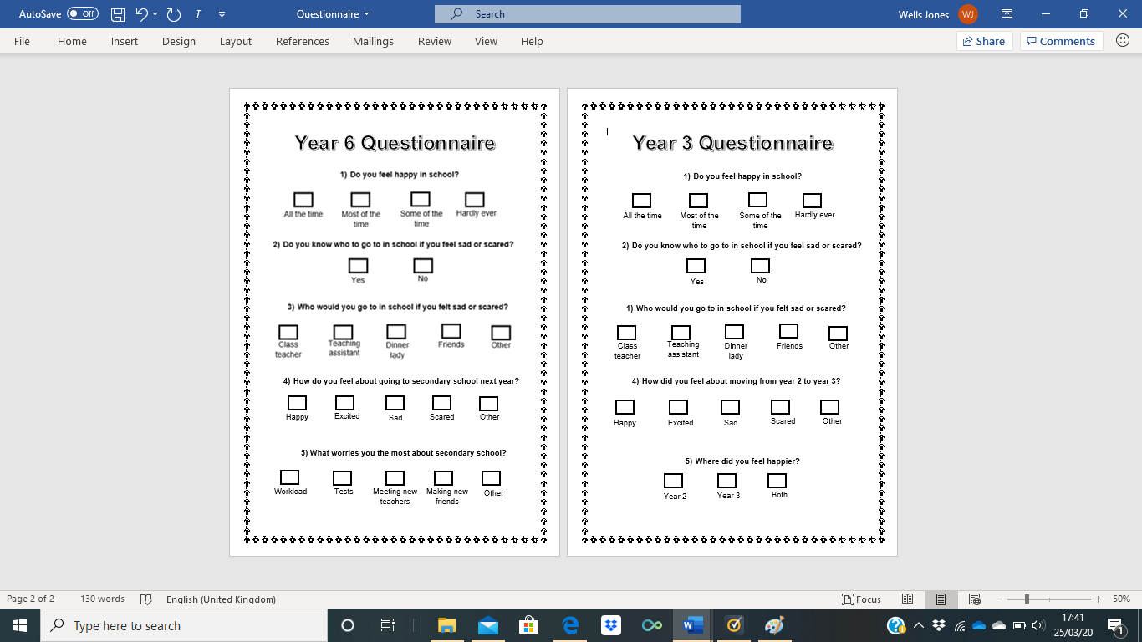
Appendix 3 – Questionnaire Year 3
Appendix 4 – Questionnaire Year 6
Appendix 5 – Data Analysis of Year 3 Results to Questionnaire

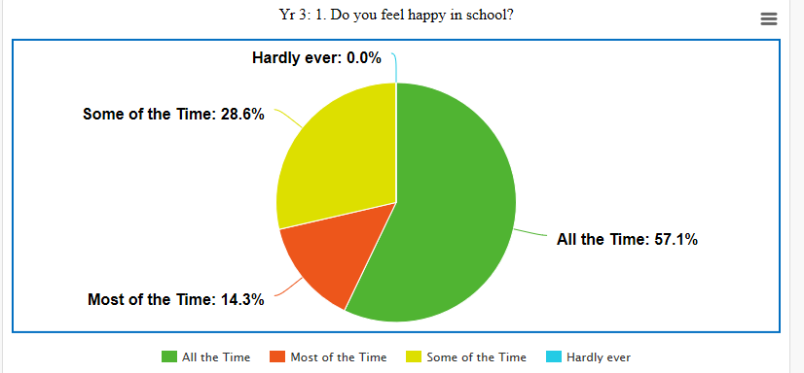
- Do you feel happy in school?

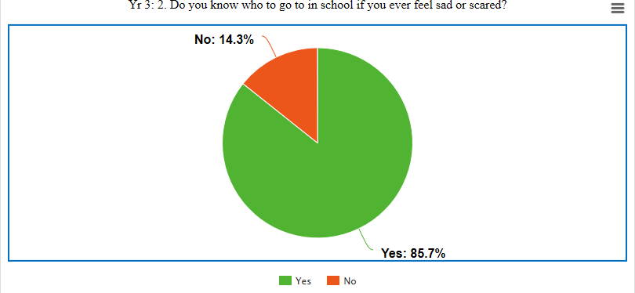
- Do you know who to go to in school if you ever feel sad or scared?

- Who would you go to in school if you felt sad or scared?

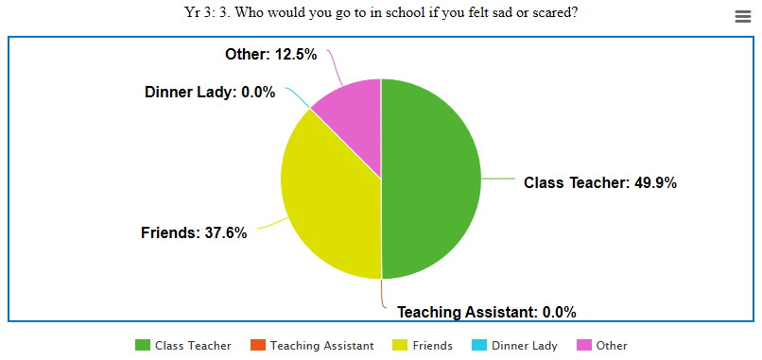

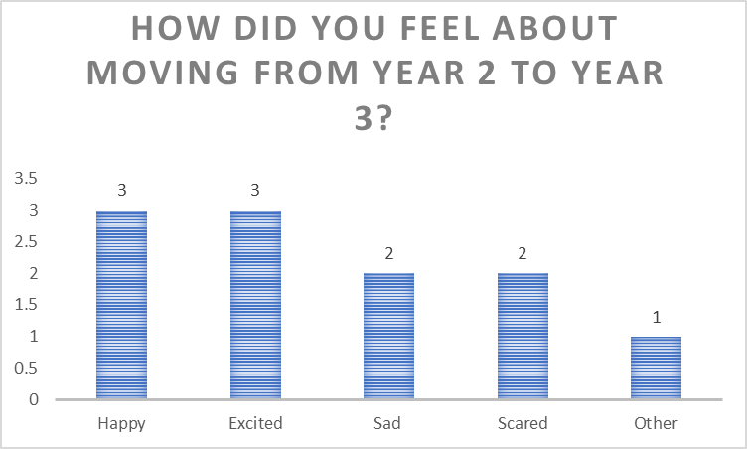
- How did you feel about moving from Year 2 to Year 3?

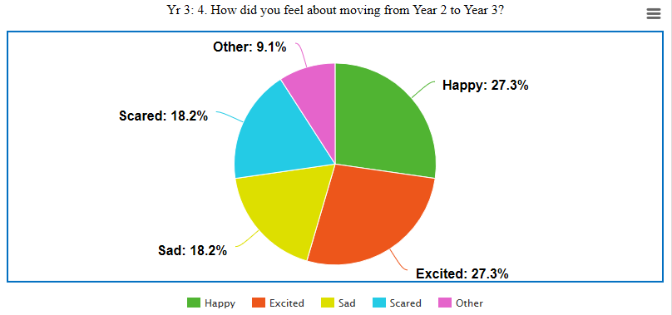

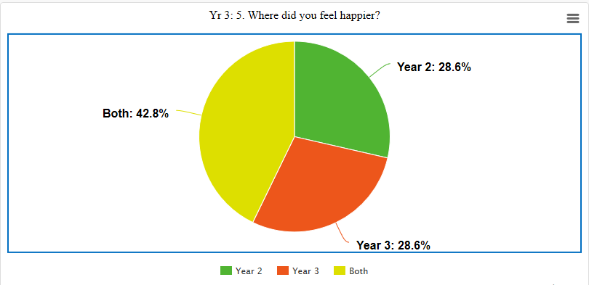
- Where did you feel happier?
Appendix 6 – Data Analysis of Year 6 Results to questionnaire
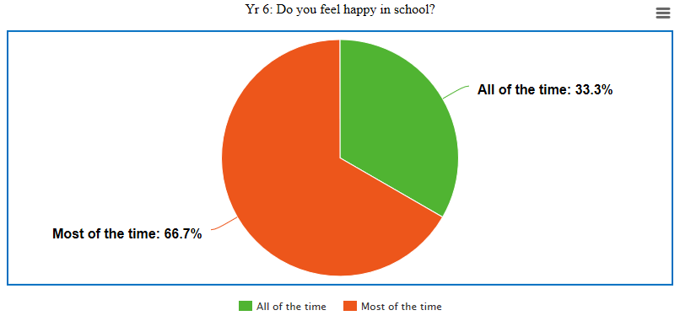
- Do you feel happy in school?

- Do you know who to go to if you ever feel sad or scared in school?
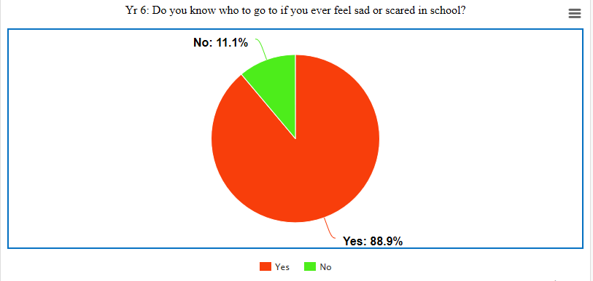

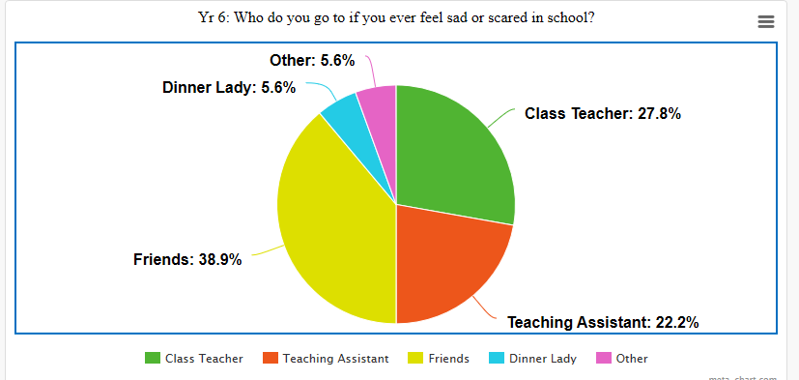
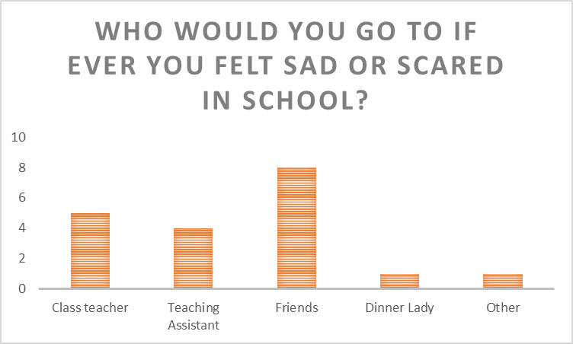
- Who would you go to if ever you felt sad or scared in school?

- How do you feel about going to secondary school next year?
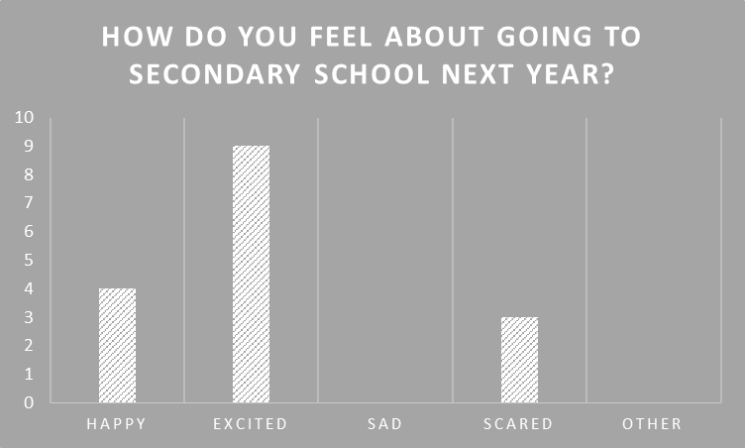

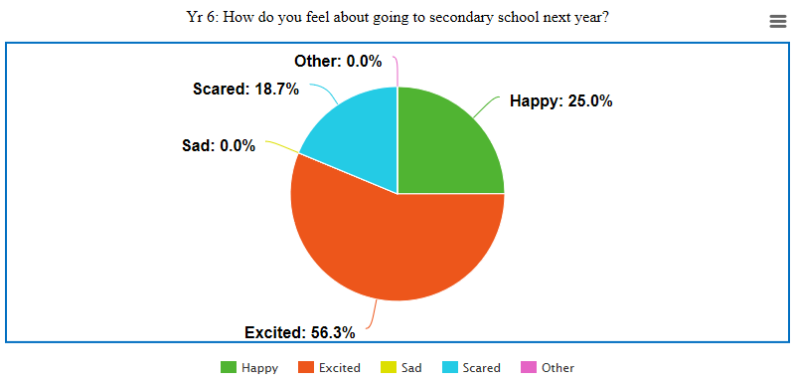

- What worries you the most about secondary school?
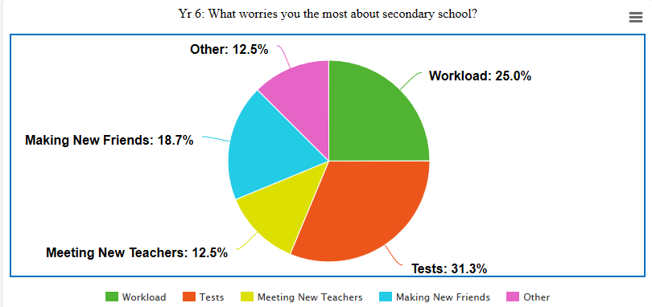
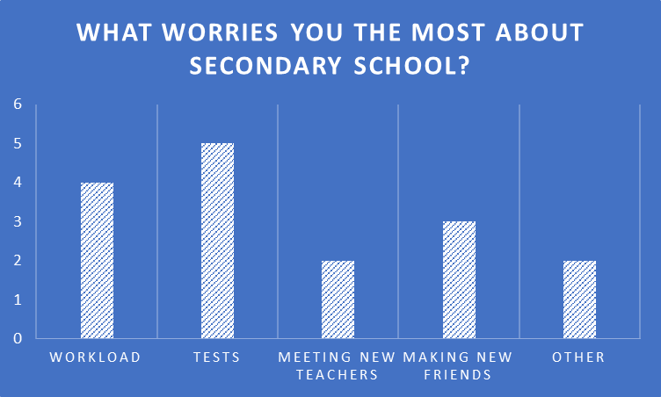

Appendix 7: Year 3 Focus Group Transcript

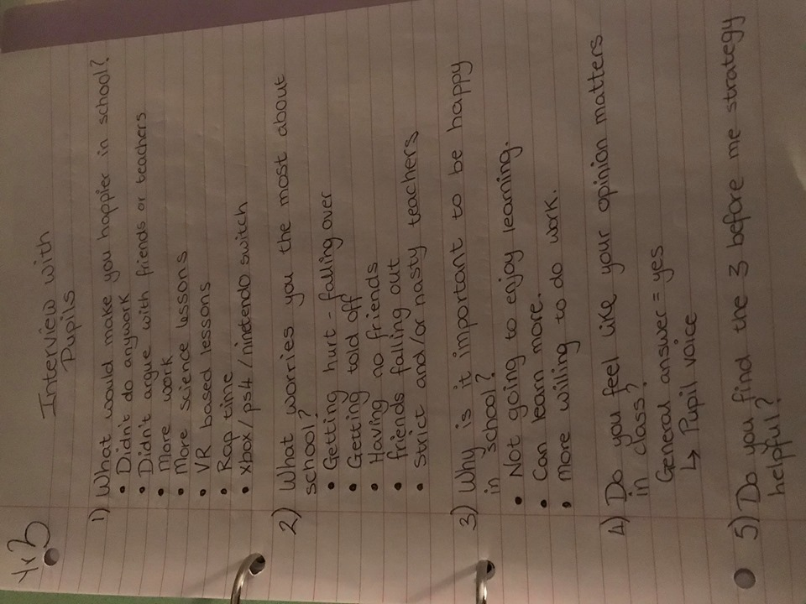

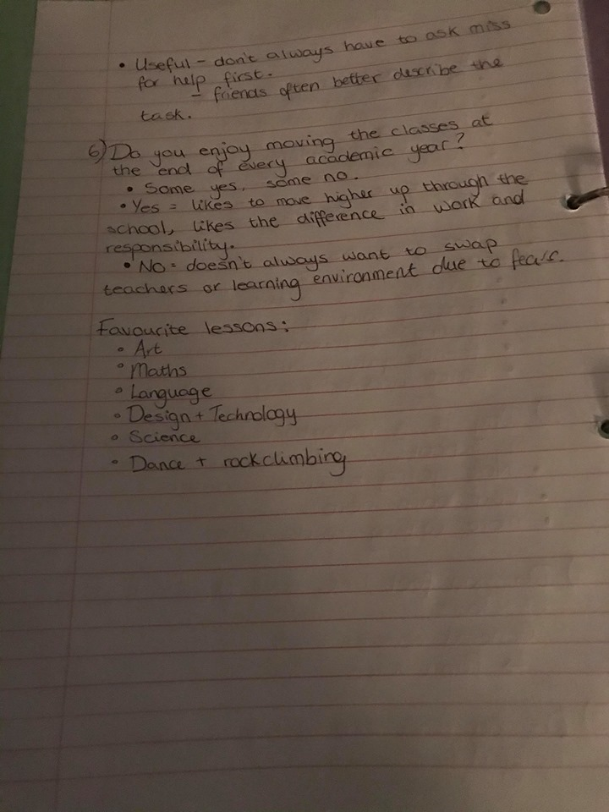
Appendix 8: Year 6 Focus Group Transcription

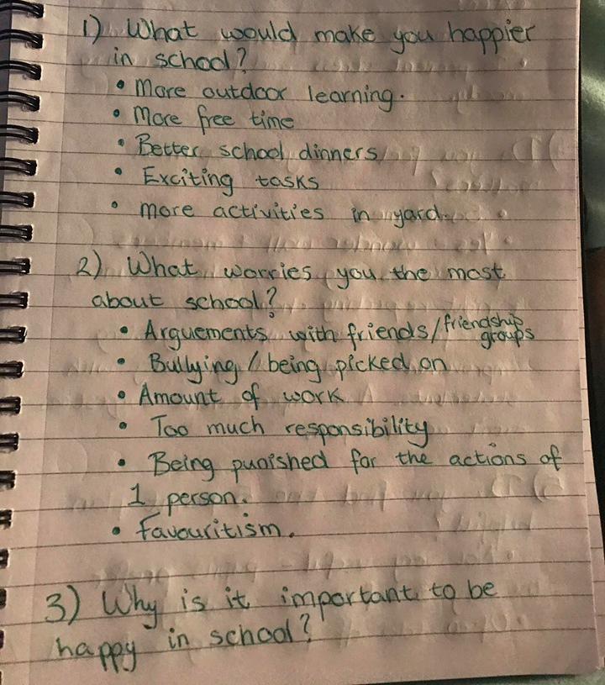
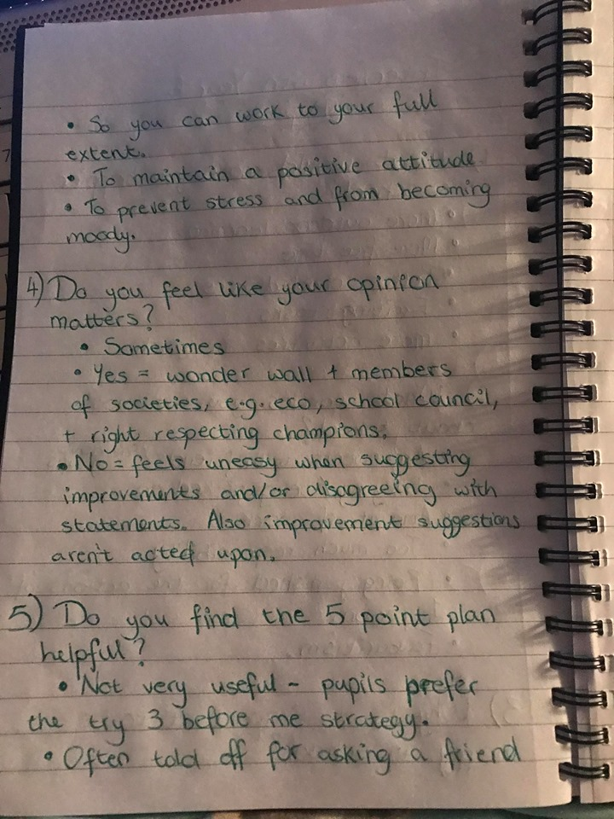

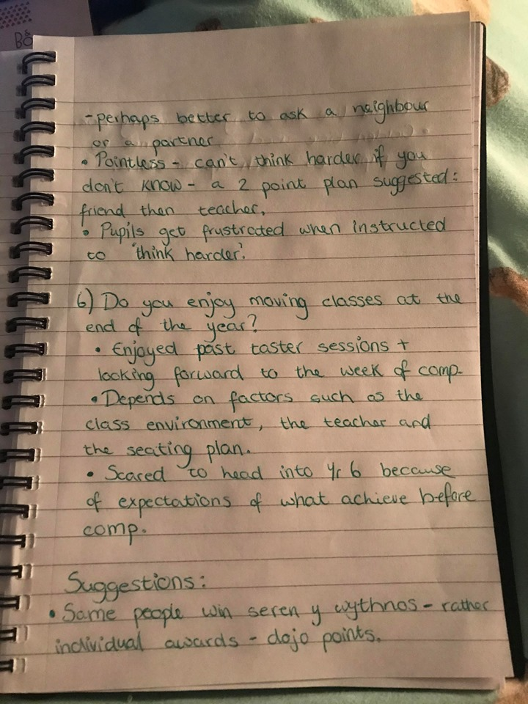

Appendix 9: Interview with Transition Lead
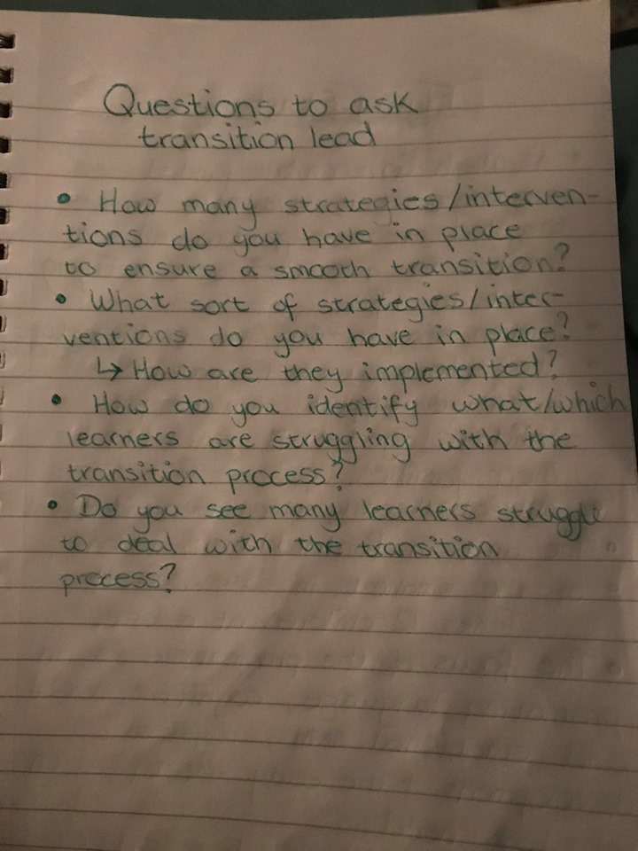

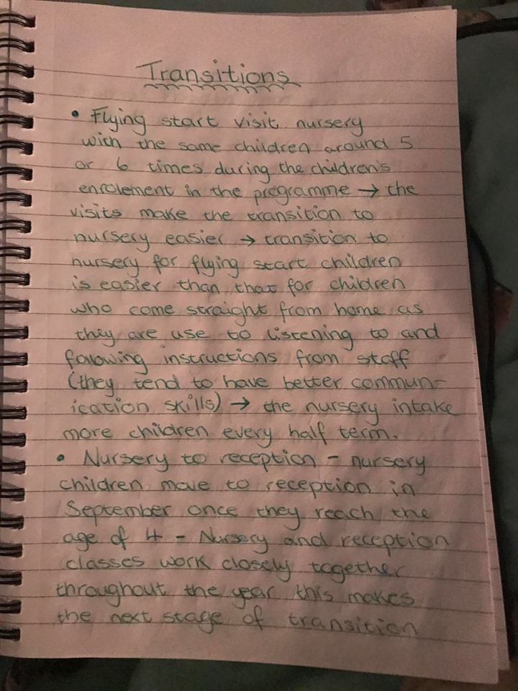
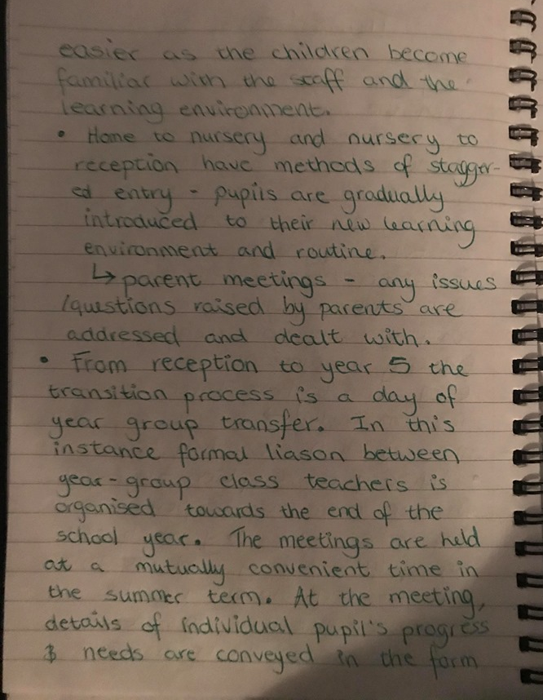
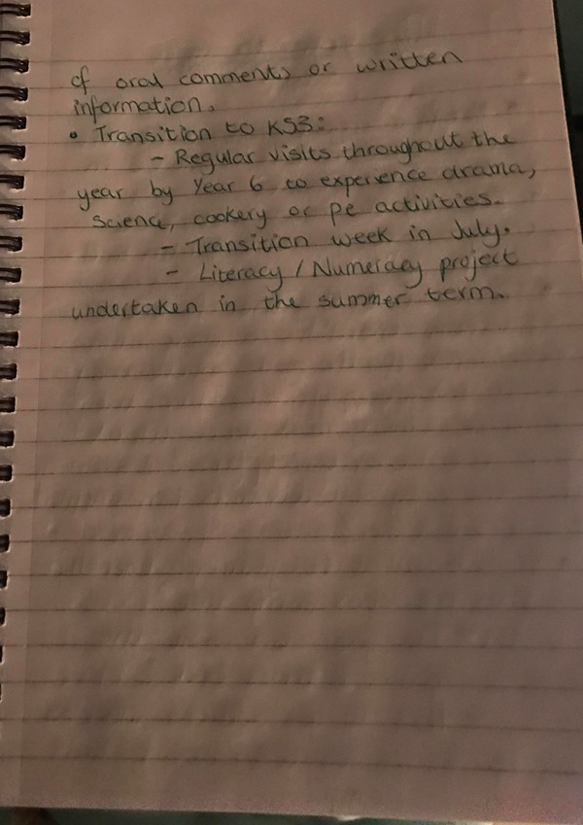

Appendix 10: Interview with ALENCO
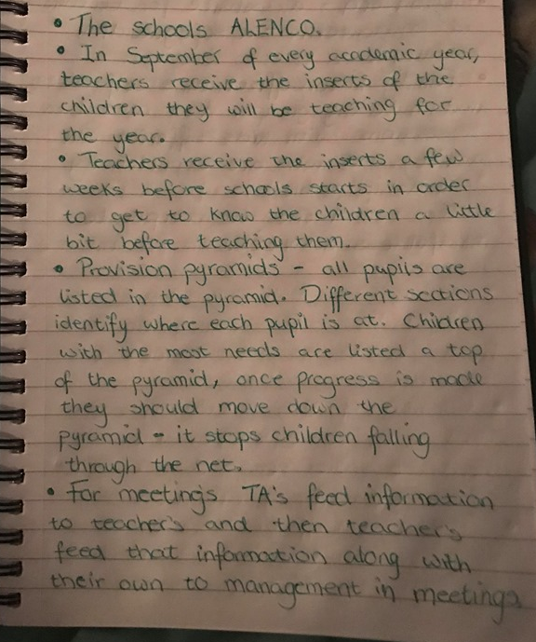

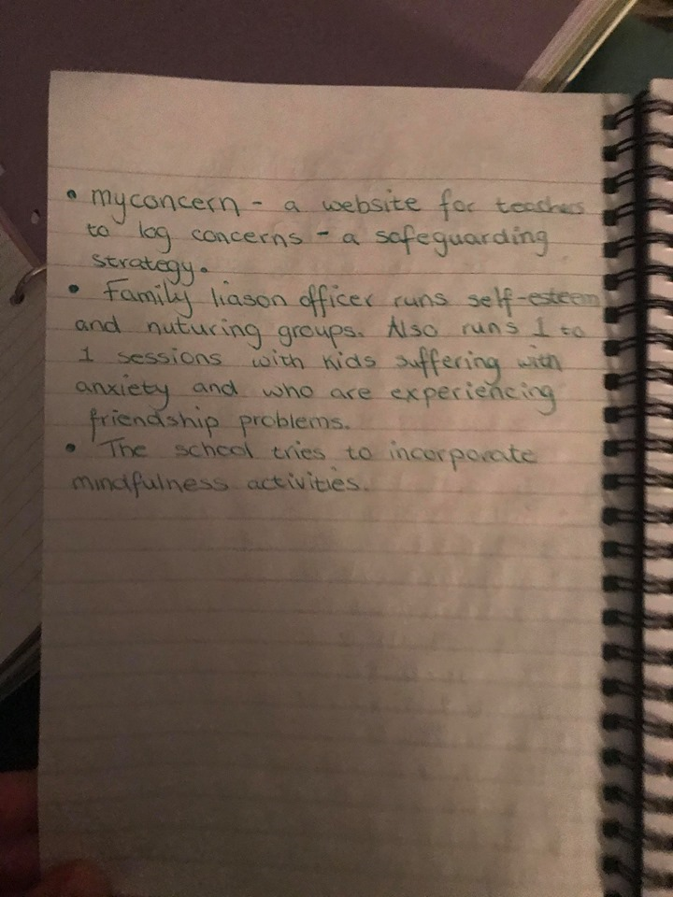

Appendix 11: Interview with family liaison officer

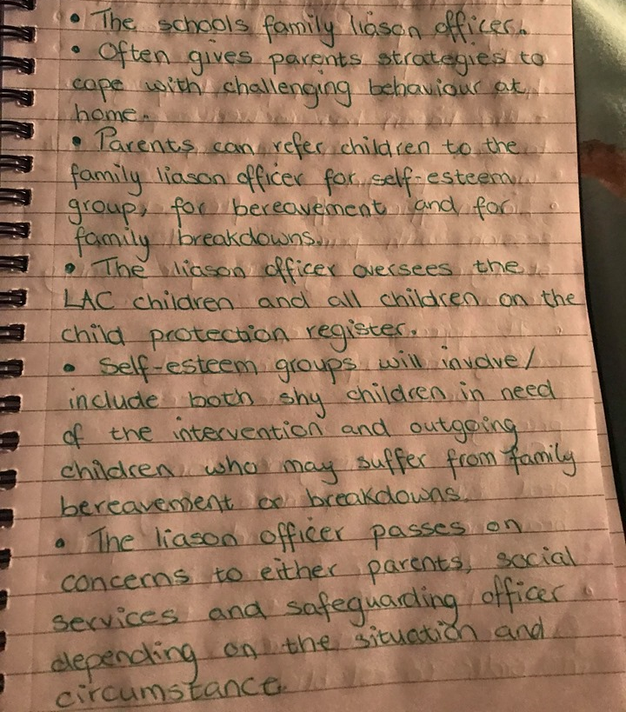
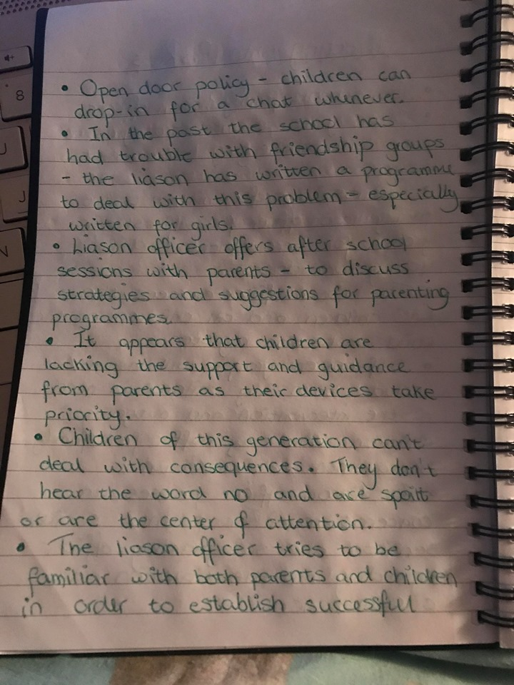

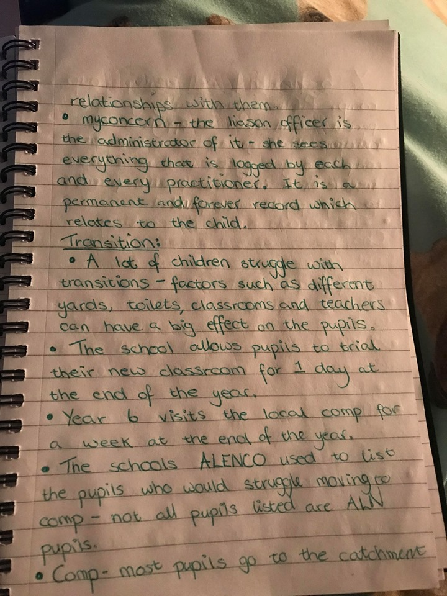

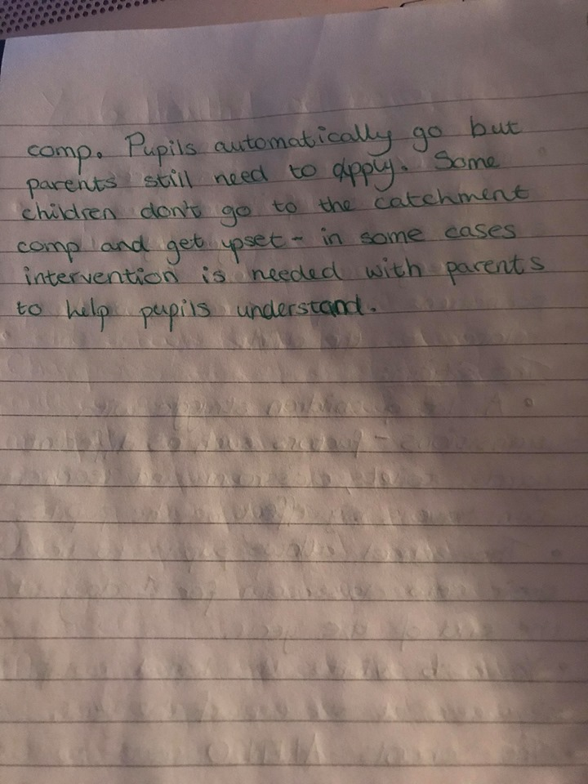

Appendix 12: Report on School A

Elective School Report
Introduction:
The purpose of this elective school report is to identify how well the school in question supports pupil’s well-being during periods of transition. However, the focus of this report will be on the well-being strategies implemented throughout the year groups in the school. This report will take the form of an Estyn report on effective practice, with my personal observations and research contributing to the overall report.
School Context:
The school in which this report is based is a primary school which is located in the city and county of Swansea. At the time of last Estyn inspection in 2018, the school had 481 pupils aged three to eleven years on roll. The school is made up of 16 single-year classes, including two nursery classes. The ethos of the school is “everyone is unique, everyone is important, everyone deserves the very best”. The pupils at this school are proud of their learning environment and show high levels of engagement during lessons and other learning experiences. In their last inspection, Estyn found that pupil focus groups contribute increasingly well to the life of the school and nearly all pupils show a good understanding of their rights and responsibilities as ethical and informed citizens. The school is also currently a pioneer school for health and well-being and is working with the Welsh Government and other schools to proceed with developments relating to professional learning.
Discussion:
The initial purpose of this elective experience was to identify what well-being strategies and/or interventions were in place at this school and how these strategies can or may be used to support pupil’s mental well-being during periods of transition. This information was acquired through qualitative and quantitative research methods. Research methods such as questionnaires and interviews were the most popular methods of research used during the elective experience and it appeared to be the most promising way of gathering the relevant data needed for pending research projects. A large sample of pupils were used for initial research; however, a focus group was then selected to provide further detail on the relevant topics, strategies and scenarios. As the school is a pioneer school, it has already made an incredible amount of progress towards ensuring the needs whether they be emotional, spiritual or physical are met.
Findings:
During the elective experience, I was fortunate enough to see what resources each classroom contained regarding the promotion of positive well-being amongst the pupils. The Foundation Phase classrooms contained many different resources which appeared to be purposeful, well used as well as well-liked by the pupils. Resources such as ‘worry monsters’, ‘the power of yet’ and the meditation exercises were particularly popular with the pupils. They were able to explain the purpose of each resource as well as expressed an enjoyment in using them and comfort in having them readily available. KS2 also have several resources in place which encourage positive well-being as well as resilience: resources such as the power of yet and the 5-point plan. Upon first glance it appears as if the Foundation Phase have more strategies and interventions effectively in place than that in KS2. However, that may be due to the fact that the needs of pupils of a younger age are often more visible, therefore, so is the resources in place to meet the needs of these pupils. Upon further discussion and inspection, I was able to identify that whilst KS2 often don’t have well-being resources presented visually in the classroom there are resources readily available around the school. The mindfulness shed is an example of this: something that was in fact suggested and designed by the pupils.
The transition plan that the school follows is also successful in assuring that the comforts and the needs of all pupils are met as they move classes, learning environments and teachers. Particular attention is given to the pupils as they enter the nursery, enter KS2 and start KS3. The school is also very fortunate to have a family liaison officer who resides in the school and has an open-door policy to allow pupils no matter the concern or circumstance. Furthermore, the school is very well equipped when dealing with all matters of pupil well-being. The only possible development that I can recommend in order to further develop pupil’s well-being in KS2 is by introducing a worry box and perhaps altering the 5-point plan. Yet, this school places great emphasis on the well-being of its pupils and indeed its staff. The matter of well-being is at the centre of everything that is done in the school.

I would like to thank everyone for giving me the opportunity to share my experiences with you. I would also like to thank all members of the school (staff and pupils) for their help, guidance and support offered throughout my elective experience. Due to everyone’s support, guidance and participation I have successfully gathered data that will inform my extended essay project at UWTSD.

