University of Wales Trinity Saint David
School of Engineering
Engine Design Report
Joshua Upson
P149438
04/11/19
Advanced Engine Design
M6X00410
Malcom McDonald

Table of Contents
1. Introduction 1
1.1 Aims 1
2. Background Research 2
3. Results for production engine 3
4. Results for Modified engine 8
5. Conclusion 9
6. Appendix 10
6.1 1500 RPM 10
6.2 1700 RPM 11
12
6.3 2000 RPM 13
6.4 2500 RPM 14
6.5 3000 RPM 16
6.6 3500 RPM 17
6.7 4000 RPM 19
6.8 4500 RPM 20
6.9 5000 RPM 22
7.0 5500 RPM 23
7.1 5700 RPM 25
7.2 6000 RPM 26

Introduction

Aims
The aim is to conduct numerous calculations on the Ford sigma 1.6 engine on major structural components. This will include calculating the peak gas forces, net compressive force on the rod, net tensile load on the rod, maximum compression and tensile stresses in rod shank, nominal static safety factor and compression distance and stretch within the engine. The calculations will be done for a production engine and a modified engine.

Results for production engine

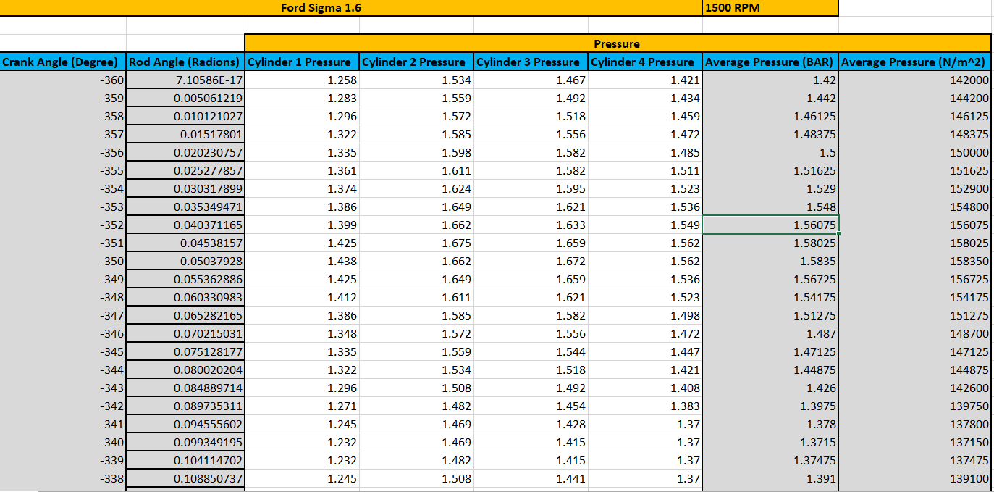
Once the required data was acquired for the cylinder pressures I was able to work out the average pressures within the engine for each degree of crank movement which would allow me to work out the peak gas forces.

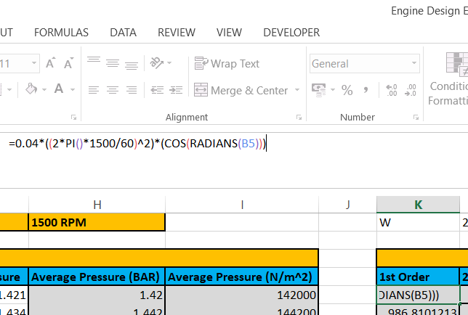
The acceleration of the piston is then needed to be worked out and to do so firstly the 1st order acceleration and the 2nd order of acceleration. The 1st order of acceleration is worked by firstly:
=crank throw (1/2 stroke) COS Crank angle
The 2nd order is worked out by:
=Crank throw/rod length * crank throw COS2 Crank angle
This then allows acceleration of the piston to be worked out. This then allows for the vertical acceleration to be worked out to allow the peak gasses to be worked out. The vertical acceleration is worked out by just adding the 1st order acceleration with the 2nd order.
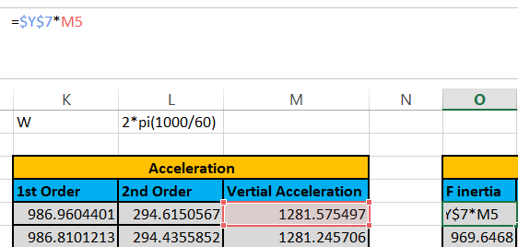
The 1st force can then be worked out which is the Finertia and this is done by multiplying the total weight of the piston by the vertical acceleration to work out the inertia force for each degree of crank angle.
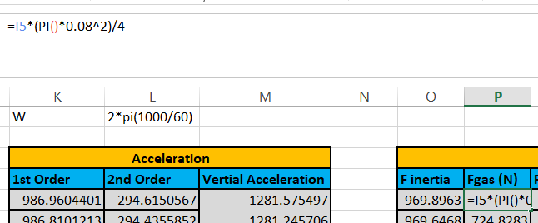
The Fgas is then worked out by the average pressure (Worked out before) multiplied by the bore area which would give us the total gas force for that degree of crank angle.

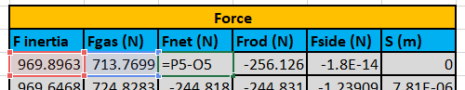
The net force can then be worked out which is the gas force take away the inertia force which in result will give us the total net force for that degree of crank angle.
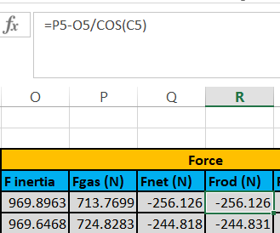
The force on the rod can then be calculated by:
Fgas – Finertia /COS (Rod angle)
This allowed the total force on the rod at that crank angle to be worked out for each degree of crank movement.

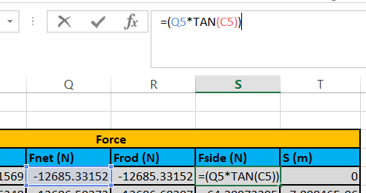
The Fside can then be worked out which is the force acting on the side of the piston. This would be done by:
Fside = Fnet*TAN(Rod angle)

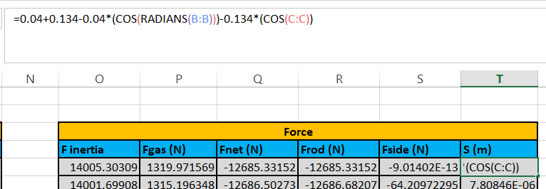

First of all for the distance of the piston movement the values for the crank throw and length of the connecting rod is needed. I used 0.04m for the crank throw and 0.135m for the length of the connecting rod. The crank throw and the length are then multiplied against the crank movement and rod angle degree movement. The total peak forces have then be worked out for each degree of crank movement. This then can be used to further analyse the engine and allow design of the engine.
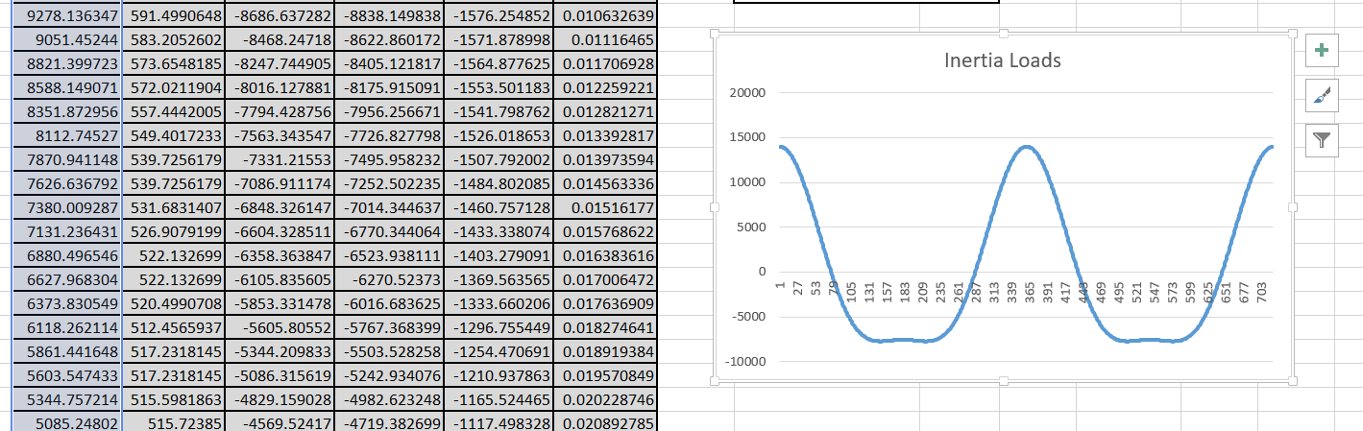
The inertia loads are then worked out for each degree of crank angle by just graphing the Finertia column against each degree of crank angle and this would allow to show the inertia force which the piston put on the rod at each degree of crank movement. This allowed to show that more load is put on the rod if the RPM is increased.
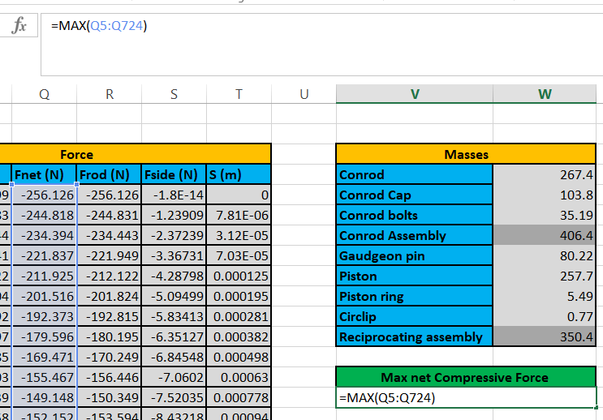
The max net compressive force can then be worked out which would give us the most amount of compressive force given at that RPM. This is worked out by using a function to find the MAX value for the net force in the engine.
=MAX(Fnet column)

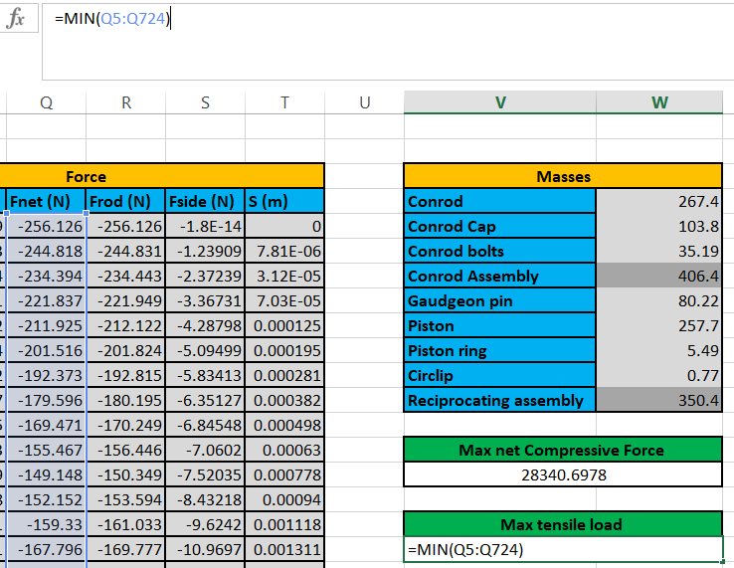
The max tensile load can then be worked out which will work out how the engine can withstand a pulling force. This is worked out by using a Min function in excel to work out the min value within the Fnet column and therefore give the max tensile load.

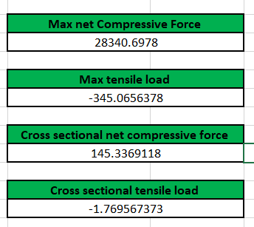
The cross sectional net compressive force and the cross sectional tensile load is then needed to be worked out and this is done by just dividing the 2 original values by the cross sectional area which is 195mm. this then gave the values.

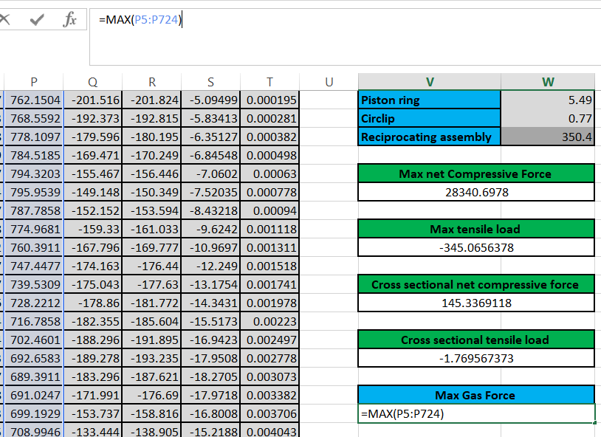
The safety factor has then got to be worked out and to do that firstly the max gas force and the nominal stress is needed. The max gas force is worked out by finding the maximum value in the Fgas column by using the MAX function as used before.

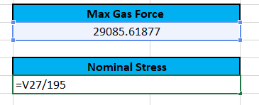
The nominal stress is then worked out by dividing the max gas force by the cross sectional area and this will allow me to work out the safety factor at the required RPM.

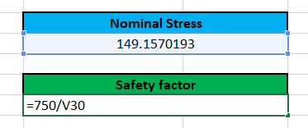
The safety factor can then be worked out by UTS/nominal stress. This then gives the safety factor for the RPM. Which shows how much stronger the engine is at the RPM beyond the actual loads.

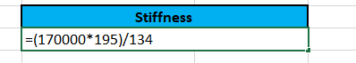
The stiffness of the engine can then be worked out at the rpm by (Young modulus * Cross sectional area)/the rod length.
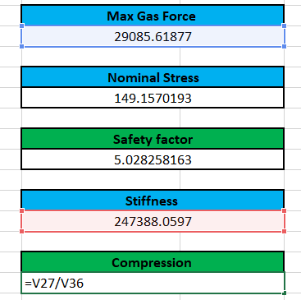
The compression of the engine at the specific rpm can then be worked out which is done by dividing the max gas force by the stiffness.

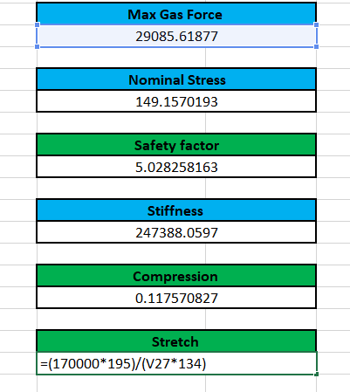
The stretch of the engine can then be worked out to show the strain of the engine which is worked out by:
(Young’s modulus * Cross sectional area)/ (Peak gas force * rod length)

This then completes analysing the production engine and therefore has worked out the max gas forces, max compressive/tensile load on the engine, cross sectional max compressive/tensile load, the safety factor, compression and the stretch of the engine at the particular RPM. This was then repeated for all RPMS as shown in the appendix.

Results for Modified engine
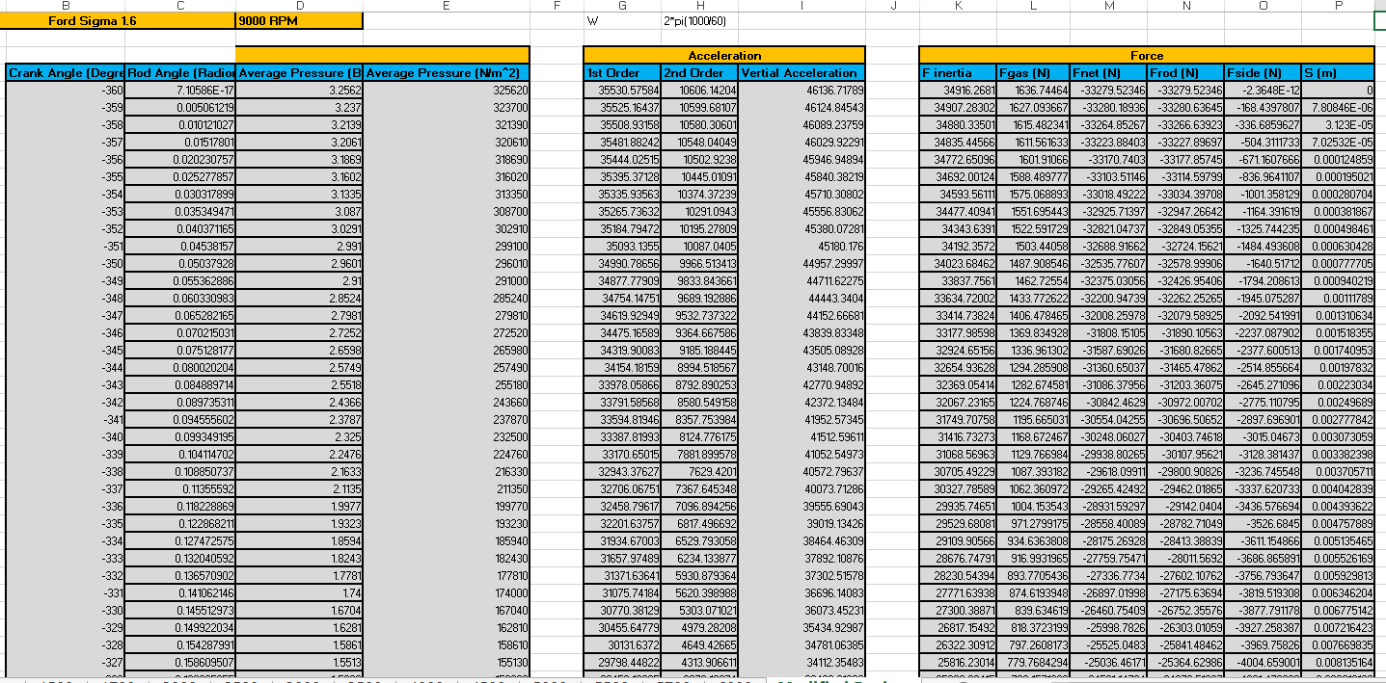
The analysing of the modified engine was done that same as the production engine however the RPM was set to 9000 RPM instead of stopping at 6000RPM to show the results for a modified (turbo) engine.

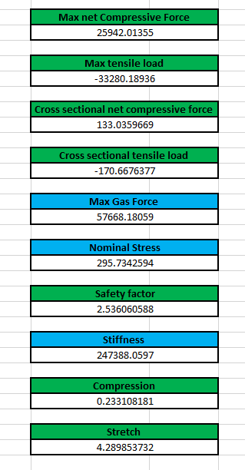
The modified engine has a lower net compressive force however a larger tensile load showing that the modified engine can withstand a higher tensile load then the production engine at a higher RPM. There is also a lower safety factor and this would be expected as the engine is put under more strain and force meaning there is a less amount of safety within the engine. The compression is higher and the stretch lower than the production engine showing that the engine is able to perform better but puts the engine at a strain and therefore has to work harder for the required output which is as expected.

Conclusion
To conclude by analysing the engine at each rpm set it showed how the forces increased or decreased as there was more power put through the engine it showed it coming under more stress and therefore is useful with the engine design. The production engine showed that the forces increased as the rpm increased with the safety factor and stress increase showing it’s under more strain and is working harder to produce the desired output. The modified engine pushed the engine to the limit showing the peak forces at maximum output with a low safety factor showing that it’s at peak performance

Appendix

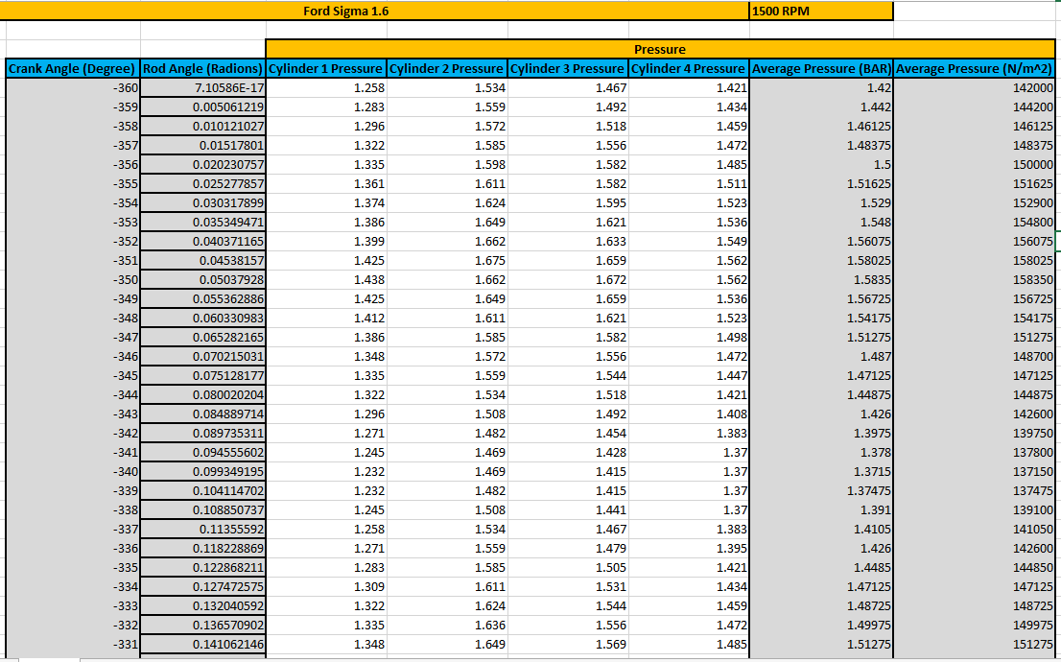
6.1 1500 RPM
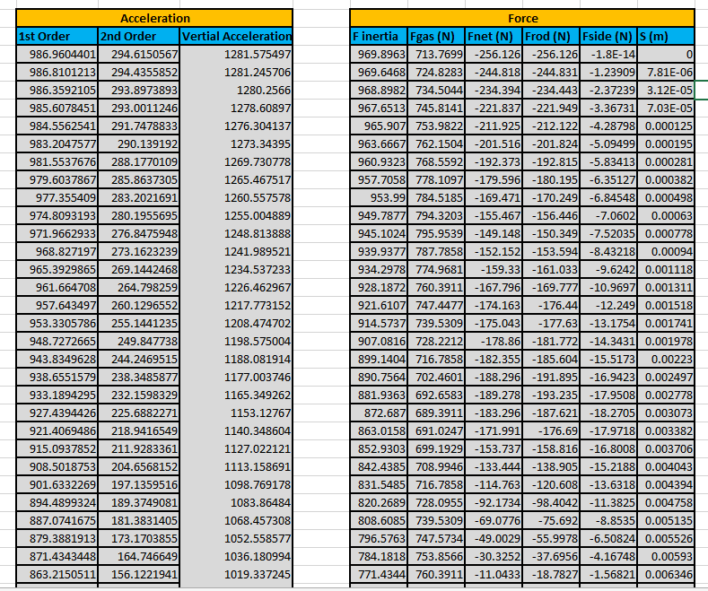

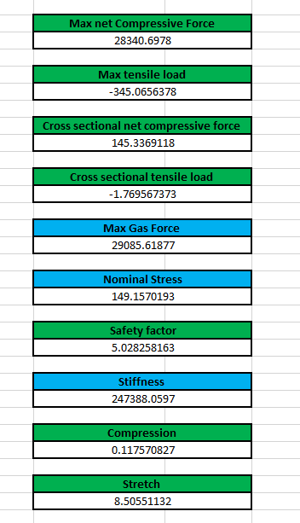

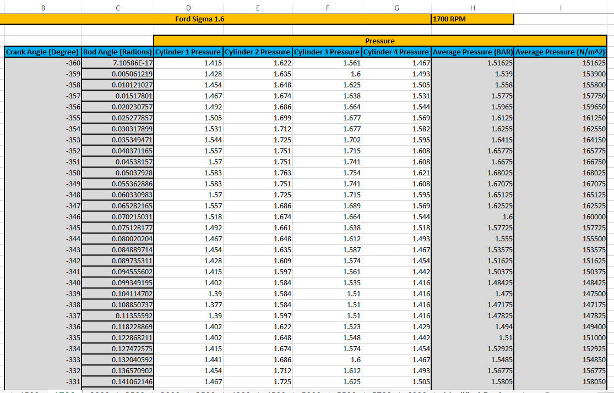
6.2 1700 RPM

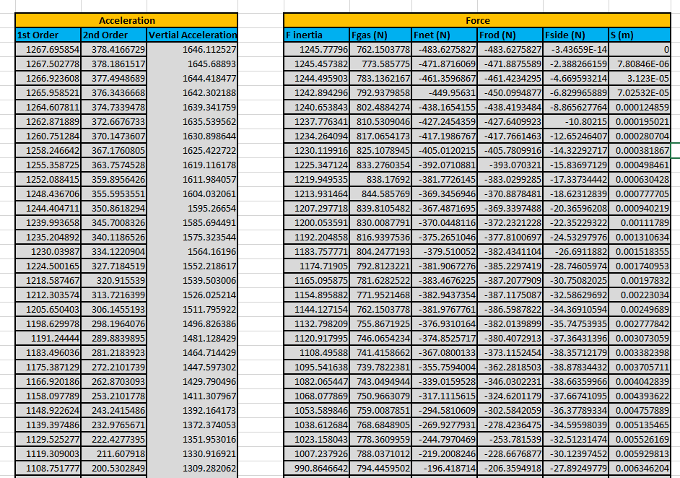

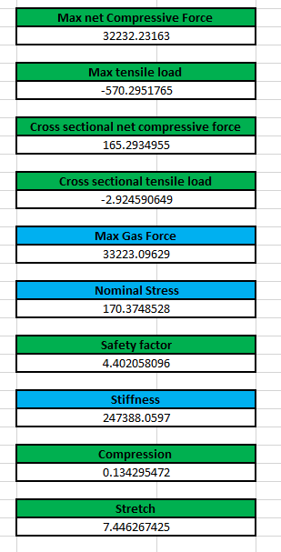

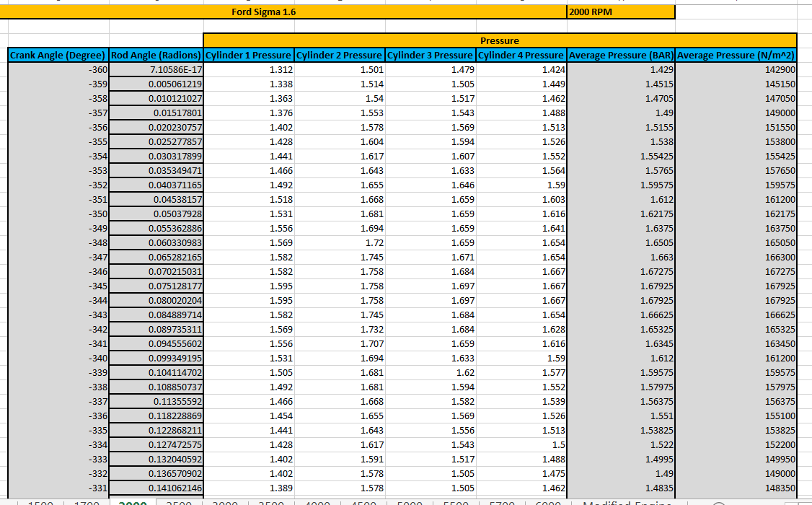
6.3 2000 RPM
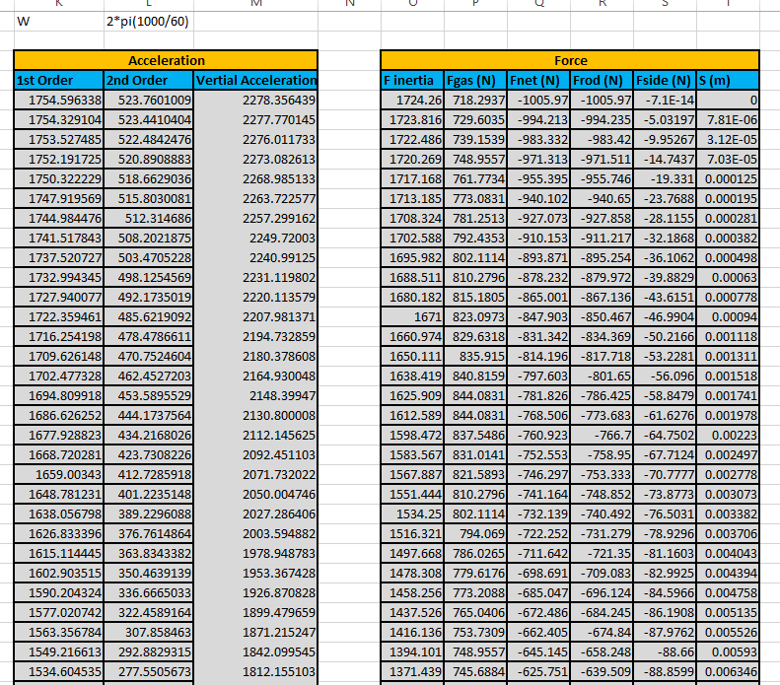

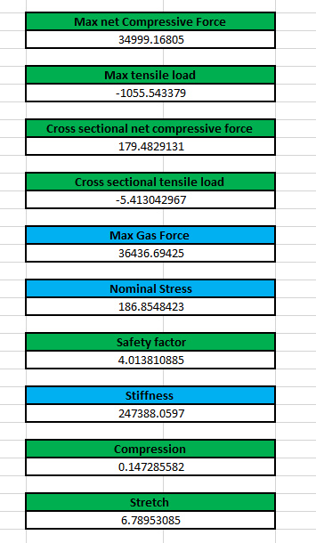

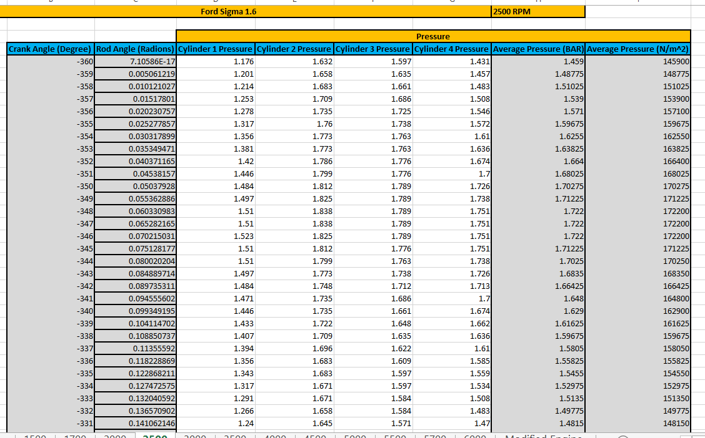
6.4 2500 RPM

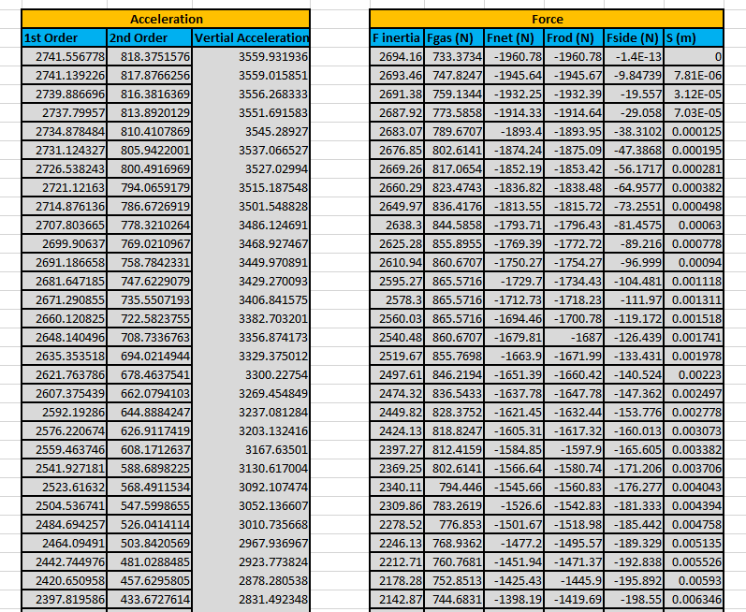

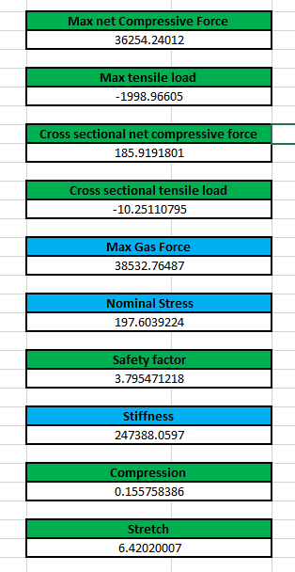

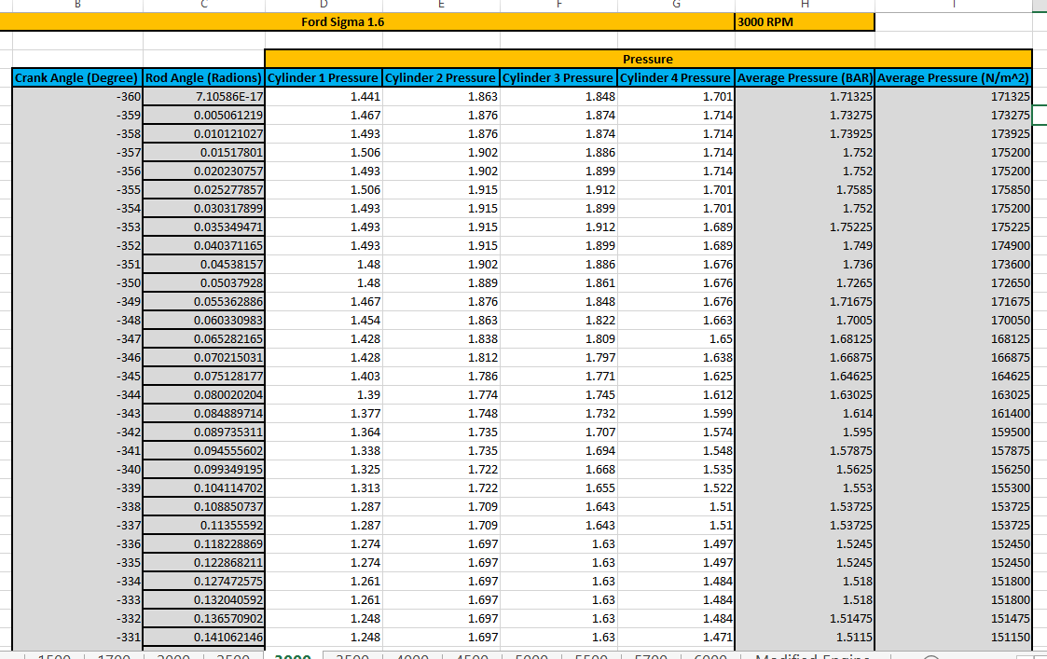
6.5 3000 RPM
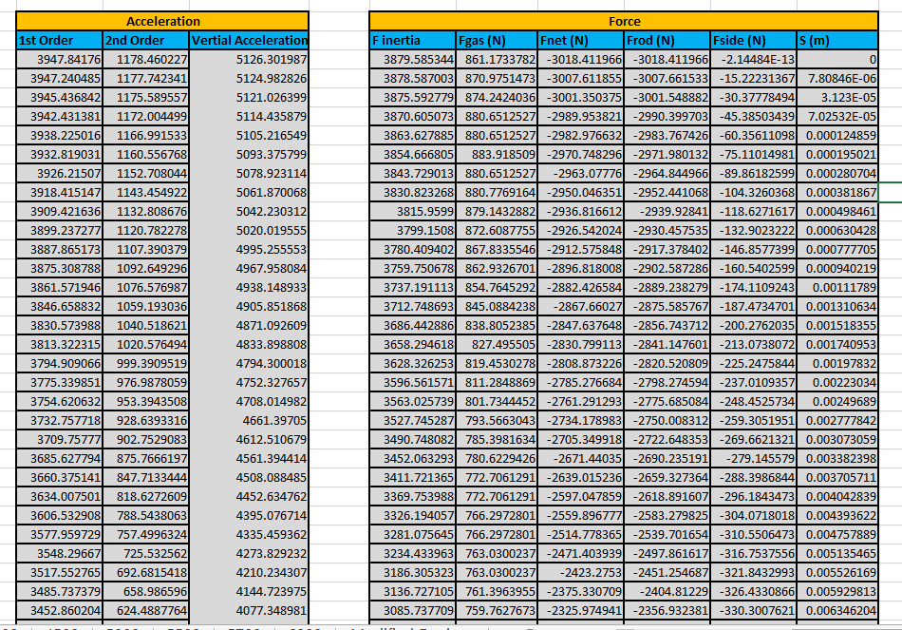

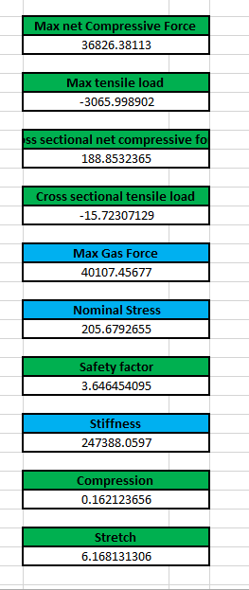

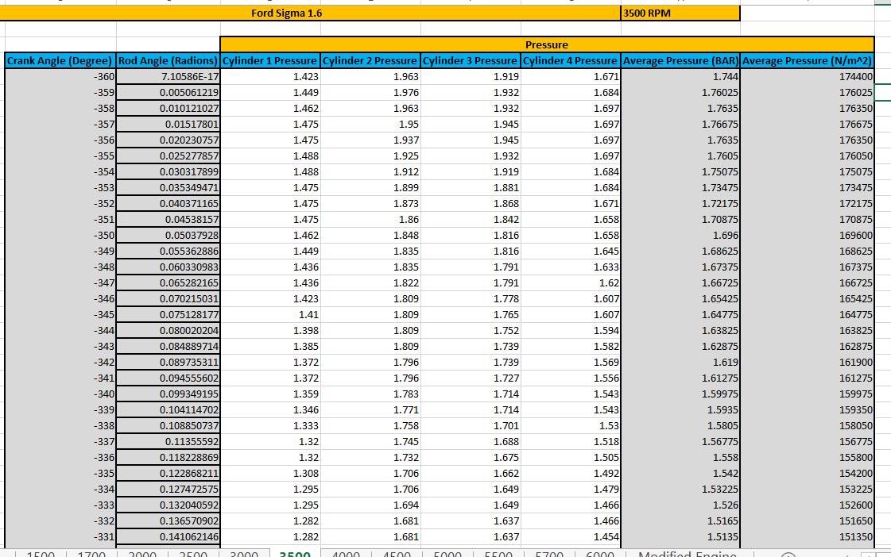
6.6 3500 RPM

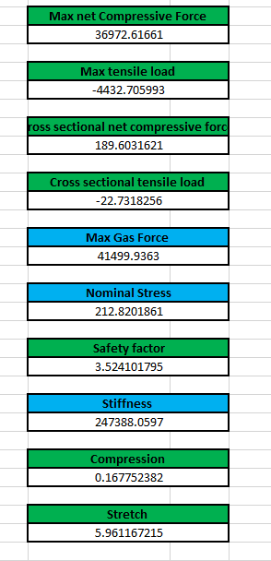
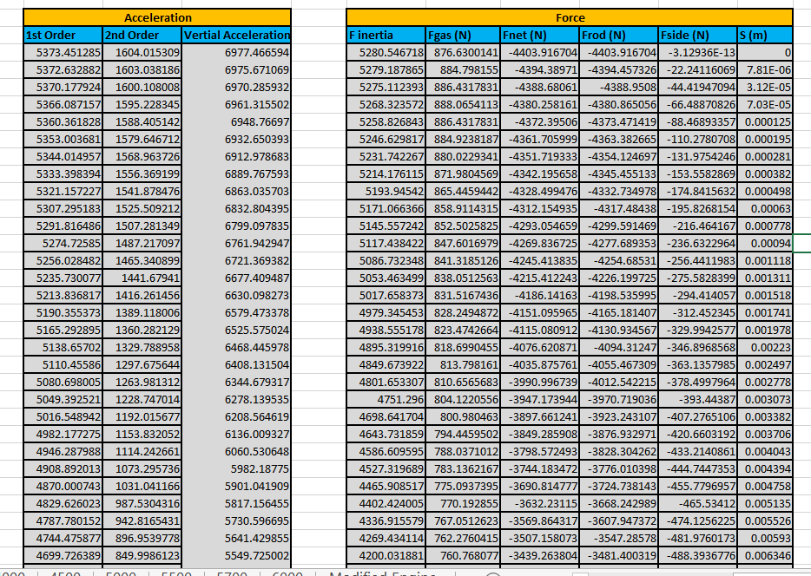

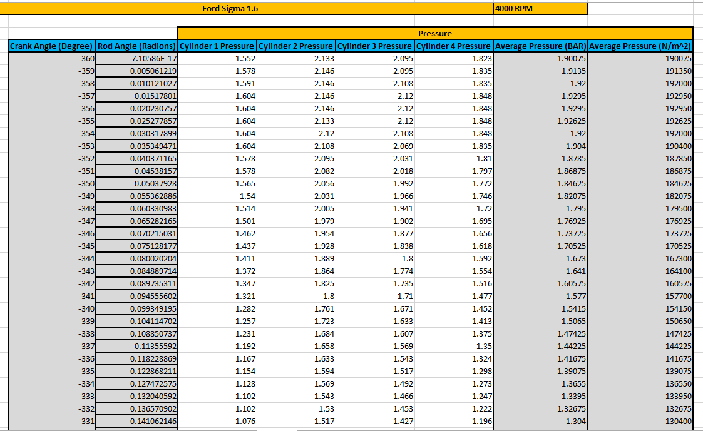
6.7 4000 RPM
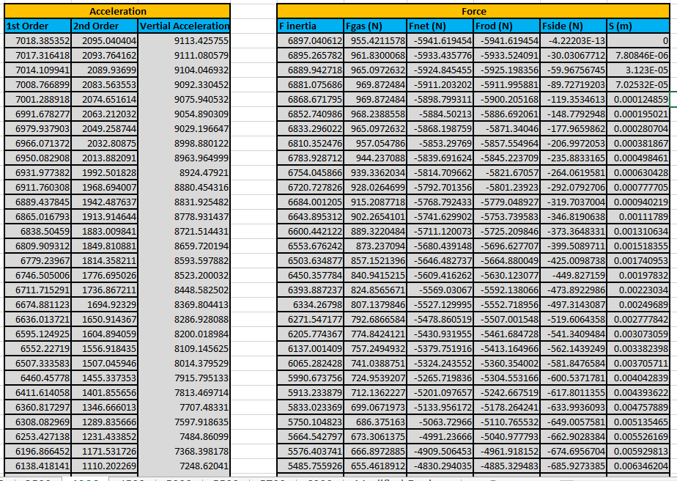

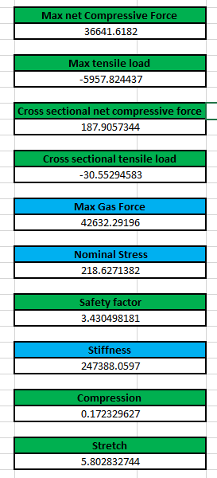

6.8 4500 RPM
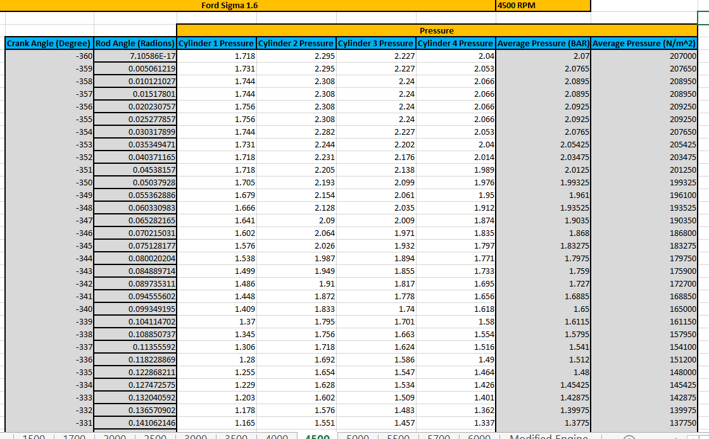

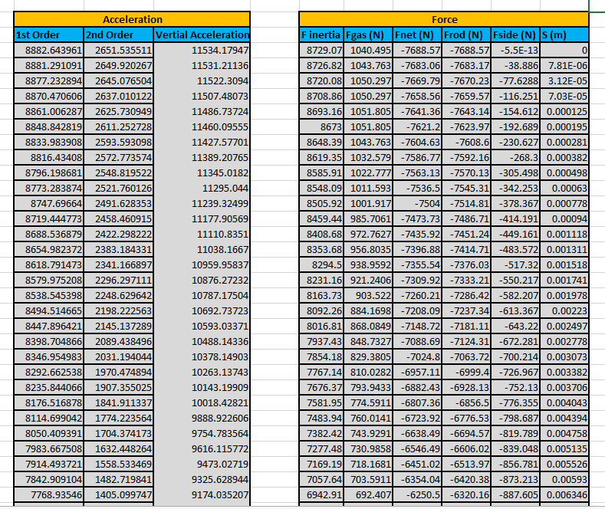

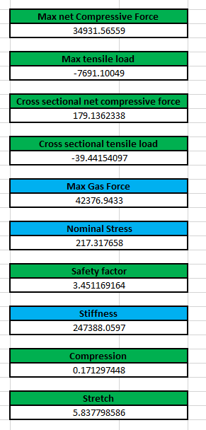

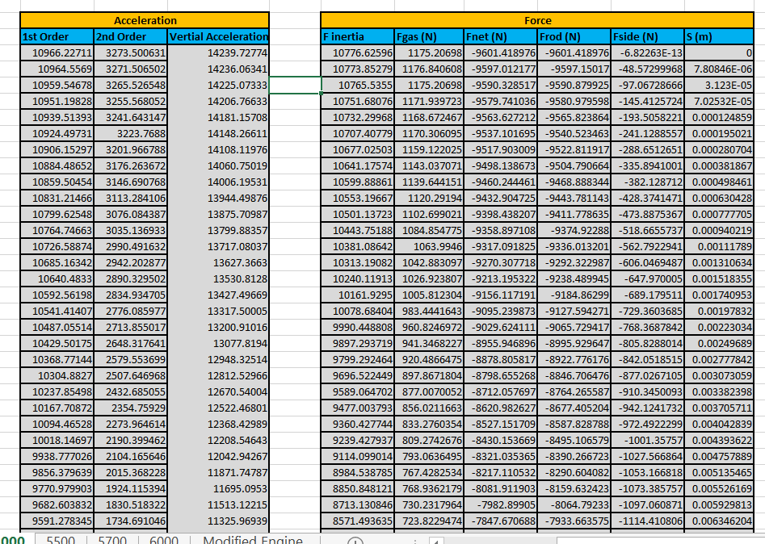
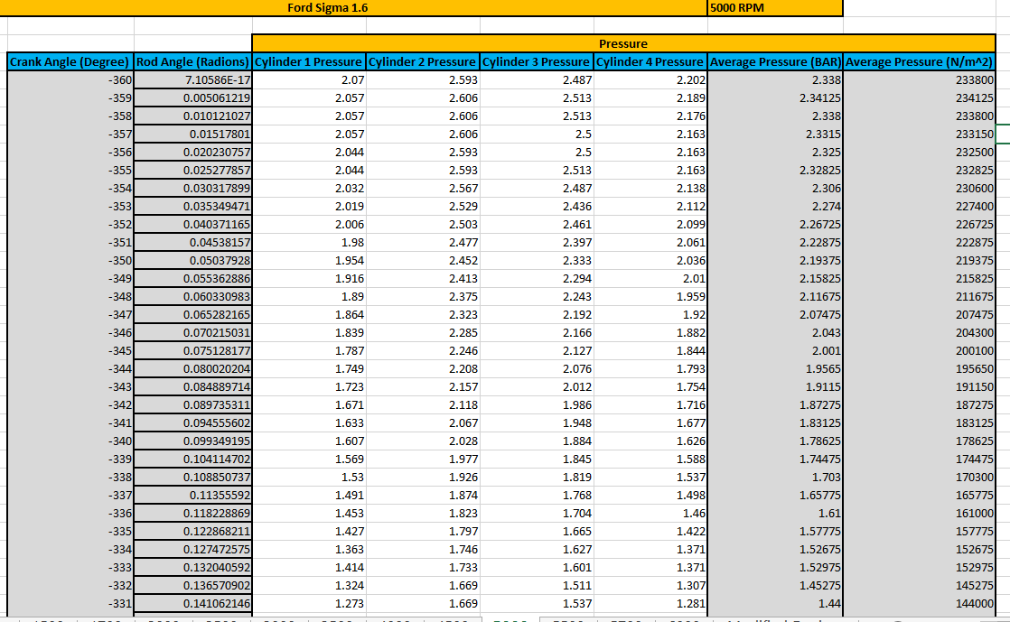
6.9 5000 RPM

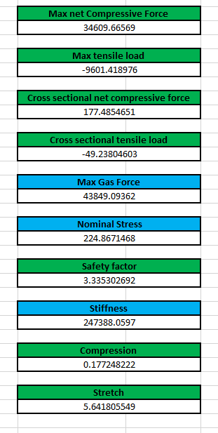

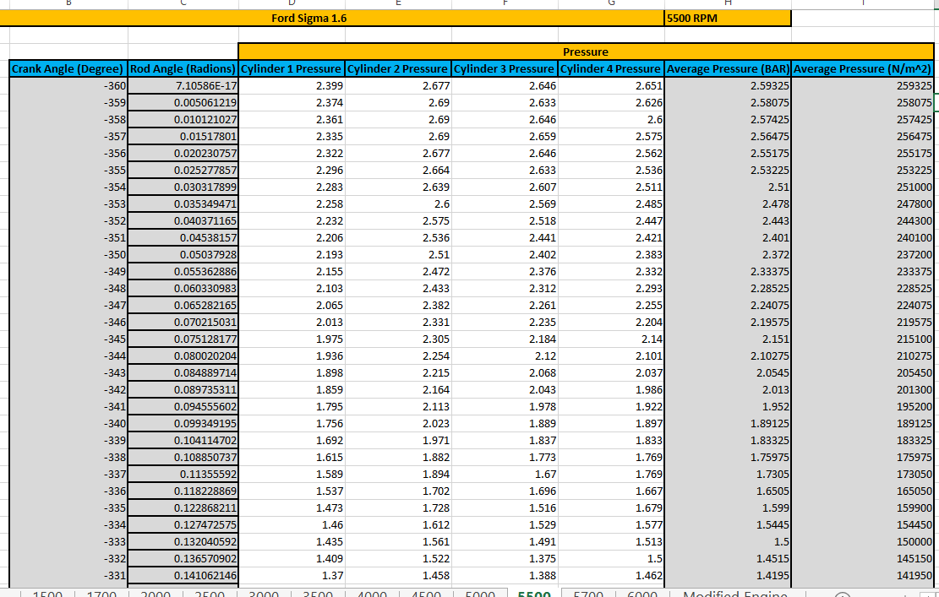
7.0 5500 RPM

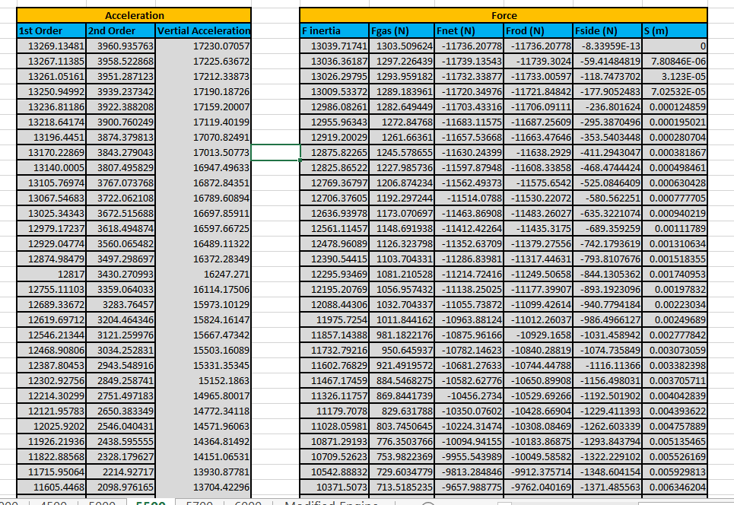
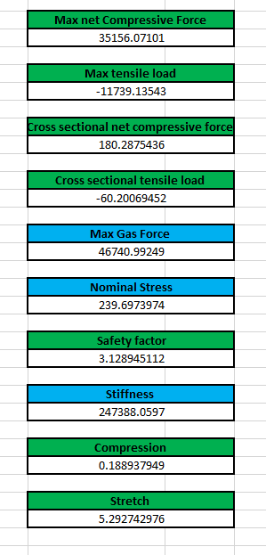

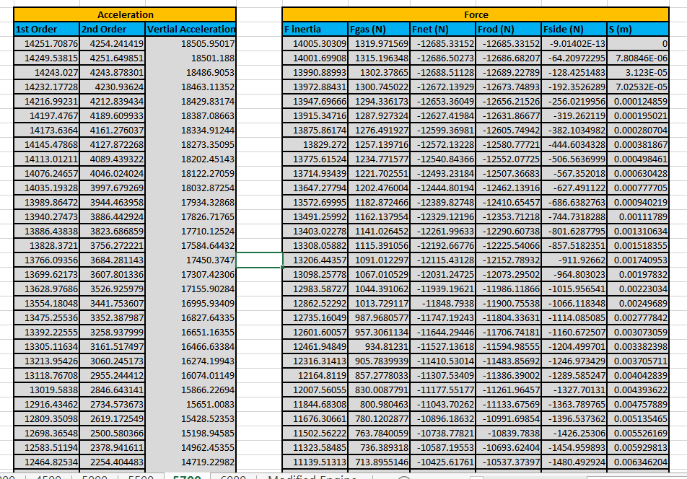
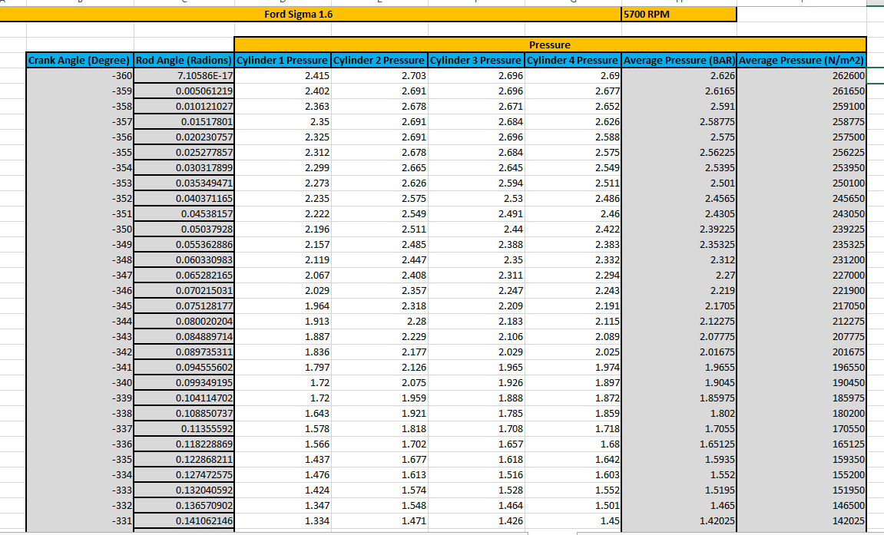
7.1 5700 RPM

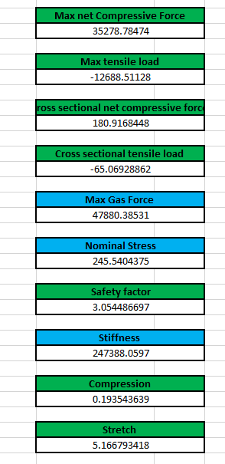

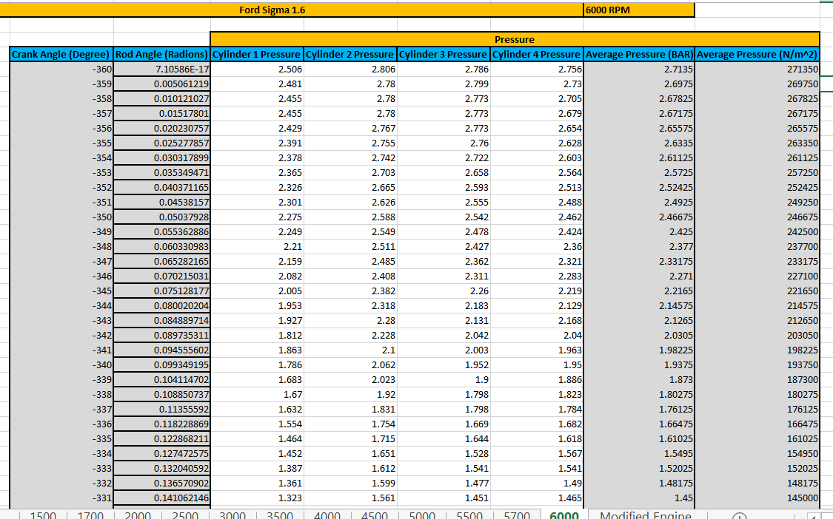
7.2 6000 RPM



