Written Business Plan
VIRTUAL ESCAPE CAFÉ
Masuma Begum (1915403)
Ricardo Alexandre (2025546)
Andrea Voros (2026576)
Module: Managing Enterprise in the 21st Century
Module code: BMSW 4006
Module Leader: Dr Oluwaseun Adegbite

Contents

Executive Summary 4
Business/Company Overview 5
Entrepreneurs-Partnership 6
Vision and Mission Statements 7
Product and Services 8
Market Audit: Competitors Analysis: 9
SWOT Analysis: 9
PESTLE Analysis: 10
Target market: 12
Formal Survey: 13
Survey Audit: 13
Promotional Vouchers: 14
Marketing Plan: 15
Management Team: 16
Financial Plan/ Cash flow forecast: 17
Profit and loss: 19
Conclusion: 21
Reference 22

Executive Summary

Business location, 18 Shopping centre, Birmingham, West Midlands B25 8YP. Virtual escape café has been running successfully for 15 months. The Business was founding by Masuma Begum, Ricardo Alexandre and Andrea Voros. The business is a Limited
liability company with a share capital. 3 shareholders each, total business investment is £60,000. Virtual escape cafe plans to expand in the worldwide market.
virtual escape cafe is open to anyone over the age 12years old and over, however anyone under the age of 12 years and under will need to be accompanied by an Adult 18years old and over. Virtual escape cafe available, age verification applies.
At Virtual Escape Café customers can play and socialize at the same time, Virtual café is a healthy option for people who are very much into gaming and enjoy meeting up to play together instead of feeling isolated and while playing at home alone.

Business/Company Overview

Virtual escape rooms are a fantastic way to stay connected as a team and have fun simultaneously in real place and enjoy refreshments. We have developed some of the best virtual escape rooms for you to play remotely using our Mobile Adventures app, and instore, no matter where you are in the world. The virtual escape room challenges incorporate clues, puzzles, augmented reality and more, and are designed to challenge your problem-solving skills while also incorporating the excitement of a traditional escape room experience.
Virtual Escape Cafe was established in 2021, main branch is located Birmingham City Centre, close to the city centre main car park, location of branch attracts majority customers. Virtual Escape Cafe has developed a large customer base since the company incorporated on 1st January 2021, the company is now working on a YouTube channel. The business is running successfully by four active employees with three partners
"In today’s environment, a business plan in an entrepreneurs most crucial business document. No company can expect to articulate its goals or to secure financing without a well-conceived and well- presented business plan." (Abrams and Kleiner, 2003)
Virtual escape café has partnered with Barclays bank to provide loans to their clients at 3.2% Apr maximum length over 5years, subject to credit search through Equifax.
The business opening hours are between 10am to 10pm.

Entrepreneurs-Partnership

“An intrapreneurship is a phenomenon of empowering the employees within the organization, by valuing their ideas and converting them into a profit-making model for the business. The organization would bear the associated risk and loss if the intrapreneur’s project failed.” (J, 2019)
Our Partnership and Entrepreneurship is the core of our business, we are working as a strong team to make our business thrive. We have each invested £15,000 each to start our business.3 business partners; Masuma Begum, Ricardo and Andrea Voros.
We are working as a team to ensure quality standards are achieved, employment legislation is thoroughly regulated.

Vision and Mission Statements

Our business vision is broader than its mission, and it offers a comprehensive overview rather than what it is at present. Our mission statement is to provide excellent gaming experience, while providing first class customer service. Diversification is at our heart of the business, we are open people of different gender, age groups, culture and fields. As a team at Virtual Escape Cafe, we have taken an Innovative Approach to succeed in our business. At Virtual Escape Cafe we have taken great care to ensure business journey is as smooth as possible by effective teamwork, our business identity reflects the owners hard work, responsibility and dedication for the business project.
“A mission statement is a brief description of an entity's fundamental purpose. It answers the question, "Why does our business (or non-profit or government agency) exist?" The mission statement articulates the company's purpose both for those in the organization and for the public.” (Ward, 2020)

Product and Services
The products and services provided by Virtual Escape Café is a unique gaming experience, the services provided is:
- Gaming console; PlayStation 4, PlayStation 5
- Xbox
- Virtual Reality gaming experience
- Small loans to our customers, subject to credit rating
- Access to the Virtual Escape Gaming App
- Stamp travel coffee mugs with personal picture
At Virtual Café tournaments will be organised for customers to play amongst each other or online with other players. We understand the importance of rules and regulations, which is why for every game the egal age limit will apply. Customers under the age of 12 years old will need to be accompanied by an adult aged 18years old and over. Our gaming experience service prices start from £5 per hour **
Service | Price
Ps4 | £5 per hour
Ps5, Xbox, VR | £6.50 per hour
refreshments | Refreshments are priced individually.
Stamped travel mugs with personal picture | £10
Customer Loans | 3.2% Apr *subject to credit rating

We have teamed with KFC; every customer will receive a 20% off voucher for playing 2 hours with Virtual Escape Café. We have many exclusive bundles for customers to purchase at our branch and online and the app. Payments can be made in cash/ PayPal/ bank transfer. We will be providing refreshments and snacks available on site for customers to purchase, which are individually priced. Refreshments purchased from Virtual Escape Café and KFC can be consumed at our premises. No alcoholic beverages will be available or allowed to be consumed at our premises. We have a smoking shelter outside for any customer.

Market Audit: Competitors Analysis:
There are numerous competitors to the Virtual Escape Cafe on the market, but we believe the following three are the most powerful: Wanyoo Esports Studio, Belong Gaming, and Loading Bar. To understand the contrasts and similarities between our firm and theirs, we focused on several aspects.
“In competitor analysis, strategic management strategies and behavioural choice theories that incorporate parts of economics and psychology are likely to be more helpful.” (Alan E Singer, Roderick J Brodie,2002)
The industrial aspect, as well as entertainment services and coffee, are two of the most striking similarities we can find. Our items also showcase the gaming areas as well as the coffee and refreshments available on site.
We can speak about several differences because we are a fresh new store on the market, but the most obvious one is our location, which is Birmingham vs London. On top of that, we maintain our store up to date with the latest technologies to make it distinctive and fascinating.
The Wanyoo Esports Studio can be powerful since they offer gaming merchandise as well, and the Loading Bar has alcohol on site, which can be a great benefit for them.
We encountered a typing error on our power point presentation slide, the comparison hourly rate for Belong Gaming's costs is £10.00 per hour.
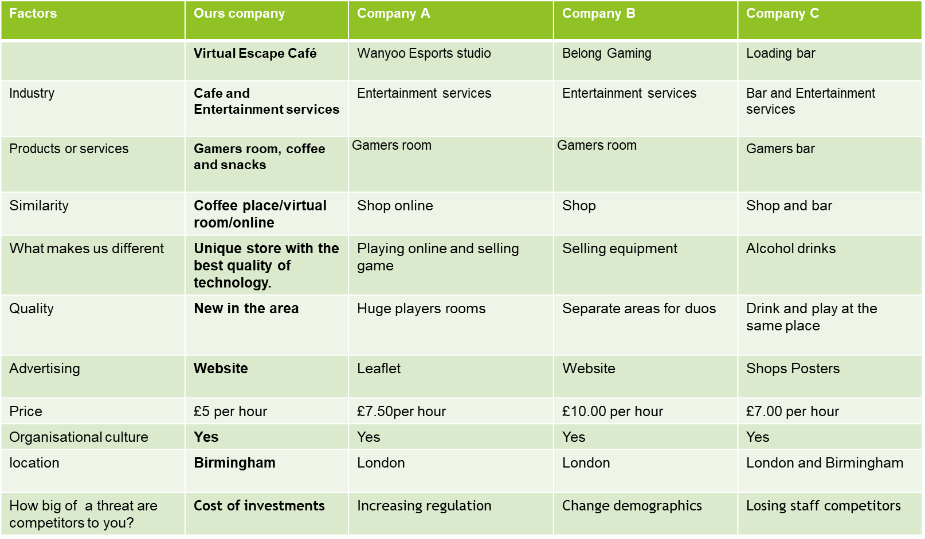
If we're talking about how serious our rivals are, we must consider the costs of our members' investments in comparison to the costs of more regulation or changing demographics. Which is why we are very competitive in our pricing.

SWOT Analysis:
“The traditional SWOT analysis implicitly conceptualises the external environment's opportunities and dangers as having the same influence on all socioeconomic agents, without exception.” (Vlados,2019)
We can examinate the company by the SWOT Analysis as well. We are very competitive on our pricing; we have excellent customer service and location. The teamwork and dedication amongst us and our employees are one of the strongest parts of our business, as we are focusing expanding and growing our business in different cities in the UK.
We can discuss language hurdles in communication as a vulnerability of our new business since they might arise at any time in a multi-cultural city like Birmingham. If time management is not done correctly, the entire organisational structure may collapse. The absence of consumer participation is a major flaw in any business, and Virtual Escape Cafe is no exception, given that we are new to the market.

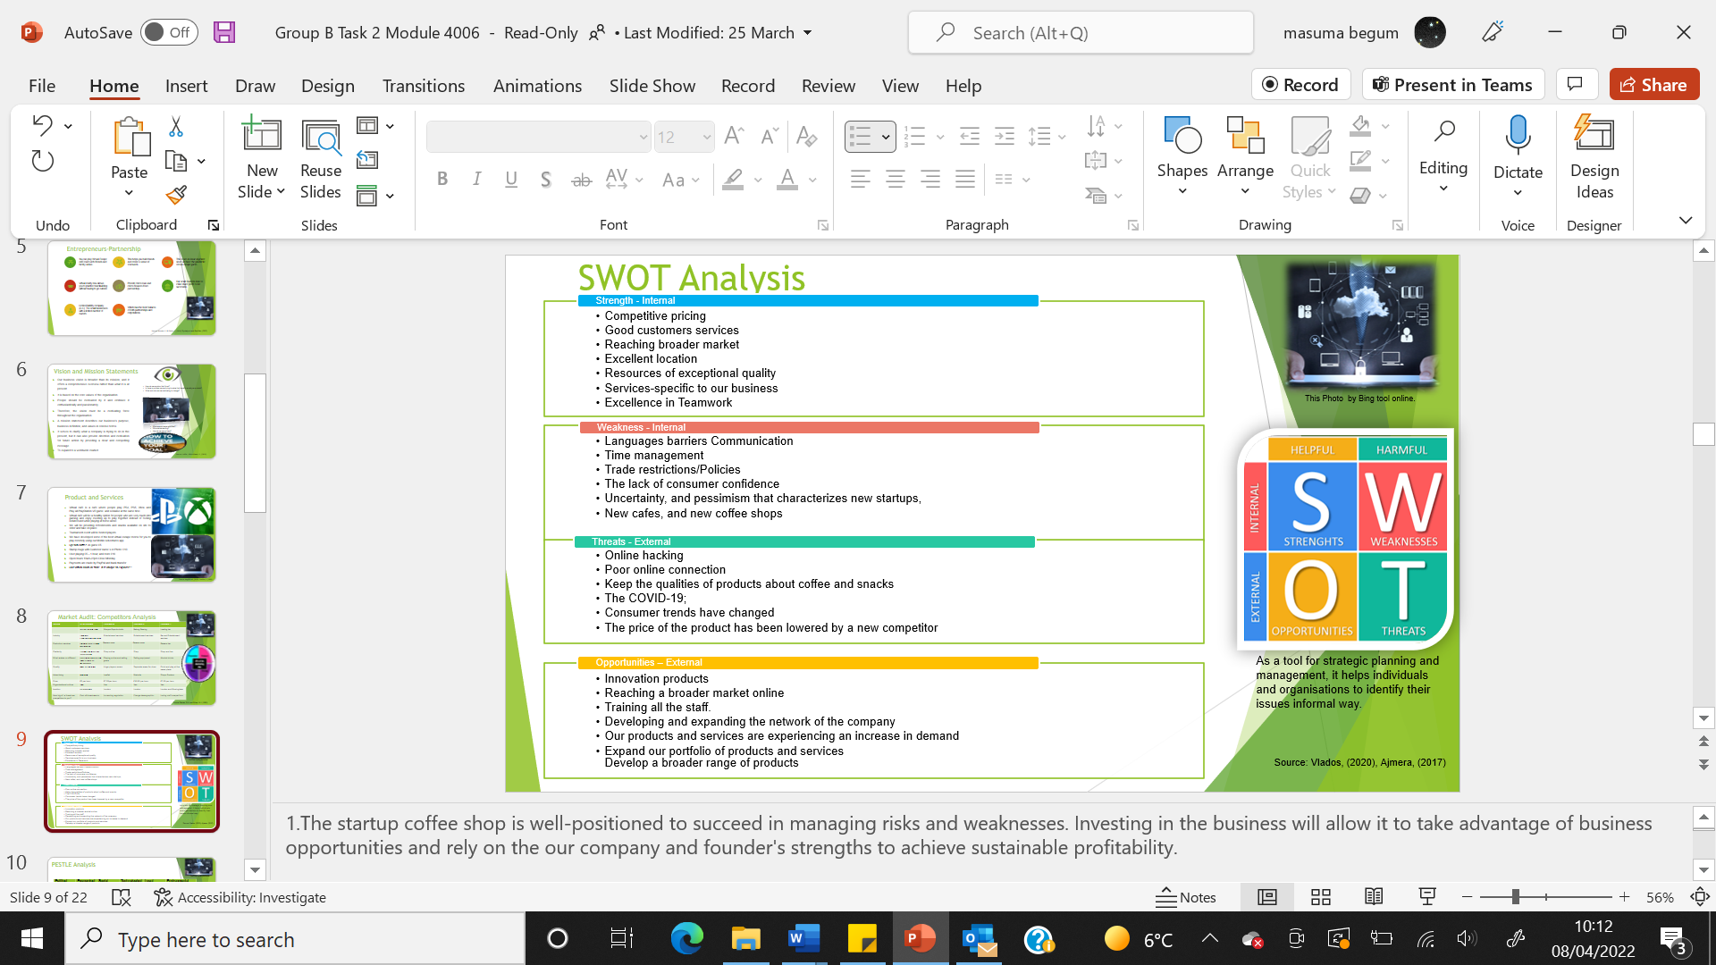

We have a lot of opportunities, such as product innovation and personnel training. Developing and growing the company's network is usually a big advantage in terms of growth.
As a new business, we face several challenges, but the following are the most concerning: online hacking, inadequate internet connectivity, maintaining the quality of our products, and pricing fluctuations by rivals. On top of that, we still have the Covid-19, which can result in a fresh lockdown and the business's demise.

PESTLE Analysis:
The PESTLE Analysis contains six elements that might affect every firm; therefore, we've compiled a list of some of the more important ones. All taxes will be paid, which benefits the government; on the other hand, employees are safe and have their rights, such as obeying health and safety regulations on a regular basis, particularly the Covid-19 limits.
Economic and social considerations are crucial since we will benefit economic growth and give a welcoming environment in our shop. We will modernise technologically with the most recent technological growth, and all laws safeguarding our customers will be enforced, with an age limit of /12+/. We will utilise environmentally friendly items and recycle according to the regulations.
“All industries, including the oil and gas industry, are clamouring for innovative and long-term solutions to the problem of offshore platform decommissioning.” (Vincenso Basile et al,2021)
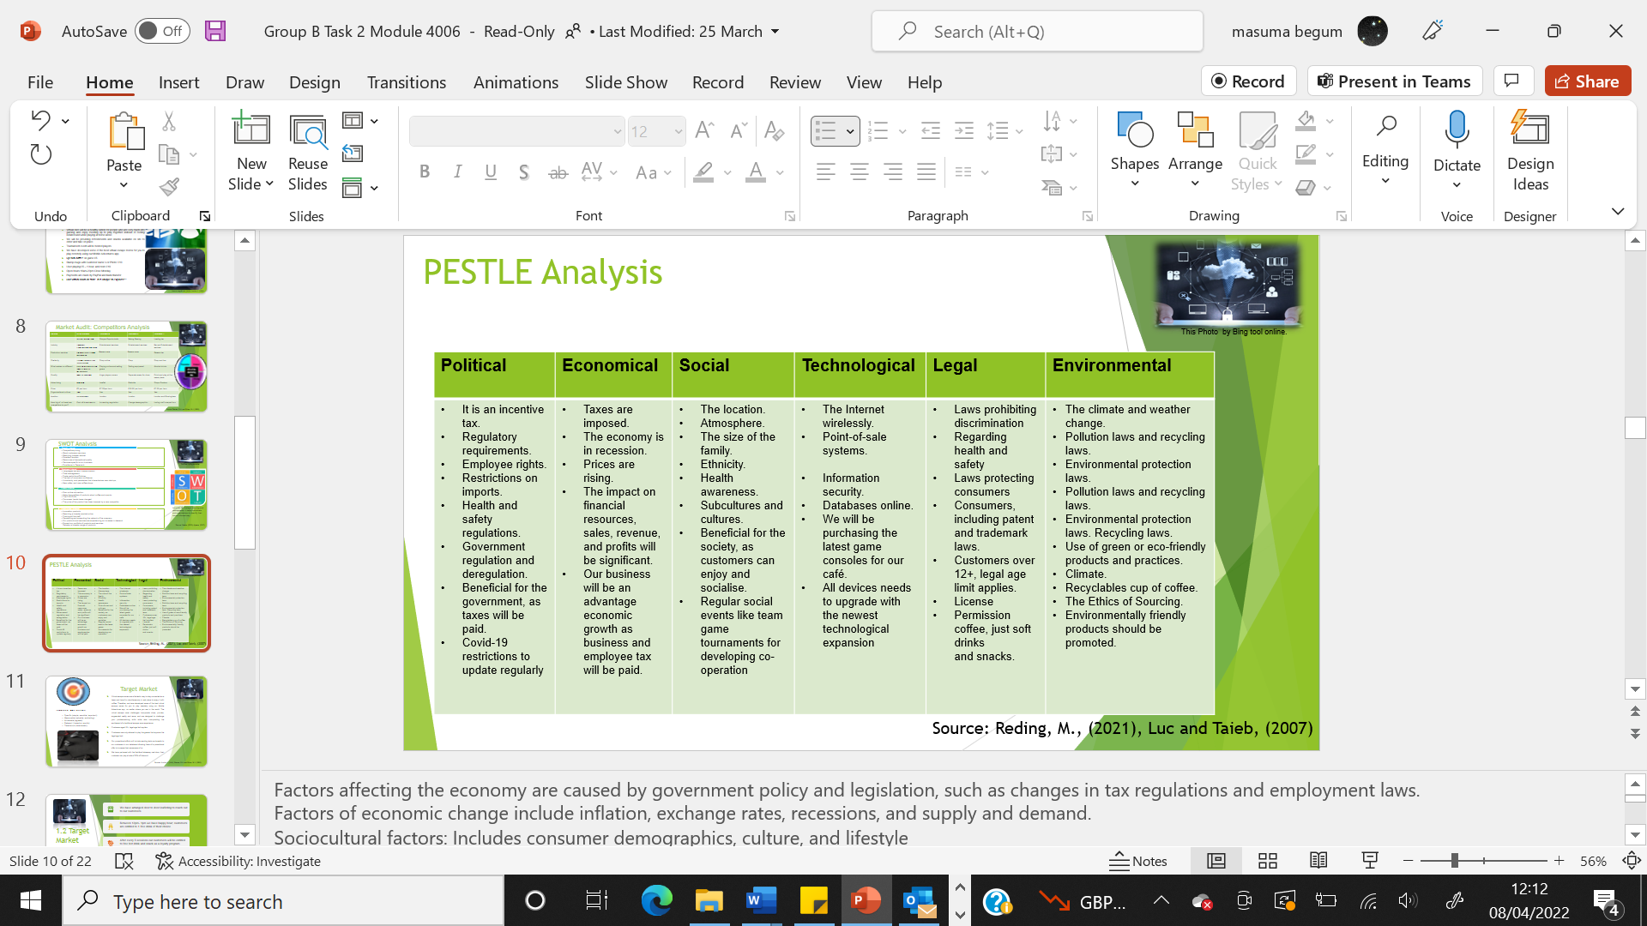

Target market:

Virtual escape rooms are a fantastic way to stay connected as a team while having stimulating fun in a real-world setting while sipping coffee. As a result, we've created some of the greatest virtual escape rooms for you to play no matter where you are using our exclusive Mobile Adventures Application. All visitors are safe since we adhere to the legal age limit. Our marketing efforts will entail sending SMS and emails to our database's customers telling them of our special offers.
We are strengthening our business by leafleting Birmingham stations, establishing first-time customer discounts, and membership deals, and making all consumers feel welcome and pleased. We have partnered with the fast-food takeaway next-door KFC; every customer will receive a 20% off voucher for playing 2 hours with Virtual Escape Café
- We have arranged door to door leafleting to reach out to our customers.
- Between 12pm- 1pm we have happy hour; customers are entitled to 1 free drink of their choice.
- After every 5 sessions our customers will be entitled to free hot drink and snack as a loyalty program.
- Leafleting at Birmingham train stations to reach out to customers, offering 20% off for immediate customer sign up. Social media
- We are running a PR package with famous youtubers to promote our business.

Formal Survey:
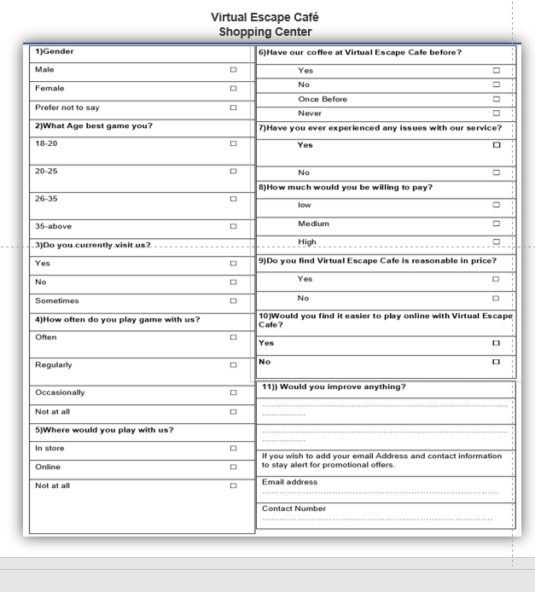
We have created a survey to form a database for our customers. The survey was filled out by customers at the train station and bullring shopping centre car park.
We appreciate your participation in our survey. You will receive 5% off any online game (Parlitz, et al., 1990).

Survey Audit:
The survey was conducting on 72 customers. The target audience that we have identified is 35 males, female 17 and unknown 20.
Therefore, we were able to determine the age range ideal for our Instagram audience based on the information.
Based on the information, our target audience is aged between 18 and 20, with a flexible income (Luc & Taïeb, 2007).

Promotional Vouchers:
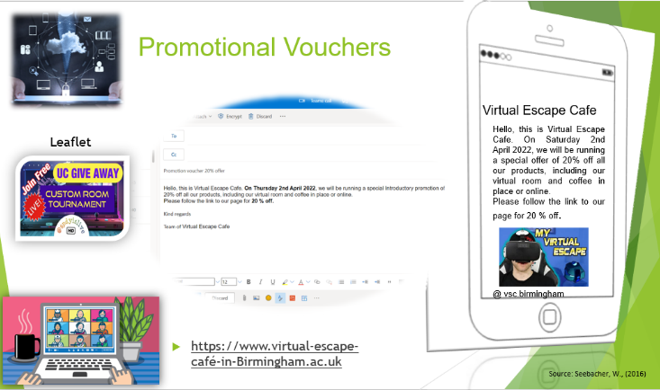

App and Email sent to customers; Hello, this is Virtual Escape Cafe. On Saturday 2nd April 2022, we will be running an exclusive offer of 20% off all our products, including our virtual room and coffee in place or online.
Please follow the link to our page for 20 % off.
Our voucher will be shared with customers by leaflet QR code to conform in our Virtual Escape Café, app and website (Seebacher, 2016).

Marketing Plan:
Determine the best advertising strategy to generate leads and reach its target market. The company oversees corporate events. Our marketing strategy will involve advertising on social media sites like Facebook, Instagram, and Twitter. We will also advertise on billboards and on the back of buses, which will allow for greater exposure to a broader audience (Barkan & McCarthy, 1975).
We have been operating the Virtual Escape Cafe since 2021.
This establishment sells soft drinks to all age groups.
- Our business has been in operation for a year. We are well known to our customers.
- The company helps the customer order online to pick up coffee and snacks in store.
- It requires a small amount of capital to start the business.
- We develop a marketing to get service for customer and offer with voucher.
- Products of excellent quality at a reasonable value pricing refer to setting prices for products and services based on their value.
- A company's value pricing is based on what it believes any thinks the customer's product is worth.
- Our prices are competitive.
- Online prices are competitive.
- The designer prices are at a prestige level.
- Our products are increase priced on value profit.
What is the best way to market our product?
- The goal of our online marketing campaign is to increase the customer base.
- ​Strategies to meet our objectives.​
- Moreover, we give to our customer feedback of satisfaction of website service and store.
- Through our Instagram page, we can reach an international audience in addition to our local Birmingham customers.
- Our objective is to increase profits after 2 years and reach more customers.
- Publicity, promotion, and advertising by app application by concerning our customers.
- Using customer telephone numbers and email addresses from the questionnaires they filled out, we create our database and send out promotions and advertisements.
- Once we have created our database, we communicate with our customers.

Management Team:

Managing partners:​
- Masuma​
- Andrea​
- Ricardo​
Manages all aspects of the business, including:
- Administration, human resources, and finances.
- Science of computing.
- 2 years of experience as a website manager.
- Communication clear, it is programming skills.
- Responsibility: Planning, implementing, managing, monitoring website and app compliance with laws and regulations concerning web security and online compliance (Maund, et al., 2017).

Financial Plan/ Cash flow forecast:
We have conducted a cashflow forecast for the last year and the next 2 years.in the first year of the business our profit margin hasn’t been great, as we had many start-up costs however, with our marketing strategy we are expecting a spike in profits for the coming years.
First year:
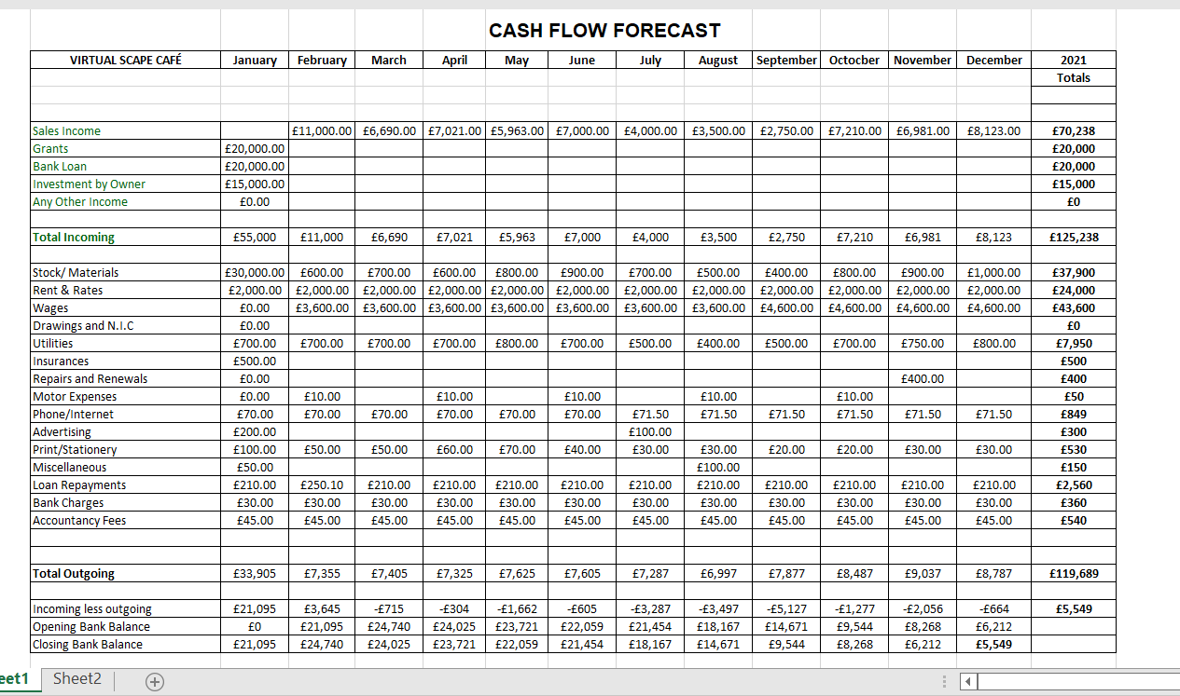

Second Year:

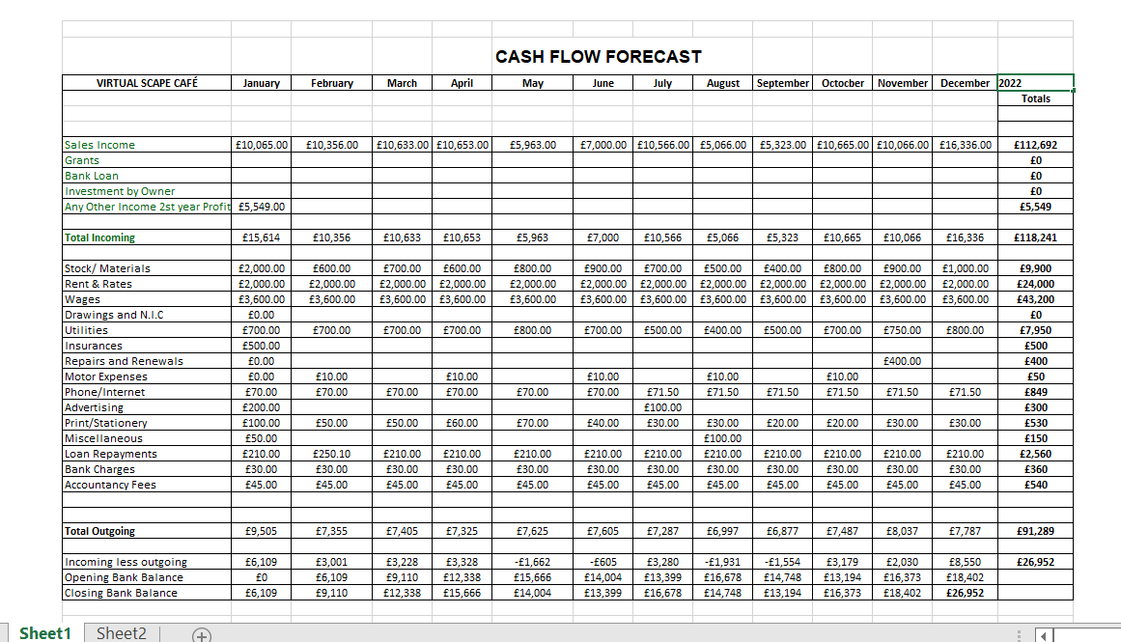

Third year:
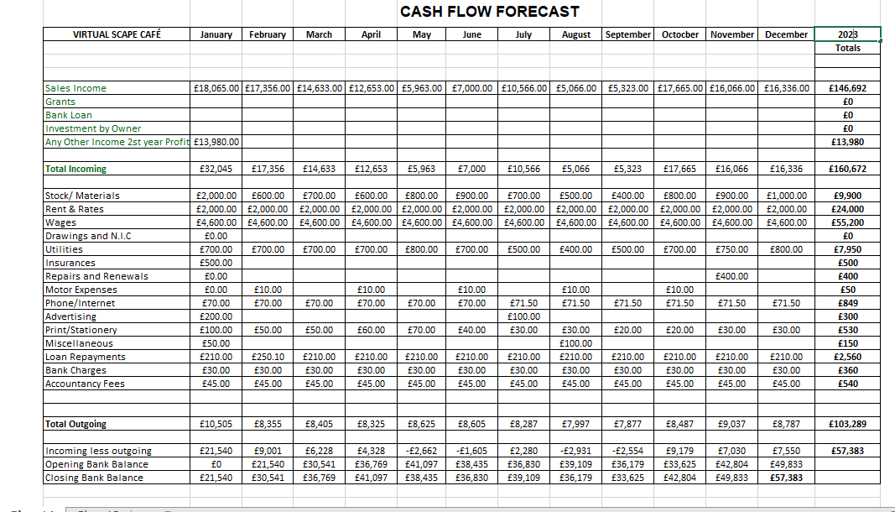
By 2023 we aim to issue a pay rise of £250 per person, which will cause the monthly cost to raise by £1000, however we are positive our sales will raise with our marketing campaign. Our aim is for a net profit of £15000. We understand the importance of a cash flow statement. This document shows the financial standing of the company.
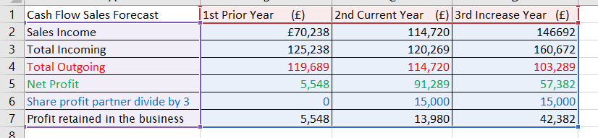
Cash flow statements identify the sources of revenue for the organisation. Flows of cash was classifying to operating, investment, and financing sources.

It is important to manage cash flow and cash flow to avoid business failure. Cash flow refers to the inflow and outflow of funds within a business and its bank accounts. Opportunities for lucrative or entrepreneurial growth (Shane & Venkataraman, 2000).

Profit and loss:
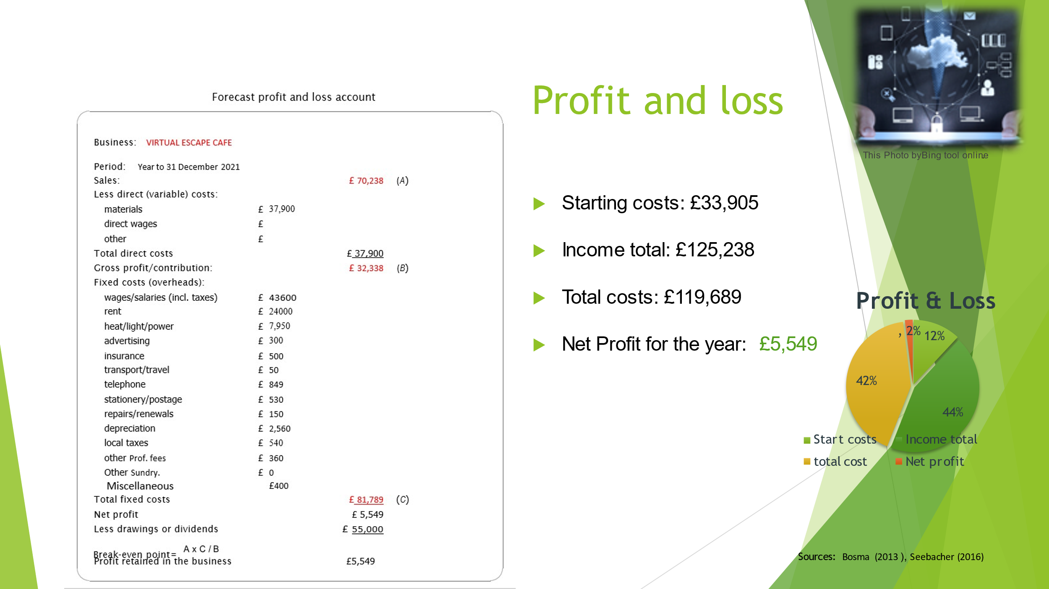
This is a correct slide for our business presentation, we are extreamely sorry for the mis calculation on our actual business presentation slide;

The loss on our first-year cash flow forecast came from starting up our business, as we had many expenditures coming from buying stock for our business.
We believe we will not need to re-buy all the stock. Therefore, our 2022/2033 financial forecast will be more positive
Chart for 3 Year Forecast:
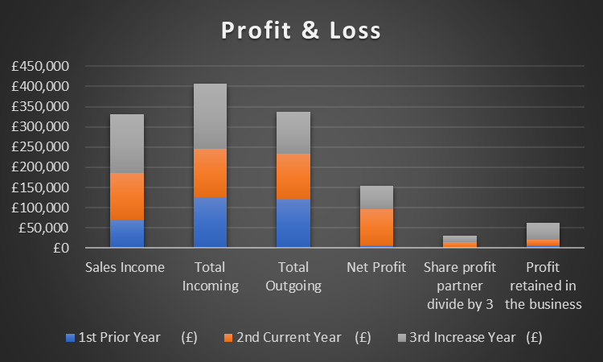

A company's net profit is the difference between what it receives from selling products and services and all the costs incurred to produce these products. As the net profit of a business includes all its fixed costs and other overhead expenses, it was considering the more important profit figure. There is also the possibility of negative net profit, which indicates that the business has suffered a loss due to its costs being greater than its sales revenue. Special Report on Entrepreneurial Employee Activity from the Global Entrepreneurship Monitor. Global Entrepreneurship Monitor (Bosma, 2013)
The Break-Even Point:
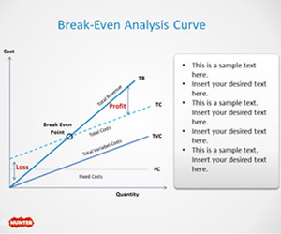
An income statement represents all the cashflow through our business in each monthly. Customers or clients are purchasing your products or services, and money is flowing in.
When customers fail to make payments at the time of purchase, they receive a portion of your revenue as accounts receivables (Beaman, et al., 2016).

Conclusion:

To conclude Market Research for VIRTUAL ESCAPE CAFÉ we have gathered numbers and figures based on the data from our surveys and financial statement. The results indicated that our companies continuing to develop and deliver excellent customer service and satisfaction. Our performance in the market is consistent. We aim to present our business in Corporate Events to develop and expand on our platform. We have received immense feedback from our loyal customers, and we are positive the PR packages launching soon will be a hit campaign for our business.
Thank you for taking your time to read our business plan, we appreciate your patience.

Reference

- Abrams, R. and Kleiner, E., 2003. The Successful Business Plan: Secrets & Strategies. The Planning Shop, p. xxiii.
- Barkan, Ö. L. & McCarthy, J., 1975. The Price Revolution of the Sixteenth Century: A Turning Point in the Economic History of the Near East. Cambridge University Press, 6(1), pp. 3 - 28.
- Barkan, Ö. L. & McCarthy, J., 1975. The Price Revolution of the Sixteenth Century: A Turning Point in the Economic History of the Near East. Cambridge University Press, 6(1), pp. 3 - 28.
- Beaman, J. E., White, C. R. & Seebacher, F., 2016. Evolution of Plasticity: Mechanistic Link between Development and Reversible Acclimation. Elsevier, Volume 237-249, p. 31.
- Bosma, N. S. W. M. G. J. E. A. A. M.-. t. a. S. S., 2013. Global Entrepreneurship Monitor. Scientific Research Publishing, 9(2).

- Charis Vlados (School of Business, University of Nicosia, Nicosia, Cyprus) (Department of Economics, Democritus University of Thrace, Komotini, Greece) Managements’: 1755-425X Article publication date: 14 May 2019 Issue publication date: 8 August 2019
- https://doi.org/10.3390/su13116266
- International Journal of Forecasting, Volume 6, Issue 1, Alan E Singer, Roderick
- J, A., 2019. What is Intrapreneurship? Definition, Characteristics, Importance, Process, Advantages, Hurdles, Example - The Investors Book. [online] The Investors Book. Available at: <https://theinvestorsbook.com/intrapreneurship.html> [Accessed 4 April 2022].
- Luc, B. & Taïeb, H., 2007. The Changing Nature of Public Entrepreneurship. Public Administration Review, 67(3), pp. 488-503.
- Maund, A., Schriek, M. & Tinkler, P., 2017. Certificate in Higher Education: Skills for the Workplace Student Yearbook Paperback. (“Certificate in Higher Education: Skills for the Workplace ...”) In: FIRST, ed. Maund, A. et al. (2017) Certificate in higher education : skills for the workplace student yearbook. London: Sage. London: SAGE Publications Ltd.
- Parlitz, U. et al., 1990. Bifurcation structure of bubble oscillators. The Journal of the Acoustical Society of America, 88(https://doi.org/10.1121/1.399855), p. 1061 ();.
- Seebacher, W., 2016. Management Accounting. Part 2 – Profit Plan, Finance Plan, Budgeted Balance Sheet, s.l.: epubli.
- Shane, S. & Venkataraman, S., 2000. The promise of entrepreneurship as a field of research.. Academy of Management Review, 25(1), pp. 217-226.
- Vlados, C., 2020. SWOT analysis: A framework for comprehensive evaluation of drivers and barriers for renewable energy development in significant countries. Elsevier , 6(https://doi.org/10.1016/j.egyr.2020.07.007), pp. 1838-1864.
- Ward, S., 2020. What Is a Mission Statement? [online] The Balance Small Business. Available at: <https://www.thebalancesmb.com/mission-statement-2947996> [Accessed 4 April 2022].

