The research of location and control technology in automatic vehicle
1 Introduction
At present, with the development of AI, information communication, the tendency of information and intelligence has gradually affected the whole life, bringing the human more convenient, environmentally friendly and intelligent equipment and facilities to the human society. Autonomous driving technology has been widely valued and applied in military, industry, transportation, medical, life and other domains, such as automatic operation vehicles in industrial parks, autonomous driving vehicles on open roads, unmanned sightseeing vehicles in scenic spots, transport vehicles in large logistics factories and so on.

Autonomous driving vehicles, also known as driverless vehicles, intelligent vehicles or wheeled mobile robots, refer to ground wheeled vehicles that can automatically sense the surrounding environment, automatically make motion decisions and drive without human intervention. Nowadays, road traffic injury has become the primary cause of accidental death in China. The inducing factors of road traffic accidents include weak road infrastructure, imperfect legal system, vehicle failure and improper operation of drivers. Among them, improper operation of drivers is the primary cause of serious malignant road traffic accidents, so improving the quality of driving behavior is the key to curb the frequent situation of traffic accidents. To improve the quality of driving behavior, one traditional approach is to increase driver training and supervision, while another emerging approach is to promote vehicle active safety technology. Vehicle active safety system generally refers to the vehicle system that can predict and warn traffic accidents before they happen and assist drivers to avoid disasters. Compared with passive safety measures (seat belts, airbags, etc.), vehicle active safety measures have more room for operation to ensure driving safety, so they have been vigorously developed and promoted by major automotive enterprises and research institutions in the world. In daily life, common vehicle active safety systems in the market include anti-lock braking system, drive anti-skid system, electronic brake force distribution system, electric power steering system, body electronic stability device, lane departure warning system, which can ensure driving safety in specific situations. However, human beings are not satisfied with existing level. The concept of autonomous driving stems from the practical need to ensure driving safety, but the significance of developing autonomous driving cars is not limited to this.

As the active safety technology is becoming mature, more and more engineers consider integrating the active safety systems to realize the transformation from functional safe driving to all-weather intelligent driving. In the process of transformation, the ultimate goal of vehicle research and autonomous driving has gradually been clearly formed. Autonomous driving technologies mainly include environmental awareness, vehicle location, planning and decision making and control execution technologies. At first, the solution to the positioning problem was based on dead reckoning with internal sensors that recorded vehicle movement. Then, various external sensors were used to calculate the location and direction of the vehicle relative to the whole environment by observing environmental features. Now, vehicle positioning methods that combine internal and external sensors have been developed. The control execution technology mainly includes longitudinal motion control and lateral motion control, the longitudinal control can determine the pedal of accelerator/brake, which can decide the vehicle speed in a desired value. However, the lateral control can keep the steering wheel according to the real road. The location technology can tell the autopilot program where the vehicle is and control technology will get command of the vehicle to follow the planning path.
2 Literature Review
Location technology is a key element of autonomous driving technology, and the accuracy and stability of positioning directly affect the navigation, decision-making and high-precision map construction of autonomous vehicles. At present, GPS, dynamic real-time differential method and inertial navigation system (IMU) are widely used to achieve positioning. Information obtained by a single sensor is difficult to ensure accuracy and reliability. Multi-sensor fusion and compensation technology can make full use of data redundancy and complementarity to ensure the accuracy of environmental perception and improve system reliability [1].

Firstly, GPS users can achieve all-weather, continuous, real-time three-dimensional navigation, positioning and speed measurement, as well as high-precision time transmission and precise positioning worldwide. Positioning will be affected by various factors, civil positioning error can be as high as ten meters. Differential GPS is to calculate the above various GPS errors. By installing a fixed base station at a reference point with a known absolute position and comparing it with the positioning result of the fixed base station by GPS, the deviation of the positioning signal can be known. Then this deviation is sent to the mobile station which needs to be located, so that the mobile station can obtain relatively accurate position signal. The positioning accuracy of real-time kinematic (RTK) positioning technique is usually up to centimeters. However, the IMU uses measurements of acceleration and rotation speed, aided by algorithms, to achieve accurate positioning. The biggest advantage of this technology lies in its high update frequency, which can generally reach 1KHz, equivalent to 100 times of GPS update frequency. However, there are displacement, proportion and background white noise errors in the process of motion, and these errors will accumulate. Although the GPS update frequency is low, the global anchoring given does not produce error accumulation over a long period of time. Therefore, the combined scheme achieves complementary advantages and provides accurate and real-time position update for vehicle positioning [2].
Nowadays, most autonomous vehicles use differential GPS technology to complete positioning, which can solve the problem of positioning accuracy, but cannot solve the problem of occlusion and reflection. In the complex environment, GPS signals are easily affected and the signals are easily weakened or even lost in serious cases which would lead to positioning failure [3]. For example, GPS receivers are easy to lose all the satellite signals in a certain direction around tall buildings, so it is difficult to meet the requirements of automatic driving in terms of accuracy. In addition, satellite signals that could not be received in the vicinity of tall buildings may be received through the specular reflection of the building, and the distance calculated based on the signal will be significantly greater than the actual distance. The technology of localization and map establishment in unknown environment is the key to solve the problem of autonomous vehicle localization. Simultaneous Localization and Mapping (SLAM) is the key technology to solve the problem [4]. As the core technology of robot positioning and navigation, SLAM is attracting more and more attention in the field of robotics, especially in the field of sweeping robots. At present, SLAM technology applied to indoor sweeping robot can achieve high precision positioning, its positioning accuracy can basically reach cm level, and the average error can be kept within 5 cm, the maximum error is not more than 10 cm. Such accuracy can basically meet the free movement of indoor sweeping robot and obstacle avoidance function. But the SLAM algorithms for robots are designed for highly structured, well-lit environments indoors, not outdoors with variable lighting. At the same time, autonomous vehicles move faster than robots, which requires faster and more efficient algorithms. When pure SLAM is applied to autonomous vehicles, the absolute error is about 0.5m on average which is unacceptable for the positioning accuracy of autonomous vehicle navigation task [5]. Furthermore, current SLAM algorithms for autonomous vehicles need to be more accurate and faster. Therefore, this design adopts the method of mapping first and positioning later to improve the rapidity and accuracy of SLAM algorithm by using a pre-created, detailed and high-precision map. Aiming at the technical difficulty that autonomous vehicles cannot achieve accurate positioning in the case of GPS loss, a multi-sensor fusion technology and open source algorithm in the field of SLAM are used to solve the problem of high-precision positioning of autonomous vehicles in the case of no GPS signal or local signal is blocked [6].

On the one hand, the laser radar is widely used in SLAM because of its high ranging accuracy, strong environmental adaptability and simple error model. At present, laser SLAM mainly uses single-line laser radar and multi-line laser radar. Due to the lower cost of the former, it is widely used, such as hotel food delivery robot and shopping mall navigation robot. And the multi-line laser radar is usually used in the field of auto driving, because it can completely show the surface information of the object, high accuracy. Generally, adjacent frame matching and analysis are performed on the collected point cloud data to determine the relative distance and attitude information of sensors. On the other hand, the information collected by visual sensors contains rich texture information on the surface of objects, which can reflect the dynamic state of the surrounding environment. Moreover, the cost of visual sensors is very low, which promotes the rapid application of visual sensors in SLAM problems. Feature points are set for successive camera frame images collected by visual SLAM (V-SLAM), and then pose estimation is realized by using trigonometry algorithm to update and complete map construction. At present, V-SLAM can be divided into monocular SLAM, binocular SLAM and depth camera SLAM according to the difference of the number and type of lens.

In the field of laser SLAM, SLAM was first proposed in 1987 by R. Smith and Durraat-Whyte et al. EKF-SLAM based on extended Kalman filter, the algorithm integrated the characteristics of EKF and improved on it, mainly consisting of two processes: The process of state estimation and update, in which the state estimation is to predict the carrier attitude based on the estimator obtained from prior information, and the state update is to adjust and update the predicted pose based on the feedback information of laser radar, and finally get a more accurate pose information. And so on. Update this process until the entire area is mapped. In 2007, Grisetti et al. proposed an optimized SLAM framework based on the principle of particle filtering, namely Gmapping algorithm , which is the most commonly used algorithm at present. The algorithm also changed the problem of SLAM into two parts. The first part is to complete odometer information estimation based on encoder information and Lidar data provided by the carrier. The second part is based on odometer information and observation information to calculate the probability distribution of environmental map. In 2011, S Kohlbrecher et al proposed a new 2D laser SLAM scheme named Hector SLAM. This algorithm can realize location and map construction on the basis of Lidar sensor without the assistance of other sensors, and it has low requirements on hardware and small measurement error. However, 2D Lidar can only obtain 2D plane information, but cannot express 3D information. With the widely application about 2D Lidar, many researchers begin to focus on THE SLAM problem of 3D Lidar. In 2014, Zhang et al. proposed a new SLAM scheme, LOAM-SLAM algorithm, based on the reasons of motion distortion caused by different time stamps of single frame point cloud information, it tends to complete the SLAM task through distortion removal, odometer calculation and map construction. The algorithm has fast running speed, simple equipment framework, and greater practical application value. Meanwhile, due to the odometer optimization program, the final result is also higher. However, the algorithm does not design loopback detection and global optimization, resulting in chaotic point clouds at the overlapping point.

The above SLAM solutions are all based on the single use of 2D / 3D Lidar. In 2016, Google introduced Canographer SLAM, a new open source framework for laser SLAM, which can be applied to both 2D Lidar and 3D Lidar. The core of Cartographer algorithm is to integrate sensor information for global image optimization by creating a graph, taking the position and pose of the moving object as the feature point and its motion relationship as the constraint edge. In addition, the loopback detection algorithm is also used to reduce the cumulative error of drawing construction. Google has already applied the algorithm to its own driverless cars.
In the automatic driving system of intelligent vehicle, it is necessary to adopt appropriate control algorithm to control the automatic driving vehicle along the pre-planned trajectory line. PID is a universal controller in the field of industrial control, without knowing the controlled object model. It is suitable for linear and nonlinear processes, and the parameters are few and easy to adjust. It has achieved very good control effect in the field of industrial control, and has been the most widely used control method in industrial process control. PI control, PD control, feedforward and feedback control are based on PID control. However, when the control performance is transitioning from regulation to optimization, it is difficult to ensure the global optimization of the system because of the lack of coupling information between vehicle variables and the actual constraints on output and intermediate variables cannot be simply treated as input constraints. For example, when the speed changes, the PID parameters of lateral control need to be adjusted accordingly. Based on the vehicle kinematics model, this paper analyzes Pure Pursuit algorithm for trajectory tracking control of autonomous vehicle. By using the Pure Pursuit algorithm to control the trajectory of the rear wheel of the vehicle, the deviation between the current position of the vehicle and the planned trajectory can be adjusted, so that the vehicle can track the preset trajectory. At the same time, due to the limitation of kinematic model, pure tracking algorithm cannot be applied to high-speed vehicle motion. In this paper [7], the horizontal motion controller of autonomous vehicle is designed by using the preview strategy and linear quadratic optimal control (LQR) theory, and the selection of preview distance and the selection of the optimal controller weighting matrix are analyzed in detail. Finally, the effectiveness of the controller is verified by simulation and real vehicle test. Then, an improved LQR algorithm was put forward [8], Firstly, a mechanical model of path tracking error based on non-previewing strategy is established, and then a transverse feedforward controller and LQR feedback controller are designed. Then, a weighted matrix adaptive adjustment strategy based on the relationship between path tracking deviation and vehicle-road position is designed to improve the control accuracy and controller adaptability. Finally, the improved LQR controller with feedforward control is compared and analyzed through simulation experiment to verify its effectiveness and the improved LQR controller with feedforward control can obtain good path tracking accuracy and control effect. However, the LQR algorithm cannot restrict the motion condition, if the vehicle speed changed higher, it is dangerous to turn the steering wheel with large angles.

A lateral path tracking controller of self-driving vehicle based on model predictive control (MPC) was designed [9]. At First，based on the theory of preview and following，a driver steering model with optimal lateral acceleration was established to analyze the influence of the driver preview time and vehicle speed on the path tracking performance．Second，a vehicle lateral path tracking controller was designed based on the MPC method, in which the predictive vehicle model was corrected by using relaxation factors to ensure that the objective function had feasible solutions．Furthermore, the optimization solutions of the proposed MPC controller was considered as a constrained quadratic programming problem in each step．The desired steering angle for path tracking was applied to the autonomous driving vehicle by using the rolling optimization of MPC．The experimental results showed that the preview time and speed have great influence on the vehicle tracking reference track controlled by the driver．The maximum lateral deviation between the actual trajectory and the reference track of the vehicle under the MPC controller was 0．085 m，which was smaller than the situation that vehicle controlled by the skilled driver．At the same time, the steering start time of the vehicle under the MPC controller was 0．89 s earlier than that of the vehicle controlled by the skilled driver．X. Wang et al. designed a sliding mode variable structure lateral controller using RBF neural network to optimize parameters by using the lateral dynamics model of autonomous driving vehicles, and achieved accurate tracking results by controlling yaw velocity. However, in the actual system, severe chattering phenomenon would occur by using sliding mode control.
3 Methods
3.1 The hardware system and component modules
3.1.1 NVIDIA Jetson TX2
In this system, the function of the embedded platform is to fuse and process the data collected by each sensor, and finally obtain the point cloud map information and positioning information constructed by it through calculation. The CPU and GPU performance of the embedded platform will determine the image processing performance of the host, because for each object that can be applied by the system, such as autonomous driving intelligent car, positioning backpack, etc., the traditional host platform is limited by the disadvantages of large size and inconvenient movement, so it is not suitable. In recent years, more and more deep learning networks have been transplanted to embedded platforms and achieved satisfactory results. The embedded platform also has the advantages of small size, strong computing power and low power consumption, which is suitable for application in the various objects facing the system. Its physical picture is shown in Figure 1.
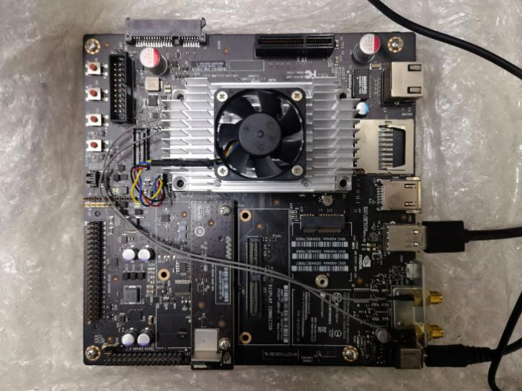
Figure 1 NVIDIA Jetson TX2
3.1.2 Laser radar
Because the Lidar sensor has higher accuracy, less computation and is almost not affected by the environment, it is more suitable for the construction map and positioning system, so Lidar is used to collect environmental point cloud information. The Lidar used in the system is the smallest and lightest OUSTER OS1 32-wire high resolution medium-range Lidar on the market. It has a horizontal field of view of 360°, a vertical field of view of 31.6°, and an effective detection range of 120 meters. It is transmitted to the computer platform in UDP data transmission format using gigabit Ethernet. The physical picture is shown in Figure 2:
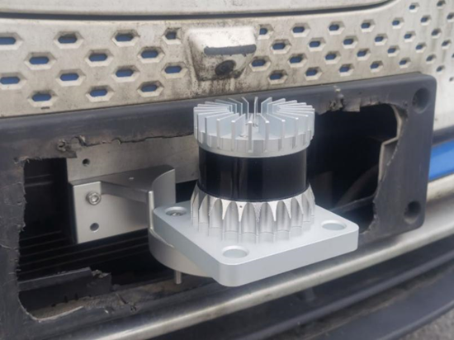
Figure 2 Laser radar
The Lidar can monitor the surrounding environment in real time, including obstacle distance information and reflection intensity information value. According to the rotation of transmitting and receiving modules, the 3d point cloud information is sensed to the surrounding environment, and then the coordinate value of the point cloud in the Lidar coordinate system can be obtained by using the distance information and the trigonometric function value of the corresponding attitude Angle.

3.1.3 IMU dynamic inclination sensor
The IMU sensor is composed of a three-axis vertical measurement accelerometer and a gyroscope. The accelerometer is based on the capacitance change of Newton's second law to obtain the three-axis acceleration measurement. According to the known initial velocity and position, the velocity is obtained by integrating the acceleration, and the displacement is obtained by double integration. Gyroscope measures inertial Coriolis force of moving object through vibrating gyro principle, thus measuring tri-axial angular velocity indirectly.

3.1.4 GPS receiver
In the mapping part, GPS signals are required to provide global coordinates for the map and map the constructed point cloud map to the global coordinate system, so the accuracy of GPS is highly required. Due to the influence of satellite orbit error, ionosphere and troposphere on positioning accuracy, the absolute positioning accuracy of ordinary GPS cannot meet the requirements, but differential GPS can solve this problem well. Differential GPS can correct the measurement result by receiving the correction number sent by the base station, so that higher precision positioning result can be obtained. Figure 3 shows the physical figure:
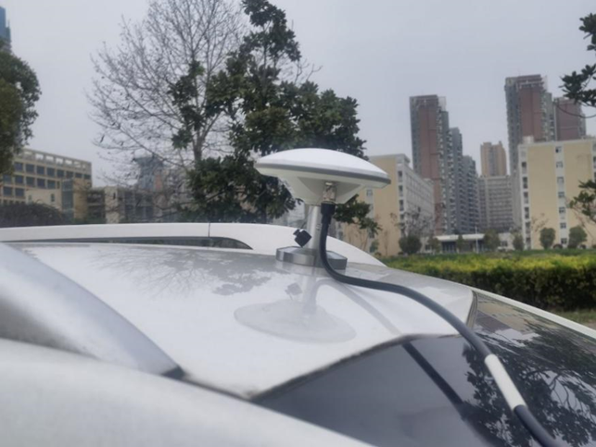
Figure 3 GPS receiver
3.2 Software system and component modules
3.2.1 Operation platform
ROS (Robot Operating System) is a highly flexible robot software operating platform for writing robot software programs. It is suitable for building a framework for Robot programming, which can combine loose parts together and provide a communication framework. The ROS software platform connects the operating system to the ROS applications that are being developed. It establishes a link between ROs-based applications and runs on Linux, not Windows or Mac. In the ROS robot operating environment, the robot's perception, decision-making and control algorithms can be better connected, organized and operated.
Table 1 the timetable about plan
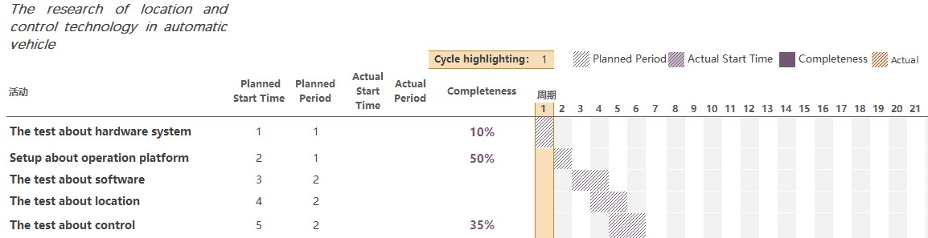
The primary goal of ROS is to support software reuse in robotics research and development. ROS is a distributed framework for processes that are packaged in packages and feature packs that can be easily shared and distributed. ROS also supports a federated system similar to a code repository, which also enables collaboration and publishing of projects. This design can make the development and implementation of a project from the file system to the user interface completely independent decision. At the same time, all projects can be integrated by the ROS base tools. Therefore, ROS can therefore provide the services that an operating system should provide, including hardware abstraction, low-level device control, implementation of common functions, inter-process messaging, and packet management. It also provides the tools and library functions needed to get, compile, write, and run code across computers. ROS has inherent universality, development and community, and ROS software development platform is fundamentally a completely open system with the basic properties of an operating system. Due to its open source nature, ROS has gradually been used and researched by more scientific research institutes of universities and enterprises. ROS also provides developers with many common development tools and open source libraries that can greatly improve development efficiency.

3.2.2 IMU pre-integrated algorithm
The function of IMU is that measures the acceleration of the object in 3D space, and the location of object can be obtained by double integration of the acceleration. The initial value of the Lidar position and pose can be corrected by short distance IMU pre-integration, and the calculation accuracy can be improved.

The original IMU information will be stored in the queues where will be checked whether the first optimization has been carried out. If not, the next step will not be carried out temporarily, otherwise the original IMU measurement value will be pre-integrated through the optimizer. Predict the latest Lidar positions and post on the topic. Although the above process can deal with the IMU information in real time, the accumulation of time will cause the accumulation of prediction errors, so the next process is needed for correction and update.

3.2.3 Lidar odometer
The purpose of Lidar odometer is that calculates the object's transform relation between frames, after the extraction of feature points and matching, using nonlinear optimization algorithm of LM algorithm to calculate the rotation and displacement between two Lidar scanning. However, the initial value has a deep influence of its precision, bad posture initial value selection of the large error, so need to integral combined with innovative marketing.

3.2.4 Factor graph-based back-end optimization
Factor graph includes variable nodes corresponding to state quantity and factor nodes corresponding to the connection between different variables. The variable node and factor node are connected by the undirected edges, which can affect the functional relationship between them. The factor graph can analyze the multidimensional probability density function into the form of multiple local functions multiplied, so as to separate out the variables irrelevant to the current local function during calculation. Before factor graph optimization, factor graph should be constructed on the first step. Then, it is obligatory to model the information of each sensor, calculate its factor representation, and then add it into the factor graph when the sensor information arrives. The next graph optimization process, which can also be called smoothing, generally regards all the states and constraints at all times as a least square problem, and gets the entire motion trajectory through the solution of the least square to complete the optimization.

3.2.5 Loopback detection
The feature description is commonly a multidimensional vector. The distance between two feature descriptions can be used to calculated the similarity of two frame point cloud images. After obtaining the scan context descriptor of the current point cloud, ring key features can be obtained to get a Ring key vector. Furthermore, each frame of point cloud will be used for mapping and the whole features are extracted, then it will be added to the queue. These descriptors are clustered, the number of categories will define the number of words in the dictionary, and then these dictionaries are organized into the form of KD tree.

KNN algorithm can be used in KD tree search candidate frame index, and then according to the distance formula calculating the difference between each candidate frame and current frame similarity score. The minimum and the corresponding frame will be marked. If the score is less than the setting threshold, argues that the historical scenes and the current scenario for the same scene, completing scene recognition and to return to the same scene.

3.2.6 Normal Distributions Transform about location
The objective function of NDT algorithm optimization is mainly the similarity of the probability distribution between the input and the target point cloud. The computational complexity of this registration algorithm is mostly affected by the point cloud density of the input point cloud. Therefore, Voxel Grid is used to down sampling the input point cloud and it will improve the speed of NDT registration.

3.3 Control algorithm
3.3.1 Lateral control based on MPC
Model predictive control (MPC) was first generated in the prediction algorithm of industrial control, such as dynamic matrix control (DMC) established on the condition of linear superposition by Cutler et al. [10] and Model Predictive heuristic control (MPHC) proposed by Richalet et al. [11]. The optimal value is solved at each sampling time by using the optimization idea of modern control theory, and the model is compensated according to the real-time state information of the system. These characteristics make it avoids the identification to minimize the difficulty of parameter model, reduced the online optimization of real-time computation and improves the robustness of the control system, very accord with the actual needs of industrial control process, once put forward the application to be successful in multiple industries, has been considered as the most effective and potential applications of advanced control methods.

The MPC algorithm is used to solve the trajectory tracking control problem of driverless vehicles. The vehicle model is mainly composed of chassis model and tire model, and the model design must follow the basic rules and specific requirements. In MPC algorithm, vehicle model is used to predict vehicle state over a period of time based on current and historical state and hypothetical input. MPC is a general optimization framework with no requirements on the specific organization form of the model. Any expression that can explain the relationship between variables and time can be used as a vehicle model. The diversity of vehicle models provides the possibility for the diversity of model predictive control applications. The future state of the vehicle is predicted based on the prediction model. Any control input can predict the future state of the vehicle according to the prediction model, and determine whether the constraint conditions are satisfied according to the future state of the vehicle, and select the optimal control strategy. The prediction model is the premise to realize the optimal control.

MPC is a kind of optimal control which objective is to find the optimal strategy under the given conditions. The criterion of performance is called performance index function or objective function, and the objective function should include the future vehicle state and control input. The most common objective function of MPC in trajectory tracking is the sum of the variance of position deviation and the squares of angular input increment. Trajectory tracking at any sampling time, the finite time period of the objective function is within the prediction time domain, not infinitely long to any time point, and the solution process is an open loop optimization problem within the finite time length. Then, the optimal control sequence in the prediction time domain is solved. Different from the traditional optimization problem, MPC does not execute the optimal control sequence one by one, but only enables one control quantity at the current time point, namely the first control quantity. At the next sampling time, the prediction time domain moves forward by a step, and then the optimal control sequence is obtained again according to the current time domain. The objective function of the MPC is not for the whole, it should be for all times. The form of objective function at different time is the same, but the time period used is different.

The advantage of rolling optimization is that due to the existence of model error, external interference and other factors in practical application, it is impossible for the vehicle to completely develop in accordance with the expected state. The system performance will decrease sharply with the increase of the accumulated error. The rolling optimization re-establishes the objective function in the prediction time domain according to the current time state, and enhances the anti-interference ability and stability of the system compared with the traditional optimal control which calculates once offline.

Building an accurate vehicle model is very difficult and has no practical significance. The vehicle models used in engineering applications are often simplified and inevitably have model errors. Error can be eliminated or its influence reduced by rolling optimization, and error can be reduced by feedback correction. At each sampling moment, the difference between the vehicle prediction model and the actual environment is compensated according to the comparison results of the real-time vehicle state and the predicted state at the previous moment, and then the solution is optimized according to the prediction model. In practical application, the inevitable deviation is compensated continuously, which enhances the anti-interference ability and stability of the system. Model predictive control revises model deviation according to the deviation between the prediction result of the current time and the current time to form a closed loop, which further improves the adaptability of the algorithm to the complex application environment.

3.3.2 Longitudinal control based on PID
The vehicle speed is mainly determined by the braking system and the driving system, so two independent control systems need to be designed. At the same time, the control switch between the two systems needs to be considered. Considering that the PID algorithm is directly used for throttle and brake control, it is difficult to ensure that the unmanned vehicle runs at the desired speed.

Therefore, a hierarchical control idea is adopted to divide the velocity tracking control problem into two layers: the upper layer is the velocity deviation control layer, and the desired acceleration can be obtained through the velocity deviation; The lower layer is the desired acceleration tracking control layer, and the throttle and brake pressure needed to achieve the desired acceleration are inversely calculated by using the principle of inverse longitudinal dynamic model of driving and braking.
4 Results
4.1 Location part
First of all, 3d mapping of offline scenes can be completed, and the software and hardware in the whole positioning system can coordinate their work. Then, it is necessary to collect the differential GPS data received in the positioning process and the actual position data. Through the trajectory drawing and comparative analysis of the two parts, the positioning trajectory and GPS trajectory are basically deviation. Finally, it is proved that the NDT algorithm can replace GPS to complete the positioning function whenever the GPS signal is normal.

4.2 Control part
In the process of locating built figure, cars will choose a path to complete the construction of a 3 d map, at the same time chose this path as control part see trajectory tracking, lateral control according to the changes of the trajectory, the control of the vehicle steering wheel rotation, the longitudinal control can control the vehicle steady progress, finally will be the actual vehicle tracking trajectory were compared with the reference trajectory. If the error between actual vehicle trajectory and reference trajectory can be controlled within 30 cm, the control effect is considered to be very good.

5 Evaluation
The design needs to have high requirements on hardware specifications, the precision of vehicle positioning and the accuracy of control part tracking are very dependent on the high performance of hardware equipment. The higher the Lidar thread, the better the graphics will be, and the more memory the processor will use. Of course, the algorithm based on map first positioning and multi-sensor fusion can effectively achieve accurate positioning of vehicles and reduce the dependence on GPS. The positioning effect will also affect the control function of the vehicle. The vehicle will calculate and reference the error of the trajectory according to the current position in real time, and gradually reduce the lateral error by using the MPC lateral control algorithm. Combined with the longitudinal control, the vehicle can complete the tracking action more quickly and stably
6 References
[1] Mowafy A. Kubo N.: ‘Integrity monitoring of vehicle positioning in urban environment using RTK-GNSS, IMU and speedometer’, Meas. Sci. Technol., 2017, 28, (5), p. 055102, 1–12
[2] Zhao Y.: ‘ GPS/IMU integrated system for land vehicle navigation based on MEMS’. Thesis, Royal Institute of Technology, Stockholm, Sweden, 2011
[3] Stephan Weiss. Monocular-SLAM–based navigation for autonomous micro helicopters in GPS-denied environments. Journal of Field Robotics. 2011,p854-874
[4] Castellanos, J. A.. Multisensor fusion for simultaneous localization and map building. IEEE Transactions on Robotics and Automation, 17(6), 908– 914.
[5] Cole, D. M., & Newman, P. M. (2006). Using laser range data for 3D SLAM in outdoor environments. In IEEE International Conference on Robotics and Automation (ICRA) (pp. 1556– 1563).
[6] Guivant, J., Nebot, E., & Baiker, S. (2000). Autonomous navigation and map building using laser range sensors in outdoor applications. Journal of Robotic Systems, 17(10), 565– 583.
[7] WANGＲB. Optimizing design and quality analysis for cyber car controller［J］.Transactions of the Chinese Society for Agricultural Machinery,2007，38 ( 1 ) : 22-25.
[8] Gao Lin lin. Research on improved LQR method for lateral motion control of autonomous driving [J]. Mechanical Science and Technology for Aerospace Engineering, 2021,40(3):435-441.
[9] CHEN Wei. Lateral path tracking control of self-driving vehicle based on MPC [J]. Journal of Nanchang University( Engineering ＆ Technology), 2020, 42(3): 279-288.
[10] Cutler C R, Ramakar B L. Dynamic Matrix Control — A Computer Control Algorithm[C]. Joint Automatic Control Conference. 1980.
[11] Richalet J, Rault A. Model predictive heuristic control: Applications to an industrial process[C]. Automatica. 1978:413-428.

