Student name Mohammed Amir Hussain Chaudhary Student registration Number 1711710 Module code B M S K – 5003 Group number One Lecturer’s name Vajira Balasuriya Module name Understanding and engaging in CUSTOMer . EXPERIENCE

Executive summery
The objective of this report is to analyse the ethical stance and Sustainability of Asda in compression to Tesco. Focusing on the negative and positive impacts of the above’s, how it effects customers and the supermarkets. Furthermore, this report will be scrutinizing the importance of using quality models and customers relationship management theories, their negatives and positives, followed by recommendations on how Asda can improve itself for the future, Finally, this report will finish with a critical conclusion.

Contents
Contents 4
1. Introduction: 6
2. Defining Ethical Stance: 7
2.1 Reviewing of the Ethical Stance of Asda: 7
2.2 Corporate social ethical responsibility of Asda. 7
2.3 Corporate social ethical responsibility of Tesco. 8
3. Defining Sustainability of Asda: 8
3.1 Reviewing of the Sustainability of Asda. 8
3.2 Environmental Sustainability of Asda. 9
3.3. Environmental Sustainability of Tesco. 9
4. Comparing Asda and Tesco’s Customers feedback and Viewpoints: 10
5. Customers Relationship Management: 10
6. Social criticisms of marketing. 11
7. Socially controversial products 12
8. Customers Experience Management. 13
9. Link between Quality and CRM. 13
10. Literature review of quality models. 15
11. Defining Deming theories of quality model. 15
11.1. Generate a constant purpose toward improvement. 15
11.2. Implement leadership 15
11.3. Use training on the job. 16
11.4. Criticism of Deming 14-point theory model 16
12. Defining Juran’s quality trilogy model. 16
12.1. Quality planning. 16
12.2. Quality control. 16
12.3. Criticism of Juran’s quality trilogy model. 17
13. Defining Crosby's cost of quality model. 17
13.1. Cost of quality model. 18
13.4. Criticism of Crosby's cost of quality model. 20
13. Opinion on the above models. 20
14. Links between Ethic’s and Sustainability. 21
15. Critical conclusion and Recommendations to improve CRM, Ethic’s. 21
16. Conclusion. 23
17. Reference 24

Table of Figures
Figure 1: Customers survey response ………………………………………………………… 6
Figure 2: Customers survey response ………………………………………………………… 7
Figure 3: Customers survey response ………………………………………………………… 8
Figure 4: Customers survey response ………………………………………………………… 9
Figure 5: Fishbone diagram …………………………………………………………………… 15

List of Tables:
Table 1: Impact of good- quality products………………………………………………… 17
Table 2: Impact of poor-quality products …………………………………………………. 17
Table 3: conclusion and Recommendations to improve CRM in Asda………………… 20
Table 4: conclusion and Recommendations to improve Ethic in Asda………………... 20
Table 5: conclusion and Recommendations to improve Sustainability of Asda………. 20

Introduction:
Customer’s commitment is deemed as the link between the product and customers and management, to provide high-quality customer experience generate loyal customers. The main objective of this report is to conduct a reflective article on the critical perspective of Asda Supermarket in comparison to a parallel Supermarket like Tesco. Appropriate tools will be used to scrutinize customer experiences, centred around its customers relationship management, focusing on ethical stance, and sustainability, an internal and external context analyses Asda will be conducted. Correspondingly focuses will be on Asda’s quality policies and operations in relation to other comparable supermarkets, as this will outline the negatives and positives impacts of the above sectors. This will examine how Asda participate in ethical trading and building sustainable resources to optimize customer relationship. Furthermore, this report will focus on analysing customer relationship management theories (CRM) and their quality’s. It is believed that ( CRM) is the process through which companies like Asda and Tesco’s try to build values for shareholders and stakeholders to generate interest of customers in particular products and services. Finally, concentration will be on discovering alternative solutions on how to make adjustments to develop the above sectors, exploring possible positive impact this might have on Asda’s quality policies and on its customer management relationship.

Defining Ethical Stance:
Ethical stance are principles of a company or an organization which they use when they are operating their business. Another simple meaning for ethics polices is a continuous standard of conduct by organizations.

2.1 Reviewing of the Ethical Stance of Asda:
Overall objective of applying ethical policies in Asda is to enhance the relationship between customers, management and employees. Asda ethical policies plays a vital role in assisting management and employees to advance, as a result, this facilitates in making Asda a successful and profitable organization. According to Seeley (1966) it is superbly demonstrated through acts of fairness, compassion, integrity and responsibility. At Asda our ethical stance are very vital to us and we cherish them. We value and have respect for all individual who shop with us as well as our employees. We strive to provide them excellence service to our customers.

2.2 Corporate social ethical responsibility of Asda.
- Asda belief in promoting and selling heathy product with proper packaging, and what ingredients displayed on them, at an affordable price for the mass.
- March 2019 Asda entered the Ocean Disclosure Development, a voluntary program throughout which Asda divulge details of their wild-caught seafood tracking, along with data’s on the environmental accomplishments of every fishery. These Authors claim (Jones, et. al. 2011).
- Asda claims clear guidelines are upheld at Asda on concerns such as working hours, health and safety of employees and customers etc, these issues will not be compromised at any costs. According to Asda Groups Ltd (1989).

Customers response, survey’s results:
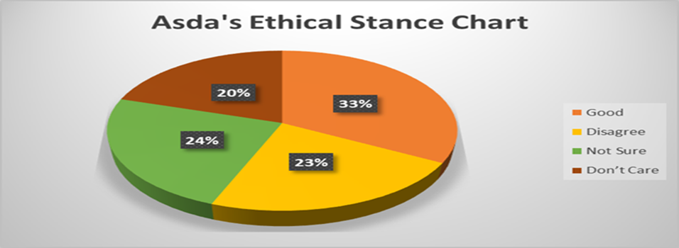
Figure 1: customers survey response.

2.3 Corporate social ethical responsibility of Tesco.
- Such as minimise waste, recycling carboard boxes, providing multi- purpose faith room for employees. not selling alcohol to underage. According to Booth (2009).
- Tesco focuses on health and safety of their customers and employees and insures the all their halal products are (HMC Approved).
- On a daily basis, collaborators in commercial and technological department’s manage wholesaler and site relationships, and ethical requirements with support from a specialist accountable obtaining group. According to Tesco plc (1989).

Customers response, survey’s results:
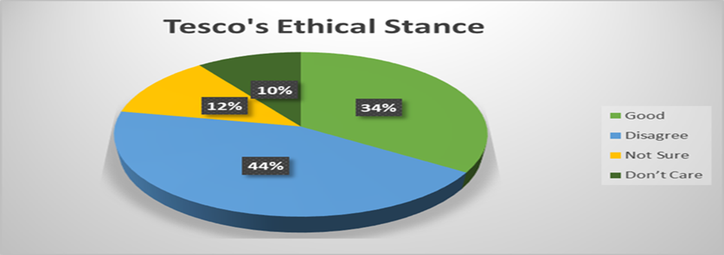

Figure 2: customers survey response.

Defining Sustainability of Asda:
Sustainability is an approach business use to establishing long-term value by taking into consideration how a given organization operates in the environmental, social and economic environment. According to Costanza and Patten (1995) sustainability is built on the assumption that creating such strategies nurture company durability.

3.1 Reviewing of the Sustainability of Asda.
At Asda, our method to sustainability is centred on the values and principle that we hold in safeguarding the environment and saving individuals money go hand in hand. We have a straightforward and clear vision to decrease the environmental effect of our processes, the goods and services we sell, and the wholesalers that make them.

3.2 Environmental Sustainability of Asda.
- Asda is committed to all packaging being recyclable by 2025. Asda has also achieved 60% decrease the emissions from their transport ventures. (Young. at. el. 2018)
- Asda is dedicated on minimizing and enhancing packaging and, since 2007, they have decreased packaging weight by 27 percent.
- Asda is working day and night to decrease the environmental effect of their operations. Bird and Hughes (1997) claims the above points in his article.

Customers response, survey’s results:
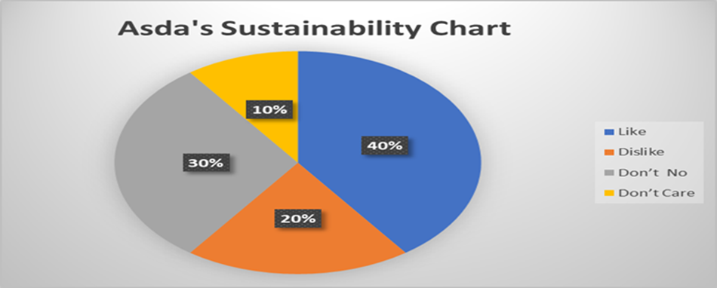

Figure 3: customers survey response.

3.3. Environmental Sustainability of Tesco.
- In 2018/19 we have lowered the sugar substance of our Own Brand baked beans variety by 20% taking the sugar category from an orangey on the traffic light nutritious information to green. According to these authors (Jones, et. al. 2014)
- We are dedicated to accomplishing zero net deforestation in the sourcing of soy, palm oil, wood/paper and Brazilian beef for our Own Brand manufactured goods by 2020. These authors claim (Jones, et. al. 2016)

Customers response, survey’s results:
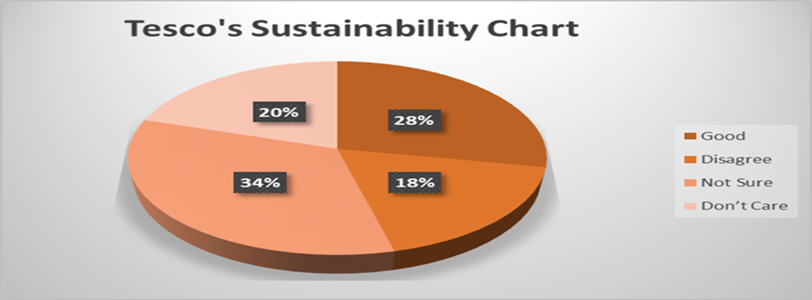
Figure 4: customers survey response.

Comparing Asda and Tesco’s Customers feedback and Viewpoints:
After evaluate Asda’s and Tesco’s ethic and sustainability, in every section there is a pie chart placed showing the results of the survey conducted based on the above policies from customers experience and their viewpoint. The survey was conducted in the establishment where I am presently employed at. the process took three weeks to complete, every Participant was entered in a lottery draw for complementary meal for two, whoever participated in this survey. A copy of the questionnaire is in the appendix.

Customers Relationship Management:
Customer Relationship Management (CRM) is much more than just a software application. It is a business resolution that gives supermarkets like Asda the capability to link with and understand real people involving every collaboration with valuable customers across your entire company. From Sales, Marketing, and service components to fully incorporated CRM, this will help expand the power of your sage business management solution right across your company. According to Buttle and Maklan.(2019). CRM theories will help you get access to the exact data you require to make knowledgeable business decisions. Below are few key points on customers relationship managements.
Advantages of CRM:
- CRM software helps store information about your customers smartly.
- CRM helps coordinate the information about your existing and potential customers in more digestible system.
- CRM software provides you with a more organized workflow. (Goodhue,at. al. 2002)
Disadvantages of CRM:
- Losing data is one of the main disadvantages points of using a CRM system. In the general business CRM data sets can be lost.
- CRM software system can be Breached at any point, the risk factors are extremely high. This poses treat to ethical image of ASDA.
- Loss of power can affect the CRM system; it slows the process and for a period time, everything gets muddled.
5.1 Customer perspective.
Asda beliefs in retain existing customers as well as acquiring new customers. Customer retaining approach developments is necessary measures for develop and enhance the loyalty of Asda’s customers. Centres and customer care services such as loyalty points programs, discounts and upgrades for customers, are among few of the actions that Asda take to retain their loyal customers.
  - Multidimensional construct.
Asda belief that it is very crucial that customers get a value for their money. Another key factor for Asda is that all their customers are satisfied as this helps build trust and understanding between and the supermarket.

Social criticisms of marketing.
One of the most vital factor that consumer view regarding supermarkets is its social criticisms. This can be conducted through many forms such as social media platforms and verbal communication etc. I have attempted to examine some of the most important ones regarding Asda and Tesco.
6.1. High pricing.
Asda believes in selling products which are good in quality, competitive in pricing. Asda’s fair-trade products which give’s certain percentages of the price to farmers and also sell fair trade products from other producers in this emerging world. These authors claim (Bird, et. al. 1997)
Impact. Consumers compare prices as well as the quality of the product they purchase, technology has created many platforms for consumers to just do that. I have been doing researches regarding supermarkets and their prices and quality comparisons. I have looked at supermarkets like Aldi, Lidl, Asda, Iceland and Tesco, this was conducted by viewing their websites and customers feedback sections. From my understanding the cheapest amongst this supermarket is Aldi followed by Lidl, Iceland, Asda and Tesco on the other hand the quality comparison from customers prospective and their feedbacks suggests that prefer them in this order Asda , Tesco, Iceland, Aldi, Lidl.
Impact. It can be argued that, is Asda really doing what they are saying or are they just doing something different, Green washing customers? examinations reveal that Asda are only giving a fraction of what they say they will give to the farmers and the rest, they are benefiting.
Impact. Some of Asda’s fair-trade products quality are very poor compared to other supermarkets fair trade products like Lidl and Aldi and the pricing is cheaper than Asda. Once I bought cod ( own brand ) to eat later we had guests in the house and needed more cod so I went Aldi’s and bought cod (Aldi’s own brand) compared both cod’s and realised that Aldi’s cod is much better then Asda’s.
6.2. High Pressure Selling.
Asda and Tesco use this technique to promote their products, for example three large packets of crisps at Asda and Tesco costs £3.00p and a single large packet of crisp costs £1.50p so a customer is pressured into buying the three large packets. Another example is if you buy a bar of snicker it coats 60p and three bars costs £1.00 at Asda and Tesco also if you buy a 4-pint milk it’s 1.10p and 6-pint milk is 1.49p.
Impact. These strategies puts the pressure on the customers to spend more money than they plan to, for example once I went Asda, the plan was to spend £5.00 on Chocolate, crisps and milk, then I noticed the above offers and spend way more then I originally intended to.
6.3. Deceiving, in Promoting goods.
Asda and Tesco belief that customers should be properly informed about the product that they are purchasing and should not be misguided or mislead in anyway.
Impacts. Asda use celebrities on their food packages, which misleads customer into thinking that these celebrities use that products. Asda and Tesco develop cereal packets by researches which colours would attracts children’s, so it will sell more. Also curries sold at Asda and Tesco’s display the halal logo but they do not clarify were the meat product is from.
Impacts. Some of Asda’s products packaging has description which are misleading ( less described on package to get a clearer image of how the product is ) and they use colourful pictures to attract customers, sometimes this can be deceiving.

Socially controversial products
Asda belief selling product with proper packaging, and proper ingredients displayed on them. Checking on all have expire dates displayed, Asda believes ID’ s should be checked before selling for all restricted product.
Impact. In 2017 Asda was ordered take out of their selves range of diet ready meals after court hearing following a disagreement with weight-loss organisation Slimming World. According to Parker (2017) A Slimming World spokesperson said: “It’s continuously been our view that Asda were mismanaging our brands to indorse the range, trading on the back of our much-loved and admired name and status, irrespective of whether the packet meals tally as Free Food on our healthy eating strategy.
Impact. Asda doesn’t display any age restriction on sells sharp products or Medicines, or detergents, these products can be very dangerous. My daughter who works in Asda informed me that last month they had the police come to their store, they had a youngster buying a knife from their store. Later in the carpark of Asda this youngster was threatening another youngster with that knife. Asda doesn’t have age restriction on purchasing dangerous item’s.

Customers Experience Management.
key points on customers experience managements.
8.1. Being committed to the customers.
Asda beliefs in being committed to their customers. Asda views one of the key points of customers commitments is maintain a positive attitude towards the customers, knowing their requirements, focus on supporting customer’s needs, quickly responding to their needs, and very carefully listening to them. To improve themselves every so often they analyse their sales to figure out what products sells the most so Asda don’t fall short on the product that their customers require.
8.2. Gaining trust the of customers.
Asda believes in gaining customer trust is the key to their success. Building customers trust is when you understand your customer's needs, respect them, and offer appropriate service for them. In Asda’s view obtaining customer's trust is crucial not only to make them loyal and come back, but also, so they insist their friends and family do business with you too. Asda beliefs in implementing the vital steps required customers trusts are enhance your security, being socially active (and visible), under-promise and over-deliver, go all-out for customer service, communicate more, always be available and make product more personal.

8.3. Achieving the satisfaction of customers.
Asda beliefs in having satisfied customers, as this helps to improve in selling their products. Asda is very cautious about the supplies they receive from other companies as this has to
meet or surpass customer expectation. Asda beliefs to attain satisfaction customers, hearing is not enough you need to listen to your customers, be responsive. response time is crucial in for Asda, be a human, not a machine with the customers. Get to know your customers, be organized and focused when dealing with customers.

9. Link between Quality and CRM.
Quality is termed as products in Asda, (everything that they sell). Standard of these goods as measured against other goods which are exact or similar kind, in other supermarkets, this defines the degree of excellence of the products. Quality of products and goods helps protect and strengthens the position of Asda in the competitive market, it also safeguards and supervises that stakeholders needs are met and ideally, that their expectations are surpassed.
According to Leventhal and Zineldin. (2006) CRM plays the key role in sustaining Asda’s products, goods and services are balanced out equally so that customers satisfaction is upheld and stakeholders expectation are met.

10. Literature review of quality models.
Total quality management (TQM) is reviewed as a management system for a customer-driven business such as Asda that requires all workforces in continual improvement. It utilizes approach, data, and effective means of communication to incorporate the quality restraint into the culture and activities of the firm. According to Evans, (2002) TQM encourages employees to focus on the quality of the product rather than focusing on the quantity of the product. TQM varies on customer reviews and feedback in order to produce new policies that can help to produce a highest quality of products compared to its rivals and achieve higher profits. These concepts are present in modern quality management systems. This section will examine the quality theory models that are available for business and their impacts on supermarkets like Asda.

11. Defining Deming theories of quality model.
Deming is known for prompting management that deals with difficulties that are universal,
It is management's obligation to boost the systems so that workers and management can do their jobs more effectively. These authors claim (Tamimi et. al. 1995). Deming theories of quality model was developed as an initial template to analyse total quality and services in organizations. Deming quality management model covers 14 key points. Diming portrayed his management philosophy as improvement for customers satisfaction and is universally oriented. Out of Deming 14 key points three will be analysed as they reflect on the guidelines of Asda, in the prospect of Asda’s quality and service.

11.1. Generate a constant purpose toward improvement.
Asda beliefs that customers relationship management plays a key role in planning for improvements in quality for the long term. Asda repulse responding with short-term solutions for any issues arise in regards to quality, product or customers satisfactions. According to Freidberg, (2007) supermarkets don't just belief in do the same things better, but to find better alternative things to do to improve customers relationship management and are always trying to forecast and prepare for future tasks, and always have the objective of getting better quality for customers satisfactions.

11.2. Implement leadership
Asda polices is that they expect their administrators and managers to recognize their employees and the procedures they use is not to just simply organized, but make available assistance and resources so that each and every employee can do their best. Asda expects their supervisor and managers to be a coach instead of a police officer. Asda expects their management team to workout in which sector which employee will be able to perform their best. Asda highlights the significance of participative management and transformational leadership, finding methods to achieve full prospective, and don't just emphasis on meeting objectives and measures. According to Hollingworth, (2012) good leadership is employee satisfaction and customers satisfactions.

11.3. Use training on the job.
At Asda one of the ethical stance is believing all employees should have proper train for stability to help reduce discrepancy. As this builds stronger base of common knowledge and understanding, this allow employees of Asda to recognize their roles in the “ larger portrait." Another key step Asda takes is to inspire employees to be taught by each another, and deliver a culture and environment for efficient teamwork.

11.4. Criticism of Deming 14-point theory model
Deming’s methodology’s has often been criticized for being unmotivating no creativity and no innovation. It is not effective for generating new products or infecting and infiltrating new markets. According to these authors Hillmer, and Karney. (2001) Joseph Juran, a famous quality guru has commented on misuse of statistical methods. Deming model is referred to as outdated.

Defining Juran’s quality trilogy model.
Juran Trilogy model is based around three sectors, these are managerial processes emphasizes as the improvement cycle that is intended to decrease the cost of poor quality by developing quality into the method and productions. According to Godfrey and Kenett (2007) Juran trilogy quality planning focuses on the developing phase, as it is essential to identify who your customers are and find out their demands, I their perspective. The three key sectors will be analysed, as they are similar to Asda principles.

12.1. Quality planning.
In the developing stage, it is critical to identify who your clients are and their requirements. Once you understand your clients requirements, you’re able to characterize the obligations for your service, merchandise and procedure etc., and improve them. Furthermore, any projects that may require to be reassigned to operatives or other key stakeholders should be done during the developing stage. Organizing events should be done with a multidisciplinary team, with all key stakeholders characterized( Benware. Et. al. 2003).

12.2. Quality control.
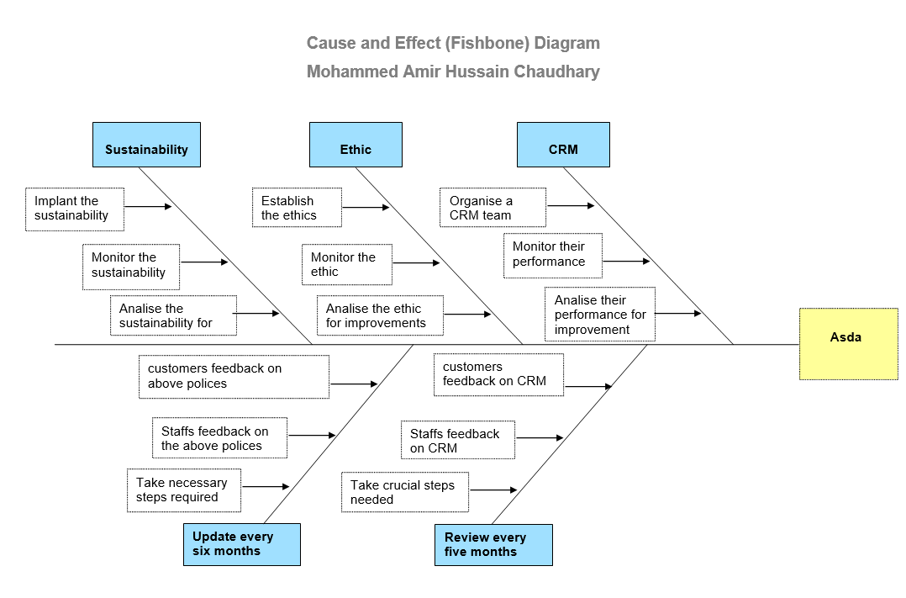
Throughout the control period, decide what you require to determine what data do you require to know if your method is working, and set an objective for your overall accomplishment. Getting feedbacks by evaluating your actual performances, and act on the difference among your performance and your aim. In Statistical Process Control (SPC). According to Tsung, and Jin.(2008).there are numerous tools that could be utilized in the “control” phase of the Juran Trilogy are Pareto Analysis, flow diagrams, fishbone diagram and control charts, just to name a few. A fishbone diagram is utilised to analyse Asda.

12.3. Criticism of Juran’s quality trilogy model.
So as to accomplish quality control there requires to be the suitable employees that know the accurate processes of this program. This framework doesn't generally work for all companies it has a higher achievement level for companies that have stringent polices and not very tolerant, this program can lead to workers being distress because there can be a high level of significance. These are a few of the criticisms of Juran’s Trilogy System.

Defining Crosby's cost of quality model.
Crosby’s cost of Quality model has two main elements. According to Schiffauerova, and Thomson. (2006). The cost of good quality or the cost of conformance and the cost of poor quality or the cost of non-conformance. Crosby argues that companies should focus on attention to customer obligations and avoidance of product deficiencies.

13.1. Cost of quality model.

Asda beliefs in purchase quality products even if it costs more money. Asda’s aim is to sell quality product that meets their customer’s needs. Asda will not purchase any goods which doesn’t meet up to the expectation of their customers. Asda has a quality-controlled subdivision where they examine all products that are purchased from other suppliers as well as their own brands, inspections are performed regards the quality of the product and its standards as products that purchased or produced, if right the first time, it cost effective in many way.

.

13.2. Impact of good- quality products 13.3. Impact of poor-quality products
Table: 1 Table: 2
If the quality of the product is good then the customers will be loyal to Asda, also they will return and recommend the product family and friends. | If the quality of Asda’s product is poor then the customer will be dissatisfied and will not return.
If the quality of the products are good at Asda’s then the business will improve, customers will increase as word of mouth from one customer to another spreads. | If the quality of Asda’s product is poor then the customer will complain and demand a refund.
If the quality of Asda’s product are good then the management will trade with less stress and there will be fewer complaint from customers. | If the quality of Asda’s product is poor then the customer will advise family and friends not to shop at Asda.
If the quality of Asda’s products are good, then it will saves time money customers as they don’t have to shop any for that product. | If the quality of Asda’s product is poor then Asda will have to return it to the supplier this will cost money and time.

Crosby’s cost and quality model is centred around similar beliefs and values as Asda, as the two components of his model focuses on the quality like Asda does.

13.4. Criticism of Crosby's cost of quality model.
On occasions, when supermarkets like Asda is incompetent to achieve the quality standards set by themselves, the cost incurred for the procedure seems like a pinch in the pocket of Asda. Another disadvantage is that when Asda fails to achieve the objectives set by themselves, they need to do an examinations, as to what went wrong and where. According to Özkan, and Karaibrahimoğlu. (2013). There many other cost such as appraisal costs are costs sustained to ascertain the level of conformance to quality requirements. Internal malfunction costs are costs related with deficiencies found before the customer obtains their merchandise or any types of service. External failure costs are costs related with deficiencies found after the customer obtains their products or services.

Opinion on the above models.
After all the research conducted, my own opinion on these models is, Deming model was very good for supermarkets like Asda at the time his model was created. Now that decades have passed by, his model seems outdated. In my opinion Juran’s quality trilogy model is more concentrated on the larger organizations, this theory mainly focuses on making profits for the organizations and doesn’t focus on the employees or their requirements. Crosby's cost of quality model is based primarily on the smaller organizations and supermarkets like Asda if focused on TMQ sections, as well as maintaining a balance between costs and quality, my personal opinion is, I prefer the Crosby’s model.

Links between Ethic’s and Sustainability.
Effects, morality, and relevance are all termed as ethically importance in order to traverse sustainability. Sustainability policy defines the objectives and activities integration to achieve organizational success. Sustainable policies entail about the natural ecosystem resources in order to protect and preserve the community. According to O’Hara. (1998). Appropriate strategies are placed to alleviate wastes, safeguard nature and reduce expenditure from the globe. It ensures that the environment is suitable, clean and safe. Ethical policies of ASDA include the guidelines to the employees to behave properly at all the time in the office environment and do the proper thing. Ethical policies refer that happy employees will bring happy customers and profitable trading.

Critical conclusion and Recommendations to improve CRM, Ethic’s and sustainability.
Table: 3
Conclusion on customers relationship management in Asda:
After extensive researches conducted on Customers Relationship management (CRM). I can conclude that CRM is a foundational strategy or a model that supermarkets like Asda use to successfully operate their business. it focuses on how supermarkets like Asda manage and enhance their relationships with consumers for long-term success. CRM is becoming a topic of increasing importance in marketing sector globe and is involved with using information technology (IT) in implementing modern day marketing strategies in supermarkets like Asda.

Recommendations on how CRM can improve Asda:

- CRM can help Asda to improve their multichannel methodology, make sure that they can offer customers an integrated experience across mobile apps and online websites.
- CRM can help Asda develop touchpoints for its customers, where customers feel more relaxed, knowing that if they need one to one support then there is always someone available.
- CRM can help Asda retaining and winning back customers, boosting profitability through pricing structure modifications and promotional cost decreases, improving sales through more efficient inventory choice and marketing.
- CRM can help Asda embodies frequent flyer, membership and loyalty programs, retention, lifecycle, attrition, as well as archive marketing and customer service.

Table: 4
Conclusion on Ethical Stance of Asda:
In completing this report I have enhanced the knowledge and understanding that ethics at Asda are very vital as these ethics create a robust relationship between employees, management and customers. Another key point that has been acknowledge, is ethics at Asda obviously helps to avoid critical situations between employees, management or customers. Asda’s brand loyalty is now a fundamental necessity of customers and this ethical strategy facilitates to enhance product value as a result commitment of customers increases. Asda’s Ethical policies helps to develop rules and regulations which employees, customers and management values.

Recommendations on how ethical stance can improve Asda:

- If Asda implants an ethics policy on plastic-free products, then this will help in improve the environment and create a platform for consumers, to feel at ease knowing that Asda is doing something for the environment.
- If Asda implants an ethics policy on plant-based foods will keep consumers healthy, this will create a strong bond between Asda and their customers.
- If Asda implants an ethics policy on re-saleable clothing’s and recycling clothing’s, this will help create sympathy in the eyes the of the customers, this will be beneficial for Asda.
- If Asda implants an ethics policy on individual shelves displaying gluten free or allergic food on them, this will help the customers feel at ease knowing, it easy to find the product they want to purchase.
Table: 5
Conclusion on sustainability of Asda:
Know that I have nearly completed this report. I have come to conclude that sustainability in Asda plays a very crucial role, as it is interlinked with ethics, without sustainability in Asda there will be a miscommunication amongst employees and managements, customers will be dissatisfied, employees motivation will be non-existence as there will be no visions implanted. Asda’s sustainability policies facilitates to develop rules and regulations which customers, employees and management respect and values, it also supports to avoid critical circumstances.

Recommendations on how sustainability can improve Asda:
- It is recommended that Asda should implants sustainability policy of introducing better sell-by dates or demanding longer sell by dates from suppliers
- Asda need to implant sustainability policy of incorporating technology to make a change to the global market
- If Asda implants sustainability policy of having more seasonal foods, then the cost will be less, also for the environment
- If Asda implants sustainability policy were, they reward their employees, also pay time of on religious occasions for their employees.

Conclusion.
Finally, this report is completed, it is concluded that customer relationship management theories helps operates and improves the relationship of Supermarket like Asda and Tesco with their potential consumers. It will help the company to manage its status and accomplishment in the market with positive environment both internally and externally. It will enhance policies and guidelines also help the Supermarkets to sustain their ethical stance and sustainability policies in order to manage the company's policies and guidelines. This in turn helps the company to control its performance level and manage its stakeholders accordingly. There are numerous issues in these management policies; however any such issues can be diminishes by correctly scheduled approaches. ASDA needs to manage its company in order to manage its performance in the market and also build strong relationships with customers. Understanding and fulfilling customer desires and their satisfaction level will enhance the company's ability to grow in numerous fields. CRM will not only help the customer but also will support ASDA to grow in the global competitive market.

Reference
      - Asda Group Ltd. 1989. Ethical consumers since 1989. (online) Available at:
https://www.ethicalconsumer.org/company-profile/asda-group-ltd
Accessed on 2-1-2020.
      - Benware, B., Schuermyer, C., Ranganathan, S., Madge, R., Krishnamurthy, P., Tamarapalli, N., Tsai, K.H. and Rajski, J., 2003, September. Impact of multiple-detect test patterns on product quality. In null (p. 1031). IEEE.
      - Bird, K. and Hughes, D.R., 1997. Ethical consumerism: The case of “Fairly–Traded” coffee. Business ethics: A European review, 6(3), pp.159-167.
      - Booth, P., 2009. Corporate social responsibility. Economic Affairs, 29(4), pp.2-4.
      - Costanza, R. and Patten, B.C., 1995. Defining and predicting sustainability. Ecological economics, 15(3), pp.193-196.
      - Buttle, F. and Maklan, S., 2019. Customer relationship management: concepts and technologies. Routledge.
      - Evans, J.R., 2002. Total quality management. INFOR, 40(4), p.364.
      - Godfrey, A.B. and Kenett, R.S., 2007. Joseph M. Juran, a perspective on past contributions and future impact. Quality and Reliability Engineering International, 23(6), pp.653-663.
      - Freidberg, S., 2007. Supermarkets and imperial knowledge. cultural geographies, 14(3), pp.321-342.
      - Goodhue, D.L., Wixom, B.H. and Watson, H.J., 2002. Realizing business benefits through CRM: hitting the right target in the right way. MIS Quarterly executive, 1(2), pp.79-94.
      - Hillmer, S. and Karney, D., 2001. In support of the assumptions at the foundation of Deming's management theory. Journal of Quality Management, 6(2), pp.371-400.
      - Hollingworth, L., 2012. Why leadership matters: Empowering teachers to implement formative assessment. Journal of Educational Administration.
      - Jones, P., Hillier, D. and Comfort, D., 2014. Assurance of the leading UK food retailers' corporate social responsibility/sustainability reports. Corporate Governance.
      - Jones, P., Comfort, D. and Hillier, D., 2016. Materiality in corporate sustainability reporting within UK retailing. Journal of Public Affairs, 16(1), pp.81-90.
      - Jones, P., Comfort, D. and Hillier, D., 2011. Sustainability in the global shop window. International Journal of Retail & Distribution Management.
      - Joseph M. Juran, a perspective on past contributions and future impact. Quality and Reliability Engineering International, 23(6), pp.653-663.
      - O’Hara, S.U., 1998. Economics, ethics and sustainability: redefining connections. International Journal of Social Economics.
      - Özkan, S. and Karaibrahimoğlu, Y.Z., 2013. Activity-based costing approach in the measurement of cost of quality in SMEs: a case study. Total Quality Management & Business Excellence, 24(3-4), pp.420-431.
      - Parker, F. 2017. Asda pulls diet ready meals from shelves after Slimming World dispute. (online) Available at: https://www.telegraph.co.uk/news/2017/03/19/asda-pulls-diet-ready-meals-shelves-slimming-world-dispute/ Accessed on 3-2- 2020.
      - Schiffauerova, A. and Thomson, V., 2006. Managing cost of quality: insight into industry practice. The TQM Magazine.
      - Seeley, J.R., 1966. The making and taking of problems: Toward an ethical stance. Soc. Probs., 14, p.382.
      - Tsung, F., Li, Y. and Jin, M., 2008. Statistical process control for multistage manufacturing and service operations: a review and some extensions. International Journal of Services Operations and Informatics, 3(2), pp.191-204.
      - Tamimi, N., Gershon, M. and Currall, S.C., 1995. Assessing the psychometric properties of Deming's 14 principles. Quality Management Journal, 2(3), pp.38-52.
      - Tesco plc. 1989. Ethical consumers since 1989. (online) Available at: https://www.ethicalconsumer.org/company-profile/tesco-plc. Accessed on 3-1-2020.
      - Young, C.W., Russell, S.V., Robinson, C.A. and Chintakayala, P.K., 2018. Sustainable retailing–influencing consumer behaviour on food waste. Business Strategy and the Environment, 27(1), pp.1-15.

Appendix
Definitions of the results of the Pie charts is Good = customer likes the polices. Disagree = the customer doesn’t like the polices. Not sure = the customer is not familiar with the polices. Don’t care = customer is not bothered with the polices.

Questionnaire
Corporate social ethic and sustainability of Asda.
Good Dislike Not sure Don’t care
            - Asda belief in promoting and selling heathy product with proper packaging,
and what ingredients displayed on them, at an affordable price for the mass.

- In March 2019 Asda entered the Ocean Disclosure Development, a voluntary
program throughout which Asda divulge details of their wild-caught seafood
tracking, along with data’s on the environmental accomplishments of every fishery.

- Asda claims clear guidelines are upheld at Asda on concerns such as working hours,
health and safety of employees and customers etc, these issues will not be
compromised at any costs.

Corporate social ethic and sustainability of Tesco.

Good Dislike Not sure Don’t care
      - Corporate social responsibility such as minimise waste, recycling carboard
boxes, providing multi- purpose faith room for employees. not selling alcohol
to underage.

      - Tesco focuses on health and safety of their customers and employees and
insures the all their halal products are (HMC Approved).

      - On a daily basis, collaborators in commercial and technological department’s
manage wholesaler and site relationships, and ethical requirements with support
from a specialist accountable obtaining group.

