

Design an Automatic Traffic Light Controller for a T-Junction Road
Daniel Frankland (2308433)

Title Page


2. Table of Contents
B. Eng. In Embedded Electronic Systems Electronics 1 (ACB5002)
[8]
[8]

1. Title Page 1
2. Table of Contents 1
3. Table of Figures 3
4. Introduction 4
5. Background Research 4
5.1. Research on Traffic Lights 4
5.1.1. Time-Based vs Sensor-Based Traffic lights 4
5.2. Microcontrollers 5
6. The Circuit and Code 6
6.1. Explanation of the Circuit 6
6.2. The Code 9
6.3. How I Tested the Circuit 13
7. Flowchart 14
8. Conclusion 15
9. References 16

Table of Figures
Figure 1 Traffic Light Circuit 6
Figure 2 Visualisation of the Traffic Light System 7
Figure 3 The Circuit: Resistors for Display 8
Figure 4 The Circuit: Pedestrian Control/ Light Control PIC Connections 8
Figure 5 The Code Part 1 9
Figure 6 The Code Part 2 10
Figure 7 The Code Part 3 11
Figure 8 The code Part 4 11
Figure 9 The Code Part 5 12
Figure 10 Traffic Light testing sequence 2 13
Figure 11 Traffic Light testing sequence 1 13
Figure 12 Traffic Light testing sequence 4 13
Figure 13 Traffic Light testing sequence 3 13
Figure 14 Flow Chart 14

Introduction
In this assignment I was tasked with designing an automatic traffic light control system for a T-Junction using a microcontroller. The objective was to create a system that could efficiently control traffic flow across 3 intersecting roads while also incorporating a 7-segment display for each traffic light and pedestrian crossing lights. To approach this, I carried out research into various types of traffic light control systems, including time-based and sensor-based methods. I also researched different types of microcontrollers and single board computers. The circuit was designed and simulated in Proteus while the code was compiled using CCS C compiler. This report contains background research, system design, circuit explanations, code structure and testing methods to confirm the systems accuracy and performance

Background Research

5.1. Research on Traffic Lights
Traffic lights are essential components in the modern traffic management systems. They control the flow of vehicles and pedestrians at intersections to ensure safety and reduce congestion. The efficiency of these systems depends on the technology used to control it. Some systems such as the one assigned in the brief relies on time-based control, where lights change at a fixed time interval regardless of traffic conditions. This is simple to implement but has significant drawbacks. If one of the roads at the intersections is empty whilst others are congested the system will still provide a green light for an empty road causing unnecessary delays.
To address this problem in most places either inductive loops, infrared sensors or microwaves are used. The inductive loop is a coil embedded into the surface of the road. It works by detecting when a vehicle passes over it which causes a change in the magnetic field induced by the loop. [1] Each of these technologies has it advantages and disadvantages which have to be considered when designing the traffic management system.

5.1.1. Time-Based vs Sensor-Based Traffic lights
Time-Based traffic light systems operate on fixed schedules meaning that each signal remains on for predetermined duration regardless of traffic conditions. This is useful in areas with predictable traffic patterns such as small towns/villages and low traffic areas. However, using this in larger more build up areas with fluctuating traffic throughout the day can lead to unnecessary waiting times where there are no cars present.
Sensor-Based traffic light systems are now used in most modern traffic light systems. These incorporate vehicle detection sensors to optimise traffic flow in real time. These sensors allow the systems to detect waiting and approaching vehicles at the intersection and will adjust the lights accordingly [2].
Inductive loops are one of the mostly used vehicle detection methods. These consist by having a coil embedded into the surface of the road. When a vehicle passes over the loop the metal in the car disrupts the magnetic field triggering the systems and informing it that there is a vehicle present [1].
Infrared sensors are mounted overhead on top of the traffic light. There are two types of infrared sensors active and passive. Active sensors emit low level infrared signals into a specific zone and when a vehicle enters the zone it disrupts the signal. Passive sensors work by detecting when a vehicle enters a specific zone which causes a change in infrared energy. There are also microwave sensors which work the same as infrared but detect microwave energy instead and are less prone to interruption by temperature changes. [1]
The problem with using sensor traffic lights is that if a vehicle is not positioned correctly in the detection zone the sensor might fail to register its presence causing indefinite waiting for the lights to change. This can be a problem with motorcycles and bicycles which might not trigger the sensor.

5.2. Microcontrollers
There are a wide choice of microcontrollers and single board computers. There are many families including Pic, AVR, ARM , ESP32 as well as platforms such as Arduino and Raspberry PI.
PIC originally known as the peripheral interface controller but now known as the programmable intelligent PC. Developed by semiconductor unit technology and was created by general instrument electronics in 1993. These are programmed to carry out a wide range of tasks and are available in 8-bit, 16-bit and 32-bit versions. [3]
AVR is a family of microcontrollers developed by Atmel that use the RISC processor. AVR are most commonly used in the Arduino line of open source board designs. These are available in 3 sizes a 8-bit tinyAVR, megaAVR and XMEGA. [4]
ARM microcontrollers was invented by Acorn computer organisation and is now manufactured by Apple, Nvidia, Qualcomm, Motorola, ST microelectronics, Samsung electronics and many others. It is an advance RISC microcontroller that is based on the RISC instruction set architecture (ISA). It is the most widely used microcontroller and most industries use it for embedded systems because it has a wide range of features. [3]
ESP32 is a series of low-cost low power system on chip microcontrollers with integrated Wi-Fi and dual mode Bluetooth. Created by Espressif Systems. ESP32 microcontrollers are powerful devices that offer a wide range of features and capabilities. [5]
Raspberry Pi was initiated in 2006 in the UK with the aim of promoting computer science education. The first model was launched in 2012 and since it has gained popularity among educators, hobbyists and industry. They offer a range of products which have multiple configurations and connectivity ports to allow for easy use. [6]
Arduino is a controller platform. It doesn’t run a full operating system instead it focuses on interfacing with sensors and controlling devices. Arduino was established in 2005 and has now become popular in education for quick prototyping. [6]

5.3. Justification of Chosen PIC
Although the PIC18f8722 may be considered as over spec’d for this task its extensive I/O availability made it suitable for early development and testing. This allowed the traffic lights, 7-segment displays and pedestrian controllers to be handled on separate ports. In future versions, a smaller more compact PIC could be used to reduce costs and power consumption.

The Circuit and Code

6.1. Explanation of the Circuit
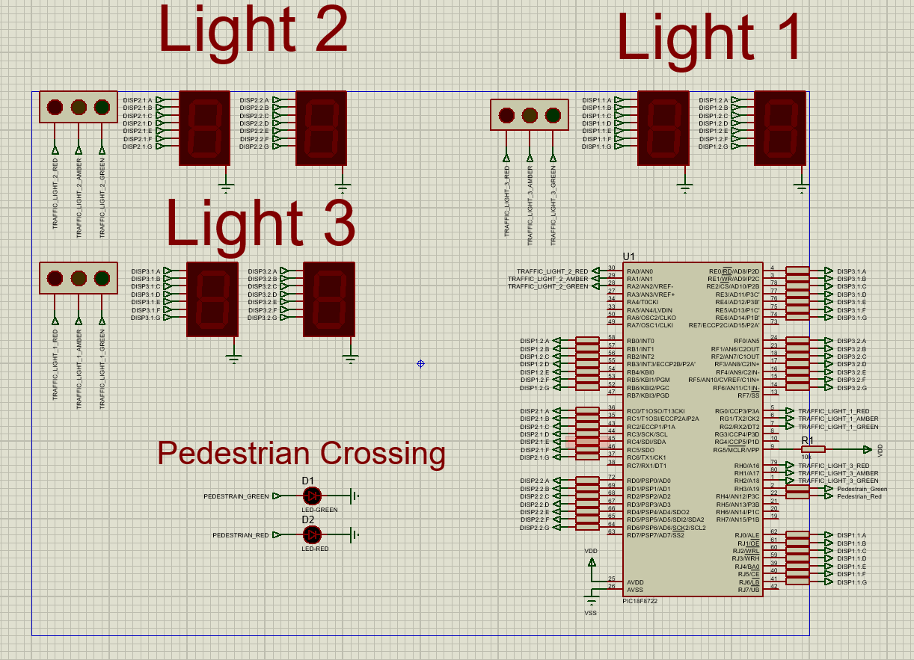
Figure 1 Traffic Light Circuit
The three 7-segment displays are each responsible for showing the timer value related to their corresponding traffic lights. I programmed these displays to count up from 0 to 40 in 1-secound intervals using an interrupt driven approach. Each set of displays resets after 40 seconds, which aligns with the complete traffic cycle. I chose to use the upward counting approach as it is simpler to use. However, a countdown from 40 to 0 would be more intuitive for drivers and pedestrians. This would allow for anticipation in light changes, improving safety and traffic flow.
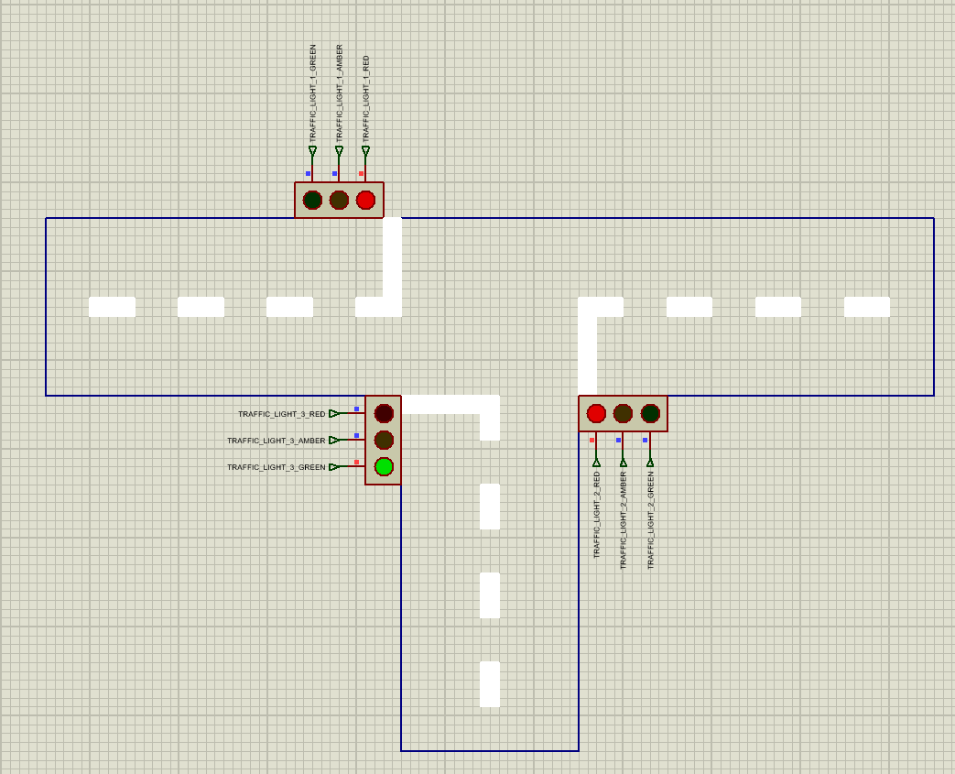
Figure 2 Visualisation of the Traffic Light System
The circuit which can be seen in Figure 1 consists of a PIC18F8722, resistors, LED’s and traffic light modules.
The PIC is used as the microcontroller for their circuit controlling the whole operation of the traffic light system. This includes all of the timing for the traffic light sequencing. I decided to use the PIC18F8722 due to the amount of available ports allowing me to have 3 separate timers one for each set of traffic lights. With this I was able to put one display on one bank. The remaining ports were used for the traffic lights, power for the pic and the crossing lights.
The circuit was designed around the PIC as this was the biggest object. To allow for neat connections I used input and output blocks to allow the traffic lights to be spaced out across the page to avoid a mess of wires and confusion of what traffic light was for what timer. Once I had my circuit fully laid out I was able to start coding. I used previous code from other modules to help me with the interrupts. Used separate functions for multiple parts of code to avoid repetition. Used a switch case for the hex for each digit for the displays.
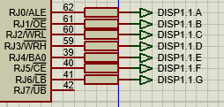
Figure 3 The Circuit: Resistors for Display
In the zoomed in section of the circuit resistors are used to restrict the flow of electrical current in a circuit. [7] Resistors also have multiple use cases but for this application I am using them as current limiting to reduce the voltage for the LED’s so they aren’t blown.
In the circuit above I then use the output block to provide an input to the corresponding component.

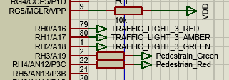
Figure 4 The Circuit: Pedestrian Control/ Light Control PIC Connections
In this zoomed in section of the circuit the resistors are used for the pedestrian crossing lights and outputs to the traffic lights.

6.2. The Code
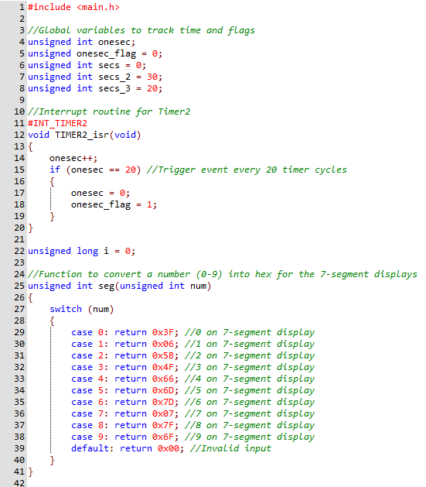
Figure 5 The Code Part 1
The code starts with defining variables which are used for tracking time. Next the interrupt timer function is created to create a 1 second counter. Then on line 25 is the function to convert numbers into hex for the display.

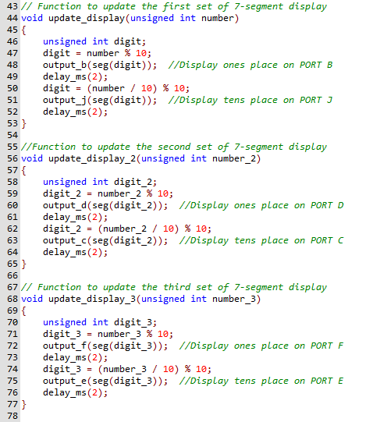
Figure 6 The Code Part 2
In the code above is the update display functions which is repeated 3 times one for each set of 7 segment displays.

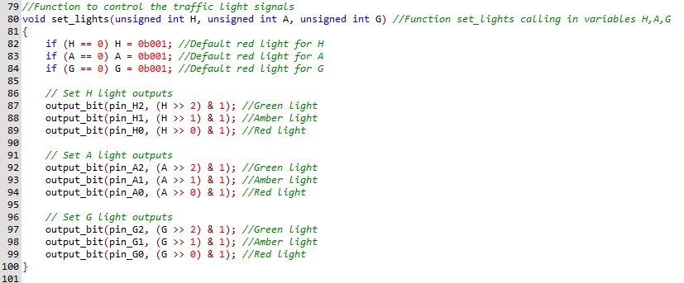
Figure 7 The Code Part 3
On line 80 is the function to control the traffic light signals for each set of traffic lights. In the command on line 87, which is repeated a total of 9 times the pin to be controlled is first, then the variable with the data to check is called in and compared to a number; on this line its 2 and then lastly it sets that light as on. This checks values from the function below and only turns it on if a 1 is present in a set position.
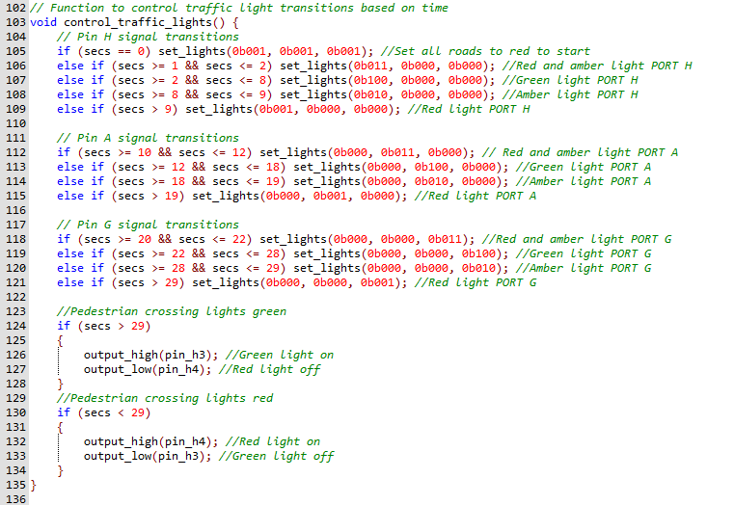
Figure 8 The code Part 4
In this part of the code is the timing sequencing for all of the traffic lights and crossing phases. This then sets the lights to the correct state. The set_lights function is called inside of this function to turn the specified lights on and off.
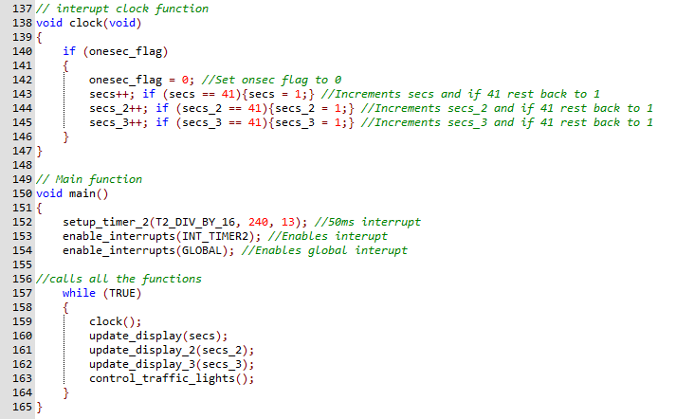
Figure 9 The Code Part 5
This is the last part of the code where the interrupt clock is made for all the timing functions for each set of displays. Lastly from line 150 is the main function where the interrupt is setup and then all the relevant functions are called in the correct orders.

6.3. How I Tested the Circuit
To confirm that the circuit met the required brief and was functioning correctly I compared the timer output to an accurate clock. Where I noted that it was indeed running to time. I then based the traffic light sequence of the UK standard and confirmed that each traffic light changed lights at the same time. Due to the lights having only 10 seconds per junction I wasn’t able to use the UK’s standard for light timings.
Since I had confirmed that the traffic lights were operating correctly I left the circuit to run for a while to confirm that it was able to continuously run the same sequence for extended periods of time.
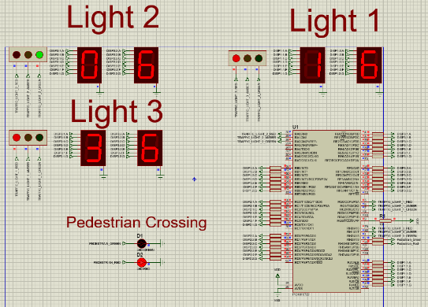
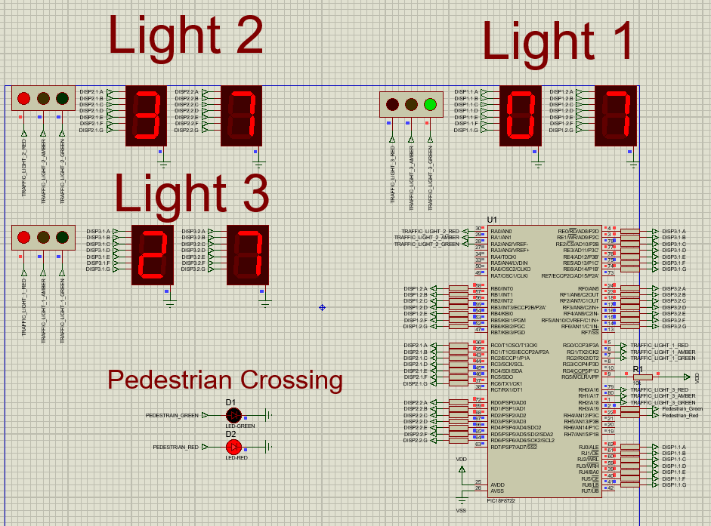
Figure 10 Traffic Light testing sequence 2
Figure 11 Traffic Light testing sequence 1

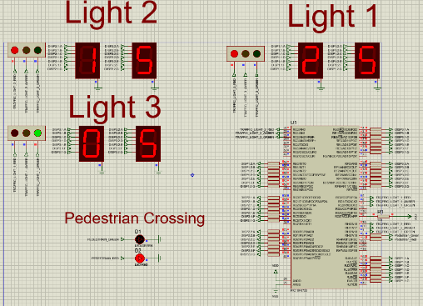
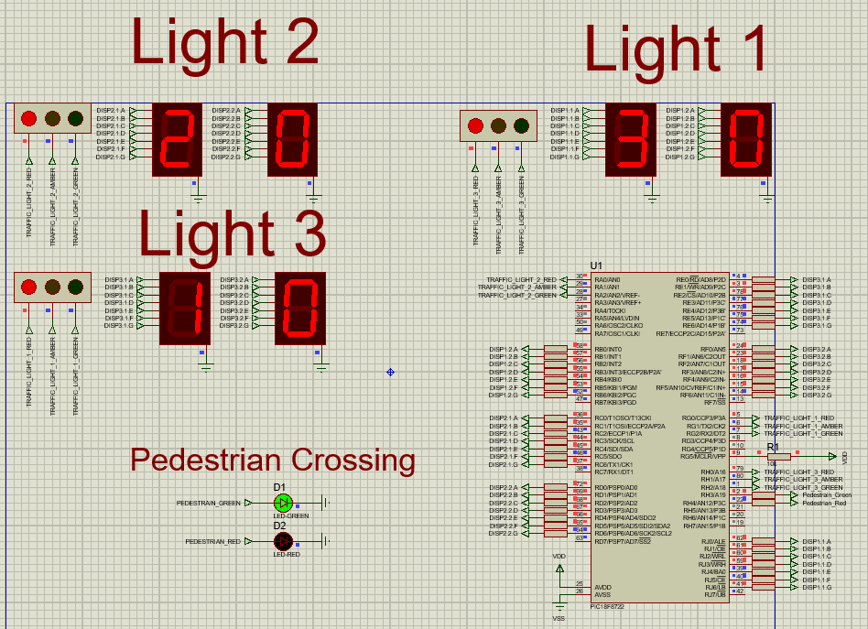
Figure 12 Traffic Light testing sequence 4
Figure 13 Traffic Light testing sequence 3
Above in Figure 10,Figure 11,Figure 12 and Figure 13 is the testing of the sequencing of the traffic lights. The software I used was proteus for the simulation and CCS for the compiler.

Flowchart
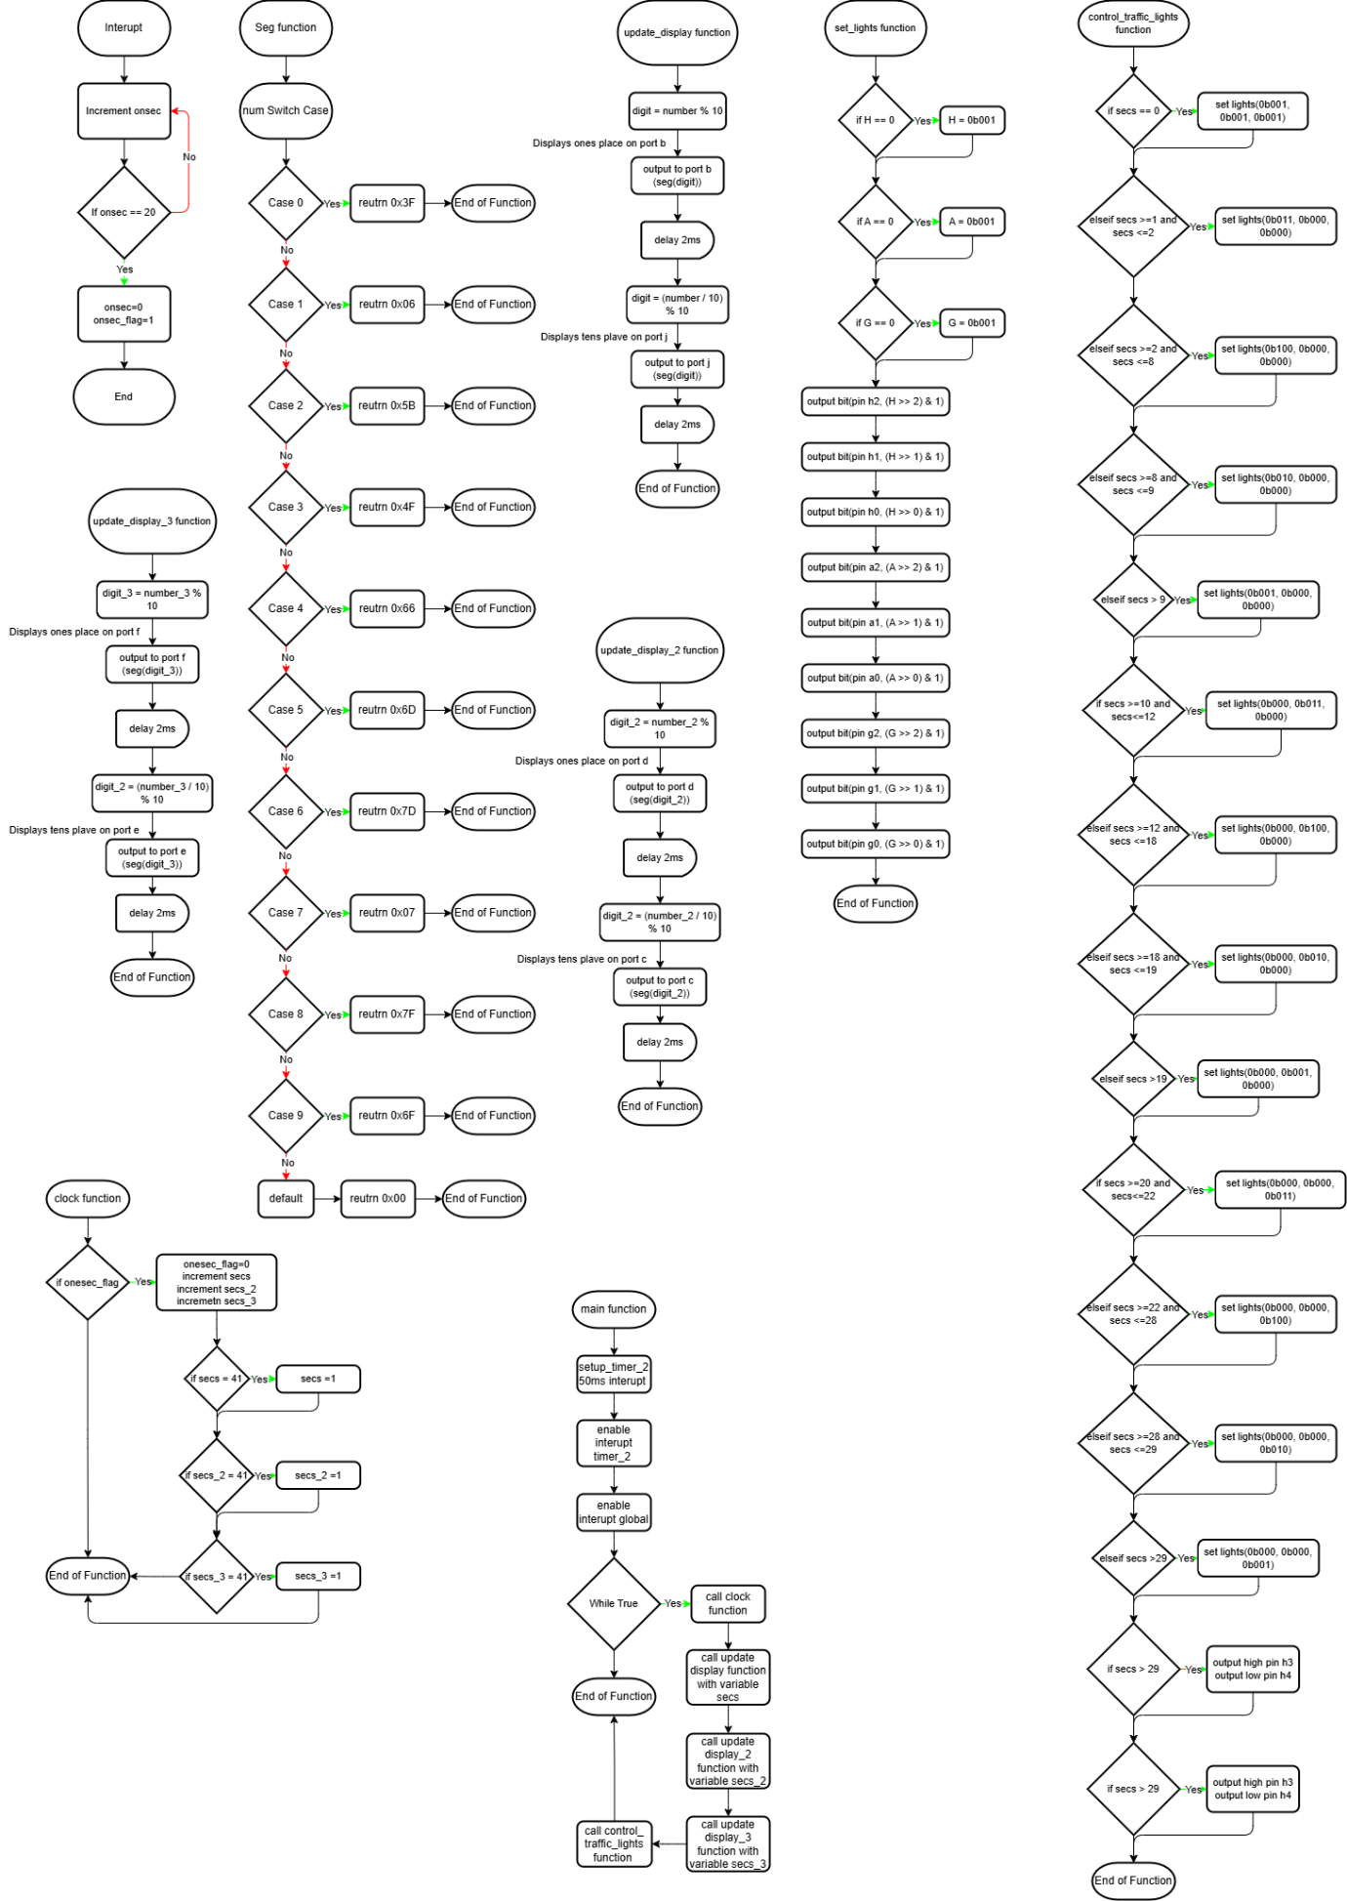
Figure 14 Flow Chart
Above is the flowchart of each function of the circuit showing how the code operates.

Conclusion
In conclusion the circuit meets the required brief with a few additional lights and timers added for the user’s convenience. I believe in future work that using the PIC I have chosen is over spec’d for the requirements. If I repeated this circuit I would ensure my clocks counted down instead of up. So that when the lights turn green, the timer would be at zero. Then I would add a second counter also counting down to zero until the lights turn red. This timer would allow drivers to anticipate changes in the traffic lights sequence, knowing that in in a set time the lights will change. For example, in 10 seconds time the lights will turn red. This means that drivers can slow down in preparation for the lights changing red. Therefore, avoiding the need to suddenly and abruptly stop at red traffic lights.
Recommendations for improving the traffic light system is to have built in traffic sensors. Discussed in my research adding this will allow for smoother operation of the traffic light system. My second recommendation for improvement is to add a request for the pedestrian crossing phase. Adding this after a full traffic cycle (30 seconds in this case, 10 seconds per traffic light) Once the request has been issued it will set all lights to red and allow pedestrians to cross safely for the remaining 10 seconds of the cycle. A timer could also be added for the pedestrians crossing phase.

References

[1] | total concrete, “How Do Traffic Lights Work?,” [Online]. Available: https://www.totalconcrete.co.uk/news/how-do-traffic-lights-work/. [Accessed 28 Febuary 2025].
[2] | J. Wu, “Understanding,” Leotek, 15 Febuary 2024. [Online]. Available: https://leotek.com/traffic-light-sensors/#:~:text=Modern%20traffic%20control%20systems%20use,smooths%20the%20flow%20of%20vehicles.. [Accessed 03 March 2025].
[3] | J. Solanki, “PIC Vs ARM | Difference | Comparison,” ECSTUFF4U, 05 March 2023. [Online]. Available: https://www.ecstuff4u.com/2023/03/pic-vs-arm-difference-comparison.html?utm_source=chatgpt.com. [Accessed 04 March 2025].
[4] | Octopart Staff, “How to Choose A Microcontroller,” Octopart, 27 October 2017. [Online]. Available: https://octopart.com/pulse/p/how-to-choose-a-microcontroller. [Accessed 04 March 2025].
[5] | J. Hertz, “esp32 history to application,” Flux, 25 July 2023. [Online]. Available: https://www.flux.ai/p/blog/exploring-esp32-from-history-to-application. [Accessed 04 March 2025].
[6] | UMATechnology, “Singled Board Computers: Raspberry Pi vs BeagleBone vs Arduino,” UMA Technology, 05 January 2025. [Online]. Available: https://umatechnology.org/single-board-computers-raspberry-pi-vs-beaglebone-vs-arduino/?utm_source=chatgpt.com. [Accessed 04 March 2024].
[7] | “RS Components,” 5 August 2025. [Online]. Available: https://uk.rs-online.com/web/content/discovery/ideas-and-advice/resistors-guide?srsltid=AfmBOoobtJJCQARIKDClBXs0Dm6vIEET6-Tnrg_OcJhNhxaSENXEQM-7. [Accessed 30 December 2024].
[8] | “TemplateLab,” [Online]. Available: https://templatelab.com/cover-page-templates/. [Accessed 01 November 2023].

