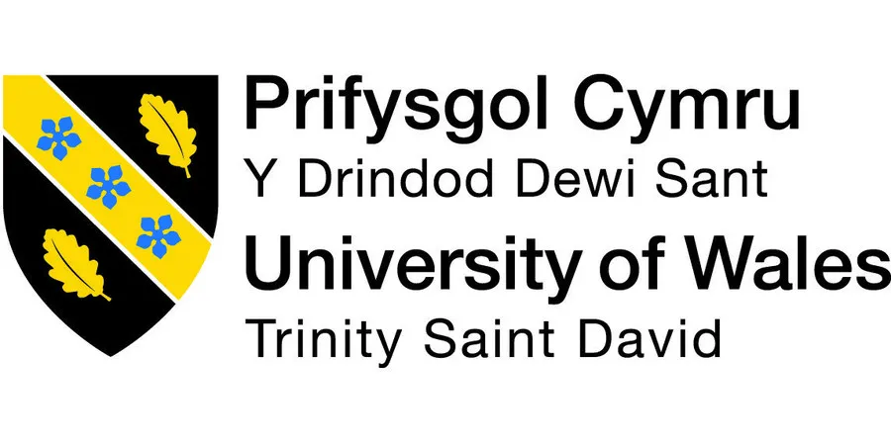

Module-BMH6021_LON
HEALTH,WELLBEING AND SUSTAINABLE DEVELOPMENT
(Level-6;Term-2)

Assessment 1 / Report : Health ,Wellbeing and Sustainable Development in Merton (UK).

Lecturer name – Dr.Laila Surani
Student name – Yuliana Abadzhieva
Student ID – 1818406
Submission deadline – 4th of January 2024;2pm (UK time).

Table of Contents
1.Introduction………………………………………………………………………………...3
2.The 17 Sustainable Development Goals……………………………………………….4
3.Discussion of the main 3 SDGs …………………………………………………………7
4.Goal 3 – Good Health and Wellbeing………………………………………………...…7
5.Goal 4 – Quality Education……………………………………………………………….9
6.Goal 17 – Partnership for the Goals……………………………………………...……10
7.UK Policies and initiatives …………………………………………………………..….12
8.Merton Borough………………………………………………………………………….14
9.Status of Merton Borough of meeting 3 SDGs………………………………….……18
10.Recommendations………………………………………………………………….….20
11.Conclusion……………………………………………………………………..……….21
12.Reference list…………………………………………………………………….……..22

Introduction

The report's main topics include sustainable development, health, and well-being in Merton Borough, United Kingdom (UK). The appearance of the 17 sustainable developments and the degree to which Merton Borough can use them. Goal 3. Good Health and Wellbeing, Goal 4. Quality Education, and Goal 17. Partnerships for the Goals. Meeting the requirements and how national and local policies meet the aim of sustainable development will have a broad scope. After the research, recommendations for improving Merton Borough's health and welfare will be given, if necessary. Health is not just the absence of illness but a state of physical, social, and mental well-being that is critical for humanity. World Health Organization (2019).
The 17 goals represent a commitment to improving the well-being of individuals and communities worldwide. Achieving the SDGs requires local, national, and international collaboration involving governments, businesses, civil society, and individuals. (Ranjula Bali Swain and Min, 2023).
The interconnectedness and complexity of global concerns are addressed by integrating the 17 Sustainable Development Goals (SDGs). The understanding that social, economic, and environmental challenges are interconnected and frequently reinforce one another forms the foundation for the SDGs' integration. The objectives are to build a more comprehensive and sustainable development approach and reinforce one another. (United Nations, 2015).

The 17 Sustainable Development Goals - SDGs -Discussion.

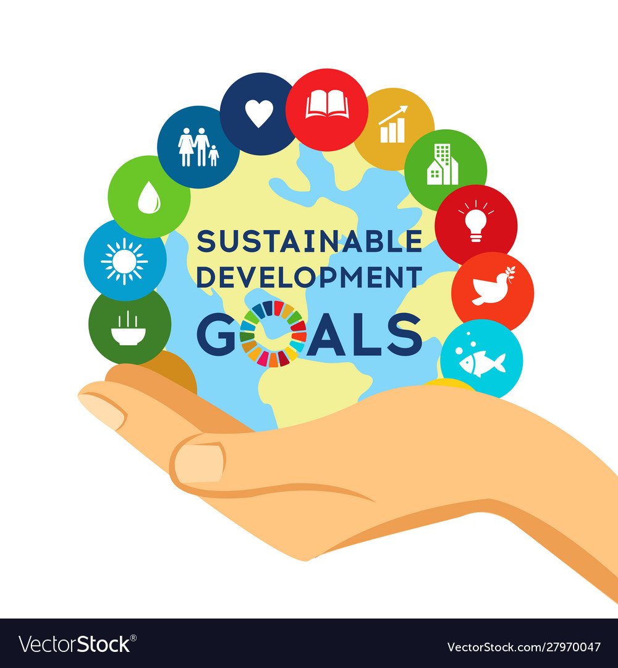

- Goal1: No poverty.
Goal: Remove all types of poverty from the world.
Key Points: Sustainable development requires addressing poverty. Ensuring that everyone has access to opportunities and primary resources, especially for the most disadvantaged, is the goal of this goal. (The Global Goals, n.d.).
- Goal 2: No hunger.
Goals: End hunger, ensure food security, and advance environmentally friendly farming practices.
Key Points: The main objective of this goal is to guarantee that everyone has access to enough food that is safe and nourishing. The focus is on sustainable agriculture methods to fulfil the increasing worldwide need for food. (United Nations, 2023).
- Goal 3: Good health and well-being.
The goal is to guarantee healthy lives and advance well-being for people of all ages.
Key Points: This goal seeks to combat diseases, enhance health outcomes, lower maternal and infant mortality, and guarantee everyone access to healthcare services. (WHO, n.d.)
- Goal 4: Quality education.
Goal: Provide high-quality, inclusive, and egalitarian education while encouraging opportunities for lifelong learning for all.
Vital Points: Education is viewed as a vital instrument for both economic and personal development. The objective is to ensure that everyone, regardless of gender or socioeconomic background, has access to high-quality education. (The Global Goals, 2023b).
- Goal 5: Gender equality.
Goal: Empower all women and girls and attain gender parity.
Key Points: The purpose is to eradicate violence and prejudice based on gender. Equal opportunities are demanded for work, education, and involvement in decision-making.
- Goal 6 :Clean water and sanitation.
Goal: Assure universal access to water and sanitation and sustainable management of these resources.
Vital Points: Access to clean water and sanitary facilities is essential for one's health and wellbeing. This objective deals with pollution, a lack of clean water, and poor sanitary facilities. (What’s the goal here? n.d.).
- Goal 7:Affordable and clean energy.
Goal: Guarantee that everyone has access to modern, affordable, dependable, and sustainable energy.
Key Points: This aim encourages energy efficiency and innovation while concentrating on increasing access to clean and sustainable energy sources. (WEO-2017 Special Report: Energy Access Outlook – Analysis - IEA, 2017).
- Goal 8:Decent work and economic growth.
Goal: Encourage full and productive employment, equitable and sustainable economic growth, and decent work.
Key Points: Raising everyone's standard of living and offering respectable employment possibilities are two aspects of inclusive economic growth.
- Goal 9:Industry,Innovation ,and Infrastructure.
Goals: Develop innovative solutions, encourage equitable and sustainable industrialization, and construct robust infrastructure.
Key Points: For economic growth and development, innovation, infrastructural development, and sustainable industrialization are essential. (United Nations, 2018).
- Goal 10:Reduced Inequality.
Reduced inequality both within and across nations is the goal.
Key Points: Sustainable development cannot be achieved without addressing inequality. Social, economic, and political inclusion for all is the focus of this objective.
- Goal 11:Sustainable Cities and Communities.
The goal is to create inclusive, secure, resilient, and sustainable cities and human settlements.
Key Points: This aim highlights the significance of sustainable urban development, encompassing secure housing, transit, and essential service accessibility. Sustainable Development Goal 11: Make cities and human settlements inclusive, safe, resilience. (IPCC, 2018b).
- Goal 12:Responsible Consumption and Production.
Goal: Assure patterns of sustainable production and consumption.
Key Points: Promoting environmentally friendly methods of production and consumption, such as recycling, waste minimization, and resource efficiency. (Wikipedia, 2020).
- Goal 13: Climate Action.
Goal: Act quickly to mitigate the effects of climate change.
Essential points: boosting renewable energy, strengthening climate resilience, and addressing climate change through mitigation and adaptation techniques. (Intergovernmental Panel on Climate Change,2018).
- Goal 14: Life below water.
Goal: Protect and responsibly use marine resources, the oceans, and the seas for sustainable development.
Three main points: encouraging sustainable fishing, reducing ocean pollution, and safeguarding marine ecosystems. (www.bing.com, 2022).
- Goal 15: Life on Land.
Goals: Preserve, repair, and encourage the sustainable use of terrestrial ecosystems; sustainably manage forests; counteract desertification; stop and reverse land degradation; and stop biodiversity loss.
The three main points are encouraging sustainable land management techniques, stopping deforestation, and protecting biodiversity. (sdgdata.gov.uk, n.d.).
- Goal 16: Peace, Justice, and strong institutions.
Goals: Establish inclusive, accountable, and peaceful societies for sustainable development; ensure everyone has access to justice; and create inclusive, effective, and accountable institutions at all levels.
The three main points are to create solid and transparent institutions, guarantee access to justice, and promote peaceful and just societies. (United Nations, 2023c).
- Goal 17: Partnerships for the Goals.
Goal: bolster implementation strategies and resurrect the Global Partnership for Sustainable Development.
Key Points: Stressing that to accomplish the other objectives, worldwide collaboration, partnerships, and support is essential. (Environment, 2017).

Discussion of the main 3 SDGs for the report.

- Goal 3 - Good Health and well-being ,aims to ensure healthy lifestyles and promote well-being for all people at all stages of life, starting from pregnancy. All key health objectives are addressed by this aim, including reproductive, maternal, infectious, and non-communicable diseases in newborns, children, and adolescents, as well as universal health coverage and universal access to affordable, high-quality, safe, and effective medications and vaccines.

- Maternal and Child Health:
Reducing the worldwide maternal mortality ratio is the goal of Target 3.1.
Ending avoidable deaths of infants and young children under five years of age is the primary goal of Target 3.2.
The under-5 death rate, neonatal mortality rate, and maternal mortality ratio are examples of indicators.
- Infectious Disease:
Ending the AIDS, tuberculosis, malaria, and neglected tropical disease epidemics is the goal of Target 3.3.
The number of new HIV infections per 1,000 people who are not infected is measured by indicator 3.3.1.
Non-Communicable Diseases (NCDs):
Target 3.4 aims to reduce the mortality rate from non-communicable diseases through prevention and treatment. This includes tracking death rates associated with cancer, diabetes, cardiovascular disease, and chronic respiratory conditions.

- Mental Health:
Target 3.4 incorporates an emphasis on advancing mental health and overall well-being.
- Access to Healthcare:
Achieving universal health coverage, including financial risk protection, access to necessary medical services, and affordable, high-quality, and safe essential medicines and vaccines for all is the aim of Target 3.8.
- Vaccination Coverage:
As part of universal health coverage, Target 3.8 specifically mentions reaching vaccine coverage.
Metrics about vaccination coverage facilitate tracking the percentage of the intended audience that receives primary medical care.
To stop the spread of infectious diseases and enhance general well-being, it is imperative to guarantee healthy child development and vaccine coverage. Reaching these goals advances global health and well-being for people and communities and helps create robust health systems. The SDGs offer a thorough framework for international initiatives to address health disparities and enhance health outcomes. (www.bing.com, 2022).

- Research and Development:
To address health issues, Goal 3 also promotes the development of medications, vaccinations, and healthcare technologies.
This involves encouraging the supply of necessary and reasonably priced medications in underdeveloped nations.

- Health Financing:
To guarantee that nations provide adequate funding for their health systems, Target 3.8 also tackles the issue of sustainable health financing.
Goal 3's principal contribution is establishing a framework for international action to improve health outcomes, particularly on illness prevention, well-being promotion, and universal access to vital healthcare services, such as immunisation. The objective is to build a more sustainable and healthy future for all people, acknowledging the relationship between health and other facets of development. (United Nations, 2022).

Goal 4 : Quality Education.
Targets and indicators:
- Access to Education: Ensure that every boy and girl has access to elementary and secondary education that is equitable, free, and of high quality.

- Equal Access: Remove gender gaps in education and provide disadvantaged populations equitable access to all educational and vocational opportunities.

- Skills Development: Ensure every student, particularly those enrolled in technical and vocational programmes, has the information and abilities to advance sustainable development.

- Gender Equality : Regardless of gender, guarantee equal access to high-quality education at all levels.
- Safe Learning Environments: Construct and renovate educational facilities that offer safe, non-violent, inclusive, and productive learning environments while taking gender, disability, and children into consideration.

- Scholarships and Financial Support: Increase the number of scholarships available for higher education and career training, especially for those in poor nations.

- Education for Sustainable Development: International collaboration for teacher training in developing nations, particularly least developed nations and small island developing states, significantly boosts the supply of trained teachers.

Even with advancements, obstacles to reaching Goal 4 still exist. These include unequal access to education, discrimination based on gender, poor infrastructure, and low funding for educational systems. Overcoming these obstacles and guaranteeing everyone access to high-quality education, focused initiatives, regulatory changes, and international collaboration are essential. (The Global Goals, 2023).

Goal 17- Partnerships for the Goals.
Targets:
- Finance - Boost domestic resource mobilisation to increase the country's ability to collect taxes and other revenue forms, especially with foreign countries' help.
Total government revenue as a proportion of GDP is shown in Indicator 17.1.1.
- Assist Developing Countries - Create a worldwide alliance for sustainable development and augment it with multi-stakeholder alliances that mobilise and exchange information, skills, technology, and monetary resources.
The number of nations reporting advancements in multi-stakeholder development effectiveness monitoring frameworks that facilitate the attainment of the Sustainable Development Goals is shown by indicator 17.16.1. (The Global Goals, 2022).
- Technology Transfer - Promote knowledge-sharing on mutually agreeable terms and strengthen North-South, South-South, and triangular regional and international collaboration on and access to science, technology, and innovation.
Indicator 17.6.2: Fixed broadband Internet subscribers per 100 residents, sorted by speed.
- Capacity Building - By implementing integrated policies to promote debt financing, debt relief, and debt restructuring, you may assist developing nations in achieving long-term financial sustainability.
Indicator 17.4.1: Debt service is a percentage of exports of goods and services.
- Trade Facilitation - Building on the experience and resource methods of partnerships, encourage and promote successful public, public-private, and civil society partnerships.
Indicator 17.17.1: The proportion of global trade to GDP.
- Data Monitoring - By 2020, strengthen developing nations' capacity-building assistance, especially for LDCs and small island developing states, to significantly expand the supply of timely, accurate, and high-quality data.
Indicator 17.18.2: Percentage of nations that have (a) completed one or more housing and population surveys in the last ten years and (b) attained 100% birth and 80% death registration.
In conclusion, objective 17 is an enabling and intersecting objective that emphasises the need for alliances, collaboration, and support systems to fulfil the more comprehensive agenda for sustainable development delineated in the other 16 SDGs. It highlights how intertwined the world's problems are and how crucial it is to collaborate to find solutions. (The Global Goals, 2022b).

UK Policies and Initiatives

International Development Strategy:
GOAL 17.
As part of its commitment to Goal 17, the UK government has historically strongly emphasised overseas development. Policies and projects frequently include strategies for collaborating with other countries, international organisations, and non-governmental organisations to address global concerns. (HM Treasury, 2015).

Aid Effectiveness and Transparency:
The United Kingdom has participated in programmes to improve aid efficiency, accountability, and transparency. Much work has gone into ensuring that aid reaches the people who need it, and that the money is used transparently. (Gov.uk, 2019).

International Partnership for Education:
The goal of the UK government's sponsorship of international partnerships for education is to increase global access to high-quality education. Financial support for education initiatives in developing nations is a common component. (Department for International Trade, 2019).

Education for Sustainable Development
The UK has implemented policies and programmes that emphasise education for sustainable development, incorporate sustainable development ideas into the curriculum, and raise public knowledge of international issues. Through ESD, UNESCO assists nations in creating and growing educational programmes that address sustainability-related concerns like biodiversity, climate change, disaster risk reduction, water, the oceans, sustainable urbanisation, and sustainable lifestyles. (UK Government, 2021).

GOAL 4.
International Partnerships for Education:
The goal of the UK government's sponsorship of international partnerships for education is to increase global access to high-quality education. Financial support for education initiatives in developing nations is a common component. To boost investment in specific, pertinent learning outcomes that benefit social and economic development, the Commission compiles the best available research and policy analysis. The Commission will give special consideration to the provision of primary education and its role in enhancing life chances and creating equitable opportunities for young people to access higher education, enter the workforce, and participate in society, even though the entire education system will be examined beginning in the early years. To accomplish these goals, especially in middle-class and low-income nations, the Commission seeks to expand more efficient investments and support the mobilisation of new partnerships. (Unesco.org, 2021).

(Department for International Trade, 2019b).

Education for Sustainable Development:
In the UK, policies and programmes have included raising awareness of international issues, integrating sustainable development concepts into the curriculum, and emphasising education for sustainable development. (‘Education for Sustainability’ The National Strategy on Education for Sustainable Development in Ireland Report of Interim Review and Action Plan for Q4 2018-Q4 2020, n.d.).

GOAL 3 .
Global Health Security:
The UK government has participated in global health security projects, such as campaigns to combat infectious illnesses and improve health systems worldwide. (Ministry of Defence, 2015).

Vaccination and Immunization Programs:
The United Kingdom has proactively participated in worldwide immunisation and vaccination campaigns. Initiatives entail funding, the creation of vaccines, and collaborations with foreign organisations. (GOV.UK, n.d.).

Merton Borough

The English borough of Merton is situated in southwest London. It is a neighbourhood in Greater London distinguished by a blend of business, residential, and recreational spaces. With a total size of about 14.5 square miles (37.6 square kilometres), the borough is well-known for its green spaces, historical significance, and diverse communities. (Merton.gov.uk, 2019).

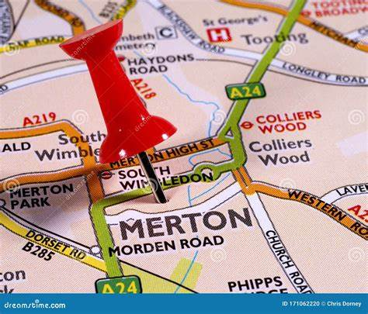

According to the 2001 census, a quarter of the borough's residents were members of an ethnic minority. Mitcham, Eastfield’s, and Pollards Hill wards in the borough's east were found to have the densest ethnic populations. Within the next ten years, it is anticipated that the borough's percentage of residents who identify as ethnic minorities will increase. Based on a 2017 Trust for London and the New Policy Institute report, Merton has the seventh lowest percentage of poverty in London at 20%. It was also found that Merton has the lowest level of pay inequality of any borough except nearby Croydon. (Wikipedia Contributors, 2020b).
History: Merton has a long and rich past spanning several centuries, during which the region has experienced substantial transformations. One of the historical sites associated with the term "Merton" is Merton Priory, a former Augustinian priory established in the twelfth century. The priory was a hub for religious and cultural activity during the Middle Ages and played a significant part in them. (Wikipedia Contributors, 2020).
Statistics: Merton's population is renowned for being diversified, with people from various ethnic backgrounds weaving together a vibrant cultural tapestry. Individuals of all ages, occupations, and lifestyles live in the borough. (data.merton.gov.uk, n.d.).
Economy: Merton's economy is broad and includes several sectors, including retail and services. The borough's business districts add to its energy by providing locals dining and retail opportunities. (data.merton.gov.uk, n.d.).
Local Government: The London Borough of Merton oversees the provision of local services, the upkeep of public buildings, and the application of laws about the welfare of the populace. (Merton | borough, London, United Kingdom | Britannica, 2019).
In conclusion, Merton is a borough that combines urban and green areas, has a rich history, and is diverse in terms of culture. Its proximity to critical athletic events, historical sites, and leisure spots makes it a vibrant and alluring region of London.
Morden Hall Park is a charming green area with meadows, marshes, and a historic rose garden. It is a National Trust property. It provides a tranquil escape from city life.

Merton 2030 Strategic Framework

- The goal is to create a borough where you can go as far as you want and where no one is left behind, one that you will be happy to call home, Merton.
- This entails expanding on our prior achievements in education and the economy while making sure you have access to the tools and employment opportunities necessary to achieve your goals. It entails enhancing the fundamental strength of our local communities and how we enable them to prosper.
- It is paying attention to what you have to say. This includes investing in the projects the people would want to see developed, like our high streets, parks and community centres and improving the areas you have indicated need improvement, like parking, transportation, and street cleanliness. (The Vision and Strategic Objectives, n.d.)

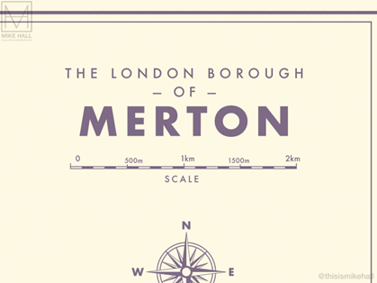

- Every inhabitant of Merton, especially the children and young people, will have their potential fully realised.
- Together with the borough's businesses, nonprofits, and voluntary organisations, the borough will collaborate with all the schools, libraries, and further education institutions to create a refreshed employability and skills programme. Enhancing the connections between school and work would help Merton expand its local talent pool and provide more chances for young people and those with lower means.
- Moving forward, Merton will focus on potential growth areas and how we may position ourselves to take advantage of skill-related opportunities. Examples are the shift to a green, net-zero economy and the ongoing expansion of the tech industry. (Steer, 2020).

Status of Merton Borough of meeting the 3 SDGs.

Strategic Policy HW2.1: Well-being and Health.

- Collaborating with key partners like NHS England, Clinical Commissioning Groups (CCG), and the Health and Wellbeing Boards of Merton to address health disparities, improve public health safety (during pandemics, for example), encourage healthy lifestyles, and establish healthy environments for everyone in Merton. (Merton Council, n.d.).
- Enhancing community health facilities, volunteer organisations, and healthcare access.
- Addressed and minimised the health disparities in Merton as stated in the Joint Strategic Needs Assessment and Merton's Health and Wellbeing Strategy.
- Address Merton's childhood obesity, as noted in the Child Healthy Weight Action Plan, with a focus on deprived neighbourhoods.
- Assist all borough residents affected by dementia in keeping with the mayor’s goal of making London a dementia-friendly city by collaborating with the Alzheimer's Society, the Merton Dementia Action Alliance, and other partners to make Merton a dementia-friendly borough.
- They are establishing areas that are accessible, safe, and healthy to encourage social interactions. These neighbourhoods should have gathering spots where individuals can join to fight loneliness and encourage active living. (Committee: Council Subject: Strategic Theme Report Health and Wellbeing, 2022).
- Promote more walking and bicycling to enhance people's health and well-being and contribute to the borough's air pollution reduction, particularly in areas designated as Air Quality Focus Areas under Merton's Air Quality Action Plan.
- It enhances accessibility to neighbourhood stores, services, and facilities to foster an inclusive community that welcomes individuals with disabilities and limited mobility. This promotes social engagement and active living.
- Ensuring well-designed neighbourhoods encourage active, healthy living and embrace active ageing strategies. To promote active travel, neighbourhoods and streets are planned to use the Healthy Streets Approach. (NHS England, 2021).

Policy HW2.2: Delivering healthy places.
The Council should expect development plans to:
- Contribute towards the health priorities of Merton Health and Wellbeing Board and partners to help reduce health inequalities across Merton.
- Development plans are compliant with the housing, design, environment, economics, and other policies in this plan that target the wider health determinants and improve quality of life, such as the Healthy Streets Approach of Transport for London (TfL).
- As part of development ideas, promote food-growing opportunities like allotments, community gardens, and other creative food-producing areas. (www.merton.gov.uk, n.d.).

Assessments of Health Impact:

- The Council advises conducting a Health Impact Assessment (HIA) early in a development project. HIAs evaluate whether a proposed development might improve or maintain existing health disparities, unwittingly harm people's health, or benefit the local community's health. Ensuring that concerns are considered when creating planning ideas can benefit the population's mental and physical well-being. Although conducting an HIA during the implementation stage is technically feasible, doing so carries a risk of retrofitting the proposal's health-sensitive solutions and is likely to increase development expenses, which could negatively impact the development's financial feasibility. (Votruba and Thornicroft, 2016).
- The HIA must demonstrate to the Council how it influenced the development plan, any subsequently made modifications to the proposal and the project’s alignment with Merton’s priorities for health and well-being. Developers are advised to consult the Council for guidance before conducting an HIA. Merton’s upcoming advice will outline the Health Impact Assessment (HIA) requirements of the Council. (GOV.UK, n.d.).

Recommendations

Improvement focuses across Goals.
- Collaborative Cross-Sectoral Strategies.
- Enhancement Priority: Boost cooperation across local government, health, and education sectors. Create collaborative solutions to solve the interrelated health and education-related concerns. Using an all-encompassing strategy can help optimise resources and enhance general well-being.
- Community Consultation in Policy Development.
- Enhance community participation in formulating and evaluating sustainable development, health, and education policies. To ensure that policies are inclusive and sensitive to the needs of the people living in Merton, include a variety of viewpoints.
- Enhanced Monitoring and Reporting Mechanisms.
- Enhancement Priority: Establish effective reporting and monitoring systems to monitor SDG progress. To increase accountability and openness, share accomplishments, provide updates regularly, and point out areas for improvement. (www.merton.gov.uk, n.d.).
- Investing in Recreational Facilities and Green Spaces.
- Enhancement Priority: Acknowledge green areas' role in fostering mental and physical well-being. To give locals accessible areas for outdoor recreation, more money should be invested in the building and upkeep of parks, recreational centres, and community gardens.
- Decision-Making for Sustainable Development Based on Data.
- It is advised that data gathering, and analysis skills be strengthened to support evidence-based decision-making while organising and conducting local projects. This helps monitor and assess advancements made towards the partnership, health, and education goals and aligns with Goal 17. (www.merton.gov.uk, n.d.).

Conclusion

By classifying the 17 Sustainable Development Goals (SDGs) of the 2030 Agenda for Sustainable Development framework, we showed that implementing the goals within a complex global system is an optimisation process driven by a compromise between maximising the realisation of expected objectives and meeting essential needs. Negative externalities between any of the 17 SDGs can be effectively excluded if they are seen holistically, even though overlaps, trade-offs, and synergies exist among them. Realising sustainable development is based on limiting the consumption of necessities to the lowest possible rate while maximising anticipated goals to meet people's material and emotional requirements and advance environmental preservation. Each nation must determine a growth path that best fits its unique national circumstances. Good governance practices are crucial to successfully balancing satisfying necessities and anticipated aspirations. Lastly, by using this analytical framework in both rich and developing countries, policy coherence may be guaranteed, whether vertical (the interactions between different policy levels) or horizontal (the interactions between different objectives). (www.mdu.se, n.d.).

Reference list
Committee: Council Subject: Strategic Theme Report Health and Wellbeing. (2022). Available at:
https://democracy.merton.gov.uk/documents/s45064/HWB%20strategic%20theme%20report%20Council%20170122.pdf [Accessed 2 Jan. 2024].
Department for International Trade (2019). International Education Strategy: global potential, global growth. [online] GOV.UK. Available at: https://www.gov.uk/government/publications/international-education-strategy-global-potential-global-growth [Accessed 30 Dec. 2023].
data.merton.gov.uk. (n.d.). Merton Data – Economy & Employment. [online] Available at: https://data.merton.gov.uk/economy-and-employment/ [Accessed 30 Dec. 2023].
data.merton.gov.uk. (n.d.). Merton Data – Population. [online] Available at: https://data.merton.gov.uk/population/#/view-report/63aeddf1d7fc44b8b4dffcd868e84eac/___iaFirstFeature/G3 [Accessed 30 Dec. 2023].
Environment, U.N. (2017). GOAL 17: Partnerships for the goals. [online] UNEP - UN Environment Programme. Available at: https://www.unep.org/explore-topics/sustainable-development-goals/why-do-sustainable-development-goals-matter/goal-17 [Accessed 21 Nov. 2023].
‘Education for Sustainability’ The National Strategy on Education for Sustainable Development in Ireland Report of Interim Review and Action Plan for Q4 2018-Q4 2020. (n.d.). Available at: https://assets.gov.ie/24989/c1a35f742acc48e09c9ea5427f6975f8.pdf [Accessed 30 Dec. 2023].
Gov.uk (2019). HM Treasury. [online] GOV.UK. Available at: https://www.gov.uk/government/organisations/hm-treasury [Accessed 30 Dec. 2023].
GOV.UK. (n.d.). UK Vaccine Network. [online] Available at: https://www.gov.uk/government/groups/uk-vaccines-network [Accessed 30 Dec. 2023].
GOV.UK. (n.d.). Healthy places. [online] Available at: https://www.gov.uk/government/publications/phe-healthy-places/healthy-places [Accessed 2 Jan. 2024].
HM Treasury (2015). UK aid: tackling global challenges in the national interest. [online] GOV.UK. Available at: https://www.gov.uk/government/publications/uk-aid-tackling-global-challenges-in-the-national-interest [Accessed 30 Dec. 2023].
International Energy Agency(2017) . Energy Access Outlook 2017. Available at: https://www.iea.org/reports/energy-access-outlook-2017 (Accessed: 18 November 2023).
IPCC (2018b). Global Warming of 1.5 oC. [online] IPCC. Available at: https://www.ipcc.ch/sr15/ [Accessed 21 Nov. 2023].
Krys, K., Haas, B.W., Igou, E.R., Kosiarczyk, A., Kocimska-Bortnowska, A., Kwiatkowska, A., Lun, V.M.-C., Maricchiolo, F., Park, J., Šolcová, I.P., Sirlopú, D., Uchida, Y., Vauclair, C.-M., Vignoles, V.L., Zelenski, J.M., Adamovic, M., Akotia, C.S., Albert, I., Appoh, L. and Mira, D.M.A. (2022). "Introduction to a Culturally Sensitive Measure of Well-Being: Combining Life Satisfaction and Interdependent Happiness Across 49 Different Cultures." (“Introduction to a Culturally Sensitive Measure of Well-Being: Combining ...”) Journal of Happiness Studies. doi:https://doi.org/10.1007/s10902-022-00588-1.
Ministry of Defence (2015). Future operating environment 2035. [online] GOV.UK. Available at: https://www.gov.uk/government/publications/future-operating-environment-2035 [Accessed 30 Dec. 2023].
Merton.gov.uk. (2019). Welcome to Merton. [online] Available at: https://www.merton.gov.uk/ [Accessed 30 Dec. 2023].
Merton | borough, London, United Kingdom | Britannica. (2019). In: Encyclopædia Britannica. [online] Available at: https://www.britannica.com/place/Merton-borough-London [Accessed 30 Dec. 2023].
NHS England (2021). NHS England» NHS health and wellbeing framework. [online] www.england.nhs.uk. Available at: https://www.england.nhs.uk/publication/nhs-health-and-wellbeing-framework/ [Accessed 2 Jan. 2024].
Ranjula Bali Swain and Min, Y. (2023). Interlinkages between the Sustainable Development Goals. Edward Elgar Publishing.
Steer, R. (2020). Report for London Borough of Merton on ‘Improving Health Together’ Public Consultation. [online] Available at: https://moderngov.sutton.gov.uk/documents/s71187/9c%20Report%20of%20Roger%20Steer%2022%20March%202020.pdf [Accessed 1 Jan. 2024].
sdgdata.gov.uk. (n.d.). Goal 15 - Life on land - U.K. Indicators for The Sustainable Development Goals. [online] Available at: https://sdgdata.gov.uk/15/ [Accessed 21 Nov. 2023].
The Vision and Strategic Objectives. (n.d.). Available at: https://www.merton.gov.uk/system/files?file=local20plan20202020-20vision20and20strategic20objectives.pdf [Accessed 3 Jan. 2024].
The Global Goals (2022). Goal 17: Partnerships for the goals. [online] The Global Goals. Available at: https://www.globalgoals.org/goals/17-partnerships-for-the-goals/ [Accessed 2 Jan. 2024].
The Global Goals (2023). Goal 4: Quality education. [online] The Global Goals. Available at: https://www.globalgoals.org/goals/4-quality-education/ [Accessed 2 Jan. 2024].
The Global Goals (n.d.). Goal 1: No Poverty. [online] The Global Goals. Available at: https://www.globalgoals.org/goals/1-no-poverty/ [Accessed 2 Jan. 2024].
United Nations (2023a). Goal 11 | Department of Economic and Social Affairs. [online] United Nations. Available at: https://sdgs.un.org/goals/goal11 [Accessed 21 Nov. 2023].
United Nations (2023c). Goal 16 | Department of Economic and Social Affairs. [online] sdgs.un.org. Available at: https://sdgs.un.org/goals/goal16 [Accessed 21 Nov. 2023].
UK Government (2021). Implementing the Sustainable Development Goals. [online] GOV.UK. Available at: https://www.gov.uk/government/publications/implementing-the-sustainable-development-goals/implementing-the-sustainable-development-goals--2 [Accessed 30 Dec. 2023].
United Nations (2022). Goal 3: Good health and well-being. [online] The Global Goals. Available at: https://www.globalgoals.org/goals/3-good-health-and-well-being/ [Accessed 2 Jan. 2024].
Unesco.org. (2021). Sustainable Development. [online] Available at: https://www.unesco.org/en/sustainable-development [Accessed 2 Jan. 2024].
United Nations (2023). Goal 2: Zero Hunger - United Nations Sustainable Development. [online] United Nations Sustainable Development. Available at: https://www.un.org/sustainabledevelopment/hunger/ [Accessed 2 Jan. 2024].
United Nations (2018). Infrastructure and Industrialization - United Nations Sustainable Development. [online] United Nations Sustainable Development. Available at: https://www.un.org/sustainabledevelopment/infrastructure-industrialization/ [Accessed 2 Jan. 2024].
Votruba, N. and Thornicroft, G. (2016). Sustainable development goals and mental health: learnings from the contribution of the FundaMentalSDG global initiative. Global Mental Health, 3(26). doi:https://doi.org/10.1017/gmh.2016.20.
World Health Organization (2019). World Health Organization(WHO) Definition of Health - Public Health. [online] Public Health. Available at: https://www.publichealth.com.ng/world-health-organizationwho-definition-of-health/.
World Health Organization (2015) . Health in 2015: From MDGs to SDGs. Available at: https://www.who.int/gho/publications/mdgs-sdgs/en/ (Accessed: 18 November 2023).
WHO. (n.d.). WHO | Health in 2015: from MDGs to SDGs. [online] Available at: https://www.who.int/gho/publications/mdgs-sdgs/en/ [Accessed 21 Nov. 2023].
www.bing.com. (2022). Microsoft - Search. [online] Available at: https://www.bing.com/ck/a? [Accessed 21 Nov. 2023].
What’s the goal here? (n.d.). Available at: https://www.un.org/sustainabledevelopment/wp-content/uploads/2018/09/Goal-6.pdf [Accessed 21 Nov. 2023].
Wikipedia (2020). Sustainable Development Goal 12. [online] Wikipedia. Available at: https://en.wikipedia.org/wiki/Sustainable_Development_Goal_12 [Accessed 21 Nov. 2023].
WEO-2017 Special Report: Energy Access Outlook – Analysis - IEA (2017). WEO-2017 Special Report: Energy Access Outlook – Analysis - IEA. [online] IEA. Available at: https://www.iea.org/reports/energy-access-outlook-2017 [Accessed 12 Dec. 2023].

www.mdu.se. (n.d.). This is how MDU work with the sustainable development goals. [online] Available at: https://www.mdu.se/en/malardalen-university/this-is-how-mdu-works-with-the-sustainable-development-goals [Accessed 2 Jan. 2024].
www.merton.gov.uk. (n.d.). Health and wellbeing - New Local Plan | Merton Council. [online] Available at: https://www.merton.gov.uk/planning-and-buildings/planning/local-plan/newlocalplan/health-and-wellbeing [Accessed 2 Jan. 2024].
www.merton.gov.uk. (n.d.). Building a Better Merton Together: London Borough of Merton Council Plan 2023-26 | Merton Council. [online] Available at: https://www.merton.gov.uk/council-and-local-democracy/plans-and-policies/council-plan-2023 [Accessed 2 Jan. 2024].
www.bing.com. (2022). microsoft - Search. [online] Available at: https://www.bing.com/ck/a? [Accessed 3 Jan. 2024].

‌

