ACDA 5015: Advanced Physics Assignment
Investigation into the effects of altering material properties when modelling a shaped charge jet
By George Tucker – 1906898

Table of Contents
Abstract 3
Introduction 3
Overview 3
Investigation Goals 3
Background Theory and Information 3
What is a shaped charge? 3
Computational modelling: Lagrangian vs Eulerian vs ALE 4
Use of modelling with shaped charges 4
Jones-Wilkinson-Lee Equations of State 4
Limitations of modelling 5
Methodology 5
Approach 5
Changes to existing model 5
Running of simulations 6
Results 7
Discussion 11
Conclusions 12
References 13
List of Figures:
Figure | Description | Page number
1 | diagram of shaped charge model showing the three different components | 5
2 | Diagrams of the different material arrangements for each simulation | 6
3 | Velocity time graph – Comp-B with copper liner | 7
4 | Jet formation - Comp-B with copper liner | 7
5 | Jet deviation - Comp-B with copper liner | 7
6 | Velocity time graph – PBX-LX-14 with copper liner | 8
7 | Jet formation - PBX-LX-14 with copper liner | 8
8 | Jet deviation - PBX-LX-14 with copper liner | 8
9 | Velocity time graph – Comp-B with LCS liner | 9
10 | Jet formation – Comp-B with LCS liner | 9
11 | Jet deviation – Comp-B with LCS liner | 9
12 | Velocity time graph - PBX-LX-14 with LCS liner | 10
13 | Jet formation - PBX-LX-14 with LCS liner | 10
14 | Jet deviation - PBX-LX-14 with LCS liner | 10
List of tables:
1 | Copper material properties | 6
2 | LCS material properties | 6
3 | Comp-B material properties | 6
4 | PBX-LX-14 material properties | 6

Abstract
This is a report which shows that an improvement in the simulated output of a shaped charge jet is possible through the use of an improved material model within the simulation software Abaqus. By selecting appropriate material properties for both the conical liner and the explosive fill of a shaped charge assembly, results can be obtained which resemble those obtained through experimental research.
Introduction
Overview
This report details the investigation into the modelling of a shaped charge jet using the Dassalt Systems: Abaqus finite element analysis software package. Within the remainder of this section you will find: an outline of the investigation criteria as set out in the ACDA 5015 brief, in addition to relevant background theory and information obtained via literature review.
The rest of the report contains information on the methodology used to model a shaped charge including adjustments to the supplied Abaqus model, and the subsequent results. Followed by analysis of the simulated outputs and finally, the conclusions which can be drawn from the aforementioned results.
Investigation goals
The brief for this investigation was to undertake research on shaped charge jets and the different ways in which they can be modelled via a literature review on the topic. To undertake this endeavour, a pre-made Lagrangian and Eulerian model were supplied with pre-selected material properties to represent a steel-cased TNT copper shaped charge assembly. The goal was to take one of these pre-formed models and make adjustments to improve the simulated result of the shaped charge jet formation. Background information on shaped charges and modelling can be found in the sub-section below obtained via literature review. Further information on the changes to the model are outlined in the methodology section.
Background theory and information
Shaped Charge Functionality – Fundamentally, a shaped charge is an assembly consisting of a high explosive and some form of conical liner. This assembly, when detonated, exploits the Munroe effect [1] which causes the liner material to collapse in on itself and propel outwards forming a jet comprised of the liner material. This jet behaves hydrodynamically, and when it makes contact with a target material, the extreme pressure causes the jet and target itself to behave like fluids. [2] There are many different parameters that can affect the performance of a shaped charge jet such as the explosive used, the liner material and the liner geometry. [3] Additionally, the impact angle of the detonation wave on the liner affects how well the jet forms. [4] As a result of the many different factors affect shaped charge jet formation and performance it is a well-researched topic which has been explored in detail with both computational modelling methods and experimental research.

Computational modelling: Lagrangian vs Eulerian vs ALE
Simulations of mechanical problems are possible through the use of computational modelling with the use of modelling packages such as Abaqus. Broadly speaking there are two different approaches to simulating a problem: Lagrangian and Eulerian.
With the Lagrangian method of simulation analysis the element mesh is embedded into the material of each component itself. This means that elements themselves deform and displace with the material. The Lagrangian method has the advantages of maintaining material boundaries within the model allowing for deformation of surfaces to be easily observed alongside their interfaces with other materials. The drawbacks to using this method are crashes of simulations due to excessive distortions of the mesh grid due to substantial loads. [5]
Eulerian modelling on the other hand makes use of a Eulerian region which is then meshed. The elements within this region are then assigned material properties to represent component parts which are to be simulated. Within the Eulerian simulation, the elements are fixed, and material flows through them as the simulation is run. By this mechanism elements represent the presence of materials in volume fractions, in comparison to Lagrangian simulations where each element is always full of material. The advantages of Eulerian analysis lay in the ability to model scenarios where extreme deformation of a material occurs such as with a fluid. [6]
Finally, Arbitrary Lagrangian-Eulerian (ALE) modelling makes use of a combination of both approaches in order to take advantage of the benefits of both. For instance, an ALE simulation will not crash when a simulation event would have otherwise caused excessive mesh distortions in a Lagrangian simulation, nor will it suffer reduced accuracy of results due to the use of homogenous materials or relying on volume-fractions of materials within elements to determine material boundaries. [7] The ALE method employs a mesh space that can resize and reconfigure whilst still allowing for material particle motion within the mesh space – allowing for greater resolution than achievable with purely Eulerian methods. [8]
Use of modelling with Shaped Charges
As experiments with explosives can be costly to set up modelling and simulation is a great way to estimate the outcome of a hypothesis. As a result there has been plenty of research carried out on the topic of modelling shaped charges. When modelling shaped charge jets, the Eulerian method has been used to deal with the large amount of deformation that occurs, however ALE approaches provide more resolution between material boundaries which can be useful when assessing target penetration. [9] Additionally, it is possible to perform a Lagrangian approach using a re-meshing technique to deal with large mesh distortions. [8]
Jones-Wilkins-Lee (JWL) Equations of State (EOS)
To use simulation software to predict the outcome of explosively driven events, JWL EOS variables are used within calculations to predict the adiabatic expansion of detonation products for an explosive geometry. These equations are based off of the observable expansion of metal cylinders. [10] The most use equation is that for the equation of state of detonation products. Abaqus makes use of several of the variables of this equation in order to model an explosive event: A, B, R1, R2, and ω. These are all parameters which are specific to each explosive. [11]

Limitations of modelling
Particularly for Lagrangian approaches are that they can crash if elements become too distorted. To remedy this, remeshing techniques are applicable, however they can impact negatively on the accuracy of the simulation, and are most appropriate to 1 dimensional, or 2 dimensional problems. Another technique is to delete elements which become too distorted. Whilst this can aid in solving the simulation, it has the drawbacks of affecting the whole model’s mass and energy values. [5] All modelling and simulation is only an estimate of reality though, and as long as the limitations are understood it is still a useful tool.
Methodology
Approach
For this investigation it was decided that the Lagrangian model would be chosen to edit and improve (see figure one for diagram of componenet assembly). This decision was made as a Lagrangian approach allows for clear definition between material boundaries (as discussed in the introduction), which would allow for a better analysis of the formed jet portion of the simulation results.

Figure 1 - diagram of shaped charge model showing the three different components: the case (blue), the HE fill (orange), and the conical liner (green)
The method for improving the jet performance of the pre-supplied shaped charge model was to edit the material property values for the explosive and the liner in order to better reflect materials that are commonly used in shaped charge design. The model would then be run, and the velocity/time values of the end nodes of each formed jet would be measured using the Abaqus software. A qualitative analysis could also be made on each solved run by looking at the quality of the jet that had been formed. Such as any out of plane jet digression, and the overall jet shape and length.
Changes to the existing model (material property changes)
The changes made to the model were to alter the material properties for both the liner and the explosive charge. The case material would remain unchanged. The goal was to be able to produce results within scope of experimental values for the different simulation set-ups.
4 different simulation set-ups were selected with material choices being influenced from the wider literature on shaped charges. The 4 different material configurations were:
- Copper liner with Composition B (Comp-B) explosive fill (fig 2 A)
- Copper liner with PBX-LX-14 fill (fig 2 B)
- Low Carbon Steel (LCS) liner with Comp-B fill (fig 2 C)
- LCS liner with PBX-LX-14 fill (fig 2 D)
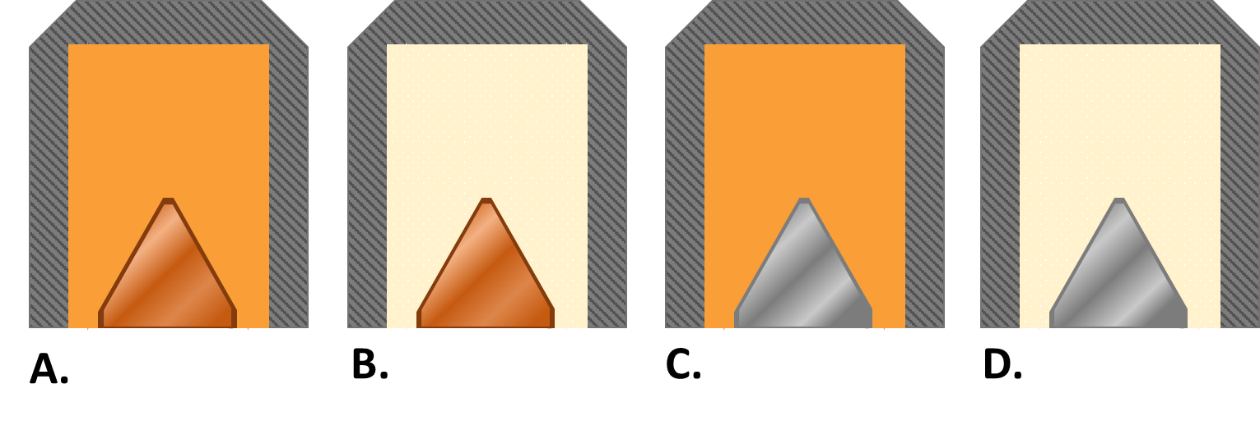
Figure 2 - Diagrams of the different material arrangements for each simulation.
These choices for material were made as both copper and Low Carbon Steels are typical choices for liner materials in shaped charge design. [12] Additionally, composition B (A mixture of TNT, RDX and Wax) and PBX-LX-14 (A plastic explosive) [13] are common choices for shaped charge high explosive fills. [14]
The material properties input into the simulation were as follows:
Copper Material Properties
Density (g/cm³) | Ultimate Tensile strength (MPa) | Yield tensile strength (MPa) | Elongation at Break (percentage) | Modulus of Elasticity (GPa) | Poisson’s Ratio | Shear Modulus (GPa)
8.93 | 210 | 33.3 | 60 | 110 | 0.343 | 46
Table 1 - Copper material properties [15]
AISI 1018 Steel Material Properties
Density (g/cm³) | Ultimate Tensile strength (MPa) | Yield tensile strength (MPa) | Elongation at Break (percentage) | Modulus of Elasticity (GPa) | Poisson’s Ratio | Shear Modulus (GPa)
7.87 | 440 | 370 | 15 | 200 | 0.29 | 78
Table 2 - LCS material properties [16]
Composition B JWL and material properties
Density (g/cm³) | Detonation velocity (ms⁻¹) | Detonation Energy (MJkg⁻¹) | A | B | R1 | R2 | ω
1.68 | 7990 | 5.02 | 5.242 | 0.07678 | 4.20 | 1.10 | 0.34
Table 3 - Composition-B JWL and material properties [17], [13]
PBX-LX-14 JWL and material properties
Density (g/cm³) | Detonation velocity (ms⁻¹) | Detonation Energy (MJkg⁻¹) | A | B | R1 | R2 | ω
1.83 | 8837 | 8.81 | 7.654 | 0.21932 | 4.5 | 1.5 | 0.33
Table 4 - PBX-LX-14 JWL and material properties [13], [18], [19]
Running of simulations
Simulation meshes were kept the same along with the number of steps, in order to reduce the chances of errors when solving, and to reduce excessive solving times.

Results
Copper liner with Comp-B fill:
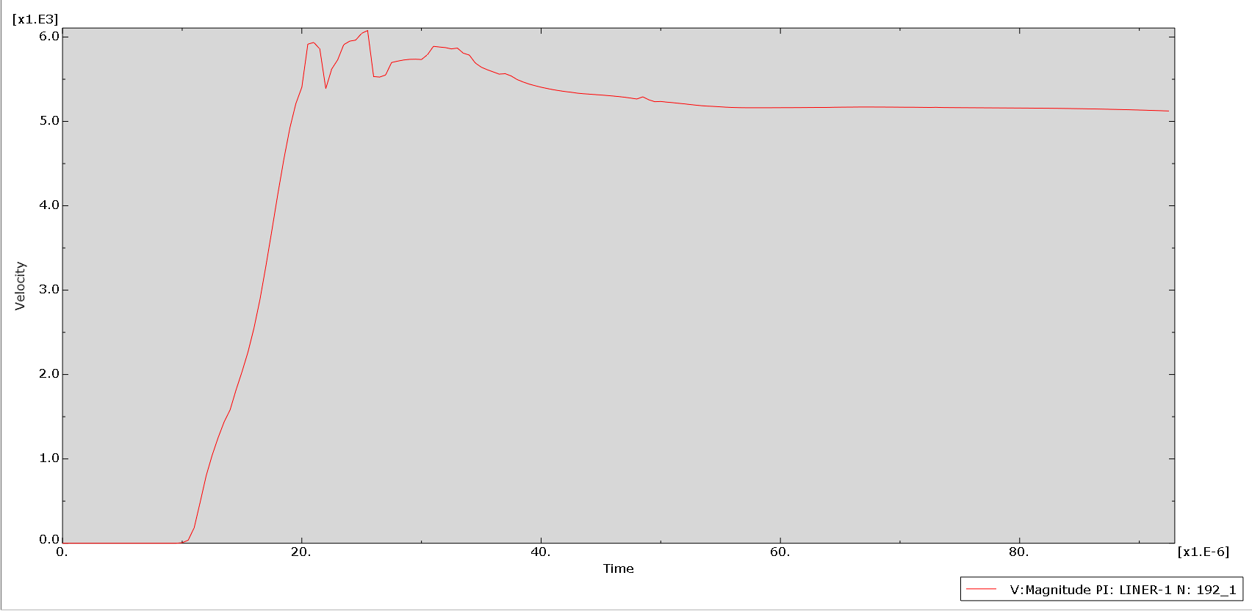
Figure 3 - velocity/time graph for Comp-B fill with copper liner
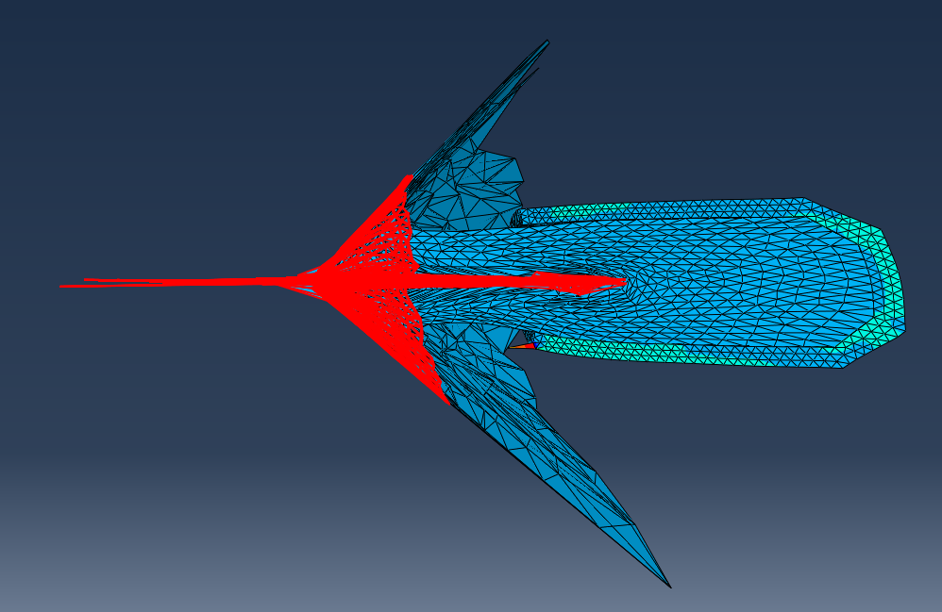
Figure 4 - Liner jet formation for Comp-B fill with copper liner
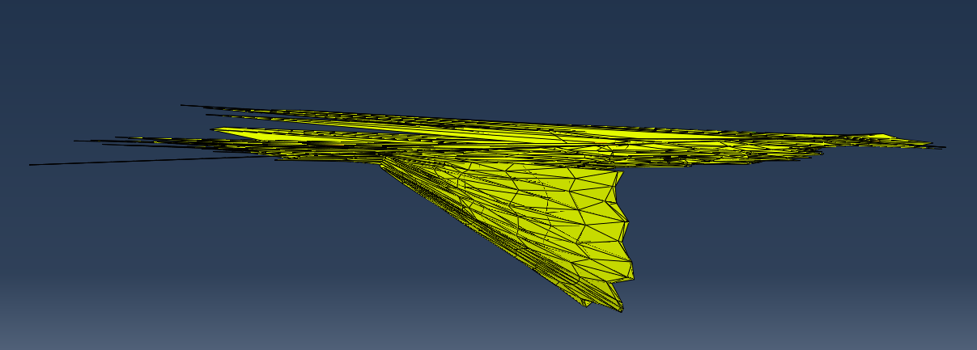
Figure 5 - out-of-plane deviation of jet for Comp-B fill with copper liner

Copper liner with PBX-LX-14 fill:
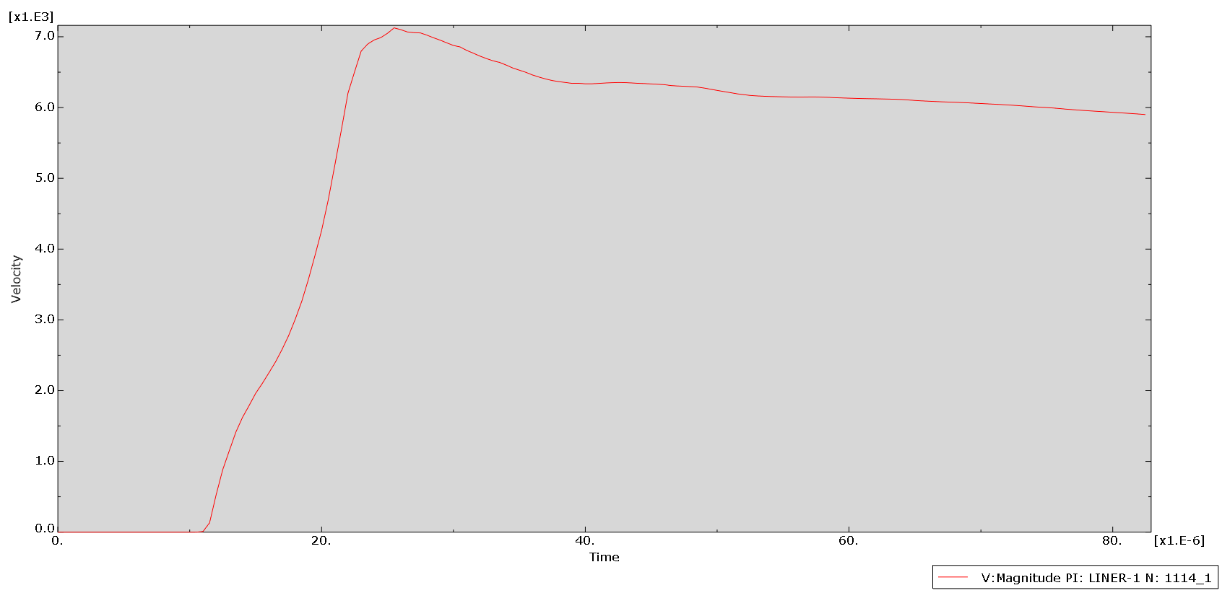
Figure 6 - Velocity/time graph for PBX-LX-14 fill with copper liner
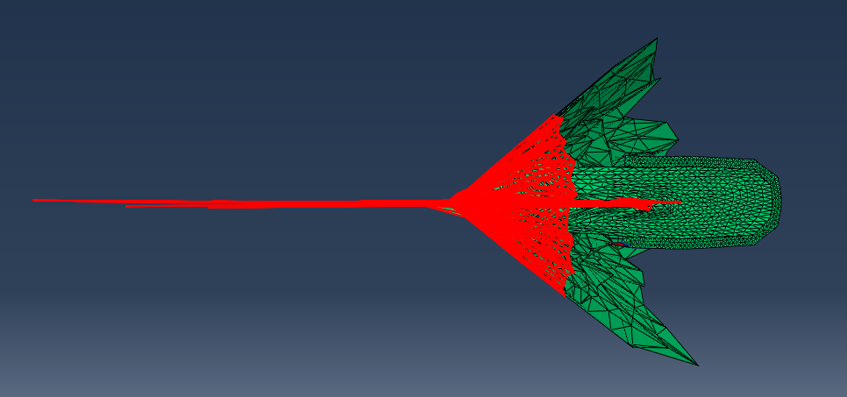
Figure 7 - liner jet formation for PBX-LX-14 fill with copper liner
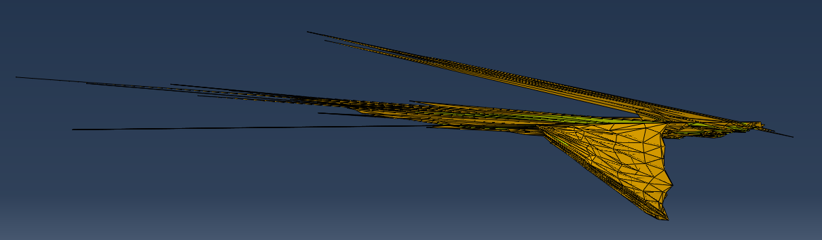
Figure 8 - out-of-plane deviation of jet for PBX-LX-14 fill with copper liner

LCS liner with Comp-B fill:
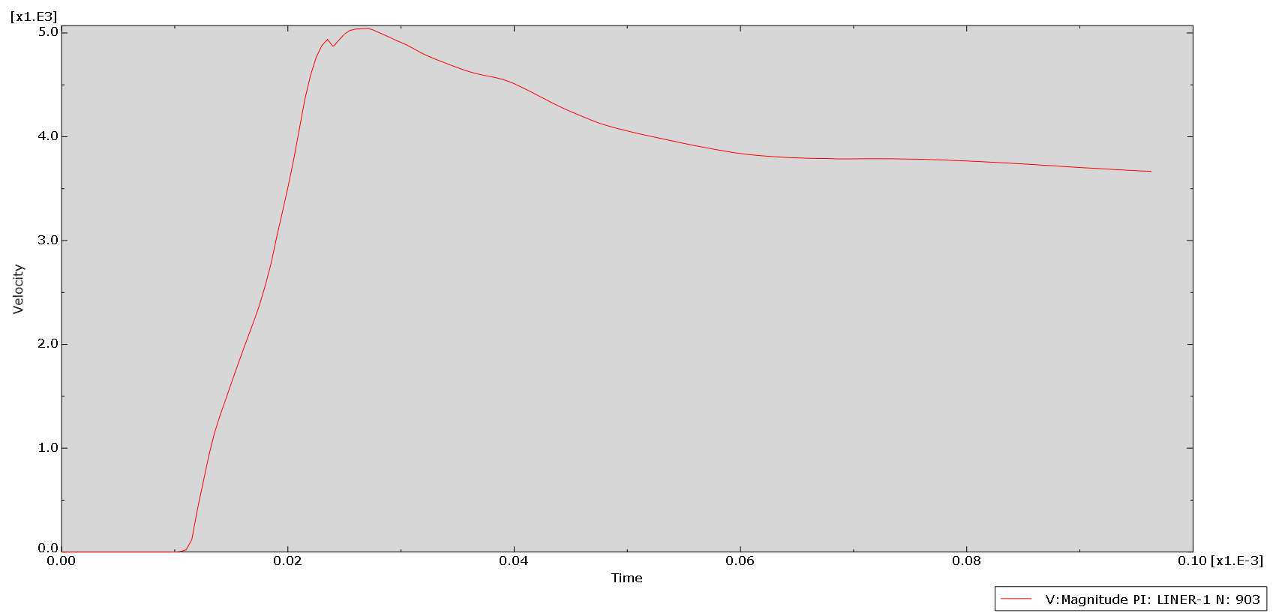
Figure 9 - Velocity/time graph for Comp-B fill with LCS liner
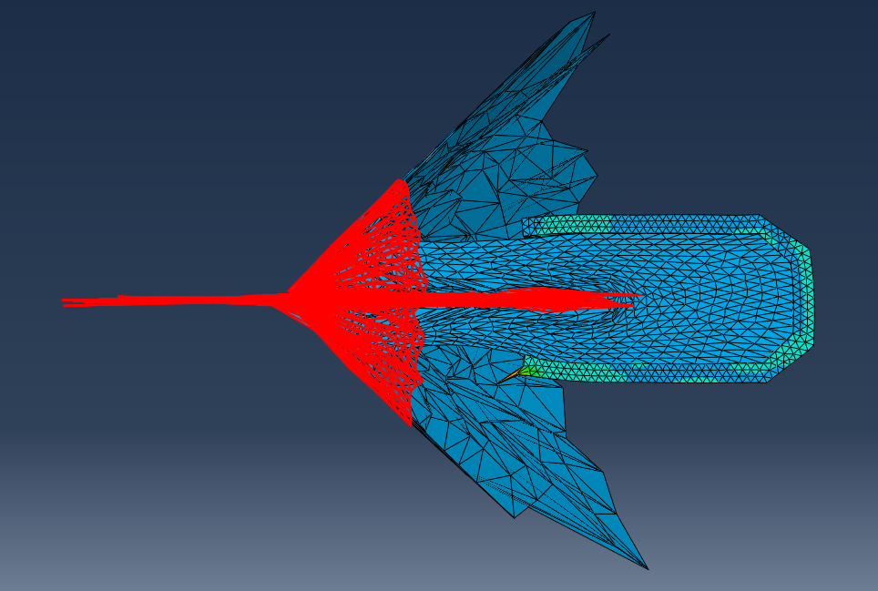
Figure 10 - jet formation for Comp-B fill with LCS liner
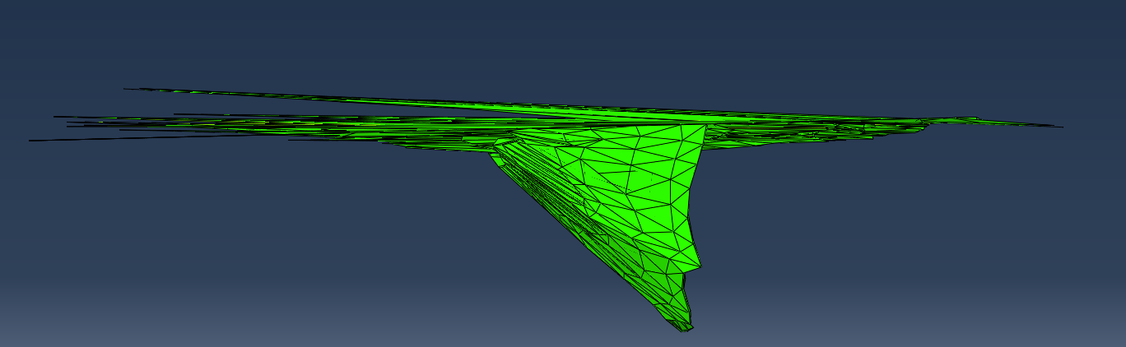
Figure 11- Jet path deviation for Comp-B fill with LCS liner

LCS liner with PBX-LX-14 fill:
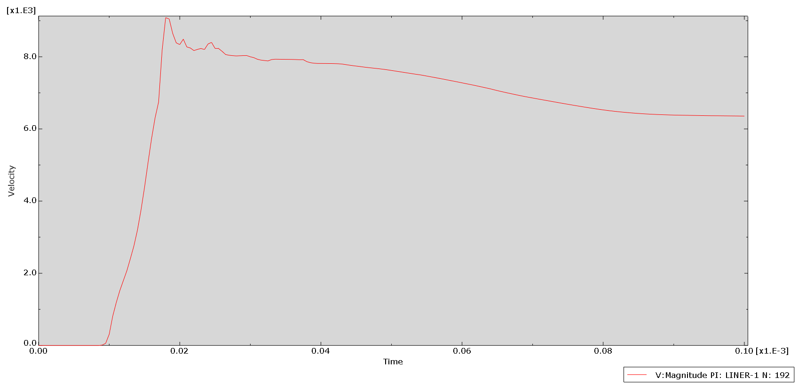
Figure 12 - Velocity/time graph for PBX-LX-14 fill with LCS liner
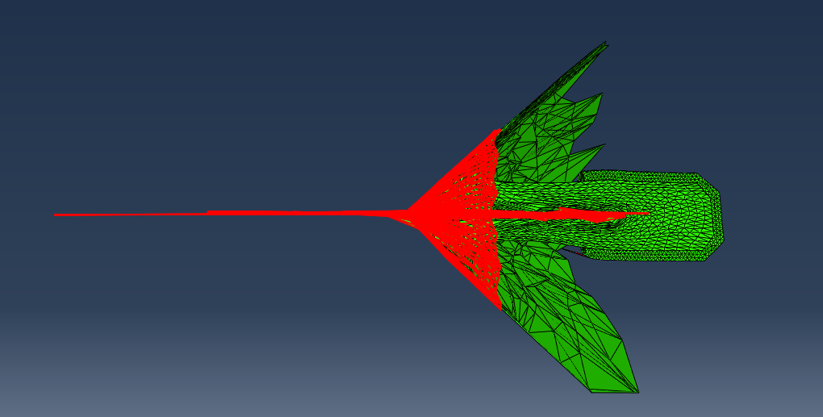
Figure 13 - jet formation for PBX-LX-14 fill with LCS liner
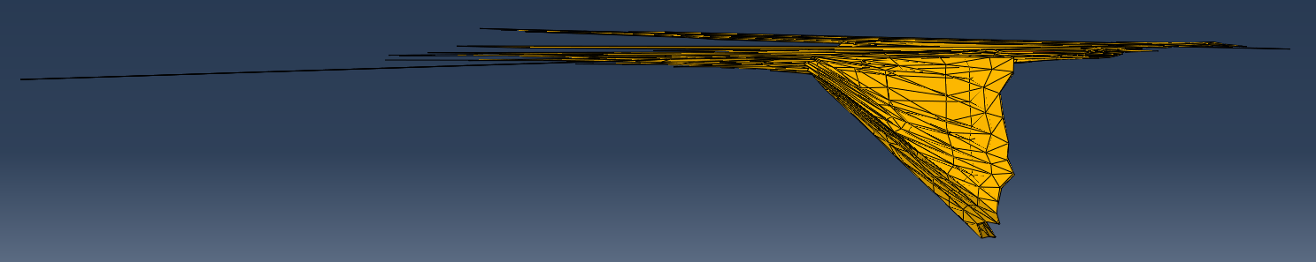
Figure 14- out-of-plane jet deviation for PBX-LX-14 fill with LCS liner

Discussion
From the results it has been demonstrated that it is indeed possible to successfully model a shaped charge jet using good material property parameters for both the explosive fill and the liner material itself. All different model configurations produced different outputs which was to be expected, and all configurations did produce a clearly defined jet of liner material.
The velocity/time graphs (fig 3, 6, 9. 12) for each simulation are an improvement on the original TNT, copper liner model, with values which are within the order of magnitude of those seen in experimental results. Other studies modelling the velocities for steel vs copper liners have shown values in the order of magnitude of 8cm/μs [15], which is similar to the values for the PBX designs as seen in figures 6 and 12. Additionally, the velocity time graphs support the theory that a more powerful explosive will produce a fast-moving jet as indicated by the fact that the peak velocities for both of the PBX-LX-14 filled models were higher than those of Composition-B, which is a comparatively less powerful explosive. As a result of this the jet lengths for PBX-LX-14 are longer than those for Comp-B.
The velocity values for the copper liner with Comp-B are higher than those for the LCS liner with Comp-B, whilst the reverse is true for the max velocity with the PBX-LX-14 fill. Assuming this is not down to inaccuracies of the models, this could present an interesting point of study to investigate the relationship between liner properties and explosive power when determining jet velocity. For instance, the greater ductility of copper may lend itself to faster forming jets with explosives that are lower in power due to the steel liner’s greater mechanical strength resisting jet formation. However, the lower density of the steel may allow for faster jets to form when the explosive power is above a certain threshold, as the smaller mass of the liner allows for faster acceleration. It has been shown in other models that steel liners can produce faster jets than copper, which supports the validity of these models. [15]
The jets formed were mostly in-plane with the section of the model, however the copper liner with PBX-LX-14 did display significant deviation from the main jet path. The steel jets overall displayed better uniformity, perhaps due to copper being more ductile and therefore more likely to deform out of plane.
As discussed earlier in this report, all models and simulations have their limitations. It did take several attempts with some of these simulations to get a result where the solution did not crash. This is one of the drawbacks of using a Lagrangian approach in a scenario with such high stresses and mesh deformation. However, the use of this method does allow for the material boundaries between the explosive fill and the liner to be preserved which allowed for easy recognition of the shaped charge liner as it collapses to form the jet.
Although it has been demonstrated that the results of such a model can be improved by altering the material properties, there are some other areas in which a modelling approach could be improved when looking at this scenario:
- For the part geometry, the whole case and assembly could be modelled to help reduce the out of plane deviation of the jet, although this would require more computational power.
- A smaller mesh size could be implemented to increase the resolution of the jet being formed. However, this would also increase computational time and possibly the risk of crashes due to excessive element distortion. To counter-this the distortion threshold could be reduced to ensure the problem can continue solving, but this may affect the accuracy of the simulation as whole.
- An ALE approach could be taken to benefit from the greater ability of this approach to not crash due to excessive mesh distortions that are present in pure Lagrangian simulations.
- Finally, the simulation could be re-meshed at instances where mesh distortion becomes too great, however this may also impact on the accuracy of the results.

Conclusions
To conclude, this report has demonstrated that the goals set out in the brief have been achieved. It has been shown from the results of this investigation that it is possible to improve the results of a simulation by selecting appropriate material property parameters to investigate their effects on the formation of a shaped charge jet within the Abaqus software package. By selecting materials regularly used for actual shaped charge design, one can produce simulations which output relevant results in terms of jet velocity, when comparing those results to those found experimentally. Additionally, this report has prompted several other areas for model-based shaped charge investigation. Specifically, to further explore the relation between material properties and jet velocity. Finally, it has been discussed and understood that although modelling has a place in understanding scenarios such as an explosively driven event, they do have several limitations that must be kept in mind when designing a simulation and analysing the results.

References

[1] | X. L. X. W. H. Y. X. C. Yusong Miao, “Munroe effect based on detonation wave collision,” in International Symposium on Resource Exploration and Environmental Science, 20017.
[2] | M. J. Murphy, “Shaped Charge Penetration in concrete: a unified approach,” Lawrence Livermore Laboratory, Livermore, 1983.
[3] | J. JANISZEWSKI, “Selection of Shaped Charge Liner Material with the Useof Electromagnetic Expanding Ring Technique,” Military University of TechnologyDepartment of Mechatronics and Aviation, Warsaw, 2013.
[4] | K. D. L. K. Thomas C, “Chapter XII : 9 - THEORETICAL INVESTIGATION OF THE WAVE SHAPING IN A SHAPED CHARGE,” in Shockwaves in condensed matter, North Holland - Elsevier, 1984, pp. 563-566.
[5] | Z. C. a. Y. L. Xiong Zhang, The Material Point Method: A Continuum-Based Particle Method for Extreme Loading Cases, Academic Press - Elsevier, 2017.
[6] | Dassault Systems, “Eulerian Analysis”.
[7] | P. C. L. B. R. A. S. Sourabh Koli, “Study on JWL equation of state for the numerical simulation of near-field and far-field effects in underwater explosion scenario,” Engineering Science and Technology, an International Journal, vol. 23, no. 4, pp. 758-768, 2020.
[8] | H. A. P. J.-P. a. R.-F. A. Donea J., “Arbitrary Lagrangian–Eulerian Methods,” in The Encyclopedia of Computational Mechanics, Wiley, 2004, pp. 413-437.
[9] | G. Luttwak, “Chapter V : 3 - NUMERICAL SIMULATION OF WATER JET PENETRATION,” in Shock Waves in Condensed Matter 1983, North Holland - Elsevier, 1984, pp. 191-194.
[10] | H. C. H. J. W. K. E. L. Lee, “ADIABATIC EXPANSION OF HIGH EXPLOSIVE,” Lawrence Radiation Laboratory, Livermore, 1968.
[11] | P. M. Elek, V. V. Džingalašević, S. S. Jaramaz and D. M. Micković, “DETERMINATION OF DETONATION PRODUCTS EQUATION OF,” Thermal Science, vol. 19, no. 1, pp. 35-48, 2015.
[12] | Zong-XianZhang, “Chapter 25 - Special Blasting Techniques,” in Rock Fracture and Blasting - Theory and Applications, Butterworth-Heinemann, 2016, pp. 483-491.
[13] | P. C. C. B. M. Dobratz, “Properties of Chemical Explosives and Explosive Simulants,” LLNL, Livermore, 1985.
[14] | H. O. AGU, “THE EFFECT OF 3D PRINTED MATERIAL PROPERTIES ON SHAPED,” Cranfield University, 2019.
[15] | Matweb, “Copper material properties,” Matweb, [Online]. Available: http://www.matweb.com/search/DataSheet.aspx?MatGUID=9aebe83845c04c1db5126fada6f76f7e&ckck=1. [Accessed 20 12 2021].
[16] | Matweb, “AISI 1018 steel material propertie Matweb,” [Online]. Available: http://www.matweb.com/search/DataSheet.aspx?MatGUID=3a9cc570fbb24d119f08db22a53e2421. [Accessed 20 12 2021].
[17] | B. T. F. &. O. E. SHEFFIELD, ENCYCLOPEDIA OF EXPLOSIVES AND RELATED ITEMS, U.S. ARMY RESEARCH AND DEVELOPMENT COMMAND, 1966.
[18] | B. W. L. H. J. P.C. Souers, “Detonation Equation of State at LLNL,” LLNL, Livermore, 1995.
[19] | Ernst-ChristianKoch, “Insensitive high explosives: IV. Nitroguanidine – Initiation & detonation,” Defence Technology, vol. 15, no. 4, pp. 467-487, 2019.
[20] | M. G. Vigil, “Optimized Conical Shaped Charge Design Using the SCAP Code,” Sandia National Laboratories, 1988.
[21] | F. G. a. C. M. T. Kevin S. Vandersall, “Shock initiation experiments with ignition and growth modeling on low density composition B,” in AIP Conference Proceedings, 2017.

