Management Accounting
Assessment 2

Name: Mihaela Madalina Calugaru
Student ID: 2013036
LCBB5002
Module Lecture’s Name: Winifred Soribe

Table of Contents
Introduction 2
Part A 3
2.1: Prepare the monthly control report showing the original budget, flexed budget, and variances 3
2.2 Using control report prepared above, prepare a report on Amana's performance during the year 2020 4
2.3 Provide recommendations to Amana's CEO on areas of improvement. 5
PART B 7
2.4 An analysis of Mr Amana's decision to go online and advise if they should set up their online shop or sell on Amazon. 7
Conclusion 11
References 12

Introduction
Management accounting is mainly a systematic algorithm where any organization goes through process of decision making. These decisions are mainly formed for short-term or long-term goals of a organization. It also helps managers of an organization to identify, measure, analyse, communicate and interpret information (Burns and Vaivio, 2001). Amana Ltd. is a UK based tourist company which is also family owned. They also provide souvenirs to the tourist. The Company is 40 years old and around this time period they have offered services to the tourist around the country. Such as Manchester City, London Bridge, Brighton, Buckingham Palace, Birmingham City, Westminister Bridge etc. However due to COVID-19 the government has set several laws against gather and tourism (Carnegie, 2021). In this report we are going to discuss about the management accounting process of Amana Ltd, control report, flexible budget and variances, report on Amana’s performance, recommendations to Amana’s CEO, the area of improvement, analysis of the company's decision, considering all relevant costs will be discussed in an organised manner.

Part A

2.1: Prepare the monthly control report showing the original budget, flexed budget, and variances
Items | Cost per unit (£) | Original (£) | Flexed (£) | Actual (£) | Variances
Units |  | (1,00,000) | 80000 | (80000)
Selling price |  | 25 | 25 | 20
Revenue |  | 25,00,000 | 20,00,000 | 16,00,000 | 400,000 U
Variable costs
Materials | 2.5 | 250,000 | 200,000 | 280,000 | 80,000 U
Labour | 4 | 400,000 | 320,000 | 440,000 | 120,000 U
Overhead | 1.5 | 150,000 | 120,000 | 120,000 | 0
Contribution | 17 | 17,00,000 | 13,60,000 | 760,000 | 600,000 U
Fixed overhead
Warehouse rental |  | 200,000 | 170,000 | 170,000
Insurance |  | 100,000 | 100000 | 100,000
Fulltime Warehouse supervisory salary |  | 50,000 | 35000 | 35,000
Profit |  | 21,50,000 | 10,55,000 | 455,000 | 600,000 F

2.2 Using control report prepared above, prepare a report on Amana's performance during the year 2020
Amana ltd is an UK based tourist company which is family owned. They give services to tourist throughout England in various spots. But in recent times because of COVID-19 outbreak around the globe, the UK govt. has implied different types of rules and regulations to minimize the impacts of pandemic (Busco, Quattrone and Riccaboni, 2007). The UK govt. implied lockdown procedure to control the pandemic. Because of this tourist would not go outside and the company cannot run their operations? So the company lost its profit. As the manager of the company I decided to take the path of online. Whereas no physical stores is open it is impossible to run a office physically. So I choose to make a online business platform. Tourist now can contract us via online and then with safety measures we can run the business. For starters we will take highest number of tourist that is allowed by the law, secondly tourist must be sincere about the distance maintaining, wearing a mask, using a sanitizer etc. These rules were the fundamentals of our online business scheme. The tourist during the pandemic wanted to travel for pleasure (Chaplin, 2016). So, the goal was to grab the maximum number of tourist from the online marketplace. This report took the opportunity of the net to make the best use for the tourists.
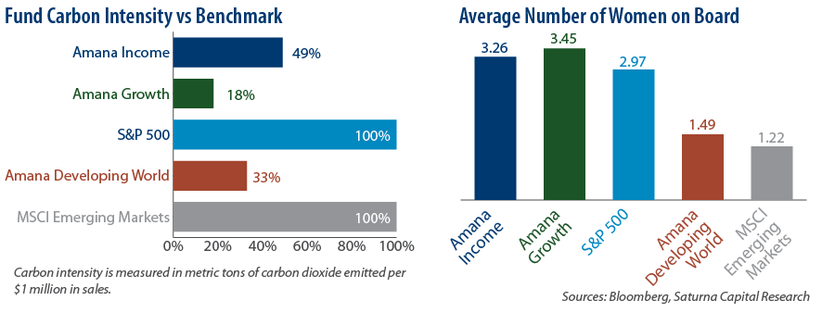
Future: (Busco, Quattrone and Riccaboni, 2007)
Management accounting is a process of looking for the performance of an organization by using financial data. By using digital and online business process, the company gained success through the pandemic situation (Carnegie, 2021). The budget report helps control and determine the future performance of the company. From the above control report of Amana ltd, it is realized that the company gained success in COVID-19 pandemic situation. Amana ltd adopted various implication in online market. Such as IT training, website, online platform etc. The company faced sudden difficulties at first but then it was controlled through the managerial process. As from the report we can see that the selling price of per unit is £25 of Amana ltd. It was more in the previous years. But as a manager I lowered the selling price of per unit in 2020. At the beginning it was challenge for the company to maintain everything with a lower selling price. But in order to gain the market trust and tourist it was necessary. By using pricing strategy it was easy to attract tourist to get service from our company. In 2020 the company gained 21,50,000 although it was tough for a tourist company to earn that much in that year. The company earned £10,55,000 flexible profit in that year. By reducing the selling price of a product it increased the overall sales which helped in the earnings. While most of the tourist companies failed to earn in the pandemic situation Amana ltd kept a good sales report throughout the year 2020. My decision on reducing the selling help me to gain and attract the tourist from every possible market place there is. The goal was to reduce the selling price but to increase the whole sales. This made the company earn 455,000 in actual revenue throughout the pandemic situation (Chaplin, 2016). By digitalizing the business we can notice that its growing quite fast in the market place which is satisfactory enough for the company. But this short term process is not beneficial for the company in the long run. For long term profit the company has create a loyal customer base and make satisfactory level of customer. After getting a satisfactory level of customer, company should focus on improving the quality in the services provided.

2.3 Provide recommendations to Amana's CEO on areas of improvement.
Amana ltd created a huge impact on the online market and the business is successfully maintained. It also gained considerable profit. But it has room for improvements though. Because of COVID-19 pandemic, the company came to a conclusion to run the business activities in online platform. This created the needs of some facilities that they have to provide as a company to ensure the required performance (Burns and Vaivio, 2001). Such as upgrading the current website and maintenance large volume of sales, digital monitoring systems, new technologies, skilled and experienced employees, IT programmer, other relevant materials and etc. To imply these facilities they have spent money on this. Which is considered as company cost. Most of the tourist company impose online business but rivals are increasing day by day. The company spends 25 per unit on materials that are huge for the company to control the pandemic. Cost of materials are a significant part of the whole expense (Harahap, 2002). I, as manager of the company and observing the whole structure and operations the recommendations for the betterment of the company are given below:
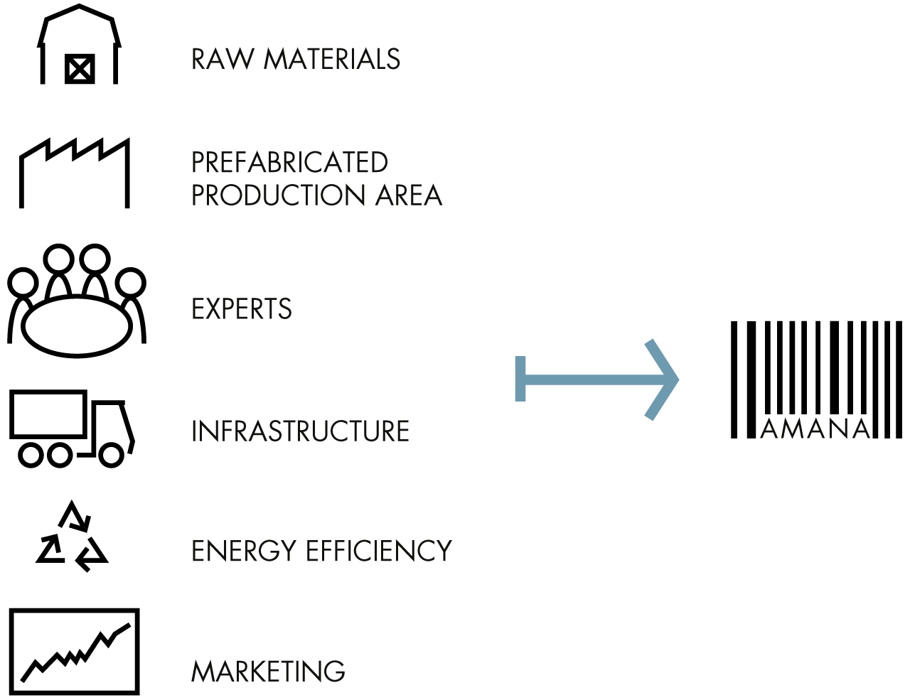
Figure: Areas of improvement (Bragg and Bragg, 2021)
- The company should lower the usage of materials to reduce the cost. But they also have to take in mind that COVID-19 pandemic is dangerous (Busco, Quattrone and Riccaboni, 2007). Materials should be used smartly.
- Identifying and maintaining every section of the company. So that the increased cost can be detected and controlled in an effective and efficient manner (Chaplin, 2016).
- Loyalty of the customers should be earned by maintaining product quality. Though lowering the selling price is to attract customers (Carnegie, 2021). But company should focus on the long term.
- Profit and customer satisfaction both should take into consideration because both play a vital role in operating the business activities.
- With time the company needs to update their technology and devices to facilitate continuous improvising services as the company can run better in long term process.

PART B

2.4 An analysis of Mr Amana's decision to go online and advise if they should set up their online shop or sell on Amazon.
Amana ltd is a family-owned business which deals with the trade of souvenirs of different locations in UK. It operates the business functions in many locations but in the very recent time, due to the massive break out of Covid-19 pandemic, the government imposes several rules and restrictions as they can control the effect and protect the people. Stay home & Stay safe, this chant prohibits the people to go outside the home (Malmi, 2016). As a result, Amana ltd decided to go online method of business operation through which they can run their business and provide the required products and services to the customers. The company is working on two options. First one is to sell the products and services by developing a website and for this, the company decided to close the store of Brighton, Manchester and Birmingham cities. Another option is that the company is going to set and run the business operation in Amazon platform. So, from this two different options, which option would be benefited for the company are critically evaluated below?
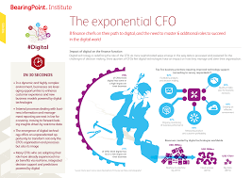
Figure: Amana's decision to go online (Chaplin, 2016)
In case of first option, Amana ltd can make an online platform to carry out the business activities among the pandemic for providing Products and services to the customers at home (Chaplin, 2016). For 50% increment of online business, the company has to incur different forms of cost. Hence, the company has closed several physical stores as they can afford to manage the required cost of doing the business activities in online platform. In order to do so, the company needs to upgrade and publishes a website including advanced technologies, digital devices and other relevant materials. It takes too long time to ensure a sound online platform for their desired business operation (Burns and Vaivio, 2001). To ensure the sound online business platform, the company needs skilled and experienced employees as they can deliver what the company wants. The company also needs digital monitoring system to supervise and control the performance of business.
Here,
- To deliver the products and services to the exact location of customers maintaining the required social distance, the company has to set out an organised delivery network. The cost of setting up a delivery network is £1,50,000 (Kim and Lee, 2021).
- The current website of the company cannot afford to provide the services for a large volume of sales. So, the company has to upgrade the current website. The cost of upgrading the website and maintenance volume of sales is £50,000.
- In order to carry out online business activities, the company needs a full time IT programmer as he can set the platform and settle the arising problems of the platform. The cost of remuneration of IT programmer is £35,000 per annum.
It would be very tough for the company to meet the huge amount of costs in those activities and it takes too long time to make sure a sound online business platform for the company (Carnegie, 2021). According to the market research, the volume of sales would be 1,00,00 units per annum in this first option.
The company has another option where they can sell out the products and services in Amazon online platform.
In case of this option, Amana ltd can directly sell out their products and services on Amazon online platform where the company has to take into consideration several factors which are illustrated in the following grounds:
- The company would be charged £50,000 to enter into the contract with Amazon as fulfilment fees so that the company can purchase the legal power to sell out their products and services directly on Amazon online platform.
- Though, there remains a large number of competitors of the company on Amazon, the guaranteed volume of sales is 65,000 per annum and the great possibility is that the sales volume keeps increasing when the demand increases (Harahap, 2002).
- The company has to follow the agreed policy of Amazon where they lose the controlling power over pricing and return policy.
From the above information regarding the terms and policies, it can be easily determined that the alternative option is better for the company (Busco, Quattrone and Riccaboni, 2007). Because, newly introduction in online as their own platform strives the company to incur more costs and more time as well. The estimated volume of sales is 1,00,000 unit per annum with a large scale of different costs in this first option. On the other hand, alternative option lets the company get more effective and organised platform by which the company will be able to earn a considerable profit among the pandemic with a smaller cost as fulfilment fees. So, the company finally should decide the alternative option to sell out their products and services on Amazon.
Directly selling products on Amazon
Amazon is an established online business platform across the world. It has effective and efficient business strategies through which a number business organisations perform their trade in online. It lets the organisations to get a lot of facilities including established customer based platform with nominal costs as fulfilment fees (Burns and Vaivio, 2001). An organisation can easily connect to worldwide customers by offering the products and services on Amazon. So, Amana ltd can make a considerable profit by performing their business activities on Amazon but there are several advantages and disadvantages there.

Figure: Directly selling products (Seal, Rohde, Garrison and Noreen, 2019)
Advantages of selling products directly on Amazon:
- Amazon lets the company to perform in an established and worldwide customers based online platform to make considerable profit (Carnegie, 2021).
- Amazon lets the company to increase the volume of sale and make a brand worldwide.
- In this online business platform, the company can perform their business activities among pandemic in organised delivery network with a nominal cost as fulfilment fees.
- The company doesn’t need to incur the different primitive costs of making own online business platform as it can minimise the overall cost and get a competitive advantage in the market (Seal, Rohde, Garrison and Noreen, 2019).
- The company can gather a lot of experiences by performing the trade on this platform which can be very effective if the company desires to make a own online business platform.
Disadvantages of selling products directly on Amazon:
- The first most affecting disadvantage of the company is that it can sell a limited number of products through this platform. Extra number of sales increases the fees (Kim and Lee, 2021).
- Amazon charges a certain amount of money whether Amana can afford to make a profit or not. It means, Amazon doesn’t have any flexibility on the certain circumstances.
- There are a number of competitors in this platform. The company has to run their business operation as they can compete with their competitors. Huge number of competitors may suffer the company (Malmi, 2016).
- The Company cannot afford to implement their own strategy as Amazon has several terms and conditions. So, the company is compelled to accept and follow the stated terms and conditions.
- The company cannot claim their customers as own. As a result, the company doesn’t get any benefits in long run and cannot create a customer based online business platform.

Conclusion
This report unearths the concept and understanding of management accounting system. It basically presents the management accounting system of a business organisation named Amana Ltd. It also includes different monthly accounts of the company. Such as, monthly control report, original budget, fixed budget and the variances of budget. It also presents the current performance of the company and highlights how the company can work for the better performance in the long run. The control report demonstrates that the company is successful even among the Covid-19 pandemic. It also includes the analysis of electing the best options how the company can sell their products in online business platform. Regarding the different types of costs and the facilities of both options, it is recommended that the company should sell their products directly on Amazon to make sure an effective and efficient current business operation and it will let the company gather more experience so that it can be successful in long run in a near future.

References
Burns, J. and Vaivio, J., 2001. Management accounting change. Management Accounting Research, 12(4), pp.389-402.
Busco, C., Quattrone, P. and Riccaboni, A., 2007. Management Accounting. Management Accounting Research, 18(2), pp.125-149.
Carnegie, G., 2021. Accounting 101: redefining accounting for tomorrow. Accounting Education, pp.1-14.
Chaplin, S., 2016. Accounting Education and the Prerequisite Skills of Accounting Graduates: Are Accounting Firms’ Moving the Boundaries?. Australian Accounting Review, 27(1), pp.61-70.
Harahap, S., 2002. Indonesian Management & Accounting Research. Management Accounting Research, 13(1), p.149.
Kim, M. and Lee, M., 2021. The Effect of Accounting Conservatism and Accounting Neutralism on Valuation Errors： Accounting Conservatism vs. Accounting Neutralism. Korean Accounting Information Association, 21(1), pp.103-127.
Malmi, T., 2016. Managerialist studies in management accounting: 1990–2014. Management Accounting Research, 31, pp.31-44.
Seal, W., Rohde, C., Garrison, R. and Noreen, E., 2019. Management accounting. London: McGraw-Hill Education.

