

Graduate Diploma in Professional Police Practice

LEVEL 6 - 40 Credits

To be completed by DHEP Detective students only

Workbook title: Competency Based Workbook 1 (DHEP) 6,500 words.

(SOUTH WALES POLICE, GWENT POLICE AND UWTSD)

Learner name: William Luka

Learner’s University Registration Number:
2319924

FACULTY OF BUSINESS AND MANAGEMENT
PUBLIC SERVICE PROGRAMME

Module title: Policing in the Workplace 3 (DHEP)
Workbook Guidance

Please read these notes carefully; they provide essential information.

What is the workbook for?

The purpose of this workbook is to enable learners to demonstrate and provide evidence of how they meet the learning outcomes set by the College of Policing, for the Graduate Diploma programme. Essentially, you are being asked to outline your experiential learning based upon your theoretical understanding in a range of operational situations.

Area of Professional Practice covered, (called elements in your module descriptor):

- Wellbeing and Resilience
- Communication Skills
- Managing Conflict
- Valuing Difference and Inclusion
- Criminal Justice
- Decision making, discretion.
- Conducting Investigations
- Criminal Justice (Managing offenders)
- Problem Solving
- Evidence Based Policing
- Maintaining Professional Standards
- Public Protection.

You may wish to use the same incidents as you’ve outlined in the Occupational Competence Portfolio.

How should the workbook be presented?

Blank electronic copies can be found on Moodle of this workbook. You must submit this document electronically therefore it is important that you save your work regularly and upload the final typed version through Turnitin on Moodle.

Word count policy can be found in chapter 7 of the Academic Quality under section 7.7 (this applies to presenting work above and under the specified word count).
(https://www.uwtsd.ac.uk/media/uwtsd-website/content-assets/documents/academic-office/aqh-chapters/chapters---en/Chapter_07_Assessment_Taught_Programmes_Pages_72-79-UPDATED-05-11-2019.pdf)

Reflective practice is a core aspect for your workbooks and although there is a variety of useful resources on Moodle, there is one particular book, that is specifically based on reflective practice in policing, here is a link to one chapter from Selina Copley’s Reflective Practice for Policing Students:
https://moodle.uwtsd.ac.uk/pluginfile.php/298870/mod_resource/content/1/Reflective%20Practice%20for%20Policing%20Students%20-%20Selina%20Copley%20Chapter5.pdf

How is the workbook assessed?

Advice and support about the completion of this workbook will be provided by university staff as part of your initial training day. Your tutor constable and in-force training staff will not be involved in assessing or marking your workbook after it has been submitted.

Dates of workbook submission will be made available during the initial training day and posted on Moodle.

Once submitted your workbook will be assessed and marked independently.

Confidentiality

It is important that no individual can be identified either directly or indirectly from the information in the workbook. Therefore, you must:

- adhere to guidance in the Student Handbook about unfair practice and plagiarism;
- not identify individuals including witnesses, victims or offenders by name;
- not write information that enables any individual to be identified indirectly through the description you provide. This includes references to names, colleagues, places (including hospitals, schools, town, villages, streets) specific incidents which were high profile and could be identified due to past publicity, other professionals or any other personal information including medical or other conditions.
- take personal responsibility for adhering to confidentiality rules.
- not include any dates of any incidents or anything that specifically identifies an actual incident.

The content of this workbook should be your own work. Do not allow anyone else to see your work or use your work for their own submissions.

Please be aware that any content that is deemed to be inappropriate, disrespectful, or abusive will not be tolerated. Following review of any content of this nature the information will be shared with the employer of the student responsible.

Should any health and wellbeing concerns be raised because of disclosures made by the student within this workbook, the employer of the student will be informed.

NOTE

Your workbook will be submitted electronically via Turnitin on Moodle. Guidance on this is in the Student Handbook.

Remember that the workbook is YOUR responsibility you must not rely on the assessor or anyone else to pick up any confidentiality breaches as this is your work and you must accept full responsibility for confidentiality. Meeting all the confidentiality requirements is very important.

Dyslexia and other special circumstances

If you have any condition that you feel may affect your ability to deal with any part of the programme, please see the Student Handbook for further guidance. The University has a Student Services Unit that may be able to help but it is the learner’s individual responsibility to contact them.

Guidance:

- Your workbook must contain the items specified in the table below (clearly identified and in the order given);
- You should use this document to insert your text / answer within each section of this workbook;
- You should upload your completed document as a saved pdf file of this workbook; if this is not possible then a Worddoc file is acceptable. Do not send a scanned file from a photocopier, an apple.dot file or a Microsoft publisher file as Turnitin will not be able to assess them, despite you being able to upload them.

Contents

Workbook | Area of Professional Practice | Word count
Task 1 | Wellbeing and Resilience | 1000
Task 2 | Communication Skills, Managing Conflict, Valuing Difference and Inclusion | 2000
Task 3 | Criminal Justice, Valuing difference and inclusion | 1750
Task 4 | Decision making and discretion, Conducting Investigations and Criminal Justice (managing offenders) | 1750
 | Bibliography
Task 5 | Independent Patrol Status Confirmation | Equivalent 1500 words
Confirmation of Confidentiality and Plagiarism
Confirmed by submission through `Turnitin

Task 1

Relevant areas of the National Policing Curriculum:
Understanding the role of a constable.

Guidance:

Focussing on your initial 6 months of learning and since being attested as a Police Constable, discuss and compare the coping strategies you have applied to develop resilience and minimise stress.

1000 words (+/- 10%: include your actual word count at the end of each section)

ANSWER:

Throughout my initial 6 months of training, I have utilised several coping strategies which I have applied and used to gain resilience and reduce my stress levels. In general, I am a calm and stress-free person however, coming into this new job really tested my stress management skills and the following methods have helped me during my training.

The first things that are key to understand are the definitions of both stress and resilience. According to the world health organisation “Stress can be defined as a state of worry or mental tension caused by a demanding situation. Stress is a natural human response that prompts us to address challenges and threats in our lives. Everyone experiences stress. The way we respond to stress, however, makes a significant difference to our overall well-being. (World Health Organization (2023)). The definition of resilience in comparison from (Cambridge Dictionary (2019)) is stated as” the ability to be happy, successful, etc. again after something difficult or bad has happened.”.

Currently in the UK the police force has one of the most stressful lines of work and according to (University of Cambridge. (2019)) “some 93% – said they would go to work as usual if suffering from psychological issues such as stress or depression.” As an officer we attend many more stressful events daily and the first 6 months of initial training is no exception, as from personal experience we were tested and pushed to our physical, mental and academic limits which caused a substantial proportion of stress.

Another set of research by the police federation of England and Wales found that 79% of officers have felt stress and anxiety within the past 12 months and 94% of these officers have said that these feelings were either a direct cause from work or amplified by their jobs. (Mind (2019)).

The first strategy that I applied to develop resilience and minimise stress was connecting with people around me such as my friends and family. This strategy is also a part of the NHS advise for stress management. The website states that it “allows you to see things in different ways” and “help us relax and relieve stress” (NHS 2021). This really helped me talk through difficult topics in work such as child abuse and allowed me to feel supported when working on these types of topics. Talking with my family, friends and work colleagues also allowed me to feel confident and resilient as when I am dealing with these tricky situations, I have people that will listen and talk to me hence relieving my stress levels. In addition to this my work colleagues who are also my friends go through the same things therefore we can relate to each other and share experiences more naturally.

The second method that has relieved my stress levels and increased my workplace resilience is relying on my hobbies and taking some more time to myself to enjoy the things I love to do. During the pandemic, a study by Reading university and connecting research on hobbies and stress relief which stated as follows; “research shows that having a hobby is linked to lower levels of depression – and may even prevent depression for some.” (Connecting Research. (2021)). This has applied to me as by doing certain hobbies such as baking and using the gym on regular occasions has increased my happiness and reduced stress levels, allowing me to think clearer and produce better work.

Regarding resilience an excellent tool that I have used to increase my resilience is
Seligman’s 3Ps Model of Resilience (Moore, C. (2019)). The model consists of three P’s – Personalisation, pervasiveness, and permanence - these three perspectives really allow a person to process and understand feelings and complex thoughts. By understanding and recognising these we can adapt positively and increase resilience. (Moore, C. (2019))

In order in increase resilience and reduce stress it is important to reflect on situations and a day's work. Another great tool I have used is the Borton’s model of reflection. I first heard of this on a website called ‘toolshero’ which helped me understand the simplicity of the model.
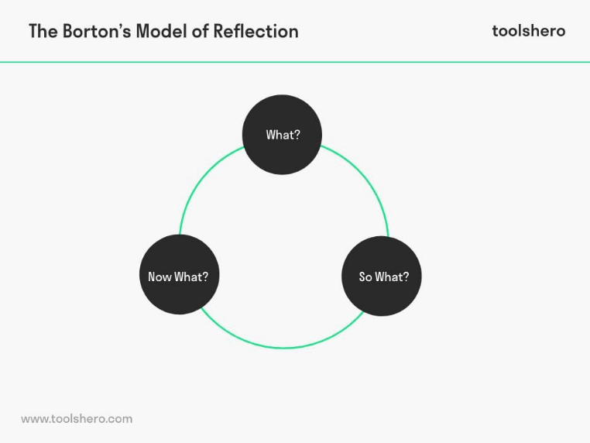
The model is made up of three sections the first being what, this is about asking what exactly happened in an event and reflection on what I saw/heard. The next is so what, this relates to understanding what happened and how it made me feel then how I feel now, and what has changed since the event. The concluding section is now what, and this relates to what actions could or should be taken prior to the event and what will the implications be.
(Janse, B. (2022))

One final method I used to de-stress is using my time off to travel and visit relatives that leave slightly further away. I have a great relationship with my one brother, and he lives in Bristol. I would often commute and spend the weekend with him which would help me to relax. I enjoyed the drive and or the train ride this time alone on the ay would allow time for reflection and thinking.

When comparing these methods, tools, and strategies I found that the combination of all of these would best suit me. By being able to readily utilise these methods whenever needed really helped. I often found if I were constantly talking to family members and friends, I would get tired and fed up so by mixing things up and taking more time for myself and hobbies I would feel a lot better. By having a combination and routine of these things I would feel more resilient and less stressed in the workplace. I think it will be imperative to maintain this balance as best I can in the future as equally all these strategies are highly effective and by comparing these against each other there is not one that just works better or is more effective. On their own they are less effective but as said before by combining several of these into my work weeks they become effective and provide me with the best results.

1013 words……………………………………………………………………………………………

Task 2

Relevant areas of the National Policing Curriculum:
Communication Skills, Managing Conflict, Valuing Difference and Inclusion

You must choose a policing incident involving conflict in which you played a significant role with an offender/service user/victim and reflect on what happened.

Critically assess the incident including social and legislative contexts and any relevant cultural, ethnicity and language issues.

Consider the use of effective communication skills that you used within the incident.

Reflecting upon your incident, critically evaluate any theories or models underpinning the causes of conflict within policing interventions. (Examples would include, Betaris Box, The Drama Triangle).

2000 words (+/- 10%: include your actual word count at the end of each section)

ANSWER:

The steps to critically assess a theory include examining the evidence, evaluating the logic, assessing the scope, comparing to alternative theories, evaluating testability, and considering the implications.

Incident overview:

It was Saturday the 30th of March 2024 when I had the occasion to attend a call at the skinny dog bar Pontypridd. The call came in as two suspects that were detained for assaults. On arrival to the location, there was one male and one female on the floor being restrained by several members of door staff working at the skinny dog bar. One colleague and I went straight over to the female who was heavily intoxicated and screaming and shouting, hurling deplorable language and offence at the door staff and us officers.

An account was given to us of what had happened from one of the victims. It had become clear that the female in question had grabbed a male bouncer by the penis and tried to pull it as hard as possible. At this point another officer joined to help restrain the woman and I proceeded to arrest the woman for sexual assault by touching – which is section 3 of the sexual offences act 2003. I then gave the necessity for the arrest which was to prompt an effective investigation and to prevent any further harm to an individual.

The woman reacted badly to this and started to kick and attempt to headbutt officers. I then handcuffed the female in a double stacked manner as this was the only feasible way to restrain her safely. I then checked if the cuffs were not too tight and she proceeded to scream that “you have f****** broken my wrists,” this was not the case her wrists were perfectly fine.

Two colleagues then conveyed the female to custody where she was booked in. The arrest was carried out under section 30 of the Police and Criminal Evidence Act 1984 (PACE). Section 30 relates to when an arrest takes place elsewhere than a police station. All points were hit in compliance with this as the female was then taken to a police station as soon as practicable after arrest.

Critical assessment/ reflection:

When it comes to an assessment of the incident there are many things to analyse:
- JPLANE – Justification, proportionality, Legality, Accountability, Necessary, Ethical
- NDM – National decision model
- The powers used.
- The offences arrested for
- Use of force – 5 step appeal
- Communication skills throughout the incident – was a rapport built?
- Use reflective models to identify any mistakes or things that could have been done differently.
- Influence of alcohol on the subject
- Is there any case studies/ research that backs up decisions made/ actions taken.

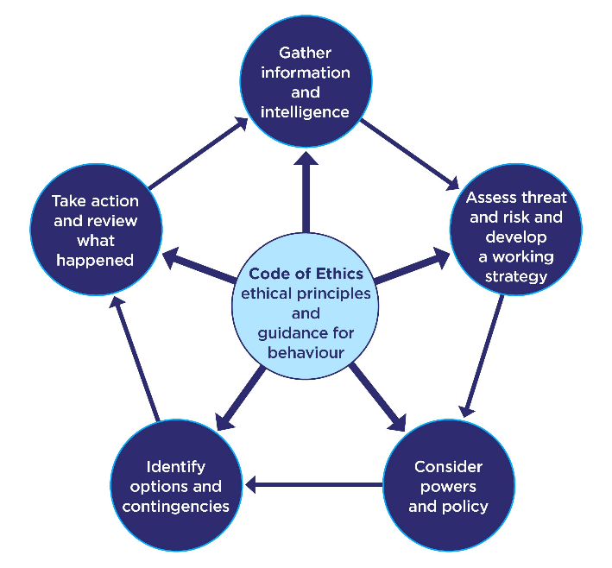
JPLANE and the NDM both come hand in hand, below is a diagram of the NDM taken from (College of Policing (2013)) website. When attending any incident, it is crucial to understand the mechanisms and apply these to every incident I attend. On attendance to this call, it was a highly chaotic scene as there were many drunk individuals around watching the incident unfold and many people who wanted to give an opinion on what happened. My colleagues and I gathered as much information as possible on what had happened to help us establish what offence if any had been committed. We collectively assessed any threats such as potential weapons and other members of the public getting involved and then developed a strategy. We decided that we would now arrest for the offence sexual assault by touching – which is section 3 of the sexual offences act 2003. By deciding this we were considering our powers and policies. We further used our powers to search the subject under section 32 PACE. This gives a police officer to search someone on their arrest.

At that moment in time the only option was to arrest the subject due to the allegations and her unacceptable behaviour. She was conveyed to custody where she would be able to sober herself up before having an interview on what had occurred. When it comes to reviewing the decisions made and actions taken its important to use JPLANE. An overall assessment was that the decisions made were justified. The next part is proportionate – are the actions we took equitable to the actions of the subject. In this case force was required to restrain the individual and handcuffs were applied. These actions were well within the proportionality scale and allowed us to restrain her safely and avoid injury to us and others. The legal side of the incident is the next part of JPLANE. Were the actions that we took legal and are the legal powers that were used correct. In this case we used section 3 of the sexual offences act, section 24 PACE, and section 32 PACE to have an effective arrest.

The next section of the JPLANE process is accountability, according to the Cambridge Dictionary the definition of accountable is “completely responsible for what they do and must be able to give a satisfactory reason for it” Cambridge Dictionary (2024). In this situation I and my colleagues were completely responsible for the actions we took and due to the level of resistance and the crime that had been committed we have full justified accountability. This leads onto whether the actions we took were necessary and, in this case, they were completely necessary for the safety of the public, ourselves and the subject. The final part of this process is ethicality of the actions taken and it was without question that how the incident was dealt with was completely ethical. (College Of Policing (2013)

Example model – five-step appeal

During conflict situations like this incident, it is important to use methods that will aim to help calm a situation or reason with a person. The first core method that most officers including myself use is the 5-step appeal. Simple appeal, reasonable appeal, personal appeal, final appeal, and action are the 5 steps involved in this conflict management process. According to the college of policing the simple appeal is about asking the person to comply with what you are asking them to do. If this fails then you move onto the reasonable appeal where you explain to them why you made that request, what may have caused the request and if any laws have been broken. If this is unsuccessful then you hit the personal appeal where you would appeal to them and explain how not complying might affect the things, they like for example family, friends, work. After this and if this is also unsuccessful you move onto the final appeal where you must use the following phrase, “is there anything I can reasonably say or do to make you cooperate with us.” After all these appeals mare made and unsuccessful then action can be taken, and reasonable force used. (College of Policing (2020)

Example model – LEAPS

Leaps is a simple pneumonic that is used to aid communication. In this incident it was particularly difficult to utilise due to the fast pace and severity of the crime. However, when dealing with my incident there were elements that I still used. LEAPS stands for Listen, Empathy, Ask, Paraphrase, Summarise (College of Policing (2020). During this call listening was used in a great deal, there was multiple conversations happening at once and I used acute listening skills to decipher what information was useful and what information was not. This allowed us to make informed decisions on what actions needed to be taken. It was challenging to use empathy in the situation due to the business of the scene and the fact there was multiple officers all talking at once. In addition to this the female was non-compliant and aggressive resistant which did not allow the time for many questions nor empathy in that moment. Paraphrase and summarise were also not fully used but only partially used during the grounds, caution, and necessity of the arrest.

Example model – Betari's Box
The model below is commonly used in policing for conflict management and again it is something that my team and I use. It shows that my attitude and behaviour have effects on the person I am dealing withs attitude and behaviour it is as simple as that. 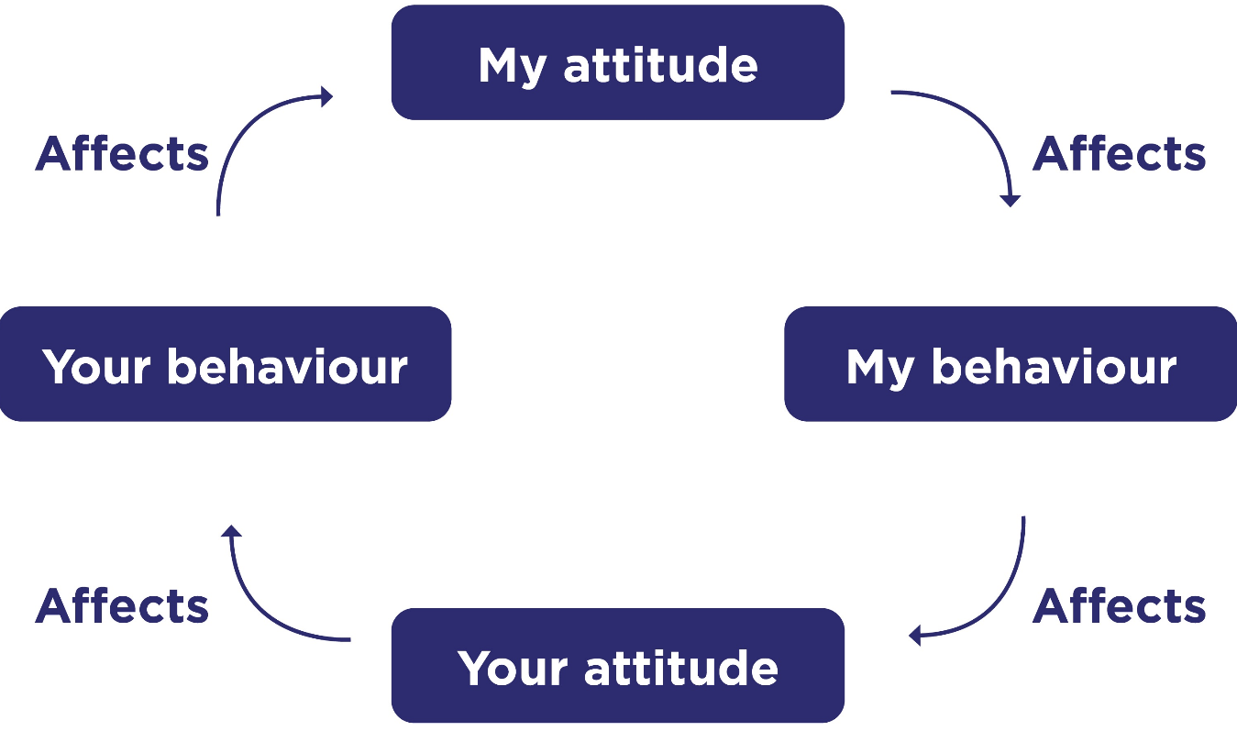
College Of Policing (2013)

Mitigating factors

In every incident it is important to take into consideration any factors that could influence the behaviour of an individual or any factors that could compromise yourself or others (Duane Brown, John Wiley & Sons, 8 Oct 2002). In relation to this incident, we received information that it was outside a popular bar on a Saturday night. From this we could already start preparing for alcohol to be a prominent factor. On arrival it was clear that the female in question was intoxicated, her speech was slurred, eyes were glossy, inappropriate behaviour and foul language was being exhibited. According to Medway council these are all things that an intoxicated person could present as (Nicoli, A. (n.d.).). There is an argument that these same factors could have been present in someone who was having a medical episode however, given the current situation, further signs such as the smell of intoxicants on her breath and observations by witnesses suggesting she has consumed at least 2 bottles of wine alone this argument was eliminated.

When dealing with conflict and incidents like this one there is also another tool that can be used. Karpman's Drama Triangle characterises unhealthy partnerships in which the individuals involved alternate between the roles of Rescuer, Victim, and Persecutor, all of which are maintained by blame and guilt. It's extremely easy to get into an extreme condition that doesn't benefit you or the people you're engaging with when you find yourself locked in a self-defeating or self-serving role. The goal is to approach the core of the triangle, which has a far healthier and more positive balance, from the outermost points. (Listening Partnership | Oxford. (n.d.)

By taking this action, we transform from oppressive persecutors into boundary-aware individuals who are forceful. Instead of acting like defenceless victims, we become more self-aware and less susceptible. We shift from being selfless saviours to being attuned and compassionate.

Rather than persecuting, you assert, although you are susceptible, you are not a victim. You also show compassion without going too far. The point where all our roles come together, the point where we are self-aware and coming from a level grownup place, is right in the middle of the triangle, the sweetest location of all. from a position where you and others feel alright. (Listening Partnership | Oxford. (n.d.) An example diagram of the triangle is referenced below.

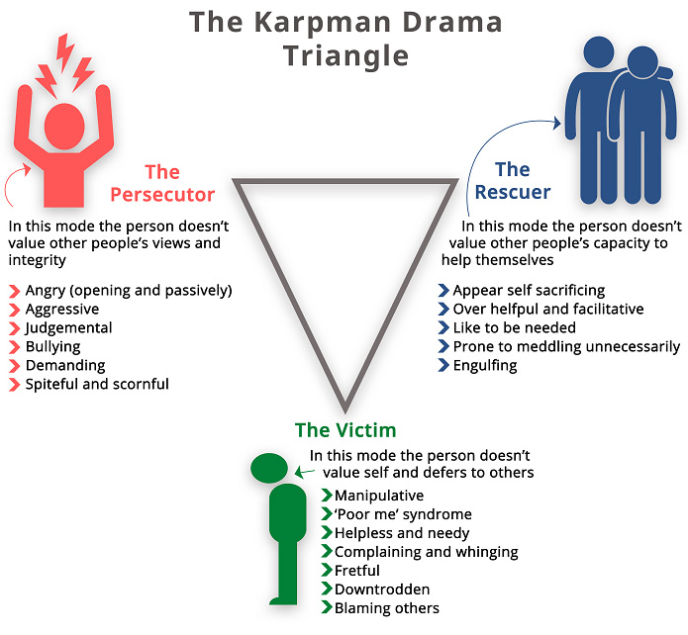

(Listening Partnership | Oxford. (n.d.)

Summary –

Throughout the course of this incident, it was difficult to utilise all the methods and models mentioned above. However, because many of these models are used so frequently in my everyday work when a fast-paced incident like the following occurs, the basic principles apply naturally and allow effective incident management to take place. I responded effectively with good levels of communication with the subject which allowed us to convey this person to custody in a safe manner for all involved. If there was one thing in which could have been improved, it would be the communication between myself and my colleagues, it was already particularly hard to communicate due to the loud noisy environment this incident happened, but this interfered with what colleagues were saying to each other which meant there was some confusion when mobilising the subject from the floor to the police van. All in all, though each person did their jobs to the best of their ability and all chances of further injury, threat, harm, risk was mitigated due to our actions.

1912 words

Task 3

Relevant areas of the National Policing Curriculum:
Criminal Justice, Valuing difference and inclusion

You must choose a policing incident in which you played a significant role with an offender/ service user/victim and reflect on what happened.

Critically explore a policing incident that you have investigated and examine how you dealt with competing issues such as legislation, social issues, culture and language.

Consider the victims code of practice and how it was used to support your victim/witness through the criminal justice system during the investigative process.

Your reflection must illustrate your understanding and application of core principles of ethics, equality, diversity and human rights.

1750 words (+/- 10%: include your actual word count at the end of each section)

ANSWER:

Overview of incident -

This incident relates to an incident where officers attended an address in the Pontypridd area in relation to a call of a father named W (for the purpose of this assignment), was coming to attack his daughter named K (for the purpose of the assignment) current boyfriend named J (for the purpose of the assignment). It is important to know that all names used in this report are falsified for data protection reasons.

On arrival at the scene no persons were present, and the flat was knocked several times. A phone call to, K was made to find out her and her partners current location, they were on route back to the flat from Merthyr.

Officers then conducted an area search for the vehicle of W in the local area. Officers asked control if there were any ANPR hits on the car, this resulted in a positive ANPR hit for the car near the original address in Pontypridd.

Officers returned to the original address where the vehicle and W were located. Initially W did not wish to talk to officers, he appeared very angry and distressed and attempted to drive off from officers stating he had no need to speak to us and that we should mind our own business.

W then turned his vehicle around by which time officers had used the police van to block any passage. W then decided to then stop to speak to officers again this time saying that he did in fact want to 'DO HIM' relating to harming J. W was very upset by K choice of boyfriend and was a very concerned father. W also said to officers that he would attend Pontypridd police station at 8pm to provide a statement in relation to an assault from J.

Officers managed to calm W down and his other daughter came over and suggested that he go to her house to calm down and that she would follow him. W agreed to this, and his daughter said if he was to deviate from this route, she would call 999 again.

K and J then returned to the address as W was leaving and officers spoke with them regarding the incident. K was advised that if this happens then to call the police, however she denied any violence from her father and that there is any history of violence.

K also said that her relationship is going well and that she feels safe and has no concerns. K believes that this has occurred because of her father not being able to pick his grandson up from school on Wednesdays as the grandson has been sick.

J has also said without prompt the alleged assault was initiated by W. Whilst officers were speaking to K, she mentioned that W had smashed up the reporting persons address she knew this from J the other sister. Officers have asked units in the home address to attend for a welfare check on RP (reporting person).

W later returned to the property of J approximately 6 hours later and physically assaulted J causing life threatening injuries.

Dealing with the incident:

From this point the first incident itself was dealt with but due to the return of W we would now need to investigate whether this was W by conducting further enquiries.

The first step in this investigation was to attend the victims current address to obtain a statement and assess what the extend of the injuries. Giving and providing a statement in relation to any criminal matter can make the difference between bringing an offender to justice or them evading the law. (Giving a witness statement to the police -what happens next? (n.d.).) once a statement was provided when the victim was able, we also seized clothes and took swabs on his persons and other items that were involved in the incident. Taking swabs will allow for forensic testing to see whether or there are any fibres or DNA relating to the aggressor. (Lifecentre. (2021).

Whilst waiting on the forensic evidence there were many other lines of enquiries to follow up with. The next thing we did was attend the address of where this assault took place to complete a house to house and CCTV enquiries. It’sIts vital that these enquiries are taken place as there is often many witnesses that have seen or heard anything, and these people may have CCTV that they would be willing to provide to the police. Having CCTV would then allow the police to see what exactly happened and establish whether the persons reporting, victims and witnesses are being truthful in what they say. (www.college.police.uk. (2024)

On conducting the CCTV enquiries, we located a CCTV camera from a local shop that was positioned directly above where the incident took place. We also managed to identify 3 witnesses that heard fighting but did not see anything, these witnesses did not wish to provide statements, however. On reviewing the CCTV, the information provided by the victim at the time proved to be false, J was in fact the person that made first physical contact. W did travel to outside of J’s address however he did not appear aggressive in any manner and the assault started with J punching W to the face who then retaliated physically.
After reviewing this footage, the investigation then turned to the welfare of W, police visited W in order to complete a welfare check and see if he was willing to provide a statement. In this instance W would not provide any statement and did not wish to speak any further to the police. This information was then passed to J who also then wished to provide a statement of withdrawal and not proceed with any further charges.

Assessing the investigation/ Legislative issues

In the initial stages of the investigation myself and colleagues provided effective strategies and planned the actions needed to be taken with precision. We first considered what offences could have been committed, we initially discussed section 39 criminal justice act 1988 which is common assault. (Legislation.gov.uk. (2018) On reviewing this we decided that with the information provided so far that this would be too low of a charge for the severity of the injuries described. We now discussed a potential crime/charge of grievous bodily harm under section 20 of the offences against the person act 1861, we decided that this would be the most likely outcome if the matter was proceeded by the injured party. The definition of GBH is as follows “Whosoever shall unlawfully and maliciously wound or inflict any grievous bodily harm upon any other person, either with or without any weapon or instrument” (Legislation.gov.uk (2011).

There was the possibility of conflicting legislative issues as due to the severity of injuries there might have been the possibility that we would need to lower the charge to Actual bodily harm under a section 47 of the offences against the persons act 1861, however we went into visiting the victim with this in mind which then allowed us to adapt to the situation. On arrival to the hospital where the victim was, we were provided with information regarding the extent of injuries and decided that it would result in GBH not ABH. Because of our preparation prior to attended this allowed us to provide effective advice and follow all the required steps for an effective investigation.

When also critically analysing the steps taken, the prompt action of enquiring about CCTV allowed us to establish what exactly has happened and further investigate as well as providing the best care and response to a serious incident. We took all the needed steps in relation to both parties care, we attended numerous addresses to carry out welfare checks on persons involved, we attempted to provide safeguarding advice and take further statements from anyone involved. Sadly, in this case the outcome was a negative one since both parties wanted nothing to do with the police and wanted no further action to be taken. We also assessed whether the injuries would result in permanent disability or death however medical professionals suggested that this was highly unlikely. Therefore, at this point we exhausted all avenues and there were no further actions to be taken. We as a team who investigated were efficient, compassionate and death with the incident with the utmost priority.

Social Issues/culture – Victims codes of practice

When dealing with this investigation we encountered varied social and cultural differences that were very different to anything that I had seen. W came from a good family with a good job, no trouble with the police prior to this and lived a respectable life. J on the other hand had a hard childhood living in the Welsh valleys in the care system who then fell into a life of crime, committing many offences involving drugs. Both persons lives were vastly different, and it became a challenging incident to manage regarding dealing with parties and helping them equally. In addition to this J also came from a background of ethnic minority identifying as a black male. According to an IOPC study 2023 ‘Black people are more likely to feel negatively towards the police (34% vs 26% overall), but less likely to feel negatively towards the government (47% vs 61% overall)’ (IOPC (2023). In my opinion and a reason that I have joined the job was to improve public perception of the police and therefore I made sure to take extra care and treat each person as I would want to be treated.

In this case both parties were treated the same with no discrimination towards either. It was important to us as police to find out the truth and gather as much evidence as possible alongside supporting victims. In this case we were unsure in the first instance who was at fault therefore no assumptions were made, and we acted proactively keeping in mind the victims codes of practice. The key codes of practice that were of more significance in this case were:

- To make a Victim Personal Statement.
- To be referred to services that support victims and have services and support tailored to your needs.
- To be provided with information when reporting the crime.
- To have the details of the crime recorded without unjustified delay.

In my opinion although the outcome was different as to what we had expected, we approached with the same courtesy, respect and efficiency as the same as any case. We attempted to refer both parties to south Wales victim focus who can give free and confidential advice to any person affected by crime in the area, however all parties refused. I also mentioned to J about ‘safer Wales’ who are an independent charity supporting groups of people who can often feel invisible in society (South Wales Police and Crime Commissioner. (n.d.).

We also believe that we met each of the codes of practice mentioned above and insured both parties had all the information to make an informed decision regarding the future of the case, in this instance neither party wanted to proceed.

1842 words
When dealing with this investigation we encountered varied social and cultural differences that were very different to anything that I had seen. W came from a good family with a good job, no trouble with the police prior to this and lived a respectable life. J on the other hand had a hard childhood living in the Welsh valleys in the care system who then fell into a life of crime, committing many offences involving drugs. Both persons lives were vastly different, and it became a challenging incident to manage in regards too dealing with parties and helping them equally.

Task 4

Relevant areas of the National Policing Curriculum:
Decision making and discretion, Conducting Investigations and Criminal Justice (Managing offenders)

You must choose a policing incident which you played a significant role with an offender/service user/victim and reflect on what happened.

Critically assess your role during a police investigation where you played a significant part with an offender/victim and reflect upon what happened.

Reflect upon your use of the National Decision-Making Model and the Code of Ethics and review how this impacted upon your decision making and use of discretion within the investigation.

Critically review your responsibilities regarding the provision of CPIA when conducting this investigation.

1750 words (+/- 10%: include your actual word count at the end of each section)

ANSWER:

Description of Policing incident:

The following incident relates to a serious domestic abuse that occurred in my third week of tuition. There was a grade one response call to a regular domestic abuse victim. This female has been in an abusive relationship for the past 6 years and every time has refused any help from police and felt like they had no choice but to stay with the male who was the cause of the domestic violence.

On arrival to the property, we placed our body-worn cameras on and knocked the front door. A male answered the door who had blood on his top and hands but no sign of physical injuries. We told the male that we had an anonymous phone call asking for police attendance as they could hear screaming and shouting. We asked the male if anyone else was home and he said that there wasn’t he was home along and he had just been having a nosebleed. We explained due to the nature of the call that police would be entering the property.

After explaining to the male with many attempts he allowed us entry. A search of the house was conducted by myself, this was a large house with three stories, on entering a small bedroom on the top floor of the house I saw a female with considerable injuries to the face and arms. The female was in distress and attempting to hide from police. I approached the female with caution and told her that we were there to help. After a considerable amount of time and persuasion the female disclosed that she had been assaulted by the male downstairs who was her husband and that he was the person who caused these injuries.

The male was subsequently arrested for a section 1 domestic abuse assault and then conveyed to custody. The female was conveyed to hospital where swabs and clothing were taken for forensic analysis and the females’ injuries were attended too by medical staff and photographs taken.

Assessing the investigation process:

The initial steps of the investigation come under the golden hour enquiries. When a crime or incident is reported, there is a window of opportunity known as "golden hour" within which time appropriate action should be accomplished. This could involve obtaining, safeguarding, or maintaining information that might otherwise be lost, hidden, harmed, changed, or destroyed. Taking efficient action during the "golden hour" will improve the chances of identifying suspects, safeguarding witnesses and victims, and assisting in the achievement of favourable criminal justice outcomes. Everybody working on a crime or incident investigation needs to assist with:
(College of Policing (2013). Investigation process.)

- preserve life.
- secure material.
- minimise the amount of material that could be lost to the investigation.
- maximise the chance of securing material that will be admissible in court.

As a team we implemented a checklist of outstanding actions of golden hour priority and non-golden hour priority as exampled below.

Golden Hour | Non-Golden Hour
House to House | Witness Statements
CCTV/Ring doorbell enquiries | Victim statements
Safeguarding advice | PPN – Public Protection Notification
Swabs of both | Safeguarding advice for victim
Seize clothing of both | Explain processes to victim
Further search of house/ photograph scene | Explain special measures that might be available if the matter goes to court
 | Explain possible outcomes and potential victimless prosecution.

Use Of the NDM - National Decision-Making Model and the Code of Ethics:
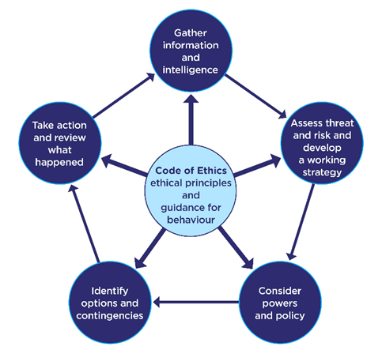
(College of Policing (2013)

Throughout the course of this investigation, I relied heavily on the NDM and code of ethics, particularly acting with respect and understanding the impact of emotions and welfare. This was a sensitive case and the victim had already taken a lot of courage and bravery to take the first steps in stopping the abuse for the first time in 6 years. The victim also put great trust in the police especially me as I was a first port of call for her in this case.

To complete instant action at the call we made our way through the NDM from gathering information from both parties which were kept separately for there to be no pressure on either party from each other reducing bias and helping obtain a full factual account.

We then assessed threats and risks, hence arresting the male, and getting the female to a hospital for medical treatment, this also encompassed considering powers and policies hence the arrest and detainment on 1 suspect. Again, this led onto identifying contingencies and acting. Within the initial arrival the NDM was fully effectively utilised.

The NDM can then be applied to the investigative process hence identifying tasks to be completed in the golden hour. As a result of this strategic plan the initial golden hour enquiries allowed us to identify 2 witnesses to the assault and the noise as a result was captured on a ring doorbell. This maximised our evidence and with the further forensic swabs and clothing being tested we found blood from the victim on the suspect and his clothing as well as hair trapped under his fingernails. We were also to match the victims full account to placings of different items in the house that had been used in the assault, for example a rolling pin that had been used had been placed in the dishwasher by the male to conceal evidence.

Due to this evidence the case was building good and strong evidence it was now crucial that we worked with the victim to ensure a positive statement and willingness to proceed down the legal channels. It is also important to build up a good relationship with the victim to instil confidence in her and show her that we would be here to support her through the entire process. We explained how the court process would work and said that would be applying for special measures if this was to go to court, such as, screens to block her from seeing the perpetrator. (Crown Prosecution Service (2023). Special Measures). We also with her permission referred her to Women’s Aid, which ‘is the national charity working to end domestic abuse against women and children. As a federation we provide life-saving services across England while building a future where domestic abuse is not tolerated’ (Women's Aid (2023).

In this case the female victim felt confident enough to proceed with the case due to the support she received. We also had body worn footage of the scene and arrival, capturing the first moments officers arrive. This evidence would help show the females injuries on arrival and capture the condition of the male and house involved in the assault. According to the college of policing this would likely help in the conviction due to the strength of the evidence. (College of Policing (2021). Body-worn cameras)

Throughout use of the NDM the policing code of ethics are a constant. Every decision made but consider the use of the code of ethics. When investigating this case there were any decisions made including taking responsibility for actions and decisions which is a main component of the code of ethics. (College of Policing (2024). Ethical policing principles). We effectively used the codes of ethics ensuring a fair and accountable investigation.

Policing discretion

The police will inevitably have to exercise some judgement in the course of their work known as policing discretion.

However, exercising excessive discretion can be risky as well. It can encourage prejudice, unpredictability, and, most deadly of all, injustice. Giving the police latitude to pursue goals that are at odds with the criminal justice system is fundamentally problematic for both the administration of justice and the general efficacy of the police. (Crotty, G. (2016). Policing the police)

In the initial stages of the incident where W calmed down and was allowed to return to a safe address to cool down, a large proportion of discretion was used. At that moment in time officers had no reason to believe that W would return to the address of the incident ad his attitude, actions and lack of prior convictions I used discretion to decide that there was no plausible reason to arrest or detain W and that the best actions were to remove W from the situation and not proceed with harsher actions. Although some would argue that this use of discretion was incorrect officers cannot assume future events when there is nothing to suggest that another offence would happen therefore the discretion was justified.

Responsibilities regarding the provision of CPIA

The CPIA stands for Criminal procedures and investigation act 1996 and defines a criminal investigation as “an investigation conducted by police officers with a view to it being ascertained whether a person should be charged with an offence, or whether a person charged with an offence is guilty of it.” Some of the main areas that the CPIA cover are as follows. Insofar as it is practically feasible, the use of legal authority must not be oppressive and must be proportionate to the offence being investigated. Additionally, investigations must be conducted with as much transparency as possible while considering the right to confidentiality of individuals. Investigators must take all reasonable measures to comprehend each person's unique needs, including any protected characteristics that they might possess, to adhere to the regulations of the Equality Act 2010; victims, witnesses, and suspects must be kept informed of case developments. (www.hse.gov.uk. (n.d.)

Throughout the investigation I maintained professional standards and on reviewing my responsibilities I believe that I followed all necessary precautions in line with confidentially, and the equality act 2010. Further responsibilities were to ensure that I remained professional throughout an di believe this was also achieved. Acting professional really helps a case and instil public trust in you. This then allows for healthy relationship building often allowing for more evidence to be gathered as the public feel more confident that you are going to help the situation. (Policing Professional Framework Personal Qualities. (n.d.).

1645 words

Total wordcount for all tasks 6412

Task 5

Independent Patrol Status confirmation – equivalent to 1,500

This compilation of this task shall be confirmed by the employer once independent patrol status is achieved.

References/ Bibliography

The bibliography should only include sources referenced within the workbook using the Harvard referencing system. Information about referencing in written assignments and how to avoid plagiarism can be found on Moodle. It is important that you are aware of the importance of ensuring that the work submitted is your original work.

Janse, B. (2022). Borton’s Model of Reflection. [online] toolshero. Available at: https://www.toolshero.com/personal-development/borton-model-of-reflection/.

NHS (2021). 10 Stress Busters. [online] nhs.uk. Available at: https://www.nhs.uk/mental-health/self-help/guides-tools-and-activities/tips-to-reduce-stress/.

Connecting Research. (2021). The science behind why hobbies can improve our mental health. [online] Available at: https://research.reading.ac.uk/research-blog/the-science-behind-why-hobbies-can-improve-our-mental-health/.
‌
World Health Organization (2023). Stress. [online] www.who.int. Available at: https://www.who.int/news-room/questions-and-answers/item/stress.

Cambridge Dictionary (2019). Resilience. [online] Cambridge.org. Available at: https://dictionary.cambridge.org/dictionary/english/resilience.

University of Cambridge. (2019). Police workforce: almost one in five suffer with a form of PTSD. [online] Available at: https://www.cam.ac.uk/stories/police-ptsd#:~:text=Two%2Dthirds%20of%20all%20respondents.

Mind (2019). Nearly 8 in 10 police officers recently felt stressed, finds Police Federation. [online] www.mind.org.uk. Available at: https://www.mind.org.uk/news-campaigns/news/nearly-8-in-10-police-officers-recently-felt-stressed-finds-police-federation/.

Moore, C. (2019). Resilience Theory: What Research Articles in Psychology Teach Us (+PDF). [online] PositivePsychology.com. Available at: https://positivepsychology.com/resilience-theory/.

‌
Janse, B. (2022). Borton’s Model of Reflection. [online] toolshero. Available at: https://www.toolshero.com/personal-development/borton-model-of-reflection/.

College Of Policing (2013). National Decision Model. [online] College of policing. Available at: https://www.college.police.uk/app/national-decision-model/national-decision-model.

Cambridge Dictionary (2024). accountable. [online] @CambridgeWords. Available at: https://dictionary.cambridge.org/dictionary/english/accountable#:~:text=%2F%C9%99%CB%88ka%CA%8An.t%CC%AC%C9%99.b%C9%99 [Accessed 9 Apr. 2024].

College of Policing (2020). Conflict management skills. [online] College of Policing. Available at: https://www.college.police.uk/guidance/conflict-management/conflict-management-skills.

Nicoli, A. (n.d.). Drunkenness. [online] www.medway.gov.uk. Available at: https://www.medway.gov.uk/info/200211/staff_training/223/drunkenness#:~:text=Identifying%20a%20drunken%20person&text=Once%20people%20drinking%20alcohol%

Listening Partnership | Oxford. (n.d.). About the Drama Triangle – And how to escape it. [online] Available at: https://www.listeningpartnership.com/insight/about-the-drama-triangle-and-how-to-escape-it/#:~:text=What%20is%20Karpman%27s%20Drama%20Triangle.

Duane Brown, John Wiley & Sons, 8 Oct 2002 - Business & Economics - 560 pages
The fourth edition of Career Choice and Development, pgs 85,86,87

Giving a witness statement to the police -what happens next? (n.d.). Available at: https://assets.publishing.service.gov.uk/media/5a7aca88ed915d71db8b27ef/620956.pdf.

Lifecentre. (2021). Gathering forensic evidence. [online] Available at: https://lifecentre.uk.com/gathering-forensic-evidence/.

Giving a witness statement to the police -what happens next? (n.d.). Available at: https://assets.publishing.service.gov.uk/media/5a7aca88ed915d71db8b27ef/620956.pdf.

Lifecentre. (2021). Gathering forensic evidence. [online] Available at: https://lifecentre.uk.com/gathering-forensic-evidence/.

www.college.police.uk. (2024). CCTV | College of Policing. [online] Available at: https://www.college.police.uk/guidance/investigation/investigative-strategies/cctv#:~:text=Studies%20into%20outcomes%20using%20CCTV [Accessed 15 May 2024].

Legislation.gov.uk. (2018). Criminal Justice Act 1988. [online] Available at: https://www.legislation.gov.uk/ukpga/1988/33/section/39#:~:text=39%20Common%20assault%20and%20battery%20to%20be%20summary%20offences.&text=%5BF1(1)%5DCommon.[online] Available at: https://www.legislation.gov.uk/ukpga/1988/33/section/39#:~:text=39%20Common%20assault%20and%20battery%20to%20be%20summary%20offences.&text=%5BF1(1)%5DCommon.

Legislation.gov.uk (2011). Offences against the Person Act 1861. [online] Legislation.gov.uk. Available at: https://www.legislation.gov.uk/ukpga/Vict/24-25/100/section/20#:~:text=N.I.-.

Legislation.gov.uk (2011). Offences against the Person Act 1861. [online] Legislation.gov.uk. Available at: https://www.legislation.gov.uk/ukpga/Vict/24-25/100/section/20#:~:text=N.I.-.

IOPC (2023). IOPC Public Perceptions Tracker Summary Report, Waves 6.1 -6.3 MAY 2023 INDEPENDENT OFFICE FOR POLICE CONDUCT (IOPC). [online] Available at: https://www.policeconduct.gov.uk/sites/default/files/documents/IOPC-public-perceptions-tracker-report-2022-23.pdf.

South Wales Police and Crime Commissioner. (n.d.). Find Support. [online] Available at: https://www.southwalescommissioner.org.uk/help-and-support/find-support/page/3/#response-tiles [Accessed 17 May 2024].

College of Policing (2013). Investigation process. [online] College of Policing. Available at: https://www.college.police.uk/app/investigation/investigation-process#golden-hour-eaaa6299-ad83-4e0d-9e3c-00be51961cdd.

Crown Prosecution Service (2023). Special Measures | the Crown Prosecution Service. [online] Cps.gov.uk. Available at: https://www.cps.gov.uk/legal-guidance/special-measures.

‌ Women's Aid (2023). Womens Aid. [online] Womens Aid. Available at: https://www.womensaid.org.uk/.

‌ College of Policing (2021). Body-worn cameras. [online] College of Policing. Available at: https://www.college.police.uk/research/crime-reduction-toolkit/body-worn-cameras.

‌College of Policing (2024). Ethical policing principles. [online] www.college.police.uk. Available at: https://www.college.police.uk/ethics/code-of-ethics/principles.

‌Crotty, G. (2016). Policing the police - when does discretion become dangerous? - Legal Cheek. [online] Legal Cheek. Available at: https://www.legalcheek.com/lc-journal-posts/policing-the-police-when-does-discretion-become-dangerous/.

‌www.hse.gov.uk. (n.d.). Key requirements of the CPIA - Pre-Trial - Enforcement Guide (England & Wales). [online] Available at: https://www.hse.gov.uk/enforce/enforcementguide/pretrial/after-key.htm.

‌Policing Professional Framework Personal Qualities. (n.d.). Available at: https://www.westyorkshire.police.uk/sites/default/files/policing_professional_framework_-_personal_qualities.pdf.

‌

‌

‌
CONFIDENTIALITY and PLAGIARISM – confirmed by submission through Turniti
Please sign to confirm the work submitted is your own work and has not been copied from another.

Signed: W.LUKA

Date: 25.05.24

