Academic Study Skills for Students.

Charlotte Turner

ECGE4002P

Submission Deadline: 07/11/19.

Contents
Developing your skills: Vision of success as a student-teacher. 3
Mind-map of all the resources available to me as a university student. 3
Developing your skills: Vision of success as a student-teacher. 4
Complete the Current Skills Audit. 4
Developing your skills: Vision of success as a student-teacher. 5
What success looks like to me as a university student. 5
Developing Critical Thinking. 6
Read Critical Thinking Skills by Stella Cottrell and identify the key points. 6
Developing Critical Writing 8
Write a short piece entitled: What I think about the new Curriculum for Wales, ‘Successful Futures’. 8
Component Two: A video presentation reflecting on the knowledge, skills and dispositions needed for Higher Education Study. 10
References 11

Developing your skills: Vision of success as a student-teacher.

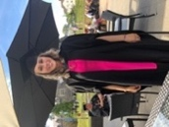
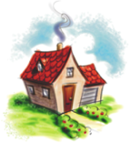
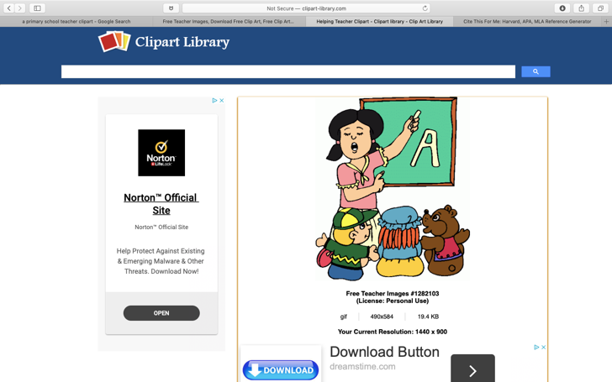
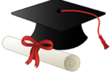
Mind-map of all the resources available to me as a university student.
Other

Other resources involve: academic clubs, sports clubs or even places of work. I feel that all these other resources, can create and improve better practice in the future. For example, playing in a sports team would allow me the skills I think I require to be a fantastic primary school teacher. These skills include: becoming a team player, supporting my team, working in cooperation with one another, being fair, inspiring, being organised (planning events and attending), being understanding and building effective relationships with all.
There are many resources available to me when I will attend school. In order to grow within my professional practice, I feel that it is paramount for me to know that asking for help is not seen as failing. Teachers within school will enable me to know the individuals that I am teaching through observation and working in collaboration. Teachers can provide me with critical feedback on what I did well and how I can improve for the future.
At School.
Personally, I feel that learning new skills and having a positive attitude comes from within. It is easy to attend a lecture, however, only I can fully motivate myself to strive for excellence within my teaching and University life. Asking for help off mentors, teachers and lecturers should not be seen as a failure. I will work hard, use all the other resources available to me, overcome challenges and change the future of education for the better.
Self.
At home, there are a multitude of ways in which I can develop the skills needed to become a superb Primary School Teacher. To begin with, I feel that it is essential to address to my family on what is going on within my academic life. For example, I have a very close relationship with my parents and I feel that it is vital for me to express to them how I am feeling each day, so that they are able to support me when necessary. Referring back to how home can help me as a student, I could practice my teaching skills in front of my family. They could provide me with feedback on how I was, what went well and how I could improve.
At Home.
At Home.
At University.

At University, I know that there are many resources available to me, to support me through my journey on becoming an ambitious, enthusiastic and outstanding teacher. Firstly, I understand the vast amount of support and pastoral care available from all my lecturers to guide me to succeed in University and on Professional Practice. University will allow me to gain more confidence both in and out of the classroom. An example of this could simply be communicating with my peers, sharing our ideas online. Moreover, other resources in the University include: the library, resource centre, Moodle and HWB.
All resources available to me as a university student.

Developing your skills: Vision of success as a student-teacher.

Complete the Current Skills Audit.

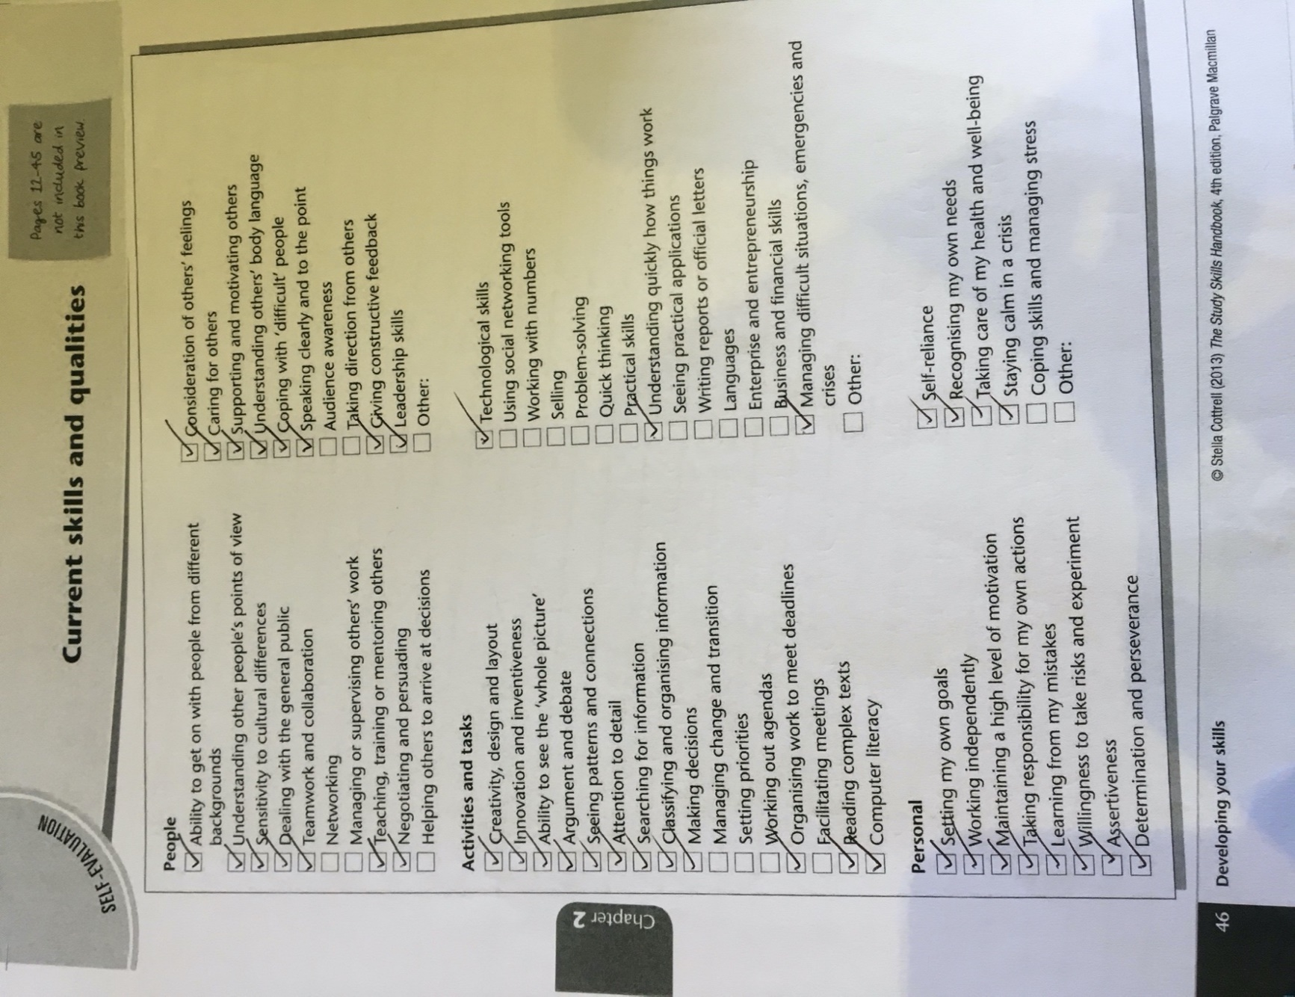
Developing your skills: Vision of success as a student-teacher.
At Home.

What success looks like to me as a university student.

In my opinion, success can be examined holistically and can encompass any aspect of life. So far, success for me has been: acquiring knowledge and skills to pass my qualifications, obtaining practical skills to learn to drive, overcoming challenges, developing communication skills to create friendships and working hard to acquire two part-time jobs, to enable me to finance my ultimate goal, which is to become an excellent primary school teacher with a First Class Honours Degree.

Nevertheless, success is essential in every stage of life and is poignant to Professor Donaldson’s Curriculum, which adopts the name ‘Successful Futures.’ I wish to adhere to Donaldson’s principles, where every child and young person in my care, can become: ‘ambitious, capable learners, enterprising, creative contributors, healthy, confident individuals and ethical informed citizens’.

Developing Critical Thinking.

Read Critical Thinking Skills by Stella Cottrell and identify the key points.

Stella Cottrell’s ‘Critical Thinking Skills’ document, is both informative and persuasive, enabling the reader to comprehend the skills required for critical thinking. Cottrell suggests that the development of these skills can make a profound difference to academic work and to everyday life.
Cottrell’s chapter one, focuses on four key points, and these include: the definition of critical thinking, the advantages associated with critical thinking, the ‘personal qualities associated with critical thinking’ and the barriers that prevent the development of effective critical thinking skills. (Cottrell, 2005).

The first key point to be considered, is Cottrell’s definition of ‘critical thinking’. Cottrell states that: ‘critical thinking is a cognitive activity, associated with using the mind…a process that relies upon, and develops, a wide range of skills and personal qualities.’ (Cottrell, 2005). Within this quotation, Cottrell is indicating that critical thinking requires intelligence and is a compound process, enabling individuals to formulate a variety of ‘ancillary’ skills such as: ‘observation, reasoning, decision-making (being sceptical), analysis, judgment and persuasion’. (Cottrell, 2005). In simplistic terms, critical thinking is about analysing evidence and making assumptions based on unbiased information. It is paramount that an individual, uses logic to ‘reflect on issues.’ (Cottrell, 2005).

Cottrell’s second key point focuses on the advantages of critical thinking. In her own words, Cottrell implies that critical thinking: ‘improves an individual’s attention and observation’ and allows more accuracy within findings. (Cottrell, 2005). Cottrell informs the reader that critical thinking, enables the individual to develop self-awareness and confidence, allowing them to embark upon any complex issues that arise in life. Cottrell discusses the advantages of critical thinking to a student; she implies that critical thinking helps: ‘construct a line of reasoning’ and enables those to ‘illustrate an argument’ effectively. (Cottrell, 2005). Cottrell is significantly underlining the importance of critical thinking and elaborating that it can be seen as a journey to success.

The third key point are the ‘personal qualities associated with critical thinking’. Cottrell demonstrates multiple qualities that are created through thinking critically, these involve: ‘attention to detail, identifying trends and patterns, repetition, taking different perspectives, objectivity and considering implications and consequences’. (Cottrell, 2005). Cottrell conveys that other personal qualities can be transformed through the thinking critically.

The final key point is, the barriers that prevent the development of effective critical thinking skills. Cottrell demonstrates that ‘critical thinking does not come easily to everyone’ and that there are a variety of barriers that must be considered, these include: misconception of the meaning of the term, ‘over-estimating our own reasoning abilities’, inefficient resources and methods in place, ‘reluctance to critique experts’, ‘affective reasons’ and ‘insufficient focus and attention to detail’. (Cottrell, 2005). In other terms, Cottrell gives a balanced viewpoint, and allows the reader to understand that some individuals may be worried or have ‘anxiety’ based attitudes when elaborating these skills. However, she indicates that individuals can overcome these barriers with further support to enable the ‘anxiety to subside’. (Cottrell, 2005).

To summarise, there are many key points that have been addressed in Cottrell’s book ‘Critical Thinking’. Throughout, Cottrell expresses what critical thinking is and the importance of what it can do to individuals, by allowing them to achieve sufficiently in education and in life as a whole. Cottrell addresses that critical thinking may take some time, but with ‘patience’, everyone can improve. (Cottrell, 2005).

Developing Critical Writing

Write a short piece entitled: What I think about the new Curriculum for Wales, ‘Successful Futures’.

Successful Futures is the new Curriculum for Wales, developed by Professor Graham Donaldson and will be introduced to three to sixteen years old by 2022. The purposes of this Curriculum is to enable pupils to be: ‘ambitious, capable learners, ready to learn throughout their lives. Pupils will be enterprising, creative contributors, ready to play a full part in life and work. Pupils will be ethical, informed citizens of Wales and the world and will be healthy, confident individuals, ready to lead fulfilling lives as valued members of society’. (GOV.WALES, 2019). Donaldson’s proposal is to ensure that all children in Wales are provided with an education that will help them to secure a “successful future.” I concur that the new curriculum is radical but certainly needed. The world is constantly evolving, and technology is transforming; and generations need to adapt to these changes so that they are prepared for the future.

The Curriculum consists of Six Areas of Learning and Experience (AoLE) these involve: ‘Expressive Arts; Health and Well-being; Humanities; Languages (Y Cwricwlwm Cymreig), Literacy and Communication; Mathematics and Numeracy; Science and Technology.’ (Curriculum for Wales Blog, 2018). Within this, ‘cross-curricular responsibilities of literacy, numeracy and digital competence are also embedded across all of the areas of learning and experience’. (Hwb.gov.wales, 2019). Donaldson’s approach to education is radical, as he believes that the curriculum and the AoLE’s can be implemented holistically. For example: within a pupil led numeracy lesson, literacy could be applied, as well as digital literacy. Indeed, a holistic approach to education is effective, but requires excellent planning from teachers. According to Newton, 2018: ‘teachers are going to need more training; they’re going to need a lot more training’. With this in mind, there will be some teachers who will be fearful to change and therefore, this could have an impact on pupils’ education.

Moreover, the new curriculum advocates the importance of the United Nations Convention of the Rights of the Child (UNCRC), which elaborates on the importance of pupil’s health and well-being. It is not only one of the AoLE’s, but indicates how paramount it is to support pupils and portrays that: ‘This area of learning and experience will support learners in developing and maintaining not only their physical health and well-being, but also their mental health and emotional well-being, as well as developing positive relationships.’ (O'Prey et al., 2019). In my opinion, it is vital to discuss and recognise the signs of mental health, as it is a growing issue as by: ‘2020 mental ill health related problems will be second to heart disease as the leading contributor to the global burden of disease’. (Timetochangewales.org.uk, 2018). I feel that the new curriculum embraces the rights of the child and ensures that children’s health and wellbeing is at the forefront of education.
To conclude, Donaldson expressed that this Curriculum will, ‘take a fundamental look at the ways in which today’s schools can prepare young people for an exciting but uncertain future’(Successful Futures, 2015), and I am personally excited to embrace this new Curriculum, as I feel it is a positive change to education in Wales.

Component Two: A video presentation reflecting on the knowledge, skills and dispositions needed for Higher Education Study.

This is my ECGE4002P video presentation, that reflects on my understanding of the knowledge, skills and dispositions required for Higher Education Study.

https://youtu.be/BdoKCDpWOK8

References

Clip Art Library (2019). Free Teacher Images. [image] Available at: http:// clipart-library.com/clipart/6Tr6KXpkc.htm [Accessed 5 Oct. 2019].

Clip Art Library (2019). Graduation Cap Cartoon. [image] Available at: http://clipart-library.com/clipart/BigrdaXjT.htm [Accessed 5 Oct. 2019].

Clip Art Library (2019). Home Cartoon Images. [image] Available at: http://clipart-library.com/clipart/pT7dr5aT9.htm [Accessed 5 Oct. 2019].

Cottrell,S.(2005). Critical Thinking Skills. 1st ed. Hampshire: Palgrave Macmillan.

Curriculum for Wales Blog. (2018). How ‘Areas of Learning and Experience’ are being developed as a central element of the new curriculum. [online] Available at: https://curriculumforwales.gov.wales/2018/06/20/how-areas-of-learning-and-experience-are-being-developed-as-a-central-element-of-the-new-curriculum/ [Accessed 27 Oct. 2019].

GOV.WALES. (2019). New school curriculum: overview | GOV.WALES. [online] Available at: https://gov.wales/new-school-curriculum-overview [Accessed 27 Oct. 2019].

Hwb.gov.wales. (2019). Assessment proposals - Hwb. [online] Available at: https://hwb.gov.wales/draft-curriculum-for-wales-2022/assessment-and-evaluation-framework/assessment-proposals/#our-vision [Accessed 27 Oct. 2019].

Newton, N. (2018). Hopes and Fears: The Development of a New Curriculum in Wales. [Blog] The Future of Educational Research in Wales. Available at: http://www.bera.ac.uk/blog/hopes-and-fear-the-development-of-a-new-curriculum-in-wales [Accessed 31 Oct. 2019].

O'Prey, L., Powell, D., Jones, T., Burgess, A., Maughan, C., Usher, S., Kennedy, L. and Griffiths, E. (2019). Curriculum for Wales 2022 Feedback Analysis. [online] Gov.wales. Available at: https://gov.wales/sites/default/files/consultations/2019-10/curriculum-wales-2022-feedback-analysis.pdf [Accessed 27 Oct. 2019].

Successful Futures, Looking at the Curriculum and Assessment Arrangements In Wales. (2015). Successful Futures. [online] Available at: http://gov.wales/sites/default/files/publications/2018-03/successful-futures-a-summary-of-professor-graham-donaldsons-report.pdf [Accessed 6 Oct. 2019].

Successful Futures, Looking at the Curriculum and Assessment Arrangements In Wales. (2015). Successful Futures. [online] Available at: http://gov.wales/sites/default/files/publications/2018-03/successful-futures-a-summary-of-professor-graham-donaldsons-report.pdf [Accessed 6 Oct. 2019].

Timetochangewales.org.uk. (2018). What is Stigma? | Time to Change Wales. [online] Available at: https://www.timetochangewales.org.uk/en/mental-health-stigma/what-stigma/ [Accessed 27 Oct. 2019].

