Dementia Awareness

What is dementia?
It is a clinical illness which causes memory loss from an individual as well as many other symptoms such as the decline of cognitive abilities (Geldmacher & Whitehouse, 1996).
It can be caused by brain injury or disease, such as Alzheimer’s. This and stroke are leading factors for the cause of dementia and the risks of it happening only increase as an individual ages (Arvanitakis & Bennett, 2019).
Dementia can be different for each person as their experiences would either be better or worse for their condition with dementia (Kitwood, 1997).
Dementia can be scary to have, as patients would know they have dementia making them unaware of several situations (Srinkath & Ratnavalli, 2005).

Types of dementia:
Alzheimer’s is the most common type of dementia and can cause a person to be more forgetful and eventually struggle with basic tasks (Cummings & Cole, 2002).
Lewy body dementia is the cause of an abnormal amounts of protein in the brain which can lead to problems with basic functions like thinking and movement (Walker, et al., 2015).
Vascular dementia is the cause of blood restriction in the brain, which would cause a person to be more confused and have slower thinking (Korczyn, et al., 2012).
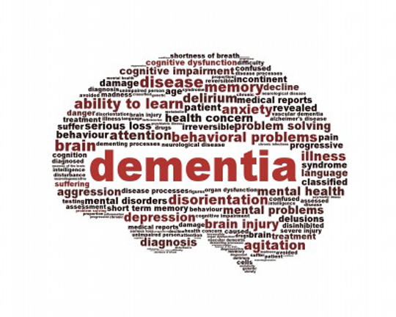

The signs of dementia:
These signs would consist of memory loss, struggling to focus and struggling with everyday activities (Rock, et al., 2001).
Another few symptoms would be aberrant behaviour, anxiety, and overall irritation (Cerejeira, et al., 2012).

Types of treatment:
Physical training is a good way to help someone with dementia, as it can slow down cognitive decline and help with better focus (G, et al., 2010).
There is also symptomatic treatment or vascular dementia, which also slows down the rate of decline in cognitive ability (Perng, et al., 2018).

Institutions:
A care home is suitable for patients with Alzheimer’s as it can produce good results. This is because of the routine maintained in a care home which helps with their emotional and mental state (Hoe, et al., 2018).

However, this can also be the opposite depending on the treatment given by said institution. It can prove to worsen the emotional state of some dementia patients and decrease their cognitive ability (L, et al., 2011).

What age dementia comes about?
It is most common for dementia to take affect on people when they are in their 60’s as they are more vulnerable to it. It is said that an elderly person’s brain is not as strong as that of a young person (Savva, et al., 2009)

Advocacy:
Advocacy is when a person speaks and acts on behalf of another individual expressing their best interests. The advocate will stand up for the rights to which the person believes in while using that person’s experience and views on the matter (Greene, 1997).

References

Anon., 2018. Equality and Human Rights Commission. [Online]
Available at: www.equalityhumanrights.com/en/human-rights/human-rights-act
[Accessed 16 March 2022].

Arvanitakis, Z. & Bennett, D. A., 2019. What Is Dementia?. JAMA, 322(17), pp. 1589-1599.

Balestrino, R. & Schapira, A., 2019. Parkinson disease. European Journal of neurology, 27(1), pp. 27-42.

Cerejeira, J., Lagarto, L. & Ladinska, M., 2012. Behavioral and psychological symptoms of dementia. Frontiers in Neurology, Issue 1.

Collinge, J., 1999. Variant Creutzfeldt-Jakob disease. The Lancet, 354(9175), pp. 317-323.

Cummings, J. L. & Cole, G., 2002. Alzheimer Disease. JAMA, 287(18), pp. 2335-2338.

Davidoff, P., 2007. ADVOCACY AND PLURALISM IN PLANNING. Journal of the American Institute of Planners, 31(4), pp. 331-338.

Davis, K., Abrams, M. & Stremikis, K., 2011. How the Affordable Care Act Will Strengthen the Nation's Primary Care Foundation. Journal of General Internal Medicine, Volume 26.

Geldmacher, D. S. & Whitehouse, P. J., 1996. Evaluation of Dementia. The New England Journal of Medicine, 335(1), pp. 330-336.

G, K. et al., 2010. Effects of a Physical Training Programme on Cognitive Function and Walking Efficiency in Elderly Persons with Dementia. Dement Geriatr Cogn Disord, 29(1), pp. 109-114.

Greene, J. C., 1997. Evaluation as advocacy. Evaluation Practice, 18(1), pp. 25-35.

Hoe, J., Hancock, G., Livingston, G. & Orrell, M., 2018. Quality of life of people with dementia in residential care homes. The British Journal of Psychiatry, 188(5), pp. 460-464.

Isenberg-Grzeda, E., Kutner, H. E. & Nicolson, S. E., 2012. Wernicke-Korsakoff-Syndrome: Under-Recognized and Under-Treated. Psychosomatics, 53(6), pp. 507-516.

Jellinger, K. & Attems, J., 2007. Neuropathological evaluation of mixed dementia. Journal of the Neurological Sciences, 257(1-2), pp. 80-87.

Kitwood, T., 1997. The experience of dementia. Aging and Mental Health, 1(1), pp. 13-22.

Korczyn, A. D., Vakhapova, V. & Grinberg, L. T., 2012. Vascular dementia. Journal of the Neurological Sciences, 322(1-2), pp. 2-10.

L, B. M., K, E., J, L. & G, S., 2011. Quality of Life among Elderly Patients with Dementia in Institutions. Dementia and Geriatric Cognitive Disorders, 31(6), pp. 435-442.

Maund, S. & Tinkler, P., 2017. Skills for the workplace student yearbook. 1 ed. London: Sage Publications.

Perng, C. H., Chang, Y. C. & Tzang, R. F., 2018. The treatment of cognitive dysfunction in dementia: a multiple treatments meta-analysis. Psychopharmacology, 235(1), p. 1571–1580.

Rock, M. H., Tak, E. C. & Staats, P. G., 2001. Development and validation of the Observation List for early signs of Dementia. International journal of Geriatric Psychiatry, 16(4), pp. 406-414.

Savva, G. M. et al., 2009. Age, Neuropathology, and Dementia. The New England Journal of Medicine, 360(1), pp. 2302-2309.

Snowden, J. S., Neary, D. & Mann, D. M., 2018. Frontotemporal dementia. The British Journal of Psychiatry, 180(2), pp. 140-143.

Srinkath, S. & Ratnavalli, A. N., 2005. Neuropsychiatric symptoms in dementia-frequency, relationship to dementia severity and comparison in Alzheimer's disease, vascular dementia and frontotemporal dementia. Journal of the Neurological Sciences, 236(1-2), pp. 43-48.

Walker, Z., Possin, K. L., Boeve, B. F. & Aarsland, D., 2015. Lewy body dementias. The Lancet, 386(10004), pp. 1683-1697.

Zhang, X. & Lin, H., 2021. Disengagement Theory. Encyclopedia of Gerontology and Population Aging, 1(1), p. 40.

