Wordsworth and Druids
1792 Iolo Morganwg (Edward Williams), the `Bard of Liberty' leads the `democratic Bards of Wales' in performing a supposed druidic ritual sheathing a sword on an altar within a stone circle on Primrose Hill in London.
`Iolo ... invented Welsh traditions the Welsh had never known.' Gwyn A. Williams When Was Wales?: A History of Wales (Penguin: Harmondsworth, 1985) p.165
‘Iolo [was] playing the noble savage.’ Prys Morgan Iolo Morganwg (UWP, 1975) p.12.

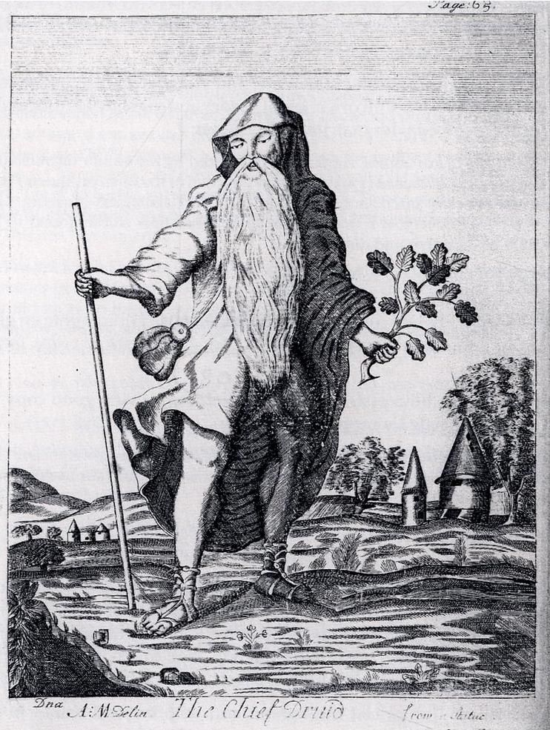
The Chief Druid from Mona Antiqua Restaurata, 1723
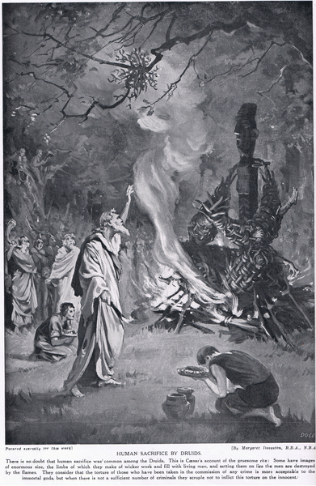
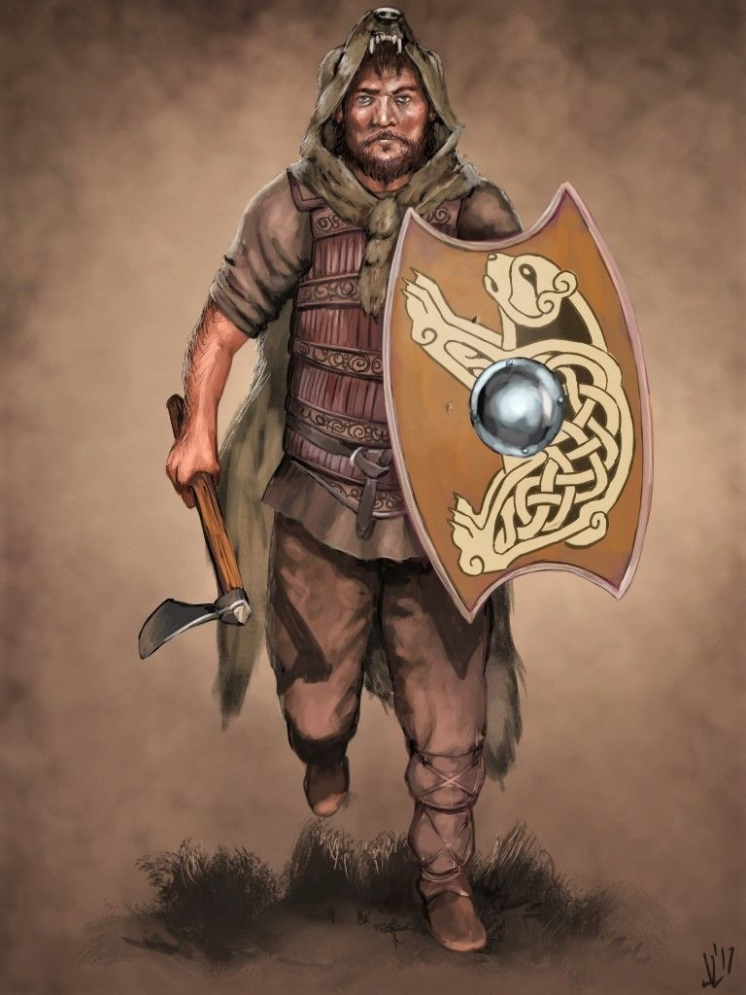
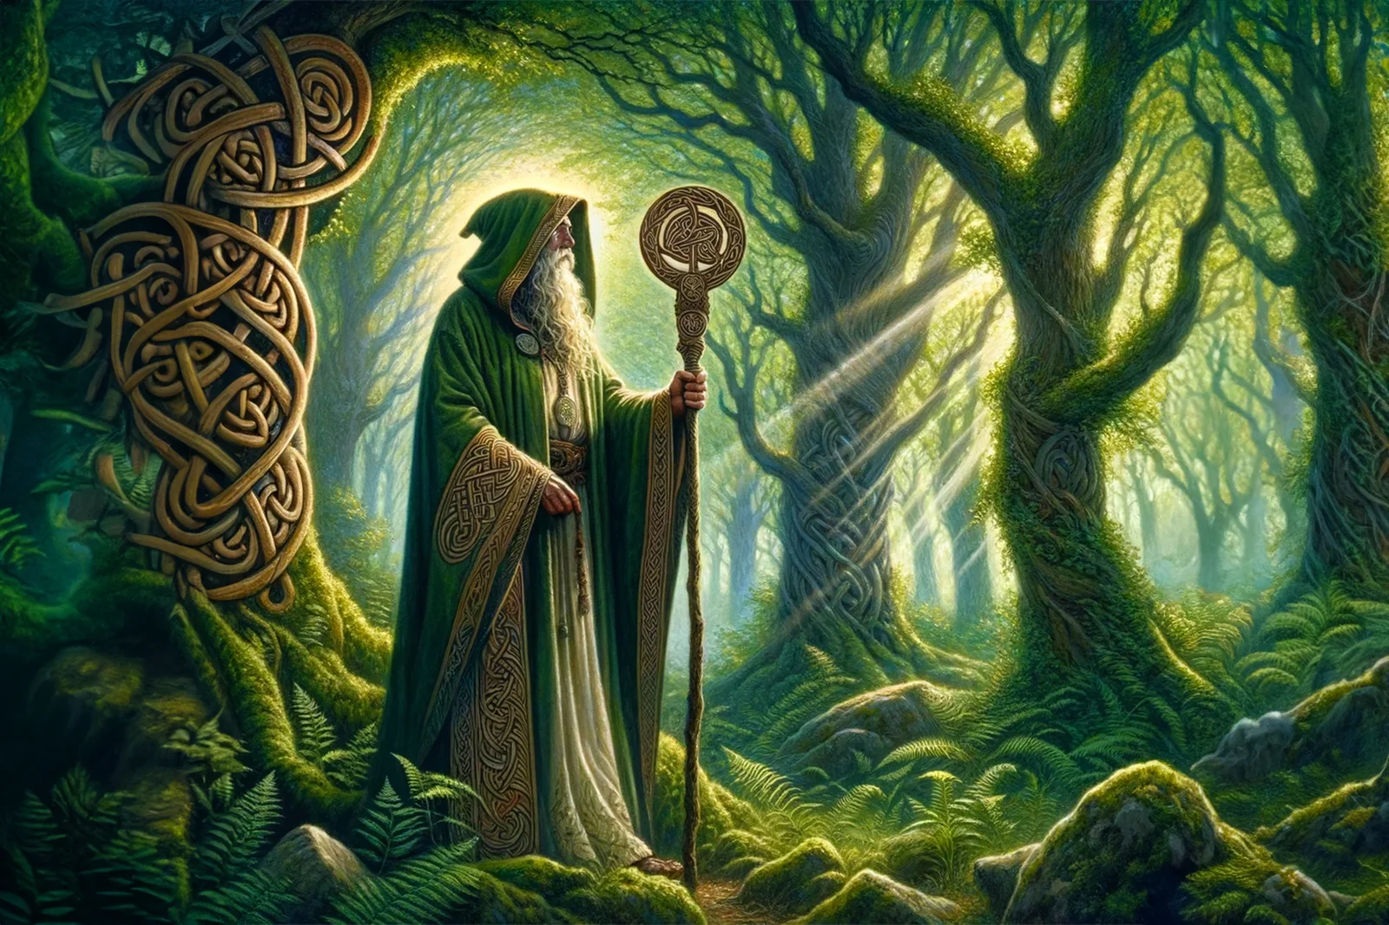

A.L. Owen's The Famous Druids: A Survey of Three Centuries of English Literature on the Druids (Oxford: Clarendon P., 1962): teacher v ‘militant’ ‘savage’.

1791 and 1793 William Wordsworth undertook two walking tours in the company of his Robert Jones, of Plas-yn-Llan, Llangynhafal, near Ruthin, Denbighshire - a place in the heart of Welsh radicalism.
A youthful Druid taught in shady groves
Primaeval mysteries, a bard elect
To celebrate in sympathetic verse
Magnanimous exploits (Book 3 of the 1850 Prelude)

Though, in the depths of sunless groves no more
The Druid-priest the hallowed Oak adore;
Yet, for the Initiate rocks and whispering trees
Do still perform mysterious office! (1 7-10) (‘Humanity’ 1829)

He identified himself imaginatively as a ‘druid’:

[a] youthful Druid taught in shady groves/ Primaeval mysteries, a bard elect’ (Prelude Bk 3 – deleted lines See Prelude ed. Earnest de Selincourt rev. H. Darbishire (Oxford: Clarendon, 1959) p. 75n.
[For Wordsworth's knowledge of the druids see Stephen Gill's ed. The Salisbury Plain Poems of William Wordsworth (Ithaca: Cornell UP, 1975) p.35 note to 1 424-7; and Robert Osborn's ed. The Borderers (Ithaca: Cornell UP, 1982) pp. 420-21].

1793 Wordsworth crossed Salisbury Plain in the summer. His journey figures largely in The Prelude; it is also the subject of a series of poems: `Salisbury Plain', which was begun in 1793 while Wordsworth was in Wales; `Adventures on Salisbury Plain' 1795-9, which contained the separately published poem `The Female Vagrant', included in the Lyrical Ballads in 1798; and, the final published version Guilt and Sorrow of 1841.
William Wordsworth, Salisbury Plain
1822 The Cambrian Society of Gwent offered a medal for the best essay on `The Credibility of the Massacre of British Nobles at Stonehenge'. The `massacre' here is a reference to the fifth century Welsh myth `The Treason of the Long Knives' (`Brad y Cyllyll Hirion'): a story continually re-invented as a mark of Welsh oppression and English betrayal, which was particularly potent during the eighteenth and nineteenth centuries. The story concerns Vortigern, the leader of the Britons, who relied on Saxon mercenaries led by Hengest to defend his kingdom. The Saxons turned on and killed their hosts.
Nennius' ninth century History of the British:
Hengest ... sent envoys to ask for peace and make a permanent treaty ... [C]onference was convened, wher[e] the two sides, British and English [i.e. Saxon] should meet unarmed to confirm the treaty. But Hengest told his followers to hide their daggers ... saying `When I call out to you and say "English draw your knives", take your daggers ... and fall upon them ...' So the conference assembled, and the English, friendly in their words, but wolfish in heart and deed, sat down, like allies, man beside man. Hengest cried out as he said and all three hundred Seniors of King Vortigern were murdered. (From John Morris ed. Nennius: British History and the Welsh Annals (London: Phillimore, 1980) p. 32.)
Prys Morgan discusses the endurance of this myth in the Welsh psyche in `From Long Knives to Blue Books' in Religion Language and Nationality in Wales ed. R.R. Davies et al (Cardiff: UWP, 1979) and cites Theophilus Jones on the common phrase `Sais yw ef, Syn!' (`He's a Saxon, Watch out!'):
The treachery of the Saxons ... and their cruelty in exterminating in cold blood the nobility of the antient inhabitants ... still rankles in the bosoms of the indigenous sons of freedom. (p.222)
Wordsworth himself would have been familiar with a version of the `Long Knives' myth from Chatterton's Battle of Hastings of 1768. Here, Stonehenge was a monument erected by Merlin.
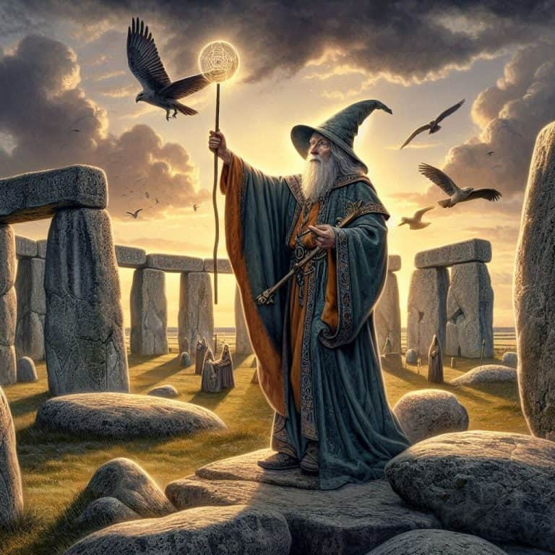

Some later versions:
1890 Thomas Hardy Tess of the d'Urbervilles: A Pure Woman (1890) – chp 58:
“Did they sacrifice to God here?” asked she.
“No,” said he.
“Who to?”
“I believe to the sun. That lofty stone set away by itself is in the direction of the sun, which will presently rise behind it.”
“This reminds me, dear,” she said. “You remember you never would interfere with any belief of mine before we were married? But I knew your mind all the same, and I thought as you thought—not from any reasons of my own, but because you thought so. Tell me now, Angel, do you think we shall meet again after we are dead? I want to know.”
He kissed her to avoid a reply at such a time.
“O, Angel—I fear that means no!” said she, with a suppressed sob. “And I wanted so to see you again—so much, so much! What—not even you and I, Angel, who love each other so well?”
Like a greater than himself, to the critical question at the critical time he did not answer; and they were again silent. In a minute or two her breathing became more regular, her clasp of his hand relaxed, and she fell asleep. The band of silver paleness along the east horizon made even the distant parts of the Great Plain appear dark and near; and the whole enormous landscape bore that impress of reserve, taciturnity, and hesitation which is usual just before day. The eastward pillars and their architraves stood up blackly against the light, and the great flame-shaped Sun-stone beyond them; and the Stone of Sacrifice midway. Presently the night wind died out, and the quivering little pools in the cup-like hollows of the stones lay still. At the same time something seemed to move on the verge of the dip eastward—a mere dot. It was the head of a man approaching them from the hollow beyond the Sun-stone. Clare wished they had gone onward, but in the circumstances decided to remain quiet. The figure came straight towards the circle of pillars in which they were.
He heard something behind him, the brush of feet. Turning, he saw over the prostrate columns another figure; then before he was aware, another was at hand on the right, under a trilithon, and another on the left. The dawn shone full on the front of the man westward, and Clare could discern from this that he was tall, and walked as if trained. They all closed in with evident purpose. Her story then was true! Springing to his feet, he looked around for a weapon, loose stone, means of escape, anything. By this time the nearest man was upon him.
“It is no use, sir,” he said. “There are sixteen of us on the Plain, and the whole country is reared.”
“Let her finish her sleep!” he implored in a whisper of the men as they gathered round.
When they saw where she lay, which they had not done till then, they showed no objection, and stood watching her, as still as the pillars around. He went to the stone and bent over her, holding one poor little hand; her breathing now was quick and small, like that of a lesser creature than a woman. All waited in the growing light, their faces and hands as if they were silvered, the remainder of their figures dark, the stones glistening green-gray, the Plain still a mass of shade. Soon the light was strong, and a ray shone upon her unconscious form, peering under her eyelids and waking her.
“What is it, Angel?” she said, starting up. “Have they come for me?”
“Yes, dearest,” he said. “They have come.”
“It is as it should be,” she murmured. “Angel, I am almost glad—yes, glad! This happiness could not have lasted. It was too much. I have had enough; and now I shall not live for you to despise me!”
She stood up, shook herself, and went forward, neither of the men having moved.
“I am ready,” she said quietly.



