

Evaluation of hybrid cloud backup solutions. To back up multiple tenancies and physical data centres.

By
Brian Morris
Supervisor: Munyaradzi Nicholas Murira
Second Marker: Nitheesh Murugan Kaliyamurthy

Project submitted as part of the requirements for the award of BSc(Hons) Computing(computer networks and cybersecurity)

July 2022
Abstract
Over the last few years, many organizations have had to make a rapid change in how they deliver service. Delivery of these services from Hyper-scale cloud providers such as Azure [1], AWS [2] and Google Cloud [3] have impacted legacy on-premises backup platforms. This project aimed to establish which backup solution will meet the need of an organization to back up a multi-cloud and multi-site datacentre. To meet this objective a literature review was undertaken to understand the technologies and working practices surrounding the backup realm. These included cloud hosting disasters, the 3-2-1 rule, Volume Shadow services, change block tracking immutable storage and total cost of ownership.
Two products Veeam and Redstor were chosen as suitable candidates for review. Several tests were run to produce quantitative data relating to performance metrics of the two solutions including backup timings and full VM restores.
During testing the performance of the incumbent solution was used as the baseline for some of the metrics and it was established that the existing system could benefit from reconfiguring before commissioning the new production system.
Both systems performed well during initial testing. Redstor had a far simpler deployment whereas Veeam required more infrastructure. However, changes by the vendor to one of the systems proved problematic during testing and Veeam became the preferred option.

Contents
Table of Figures 6
1 Introduction Aims and Objectives 8
1.1 Introduction 8
1.2 Research Aim 9
1.3 Research Objectives 9
1.4 Project structure 9
Literature Review 10
2 Introduction to literature review 10
2.1 What to look for in a backup solution? 11
2.2 Cloud hosted back repository disasters. 12
2.2.1 Extending the 3-2-1 rule 12
2.3 Solution costs, Total Cost of Ownership and Recovery Oriented Computing 13
2.4 Backup Types 14
2.5 Volume Shadow Copy Service 15
2.6 Changed Block Tracking 16
2.7 Object storage 17
2.8 Block level storage deduplication 18
2.9 Variable Length block level deduplication 19
2.10 Definition of Immutable 20
2.10.1 Achieving storage immutability with cloud solutions 22
2.11 Literature review summary 23
3 Research Methodology 24
3.1 Introduction 24
3.2 Hypothesis 24
3.3 Methodology 24
3.4 Existing solution 25
3.5 Existing volumes of data 26
3.6 Products Reviewed 27
3.6.1 Veeam 27
3.6.2 Redstor 27
3.6.3 Why were these products selected? 27
3.7 Summary 28
4 Test Platform Design and Implementation 29
4.1 Introduction 29
4.2 Source systems used for testing 29
4.3 Testing schedules 29
4.4 Design and implementation of Veeam 30
4.5 Overview of the build of the test Veeam environment 31
4.6 Alternative solution with Redstor BaaS 32
4.7 Summary 32
5 Testing and Evaluation 33
5.1 Introduction 33
5.2 Full Backups 33
5.3 Backup Testing 33
5.4 VM restore timings using Redstor 38
5.4.1 Redstor cloud to on-premises datacentre via remote laptop 38
5.4.2 Redstor cloud to onsite datacentre via on-premises virtual machine 39
5.4.3 Redstor cloud to Azure hosted virtual machine via local datacentre virtual machine 39
5.4.4 Redstor cloud to Azure hosted virtual machine via Azure hosted virtual machine 39
5.5 Veeam Restore timings 41
5.6 Restore comparative timings 42
5.7 Datacentre bandwidth speeds 43
5.8 On-Premises 43
5.9 Azure Datacentre 44
5.10 The scale of hardware requirements could negatively impact the TCO 46
5.11 Cloud Resources are not limitless 46
5.12 Cloud Compute Costing 47
5.13 Data Egress 49
5.14 Office 365 backup 51
5.15 Commercials 52
5.16 Changes to authentication and additional restore testing 53
5.17 Summary 53
6 Conclusion 55
6.1 Summary 55
6.2 Conclusion 55
6.3 Further areas of study 56
7 Reflection 57
7.1 Introduction 57
7.2 Areas that could be done differently 58
7.3 Additional outcomes 58
7.4 Summary 58
8 References 59
8.1 Reading list 61
9 Appendix:- 63
9.1 Usage reports from existing backup solutions 63
9.2 Backup specification 65
9.3 Post-build documentation Veeam/iLand 67
9.3.1 Introduction 67
9.3.2 Azure 67
9.3.3 Veeam admin console 68
9.4 Post-build documentation Redstor 76
9.4.1 Introduction 76

Table of Figures
Figure 1 Backup types 14
Figure 2 The Flood Tablet 700BC 20
Figure 3 Punch cards used on a Jacquard loom 20
Figure 4 Physical and logical topology of master/media server backup solution 25
Figure 5 Potential Veeam implementation 30
Figure 6 Redstor BaaS solution 32
Figure 7 Extract of incremental backup Redstor Pro report 34
Figure 8 Redstor incremental timings of backup of Azure hosted device 34
Figure 9 Volume of data backed up per job 35
Figure 10 Redstor volume compared to the time of incremental backups 35
Figure 11Branch office backup data volumes and timings 36
Figure 12 MB of data backed up compared to the time for job completion 37
Figure 13 Data churn compared to the data transfer 37
Figure 14 Domestic ADSL connection 38
Figure 15 Redstor restore times in minutes 39
Figure 16 Redstor restore times in minutes ignoring failed job 40
Figure 17 Veeam restore times in seconds 41
Figure 18 Restore job timings of both Veeam and Redstor 42
Figure 19 On-premises bandwidth recordings 43
Figure 20 Azure bandwidth measurements 44
Figure 21 Bandwidth of connected data centres used for corporate traffic 45
Figure 22 - 3 Year reserved instance cost per month 47
Figure 23- Pay as you go cost per month 47
Figure 24 illustration of egress charges from Azure cost calculator 49
Figure 25 Data egress volume testing 50
Figure 26 Treemap of incremental backups over 7 days 63
Figure 27 Tree map of full backups over 7 days 64
Figure 28 MoCoW analysis of backup requirements 66
Figure 29 Azure virtual machines filtered to only include Veeam 67
Figure 30 Login screen for Veeam Backup and Replication 11 68
Figure 31 Backup and Replication Console home screen 68
Figure 32 Backup and Replication 3rd party service provider 69
Figure 33 Backup software interrogating production storage 70
Figure 34 Files shares configured with the application 71
Figure 35 Single sign-on login screen for the Veeam enterprise application 72
Figure 36 Primary dashboard 73
Figure 37 Backup Policies 73
Figure 38 State of system protection 73
Figure 39 Unprotected resources 74
Figure 40 Session logs 75
Figure 41 Main dashboard 77
Figure 42 Office 365 dashboard 77
Figure 43 Azure Hosted servers 78
Figure 44 Servers at different physical sites 78

1 Introduction Aims and Objectives

Introduction
Cyber security comes in many forms, software, hardware, user training and working practices etc. this paper looks at a backup solution to protect data. The author’s organization is moving the base of its’ server infrastructure and services to cloud-based technologies [2]while it will maintain a limited on-premises data centre it is projected that approximately 60% of its data centre compute resources will be based in the cloud. Primarily using Azure IaaS and PaaS with Office 365 SaaS solutions including Email, SharePoint, Teams, and OneDrive etc [4]. Solutions also exist in Oracle cloud [5] with the possibility that further cloud provider services could be utilized in the future.
Following an organizational change where two separate back office teams were merged into one, it has been observed that additional savings could be made by reducing duplicated services. In this instance, the backup solutions have been highlighted as they are no longer suitable to meet the needs following organizational changes and fundamental changes to the technologies employed by the organization.
The existing backup solutions still require a lot of manual intervention regarding the tape handling process of backups and multiple solutions are duplicating the same service that requires specialist experience to manage and maintain these products. As the organization moves from an on-premises private cloud to using more SaaS and IaaS solutions the backup solutions need updating to meet these new challenges.
The onsite hardware consists of a replicated storage area network device that has a presentation capacity of 180 TB of data. This primary storage appliance is soon to be replaced as it has reached the end of manufacture support. Several secondary storage arrays are used to house deduplication [6] pools for a variety of backup solutions and several tape libraries utilising LTO 4 tape technology. Two distinct networks utilising two separate virtualised environments that were previously managed by two separate teams are housed on the primary storage array as the first step to remove duplication from the estate.
The research aims to aid in the decisions making for a new production backup solution that can meet the existing and future needs of the organization whilst reducing silos of solutions bespoke to specific areas of the business. With the supplementary benefit of reducing wasted resources within the business and driving efficiencies while improving levels of protection across systems.
To meet this objective, it planned for a limited review of backup solutions will be undertaken. Baselining performance of the reviewed systems compared to the existing solutions. By implementing solutions from vendors to backup and restore data from systems, data can be used to measure the performance of backups, restorations, deduplication, compression, and data egress. Highlighting the shortcoming of the solutions, and how the newer solutions perform compared to the existing solutions and each other. Gathering pricing information from the vendors used in the solutions to form a projected total cost of ownership of the solutions. This information will be used in a report to the organization on which solution to procure.

Research Aim
Evaluate backup solutions to backup multiple hybrid cloud platforms and physical data centres.

Research Objectives
- A literature review is to be undertaken to understand some of the working practices, technologies and products used for data protection
- Where applicable the existing solution is used to provide baseline measurements for system performance
- Build and test two differing backup solutions. One solution is based on Veeam Backup and Replication, the other Redstor.
- Evaluate the products by objectively measuring the performance of typical backup and restore tasks
- Decide on a product to procure

Project structure

Directly following this introduction in chapter two there will be a literature review covering a range of topics that attempt to highlight, explain, and illustrate some of the technologies, working practices and concepts that will ultimately aid in the decision-making process.
In chapter three we will establish the hypothesis and methodology to prove the hypothesis. Provide an overview of the existing platform and the volumes of data to be protected also why the products to be tested were selected.
Chapter four will provide a review of the test clients and highlight the operation hours and a high-level design of the product's implementation for the test environment.
Chapter five will show the outputs of tests to run to produce quantitative data on the backup systems performance including details on network bandwidth testing for both cloud and on-premises networks. Also included are reports on other factors beyond the procurement cost of licensing the solution that also impacts the total cost of ownership. How the last two years have impacted cloud service providers' offerings. Where the original specification was modified to include Office 365 backups and where feedback up the testing with the vendor resulted in implementing a better performing but unworkable product.
In chapter six we draw a conclusion based on the above, with chapter seven covers a reflection of the project overall.

Literature Review

Introduction to literature review

The material gathered below should help guide the research into relevant areas and improve the understanding of some of the technologies surrounding backups and data protection.
Starting with what backup industry leaders advise consumers to look for in a backup solution. Followed by an illustrated example of why backup for cloud solutions should not be ignored. We continue to cover the concept of the 3-2-1 rule within data protection and look at extending this to the 3-2-1-1-0 rule. Followed by a brief discussion on the total cost of ownership of recovery-orientated computing understanding some of the concepts used within hardware and software to maintain operational systems and limit the effects of downtime.
We cover a brief overview of the different types of backups that can be employed when protecting data. With a further explanation of two types of storage used within these solutions including an overview of the benefits of blob storage and how it operates in the cloud as well as the benefits of block storage and how variable-length deduplication can achieve better storage compression and deduplication ratios. Also covered is how Volume Shadow Services and Block level backups can reduce backup times. The subject of immutable storage is touched upon and how in an always-on connected digital world we can safeguard data from change.

What to look for in a backup solution?

Several directors or chief officers of major backup software vendors were asked in an article for HelpNetSecurity.net [7]what to look for in a backup solution and whilst some of the answers were possibly influenced by their own product's strengths, they did raise very valid points which did aid in the process of defining the scope of the solution.
Oussama El-Hilali, CTO of Arcserve . Identified that businesses need to know where most of their data reside and to choose a backup solution that can protect that environment. Organizations may presume incorrectly that their SaaS solution is backed up, by and large, this is not the case, and the backup solution should include these capabilities. Backup solutions may also consider continuous replication of data to limit downtime in the event of an unplanned outage. There is also no one size fits all solution for every organization.
Nigel Tozer, Solutions Director for Commvault. Stressed four points. Flexibility in the solution to support a wide ecosystem to not hamper the agility of your production solutions. Automation to remove some of the mundane tasks out of backup processes. A budget that scales to meet the needs of the organization. Finally, consolidation to reduce multiple systems out of silos to reduce wasted space and complexity to improve infrastructure savings.
Nathan Fouarge, VP of Strategic Solutions of Novastore outlines six points to consider. How quickly do you need to restore to meet an SLA for the recovery time objective (RTO)? How much data is acceptable to be lost for your Recovery Point Objective(RPO)? How long do we need to retain the data for general business practice or compliancy? How do we want to store data to achieve compliance with the 3-2-1 rule of data protection? Also as mentioned by Nigel Tozer, how much is willing to be spent to meet the requirements?

Cloud hosted back repository disasters.
The placement of the backup solutions cloud repository does affect several elements especially if the cloud host provider itself becomes the focus of a disaster or other catastrophic event. Steps to mitigate this need to be factored in as this can also incur additional costs for a proposed solution. To mitigate the loss of a cloud provider, backup solutions will be sought that store the backup data outside of, in this instance, Azure data centres.
To help illustrate this [8] in March 2021 OVH a large cloud hosting provider in France had one of its data centres destroyed by fire and another one damaged by smoke. Users of the systems housed in this data centre lost all their systems and data. Customers who had implemented their own disaster recovery solution to an offsite data centre or who had subscribed to the vendor's disaster recovery service would have been able to recover solutions and data. However, those organizations that did not have any offsite backup lost both their configurations and their data. Consequently, some of these businesses would have fallen foul of GDPR [9] legislation, lost revenue, and suffered reputational damage as a result.

Extending the 3-2-1 rule
In the OVH example above the fundamental component of meeting the 3-2-1 rule of having at least three copies of your data on two different media one of which is off-site was not observed either through administrative error, budgetary constraints or miss understanding of the shared responsibility of using cloud services [10], thinking that “it is in the cloud” meant the system was secured by the cloud provider.
Chris Childerhose in his book “Mastering Veeam Backup and Replication” [9] features an extension to the rule by calling it the 3-2-1-1-0 rule. Still three copies of data, one being the primary with two secondary copies. Storing backups on at least two different media types. With one copy offsite. However, ensure one copy is offline or has immutability. With Zero errors after testing the data. This recognized backup practice doesn’t prevent data from being compromised it can help if one copy of the backup is corrupted or if technology fails and can also help if the data is stolen or affected by ransomware. Interestingly one of the two copies can be a snapshot of the production data stored on the same production storage media.

Solution costs, Total Cost of Ownership and Recovery Oriented Computing
In their 2002 paper. “Recovery Oriented Computing (ROC): Motivation, Definition, Techniques, and Case Studies “ David Patterson et al [10] discuss the total cost of ownership reported to be 5 to 10 times the purchase price for either software or hardware. For clustered systems, the ratio has been calculated to be between 3.6 to 18.5 times the procurement cost. The higher ratio costs tend to be for clusters built on open source platforms.
The research indicated that most errors appear to be operator errors due to poor design in systems. To reduce errors its best to reduce complexity removes latent errors and test recovery systems. Conversely over-reliance on automation can lead to system operators missing visibility of the system leading to limiting exposure in interacting with the system making diagnosis harder for the operator compounding the likelihood hood to make mistakes.
Whilst this paper is nearly twenty years old this report's relevance is still valid for new systems tied to legacy modes of operations. However, detail on cloud-based services has not been factored into this report. For example, large hyper-scale BaaS (Backup as a Service) operations where the investment has been to provide a well-supported secured service, charged at a simple predictable commodity price may produce a different TCO.
For legacy mode operations simple configuration changes can make a major difference. For example, RAID 5 systems can only survive a single disk failure. It is very possible that during the operation to swap out a failed drive from an array that the wrong disk is removed thereby failing the whole array. RAID 6 improves the resilience by allowing the system to survive 2 disk failures.
Even RAID 6 has its limitations. Storage Area Networks can be configured to utilize many 100s of disks. A newly commissioned storage array would probably be supplied with all new disks that came from the same manufacturing run. A failure in the model or the batch or the firmware could potentially take out multiple disks in quick succession.
The author has personally experienced a catastrophic failure on multiple SANs. On one occasion an arc of electricity destroyed an entire shelf of an array and caused data loss on multiple disk groups. On the second occasion after during a maintenance exercise where power was removed from a data centre, all hard drives within an enclosure were powered off. When power was restored to the DC the hard drives in the array all operated normally. Overnight several hard drives that had been operating for years without issue began to fail. Whilst the array was configured to handle multiple failures too many disks of the same model within the same manufacturing batch, failed in too short of a period and data rebuild mechanisms within the array failed to cope. On both occasions, major disaster recovery efforts were employed to recover the services some of which were offline for several days due to the type of technology used to recover

Backup Types
Krassie Petrova and Anne Abbot [11] refer to back up being a series of copies of a particular set of data made at a particular point in time. Created at regular intervals and stored independently of the original data. They further go on to say a snapshot process copies data locally and then transfers it to actual backup media. Snapshots should not negatively impact the availability of the service of the system and should also support the easy recovery of data.
Due to the associated risk of placing data in a system not directly controlled by the customer cloud service providers have numerous standards and frameworks they need to adhere to ISO 17788,17789, 19086-1 are available with further ISOs being developed.
We have a range of backup options below is a brief outline of some backup types with associated benefits and drawbacks:-
Type | Description | Pros | Cons
Full Backup | A complete backup of all files | Easier to restore | Slow to perform and transfer data offsite
Differential  Or  Cumulative Incremental | A backup of files that have changed since the last full backup | Quicker to backup than a full | Each subsequent backup becomes slower as the number of files increases. Requires multiple backups to restore. Utilises periodic full backups
Incremental | A backup of files that have changed since the last backup | Quicker to backup than a differential | Requires multiple backup files to perform a full restore. Utilises periodic full backups
Continuous | A continuous backup of files as they change | Recovery point objectives can be easily met | Can be costly to operate and consume system and storage resources
Reverse Incremental | Incremental backups are injected into an existing full backup | Lower storage requirements, lower network load
Forever incremental | One full backup is created. Then every subsequent backup is an incremental | Lower storage requirements, lower network load
Figure 1 Backup types
The type of backups directly influences the associated service. Too much backup can impact production services, consume computer, and network bandwidth, and require additional storage. Whilst too little backup can leave data vulnerable and under-protected which exposes the organizations that depend on the data to possible service issues if access is disrupted.

Volume Shadow Copy Service
Integral to most modern backup solutions is the utilization of Volume Shadow Copy Service or VSS. This toolset can permit data to be backed up whilst still being active [12]. This is especially useful for volumes of data that can take a long time to secure. VSS coordinates the actions required to create a consistent shadow copy or point-in-time copy. This copy can subsequently be used for backups to another hard drive, tape, or some other removable media type.
VSS requires several components to operate effectively. The VSS service on a Windows server communicates and coordinates with the other components.
The VSS Requestor requests the creation of shadow copies. Typically, in the Microsoft Windows environment, it is the backup software that requests the creation. However, the requestor can also action imports and deletions of snapshots.
The VSS writer is designed to ensure that snapshots created are consistent. The writer is typically provided by the application. For example, Windows has its own for its operating system functions, but Microsoft Exchange and Microsoft SQL provide VSS writers for their applications.
The VSS provider creates and maintains the shadow copies. These can be software or hardware based. Storage Area Networks typically provide VSS Provider drivers that can offload the VSS creation task away from Windows onto the hardware storage vendor's appliance.
During the creation of a shadow copy, the VSS Service will gather the details from the VSS Writers in preparation for the snapshot. At which point the VSS Writers create an XML file to include components and data stores to be backed up and pass this info back to the VSS Service which in turn passes this info to the VSS Requestor to select what will be backed up. The VSS service then notifies the VSS Writers to prepare the selected data for backup. The VSS Writer prepares the data by completing existing transactions before notifying the VSS Service. The VSS Service informs the VSS Writers to temporarily halt write requests, read requests are still permitted. The VSS Service then informs the VSS Provider to create the shadow copy. If the temporary halt exceeds 60 seconds the creation process may be aborted. If successful, the VSS Service permits writes that have been cached during the creation process and the VSS service communicates to the VSS Writer to continue to permit write operations and communicates the successful information to the VSS Requestor.

Changed Block Tracking
Changed block tracking improves the incremental backups by recording the blocks of data that have changed on the storage media rather than backing up every block of data used by the file. An iteration of changed block tracking was introduced by Veritas with a no-data checkpoints backup solution in its version of NetBackup 4.5 [13]. Since vSphere 4.0 VMware has supported CBT.
This technology proves useful in the following example, a multi-gigabyte file such as a database may only update a few blocks worth of data during an update. Earlier backup solutions would have identified that the whole database file had changed and needed backing up however by tracking the blocks of data that have been updated the incremental backup can be substantially quicker.

Object storage
Conversely to the author's research into a backup solution W Curtis discusses if there is a need for a separate backup in his paper [14]“Object storage in the cloud: Is backup needed?” Cloud object storage for example Amazon Simple Storage Service(S3), Azure Blob Store and Google’s cloud storage. Where files are stored as objects. An object is a file system but there is no hierarchical structure of directories and subdirectories. Whereas a hierarchical file system uses a combination of directory and filename, object-based storage uses a Unique ID or UID. The UID is created by applying a cryptographic algorithm such as SHA-1 to the file and the value becomes the object's identifier. The file is then written to at least three separate places or availability zones by the cloud providers subsystems.
Objects in the file system are never modified. As file contents are updated a new version of the file is created as a new object as its calculated UID would be different this also manages the creation of similar copies of the file suitable for file versioning.
Block data however is designed for performance, whereas object data storage is designed for data integrity. Periodically checking the hash value / UID of the object file can be used to detect errors, bit rot, or corruption of the data and if an error is detected it can be retrieved from another region or zone.

Block level storage deduplication
Dongchul Park et al [15]outline the process of a typical block level deduplication process in their paper ‘A Lookahead Read Cache: Improving Read Performance for Deduplication Backup Storage
Deduplication (Dedupe for short) is a compression technique that has been widely adopted to save on backup time and storage space. It has been postulated that 75%-80% of digital data is duplicated. Many cloud services and storage appliances use application-aware data reduction and encryption services to retain only one copy of the data on storage.
A typical dedupe process begins by dividing a data stream into smaller fixed or variable length chunks. Each chunk is processed to produce a hash value typically using an SHA algorithm. For backup applications variable length chunks typically outperform fixed-length chunks. A flash index table or Key-Value store is also created and maintained. The purpose of the index/table/store is to associate the hash values with the storage locations. If a new hash value is unique its data is added to the hash index. Initially, most of the operation occurs in RAM as data sizes are relatively small and would be inefficient if constantly being pushed through a storage sub-system. Once new entries have reached a required size the hash index is written into a fixed-size container.
When backing up data to the cloud over the WAN or from cloud to cloud and where egress charges become a significant cost factor. Client-side dedupe can be the preferred method. Yin-Jin Fu et al.: “Application-Aware Client-Side Data Reduction and Encryption” [16] highlight that client-side dedupe can significantly reduce the volume of data sent over the network. This does however come at the expense of higher system resource usage including CPU activity for calculations, hashing and compression. Plus, an upturn in storage subsystem I/O operations identifying and eliminating duplicate data. Despite the local resource usage many vendors including Dropbox use client-side dedupe to reduce backup times network bandwidth and destination storage requirements.

Variable Length block level deduplication
By not using a fixed size of data to compare against when applying a hashing algorithm to identify unique/similar data huge savings can be made in storage requirements. [6]This simplified explanation below should demonstrate how hardware vendors can start to achieve deduplication and compression ratios of nearly 80:1
In this simplified example, a 128kb file is made from 16 8Kb chunks or blocks of data

During its initial pass through the hash values are made for each block and identified as individual blocks and the hash table is updated. During the process, blocks are also compressed down to 4kb blocks.

A user then opens the file, and a small modification is made that only changes data in one block.

Without compression and deduplication, this file would consume another 128kb. However, the compression and deduplication service identifies only one block of data is unique. Ultimately leading to the two files being saved with only an increase of storage capacity of 4kb.
+
The database that manages the pointers to these blocks keeps track of the dependencies so if the original file was to be deleted the underlying blocks would not be removed from the duplication pool as it has dependencies.

Definition of Immutable
The Cambridge dictionary [17] defines immutable as:- “not changing, or unable to be changed”
Traditional backup systems need to ensure the immutability of the data that is stored. Often covered under the banner of WORM or Write Once Read Many.
Outside of the electronic world WORM technologies have existed from the earliest times. Be it Babylonian clay tablets [18] recounting tales of the great flood from 700 BC.

Figure 2 The Flood Tablet 700BC
Or punch cards used by Joseph-Marie Jacquard in his Jacquard looms. That allowed complex intricate patterns to be repeated on an industrial scale to dramatically lower the costs of fine fabrics of the time. These punch cards can be seen to be the predecessors of the punch cards commonly used in the early days of electronic computers before magnetic tape become commonly available.

[19]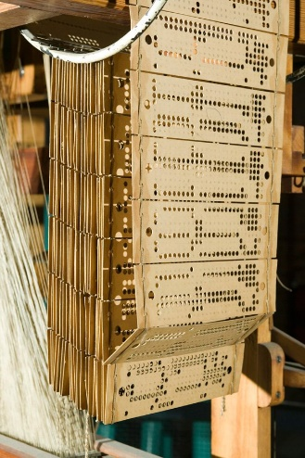
Figure 3 Punch cards used on a Jacquard loom
Magnetic tape whilst easily accessible robust and cheap does have a potential drawback regarding the immutability of the data stored on the media in that the data can be overwritten or deleted.
LTO tape cartridges contain a memory chip within the WORM tape cartridges that contain a microcode that identifies the tape cartridge as a WORM tape cartridge. This hardware mechanism within the tape cartridge is used to prevent data on the tape from being overwritten deleted or modified. Other examples of WORM media include the Magneto-optical drives pressed CDs etc and CD-R etc.
The last four examples are all optical storage media however these services are not practical when using cloud-based media. To date, there has been little commercial hosted storage available through cloud providers based on optical storage.
In Andreomachi Chatsieleftheriou et al’s paper [20] ”Could Cloud Storage be disrupted in the next decade?” Andreomachi highlights that over the last decade there has been little movement on the storage technologies used in the cloud. Consisting of flash storage, a mechanical hard drive, and tape.
As the technologies have matured as part of their life cycle, for example, higher capacity flash drives becoming the default for storage for infrastructure, while higher capacity mechanical hard drives have not been able to keep up in terms of Input Output operations per second, they are impacting some of the roles traditionally occupied by tape. Whilst tape capacity itself continues to increase in capacity on raw capacity sold year on year its market growth is slowing as customers require physically less higher capacity cartridges to achieve their storage requirements coupled with the decrease in tape manufacturers producing or investing in developing tape technologies.

Achieving storage immutability with cloud solutions
If using a cloud-based repository for the backup data, immutability is a feature that can be enabled upon the repository or storage account. These are not physical locks, but policy-based solutions that are applied to the above that can restrict modification or deletion of the data based on a time frame stipulated by the policy to be applied during the data’s life cycle between the initial upload and the final deletion of the data. On-site solutions can include options to utilize a specifically hardened server to act as a repository again the immutability is based on a policy for the data.
It is important to limit access to the mechanism that controls the immutability policies ideally some form of multi-factor authentication should be used at the very least. If these settings can be easily altered an unscrupulous attacker could modify the policies down to zero days as well as remove the soft delete options before deleting all the existing backups before infecting the systems with ransomware.
Some BaaS vendors implement additional hidden storage or proprietary “air gaps” between data sets so that a potential breach that can affect the backups can be resolved. It is however important to monitor backup solutions for modifications to storage lifecycle policies or backup deletion events that occur outside of standard storage policy events as this can be seen as an indication of an impending ransomware event.

Literature review summary
From the above literature review, we can deduce that backup can be provisioned to meet many requirements based on the appropriate budget. An understanding of the service level agreements within the organization needs to be understood to ensure backup requirements can meet the business needs and reducing the silos of backup solutions can lead to improved efficiencies within an organization.
Cloud services providers do suffer major outages that directly impact the service users and Software as a Service user needs to ensure the data used by the software has a suitable backup solution.
Data volumes that need to be protected may not be as great as originally considered as block length and variable block length deduplication can reduce backup data volumes to a fraction of their original size.
The type of backup used has a direct impact on the costs and timings of a backup. Changed block tracking can reduce the time taken to perform a backup of the actual data that has changed. Object storage has native mechanisms that can help protect the data from corruption and the solution of the immutability of data in the cloud is met in different ways depending on the vendors' implementation.

Research Methodology

Introduction

This chapter will introduce the hypothesis being tested and how it is to be tested. A high-level summary of the current configurations used to protect the systems with an insight into some of the volumes of data being protected daily. An outline of the products tested and why they were selected. The client systems are being used for testing and when the tests are being conducted.

Hypothesis
It is hypothesized that while both solutions are marketed to be suitable to backup both the cloud and on-premises infrastructure, one product will be more suitable to the organization in terms of features, performance, manageability, and total cost of ownership.

Methodology
Deductive research will be used to identify technologies related to data protection and which product will meet the needs of the organization as it transitions to a more cloud-based platform. With additional research documenting the pertinent components of the existing infrastructure.
Inductive research is to be employed while testing various backup scenarios to measure the performance to prove that both systems meet the initial needs of the organization to back up the estate.
Where the platform produces issues or unexplained data there expect an element of action research, as the product vendor is liaised with to assist in solving issues or understanding the results as the product vendor in theory should have a better understanding of the product than the product researcher in this instance.

Existing solution
This typical solution is used several times within the author's organization to manage the backup of different technologies and several comparisons with the existing and revised solutions will be sought during the testing. Whilst the scale of the solution may vary the logical topology of the layout is similar. A master server controls which server performs what action and when and with which client. For example, the master server will identify which media server will communicate with which client to perform the backup and which media server will manage the backup into the dedupe pool subsequently which media server will copy the data from the dedupe pool out to the tape robot so media can be taken offsite. In reverse the master server controls which tape is required in the tape library if the data isn’t already in the dedupe pool to restore data and which media server will handle that operation to restore the data.

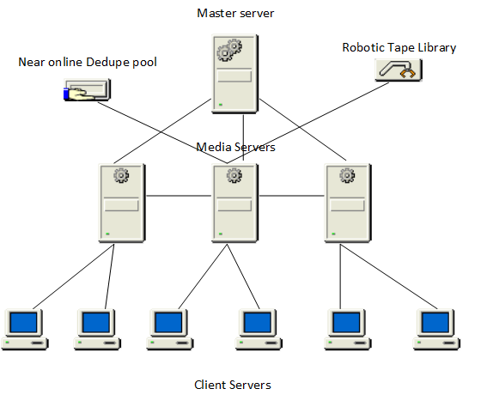
Figure 4 Physical and logical topology of master/media server backup solution

Existing volumes of data
Running RVtools [21] to extract data from the existing VMware estate for corporate infrastructure reported that the VMs were consuming 84TB of disk space.
In 7 days from the 10th of April until the 16th of April backups consisted of the following
Full backups 49.73TB
Incremental/Differential/Cumulative Incremental 47.62TB
The total backup in this period is 97.35TB
On average each day incremental backups were 6.8TB
This would indicate an approximate data churn of 6.18%
A projected 5% of all 84 TB would equate to 4.2TB per day. 2.6TB per day less than currently being processed. This equates to 18.2TB of data per week being overly processed. That can add significantly to bandwidth and storage requirements. Using a 1Gbps link this volume of data would require 8.7 days to upload per week as this is not possible, we need to either reduce the volume being sent over the network or increase the bandwidth.

Products Reviewed

Veeam
Veeam a Swiss company was founded in 2006 to provide system management solutions for virtualised platforms. [22] Veeam Backup version 1 was released in 2008 at the time and was the first solution that combined backup and replication into a single product. In the intervening years, the product has been updated to accommodate newer technologies and has garnered awards and praise across the board. With over 400,00 customers and 83% of the Fortune 500 companies using Veeam as part of their protection solution.

iLand
iland founded in Texas in 1995 is a cloud hosting company with data centres around the globe, crucially it has two data centres in the UK. It offers a range of services in its portfolio of products Backup as a Service is one among them.

Redstor
Created in 1998 by Paul Evans and Tony Ruane [23] Redstor has its main headquarters in Reading UK. Following a long-term partnership In 2015 Redstor acquired Attix5 a software company that specialized in managed backup and DR services including the software that was the basis for the existing Redstor backup service. The software itself has since been rebranded to Redstor Pro

Why were these products selected?
Veeam has been identified as one of the market leaders in backup for several years and before this exercise, the organization had investigated the use of Veeam to replace its existing backup solution. At the time it was considered that the product didn’t cover all the platforms used sufficiently specifically when it came to AIX, Sparc, and earlier versions of Linux. However, with the organizations moving to the cloud and the legacy platforms moving to alternative solutions it was considered to re-investigate Veeam. Partnering Veeam with iland added a level of protection to hosting the backups in the cloud as the backups taken would be stored away from the main azure datacentres.
Redstor is a BaaS provider with a large presence in the education market. What initially was an attractive option is their cloud platform is independent of the cloud solution used by the organization. If the major production cloud provider services are offline there is still an option to backup up existing on-premises services and restore services and data to an alternative offering. The solution is also based on a relatively simple pricing model being based on the volume of data presented to be protected, not the actual volume of consumed space used in the backup or the number of clients.

Summary
Clearly stating the hypothesis helps establish the project objectives are contained to suitable experiments. Understanding what the existing protection solution is achieving provides a base level of the requirements for the new solution. By maintaining a reference machine, it is planned that quantitative data can remain consistent.

Test Platform Design and Implementation

Introduction
Veeam and Redstor whilst attempting to achieve the same outcome do so with significantly different approaches, with Veeam needing additional infrastructure to operate fully as a data protection platform. Test environments were built and configured for both products.

Source systems used for testing
As the basis for backup and restore timing testing, a clean machine with 2 virtual cores, 8Gb of RAM, a thin provisioned 60GB hard drive and running Microsoft Windows Server 2019 is to be utilized to ensure the results are reliable. Also, the loss or non-availability of this machine should not impact production services.
Complete restores of virtual machines are useful in understanding the steps required to perform in a disaster recovery event or a simple migration event from on-premises to cloud and back. Understanding how the product performs will allow administrators to set expectations during migration and DR events. Also, it allows the administrator to identify potential issues that could arise during a restore.
Where real-world examples of backups were required, the solutions will be configured to not impact production processes. These will test the compatibility and performance of existing platforms and although not covered under this paper the results will be used to aid in planning the migration over to the revised backup solution.

Testing schedules
Ad hoc testing of most of the system is conducted during normal business hours between Monday – Friday 8:30 – 18:00. Some of the test results may be impacted by network and system availability during production hours. To mitigate this some jobs are scheduled to run overnight and at weekends if required based on the volume of data or the task to be completed.

Design and implementation of Veeam
One option proposes to use a Veeam backup and replication server in the Azure cloud to connect both the on-premises infrastructure and the IaaS solutions hosted in each cloud provider. This option is not too dissimilar to the existing solution however it will utilise a few benefits of the Veeam technology.
For example, the Veeam backup solution can tightly integrate with the Storage Area Network device used for production storage. This SAN appliance does use block-level snapshots to maintain multiple versions of the production data. These snapshots have a negligible impact on the performance of the storage appliance while backups are being taken and can be classed as a second copy of the data in a 3-2-1 rule. This should also allow for the recovery time of data on-site to be faster negating the need to go to secondary storage or incurring egress charges for a data restore from the cloud.
The backed-up data will reside in a cloud-hosted repository. However, this repository should reside in a data centre that is separate from where the production services are maintained. There is little point in hosting production and backup in the same data centre as evidenced in the OVH data centre fire above.
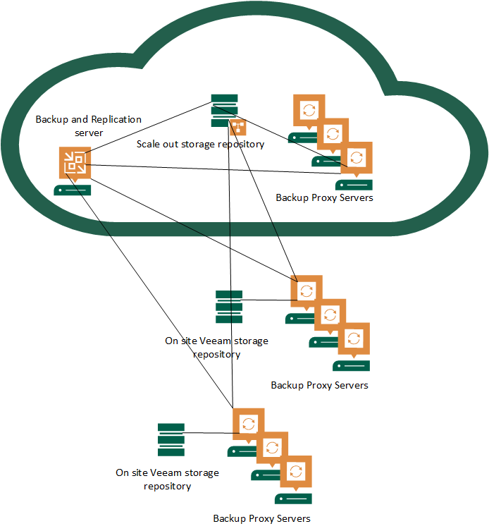
Figure 5 Potential Veeam implementation
The design (Figure 5) can reduce the number of backup solutions used throughout the estate however as it scales across the infrastructure there will be a requirement to deploy more proxy servers to meet the computational, storage and networking demands of the platform. This will incur additional tenancy costs within a cloud environment. It also introduces points of failure within the platform that will need to be managed to ensure the systems run smoothly in the longer term.

Overview of the build of the test Veeam environment
A test environment was built to accommodate backing up limited test systems. Whilst a fully realized production platform would typically have more resources to ensure service ran without being hampered by inadequate performance of under-specified hardware as workloads scale up to production levels.
The bulk of the infrastructure provisioned in the primary tenant consists of a Veeam Backup and Replication server a Veeam Cloud backup server and up to 6 Veeam Proxy servers. The secondary tenancy contains one Veeam Backup and Replication server.
On-premises VMware estates each contain locally a minimum of 2 proxy worker servers. Typically, a worker server would be required for every 3 VMware host servers to help balance network loads across the local resources.
In the test environment, there is a 4TB local backup repository used as a target for the local backup jobs. This repository has a local backup job configured to replicate the local copy into the cloud to mitigate the loss of data at the primary site.

Alternative solution with Redstor BaaS
The solution (figure 6) utilises an agent-based backup that is deployed to each endpoint that is to be protected. The main benefit of this solution is that there is less infrastructure to manage. From an infrastructure perspective, provided the agent works on the client and the client's network services permit it to access the cloud-hosted service with sufficient bandwidth this is fundamentally all the client needs. All other services are hosted and managed by the provider.
The backed-up data is hosted on two geographically separated data centres and the charging model is based on front-end consumed storage on the client device with a 4-month retention period as standard.
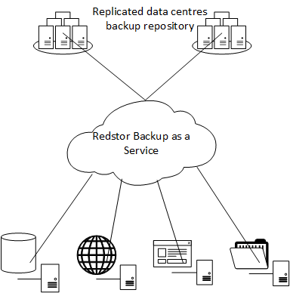
Figure 6 Redstor BaaS solution

Summary
From the two figures (fig 5, fig 6) we can see how the cloud-hosted backup solution from Redstor significantly abstracts an administrator from the backup infrastructure required to operate a cloud-hosted backup solution. However inherent in the above design is the core requirement for well-connected networks to maintain suitable levels of performance.

Testing and Evaluation

Introduction
With both products setup and jobs configured a series of tests were run to establish what the expected levels of performance were for the platforms as these could be fed back into service level agreements. Where tests have produced results that were not expected further investigations were undertaken to establish the reasons behind the results.
Procuring a new product is not the only cost or factor when establishing which solution will meet the aim of the solution. Resources need to run the products also add to the overall cost. When these resources include ‘virtually unlimited’ cloud resources we see the impact when these resources are scarce due to unprecedented demand and illustrate the potential cost of running guests in the cloud. As data will be leaving both the on-premises and cloud-hosted data centres we review

Full Backups
While the testing will include timings for a full backup in practice it is expected that they will have little effect on the final solution. It is planned that the first backup job will be a full backup with each subsequent job being an incremental backup. Synthetic full backups [24]will be employed as required as they help reduce the volume of data being backed up from the source systems and reduce the space required on the destination storage.

Backup Testing

Full back up Azure to Redstor cloud
A new Windows 2019 server was provisioned within Azure and the initial full backup job was run to produce the following results:-
Backup | OS |  |  | Backup Duration | Data Protected | Files Protected | Transferred | On Disk
18 Mar 2022 13:34 | Windows Server 2019 |  |  | 13m 11s | 17,947.98 MB | 109,630 | 7,077.21 MB | 6,416.11 MB
From the above figures, we can see that the base machine has nearly 18GB of data to be protected. However, utilizing deduplication, compression and not backing up swap files there is a significant decrease in the volume of data not only transferred over the network but also stored in the backup location. The timing of the job shows that 8.9MB are processed every second or 536.8MB per minute.

Incremental backup Azure to Redstor cloud

As the system in Azure continued to be protected by the backup policy and was left to run multiple backup jobs throughout the days. The system although it didn’t contain any production workloads it was covered by protection policies that meant the device was still being patched for security updates, anti-virus signatures etc so the file count will fluctuate as would the volume of data.

Backup | Backup Duration | Data Protected MB | Files Protected | Transferred MB | On Disk MB
18/03/2022 18:00 | 1m 35s | 24,132.42 | 110,817 | 18.87 | 6,690.08
27/03/2022 17:00 | 1m 19s | 25,155.68 | 111,676 | 17.99 | 9,127.42
27/03/2022 19:00 | 1m 18s | 25,165.18 | 111,681 | 19.77 | 9,147.34
27/03/2022 20:00 | 1m 18s | 25,166.45 | 111,683 | 17.29 | 9,164.79
27/03/2022 23:00 | 1m 17s | 25,171.46 | 111,689 | 19.5 | 9,201.16
28/03/2022 01:00 | 1m 18s | 25,177.29 | 111,694 | 18.89 | 9,220.21
28/03/2022 03:00 | 1m 19s | 25,175.28 | 111,706 | 32.48 | 9,252.80
28/03/2022 05:00 | 1m 23s | 25,181.84 | 111,715 | 146.86 | 9,374.00
28/03/2022 07:00 | 1m 22s | 25,186.62 | 111,712 | 20.86 | 9,394.98
28/03/2022 09:00 | 1m 18s | 25,190.51 | 111,715 | 20.33 | 9,415.43
28/03/2022 20:00 | 3m 07s | 25,202.44 | 111,731 | 267.23 | 9,636.76
29/03/2022 20:00 | 2m 54s | 25,198.67 | 111,763 | 189.01 | 9,788.16
Figure 7 Extract of incremental backup Redstor Pro report

From the whole data set the following information was gathered:-
Figure 8 Redstor incremental timings of backup of Azure hosted device

Figure 9 Volume of data backed up per job

The average transfer was 103MB

Figure 10 Redstor volume compared to the time of incremental backups

Although the average backup time was 135 seconds the timings were not 100% consistent with the volume of data being transferred this could be down to either system activity on the host or additional bandwidth being consumed by the network at the times the jobs were scheduled to run.

Branch office server backup to Redstor cloud

A remote branch office server has approximately 6TB of disk space made available to end users to use as a file store. The branch office site has a 300MB connection to the internet however it only has a 100MB connection back to the datacentre. Due to bandwidth limitations from the remote site back to the central datacentre it has proven to be problematic in backing up more than 2TB of data within the backup window using the existing backup solution. The server was configured to use Redstor services, and its backup traffic was routed over the internet connection.
Backup | Backup Duration | Data Protected | Difference from the previous job | Files Protected | Transferred | On Disk
07/03/2022 19:05 | 3d 14h 52m 47s | 2,147,937.00 MB |  | 2,073,598 | 1,504,665.62 MB | 1,069,111.75 MB
11/03/2022 19:00 | 3h 43m 47s | 2,148,882.00 MB | 945.00 | 2,077,397 | 6,919.14 MB | 1,073,060.25 MB
12/03/2022 19:00 | 46m 50s | 2,149,208.75 MB | 326.75 | 2,077,377 | 248.58 MB | 1,073,314.12 MB
13/03/2022 19:00 | 47m 48s | 2,148,848.75 MB | -360.00 | 2,077,310 | 383.65 MB | 1,073,702.88 MB
14/03/2022 19:00 | 1h 40m 36s | 2,149,367.00 MB | 518.25 | 2,078,892 | 1,731.09 MB | 1,074,548.00 MB
15/03/2022 19:00 | 1h 47m 27s | 2,149,025.00 MB | -342.00 | 2,078,918 | 1,160.61 MB | 1,075,237.88 MB
16/03/2022 19:00 | 2h 03m 34s | 2,147,431.00 MB | -1,594.00 | 2,080,087 | 1,966.11 MB | 1,076,370.88 MB
17/03/2022 19:00 | 1h 59m 00s | 2,146,841.00 MB | -590.00 | 2,079,872 | 1,588.57 MB | 1,077,276.88 MB
18/03/2022 19:00 | 1h 50m 42s | 2,146,936.25 MB | 95.25 | 2,079,737 | 1,295.92 MB | 1,078,412.75 MB
19/03/2022 19:00 | 50m 09s | 2,146,941.00 MB | 4.75 | 2,079,733 | 386.76 MB | 1,078,804.75 MB
21/03/2022 19:00 | 2h 04m 07s | 2,146,165.00 MB | -776.00 | 2,081,836 | 2,776.09 MB | 1,079,948.50 MB
22/03/2022 19:00 | 1h 54m 36s | 2,138,296.25 MB | -7,868.75 | 2,085,522 | 1,683.13 MB | 1,080,684.38 MB
23/03/2022 19:00 | 2h 04m 31s | 2,135,127.75 MB | -3,168.50 | 2,085,706 | 2,056.51 MB | 1,082,316.75 MB
24/03/2022 19:00 | 2h 17m 10s | 2,135,191.25 MB | 63.50 | 2,086,267 | 2,702.36 MB | 1,084,330.12 MB
25/03/2022 19:00 | 1h 41m 16s | 2,134,767.50 MB | -423.75 | 2,087,004 | 1,458.61 MB | 1,085,192.25 MB
26/03/2022 19:00 | 54m 38s | 2,134,743.50 MB | -24.00 | 2,087,181 | 389.65 MB | 1,085,587.25 MB
27/03/2022 19:00 | 46m 02s | 2,134,754.00 MB | 10.50 | 2,087,212 | 389.89 MB | 1,085,982.25 MB
28/03/2022 19:00 | 1h 46m 53s | 2,132,451.75 MB | -2,302.25 | 2,093,191 | 1,412.38 MB | 1,087,066.00 MB
29/03/2022 19:00 | 5h 25m 10s | 2,138,058.25 MB | 5,606.50 | 2,106,815 | 7,141.23 MB | 1,089,860.62 MB
30/03/2022 19:00 | 1h 53m 01s | 2,137,775.00 MB | -283.25 | 2,107,490 | 1,368.68 MB | 1,090,714.25 MB
31/03/2022 19:00 | 3h 42m 46s | 2,136,002.00 MB | -1,773.00 | 2,105,018 | 3,834.48 MB | 1,092,616.00 MB
Figure 11Branch office backup data volumes and timings
Coincidentally during the testing phase, the internet connection used suffered a protracted outage that impacted the time taken to perform the initial seed of the backup. However, as the solution is designed to cope with inconsistent networks the job did not fail despite taking over three and a half days to complete. The subsequent incremental job is significant compared to most of the other increments which is understandable as there is a 4-day gap between the jobs. We can infer that data deduplication and compression techniques have produced roughly 50% savings on required backup space. As data protected is approximately 2.14TB however just under 1.1TB of storage is required for the backup.

Figure 12 MB of data backed up compared to the time for job completion

We can gather from figure 12 that there is a consistent correlation between the volume of the backup compared with the time taken to back up the data. However, the server on this site is on a network that has minimal production load outside of office hours.
Typical estimations for productions servers when specifying rates of data change suggest a 5% data churn, we have recorded a churn of 3% with this server. Interestingly there is still a significant volume of data being transferred even when the overall volume of data has reduced (figure 13).

Figure 13 Data churn compared to the data transfer

VM restore timings using Redstor

Redstor does not utilize a media server or control servers as used by some backup solution providers each machine that needs to backup is responsible for running its own backup likewise a full virtual machine restore requires a machine to be responsible to manage the data out of the cloud to the destination
Using the clean guest Windows Server 2019 virtual machine image with 28.56Gb of data and 417169 files tests were run to gather the timings of specific restore jobs.
The restore job would retrieve the latest backup image from the Redstor data centre and restore the virtual machine either into the on-premises VCentre infrastructure or into an Azure tenancy. All restores except for the first restore resulted in the backup image being successfully converted and starting up in a working state accepting the login credentials of the administrative account used for testing.

Redstor cloud to on-premises datacentre via remote laptop
In the first test, a restore was initiated at 15:30 running the restore agent on a laptop that was connected via an always-on VPN connection back to the corporate network.
This proved to be less than ideal and whilst possible it would not be advisable to run this scenario in a production environment. Whilst download speeds from the cloud were tolerable the speed from the laptop back into the corporate environment via the VPN proved to be a major bottleneck with only 1.8GB of data being uploaded in the first hour of the job. A restore approaching nearly 16 hours would not be acceptable for production demands. As the end user device also runs power-saving features to power itself down during inactivity the job timed out and was marked as unsuccessful.

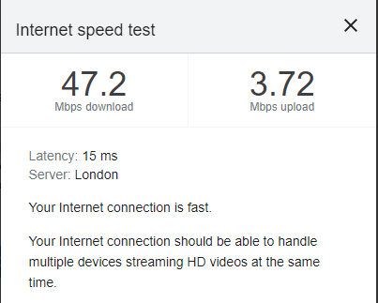
Figure 14 Domestic ADSL connection

Redstor cloud to onsite datacentre via on-premises virtual machine
A guest virtual machine that was hosted within the VCentre data centre was utilised to run the restore job. Again, the same 28.56Gb source virtual machine backup was used to test the restore. This restore was started at 9 am. The on-premises servers are connected within the VCentre via 10GB ethernet and share a 1GB internet connection. In this instance, the restore took 1 hour and 13 minutes.

Redstor cloud to Azure hosted virtual machine via local datacentre virtual machine
A machine in the on-premises datacentre was used to run the restore of the same virtual image into the Azure UK South data centre. The job was initiated at 14:10 and finished at 16:13 or 2 hours 3 minutes.

Redstor cloud to Azure hosted virtual machine via Azure hosted virtual machine
A virtual machine hosted in the UK south data centre was used to run a restore of the same test virtual machine image into the same UK south data centre and onto the same VNET. This restore job was initiated at 17.01 and finished at 19:03 taking 2 hours 2 minutes

Figure 15 Redstor restore times in minutes

It is highly unlikely given what we know about the speed of the broadband connections that in a production environment the restore would be run on a remote laptop as the network speeds would prove to be prohibitive in meeting service level agreements so these results will be discounted or ignored.

Figure 16 Redstor restore times in minutes ignoring failed job

Hypothetically it would be safe to assume that cloud-to-cloud transfer for restores would be a lot faster than what has been recorded. Backup timings appear to indicate that public cloud connectivity is generally composed of well-connected networks with sufficient bandwidth. However, near identical timings for restores from Redstor to Azure one with an on-premises agent and one with an Azure agent indicate that there may be something else that was not originally factored into this hypothesis.
At this point, it was postulated that the Azure-hosted agent machine that was directing the restore does not have a publicly accessible IP. It is probable the data for restore is being routed through the on-premises VPN. This not only increases the time taken to restore a virtual machine or data but also becomes a point of failure in the event of a disaster if the primary data centre is lost.

Veeam Restore timings
To maintain a consistent and fair test the same Windows 2019 server was used in this set of tests as was used in the above. However, as the architecture is different with dedicated servers used to manage the backups and perform proxy agent jobs for the management of backups some of the tests were omitted as they were considered irrelevant.
Restore from default cloud backup location to on-premises VM in VSphere. Job started at 9:53 on 13/4/2022 and ended at 10:04. During this restore multiple servers acted as proxies to the job which aided in the acceleration of the task. Reducing the restore time down to 11 minutes.
Restore from the default cloud backup repository to an Azure-hosted VM. Job started at 11:18 on 12/4/2022 and ended at 11:30. Again there are multiple proxy servers hosted in Azure as part of the configuration that can be used to accelerate the restore job.

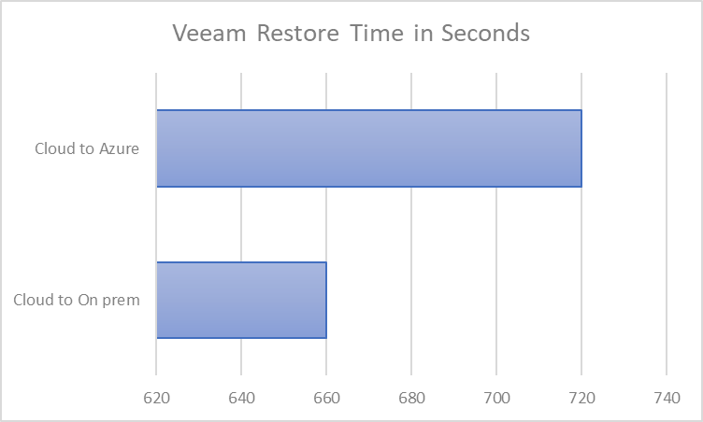
Figure 17 Veeam restore times in seconds

Restore comparative timings
The chart below shows the dramatic difference between the two solutions for restore timings and the impact the management servers and proxy servers have on the timings. These could impact the delivery of a service level agreement in some circumstances however for individual jobs the impact is negligible. Only in the event of a mass restore for example in the event of a disaster recovery situation will this impact the outcomes.

Figure 18 Restore job timings of both Veeam and Redstor

Datacentre bandwidth speeds

On-Premises
The main on-premises datacentre is connected to the Azure data centre via a 1Gbps VPN. Running OKLA speed test jobs on a virtual machine within the on-premises data produced the following results.
Upload 535Mbps
Download 138Mbps.
There are multiple factors in the advertised service not achieving the results. As the report was run during the middle of the working day on a weekday there is already a high baseload of users and systems utilising services over the VPN. During the same period, approximately 2800 users were connected to the data centre using a VPN connection that was routed through the same infrastructure.

Figure 19 On-premises bandwidth recordings

Azure Datacentre
The cloud-hosted servers in the Azure datacentre as alluded to above utilize well-connected network infrastructure. Similar tests were run on a VM hosted within Azure and returned the following results
Download 586Mbps
Upload 725 Mbps

Figure 20 Azure bandwidth measurements
Combining the two charts illustrates what was already hypothesized that the bandwidth of the network in the Azure Data Centre allows for a faster upload and download of data to other cloud-connected services than the client’s on-premises infrastructure. What physical infrastructure and bandwidth connections are used in the Azure data centre evidently have more capacity than what is provisioned by the client’s own infrastructure services

Figure 21 Bandwidth of connected data centres used for corporate traffic
While the above details were accurate at the time of recording. They represent a small sample size and generalizing the performance of the networks based on these samples may not be representative of the system performance overall. In this example, no network measurements were taken outside of working hours. Further measurements that focus on the local data centre need to be taken to aid in the research. If the onsite network is unable to meet bandwidth requirements additional spending will need to be added to the project to ensure systems are protected in a timely manner.

The scale of hardware requirements could negatively impact the TCO
Veeam Proxy agents are running in both the on-premises and cloud-hosted environments. As the number of these agents can vary depending on the scale of the infrastructure this cost should be considered as part of the total cost of ownership of the specification.
Beyond the physical costs of the infrastructure cloud or on-premises, the Windows server requires server licenses any management agents for SCCM/Insight SCOM used to maintain and monitor these servers need to be licensed. The servers themselves become entities that also need to patch regularly to meet security and compliance standards and configurations are periodically backed up adding to the overall running costs.

Cloud Resources are not limitless
During the last two years, there has been an extraordinary growth in organizations adopting cloud-hosted services. Gaurav Aggarwal wrote in a Forbes article [25]“How the Pandemic Has Accelerated Cloud Adoption”
“The lockdown and remote working necessitated by the Covid-19 pandemic were an unexpected reality check for organizations of all sizes. The restrictions imposed by the pandemic turned the world upside down, with industries like travel and hospitality going bust and many businesses experiencing survival challenges.
Because of the uncertainty of the times and the likely realities of the "new normal," more and more organizations are now charting the course for their journeys toward cloud computing and digital transformation.”
Gaurav goes on to include Microsoft CEO Satya Nadalla statement [26]
“We’ve seen two years worth of digital transformation in two months”
Gaurav continues to highlight growth areas for cloud services during the pandemic include, business resilience, evolution of business operations (e-learning, e-commerce), remote working, investment from the public sector and a renewed focus on environmental sustainability.

The above factors although not too impactful on the solutions being tested did highlight some of the unprecedented growth and shift to cloud services over the last few years. To ensure costs were maintained to an acceptable level cloud hosted infrastructure was turned off during periods when there was no requirement to test the backup infrastructure. This is a common practice as it reduces the cost to purely a storage cost as CPU and RAM resources are returned to the vendor to be utilised for other resources. This practice did cause an unforeseen problem that highlighted issues with cloud services that an end user would not typically see or expect.
When powering up the servers to continue testing the hosting provider did not have sufficient resources available to power up the device. The class of resource type D4_V5 was consistently out of resources. To alleviate the issue the device was changed to a D2_V4. For testing purposes this was acceptable, and testing was able to continue. A call was logged with the provider and support indicated that there was indeed a known capacity issue in that region and if possible, build the asset in another data centre where resources were available. This was not acceptable as data governance guidelines require the data to remain in the UK. Subsequent follow-up responses from the supplier have shown that additional infrastructure has been added and resources within the data centre have been moved to address the capacity issues.

Cloud Compute Costing

Looking at the specification as listed above the cost to provision the cloud-hosted servers in Azure per month utilizing 3 years of reserved instance pricing option to reduce the cost compared to a pay-as-you-go model:-
Figure 22 - 3 Year reserved instance cost per month

For comparison included is the Pay As You Go option. The worker servers have had their time cut to 365 hours a month as it is unlikely these servers would be active between 6 am and 6 pm.
Figure 23- Pay as you go cost per month

Cost to run the service for 5 years using reserved instances £17422.80
Cost to run the service for 5 years using the Pay As You Go, model, is £34987.80
As this infrastructure is unlikely to be removed from the estate during the life of the product it would be financially prudent to commit to three years. Over a five year period, this would save £17565 on running costs.
However, the maximum reservation available is currently 3 years. As this period ends specifications could be reviewed to establish what suitable options would be financially beneficial for the remaining period and if required resize the virtual hardware to accommodate the ongoing requirement.

Data Egress

Data flows in two ways. In this example ingress is data going into the data centre there is no charge levied at data going into a data centre via the internet or over VPN. Egress is data leaving the data centre and charges are applied regardless of the route unless a dedicated circuit is procured with an unlimited data plan [27].
Large volumes of data leaving the data centre will be a normal part of the solution however it needs to be understood what data is leaving the data centre for what reason and how best we can limit the data movement without impacting the operations of the systems. Particularly in the public cloud environments where the revenue cost of data egress is so visible.
Within the Azure platform, a typical server currently has 5 GB of data egress included in its monthly charge. However, a multi-terabyte server with a large rate of data change that requires data to be backed up outside of the data centre will soon start to build up significant costs.
Coupled with this more data leaving the data centre also impacts the length of time required to protect the data whilst backing up the servers within the backup window. Which then becomes more of an impact on those platforms where the system is taken offline whilst being backed up.
Referencing the existing solution, the largest part of the estate was analysed for data backup volumes. Currently, 84TB of data is presented to its VMware estate a typical 5% data churn would indicate 4.15TB of data per day or 29.05 TB per week extrapolating this figure to 120TB per month. Applying these figures to the azure cost calculator the estimated egress charges were £6211.20 per month.
Figure 24 illustration of egress charges from Azure cost calculator

However, previous analysis of the protected 84TB it was discovered that each week excluding full backups 47.62TB of data were backed up this equates to a 6.9% data churn. Or in financial terms £139000 per year purely on data egress charges. The above represents a worst-case scenario for the given data but consider these calculations did not include additional systems that would add approximately 40% to the cost of the platform. This is an excessive cost that would not be acceptable for the overall solution.

Reviewing the existing solution for its configuration it was observed that the many incremental backups were cumulative incremental backups. This type of backup backs up all data that has changed since the last full backup, typically employed to reduce the number of tapes required when performing a restore as recently changed data would only require one tape or in the event of a full system recovery two, the most recent full and the most recent cumulative incremental. The downside to this configuration means each subsequent cumulative incremental job takes longer than the previous job which impacts service windows, consumed bandwidth etc.
As the initial backups are written to near online disk-based storage this configuration does not make practical sense as it has the same issues regarding the time taken to complete the jobs that impacted the service window and consume data bandwidth whilst additional workload is added to the deduplication process.
As egress charges are not included as part of the product and are born directly by the client this demanded a deeper analysis of how these figures would look when transitioned across to the new platform it was important to get real-world statistics on how the new platforms compression and deduplication platforms performed to limit data egress.
Although it should be noted that data change rates from the branch office produced a figure of 0.09% on average this site has a limited group of users and is too small a sample size. Two additional on-premises file servers were also configured and the average volume of data over a week produced the following results.

Server | Backup solution | Average Volume protected | Average Data transferred | % of data
FS08 | Redstor | 1748.6GB | 0.84GB | 0.05
FS12 | Veeam | 1433.6GB | 4.06GB | 0.28

Figure 25 Data egress volume testing

Office 365 backup
The original specification for the backup solution did not include the backup of SaaS services such as Office 365. This solution was not protected by a backup solution however recent events in Ukraine have changed the focus to backup O365 services including Email, Teams, SharePoint, and OneDrive data.
Both vendors do have solutions to protect the data however the backend solutions differ on how they are billed.
Redstor charges are based on the volume of data consumed. The organization is in the process of migrating shared data to SharePoint and personal data to OneDrive. Data growth within O365 was growing and was predicted to be at 76TB at the end of the migration project.
iLand bases its usage charge on the number of active licensed users this number fluctuates. Currently at around 4500 our anticipated usage is predicted to increase to over 5300 as frontline workers are added to the service.
As users leave the organization their O365 licenses are removed and by default the data would be deleted after 90 days. Within the iLand solution, the data for these users are archived indefinitely. However, the data can be moved to another user or purged from the system to meet GDPR compliance regulations if required. The management of O365 licenses is tightly managed within the organization's processes for maintaining an accurate number of licensed users is already in place.

Commercials

Discussions were had with two resellers and associated vendors to specify the appropriate solutions. Redstor is a single vendor solution that provides the backup software used for writing to its own data centre services. iLand was chosen as a Veeam partner. With iLand the Veeam software was covered by a subscription whilst the data repository was housed in iLands own data centre.
Both vendors had access to the information to aid in the specification of 120TB of production data to be protected and prices were gathered from the suppliers. Redstor base its price on frontend data used. This 120TB is based on virtual and physical servers covered by existing production backup workloads. Whereas iLand bases its prices based on the number of servers to be protected, the storage required to protect the data including retention periods and separate ransomware protection storage. The actual financial details would be covered by commercial confidentiality however it was calculated that based on the protection of 120TB per GB per year iLand was 10% more than the Redstor solution.
Office 365 solutions are priced differently, and the volumes of users and data are charged at different rates. Again, commercial confidentiality means the actual costs are not displayed however there is a 46% difference in costs, based on usage between the solutions. This time iLands solution is the one to win out on the commercial front. This was highlighted to Redstor as the difference between the solution was so large. Due to the nature of how the solutions are built, there is an egress charge applied to data leaving O365 to Redstor servers that must be accommodated in the charges.

Changes to authentication and additional restore testing
On May the 27th 2022 the authentication mechanism used by Redstor was changed from a standalone authentication mechanism to an Azure integrated multifactor authentication solution providing an additional layer of protection to the solution.
The method of restore first used was to connect to the Redstor site and download an agent on the proxying machine and initiate the restore. Initially, it was considered the proxying server was transferring data directly from the Redstor storage to the destination storage via the proxying agent and was the reason for the slow restores. However, this was not the case, the proxying client device was checking the file integrity of each file being transferred between the Redstor service and the destination storage which caused the subsequent delays. An alternative method using the vendors Azure Mobility restore function where the restore was all performed from within the vendor's cloud portal dramatically reduced a 30Gb restore from over two hours down to less than 40 minutes. This brought the restore times to within 10 mins of a Veeam restore from infrastructure and was an acceptable level of performance.
During this period of change in the restore process, a usability issue became apparent. When initiating a cloud-based restore an existing storage account needs to be specified as a preconfigured Windows PE machine is deployed to the storage account to act as the proxying machine within the tenancy. When restoring a full VM the machine being restored is given a temporary name with a suffix based on the time stamp of the restore e.g., ServerName- 21062022-092635. However, due to the length of the field, the name gets truncated to the first four characters followed by the suffix in the above example the name is truncated to Ser-2106022-092635.
The machine is also placed in the same resource group as the storage account as the proxying machine. This is problematic as the resource group within the production environment is the basis for the recharging mechanism as most services i.e., storage and compute would be in this resource group.
These factors make the solution unsuitable for a production service as the volume of clean-up work per restore, especially in the event of a DR of multiple systems would hamper the recovery time of the solutions.
A conversation was had with the product manager, it was established that these features are by design. It was highlighted to the product manager that in its current guise the solution would be unsuitable for a production service as the volume of work to clean up after a restore, especially in the event of a DR scenario where multiple systems are restored would overall hamper the solution. It was acknowledged by the vendor that the process needs to change to resolve the issues raised from this testing and development teams are taking steps to address the process.

Summary
Two solutions were implemented, and tests were run to produce quantitative data. It was established that Veeam has significantly more infrastructure to protect the production workloads but can attain a better Recovery Time Objective. Understandably network bandwidth also greatly influences the performance of the systems especially if there is limited local infrastructure. As the project has progressed global pandemics and political turmoil have influenced the scope of the project and the design of the solutions to offer more protection.
Redstor has a product that can meet the needs of the organization however recent changes to the product resulted in a product that introduced undesirable features. Whilst the vendor will undoubtedly resolve these issues the time scale to resolution is uncertain.

Conclusion

Summary

During the literature review, we highlighted what to look for in a backup solution, and why cloud SaaS solutions should also be included in your backup solutions and need to be backed up. What is classed as effective storage for a backup, and how systems are configured to minimise downtime. We gained an understanding of VSS, object and block storage types, how object storage protects its data from corruption and how changed block tracking and block level deduplication can reduce storage requirements. Followed by how data stored electronically can be stored on re-writable media but maintain immutability.
Through the research methodology, we stated the hypothesis to help establish the project objectives to ensure suitable experimentation. Understanding what the existing protection solution is achieving provided a starting point for the new solution. Maintaining the reference machine, limiting the variables that could impact the results, removed a layer of doubt that could have surrounded the quantitative data results.
Through the design phase, we could see the inherent need for a well-connected network regardless of which platform was being chosen.
While producing the quantitative data it was established that Veeam has significantly more infrastructure to protect the production workloads but can attain a better Recovery Time Objective. As the project progressed global pandemics and political turmoil meant the scope of the project and the design of the solutions had to be amended to offer more protection.

Conclusion

Overall, both products could meet the need of the organization’s desire to protect its data and choosing between the two solutions is not easy. Veeam has numerous features that allow the organization to function smoothly. For example, AD attribute restoration and integration with storage hardware to allow restores snapshots taken directly from the storage arrays. Whereas Redstor has a far simpler solution that requires less infrastructure to implement and manage.
The Redstor cost model is easier to forecast and express to lay persons who may not understand how backup solutions costs need to be calculated. As is based on the cost of how much data is presented upfront to be protected and not how much storage is consumed to protect the data.
Out of the research and implementation, it was identified that licensing and the cost of the provisioned infrastructure are not the only elements to consider when calculating the total cost of ownership. For example, egress data charges impact the cost and how the backup jobs are configured can greatly influence the egress of data from the systems and therefore the performance.

Although not a key part of the research initially the backup solution for Office 365 backup has been selected; the organization will be procuring a solution based on the Veeam/iland platform. Despite the user numbers increasing during the project from 4100 to over 5300 and data growth increasing faster than anticipated there is still a significant saving between the two solutions.
Initial testing with Redstor was positive, there were some doubts if there would be sufficient data bandwidth from on-premises to be able to complete the system backups promptly considering it was so reliant on network resources.
Analysis of the on-premises backups established too much data was being backed up creating an excessive volume in the data churn calculations. Additional tests on production servers significantly reduced the estimated volume of data churn to a more achievable figure.
However, considering the changes to the Redstor solution it was deemed to be unworkable in the event of a disaster recovery using its revised tools. There is no doubt that the vendor will resolve the issues raised during testing but as there is a timeline to this project from a business perspective the decision was made to procure the solution from Veeam/iLand.

Further areas of study

Data security has many layers, one of them being user authentication. To protect the systems from brute force attack part of the configuration within Veeam an Azure hosted server was configured to use single sign-on authentication and utilise Azure multi-factor authentication service.
The ability to share services over the cloud between tenancies also requires further investigation. The multitenancy solution used with this Veeam solution whilst housed in the corporate tenancy is also backing up servers in other tenancies and domains. Coming from a tradition of NT domains and Active directories understanding how these platforms can be utilized for the benefit of the organizations would be of benefit to the author.
The immutability of data in the cloud appears to follow some vague pattern of either hiding data from malicious access or applying policies to data to prevent deletion. Understanding the techniques used by other solution providers on how they achieve data immutability in their platforms and identifying if there is a common emerging standard or best practice is also worthy of further research.

Reflection

Introduction
This project aimed to assist in the decision-making behind introducing a new backup solution to the organization. It covered not only the backup products themselves but the technologies which the products themselves would utilize.
While the author's experience with older backup solutions led to the investigation of how newer backup solutions compared to legacy solutions would improve the overall security posture of the estate it was heavily influenced by a financial decision and how the different products impacted the budgets but ultimately in a workable product suitable for the needs of the organization.
During the project, a few skills were employed some to greater effect than others:-
Scope management - Key to the timely delivery of any project is the setting out and adherence to scope. The scope of this project did creep partially due to the literature review introducing technologies that required further reading which is a major benefit of the literature review and political changes that influenced the products being reviewed. One of the project's initial aims to observe if reducing the number of solutions would improve efficiency was too much in the overall scope. As the time to implement the solution will not be met before the submission of the project, therefore, measuring the time spent on administrating the solution across the estate will not be possible. However, staff who have used the solution appear confident in the product's ability to meet the objectives going forward.
Project planning and third-party engagement- The use of the project plan whilst beneficial in the initial stages was not rigorously adhered to as factors relating to the project required the use of third-party suppliers and services some time scales were more fluid to fit around their availability.

Areas that could be done differently

The student handbook relating to this project should have been read a lot sooner. It provides a wealth of information needed to produce the final report. If it was not for the supervisor's insistence to read the guide and their guidance throughout the process the report could have been far worse.
To achieve a higher accuracy repeating some of the tests or repeating several processes at different times of the day and avoiding business hours may have proven beneficial.
Some of the reports on Veeam appear to be light in comparison to Redstor. Whilst equal importance was given to each solution more evidence should have been included. However, at the time it was not considered relevant as it had outperformed Redstor.
Some of the graphs used in the report do not convey the information they present in an easy-to-understand way and require some time to truly understand the data presented.
The anonymization of the data particular in fig 26 and 27 could have been handled systematically and not by a manual find and replace.

Additional outcomes

When one supplier's service suffered following the change to multi-factor authentication it showed the importance of a thorough testing plan when introducing new technology. To this end the author has been working with the management team to produce a framework of a testing plan to pass on to subject matter experts to ensure when new systems and patches are being deployed, tests are conducted and the results are recorded and fed back to technical staff, so problems can be resolved or highlighted back to the third party before going live.

Summary

The experience of creating this paper has led to a decision on which product to select for the organization. It is hoped that this product will achieve the objective of reducing the time to administer multiple backup solutions by reducing the silos of solutions used in the estate and ensure better protection for the estate overall. Whilst not the author's first choice for a final project the experience has permitted the opportunity to delve deeper into data protection technologies used every day.

References

[1] | Microsoft, “What is Azure,” Microsoft, 2022. [Online]. Available: https://azure.microsoft.com/en-gb/overview/what-is-azure/?OCID=AIDcmm3bvqzxp1_SEM_29b24f20e777174982592ded9eb2d09b:G:s&ef_id=29b24f20e777174982592ded9eb2d09b:G:s&msclkid=29b24f20e777174982592ded9eb2d09b. [Accessed 12 07 2022].
[2] | “What is AWS,” Amazon, [Online]. Available: https://aws.amazon.com/what-is-aws/. [Accessed 12 7 2022].
[3] | Google, “Google Cloud Overview,” Google, 2022. [Online]. Available: https://cloud.google.com/docs/overview/. [Accessed 12 07 2022].
[4] | Microsoft, “What is IaaS?,” Microsoft, 2022. [Online]. Available: https://azure.microsoft.com/en-gb/resources/cloud-computing-dictionary/what-is-iaas/#overview. [Accessed 12 07 2022].
[5] | Oracle, “Oracle Cloud Infrastructure,” Oracle, 2022. [Online]. Available: https://www.oracle.com/cloud/. [Accessed 12 07 2022].
[6] | P. d. Guise, “Basics: Why Deduplication Block Size is Important,” 30 September 2019. [Online]. Available: https://nsrd.info/blog/2019/09/30/basics-why-deduplication-block-size-is-important/. [Accessed 26 04 22].
[7] | M. Zorz, “How do I select a backup solution for my business?,” Help Net Security, 26 May 2020. [Online]. Available: https://www.helpnetsecurity.com/2020/05/26/select-backup-solution/. [Accessed 1 April 2022].
[8] | W. C. Preston, “Backup lessons from a cloud-storage disaster,” 23 April 2021. [Online]. Available: https://www.proquest.com/trade-journals/backup-lessons-cloud-storage-disaster/docview/2517577432/se-2?accountid=130472. [Accessed 6 March 2022].
[9] | C. Childerhouse, “The 3-2-1-1-0 Rule - Keeping Data Safe,” in Mastering Veeam Backup and Replication , Birmingham UK, Packt Publishing Ltd, 2022, pp. 39-61.
[10] | D. A. P. e. al, “Recovery Oriented Computing (ROC): Motivation, Definition, Techniques, and Case Studies,” Computer Science Technical Report UCB//CSD-02-1175, U.C. Berkeley, Berkeley, 2002.
[11] | A. A. Krassie Petrova, “Backup Monitoring in Large Heterogeneous Business,” in Int'l Conf. Security and Management, 2017.
[12] | Microsoft, “Volume Shadow Copy Service,” Microsoft, 10 08 2021. [Online]. Available: https://docs.microsoft.com/en-us/windows-server/storage/file-server/volume-shadow-copy-service. [Accessed 4 6 2022].
[13] | rash127, “Changed Block Tracking: A powerful weapon for backup applications to shrink backup window,” 03 12 12. [Online]. Available: https://communities.vmware.com/t5/Legacy-User-Blogs/Changed-Block-Tracking-A-powerful-weapon-for-backup-applications/ta-p/2770464. [Accessed 07 06 2022].
[14] | W. C. Preston, “Object storage in the cloud: Is backup needed?,” Network World , 2019.
[15] | D. Park, “A Lookahead Read Cache: Improving Read Performance for Deduplication Backup Storage,” JOURNAL OF COMPUTER SCIENCE AND TECHNOLOGY, vol. 32, no. 1, pp. 26-40, 2017.
[16] | Y.-J. F. e. al, “ Application-Aware Client-Side Data Reduction and Encryption,” JOURNAL OF COMPUTER SCIENCE AND TECHNOLOGY, vol. 28, no. 6, pp. 1012-1024, 2013.
[17] | “Immutable,” Cambridge Univeristy Press , 2022. [Online]. Available: https://dictionary.cambridge.org/dictionary/english/immutable. [Accessed 20 Feb 2022].
[18] | The British Museum, [Online]. Available: https://www.britishmuseum.org/collection/object/W_K-3375. [Accessed 20 Feb 2022].
[19] | “PROGRAMMING PATTERNS: THE STORY OF THE JACQUARD LOOM,” Science and Industry Muesem, [Online]. Available: https://www.scienceandindustrymuseum.org.uk/objects-and-stories/jacquard-loom. [Accessed 20 Feb 2022].
[20] | I. S. D. N. Andromachi Chatzieleftheriou, “Could cloud storage be disrupted in the next decade?,” Microsoft Research, 2020.
[21] | “rvtools,” [Online]. Available: https://www.robware.net/rvtools/. [Accessed 5 July 2022].
[22] | “Leader in Backup since 2006,” Veeam, [Online]. Available: https://www.veeam.com/timeline.html. [Accessed 19 April 2022].
[23] | “Experts in Data Management,” Redstor, [Online]. Available: https://www.redstor.com/about/. [Accessed 23 04 2022].
[24] | Veeam, “How synthetic full backup works,” Veeam, 21 8 6. [Online]. Available: https://helpcenter.veeam.com/docs/backup/vsphere/synthetic_full_hiw.html?ver=110. [Accessed 12 07 2022].
[25] | G. Aggarwal, “How The Pandemic Has Accelerated Cloud Adoption,” Forbes Technology Council , 15 Jan 2021. [Online]. Available: https://www.forbes.com/sites/forbestechcouncil/2021/01/15/how-the-pandemic-has-accelerated-cloud-adoption/?sh=2835b4ae6621. [Accessed 17 May 2022].
[26] | J. Spataro, “2 years of digital transformation in 2 months,” Microsoft, 30 April 2020. [Online]. Available: https://www.microsoft.com/en-us/microsoft-365/blog/2020/04/30/2-years-digital-transformation-2-months/. [Accessed 17 May 22].
[27] | “Azure ExpressRoute pricing,” Microsoft, 2022. [Online]. Available: https://azure.microsoft.com/en-gb/pricing/details/expressroute/. [Accessed 31 May 2022].
[28] | B. Moris, Brian Morris 1809130 Workplace assignment, Swansea, 2022.

Reading list
Checkpoint and Restoration of Micro-service in Docker Containers.pdf
A cost-effective strategy for Cloud system maintenance.pdf
A New Secure Model for Data Protection over Cloud Computing.pdf
Analysis of the age of data in data backup systems.pdf
Application Aware Client-Side Data reduction and Encryption of personal data in cloud backup service.pdf
Application-specific Delta-encoding via Resemblance Detection.pdf
Backup lessons from a cloud-storage disaster.pdf
Backup_Monitoring_in_Large_Het.pdf
Bartolini2018_Article_CloudProvidersViability.pdf
Concurrency and Computation - 2015 - Zeng - VMBackup an efficient framework for online virtual machine image backup and.pdf
Concurrency and Computation - 2017 - Lee - Ransomware prevention technique using key backup.pdf
Concurrency and Computation - 2021 - Wang - A cost‐efficient resemblance detection scheme for post‐deduplication delta.pdf
Database Migration on Premises to AWS RDS.pdf
Filesystem backup to the cloud.pdf
Huge spike in ransomware attacks calls for adoption of backup as a service solution by modern enterprises - ITWeb.url
IET Information Security - 2017 - Liu - A secure data backup scheme using multi‐factor authentication.pdf
Infrastructure failure, skills gap to drive backup-as-a-service - ITWeb.url
Int J Network Mgmt - 2015 - Chung - A management architecture for client‐defined cloud storage services.pdf
ISO_DIS_22301_(E).pdf
Network-Systems-Administrator-Pre-Competition-Task.pdf
Object storage in the cloud Is backup needed.pdf
Optimal Backup Policy for a Database System with incremental and full backups.pdf
Optimal internal pricing and backup capacity of computer system subject to breakdowns.pdf
Overview of Recovery Services vaults - Azure Backup - Microsoft Docs.url
OVHcloud Data Center Devastated by Fire, Entire Building Destroyed.url
Park2017_Article_ALookaheadReadCacheImprovingRe.pdf
Performance evaluation of hybrid disaster recovery framework with D2D communications.pdf
Pro Data Backup and Recovery - Steven Nelson - Google Books.url
recovery-oriented-computing-motivation-definition-principles-and-examples.bib
Redundancy-Guaranteed_and_Receiving-Constrained_Disaster_Backup_in_Cloud_Data_Center_Network.pdf
ResiliNetsWiki
Recovery Oriented Computing (ROC): Motivation, Definition, Techniques, and Case Studies.pdf
Secure Cloud Backup for Data Sources Based on blockchain.pdf
Server placement with shared backups for disaster-resilient clouds.pdf
Taranin2018_Article_DeduplicationInTheBackupSystem.pdf
The 60 Second Marketer What to Look for When choosing a cloud backup provider.pdf
THREAT_PROTECTION_AND_CONVENIE.pdf
Towards a Big Data system disaster recovery in a Private Cloud.pdf
Veeam Announces General Availability of Enterprise Ready cloud backup and recovery.pdf
Veeam Expands Google Cloud Partnership.pdf
https://www.proquest.com/magazines/what-is-cloud-backup/docview/2234280640
WORM tape cartridge characteristics - IBM Documentation

Appendix:-

Usage reports from existing backup solutions
Usage reports were extracted from the existing backup solution and tree maps were created to visualise the relationship between different volumes of data to help find the backups that consumed the most data therefore time and bandwidth. Backups were targeted to systems to get a real-world example of backup performance.
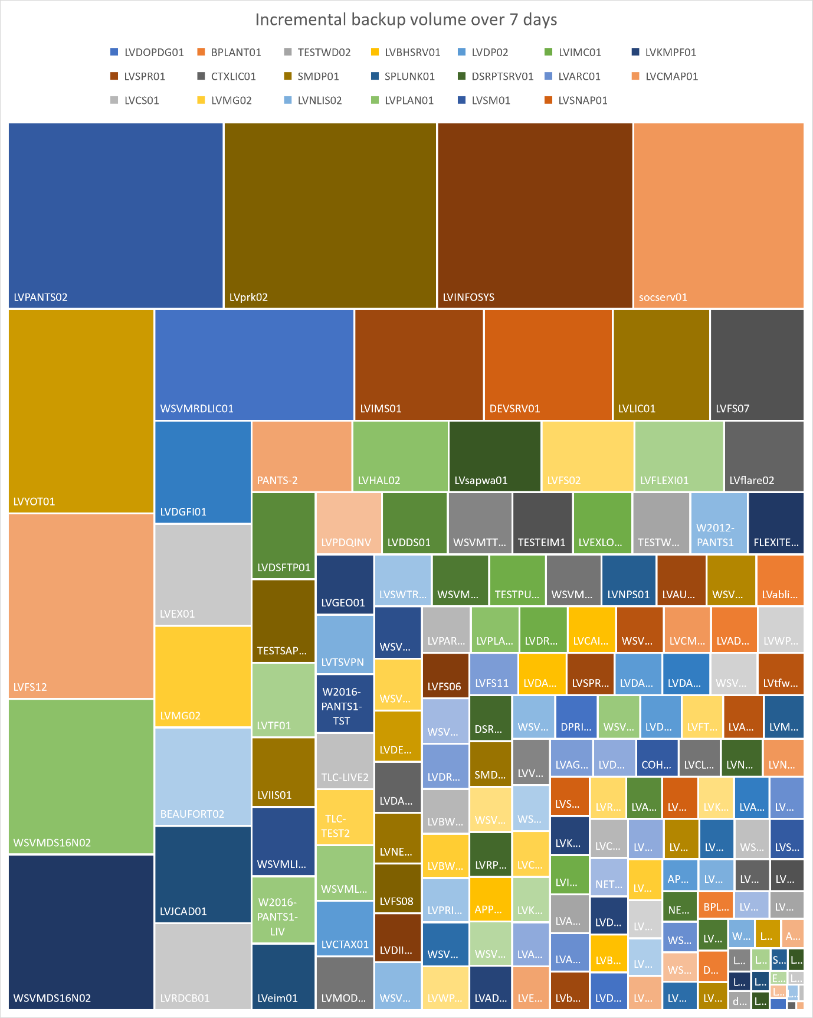
Figure 26 Treemap of incremental backups over 7 days

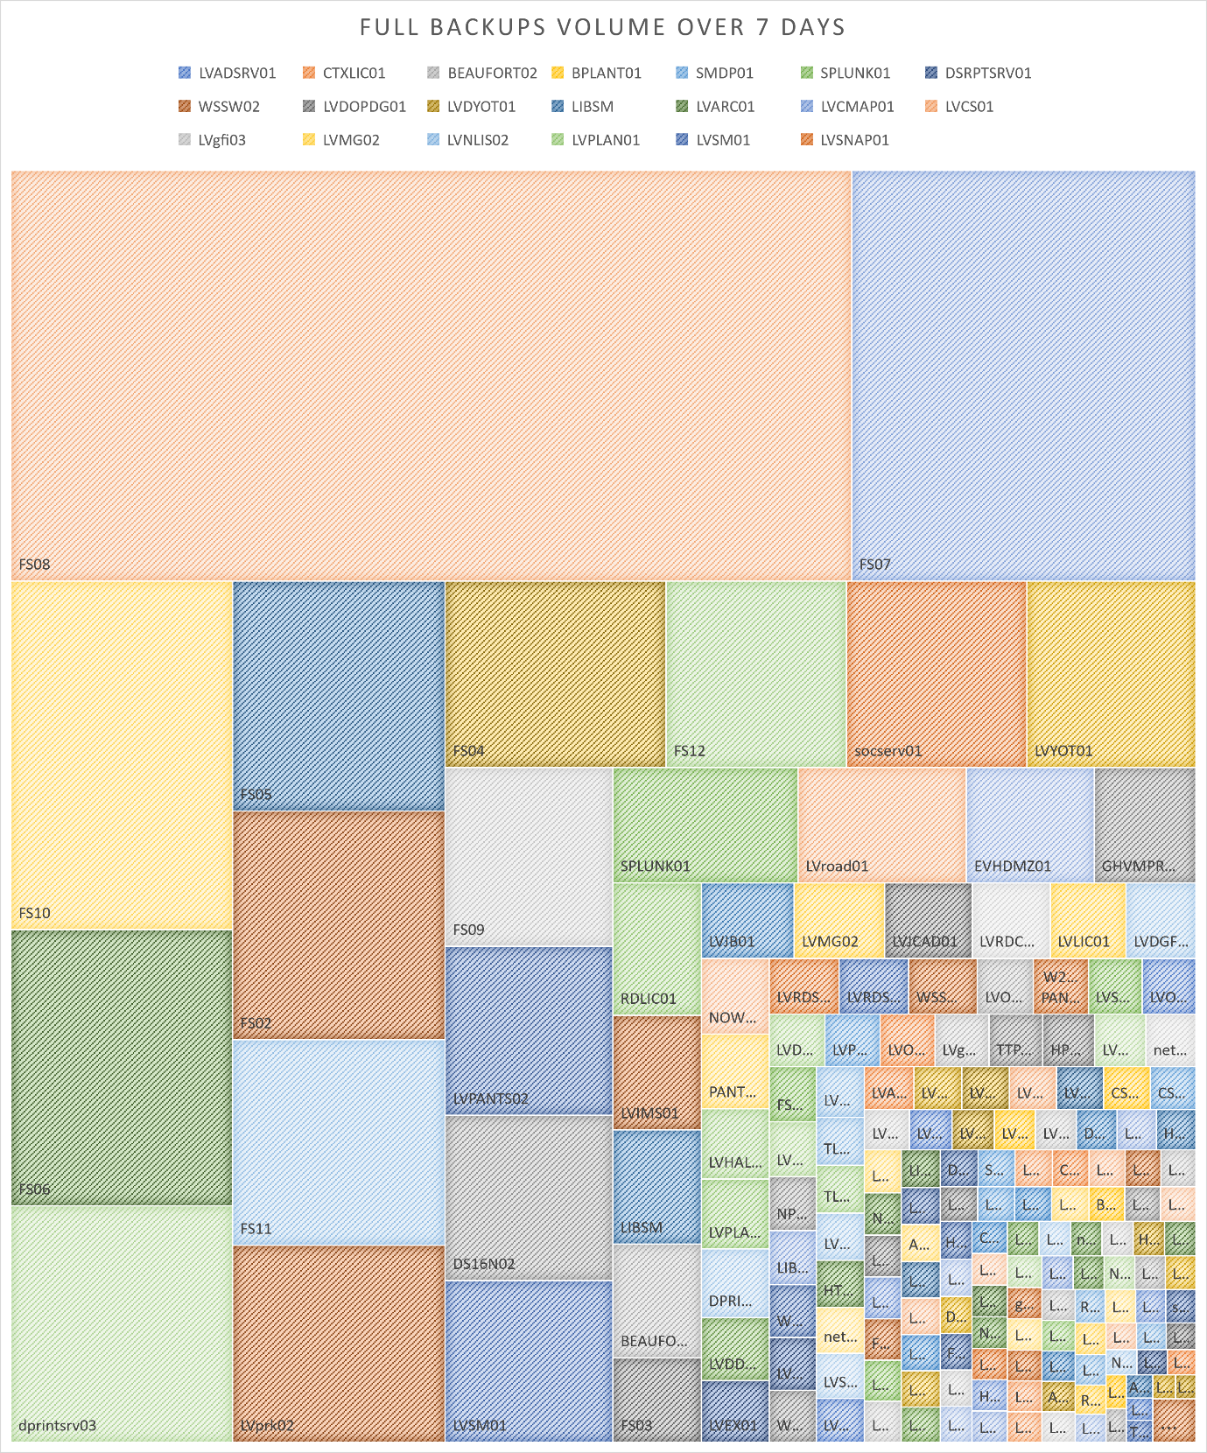
Figure 27 Tree map of full backups over 7 days

Backup specification
To limit the scope of the backup solution the author performed a Moscow analysis for a previous industrial research project. Reviewing the requirements with other interested parties with the organization produced the following list. [28]
Requirement | MoSCoW
Allow developers to restore their own data | Could
Manage solutions across different cloud tenancies | Could
Simplified process. | Could
Must be able to backup cloud VMs | Must
Be able to manage the backups of non-Wintel and x86 services | Must
be able to manage SQL and Oracle backups without additional expensive licensed features | Must
Be comparable in cost to the existing backup solution | Must
Reduce the number of consoles needed to support the whole estate | Must
Lower in cost than the existing solution over the next 5 years. | Must
Reduce the management overhead of running multiple backup solutions. | Must
Able to connect to multiple networks to backup different hosts across the network. | Must
Able to offload backups to the cloud for long-term archive and ensure that resilience is in place for that cloud archive. | Must
Maintain a minimum of 28 days of on-site backup. | Must
Be able to backup over 120TB of production data. | Must
Able to upscale / reduce easily to accommodate more / less production data without significant costs (including Office 365 and other cloud solutions/providers ). | Must
Backup cloud workloads i.e., Infrastructure as a service (IAAS). | Must
Complement our DR strategy by allowing us to recover from a major incident quicker than at present. | Must
Network integrity, better security. | Must
Potential offsite cloud backup – in theory, we could recover from a completely new site. | Must
Reduced bandwidth allowing us to backup more production data. | Must
Reduce resources to maintain the backup/restore process. | Must
Can aid the disaster recovery process and business continuity. | Must
Be able to interact with on-premises backup solutions | Should
be able to take existing backups offline (protect them using MFA or immutable storage) | Should
Allow for different Recover point objective | Should
Allow for different recovery time objectives | Should
Allow for different data life cycle policies | Should
Remove the need for tape media within the backup solution. | Should
Back up our current estate i.e., VMs, Physical Windows Hosts, UNIX hosts, Exchange, Oracle, File shares. | Should
More frequent recovery points and shorter recovery times. | Should
Smaller hardware footprint. | Should
Automation – devices can be added to backup processes without configuration. | Should
Licensed to back up all our production data (unlike at present). | Should
Tailor our backup service (at cost) to the needs of the service area i.e., longer retention periods. | Should
Backup SaaS Solutions | Wont
allow end-user to restore their own data | Wont
Disaster Recovery – A new backup solution does not provide resilience to infrastructure and hardware devices on our network. | Wont
Data stored on laptops, mobiles, and tablets. | Wont
Figure 28 MoCoW analysis of backup requirements

Post-build documentation Veeam/iLand

Introduction
Outlined below is a brief run-through of the infrastructure and services provisioned to meet the objectives to test the platforms. With screenshots of the platforms through various stages of operation.

Azure
Below are two machines that have been provisioned manually in the Azure infrastructure,
The Microsoft Windows guest was configured manually to use Veeam Backup and Replication server. Another Windows server has also been provisioned in a different tenancy that will be linked to later.

A preconfigured Azure backup appliance deployed from the marketplace was deployed as a Linux guest to manage Azure machine backups.

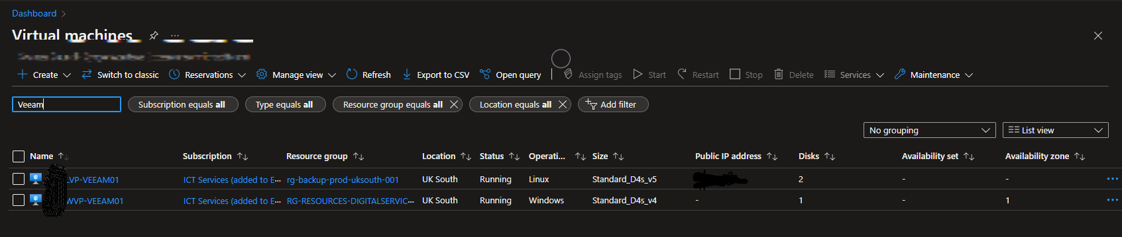
Figure 29 Azure virtual machines filtered to only include Veeam

Veeam admin console
On the Windows client machine, the applications have been installed.
Only administrative accounts are currently configured to log into the server that is hosting the application. Users currently only have access as Administrators within the application, their administrate access is accessible by logging in using domain-based credentials

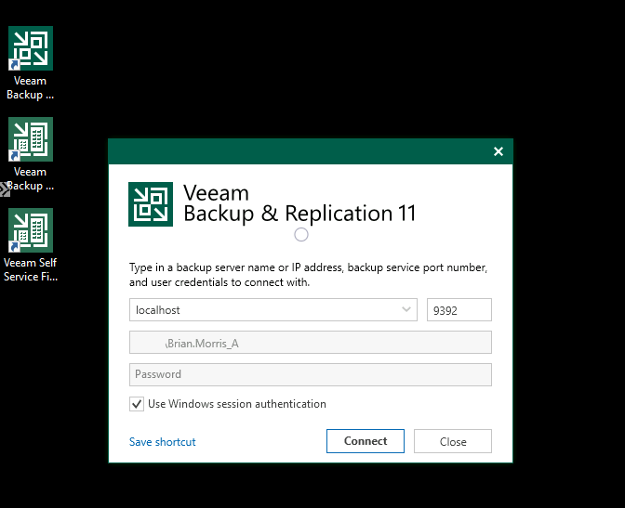
Figure 30 Login screen for Veeam Backup and Replication 11

Application home page with a list of jobs that have been configured.
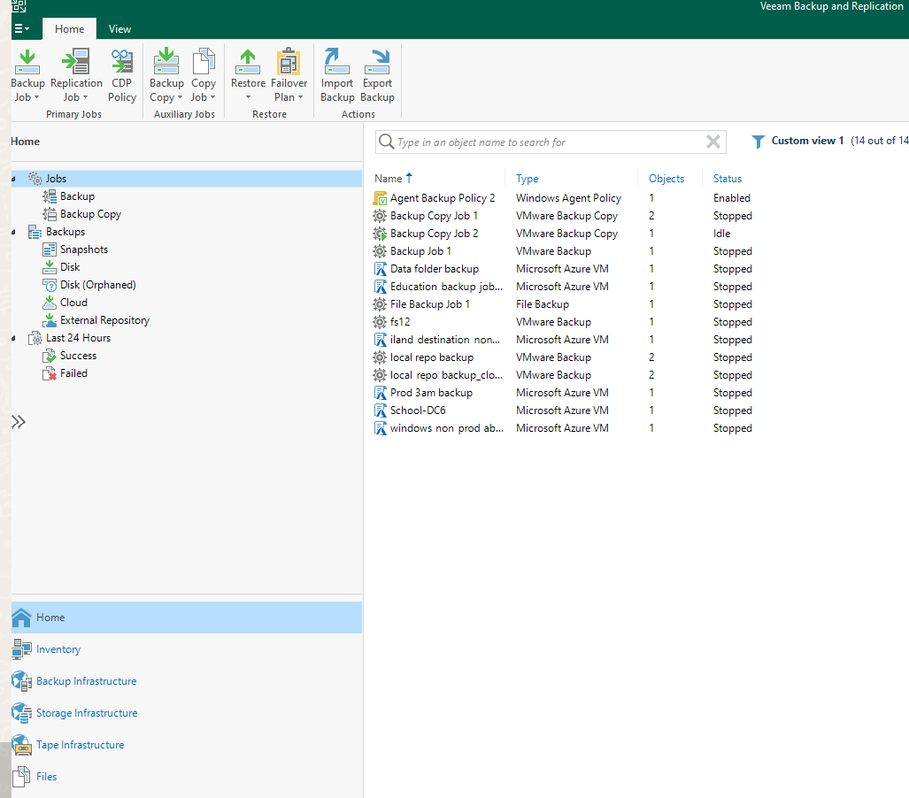
Figure 31 Backup and Replication Console home screen

Details of the third-party service providers the configuration is connecting to for the test.

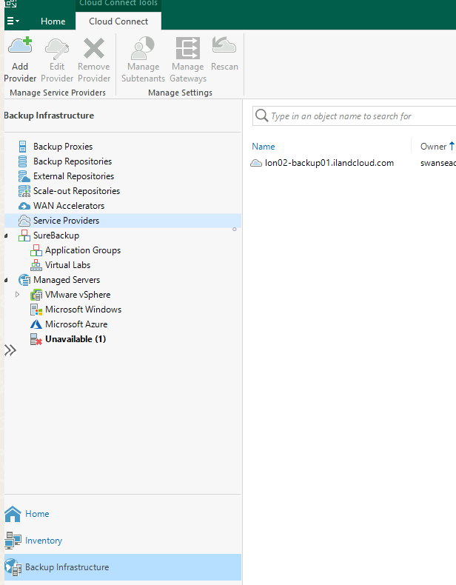
Figure 32 Backup and Replication 3rd party service provider

The application service has access to the primary storage arrays. Visible in this screenshot are some of the disk LUNS that have been presented to hosts. Snap shots taken at the hardware level are also available within the application to be restored from if required.

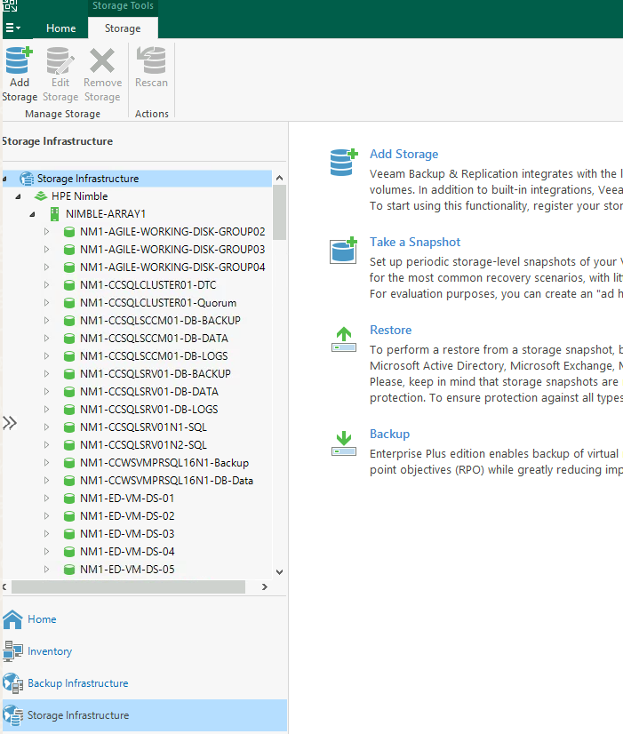
Figure 33 Backup software interrogating production storage

A selection of file shares has been made available for the application to utilise as required to write out backup jobs to disk.

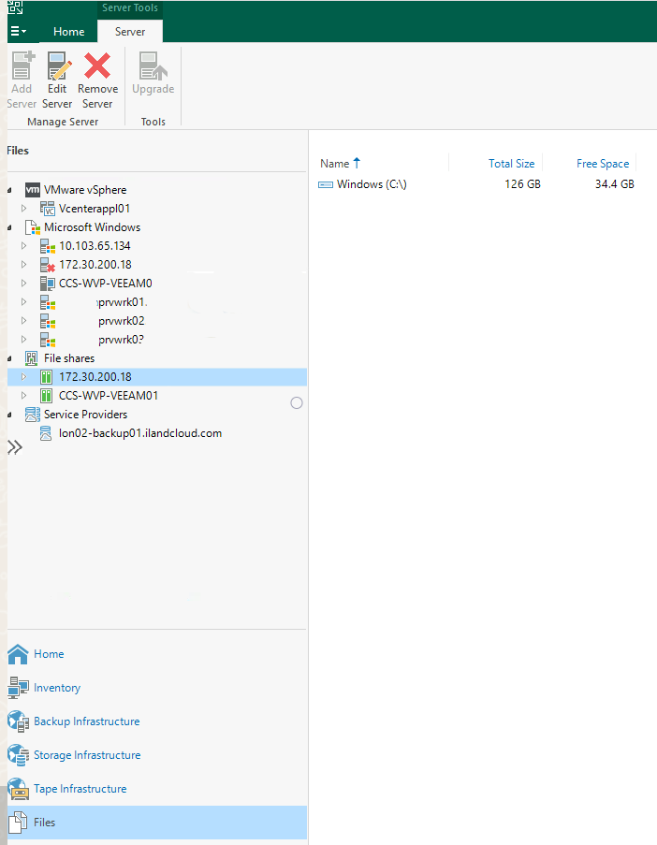
Figure 34 Files shares configured with the application

The above solution was replicated in another separate Azure tenancy. Once configured the native Veeam Backup Enterprise Manager administrative tool can be used to monitor and review the status of the clients in the additional tenants.

The application was configured to use Single sign-on functionality coupled with MFA to mitigate against malicious logins. The Application currently is only configured to permit designated backup administrators access to the service.

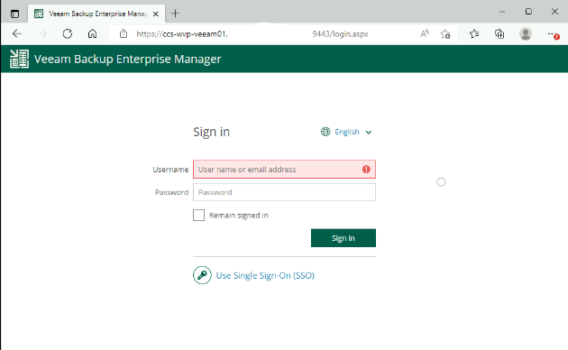
Figure 35 Single sign-on login screen for the Veeam enterprise application

The primary dashboard of the appliance shows jobs run in the last 24 hours

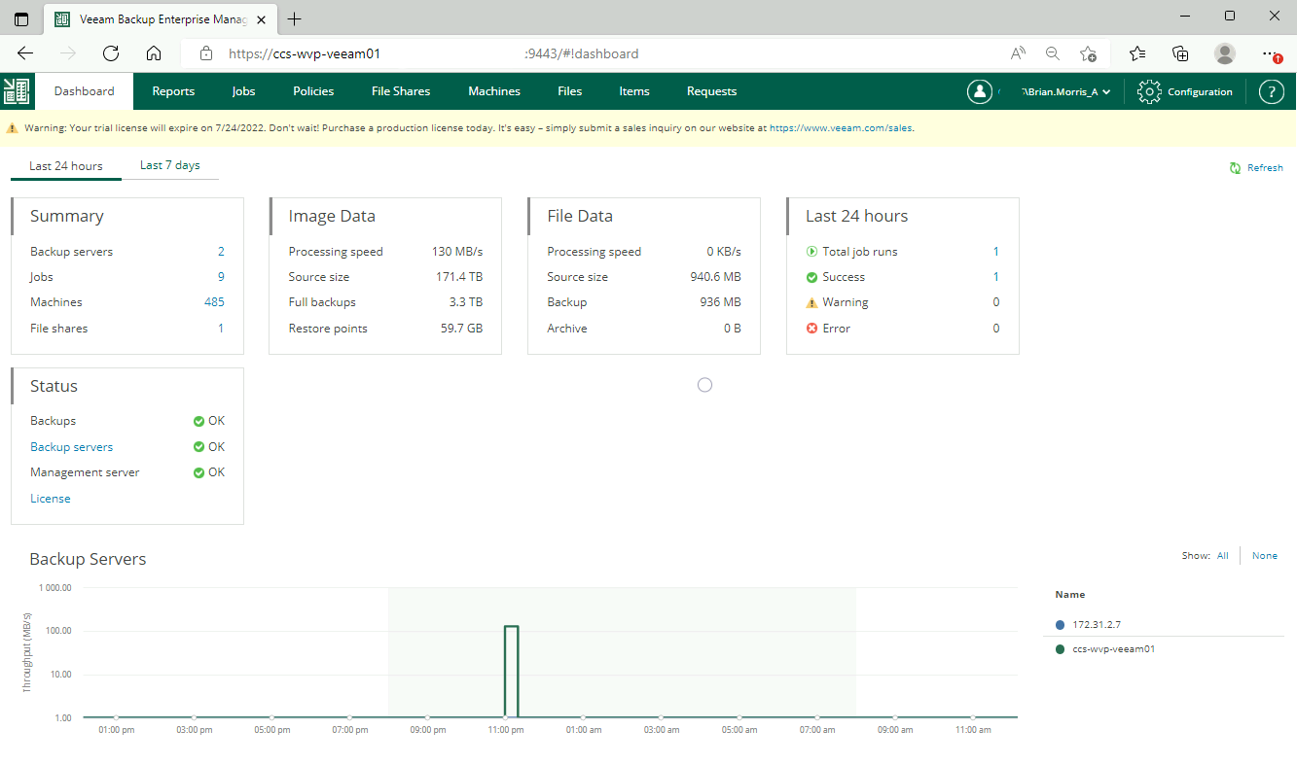
Figure 36 Primary dashboard

Overview of backup policies set to protect azure infrastructure

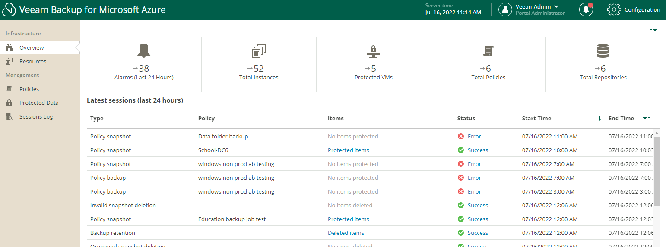
Figure 37 Backup Policies

Protected machines how many restore points are available and the date of the most recent.
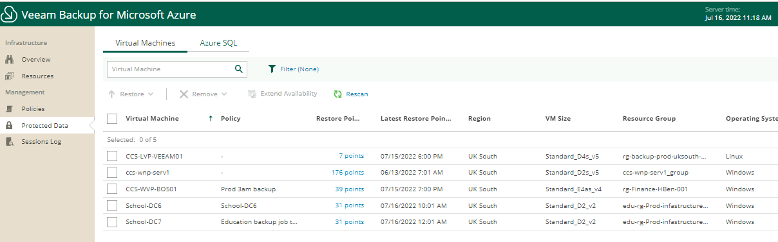
Figure 38 State of system protection

List of Azure hosted resources that are or are not protected by the platform

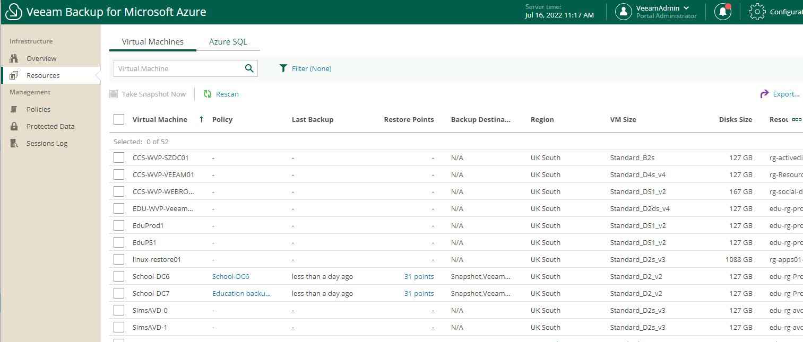
Figure 39 Unprotected resources

Session logs of different policies to drill down into job failures or successes.

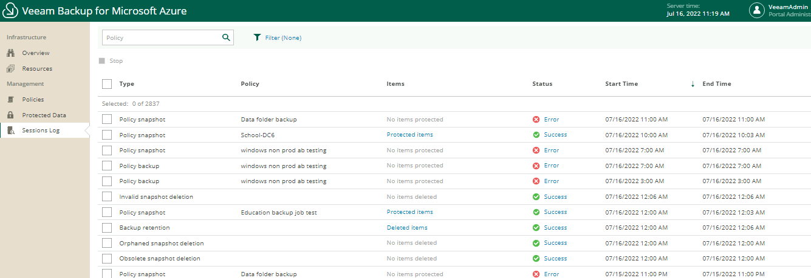
Figure 40 Session logs

Post-build documentation Redstor

Introduction
Redstor as highlighted before does not require as much infrastructure to be provisioned. The application vendor grants the end users organization access to use its service and authentication services are configured to ensure only permitted users within the organization can access the service with validated multi-factor authentication to the service.

An additional layer of multi-factor protection before permitting a registered user access to the cloud-hosted service.
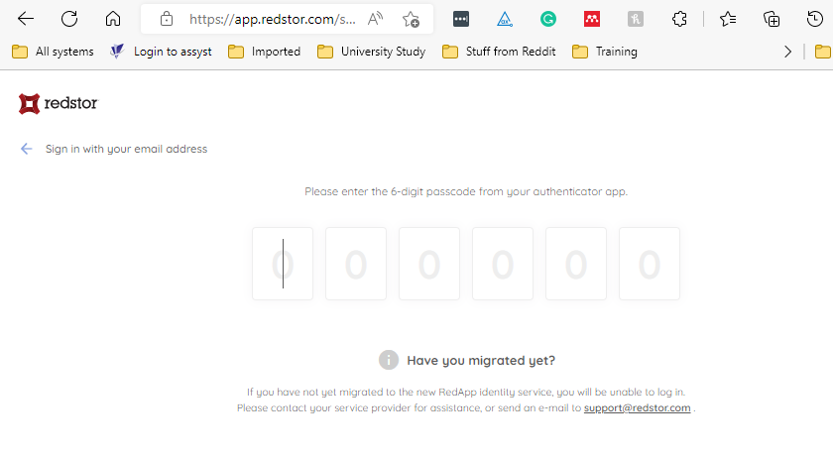

Primary dashboard of the server protection platform
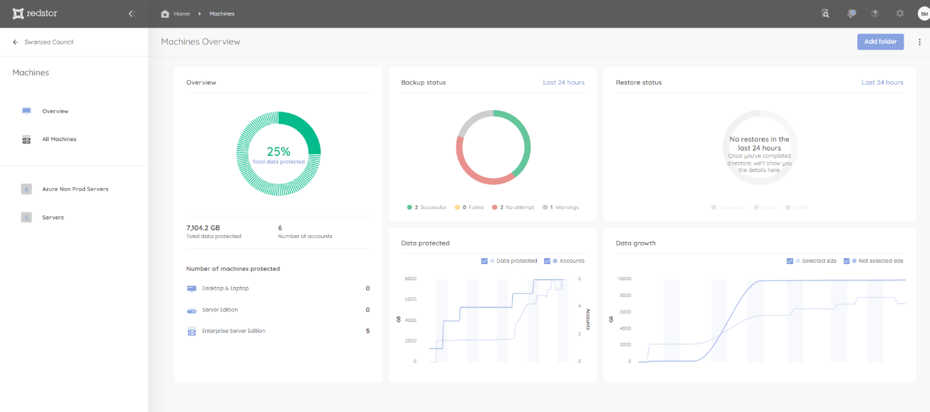
Figure 41 Main dashboard

Primary dashboard of the O365 protection platform
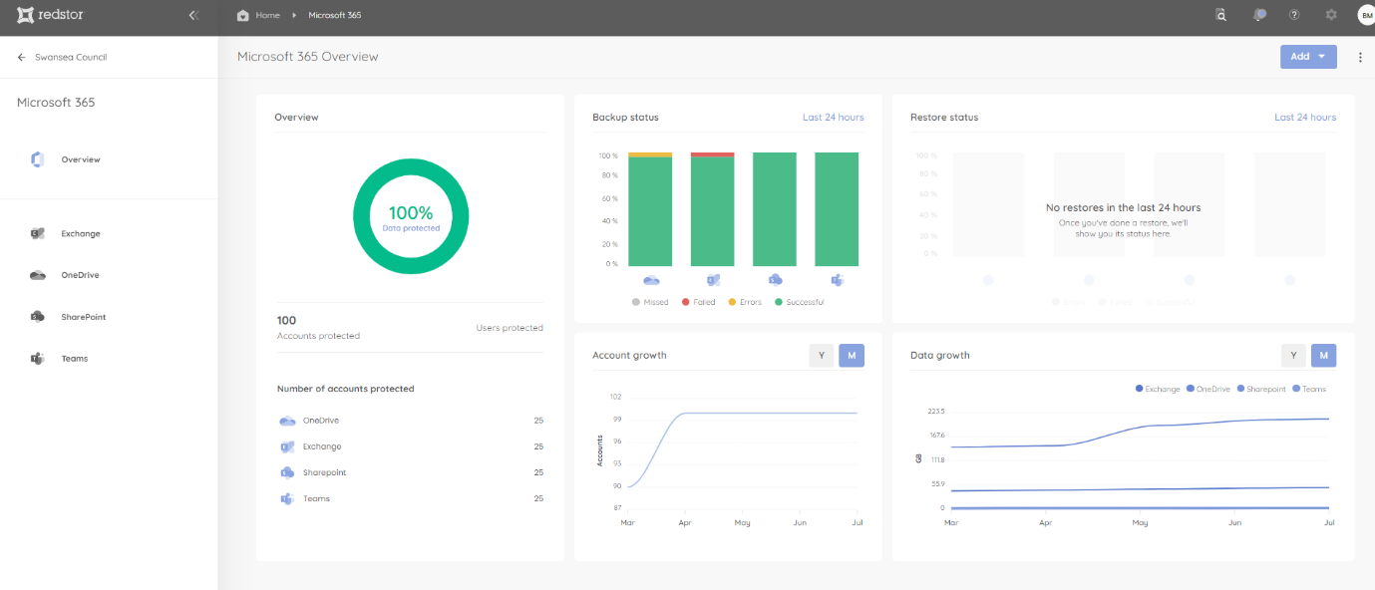
Figure 42 Office 365 dashboard

Azure hosted Servers
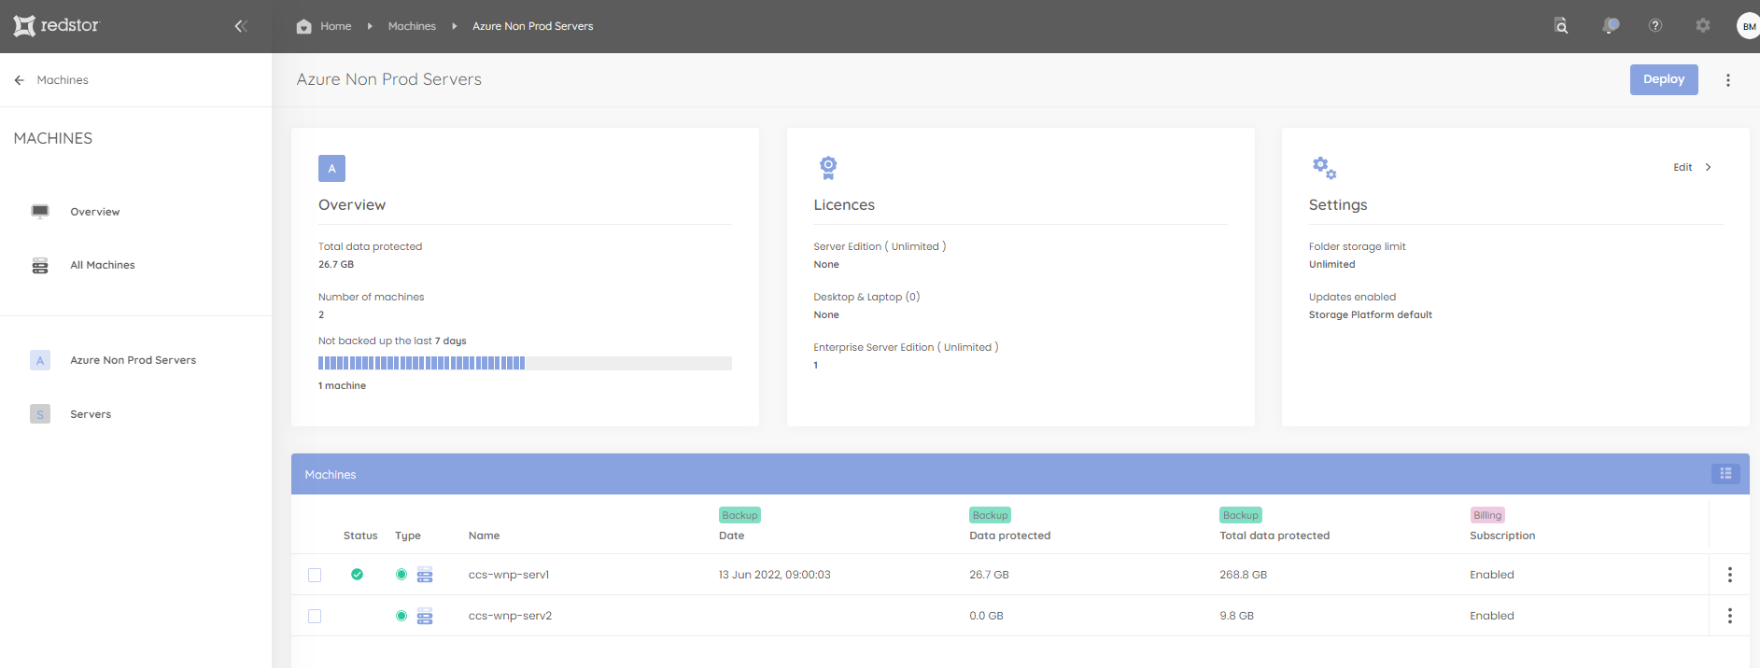
Figure 43 Azure Hosted servers

Physical and virtual machines running in different tenancies physical data centres and remote sites
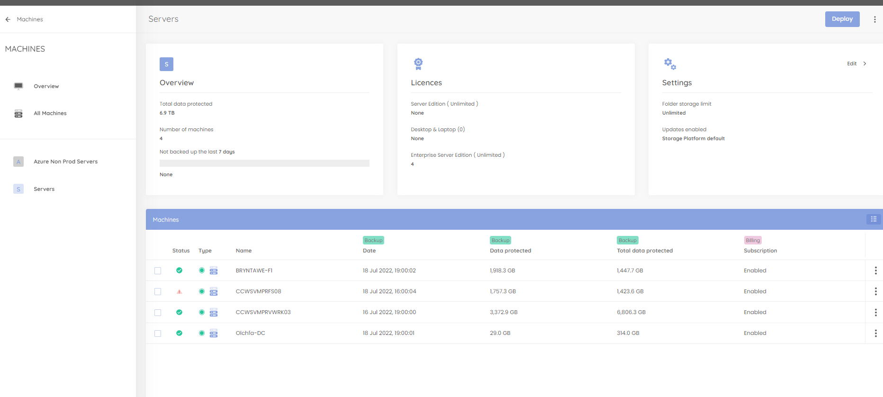
Figure 44 Servers at different physical sites

