Charging process within a capacitor ( Very simplified explanation )
An uncharged capacitor has no net charge on its plates. If we try to apply a charge, by connecting a battery, then electrons will flow from the top plate of the capacitor towards to plus terminal of the battery and electrons will flow from the negative terminal of the battery towards the bottom terminal of the capacitor to maintain a constant battery terminal voltage.
It takes time for the electrons to transfer to and from the battery; hence there is a time delay between the application of the applied voltage and the time taken for the charge on the plates to equal that on the battery terminals. To compound the problem, the molecules of the dielectric orientate themselves in such a way as to reduce the net applied field and so the charging process is slowed whilst we wait for all of the molecules to rotate. When all the molecules have rotated then there will be no further reduction in electric field and the capacitor will then continue to charge-up .
The initial current will be high as there is no initial negating field from the molecules, however, as the molecules start to align with the field there is a net reduction in effective charging and the charging current slows and so the rate of change of the capacitor voltage on the capacitor plates will slow to almost zero and the charging current will fall to almost zero. This final stages theoretically takes forever as the charging current reduces to zero and the capacitor voltage approaches the battery voltage.
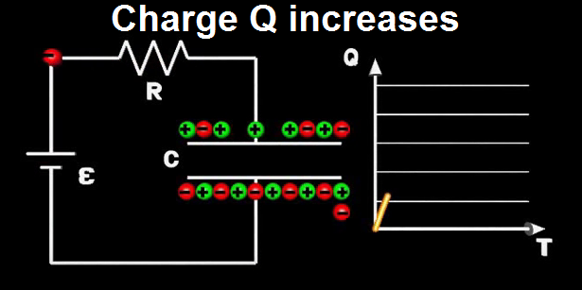

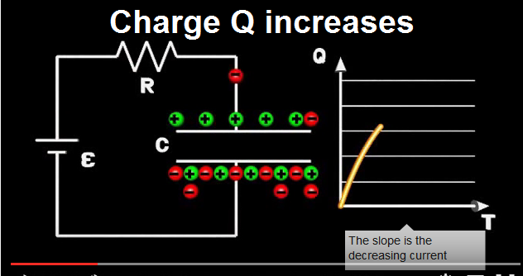

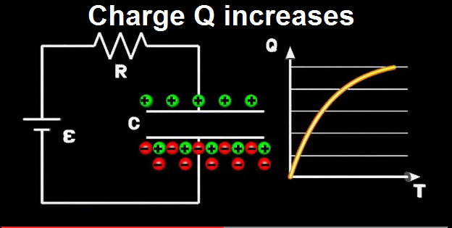

Note: Speed of charge transfer reduces as the capacitor charges up. This means that the charging current is initially high but reduces with time such that the charging current goes to zero as the capacitor voltage reaches the voltage of the charging battery.

