

Site Investigation Case study

December 8

Darlow Lloyd Construction
Authored by: Kyle Davies

Contents
Contents 2

Introduction …………………………………………………………………………………………………………… 3

History of the site ………………………………………………………………………………………………….. 4

Geological information/Desktop Study ………………………………………………………………..... 5

My Advice for the Site investigation …………………………………………………………………. 6

Foundations ………………………………………………………………………………………………………… 7

What are foundations used for ? ……………………………………………………………………… 7

What foundations won’t I recommend for the site ………………………………………….. 7

What foundation should be used ……………………………………………………………………. 8

References ……………………………………………………………………………………………………………. 9

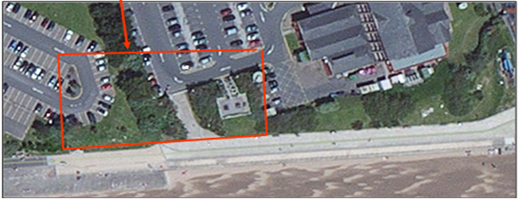
Introduction

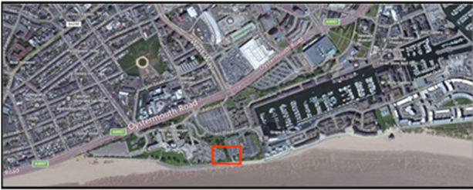
My name is Kyle Davies and I work for the company Darlow Lloyd Construction. I have been asked to tender work for a new Ice cream parlour and new restaurant, including Manager’s apartment in Swansea foreshore. The building that is being requested for tender needs to ‘contain a restaurant, Café bar, Ice cream Parlour, kitchen, food stores etc.’ I will also undertake appropriate site investigation of the ground before planning the foundations that will need to be used for the new building to be built.
This image was taken from google maps 2018 as a snapshot to see the whole area of the site.

The new agreement in place to build a new restaurant and ice cream parlour with a manager apartment area within a new constructed building in City of Swansea. The location of the new building would be located between country hall and the Marriot Hotel. There is a joint agreement with the Marriot Hotels to create the restaurant and ice cream parlour on the Swansea foreshore, but, before the work can go ahead site investigations and appropriate testing will need to be done on the existing ground for the appropriate foundations to be put in place for the new building as requested. To understand the requirements of the site I will need to look at the full historical background of the site, including drawings and the history of the ground with the appropriate testing to be undertaken. With this information I will give my recommendations for the contents of the site and what can be done with the waste given its historic background. I will give brief information about the building regulations/ codes of Practice which are used from my research that will be used in the project. Finally, once all of this has been looked at I will give my opinion on what type foundation should be used on the site from what I have discovered from the drawings and research, I will also explain why I would use the given foundations for this particular building.

History of the Site

Before any work can be done on the site a full background and historical look on the site must be done. During the desktop study I conducted on the site I looked at aspects such as, what was there previously, what could be in the ground e.g. bombs from the war or contaminated material, any geotechnical information, environmental and possible hazards on the site. To make sure that my information was correct I used websites and paper information to come to a conclusion what was most likely to be in the ground. With this information I can decide what foundation is best suited for the ground of the site.
During the outbreak of World War II Swansea had been hit with bombs during the ‘Three Nights Blitz’ in February, 1941. The bombs were mainly focused on the city Centre of Swansea but also hit the docks and ‘industries virtually unscathed but the town Centre was completely obliterated’ (Swansea Museum (N.d), this was stated in the Swansea museum website about World War II in Swansea town. This means there is a possibility that during this period of time the site that we are looking at could have un-exploded bombs or bits of scalpel scattered around. To make sure in the ground that we were going to build on, there were none of these materials I needed to get a geotechnical look on the site and investigate where the bombs dropped during the war.
I went to the local Swansea Civic Centre to look up the Maps and other Service information about the site. I needed to look at the locations of where the bombs were dropped to see if the site could have un-exploded or scalpel to be aware of. I looked up a booked called ‘The three nights blitz’ by J R Alban February 1941 ‘ and this book give the locations of where the bombs were dropped during the War, that were recorded (Alban, J R (1941, February). The problem was this book had only shown the ones recorded and it is possible that some were missed, meaning they landed and didn’t exploded. During my research I discovered that the town Centre was the area that was bombed the most so it would be unlikely to discovered any un-exploded bombs around the area of the site (Swansea foreshore , Shown in the pictures on page 1), but, when excavating for the foundation it is important to keep in mind there is a possibility of finding bombs or other materials in the ground.
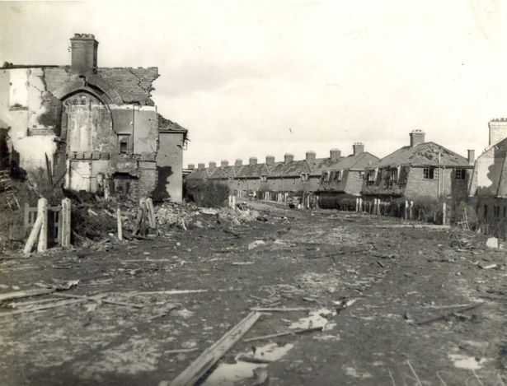
(Turner, R (2014, 14th September)
(Thomas, G (2018, 14th March)
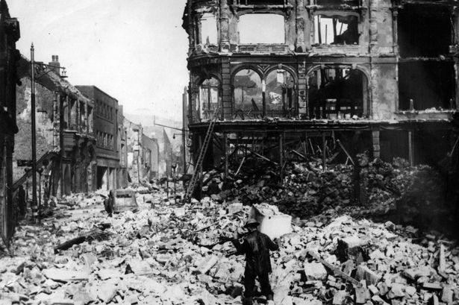

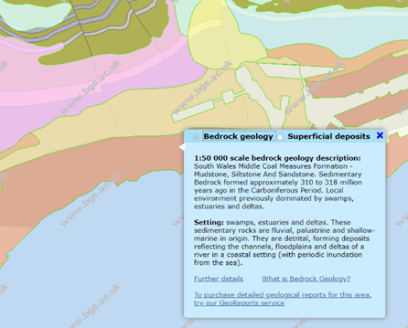
Geological information/Desktop Study
(British Geological Survey (N.d)

During the Study of the site I needed to know what was in the ground to understand what foundation was needed. During the desktop study I used a website that showed the general information of what would typically be in the soil in the area of the site in Swansea. This give me a general idea of what I am expected to find during the study of the site. South Wales was massively involved in the coal industry due to the amount of coal that was in the ground. Typically, in this ground I would expect to see Mudstone, Siltstone and Sandstone. I could expect to see swampy like setting on the site as it is near the sea line, and water is being soaked into the ground through channels, and also the ‘river in the coastal setting’. From looking at this website I made an observation that the main materials that would be found in the ground are, Sand, Silt and Clay. This is what typically would be found in this ground as the site is near the shoreline of Swansea. This is important to take into account as the ground is most likely to be soft and may need to dig to a deeper depth than normal to make sure the foundations are built on solid ground. Also, water could be a problem on this site as the water table could be high so appropriate water pumping services should be provided during the excavation of the site. I would recommend that ground tests and sampling should be done to check if there are any problems with the condition of the site for additional information, and as a double check before work starts. During the desktop study I discovered that there used to be a trainline that used to run across the site.

I looked at the trainline that used to run across the site.

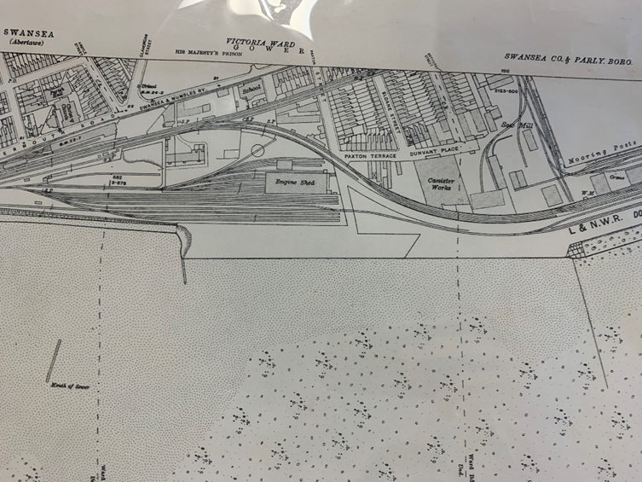
By looking at the drawing you can see that there used to be an old Engine Shed and also a live train line tracks. In the Shed there could have been oils and other contaminated materials that may have gotten into the ground. The ground of the site that is going to be built on could be contaminated so the appropriate removal and excavation of the material will need to be looked at by specialist constructors to dispose of the material responsibly. If there used to tracks running through the site there could possibly be material left during the removal of the tracks and left metal in the ground. Going back to the Geology map of Swansea we could expect the following substances in the ground shown in the table below:
Glamorgan, Sheet XXIV.9, Swansea Co & Parly.Boro 1919 – Civic Centre Swansea
Computer Code: | MBD | Preferred Map Code: | notEntered
Status Code: | Index Level
Age range: | Quaternary Period (Q) — Quaternary Period (Q)
Lithological Description: | Shingle, sand, silt and clay; may be bedded or chaotic; beach deposits may be in the form of dunes, sheets or banks; in association with the marine environment. [Generic description].
Oils and contaminated material could be in the ground as well as the ones stated in the above table. Other subcontractors should construct a full environmental site investigation on the site to check for any containments to make sure all work conducted follows the good Codes of Practice. (British Geological Survey (N.d)
(British Geological Survey (N.d)

Recommendations for the Site investigation

After looking at the site and reviewing the desktop study information that was collected, there are a few things that will need to be looked at during the site investigation. When I looked at the soil characters of the site I found out that the ground is most probably soft and contains materials such as clays, sand and other gravely material as It is near the coast. This means that the ground type is a Type C soil, meaning it has the least stable materials, in which water is most likely to be flowing and have a high water table. During the site investigation the ground should be assessed to determine the water table and main characteristics of the ground. A method that would be acceptable to use to get a better understanding of the ground is creating a few boreholes around the site. This can investigate if ground water is there and the characters of the site. When doing this the geotechnical advisor should be the one to access the amount of holes needed when sampling. When doing exploratory holes it is important to use the appropriate Codes of practice (BS EN 1997-2). The samples should be tested at different depths and locations around the site for the best accurate results. This site investigation must include bore holing to different depths and disturbed and un-disturbed should be tested. When conducting the tests there are few sampling rigs that are available but the best one for this site would be hand-held rigs for the small depths and feed frame mounted machine rigs for the greater depth as the ground is soft and possibility uneven. During this site investigation it is important to look at the environment and the possible habits that the site may have. To understand what foundation should be used on the site it is important to understand the load bearing capacity of the ground, ground bearing tests should be completed on this site to see the possible load it can take. The building that is being created on the site will be a two-story building so the load bearing will need to be able to take the ground that it is on. Ground bearing tests on this site during the site investigation is highly recommended. It is also important during the site investigation to check the services pipe lines that may go across the site such as sewage or general waste drainage systems.

Foundations

What are foundations used for ?

Foundations are used to support the building and the loads that it carries. This makes sure that the load of the building that is going to be built can transfer the weight of the foundation in the ground. The primary use of a foundation is to make sure the building has a secure platform to build on during the project and throughout the building life cycle.

What foundation type are not suitable for this given site?

As discovered during the desktop study we know that the ground is soft and has a high water due to fact it is near the coast line in Swansea. So when looking at foundations we can rule out the following types; Strip, Pad and raft foundations can be ruled out. See the pictures and information below to explain why:

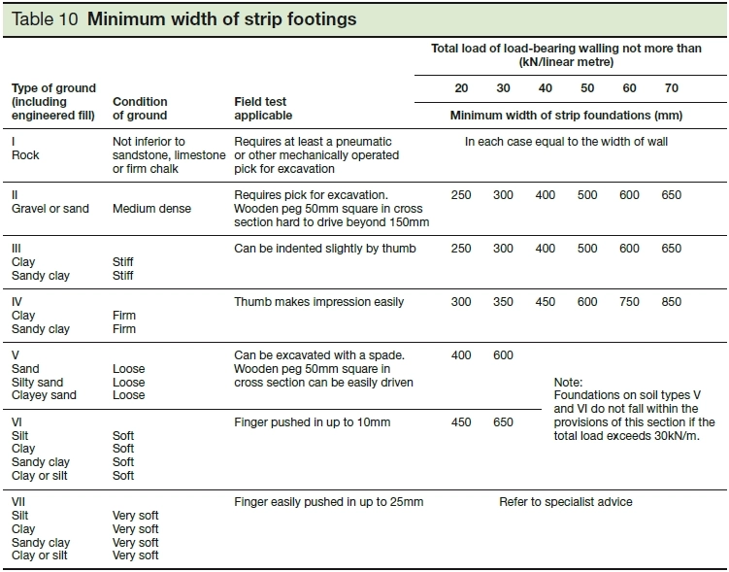
Strip foundation wouldn’t be used on this given site. The ground is made up of sand, silt and clay which this type of foundation will not bear good against. As you can see in the table on the right, this shows that type 5 soil is unsuited to strip foundation and it won’t work on the ground of this site as the approved building regulations that were published in 2013.

Pad foundations are another type of foundation that wouldn’t be used on this site due to the loose sand and gravels similar to the strip foundations.
I also looked at possible use of a raft foundation. Raft foundations are good when building on bad good conditions as the load is spread across the whole of the foundation. You can thicken the raft foundation edges with additional reinforcement. On the site ground settlement is a problems as it is most likely to move or have a differential settlement is very likely on this site. The raft is a good option for the site where as it may be impractical to create individual strip or pad foundations. The problem with using a raft foundation on this is site is the possibility of the foundation cracking due to the movement of the foundation on the soft and water controlled ground. Water pumping could be used to reduce the water content in the ground but this can be an expensive and complex process when it comes to making the foundation. The load bearing stress of the can be high as it is a two Storey building and we need a foundation that is strong and secure at those levels. The foundation I would use for this site is a piled foundation.
Approved document A of Building Regulations published in 2013. (Designing Buildings Wiki (2019, 29th November)
Piled Foundation

Piled foundations are the best type of foundation to use for this given site in Swansea. Piled foundations can be made into any length and designated to take the load of the building of a two Storey building. But when coming to the type of Piled foundation to use it was important to look into the properties and which type would be the best. After researching I believe the best type of foundation is a piled raft foundation.

Raft foundations are shallow foundations that are formed like concrete slab and it spreads the load across the area of the raft, the Ables this to ‘float on the ground as raft floats on water’ (Designing Buildings Wiki (2018, 17th January). Piled foundations are deep foundations that are piled down to stronger ground to be able to support the load. Piled raft foundations are typically used on high rise buildings as the can support a large load which you would find in a high rise building such as 2 or 3 Storey structure. I believe this is the appropriate foundation as it is suitable for ground and soil that is hard to settle and a prone to movement due to the properties in the soil. The raft and piles will work together in the building process to make sure where the ground Is unsettled it will be able to provide the loading capacity needed. Piled will make sure the ‘stiffness while the raft provides additional capacity at the ultimate loading’. A piled foundation in the most suitable for this site due to the soft ground. A typically piled foundation will go approx. 20m deep achieve maximum loading capacity on the two Storey building. There is also another option that could be used for this site and that is pilled raft which uses the properties of raft foundation and the piled together to achieve the goal necessary. The raft will make sure that the load is spread across the area required and the piled foundation will allow the stability of the foundation as the building increases in height during the construction process.
Two Storey Building
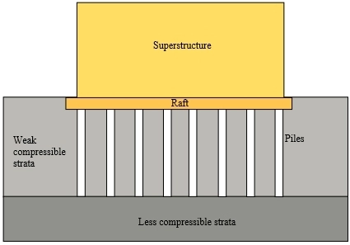
The raft foundation with approx. 300mm thickness.

Piled foundation is approx. 20m deep to hit solid ground so the Weak compressible strata can be supported giving the building a suitable foundation to build on.
Weak Compressed Soil

References

- (Turner, R (2014, 14th September). How Swansea's devastating Blitz was seen through the eyes of children. Retrieved from: https://www.walesonline.co.uk/news/wales-news/how-swanseas-devastating-blitz-seen-7769298

- (Thomas, G (2018, 14th March). The telltale evidence of the Swansea blitz you walk past every day without realising. Retrieved from: https://www.walesonline.co.uk/news/wales-news/telltale-evidence-swansea-blitz-you-14422515

- (Alban, J R (1941, February). The Three Nights Blitz. Location: City of Swansea

- (Swansea Museum (N.d). World War Two. Retrieved from: http://www.swanseamuseum.co.uk/swansea-a-brief-history/world-war-two?doing_wp_cron=1575124468.4653010368347167968750

- (British Geological Survey (N.d). Geology of British Viewer. Retrieved from: http://mapapps.bgs.ac.uk/geologyofbritain/home.html

- (British Geological Survey (N.d). The BGS Lexicon of Named Rock Units — Result Details. Retrieved from: https://www.bgs.ac.uk/lexicon/lexicon.cfm?pub=MBD

- (Designing Buildings Wiki (2019, 29th November). Strip Foundation. Retrieved from: https://www.designingbuildings.co.uk/wiki/Strip_foundation

- (Designing Buildings Wiki (2018, 17th January). Piled Raft Foundation. Retrieved from: https://www.designingbuildings.co.uk/wiki/Piled_raft_foundation

