Reconstruction of the Flood-Damaged Transport Corridor between Worcester and Kidderminster

Table of Contents
Part B: Reflection on Feedback 3
Part C: Project Management Plan 5
1. Introduction 5
2. Project Description 5
3. Project Scope 6
4. Work Breakdown Structure 7
5. Quad Chart 9
6. Gantt Chart: Project Schedule 10
7. Stakeholder Involvement 11
8. Resource Allocation 13
9. Risk Analysis 14
10. Conclusion 15
References 16

Part B: Reflection on Feedback
The project proposal poster of the Transport Corridor Reconstruction Project was submitted to the tutor and peers to describe the planned reconstruction of the damaged transport corridor by the floods between Worcester and Kidderminster. The purpose of the poster was to cover a brief history of the flooding incident, state the purpose of the project and show how some of the project management tools would be utilised. The received feedback on the presentation was useful in determining the strengths of the proposal and areas where further improvement was necessary prior to coming up with the project management plan in final.

The clarity of the project idea and the relevance of the selected project in the scenario of flooding as outlined in the assignment brief were one of the key strengths identified in the feedback. It was found that the explanation of the flood disaster and its effects on the transportation infrastructure was clear and relevant. Application of visual project management tools such as the Work Breakdown Structure, Gantt chart and stakeholder power-interest matrix were also positively accepted since they assisted in presenting project structure in a brief and comprehensible way. Moreover, the project goals were also viewed as pragmatic and in line with the overall objective of restoring transportation linkage in the region that was affected.

Nevertheless, various improvisation points were also found in the feedback session. One of the recommendations was that more elaboration of the project management tools in the written project plan should have been made instead of showing reliance on diagrams only. As an example, the risk analysis section in the poster was deemed to be rather short and it needed to be extended to incorporate more potential risks and mitigation measures. It was also indicated that stakeholder involvement segment ought to have additional explanation of communication plans and stakeholder participation at the project lifecycle. In addition, the section on resource allocation should have been elaborated further on allocation of human, financial and material resources that are needed in the process of the reconstruction activities.

Based on this response, many changes were made that were incorporated when coming up with the final project management plan. The section of risk analysis was to be expanded by adding more risks that could occur such as delays associated with the registration procedure, equipment failure and compliance issues. The explanation of each project management tool was also provided with further justifications on how the tool achieves project planning and control success. The section of stakeholder interest was improved by providing information about such communication methods as progress meetings, project reports, and community engagement programs. Such additions rendered the end plan of project management very clear and complete.

In general, the poster presentation feedback was crucial in the process of polishing project plan and enhancing the quality of final submission.

Part C: Project Management Plan

1. Introduction
During July, 2025, the West Midlands was hit by severe flooding following prolonged rainfall linked with an unusual weather pattern that was an Atlantic that had been experienced. The rise in the water level of the River Severn caused the flood defences to be broken in various places such as Worcester, Shrewsbury and Kidderminster. The damage of infrastructure was also a major consequence of the flooding especially in the transportation system where roads and bridges were blocked temporarily as a result of the structural damage. These interferences impacted the transportation of commodities, emergency and daily commuters providing economic and logistical problems to the local communities and business (Kurth et al., 2020).
It is necessary to then repair the broken transport route between Worcester and Kidderminster to enhance connectivity and promote regional recovery. The following project management plan outlines the systematic way in which the reconstruction project is to be implemented by employing the most important project management tools and techniques.

2. Project Description
The project to be proposed is aimed at reconstruction of a transport corridor that is damaged by floods between the towns of Worcester and Kidderminster in the West Midlands. After the July 2025 floods, which were very devastating, a number of parts of the corridor were damaged structurally because of continuous floods and debris deposits. There was flooding, damage of bridges and drainage systems, which led to the temporary shutting down of major transportation channels (Hirwa and M. H. Mostafa, 2025). The reconstruction project will be geared to find remedy to the functionality and safety of this vital infrastructure by employing a systematic project management strategy.

Worcester and Kidderminster transport passage is a very vital part of the transport structure in the region. It helps in transferring commuters, business goods, and emergency services in the key cities and industry regions in the West Midlands. Any interruption to this passage can have profound effects on the economic activity of the region, supply chains, and movement of people. Hence, it is important to recover such infrastructure to facilitate economic recovery and guarantee assured connection among affected populations (Gajanayake, Khan and Zhang, 2020).

The project will entail the following activities that will include a site inspection, development of the engineering design and the procurement of the construction materials and reconstruction of the damaged sections of the road and bridges. Drainage systems will also be improved in order to make them more resilient to future flooding incidences. Also, the safety checks and quality assurance measures will be carried out to verify that the infrastructure standards and regulatory standards are met (Sargsyan et al., 2024).

When the project will be completed, the current situation is expected to be reinstated with safe and efficient transportation along the corridor and the capacity to withstand extreme weather conditions. The construction will contribute to the stability of the region economy, the safety of roads, and the accessibility of the region by the local communities and emergency services.
Table 1: Project Overview
Element | Description
Project Name | Transport Corridor Reconstruction Project
Location | Worcester – Kidderminster, West Midlands
Project Duration | Approximately 9 months
Estimated Budget | £15 million
Project Objective | Restore safe and resilient transportation infrastructure

3. Project Scope
The project scope outlines the scope and deliverables of the transport corridor reconstruction project between Worcester and Kidderminster which was damaged by floods. The importance of scope definition is also very clear in project management because it guarantees that all the project activities are in line with the project objectives without necessarily increasing the scope and attention of the project. Scope management is specifically significant when it comes to infrastructure reconstruction projects because of the complexity of construction process and multiple stakeholders involved (Ajmal et al., 2022).

The main role of this project is to rehabilitate the structural integrity of the transport corridor and operational functionality. Some of the activities that may fall under the project scope are reconstruction of damaged roads, repair of structures at the bridges, enhancement of the drainage system and carrying out of safety checks to make sure that the transportation infrastructure complies with the standards of the infrastructure. The aim of these activities is to reinstate safe and efficient transportation and enhance resilience of the corridor to future occurrence of floods.

Nevertheless, there are a number of activities that are not within the scope of the project. These would include rebuilding residential properties that were destroyed during the flooding, building up of the flood defence in the region and wider urban regeneration programs. With such definitions of the exclusions, the project team will be able to keep on track of the key infrastructure goals and prevent scoop creep which otherwise could result in higher costs, delays and ineffective use of resources (Ngacha, Abhukalaf and Orono, 2023).
Table 2: Scope Definition
In Scope | Out of Scope
Road reconstruction | Residential property rebuilding
Bridge structural repair | Regional flood defence construction
Drainage system improvements | Environmental restoration programmes
Safety inspections | Urban redevelopment projects

4. Work Breakdown Structure
WBS means the Work Breakdown Structure, which is a significant project management tool and is applied to break down a project into smaller manageable units. It offers a hierarchical break up of the scope of the entire project into integrated tasks and subtasks which allows the project managers to plan, structure and monitor the activities of the project. The WBS enhances clarity by dividing the large projects into small units of work, hence streamlining the process of resource allocation and further easing coordination among project teams (Griffin, Thomas and McMurtrey, 2022).

In the case of the Transport Corridor Reconstruction Project, the WBS shows the key stages that need to be undertaken in the process of reinstating the damaged road network between Worcester and Kidderminster. The initial stage entails planning and approval of project whereby the project objectives are established, and relevant authorizations granted. This stage also incorporates the preliminary site inspections to determine the level of damage caused by floods and determine the need to repair infrastructural damages (Sanchaniya, Somrajan and Geipele, 2023).

The second stage is concerned with the development of the engineering design, wherein the engineering teams prepare the technical plans to reconstruct the roads and do repairs to the bridges. After this, the procurement phase is where the contractor is selected and materials needed in the construction works are sourced.

Construction phase is the most critical part of the project, in which the damaged areas of the roads will be built, bridges will be installed, and drainage systems will be improved to increase the resistance to the floods. Upon completion of construction, the project enters the testing and quality inspection stage where all infrastructural measures are checked to fit the safety standards and regulatory measures.

The breakdown of tasks with the help of the WBS facilitates the effective scheduling of tasks, enhances accountability within project teams and allows monitoring of project progress to be efficiently conducted during the reconstruction process.
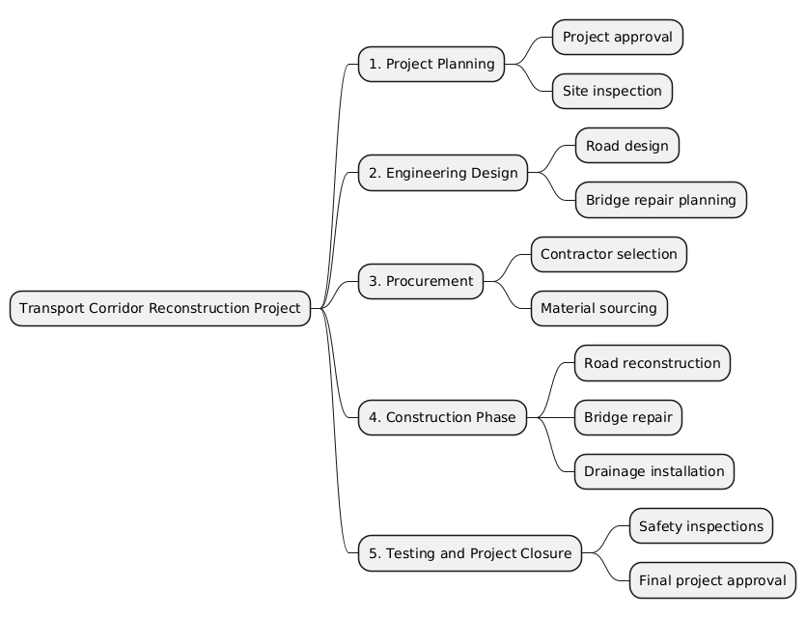

5. Quad Chart
The Quad Chart is a visual project management system that gives a brief overview of the most important areas of a project in one system. It normally displays four project dimensions, including objectives, schedule, and budget and risks. Having all these factors in one overview, the quad chart enables the stakeholders to have a brief overview of the key objectives of the project, the time schedule intended, the funds available and the possible obstacles that are likely to be encountered in the implementation process (Kyriakogkonas et al., 2022).

Under the Transport Corridor Reconstruction Project, the quad chart indicates the main aim which is to restore the transport corridor destroyed by floods in Worcester to Kidderminster and enhance infrastructure resilience and safety of the roads. It also defines the suggested plan, which entails planning, designing, building, and final test. Also, the chart will give an understanding of the approximate project budget and the major risks that can influence the project delivery including delays in the weather, supply chain problems, and possible cost overruns.

All in all, the quad chart helps to create the process of effective communication with the stakeholders by demonstrating the complex data of the project in the form that can be easily interpreted.
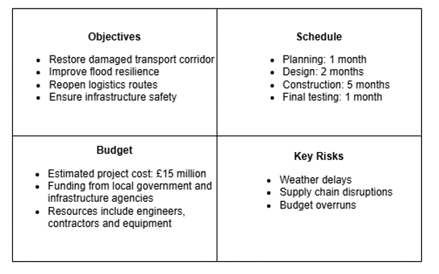

6. Gantt Chart: Project Schedule
Gantt chart is a project management tool that is very popular because it shows the project schedule visually and represents activities in their order and time. It allows the project managers to design tasks, track progress and dependencies among the project stages. In the case of the Transport Corridor Reconstruction Project, the Gantt chart will provide a chronological order of the completion of the flood-damaged infrastructure in Worcester to Kidderminster.

The project starts with the project approval and initiation which is followed by inspection of the site and assessment of damages as an indication of the level of the damage caused by the floods. Planning and design of engineering are then designed to assist the road reconstruction, bridge repair and drainage enhancement. The procurement processes such as contractor selection and acquisition of materials occur after the budget is passed. The primary construction operation involves the road reconstruction and bridge repair which will occur at the same time to enhance efficiency. The finishing stage of the project includes the installation of drainage, safety test and approval, and the opening of the transport corridor again.
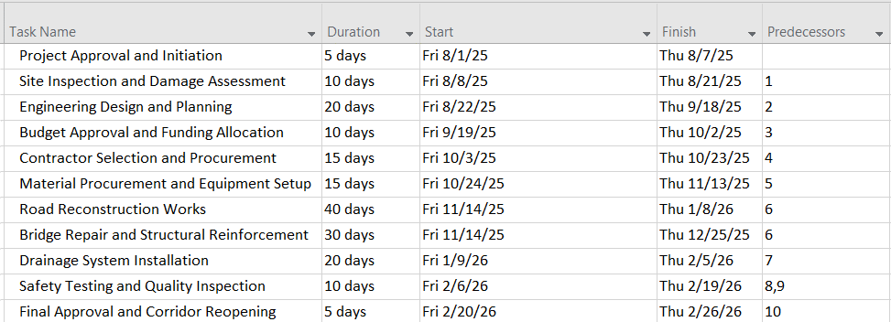
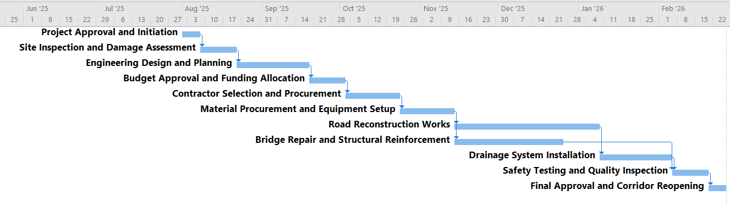

7. Stakeholder Involvement
Stakeholder management is a very essential part of the successful project delivery, especially in large infrastructure rebuilding projects which involve various organisations and community organisations. Stakeholders are persons or organizations that are interested in the project or whose actions may affect its results. As it is in case of the Transport Corridor Reconstruction Project, there are a number of stakeholders who have important roles in the planning, implementation and monitoring of the project activities. The stakeholders must be identified and engaged in the right way, and this will ensure that the project goals are obtained effectively yet being transparent and collaborative (Michael Osinakachukwu Ezeh et al., 2024).

The Local Government Authorities can be considered one of the most powerful stakeholders because it is the authorities which have to approve the project and which have to offer funds to support the reconstruction works. They are required to play a central role in making sure that the project is aligned to the regional development plans and infrastructure policies. The Environment Agency is another key player since it makes sure that the construction activities are carried out according to the environmental regulations and standards on flood resilience. Besides this, the Transport Infrastructure Authority also coordinates the technical planning and that the reconstruction activities should be within the requirements of transportation safety.

The actual work to be carried out to physically reconstruct the transport corridor will be carried out by construction contractors and engineering teams. They are engaged in repairing roads, reinforcing bridges and laying drainage systems. The ultimate beneficiaries of the project are the local communities and residents since by restoring the corridor, the area will become more accessible, mobile and economic. The emergency services are also the important stakeholders since the existence of good transportation routes is the main way of response to the events and ensuring the safety of the population (Marzena Kramarz, 2025).

Stakeholder involvement at all stages of the project lifecycle will be assisted by frequent progress meetings, project reports, and community communication programs. The stakeholder power-interest matrix assists in ranking stakeholder engagement where the stakeholders are classified based on the degree of influence and interest in the project. The government authorities as high-power stakeholders should be closely managed, and the local communities need to be informed via regular communication.
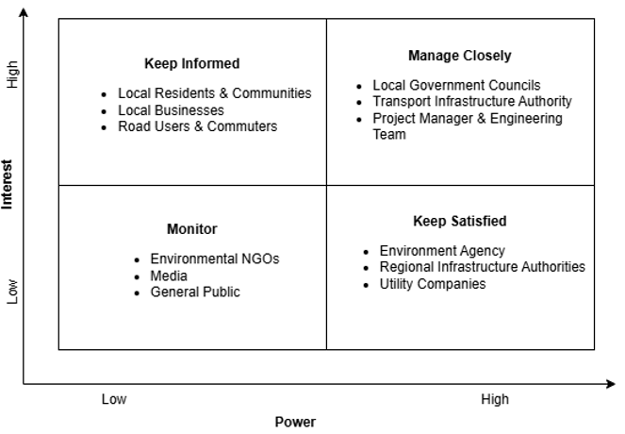

8. Resource Allocation
A resource allocation is a core component of project management that guarantees that there is proper allocation of resources needed to successfully accomplish activities of project. In mega projects like the Transport Corridor Reconstruction Project, resource planning should be effectively utilized in order to generate efficiency and control costs and make sure that the project schedule is adhered to. This is achieved through proper resource allocation to coordinate personnel, equipment and materials without delays or unnecessary spending by project managers (Chaudhary and Meshram, 2025).

The reconstruction project will need a mixture of both human, physical and financial resources to sustain various stages of the project lifecycle. The human resource will comprise of professionals like civil engineers, project managers and construction workers who will be involved in planning, supervising and undertaking the reconstruction activities. The engineers will be concerned with technical design and structural integrity tests whereas the project managers will involve scheduling of the projects, coordination and communication among various stakeholders. The road resurfacing and bridge repairs and drainage system installation are some of the work that will be done by the construction workers.

Besides staffing, it needs specialised equipment that can be used to efficiently restore infrastructure. The machinery that will be engaged in site preparation, structural repairs and road rebuilding will include machinery like excavators, cranes and road construction machines. These resources should be planned well so that they have equipment at the right time when the project is undertaken.

The construction materials also constitute a very important aspect in resource allocation. Asphalt, concrete and steel reinforcement are some of the materials which will be needed to reconstruct damaged parts of the roads and reinforce the structures of bridges. The continuity of a steady supply of such materials will facilitate the elimination of delays in the construction stage.

The funding is done using financial resources, which are mainly government infrastructure funding, to acquire equipment, labour and materials. Effective budgeting of the financial resources can guarantee cost containment and the project will not exceed the estimated budget with the planned schedule.
Table 3: Resource Allocation
Resource Type | Examples
Human Resources | Engineers, construction workers, project managers
Equipment | Excavators, cranes, road construction machinery
Materials | Asphalt, concrete, steel reinforcement
Financial Resources | Government infrastructure funding

9. Risk Analysis
Risk management is an essential aspect of the project management especially in mega projects involving the reconstruction of infrastructure where the uncertainties can impact on project performance, cost and schedule. Risk analysis entails the identification of risks that are likely to interfere with the activities of a project and putting in place measures to help in curbing their effects to a minimum. In the case of the Transport Corridor Reconstruction Project, proper risk management will help in ensuring that reconstruction of the corridor that had been damaged by the floods between Worcester and Kidderminster is done safely, efficiently and within the scheduled time (Canesi and D’Alpaos, 2024).

Reconstruction projects of infrastructure are vulnerable to operations risks, and environmental risks as well as financial risks. Weather extreme is one of the greatest risks since the heavy rain can slow down construction operations and impact on the structural construction that is in progress. Disagreements in the provision of materials due to logistical failure can also affect the schedule. Budget overruns or unexpected technical problems may be some of the financial risks that may occur. Also, the hazardous safety of workers related to heavy machinery and construction activities should be provided with rigorous measures. Their constant observation, back-up plans and periodic checks of the project should be therefore encouraged to efficiently combat the risks that may come up.
Table 4: Risk Assessment
Risk | Probability | Impact | Mitigation Strategy
Extreme weather conditions | Medium | High | Flexible construction scheduling and weather monitoring
Material supply delays | Medium | Medium | Establish alternative suppliers and maintain buffer stock
Budget overruns | Low | High | Continuous cost monitoring and financial control
Worker safety hazards | Low | High | Implement strict safety protocols and training programmes
Equipment failure | Medium | Medium | Regular equipment maintenance and backup machinery
Regulatory approval delays | Low | Medium | Early coordination with regulatory authorities
Environmental compliance issues | Low | Medium | Environmental monitoring and adherence to regulations
Stakeholder conflicts | Low | Medium | Clear communication and stakeholder engagement strategies

10. Conclusion
The Transport Corridor Reconstruction Project is an important project in terms of reconstructing essential infrastructure that had been compromised due to the July 2025 West Midlands floods. The corridor between Worcester and Kidderminster is crucial and it needs to be rebuilt to help enhance the transportation accessibility and therefore aid in the economic revival of this region and community resilience. This project management plan has utilized some of the most important project management tools amongst them being the scope definition, the work breakdown structure, schedule using Gantt charts, stakeholder analysis, allocation of resources and management of risks. These tools offer an orderly pattern of structuring project activities, resources and reducing possible risks. The effective execution of this project will help to re-establish the safe routes of transportation and will add long-term stability of infrastructure in the area.

References
Ajmal, M.M., Khan, M., Gunasekaran, A. and Helo, P.T. (2022) “Managing project scope creep in construction industry,” Engineering, Construction and Architectural Management, 29(7), pp. 2786–2809. Available at: https://doi.org/10.1108/ECAM-07-2020-0568.
Canesi, R. and D’Alpaos, C. (2024) “A Fuzzy Logic Application to Manage Construction-Cost Escalation,” Buildings, 14(9), p. 3015. Available at: https://doi.org/10.3390/buildings14093015.
Chaudhary, A. and Meshram, S. (2025) “Comparison of Various Techniques for Project Scheduling under Resource Constraints,” International Journal of Engineering Trends and Technology, 73(2), pp. 57–72. Available at: https://doi.org/10.14445/22315381/IJETT-V73I2P106.
Gajanayake, A., Khan, T. and Zhang, G. (2020) “Post-Disaster Reconstruction of Road Infrastructure: Decision making processes in an Australian context,” European Journal of Transport and Infrastructure Research, 20(1). Available at: https://doi.org/10.18757/ejtir.2020.20.1.3919.
Griffin, M.B., Thomas, J.Y. and McMurtrey, M.E. (2022) “The Evolution of Project Management: The Future Is Now?,” Journal of Management Policy and Practice, 23(2). Available at: https://doi.org/10.33423/jmpp.v23i2.5445.
Hirwa, E.M. and M. H. Mostafa, M. (2025) “Lessons From Climate and Pandemic‐Induced Disruptions in Building Public Transport Resilience,” Urban Planning, 10, p. 9943. Available at: https://doi.org/10.17645/up.9943.
Kurth, M., Kozlowski, W., Ganin, A., Mersky, A., Leung, B., Dykes, J., Kitsak, M. and Linkov, I. (2020) “Lack of resilience in transportation networks: Economic implications,” Transportation Research Part D: Transport and Environment, 86, p. 102419. Available at: https://doi.org/10.1016/j.trd.2020.102419.
Kyriakogkonas, P., Garefalakis, A., Pappa, E. and Kagias, P. (2022) “Sustainable Project Management under the Light of ESG Criteria: A Theoretical Approach,” Theoretical Economics Letters, 12(06), pp. 1517–1538. Available at: https://doi.org/10.4236/tel.2022.126083.
Marzena Kramarz, M.K. (2025) “RESILIENCE OF THE URBAN LOGISTICS SYSTEM,” Scientific Papers of Silesian University of Technology. Organization and Management Series, 2025(225), pp. 333–354. Available at: https://doi.org/10.29119/1641-3466.2025.225.20.
Michael Osinakachukwu Ezeh, Adindu Donatus Ogbu, Augusta Heavens Ikevuje, and Emmanuel Paul-Emeka George (2024) “Stakeholder engagement and influence: Strategies for successful energy projects,” International Journal of Management & Entrepreneurship Research, 6(7), pp. 2375–2395. Available at: https://doi.org/10.51594/ijmer.v6i7.1330.
Ngacha, Njeri.S., Abhukalaf, R. and Orono, V.B. (2023) “Exploring the Significance of the Project Scope in the Successful Implementation of Infrastructure Projects – A Case Study of Level Two Health Projects,” Journal of Sustainable Development, 17(1), p. 66. Available at: https://doi.org/10.5539/jsd.v17n1p66.
Sanchaniya, R., Somrajan, N. and Geipele, I. (2023) “Problems and Possible Solutions of Post-Disaster Housing Reconstruction Projects in India,” Baltic Journal of Real Estate Economics and Construction Management, 11(1), pp. 37–47. Available at: https://doi.org/10.2478/bjreecm-2023-0004.
Sargsyan, G., Venta, E., Slaydon, J. and Colon, R. (2024) “The Financial Recovery of Region From Economic Disruptions and Resiliency of Real Estate — Construction Sector: A Case Study of Southeast Texas Economy and Real Property Values,” Journal of Applied Business and Economics, 26(2). Available at: https://doi.org/10.33423/jabe.v26i2.6979.

