Problem solving and Decision Making

Student: Mohamed Wasim Samsudeen
Student ID: 1908197
Module Code: BMSW4004_LON
Tutor: Mushfiqur Rahman



Table of content
Introduction……………………………………………….3
Define the complex problem……………………….4
Analyse information to help inform the decision-making process….5
propose a range of alternative solutions to the problem….6
identify the most appropriate option………………………….8
communicate the plan to stakeholders…………………………8
develop a plan for implementing the solution………………….9
successful implementation of the solution………………………10
Conclusion………………………………………………………….10
Reference………………………………………………………11
Appendix…………………………………………………………12

- Introduction

I will be talking about the conflict problems that I faced when I was working as a team leader for Tesco. I have been working for Tesco for the last 3 three years. It is important to solve problem within the workplace because problem-solving is important both to individuals and organizations. I’ll be suggesting the best solutions to identify errors and fix them. The coronavirus had a big impact on the Tesco company and the staff members are struggling to work and achieve the aim of the company. The main problems that I’m going to be covering is heavy workload, stress, and conflicts with co-workers. And the effect it has on the overall performance of the company. Providing suitable solutions to make a good problem-solving decision to solve the problem. Create a plan to implement to solve the problem and communicate the problem to the people within the organization. The best way to monitor and review the progress of the plan to see if the problem is being solved. I will use two different problem-solving tools such as the six easy steps to solve a problem and the cause and effect diagram.

- Define a complex problem in the workplace including its scope and impact.
The Covid-19 is the new virus which is currently affecting the economic negatively. It is seriously affecting the performance of the organization in different ways such as the aim and goals of the company are not met. Heavy workload, stress, and conflict with co-workers. The employees are calling sick at any moment and the Employees searching for other jobs safer, as the organization is being badly distracted by this new virus Covid-19. Employees searching for other jobs safer. The company must develop an effective process of management decision making under various scenarios.
Effective communication is important with all the employees. The management people should be very carefully need to maintain the company performance and provide good customer service to the clients. The effective communication is the key to improve it culture.
It is important to work from home during this time of coronavirus. But the government is allowing the people to go to work in the company if it is Covid-19 secure. The employer should contact all the employee and consult with you to work safely.

- Analyse information on the identified problem, to inform the decision-making process
The Covid-19 is seriously harming the people’s health. And, it has a major effect on the performance of the organizations and the economy.

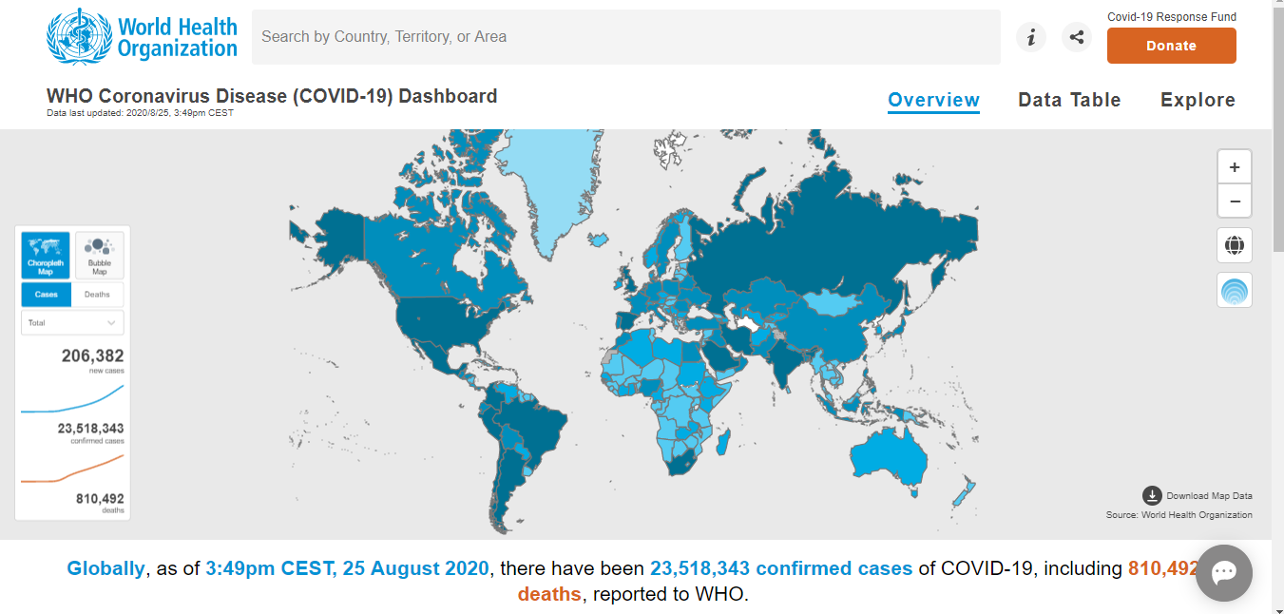
This is the evidence of Covid-19 it is real, and it continue to evolve around the world.
Source – World health organization.

- Propose a range of alternative solutions to the problem
The six easy steps to solve any problem at work. Firstly, Discuss the problem with your colleagues about the problem and ask questions relating to the specific problem. For example, an interpersonal conflict between co-workers. Talk to your employees to know about what is it that causes the problem to occur and why they are behaving in a bad manner towards their co-workers. How it is affecting the overall performance of the company. Try to get to the root of the problem which of the employee is no happy with the work.
Secondly, Proof that the problem exists by showing evidence. For example, it can be a graph to show the employees that we are not performing like the way we used to function. The customers are not happy with our service lots of customers are complaining about how they are being treated within our company.
Thirdly, discuss with your colleagues to identify the causes of the problem. Brainstorming the potential causes of the problem. Generate ideas relating to the problem. Figure out what is going wrong within the company that causing the co-worker to misbehave. The heavy workload and no one are taking responsibility for what they are doing in the organization.
Fourthly, at this stage, you should be able to prove what is causing the problem. Monitor and fix the process of the problem by talking to co-workers. The leader of the team should monitor the co-worker’s performance every day to ensure everything is working according to the plan.
Fifthly, implement the solution to the problem. For example, reduce the amount of work is given to one employee and make sure everyone is involved to do a task. Make the task is completed without any delays. Communication is the key to solve problems the co-workers should ask help from other employees if needed.
The final step, to ensure the problem is sorted out completely. You should provide before and after the results of the problem. And discuss with your co-workers the organization's performance is good and if we were to function this way then everything will be fine, and we will be able to reach our aims and goals daily.

Cause and effect diagram
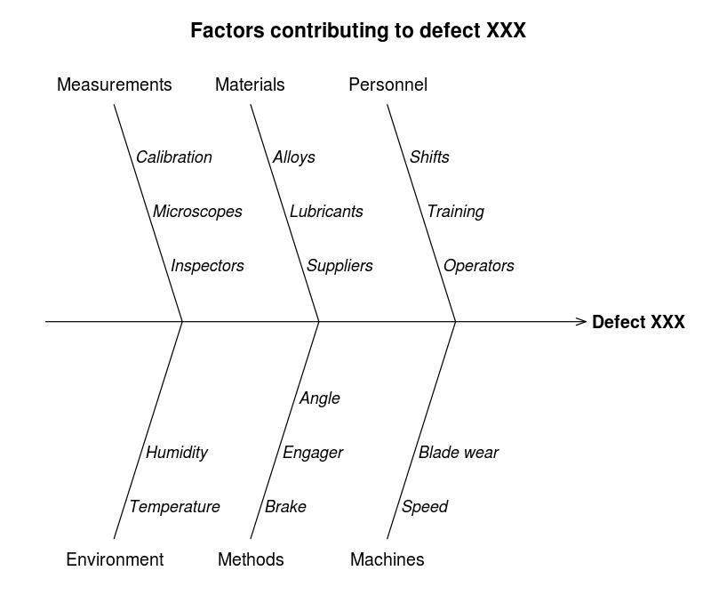

Source – Wikipedia
It is one of the problem-solving-tool. Gather all your organization members and perform a brainstorming task about the potential cause of the problem. The people can be your co-workers, management team, and the manager. Then draw the cause and effect diagram on board and write the main problem on the head of the fishbone diagram indicating the problem. Then brainstorm the things that are involved to solve the problem such as, the people, environment, materials, and method, etc. and write down all the causes of these categories that you have chosen. Finally, if the fishbone is filled up with all the key information relating to the problem discuss with your co-workers about whether if they can cause that specific problem or not. From there you can find a solution to the problem by identifying the errors.

- Use a decision-making technique to evaluate a range of solutions to identify the most appropriate option
For the problem that I have mentioned the best solution, I will choose it the cause and effect diagram. I believe that this method will provide the best solution to any problem the organization is facing. Gathering all your workers and brainstorming the cause to get to the root of the problem is a good way to solve the issue. This problem-solving tool is easy to understand and analyse. It provides more ways to improve the process to ensure the issue is sorted out. And it also shows where the organization needs improvement. You can ask questions to find out why the problem is occurring to find out the possible cause of the problem.
Perform online surveys and ask customers to answer questions to evaluate the effectiveness of the decision. For example, ask customers questions to know how they are being treated in the organization and the way the employees are treating them.

Document workplace data to test and pre-test doing this is important because it will allow you to monitor and review if any error occurs in the process and you will be able to make the improvement where it needed.

- Communicate the plan to stakeholders
Research shows lots of plans fail due to poor communication. Communication is vital it can save time and remove obstacles immediately. To communicate with the stakeholders of the organization should schedule a meeting to discuss the problem with the employees about the new plan and how they are going to implement the plan. And explain to them about the advantages and the positive impact it will make on the overall company performance. Being with the right people is important and to convey the message to the employee the software like the PowerPoint can be used.
Another way to communicate has effective communication with stakeholders will be online video meeting screen to screen. It is very effective because you can have a one to one communication with the stakeholder to get and a better understanding of their problems and make a provide a better solution to the problems they have and understand it from a different perspective.

- Develop a plan for implementing the solution
Outline goals and objectives:
The main purpose of this plan is to increase the overall performance of the company and solve the problems that occur within the organization. For example, to stop the work heavy load, interpersonal conflict with co-workers. To make the work environment peaceful and less stressful for the stakeholders within the organization. It is important to solve issues that your workers face because if their problems were not solved then it will cause problems to the overall performance of the company.
Assign Responsibilities:
The management team needs to make a good timetable and assign a strong team leader to make sure that everything is going according to the plan. The employees should report any issue immediately
Implementation Schedule:
Starting up a regular meeting with the people in your organization to keep them updated on what is going on within the company and discuss with the employees their current progression. Communicate with the stakeholders keep them updated with the current information.
Resource Allocation: To ensure that there are enough workers in every shift and flexibility. The management team must take care of any problem that occurs.
Define Metrics: Keep tracking each of the employee’s progression and how they are doing with the assigned task to ensure they complete the task. To make the company progress increase and achieve its goals.
Contingency Plan: The management team and the team leader are responsible to solve any problem within the organization. And report any bigger issue to the manager to get it short it out immediately.

- Assess appropriate monitoring and review techniques to ensure successful implementation of the solution
One of the ways to monitor and review the company and staff members progressing to achieve the goal of the company. Is by using the organization control method. The manager of the organization should monitor their employee’s progression daily to ensure they are performing well and get to know if the customers are happy with the service they get. The manager should get instant feedback on the assigned task and the progression of the task. Managers should solve any complaints and problems that occur in the workplace.
The management team should be very effective. They should keep communicate with the staffs and provide the necessary information to further communication with the customers, employees, and stakeholders.

- Conclusion
I have talked about different types of issues the business environment is currently facing due to the impact of the corona virus. I have discussed about the problem-solving strategies to solve work related problems. The importance of effective communication between colleagues to avoid irrelevant errors that will cause problems to arise. I have talked about two different problem-solving method that I think is suitable my work-related problem.

Reference
- Rolfe A. (2020) ’14 work email problems everyone has experienced, Reed employment career advice. Available at https://www.reed.co.uk/career-advice/14-work-email-problems-everyone-experienced/ (Accessed on 25/08/2020)
- McNeese B.(2020) ‘what is a cause and effect (fishbone) diagram? , spcforexcel, Available at https://www.spcforexcel.com/spc-blog/what-cause-and-effect-fishbone-diagram( Accessed on 25/08/2020)
- Team C. ‘(2020) ‘Problem solving vs decision making – what is the difference?, changeboard, Available at https://www.changeboard.com/article-details/16960/problem-solving-vs-decision-making-what-is-the-difference-/( Accessed on 25/08/2020)
- https://kanbanize.com/lean-management/improvement/5-whys-analysis-tool (Accessed on 25/08/2020)
- Owen C.’2020 ‘describe which planning, monitoring and review techniques could be used to manage innovation and change, skillsforleadership, Available at https://www.skillsforleadership.co.uk/describe-which-planning-monitoring-and-review-techniques-could-be-used-to-manage-innovation-and-change/ (Accessed on 25/08/2020)
- https://businessdegrees.uab.edu/blog/management-techniques-and-leadership-strategies-you-can-use-right-now/ (Accessed on 25/08/2020)
- https://www.healthline.com/health/interpersonal-conflict (Accessed 25/08/2020)
- https://www.structureddecisionmaking.org/steps/step3alternatives/ (Accessed 2/08/2020)
- https://getlighthouse.com/blog/organizational-problems-root-cause-fix/ (Accessed 25/08/2020)

Appendix
This Fishbone diagram.

Measurement Assistant
Work Heavy load
Cashier mistake Lack of training
Less product knowledge Task not completed
Wasted of time New employee
Team leader did not check

New environment
Don’t know the requirements Busy hours
Timetable issues Less product knowledge Lots of tasks assigned

Processes
Product Environment

