University of Wales Trinity Saint David

Marian Catalin Leftarache

2014677

Teacher name- Renuga Jayakumar

Table of Contents
PART A (Understanding) 3
A1: 4
A2: 4
A3: 5
PART B (Implementation) 8
Exercise 1: 8
Flowchart: 8
Code: 8
Result: 10
Validation & Testing: 10
Exercise 2: 11
Flowchart: 11
Code: 11
Result: 12
Validation & Testing: 12
Exercise 3: 14
Flowchart: 14
Code: 14
Result: 15
Validation & Testing: 16
Exercise 4: 17
Flowchart: 17
Code: 18
Result: 19
Reference: 20
Appendices: 21

Table of Figures
Figure 1: Example of multiple conditions 5
Figure 2: Output of above code 5
Figure 3: Example of for loop 6
Figure 4: Output of for loop 6
Figure 5: Example of while loop 7
Figure 6: Output of while loop 7
Figure 7: Flowchart 1 8
Figure 8: Exercise 1 Code Part 1 9
Figure 9: Exercise 1 Code Part 2 9
Figure 10: Exercise 1 Output 10
Figure 11: Testing of Exercise 1 10
Figure 12: Flowchart 2 11
Figure 13: Exercise 2 Code 12
Figure 14: Exercise 2 Result 12
Figure 15: Testing of Exercise 2 13
Figure 16: Flowchart 3 14
Figure 17: Exercise 3 Code 15
Figure 18: Exercise 3 Result 16
Figure 19: Testing of Exercise 3 17
Figure 20: Flowchart 4 18
Figure 21: Exercise 4 Code 19
Figure 22: Exercise 4 Result 20

PART A (Understanding)

A1:
Variable:
It is just a memory location that is used to store the values. We don’t need to define the type of variables in python. Variable names always start with alphabets or underscore or do not start with numbers. The variable defines only at the required time in python. And when we assign any value to a variable then it automatically declared. There are different types of variables such as global, local, instance, class, and constants.
Importance:
It is a very important part of all programming languages because it helps us to write flexible code. It provides us to represent the data so that for the future, it may help that which type of data it is or where we can use it properly so that unknown peoples will also understand the data representation.
Is Python strongly-typed language:
Python is a strongly typed language which means in python, variables have a type and its data type also matter when performing any operations in it. Python is also a dynamically typed language which means the interpreter already understands the type of variable received without any help from the user or developer.

A2:
If/else statement:
If else statement is used to check the certain condition. It is used to take a particular decision based on condition. If in case, if condition falls then it will go into the elif part of a code, and again elif part does not satisfy any condition then by default it goes into the else part of the program.
The main usage of using the if-else or nested if-else conditional statements to check certain conditions and predict the proper results. It is used to test the condition.
Multiple conditions in if-else:
Multiple conditions will also be check by if-else conditions. For checking the multiple conditions, we use the OR & AND operator between the conditions. By using the OR operator, we have to prove that either one of the conditions should be true while in AND operator, all the provided conditions in if statements should be true. We can also provide the nested AND & OR operator in a given else condition. If the if conditions do not satisfy the condition then it goes into the else parts.
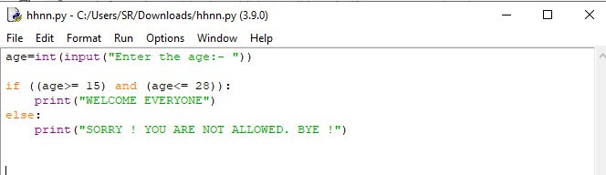
Figure 1: Example of multiple conditions

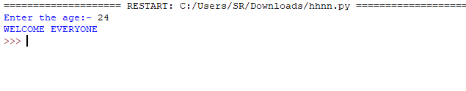
Figure 2: Output of above code

A3:
The necessity of Loop in Python:
Loop is used to iterate the particular sequence at a certain range. Repeating any task is very common and to reduce the thousands of lines of code for writing the same code that’s why we can use the loop. There are 3 types of loops whose functionality is similar while their syntax is something different from others.
For loop:
It is a control flow statement that is used when we know the total number of iterations required for execution. For loop can incorporate a line of code with various proclamations. Before executing the code inside the loop, the value from the grouping gets appointed to the repeating variable. The range function is used in for loop for defining a certain integer sequence at the runtime. We can also use the break and continue in for loop.
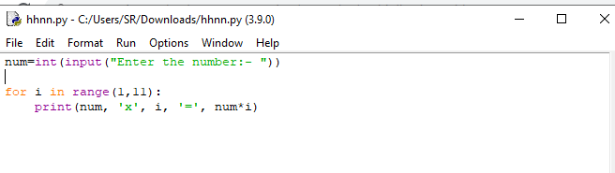
Figure 3: Example of for loop

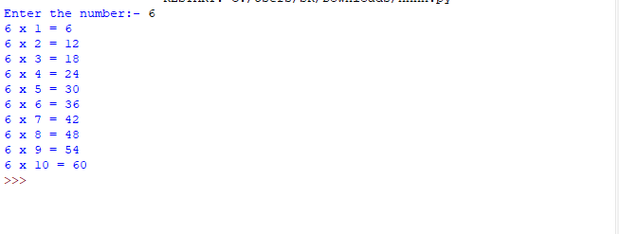
Figure 4: Output of for loop
While loop:
While loop is a control flow statement that is used to execute the statements until a given condition is satisfied. The break and continue function is also used in the while loop. Sometimes, if any condition in a while loop does not get false then the loop will never go terminate which is called an infinite while loop.
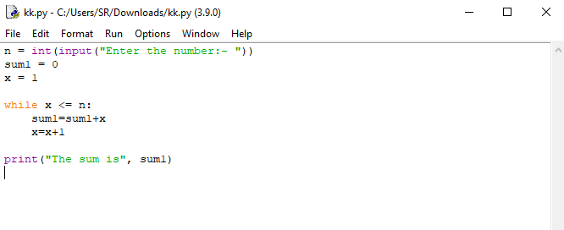
Figure 5: Example of while loop

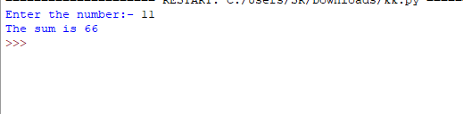
Figure 6: Output of while loop

PART B (Implementation)

Exercise 1:

Flowchart:
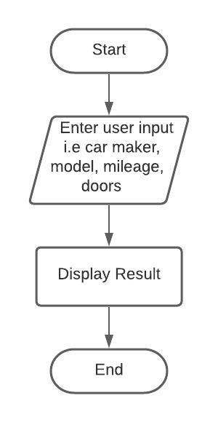
Figure 7: Flowchart 1

Code:
This is a python code for taking the user input such as the model of the car, maker of the car, mileage of the car, and the number of doors that are present in the car. We also perform the validation to check that the user input type is correct or not.
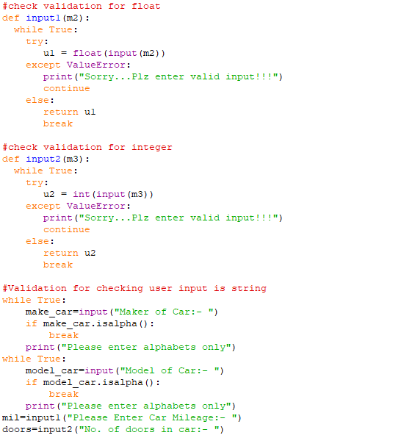
Figure 8: Exercise 1 Code Part 1

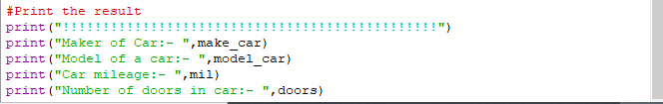
Figure 9: Exercise 1 Code Part 2

Result:
After writing the code in python, we run it in the Python IDLE. This code is displaying the proper requirement of the users.
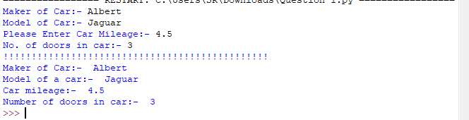
Figure 10: Exercise 1 Output

Validation & Testing:
All the python code is ready and it is providing a proper output. But with writing a simple python script, we also a python validation code for the valid user input otherwise it will display a message until the user does not enter a valid input. The below screenshot is showing proper validation in python.
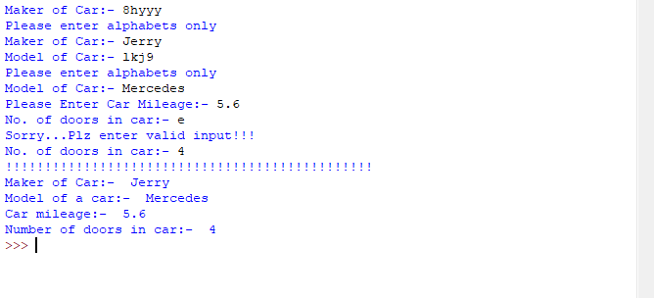
Figure 11: Testing of Exercise 1

Exercise 2:

Flowchart:

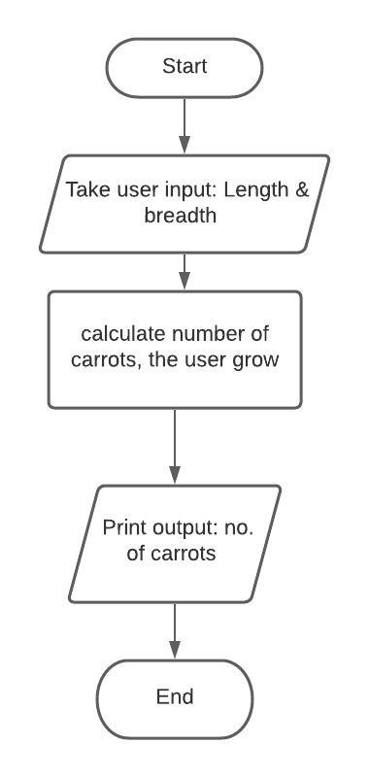
Figure 12: Flowchart 2

Code:
This is a python code for exercise 2 in which we have to calculate the number of carrots grows in the vegetable bed. And the dimension of the vegetable bed should be entered by the user and the dimension of a soil area for each carrot is 64cm2 (8cm * 8cm). In this exercise, we cannot consider the half or stunned carrot that’s why we use a minimum function to calculate the optimum number of carrot grows.

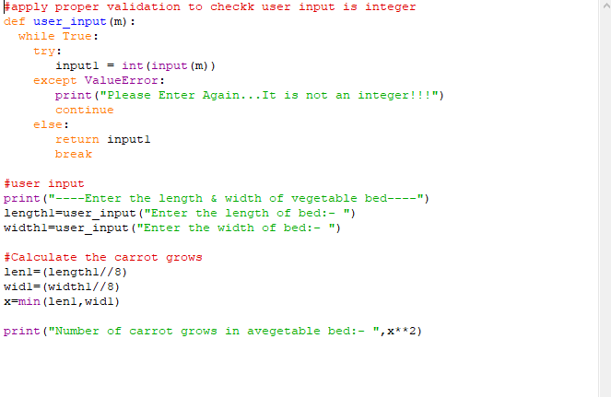
Figure 13: Exercise 2 Code

Result:
This is the screenshot of the output result of exercise 2 which is displaying a proper number of carrots.

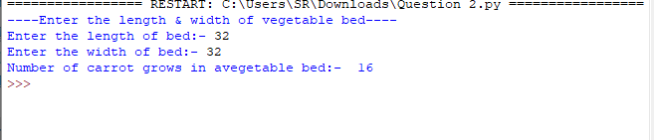
Figure 14: Exercise 2 Result

Validation & Testing:
The below screenshot is showing a validation output that if the user does not enter a valid input then how it will be displayed. In the below image, the user enters the width in string then it shows an error. Validation is very important so that we can achieve accurate and efficient output.
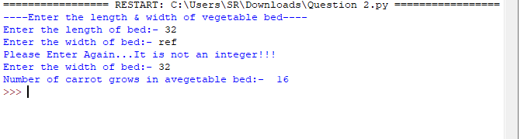
Figure 15: Testing of Exercise 2

Exercise 3:

Flowchart:
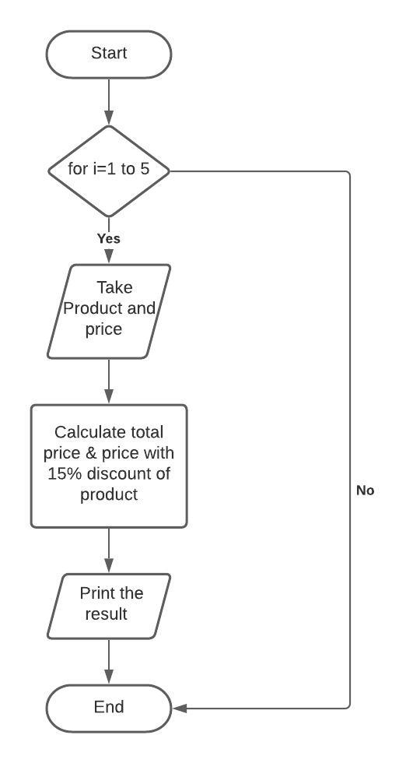
Figure 16: Flowchart 3

Code:
This is a python code in which we have to take the 5 products and their respective price from the user and store it in a list. After that, we are calculating the total price of all the 5 products and the price after applying a 15% discount.
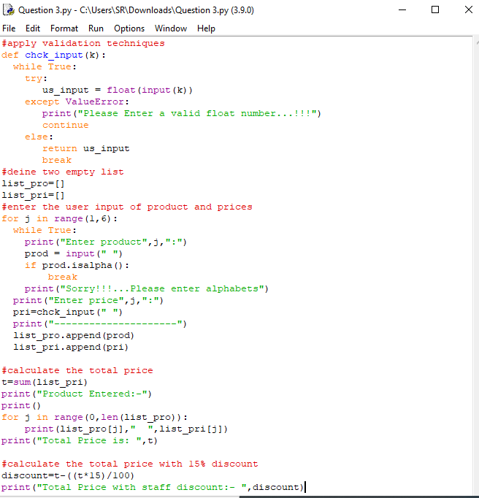
Figure 17: Exercise 3 Code

Result:
The below screenshot is showing the proper output of the list of products and prices. The total prices of all the products are 7.99 and the total prices after applying the 15% discount is 6.79.
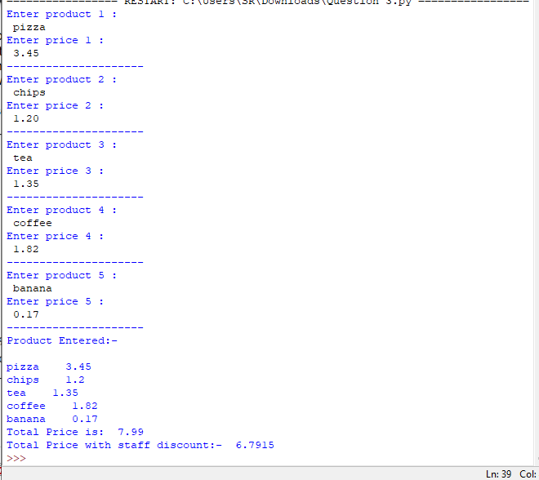
Figure 18: Exercise 3 Result

Validation & Testing:
This screenshot is showing a validation on the string, integer, and float value that user input value is according to the proper requirement of exercise 3 or not.
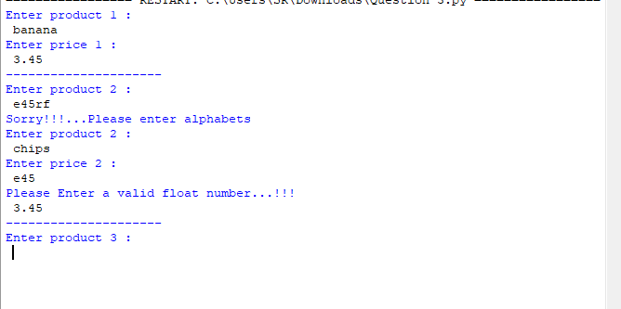
Figure 19: Testing of Exercise 3

Exercise 4:

Flowchart:

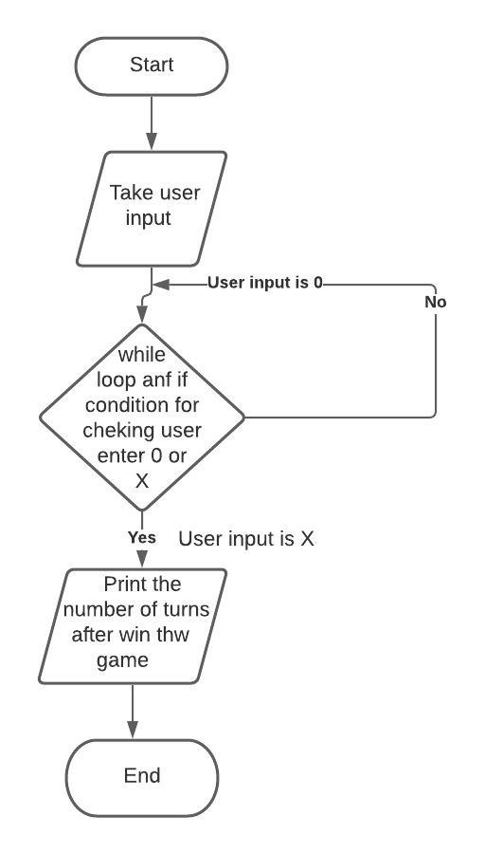
Figure 20: Flowchart 4

Code:
This python program is working on the treasure hunt of 0 & X. And we have to calculate the number of turns to win the games.
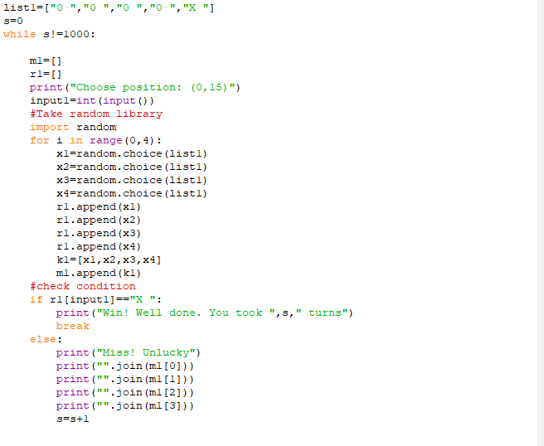
Figure 21: Exercise 4 Code

Result:
The below screenshot is showing the output of the number of turns of a treasure hunt.
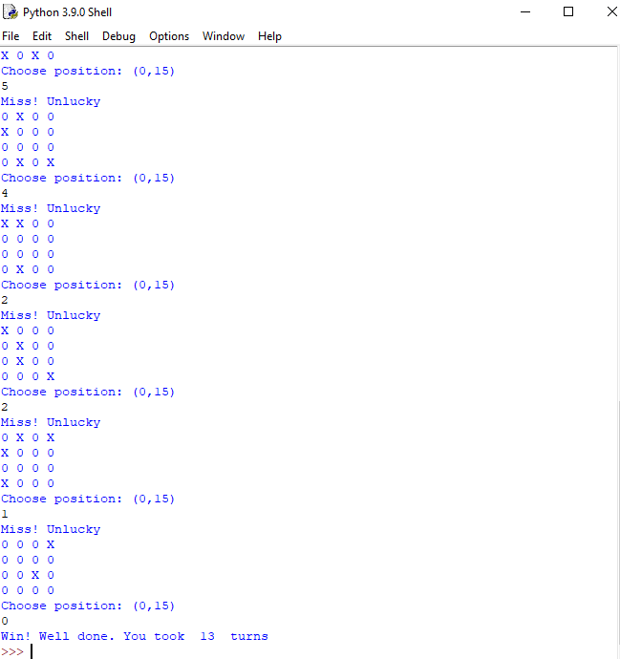
Figure 22: Exercise 4 Result

Reference:
Nagar, S., 2018. Functions and Loops. An Introduction to Python for Engineers and Scientists (pp. 187-205). Apress, Berkeley, CA.
Feinstein, W., 2017. Introduction to Python.
Shi, J., Davis, H., and Howard, Y., Computer Applications: Python-Variables, maths, and comments.
Srinath, K.R., 2017. Python–the fastest growing programming language. International Research Journal of Engineering and Technology, 4(12), pp.354-357.

Appendix:

