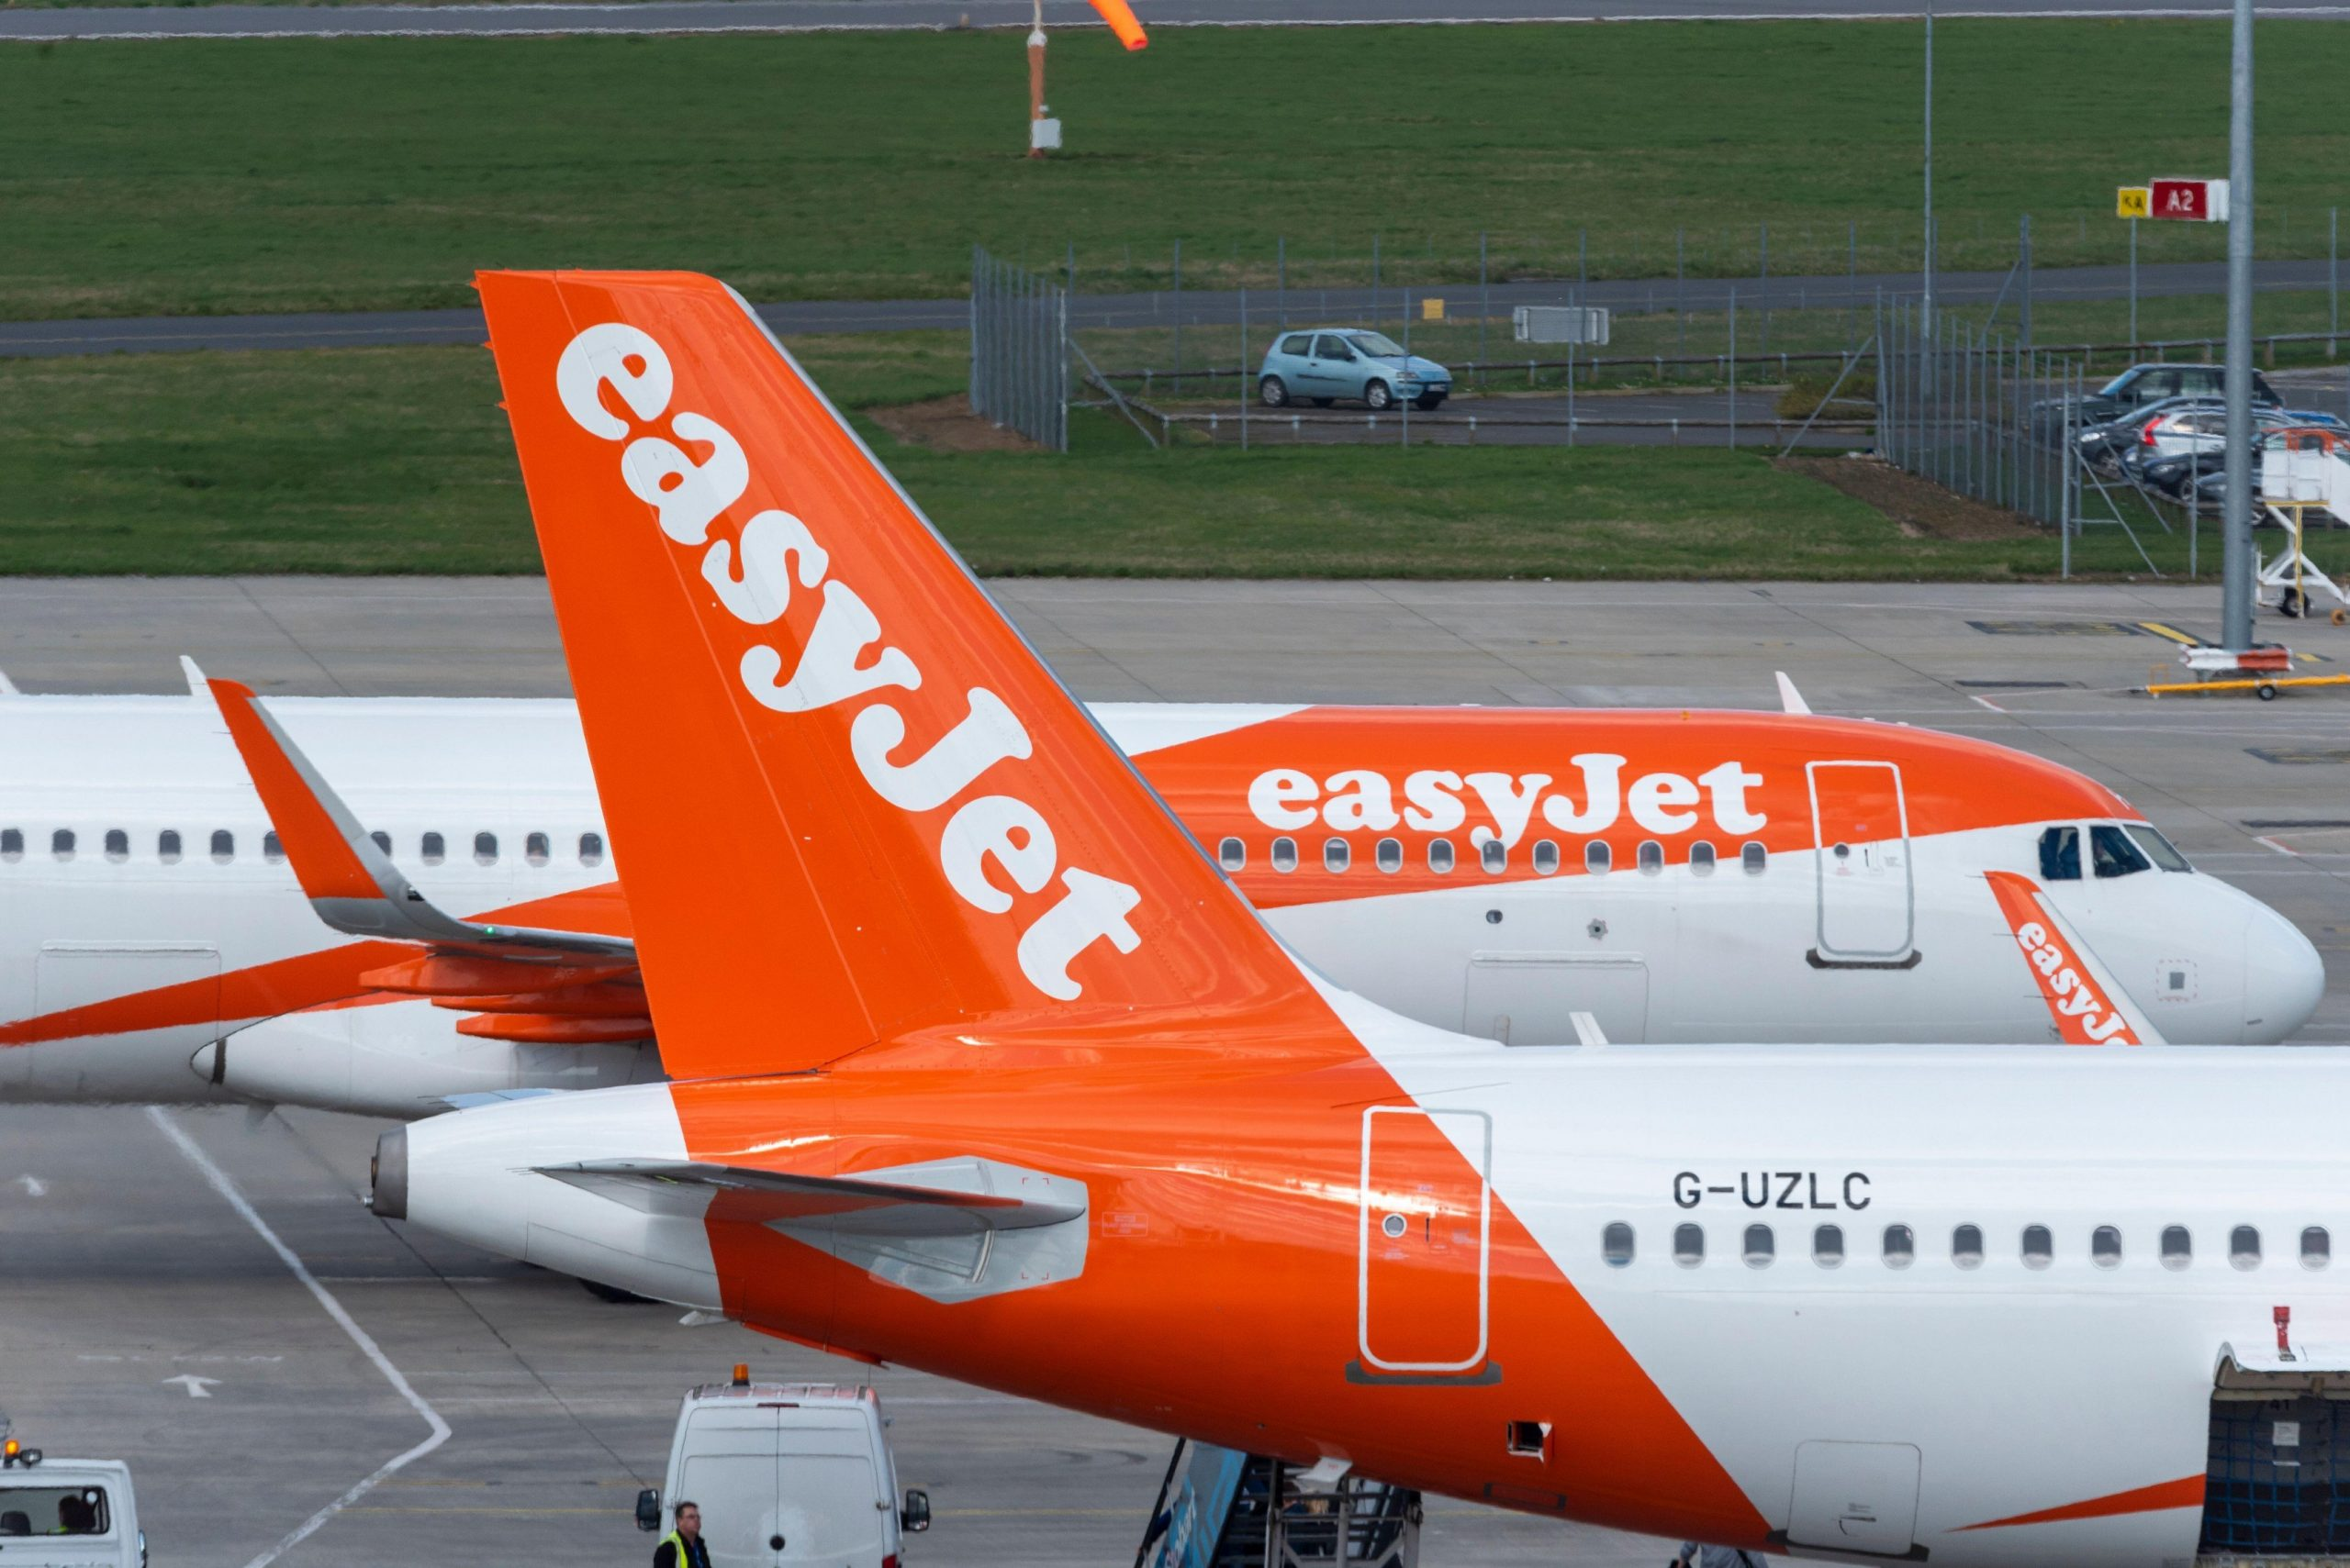 | PROFESSOR: N Mirza  STUDENT: LEONARD HONDOR (2115347)
WORKPLACE CULTURE AND ITS IMPACT ON ORGANISATIONAL EFFICIENCY
SUMMARY
EasyJet is a low-cost airline that has become one of the most popular carriers in Europe. This paper examines various aspects of EasyJet, including its organizational culture and structure, customer base, workplace culture, external environment, ethical practices, carbon strategy, advantages and disadvantages, and recommendations.

The paper begins by introducing the reader to EasyJet and highlighting the importance of studying its organizational culture and structure. The relationship between these two factors is explored in detail, and it is shown how they affect the financial and non-financial performance of the company.

The next section of the paper focuses on why EasyJet has more customers than other low-cost flying companies. Factors such as pricing strategies, customer service, and branding are discussed, and it is concluded that EasyJet's success is due to a combination of these factors.

The third section of the paper examines the workplace culture of EasyJet and analyzes its organizational efficiency. The importance of employee satisfaction and retention is emphasized, and it is shown how EasyJet's culture promotes these factors.

The external environment of EasyJet is analyzed in the fourth section using PESTLE analysis and Porter's Five Forces. The various factors that affect the airline industry, such as economic, political, and technological factors, are explored, and it is shown how EasyJet has adapted to these changes.

The fifth section of the paper discusses how EasyJet has been practicing ethical approaches as a part of its organizational culture and the benefits thereof. The company's commitment to sustainability, diversity, and transparency is highlighted, and it is shown how these practices have helped the company maintain a positive reputation.

The sixth section of the paper examines EasyJet's carbon strategy and its efforts to reduce its carbon footprint. The company's approach to sustainability is discussed, and it is shown how EasyJet's carbon strategy aligns with its broader organizational culture.

In the seventh section, the advantages and disadvantages of EasyJet PLC are analyzed. The benefits of being a low-cost carrier are explored, as well as the potential drawbacks such as competition and cost-cutting measures.

The penultimate section of the paper provides recommendations for EasyJet to maintain its success and improve its performance. Suggestions include expanding into new markets, investing in employee development, and enhancing the customer experience.

Finally, the paper concludes by summarizing the key points and emphasizing the importance of organizational culture and structure in the success of EasyJet. The airline's commitment to sustainability, employee satisfaction, and customer service are noted as key factors in its continued success.

REFERENCES:
• Saunders, M., Lewis, P., & Thornhill, A. (2019). Research methods for business students. Pearson Education Limited.

• Schumpeter, J. A. (1934). The theory of economic development: An inquiry into profits, capital, credit, interest, and the business cycle. Harvard Economic Studies.

• Smith, M. (2017). The PESTLE analysis tool. Strategic Management Insight. https://www.strategicmanagementinsight.com/tools/pestle-analysis-how-to-guide.html.

