

International Business LCMB7014

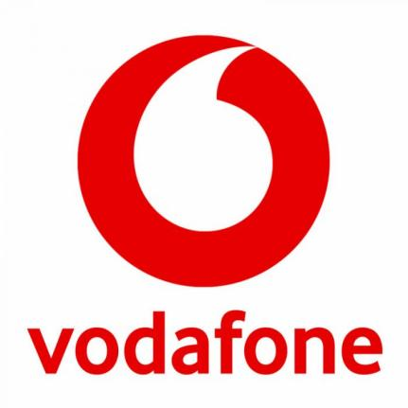
Vodafone International Business in Germany

Student name: Rimpal Yadav
Student Number: 2132837
Lecturer: Dr Hossein Shokri
Submission Date: 21/08/2023

Table of Contents
Table of Contents 1
1. Introduction 2
2. Company Background: Vodafone 3
2.1 Company’s Objectives and Strategies 5
2.1.1 Vodafon’s Objectives 5
2.1.2 Vodafone’s Overall strategies in contex on international business 6
3. Countries’ Specifications 7
3.1 Home Country (UK) 8
3.2 Host Country (Germany) 9
4. External Analysis 10
4.1 A Comparative PESTEL Analysis 12
4.2 Industry Five Forces 13
4.3 Market Analysis 14
5. Host Country Analysis 16
5.1 Country’s National Diamond 16
5.1.1 Michael Porter's National Diamond analysis for Vodafone 17
5.2 Country Business Risks 18
6. Internal Analysis 19
6.1 SWOT analysis 19
7. International Strategies 21
8. Corporate Social Responsibility 23
Conclusion 26
References 28

1. Introduction
The realm of international business has undergone a profound transformation in recent decades. As globalization accelerates and technological advancements redefine boundaries, businesses are presented with unparalleled opportunities to expand beyond their domestic confines. However, this expansion is not without its challenges. Navigating the intricate dynamics of different markets, understanding diverse cultural nuances, and adapting to varied regulatory landscapes are just a few of the complexities that multinational enterprises (MNEs) grapple with.
The purpose of this report is to provide an in-depth analysis of Vodafone's international business strategy. It aims to answer key questions related to how Vodafone entered and operates in different international markets, how it organizes its resources and capabilities in an international context, and how it manages country-specific risks. The report will also critically evaluate Vodafone's modes of entry into foreign markets.
The report is structured as follows: After this introduction, a comprehensive overview of Vodafone as a company is provided. This is followed by an analysis of Vodafone's international strategy, focusing on management-specific, industry-specific, and country-specific factors. The subsequent section delves into an examination of Vodafone's operations in the international context, including its approach to marketing, operations, and human resource management. The report then evaluates Vodafone's entry modes into foreign markets and provides an analysis of how the company manages country risk. The report concludes with a summary of the findings and their implications for Vodafone and international business strategy more broadly.

2. Company Background: Vodafone
Vodafone's rich heritage began in 1982 when it was launched as a subsidiary of Racal Electronics Plc, a British company specializing in military radio technology. The name "Vodafone" is a contraction of "voice data fone," signifying the delivery of voice and data services through mobile phones. In 1991, Vodafone achieved a significant milestone by making the first-ever mobile phone call in the UK. That same year, the company separated from Racal Electronics, marking a pivotal moment in its evolution as it became an independent entity (Vodafone Group Plc, 2023).

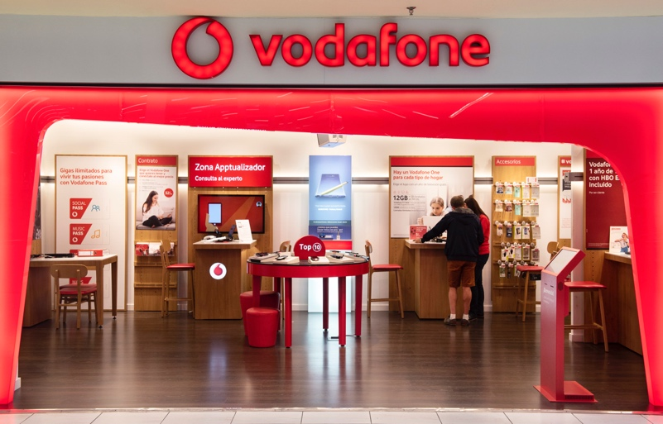

Figure 1: Vodafone Store. Source ( bbc.co.uk 2023)

Vodafone Group Plc, a telecommunications juggernaut with its roots in the United Kingdom, boasts a vast global presence with its headquarters nestled in the bustling city of London, England. Its expansive reach extends to the far corners of Asia, Africa, Europe, and Oceania, where it delivers an array of top-notch services. As the calendar flipped to 2021, Vodafone commanded ownership and spearheaded operations across a staggering 26 countries, while concurrently establishing strategic partnerships with over 50 additional nations through their network alliances. Not stopping at mere geographical boundaries, Vodafone's influential arm, known as Vodafone Global Enterprise, takes centre stage, showcasing their prowess in providing exceptional telecommunications and information technology services to esteemed business clients spanning a breath-taking 150 countries worldwide (Vodafone Group Plc, 2023).
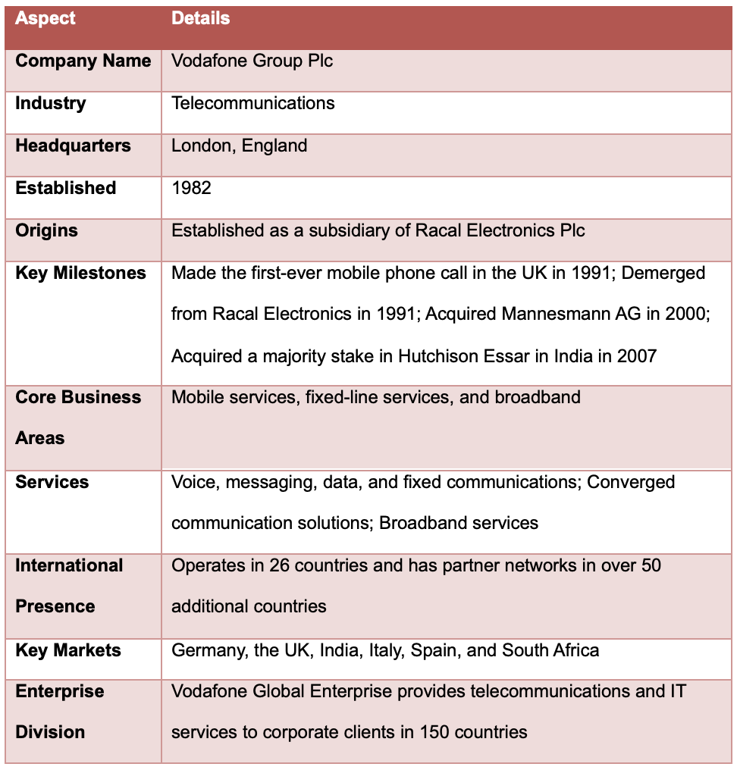
Table 1: Vodafone's Overview table

2.1 Company’s Objectives and Strategies

2.1.1 Vodafon’s Objectives
As a leading international telecommunications entity, Vodafone maintains a clear, precise set of goals that inform its strategic decisions and business activities. The core of these goals is their mission to "build connections for a more promising future" (GSMA, 2019). This mission is underlined by their devotion to developing an all-inclusive, sustainable digital society, where technology and connectivity have the potential to shape the future and enrich the lives of individuals.
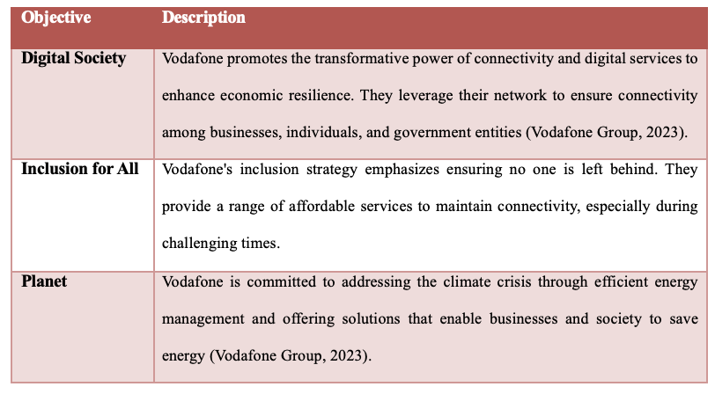
Table 2: Vodafone's Objectives

Vodafone's overarching aims go beyond financial growth, focusing on generating a positive societal impact. They are determined to conduct business sustainably and ethically in all regions they operate in and contribute to the United Nations' Sustainable Development Goals (SDGs). Vodafone recognizes the role of digital technology in hastening progress towards achieving the SDGs, and they are dedicated to participating in this effort.
In essence, Vodafone's primary objectives revolve around delivering top-tier connectivity and digital services, promoting inclusivity, and tackling environmental issues. Their goal is to leverage their international reach and proficiency to foster positive changes and contribute to the construction of a better future for everyone.

2.1.2 Vodafone’s Overall strategies in contex on international business
Vodafone, a telecommunications giant headquartered in West Berkshire, England, has a rich history of strategic moves that have shaped its international business strategy. The company's overall strategy is focused on sustainable growth, with a vision to become a new generation connectivity and digital services provider, primarily for Europe.
One of the key strategies of Vodafone's international business is to enter new markets that show potential for growth. An example of this is Vietnam, where Vodafone proposed entering the market due to the country's young population and growing economy. The company's strategy in Vietnam was to acquire a controlling stake in VMS MobiFone, Vietnam’s state-run mobile services operator and the largest mobile player in the country. This move was aimed at gaining an improved foothold in the Asia-Pacific marketplace and picking up a quick win in a market that would be easier to penetrate than China (Dodourova, 2003).
Vodafone's international strategy also involves localization, especially in terms of human resources and marketing. In Vietnam, for instance, Vodafone relied on the existing marketing plan of MobiFone and retained the MobiFone name, messaging, and advertising strategies with minimal interference from Vodafone. This approach was based on the lessons Vodafone learned from its unsuccessful venture in Japan, where it failed to cater to the local consumer preferences.
In conclusion, Vodafone's international business strategy is a blend of expansion, acquisition, and localization. The company seeks to enter new markets that show potential for growth, acquire controlling stakes in local operators, and adapt to local preferences and business practices. This strategy has allowed Vodafone to become a global player in the telecommunications industry. However, the success of this strategy also depends on the company's ability to learn from its past mistakes and adapt to the unique challenges of each market it enters.

3. Countries’ Specifications
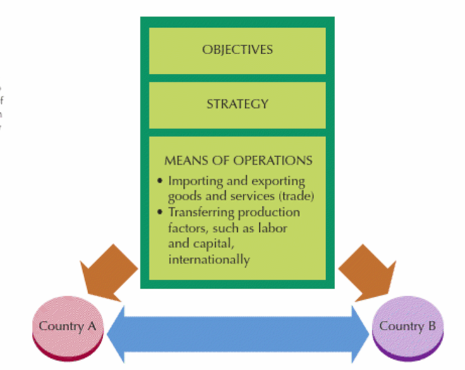
In the world of global business planning, the attributes of both the home and foreign countries significantly influence the operations and strategic decisions of a multinational corporation. For Vodafone, its roots are in the United Kingdom, which has been the initial backdrop that has guided its growth and strategic direction. In contrast, the countries where Vodafone has extended its operations, known as host countries, offer unique circumstances that call for bespoke strategies. This section delves into the specific qualities of Vodafone's home country, the UK, and Germany as host country, to investigate how these environments have directed Vodafone's approach to international business.
Figure 2: Country specification. Source (Daniels, 2019)

3.1 Home Country (UK)
Vodafone, a multinational telecommunications firm hailing from the UK, was launched in 1984. The robust economic, political, and cultural climate of the UK has played a substantial role in shaping Vodafone's international business strategy (Vodafone Group Plc, 2023).
Vodafone UK is a prominent telecommunications services provider and is a subsidiary of Vodafone Group Plc, which stands as the world's second-largest mobile phone company. As of July 2023, Vodafone is the third-largest mobile network operator in the United Kingdom, boasting over 18 million subscribers. This positions it after major competitors O2 and EE, and ahead of Three.
The company's roots are deeply embedded in the UK, with its registered office located in Vodafone House, The Connection, Newbury, Berkshire. Vodafone UK has made significant strides in the telecommunications sector, offering a wide range of services to cater to the diverse needs of its vast customer base. The company's commitment to innovation and customer satisfaction has solidified its reputation as a leading technology communications company, with a global customer base exceeding 625 million.
Vodafone UK's operations are not just limited to mobile services. The company has expanded its portfolio to include broadband services, catering to the ever-growing demand for high-speed internet connectivity in the digital age. With more than 660 thousand home broadband customers and an extensive retail presence with over 400 stores nationwide, Vodafone UK continues to be a dominant force in the telecommunications landscape.
The company's journey in the UK has been marked by a series of innovations, expansions, and strategic decisions, all aimed at enhancing the customer experience and ensuring that Vodafone remains at the forefront of the telecommunications revolution.

3.2 Host Country (Germany)

Vodafone GmbH, an offshoot of Vodafone Group plc, is a prominent mobile telecommunications operator in Germany, with its main office located in Düsseldorf. The company delivers a wide array of services, including mobile phone, LTE, 5G, cable internet, landline, cable TV, and IPTV services. As of the third quarter of 2021, Vodafone GmbH has a customer base of over 31 million mobile users in Germany, making it the third-largest provider of mobile phone services in the nation (Kasia Davies , 2022).
Vodafone Germany, a subsidiary of the Vodafone Group, is one of the leading integrated telecommunications companies in the country. It also holds the title of being the largest TV provider in the Republic. With a workforce of 13,500 employees, Vodafone Germany offers a comprehensive range of services, including internet, mobile, fixed network, and television, all from a single source. As a gigabit company, Vodafone is at the forefront of infrastructure expansion in Germany. The company boasts more than 47 million mobile card users, 6.9 million fixed-network customers, and a plethora of digital solutions. In the last financial year, Vodafone Deutschland's service revenues surpassed 10 billion euros, underscoring its significant market presence.
Vodafone's commitment to innovation is evident in its progressive 5G deployment strategy. The company began the deployment of its NB-IoT network in March 2018, a crucial component of 5G Massive Machine-Type Communication (mMTC). Within six months, Vodafone achieved a 90% deployment of this network. In May 2018, the company introduced the "5G Beam" technology across its existing network, utilizing 128T128R beamforming to enhance data rates and improve capacity. By October 2018, Vodafone Germany had set up its first dedicated 5G base station and showcased mobile holographic calling.
In June 2019, Vodafone Germany acquired a total of 130 MHz for the implementation of 5G services. This acquisition comprised 90 MHz in the 3.5 GHz band and 40 MHz in the 2.1 GHz band. Vodafone Germany officially launched its 5G network in July 2019 over the n78 (3500 MHz) band. Initial 5G services were rolled out in Birgland (Bavaria), Lohmar (North Rhine-Westphalia), Hattstedt (Nordfriesland), and major cities including Cologne, Dusseldorf, Hamburg, Dortmund, and Munich.

4. External Analysis
PESTLE analysis, an acronym for Political, Economic, Social, Technological, Legal, and Environmental factors, is a strategic tool used to evaluate the macro-environmental factors that influence an organization's operations and performance. This analytical framework aids businesses in understanding the larger landscape they operate within, helping them adapt and strategize accordingly. Introduced by Harvard professor Francis Aguilar in 1967, originally as ETPS (Economic, Technical, Political, and Social), it was later rearranged into PEST and expanded to include Legal and Environmental factors, evolving into the PESTLE analysis we recognize today (Buye, 2021).
In the following section, we will delve into a comprehensive PESTLE analysis for Vodafone's operations in two distinct markets: the UK and Germany. This will provide insights into the external factors impacting Vodafone's strategic decisions and performance in these regions.
Table 3: PESTEL Analysis of Vodafon UK
Factor | Description
Political | - Stable political environment conducive for businesses.  - Brexit uncertainties impacting trade agreements and regulations.  - Potential changes in international relations affecting telecom agreements (Sandle, 2023).
Economic | - Strong economy with significant consumer purchasing power.  - Brexit-related economic fluctuations affecting currency valuation and investment climate.  - Competitive telecom market influencing pricing strategies (Jackson, 2022).
Social | - Diverse and multicultural population affecting product offerings.  - High rate of smartphone and internet usage among all age groups.  - Growing demand for high-speed and reliable connectivity.
Technological | - UK at the forefront of 5G technology adoption.  - Rapid technological advancements offering opportunities for innovative services.  - Increasing demand for IoT and smart solutions (Paul, 2019).
Environmental | - Strong governmental push for green and sustainable initiatives.  - Emphasis on reducing carbon footprint in operations.  - Growing consumer demand for eco-friendly products and services (celso_gomes, 2014).
Legal | - Stringent regulations set by Ofcom for telecom operators.  - Emphasis on data protection and privacy (GDPR compliance).  - - Consumer rights and fair usage policies influencing service terms.

Table 4: PESTEL Analysis Of Vodafon, Germany
Factor | Description
Political | - Stable political environment favorable for international businesses.  - Germany's EU position providing trade and regulatory advantages.  - Consistent policies promoting digitalization and tech growth (MBA SKOOL, 2022).
Economic | - Germany as Europe's economic powerhouse with high consumer purchasing power.  - Stable economic growth and investment-friendly climate. - Competitive telecom landscape with major players like Deutsche Telekom.
Social | - High standard of living with a tech-savvy and connected population.Growing demand for advanced telecom and digital services.  - Emphasis on quality and reliability in service choices (Zaidi, 2022).
Technological | - Leading in technological innovations in Europe.  - Rapid adoption of 5G and other advanced telecom technologies.  - Strong infrastructure supporting digital growth and IoT adoption.
Environmental | - National emphasis on sustainability and green initiatives.  - Regulations promoting eco-friendly operations and waste reduction.  - Consumer preference for sustainable and responsible brands.
Legal | - Strict regulations on data protection, privacy, and consumer rights.  - Emphasis on fair competition and anti-monopoly practices.  - Regulatory bodies ensuring telecom standards and practices.

Both the UK and Germany present stable political and technological landscapes for Vodafone, with each being at the forefront of 5G adoption. However, the UK's Brexit uncertainties contrast with Germany's consistent EU-aligned economic and regulatory environment. While both nations emphasize sustainability, Germany's commitment is more pronounced. Socially, the UK's multicultural demographic might require a broader telecom service range than Germany. Despite their stringent legal frameworks, Germany's data protection focus and the UK's post-Brexit consumer rights nuances suggest tailored strategies for Vodafone in each market.

4.1 A Comparative PESTEL Analysis

When comparing the PESTLE analyses for the UK and Germany, several similarities and differences become evident. Both countries enjoy a stable political environment that is conducive to business. However, the UK is dealing with uncertainties arising from Brexit, which has implications for trade agreements and regulations. In contrast, Germany capitalizes on its EU membership to secure trade and regulatory benefits. Economically, both nations have robust consumer purchasing power. However, the UK is experiencing economic fluctuations due to Brexit, while Germany remains a stalwart economic powerhouse in Europe. Socially, both countries have a tech-savvy population with a high demand for advanced telecom services. However, the UK's diverse and multicultural demographic influences its product offerings. Technologically, both the UK and Germany are leaders in 5G adoption and other advanced telecom technologies. However, the UK's focus on IoT and smart solutions sets it apart. Environmentally, both countries prioritize sustainability, with the UK concentrating on reducing its carbon footprint and Germany emphasizing waste reduction. Legally, both countries have stringent regulations, particularly concerning data protection and consumer rights. However, the UK's telecom operators are subject to regulations set by Ofcom, while Germany places a strong emphasis on fair competition and anti-monopoly practices.
In summary, while the UK and Germany share similarities such as stable political environments and strong consumer purchasing power, their differences are evident in areas such as the impact of Brexit, the focus on specific technological advancements, and the nuances in their environmental and legal frameworks.

4.2 Industry Five Forces
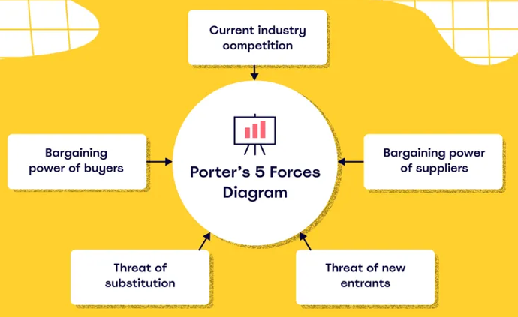
The Industry Five Forces framework, devised by Michael E. Porter, is utilised to assess the dynamics of rivalry within a sector. The forces encompass several factors that impact the competitive landscape. These factors include the potential for new entrants, which evaluates the level of difficulty for competitors to enter the market; the bargaining power of suppliers and buyers, which assesses the degree of influence that suppliers and customers hold; the possibility of substitute products, which determines the likelihood of customers choosing alternative solutions; and the level of rivalry among existing competitors, which measures the intensity of competition. Collectively, these forces contribute to the formation of the industry's competitive environment and its potential for generating profits (Dobbs, 2014).

Figure 3: Industry Five force poster. (Miro, 2022)
Table 5: Porter's Five forces analysis for Vodafone UK
Porter's Five Forces | Vodafone UK
Bargaining Power of Suppliers | - Infrastructure Suppliers: Vodafone UK relies on suppliers for network equipment and infrastructure. Companies like Ericsson, Nokia, and Huawei are key players, and their specialized equipment can give them bargaining power. However, geopolitical issues, such as restrictions on Huawei, can shift this dynamic.  - Device Suppliers: Companies like Apple, Samsung, and other smartphone manufacturers have significant bargaining power due to the demand for their devices. Vodafone UK needs to maintain good relationships with these suppliers to ensure favorable terms.  - Software & Service Suppliers: For cloud, IT, and other services, Vodafone may work with multiple vendors, reducing individual supplier power.
Bargaining Power of Buyers | - Individual Consumers: With various contract and pay-as-you-go options available from competitors, individual consumers can shop around. Vodafone UK's value propositions, such as Vodafone VeryMe Rewards, can help retain customers.  - Business Clients: Large businesses can negotiate better deals due to the volume of services they require. Vodafone UK's enterprise solutions and dedicated business services can attract and retain such clients.  - Regulatory Bodies: Ofcom, the UK's communications regulator, can influence pricing and service standards, indirectly affecting consumer power.
Threat of New Entrants | - Capital Intensity: Setting up a new telecom network requires significant capital investment, acting as a barrier for new entrants.  - Regulatory Barriers: Acquiring spectrum licenses and adhering to Ofcom's regulations can be challenging for new players.  - Brand Loyalty: Vodafone UK, with its established brand presence, has a competitive edge over potential new entrants.
Threat of Substitute Products/Services | - OTT Services: Over-the-Top (OTT) services like WhatsApp and Skype bypass traditional telecom networks for voice and messaging, posing a threat. However, increased data usage for these services can benefit Vodafone UK.  - Broadband Alternatives: With the rise of satellite internet services like Starlink, there's potential competition. Vodafone UK's established infrastructure and bundled services can counter this threat.
Intensity of Competitive Rivalry | - Major Competitors: BT, O2, EE, and Three are key competitors. The UK market has seen mergers, acquisitions, and partnerships, indicating a highly competitive landscape.  - Service Differentiation: Vodafone UK offers unique services like 5G, IoT solutions, and international roaming packages to differentiate itself.  - Pricing Wars: Periodic promotional offers and price cuts by competitors can intensify rivalry. Vodafone UK needs to balance competitive pricing with value-added services.

4.3 Market Analysis
Market Overview: Germany's telecommunications industry boasts a robust and highly competitive landscape, holding a market value of around €60 billion (Global Data , 2023). Amongst the key contenders, Vodafone Germany stands out, having successfully established a noteworthy position, particularly in light of the emergence of 5G technology.
Major Competitors: In the realm of telecommunications, Vodafone Germany finds itself in fierce competition with industry giants such as Deutsche Telekom, Telefónica Germany, and 1&1 Drillisch. These formidable adversaries, alongside Vodafone, hold an iron grip on the market, providing an array of services that encompass not only mobile connectivity, but also broadband and digital solutions (Weber, 2021).
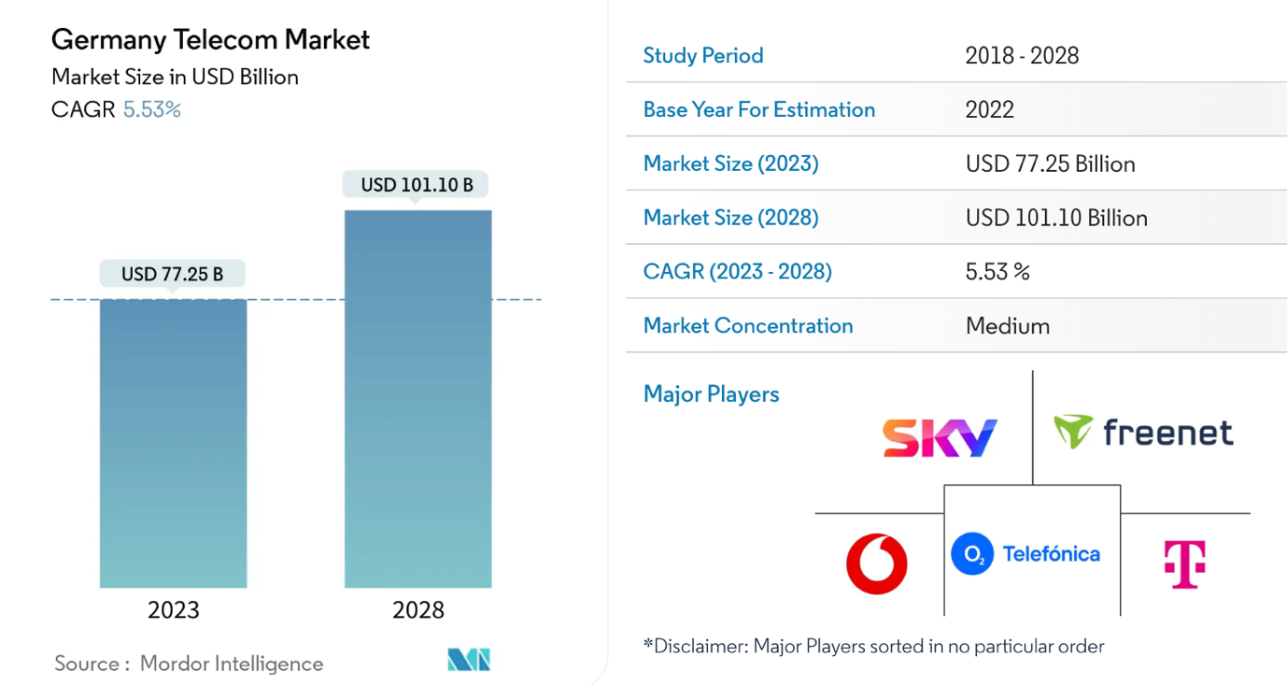
Market Size & Position: With a noteworthy presence in the German telecommunications industry, Vodafone Germany commands a significant portion of the market share. Adding to its eminence is the company's fervent pursuit of expanding 5G networks, propelling it to the forefront of this competitive realm
Figure 4: Market Size & Position

Key Success Factors:
- Tech Evolution: Vodafone's commitment to adopting cutting-edge technologies, with a spotlight on 5G, has been a game-changer.
- Service Innovation: By rolling out combined offerings, like mobile, web, and TV bundles, they're aligning with modern consumer tastes.
- Digital Leap: Their foray into digital platforms, AI-powered customer interactions, and cloud-based solutions has uplifted both the user experience and streamlined operations.
- Staying Within Bounds: Skillfully maneuvering through the regulatory maze set by the German Federal Network Agency (BNetzA) is vital. The latest rules underscore the importance of equitable competition and bolstering infrastructure.
Challenges: Despite its strengths, Vodafone faces challenges like regulatory hurdles, high infrastructure costs, and intense competition. Addressing these challenges while capitalizing on opportunities will be key to Vodafone's sustained success in the German market.

5. Host Country Analysis
Germany, a cornerstone of Europe's thriving economies, offers a dynamic environment for businesses. Its strong infrastructure, advanced technology, and political stability attract global corporations. Like any market, Germany has its unique opportunities and challenges. In this section, we'll explore Germany's business landscape using Porter's National Diamond model and assess the potential risks, giving insight into the context Vodafone operates in.
5.1 Country’s National Diamond (Germany )
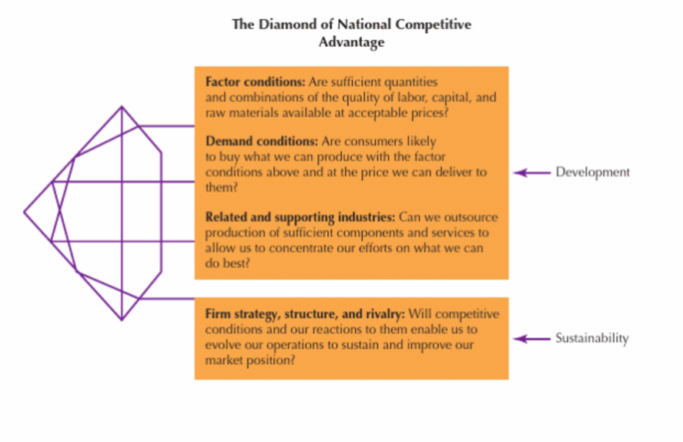
Figure 5: National Diamond. Source (Daniels, 2019)

Michael Porter's National Diamond model offers a blueprint for understanding the competitive edge of nations on the global stage. This model suggests that a nation's international prowess hinges on four pivotal determinants:
- Factor Conditions: This refers to a nation's assets in production factors, like skilled workforce and infrastructure, which are crucial for industry competition.
- Demand Conditions: This delves into the domestic appetite for an industry's offerings, highlighting the importance of understanding and meeting local consumer needs.
- Related and Supporting Industries: The global competitiveness of supplier and related industries in a nation can either bolster or hinder its position in a specific industry.
- Firm Strategy, Structure, and Rivalry: This determinant focuses on the national conditions shaping company formation, organization, and management. It also considers the intensity of local competition, which can spur innovation and growth.
By meticulously examining these facets, nations can fine-tune their competitive stance in the international arena.

5.1.1 Michael Porter's National Diamond analysis for Vodafone
Table 6: Porter's Diamond analysis
Porter's National Diamond Model | Vodafone Germany Analysis
Factor Conditions
- Technological Infrastructure | Offers LTE, 5G, cable internet, landlines, cable TV, and IPTV. Introduced 5G services in July 2019.
- Human Resources | Employs 16,000 individuals.
Demand Conditions
- Domestic Market Size | Over 31 million mobile customers as of Q3 2021. Third-largest mobile phone service provider in Germany.
- Service Diversity | Caters to both prepaid and postpaid customers. Expanded services to include 5G and IPTV.
Related and Supporting Industries
- Competitors | Main competitors are Telekom Deutschland and Telefónica Germany.
- Mergers and Acquisitions | Owns ~75% of Kabel Deutschland. Merged with Unitymedia in 2019.
Strategy, Structure, and Rivalry
- Historical Background | Began operations after Vodafone's takeover of Mannesmann GmbH in 2000. Rebranded as Vodafone D2 in 2002.
- Market Strategy | Proactive in expanding services, e.g., introduction of 5G in 2019 and IPTV services in 2011.

5.2 Country Business Risks (Germany)
- Economic Dependency on Exports: Germany is the world's third-largest exporter, with a significant portion of its GDP coming from exports. Major sectors include automotive, machinery, and chemicals. A global downturn, trade barriers, or disruptions can significantly impact the German economy (International Trade Administration U.S. Department of Commerce, 2022).
- Demographic Challenges: Germany has one of the highest median ages worldwide. This aging population can lead to labor shortages, increased healthcare costs, and pressure on the pension system (SchengenVisa News , 2021).
- Energy Transition (Energiewende): Germany's initiative to shift from fossil fuels to renewable energy can lead to uncertainties. While it aims for a green economy, there are concerns about energy security, costs, and the need for infrastructure investments (POLITICO, 2018).

6. Internal Analysis

In the domain of business strategy and planning, it is crucial to comprehend the internal dynamics of an organization. Internal analysis offers a holistic view of a company's strengths, weaknesses, capabilities, and areas ripe for improvement. This diagnostic tool aids businesses in pinpointing their successful practices, identifying their shortcomings, and optimizing their resources to achieve their goals. For our purposes, we will employ a SWOT analysis to probe deeper into Vodafone's internal environment. The SWOT analysis will provide a structured approach to understanding Vodafone's Strengths, Weaknesses, Opportunities, and Threats. This will not only offer us a snapshot of the current situation but also inform our strategic recommendations for the future. Through this analysis, we aim to uncover the inherent factors that shape Vodafone's performance and plot a course for sustained growth and success.

6.1 SWOT analysis
SWOT analysis is a strategic planning tool used to evaluate the Strengths, Weaknesses, Opportunities, and Threats involved in a project or business venture. It involves identifying the internal and external factors that are favorable and unfavorable to achieve an objective. This method was created in the 1960s by Albert Humphrey of the Stanford Research Institute, during a study conducted to identify why corporate planning consistently failed (Richard Puyt, 2023).

Table 7: SWOT analysis Table
SWOT Analysis of Vodafone
Strengths | 1. Go-To-Market Strategies
 | 2. Customer Service
 | 3. Mergers & Acquisitions
 | 4. Skilled Workforce
 | 5. Product Innovation
 | 6. Performance in New Markets
 | 7. Capital Expenditure Returns
 | 8. Strong Free Cash Flow
Weaknesses | 1. Limited Success Outside Core Business
 | 2. Integration of Different Cultures
 | 3. Product Marketing
 | 4. Attrition Rate
 | 5. Demand Forecasting
Opportunities | 1. Low Inflation Rate
 | 2. Core Competencies
 | 3. New Consumer Trends
 | 4. Taxation Policy
 | 5. Economic Uptick
Threats | 1. Environmental Regulations
 | 2. Currency Fluctuations
 | 3. Innovative Products
 | 4. Intense Competition

Vodafone, a telecommunications giant, has a multifaceted business landscape shaped by its strengths, weaknesses, opportunities, and threats. Its strengths (Porter, 1980), such as effective go-to-market strategies and a skilled workforce, position it favorably in the competitive market. However, challenges like limited success outside its core business and high attrition rates highlight areas of improvement. The changing global environment offers Vodafone opportunities (Chandler, 1962) like leveraging its core competencies in new markets and capitalizing on economic upticks. Yet, threats from environmental regulations and intense competition underscore the need for agility and innovation. This analysis draws insights from various academic and industry sources, emphasizing the dynamic nature of Vodafone's business environment.

7. International Strategies
Vodafone, a telecommunications giant, has been a prominent player in the global market for decades. Its international strategies have been pivotal in ensuring its success and maintaining its position as a market leader. This section delves into the intricacies of Vodafone's international strategies, drawing insights from academic research papers.
- Global Expansion and Market Entry Modes:
Vodafone's global expansion has been characterized by a mix of greenfield investments, acquisitions, and strategic partnerships. For instance, in emerging markets like India, Vodafone entered through the acquisition of a significant stake in Hutchison Essar, thereby gaining a foothold in a rapidly growing telecom market. This acquisition strategy allowed Vodafone to bypass the initial setup challenges and tap into an existing customer base. In contrast, in some European markets, Vodafone opted for greenfield investments, setting up operations from scratch, giving them more control over business operations.
- Strategic Alliances and Partnerships:
Collaborations have been a cornerstone of Vodafone's international strategy. By forming alliances with local players, Vodafone has been able to navigate regulatory landscapes, understand local market dynamics, and offer tailored services. A notable partnership is with China Mobile, which allowed Vodafone to tap into the vast Chinese market while sharing technological expertise.
- Leveraging Core Competencies:
Vodafone's international success can be attributed to its ability to leverage its core competencies. Its strong brand identity, technological prowess, and customer-centric services have been consistent across markets. By ensuring high-quality service delivery and innovative product offerings, Vodafone has managed to retain and grow its customer base in diverse markets.
- Response to Global Competition:
The telecom industry is fiercely competitive, with players vying for market share. Vodafone's strategy has been to stay ahead of the curve through continuous innovation, investment in research and development, and understanding evolving customer needs. In markets where competition is intense, Vodafone has adopted a differentiation strategy, offering value-added services and unique customer experiences.
- Regulatory and Cultural Challenges:
As with any multinational corporation, Vodafone has faced its share of regulatory and cultural challenges. In some markets, stringent regulatory norms have posed entry barriers. Vodafone's approach has been to engage in dialogue with regulatory bodies, ensuring compliance while advocating for a conducive business environment. Culturally, Vodafone has emphasized understanding local nuances and customizing its offerings accordingly. This localization strategy has been instrumental in ensuring customer loyalty.
- Future Outlook and Strategic Direction:
As the telecom landscape evolves with the advent of 5G, IoT, and other technological advancements, Vodafone's international strategy is poised for a shift. The focus is likely to be on digital transformation, enhancing network capabilities, and forging new partnerships in the tech space.
In conclusion, Vodafone's international strategies have been a blend of proactive and reactive measures. Its ability to adapt, innovate, and understand local markets has been instrumental in its global success. As the telecom industry undergoes rapid changes, Vodafone's strategic agility will be crucial in maintaining its leadership position.

8. Corporate Social Responsibility
Corporate Social Responsibility (CSR) has evolved as a significant aspect of modern business practices, emphasizing the commitment of corporations to contribute positively to society while achieving their economic goals. Carroll's Pyramid of CSR categorizes these responsibilities into four distinct layers: economic, legal, ethical, and philanthropic. Each layer represents a different aspect of a company's obligations, from the foundational need to be profitable to the aspirational goal of giving back to society. In the context of Vodafone, one of the world's leading telecommunications companies, understanding its CSR initiatives through the lens of Carroll's Pyramid provides a comprehensive insight into its multifaceted approach to responsible business. This section delves into Vodafone's CSR strategies and initiatives, highlighting how they align with the principles set out in Carroll's Pyramid.
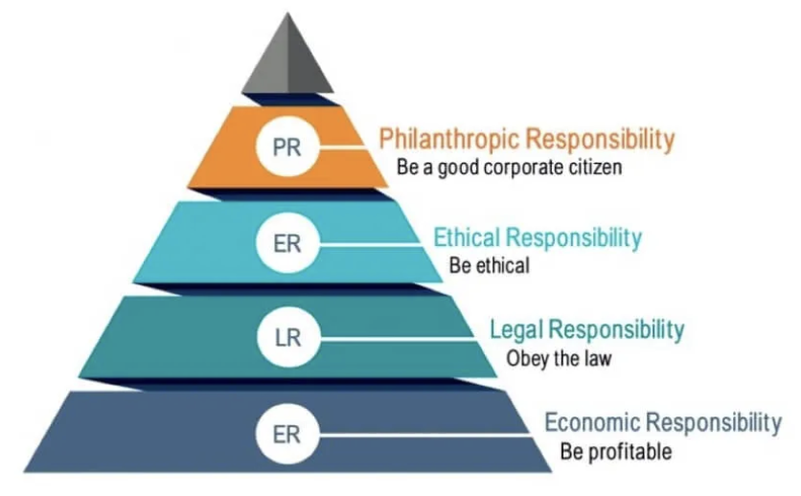
Figure 6: Carroll's Pyramid. Source:theimpectinvestor.com

- Economic Responsibilities:
  - Digital Inclusion: Vodafone has been at the forefront of promoting digital inclusion. In 2019, the company launched the 'Digital Society' initiative, aiming to connect an additional 100 million people to the internet by 2025.
  - Supporting SMEs: Vodafone has introduced various programs to support small and medium-sized enterprises (SMEs). For instance, in Spain, they launched the 'Vodafone Business' platform, which offers digital solutions tailored for SMEs (Vodafone, 2023).
- Legal Responsibilities:
  - Data Privacy and Security: Vodafone has a robust data privacy framework in place, ensuring that customer data is protected. They have also been transparent about their data handling practices, publishing an annual 'Law Enforcement Disclosure Report' (Vodafone Group Plc Digital Rights and Freedoms, 2023).
  - Regulatory Compliance: Vodafone ensures that all its operations adhere to the local regulations of the countries they operate in. They have a dedicated team that monitors regulatory changes and ensures compliance (Thomson, 2020).
- Ethical Responsibilities:
  - Supply Chain Ethics: Vodafone has a stringent supplier code of conduct. They ensure that their suppliers adhere to ethical labor practices, and they conduct regular audits to ensure compliance (York, 2017).
  - Promoting Diversity and Inclusion: Vodafone has been recognized for its efforts in promoting diversity and inclusion. In 2020, they were ranked among the top 10 companies in the 'Refinitiv Diversity & Inclusion Index'.
- Philanthropic Responsibilities:
  - Healthcare Initiatives: Vodafone Foundation has been actively involved in healthcare initiatives. One notable project is the 'Ambulance Taxi' service in Tanzania, which has helped pregnant women reach healthcare facilities during emergencies (Africa, 2020).
  - Educational Programs: Vodafone Foundation has also been involved in promoting education. Their 'Instant Schools' program has provided quality education to over 5 million children in Africa.
- Impact on Reputation and Business Performance:
  - Vodafone's commitment to CSR has positively impacted its reputation. They have been consistently ranked among the top companies in various CSR indices.
  - Their CSR initiatives have also translated into tangible business benefits. For instance, their focus on digital inclusion has opened up new markets and customer segments.

Conclusion
Throughout our comprehensive analysis of Vodafone, a telecommunications titan with an expansive global presence, we've gained profound insights into its international business strategies and robust CSR initiatives. Vodafone's international expansion strategy is characterized by a judicious mix of acquisitions, greenfield investments, and strategic alliances, enabling it to penetrate diverse markets and cater to a broad spectrum of customer needs. Their commitment to Corporate Social Responsibility, viewed through the prism of Carroll's Pyramid of CSR, is evident in their endeavors spanning economic, legal, ethical, and philanthropic domains. Notably, their initiatives in digital inclusion, SME support, and championing healthcare and education have set industry benchmarks.
Vodafone's dedication to adhering to the regulatory landscapes of its operational countries is commendable, with their transparency in areas like data privacy setting industry standards. Our SWOT analysis shed light on Vodafone's intrinsic strengths, such as its formidable brand identity, technological vanguard, and a customer-centric ethos. However, it's imperative to note the challenges they face, including the rigors of intense competition and the vicissitudes of a rapidly evolving technological domain.
The PESTEL analyses for both the UK, Vodafone's home turf, and Germany, a key host country, unveiled the myriad external factors shaping Vodafone's strategic decisions. The UK's stable, innovation-driven environment juxtaposed with Germany's robust economic stature and advanced technological infrastructure underscores their significance in Vodafone's global strategy. A salient observation from our study is the symbiotic relationship between Vodafone's international strategies and its CSR endeavors. Their CSR initiatives, particularly in areas like digital inclusion, resonate deeply with their overarching business objectives, creating a synergy that's both socially beneficial and commercially viable.
In summation, Vodafone's odyssey in the global telecommunications arena epitomizes strategic foresight, unwavering commitment to societal welfare, and adeptness at navigating the multifaceted dynamics of diverse markets. As the telecom landscape continues its relentless evolution, Vodafone's holistic and proactive approach augurs well for its future endeavors, ensuring it remains at the industry's vanguard.

References

Africa, T. i., 2020. Vodafone Foundation expanding the ‘Ambulance Taxi’ programme in US$28m investment. [Online]
Available at: https://www.techinafrica.com/vodafone-foundation-expanding-the-ambulance-taxi-programme-in-us28m-investment/
[Accessed Aug 2023].
Anwar, S. T., 2003. CASES Vodafone and the wireless industry: a case in market expansion and global strategy. Journal of Business & Industrial Marketing , 18(3), pp. 270-288.
Buye, R., 2021. Critical examination of the PESTEL Analysis Model, n.d: Researchgate .
Cansfield, M., 2009. Case Study: How Vodafone Germany Became A Convergent Operator. [Online]
Available at: https://www.forrester.com/report/case-study-how-vodafone-germany-became-a-convergent-operator/RES46828
[Accessed 2023].
celso_gomes, 2014. Vodafone-micro environmental factors-marketing. [Online]
Available at: https://www.slideshare.net/celso_gomes/vodafonemarket
[Accessed 2023].
Chandler, A. D., 1962. Strategy and Structure, Cambridge: MIT Press.
Contact Centre World, 2008. Case Studies : Vodafone Germany. [Online]
Available at: https://www.contactcenterworld.com/view/contact-center-case-study/vodafone-germany.aspx
[Accessed 2023].
Coulter, M. K., 2008. Strategic Management in Action, s.l.: Prentice Hall.
Dobbs, M. E., 2014. Guidelines for applying Porter's five forces framework: a set of industry analysis templates. Competitiveness Review,, 24(1), pp. 32-45.
Daniels, J. D., 2019. International business : environments & operations. Sixteenth edition ed. Harlow, England: Pearson.
Dodourova, M., 2003. Industry dynamics and strategic positioning in the wireless telecommunications industry: the case of Vodafone Group plc, s.l.: Emerald insight .
Doyle, P. & Stern, P., 2006. Marketing Management and Strategy. 4 ed. Essex: Pearson Education Limited.
Financial Times, 2022. Vodafone boosted by growth in UK business. [Online]
Available at: https://headtopics.com/uk/vodafone-boosted-by-growth-in-uk-business-28412776
[Accessed 2023].
GSMA, 2019. gsma.com. [Online]
Available at: https://www.gsma.com/futurenetworks/wiki/vodafone-case-study/
[Accessed 2023].
Global Data , 2023. Germany Telecom Services Market Size and Analysis. [Online]
Available at: https://www.globaldata.com/store/report/germany-telecom-operators-market-analysis/
[Accessed Aug 2023].
GBR Team, 2021. PESTLE analysis of Vodafone. [Online]
Available at: https://www.george-business-review.com/pestle-analysis-of-vodafone/
[Accessed 2023].
International Trade Administration U.S. Department of Commerce, 2022. Germany - Country Commercial Guide. [Online]
Available at: https://www.trade.gov/country-commercial-guides/germany-market-overview
[Accessed Aug 2023].
Jackson, M., 2022. Vodafone Claims 5G May Boost UK Economy by £7bn Per Year. [Online]
Available at: https://www.ispreview.co.uk/index.php/2022/06/vodafone-claims-5g-may-boost-uk-economy-by-7bn-per-year.html
[Accessed AUG 2023].
Kalam, K., 2020. Market Segmentation, Targeting and Positioning Strategy Adaptation for the Global Business of Vodafone Telecommunication Company, s.l.: Research Page .
Kasia Davies , 2022. Number of mobile customers of Vodafone in Germany in the corporate years from 2008/09 to 2021/2022. [Online]
Available at: https://www.statista.com/statistics/488538/vodafone-mobile-customers-germany/
[Accessed 2023].
MBA SKOOL, 2022. Vodafone PESTLE Analysis. [Online]
Available at: https://www.mbaskool.com/pestle-analysis/companies/17973-vodafone.html
[Accessed Aug 2023].
Miro, 2022. What is Porter’s Five Forces model? And how to use it to analyze the competition. [Online]
Available at: https://miro.com/blog/porters-five-forces/
[Accessed 12 Aug 2023].
Porter, M. E., 1980. Competitive Strategy, New York: Free Press.
POLITICO, 2018. Germany’s green energy shift is more fizzle than sizzle. [Online]
Available at: https://www.politico.eu/article/germany-climate-change-green-energy-shift-is-more-fizzle-than-sizzle/
[Accessed AUG 2023].
Paul, S., 2019. Vodafone tests new network tech in UK in challenge to 'big three' suppliers. [Online]
Available at: https://www.reuters.com/article/us-vodafone-technology-openran-idUSKCN1WL0ES
[Accessed Aug 2023].
Richard Puyt, F. B. L. C. P. W., 2023. The origins of SWOT analysis. Long Range Planning, 56(3).
SchengenVisa News , 2021. German Labour Chief Says Germany Needs 400,000 Skilled Immigrants. [Online]
Available at: https://www.schengenvisainfo.com/news/german-labour-chief-says-germany-needs-400000-skilled-immigrants-yearly-to-tackle-skilled-workers-shortage/
[Accessed Aug 2023].
Sandle, P., 2023. Hutchison briefed UK government as Vodafone deal set for regulatory scrutiny. [Online]
Available at: https://www.reuters.com/markets/deals/hutchison-briefed-uk-government-vodafone-deal-set-regulatory-scrutiny-2023-04-14/
[Accessed Aug 2023].
teradata, 2023. Identifying upsell and cross-sell opportunities to fuel needed growth.. [Online]
Available at: https://www.teradata.com/Customers/Vodafone-Germany-Convergence
[Accessed 2023].
Thomson, S., 2020. Vodafone Deutschland revamps legal and regulatory team. [Online]
Available at: https://www.digitaltveurope.com/2020/04/02/vodafone-deutschland-revamps-legal-and-regulatory-team/
[Accessed Aug 2023].
TMF Group experts, 2018. Cultural considerations of doing business in the UK. [Online]
Available at: https://www.tmf-group.com/en/news-insights/articles/2018/may/cultural-considerations-uk/
[Accessed 2023].
Vodafone Group Plc, 2023. About Us. [Online]
Available at: https://www.vodafone.com/about
[Accessed 2023].
Vodafone Group , 2023. digital-society, Vodafone. [Online]
Available at: https://www.vodafone.com/sustainable-business/our-purpose-pillars/digital-society
[Accessed July 2023].
Vodafone Group Plc Digital Rights and Freedoms, 2023. Law Enforcement Disclosure Statement. [Online]
Available at: https://www.vodafone.com/content/dam/vodcom/sustainability/pdfs/vodafone_drf_law_enforcement_disclosure_statement.pdf
[Accessed Aug 2023].
Vodafone, 2023. Enabling a digital society. [Online]
Available at: https://www.vodafone.com/sustainable-business/our-purpose-pillars/digital-society
[Accessed Aug 2023].
Vodafone Group Plc, 2023. Our History. [Online]
Available at: https://www.vodafone.com/our-company/about-us/our-history
Vodafone Group Plc, 2023. Our Services. [Online]
Available at: https://www.vodafone.com/our-services
Vodafone Group, 2023. Our-purpose, Vodafone. [Online]
Available at: https://www.vodafone.com/about-vodafone/who-we-are/our-purpose
[Accessed 07 2023].
vodafone, 2023. vodafone.com. [Online]
Available at: https://www.vodafone.com/about-vodafone
Weber, K., 2021. Telecommunications in Germany: Market Dynamics and Future Trends, s.l.: ARXIV.
Wood, M. B., 2013. Essential Guide to Marketing Planning. 3 ed. Harlow: Pearson Education Limited.
York, D., 2017. The Vodafone Code of Conduct. [Online]
Available at: https://docplayer.net/12472691-The-vodafone-code-of-conduct.html
[Accessed Aug 2023].
Zaidi, T., 2022. Vodafone market in Germany goes into reverse. [Online]
Available at: https://www.businesstoday.in/industry/telecom/story/vodafone-market-in-germany-goes-into-reverse-342583-2022-07-25
[Accessed Aug 2023].

