(Mind Help, no date)
Student name: Orsolya Kaszas
Student ID: 2008742
Module code: BMHP 6009
Assignment title: Leaflet
Lecturer’s name: Joanne Davies

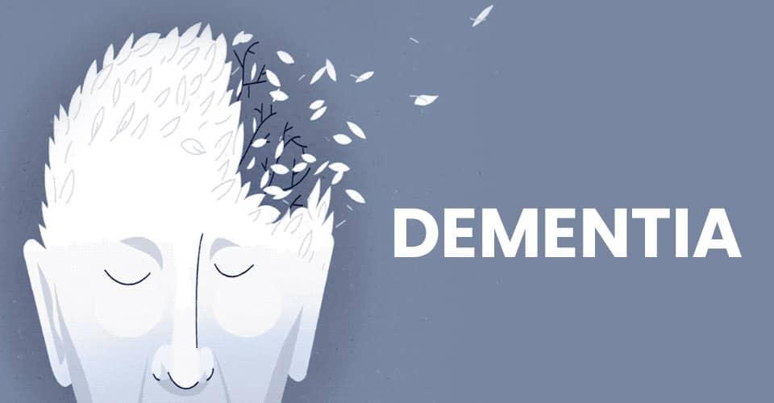

The loss of the short-term memory is the first sign of AD. This leads to increasingly severe memory issues, confusion, disorientation, personality changes, and difficulty with language and speaking. (Brace Dementia Research, no date). The disease is caused by a protein, called amyloid – b, which build up plaques in the brain. This damages the cells and loss of connection between them. As the conditions progress, the size of the brain shrinks. Because AD develops slowly, it is difficult to spot the signs. Vascular dementia (VaD) is the second most common type of dementia. (Alzheimer’s Society, 2015). VaD is caused by leaking and blocked blood vessels which eventually lead to destroying brain cells. Declining cognitive skills, hallucinations and delusions can be symptoms of VaD. High blood pressure, high cholesterol - and body weight can increase the risk of developing Vascular dementia. Dementia patients after the age of 85 often suffer from a mix of VaD and AD. (Erber, 2012, p. 353).

This leaflet is designed for family members of a dementia patient to provide information about the condition.

According to the World Health Organization (2022) dementia is an umbrella term for numerous condition, which severely interfering with the person’s ability to carry out daily tasks. Dementia affects memory, behaviour and cognitive abilities. Although age is a known risk factor for dementia, it is not a necessarily part of the ageing process.

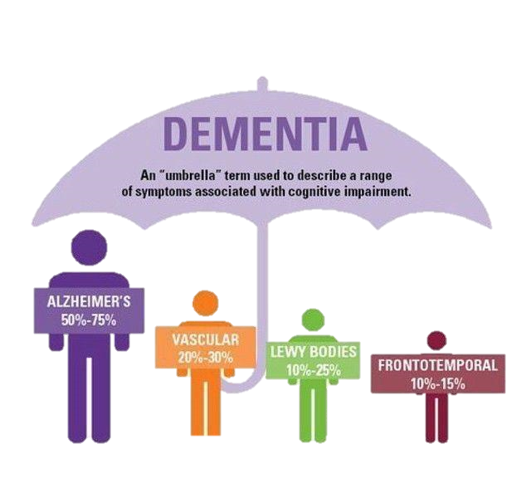
Memory loss is a significant symptom of dementia, although it may only indicate mild cognitive impairment (MCI) which can lead to dementia. (NHS, 2020). Alzheimer’s disease (AD) is the most common type of dementia. 60 percent of dementia patients suffer from dementia.
(dementia friendly Wyoming, 2021)

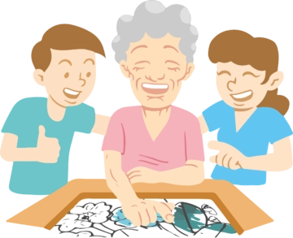
Although dementia is a progressive, incurable disease, there are medications to reduce symptoms temporarily. Donepezil and Memantine influence brain processes. Donepezil is used to treat Alzheimer's disease at various stages. Memantine is not only for Alzheimer’s patients but for those who suffer from vascular or Lewy body dementia. Risperidone or Haloperidol are medications which are used to treat aggressive behaviour. (NHS, 2020).
Medications are not always the best option for dementia patients, but there are various non-medical therapies available.
Cognitive stimulation therapy: Patients are engaged in activities which stimulate brain functions. (Cognitive Stimulation Therapy 2022).
(Acerize, 2021)
The other benefit of this activity is socialising, as sessions usually take place in groups. The therapy is evidence based and recommended for patients with mild or moderate dementia. Cognitive rehabilitation is also advised for people in the same stages of dementia, although it is not widely available yet. (University of Exeter, no date). It helps patients to manage their everyday life. The focus of this therapy is the individual’s preference, as it determines the goals of the patient.
Reminiscence therapy (RT): Dementia patients have difficulties with short-term memory, but they can remember what happened a long time ago. In RT sessions, experiences, events from the past are recalled using photos and videos. Life story work is an RT activity, which is great opportunity for the patient and his family to spend valuable time together. (Dementia UK, 2022). A study suggests that individual RT has a positive effect on mood and cognitive abilities, and RT in groups improves communication in patients. (Woods et al. 2018)
The condition affects each patient differently; it also depends on the type of dementia they have and where they are in the disease's progression.



Alvernia University, 2019

Early diagnosis of dementia is important, because the patients can plan their care and their family can be prepared.
Memory, communication, and behaviour deteriorate as the stages progress. At the early-stage patients might only need a little bit of assistance like developing a daily routine or helping to use technology. (Alzheimer’s Society, 2022). In the first two years memory problems already present, there are changes in behaviour and patients can get lost easier even in a familiar environment. Cognitive abilities started to decline.
In the middle stage depression, anxiety, and irritability, are common symptoms. Communication becomes more difficult in both ways. It can help if the carer speaks slowly. Although patients become less independent it is important to encourage them to do as much as they can. (Alzheimer’s Association, 2022).
The disease eventually progresses to its final stage when the patient loses physical and mental abilities. (Dementia.org, 2015). At this stage, difficulties with communication become more severe, patients require more sleep, and they lose weight and mobility.


(AlzProduct, no date)

Although major changes are not recommended in the environment, adaptations to the patient’s requirements are necessary. Assistive technology promotes independence and safety for patients. Medical reminders, night and day clocks and locator devices are helping in their everyday life. (Social Care institute for excellence, 2019). Adapted, telephones, Skype and Messenger enable communication between patients and their careers. In the event of an accident, a fall detector can notify family members. Personal alarms work with a button which alarms the Emergency Resolution Centre. (ageUK, no date).


Reference list:

Acerize (2021) Reminiscence how and why [image]. Available at:
https://acerize.com/reminiscence-how-and-why/ (Accessed: 28 October 2022).
Age UK (2022) Personal Alarms. Available at:
https://www.ageuk.org.uk/products/mobility-and-independence-at-home/personal-alarms/ (Accessed: 20 October 2022).
Alvernia University (2019) Dementia Stages: Recognising the Sign and Symptoms.
[image]. Available at: https://online.alvernia.edu/articles/dementia-stages-signs-symptoms/ (Accessed: 28 October 2022).
Alzheimer’s Association (2022) Middle-Stage Caregiving. Available at:
https://www.alz.org/help-support/caregiving/stages-behaviors/middle-stage
(Accessed: 17 October 2022).
Alzheimer’s Society (2021) Early-stage signs and symptoms of dementia. Available at: https://www.alzheimers.org.uk/about-dementia/symptoms-and-diagnosis/how-dementia-progresses/early-stages-dementia (Accessed: 20 October 2022).
Alzheimer’s Society (2015) What is vascular dementia?. Available at:
https://www.jpaget.nhs.uk/media/275007/What-is-vascular-dementia.pdf
(Accessed: 12 October 2022).
AlzProduct (no date) MemRabel 2 - Calendar Clock with Audio & Visual Reminders
[image]. Available at: https://www.alzproducts.co.uk/memrabel-2-dementia-clock?gclid=Cj0KCQjwnvOaBhDTARIsAJf8eVMxg1vhrPsdF1gc70KXEWw4AAxYairZeHH7DtRETgC7p3mWXpyYNrQaAgh_EALw_wcB (Accessed: 28 October 2022)
Brace Dementia Research (no date) Alzheimer's disease (AD). Available at:
https://www.alzheimers-brace.org/alzheimers-disease-ad/?gclid=Cj0KCQjwy5maBhDdARIsAMxrkw0N_AG8PuUfAQI1KsxdQdKmWkg8qUENoUBR67rmxCADt5WKlZhM_A4aAg-lEALw_wcB (Accessed: 10 October 2022).
Cognitive Stimulation Therapy (2022) An Introduction to Cognitive Stimulation Therapy. Available at: http://www.cstdementia.com/
(Accessed: 13 October 2022).
Dementia Friendly Wyoming (2021) Types of Dementia [image]. Available at:
https://www.dfwsheridan.org/types-dementia (Accessed: 20 October 2022).
Dementia.org (2015) End Stage Of Dementia. Available at:
https://www.dementia.org/end-stage-of-dementia (Accessed: 17 October 2022).
Dementia UK (2022) Meaningful activities part four: Reminiscence. Available at:
https://www.dementiauk.org/reminiscence-activities/ (Accessed: 13 October 2022).
Erber, Joan T. (2012) Aging & older adulthood. 3rd edn. Chichester, West Sussex:
Available at:
https://www-vlebooks-com.ezproxy.uwtsd.ac.uk/Product/Index/156495?page=0
(Accessed: 12 October 2022).

Gov.UK (no date) Definition of disability under the Equality Act 2010. Available at:
https://www.gov.uk/definition-of-disability-under-equality-act-2010
(Accessed: 4 November 2022).

Mind Help (no date) Dementia [image]. Available at:
(Oxford Population Health, 2022)

https://mind.help/topic/dementia/ (Accessed: 27 October 2022).
NHS (2020) Common early symptoms of dementia. Available at: https://www.nhs.uk/conditions/dementia/symptoms/ (Accessed: 9 October 2022).
NHS (2020) Medicines to treat dementia. Available at:
https://www.nhs.uk/conditions/dementia/treatment/ (Accessed: 13 October 2022).
Oxford Population Health (2022) Electronic Assistive Technologie [image].
Available at: https://www.ndph.ox.ac.uk/research/health-services-research-unit-hsru/research/carers-experience-of-assistive-technology-use-in-dementia
(Accessed: 27 October 2022).
Social care institute for excellence (2019) Assistive technology. Available at:
https://www.scie.org.uk/dementia/support/housing/assistive-technology?gclid=CjwKCAjwwL6aBhBlEiwADycBIBzUh6iooAJCUMYFfMdhy8mfKjAXin4z_sw-ltbnwl5QXNHdQIBqyBoCBCMQAvD_BwE (Accessed: 17 October 2022).
United Nations (no date) Article 12. Available at:
https://www.un.org/development/desa/disabilities/convention-on-the-rights-of-persons-with-disabilities/article-12-equal-recognition-before-the-law.html (Accessed: 4 November 2022).
United Nations (1991) United Nations Principles for Older Persons. Available at:
https://www.ohchr.org/en/instruments-mechanisms/instruments/united-nations-principles-older-persons#:~:text=Older%20persons%20should%20be%20able%20to%20enjoy%20human%20rights%20and,the%20quality%20of%20their%20lives.
(Accessed: 4 November 2022).
University of Exeter (no date) GREAT Cognitive Rehabilitation. Available at:
https://sites.google.com/exeter.ac.uk/great-cr/cognitive-rehabilitation
(Accessed: 14 October 2022).
Woods, B. et al. (2018) Reminiscence therapy for dementia. Available at:
https://www.cochranelibrary.com/cdsr/doi/10.1002/14651858.CD001120.pub3/full
(Accessed: 20 October 2022).
World Health Organization (2022) Dementia. Available at: https://www.who.int/health-topics/dementia#tab=tab_1 (Accessed: 10 October 2022).

