
LEVEL 5 ASSESSMENT 1
Title: Research, build, and deploy a Virtualised Enterprise network
Student name:
Muhammad Ameer Faisal
Student ID number:
2335795
Programme: BSC Applied Computing
Module: Network Operating Systems and Services Module code: ACCA5023
Lecturer: Dr.Dipo Dunsin & MD. Sadeque Imam Shaikh
Internal Verifier: Dr Sana Jokhio
Assignment Word count (or equivalent): 2500 Words equivalent
Submission deadline: Friday, 5th December 2025

Task 1 – Research Report

1. Research on Hypervisors (240 words)
Type 1 and Type 2 hypervisors differ primarily in their position within the system architecture.
Type 1 hypervisors, such as VMware ESXi and Microsoft Hyper-V, operate directly on bare-metal hardware. This structure enables higher performance, reduced latency and improved isolation because the host OS layer is removed (Tanenbaum and Bos, 2015). In contrast,
Type 2 hypervisors like VirtualBox or VMware Workstation run above a traditional operating system, offering ease of use but introducing additional abstraction layers that reduce efficiency and security (Stallings, 2021).
For the SWANSEA.ACCA domain environment—hosting Windows Server 2022, Debian Server, DHCP services, AD DS, and potentially a Certificate Authority—
a Type 1 hypervisor is the more appropriate choice but we going to use type 2 because we are already using virtual Box . It offers enterprise-grade scalability, supports mixed OS environments, and provides secure VM isolation, which is essential for protecting AD DS and PKI services. The enhanced topology, with increased numbers of subnets, domain clients and potentially VPN services, also benefits from the performance optimisation typically provided by Type 1 virtualisation.
Hardware considerations also justify this choice: modern CPUs with VT-x/AMD-V extensions achieve best performance under Type 1 architecture. Security needs further favour Type 1: since it removes the host operating system, the attack surface is significantly reduced (Tanenbaum and Bos, 2015).
Therefore, for compatibility, security, and scalability within the SWANSEA.ACCA infrastructure, Type 1 hypervisors provide the most suitable and technically robust foundation.

2. Research on IP Addressing (245 words)
IP addressing is the foundation of modern computer networks. It enables devices to identify each other, communicate reliably, route data across local and global networks, and scale efficiently. Without a structured and logical IP addressing scheme, networks would suffer from poor performance, routing conflicts, and security issues.
During group discussions, we explored how data travels across networks in packets labelled with source and destination IP addresses. Routers interpret these addresses to determine forwarding paths, while switches handle local delivery using MAC addresses (Kurose and Ross, 2021). IP addressing therefore provides the logical structure required for end-to-end communication across the Internet.
IPv4 uses a 32-bit format (e.g., 192.168.10.5), enabling approximately 4.3 billion unique addresses. Address limitations led to the introduction of subnetting, which enhances efficiency by dividing networks into smaller logical groupings to reduce broadcast traffic (Forouzan, 2017). IPv6, using a 128-bit format (e.g., 2001:db8::/64), expands address availability and enhances routing efficiency through hierarchical addressing (Tanenbaum and Wetherall, 2021).

IPv4 Subnetting Example
Subnet Name | Network Address | CIDR | Range | Number of Hosts
Server Network | 192.168.20.0 | /26 | 192.168.20.1–62 | 62
Client Network | 192.168.20.64 | /26 | 192.168.20.65–126 | 62

Diagram: Simplified Packet Flow
+---------+ +----------+ +------------+
| Client | ---> | Switch | ---> | Router | ---> Internet/Server
+---------+ +----------+ +------------+
(Uses MAC) (Uses MAC) (Uses IP)
Effective IP addressing ensures reliable communication across SWANSEA.ACCA by enabling subnet separation, broadcast reduction, clear IP allocation via DHCP, and secure segmentation between Windows and Debian hosts.

3. Research on Routing (240 words)
Routing protocols determine how packets traverse interconnected networks.
Static routing requires manual configuration, offering predictable behaviour and strong administrative control but lacking adaptability to network changes (Stallings, 2021). Dynamic routing, using protocols such as RIP or OSPF, automatically exchanges routing information, calculating optimal paths using algorithms such as Dijkstra’s shortest-path method (Tanenbaum and Wetherall, 2021).
Within the SWANSEA.ACCA topology, the Debian Server acts as a DHCP relay, forwarding broadcast-based requests to the Windows Server DHCP service. Reliable routing is essential so that DHCPDISCOVER messages travel between subnets. In small, predictable topologies, static routing is often adequate, simplifying administration. However, for larger or enhanced environments with multiple routers, redundant pathways, or complex subnetting, dynamic routing—preferably OSPF—is more appropriate due to faster convergence and improved scalability.

Comparison Table
Routing Type | Advantages | Disadvantages | Suitability
Static | Secure, predictable | Manual updates required | Small/simple topologies
Dynamic (OSPF) | Fast convergence, scalable | More complex | Enhanced/expanding topologies
Given the expected growth and multi-subnet environment, a hybrid routing approach is ideal: static routing for core internal networks and dynamic routing for scalable or redundant links.

4. Research on Network Services (245 words)
Network services form the backbone of enterprise operations. VPNs enable encrypted communication over untrusted networks, supporting remote access and secure site-to-site tunnels. Best practice includes strong encryption suites, MFA, and minimal attack exposure (NIST, 2020).
DHCP automates IP assignment, reducing configuration errors and enabling consistent network configuration. Recommended practices include scope segmentation, failover configuration, and protection from rogue DHCP servers (Stallings, 2021).
Active Directory Domain Services (AD DS) centralises authentication, identity management, and policy enforcement within SWANSEA.ACCA. Its effectiveness depends on secure organisational unit (OU) structures, access control, and continuous auditing (Microsoft, 2022).
Certificate Authorities (CAs) provide cryptographic trust by issuing and validating certificates for servers, users, and devices. Best practice includes operating an offline root CA, securing private keys, and publishing regular Certificate Revocation Lists (CRLs) (NIST, 2020). Windows AD CS integrates naturally with AD DS, simplifying deployment across Windows and Debian clients.
Together, these services ensure secure authentication, encrypted communication, efficient network automation, and trustworthiness of user and device identities across the entire network.

bjective
To set up a virtualized network environment using Oracle VirtualBox.
Tasks include installing VirtualBox, creating two virtual machines (Server and Client), configuring a NAT network (SWAN), assigning static IPs, and testing network connectivity between the machines.

Task 1: Install VirtualBox
Steps Performed:
- Downloaded and installed Oracle VirtualBox from the official website.
- Verified installation by launching VirtualBox Manager.
Screenshot:
( screenshots of all steps are here VirtualBox main window after installation)

2.1 Hypervision: Oracle Virtualbox Manager
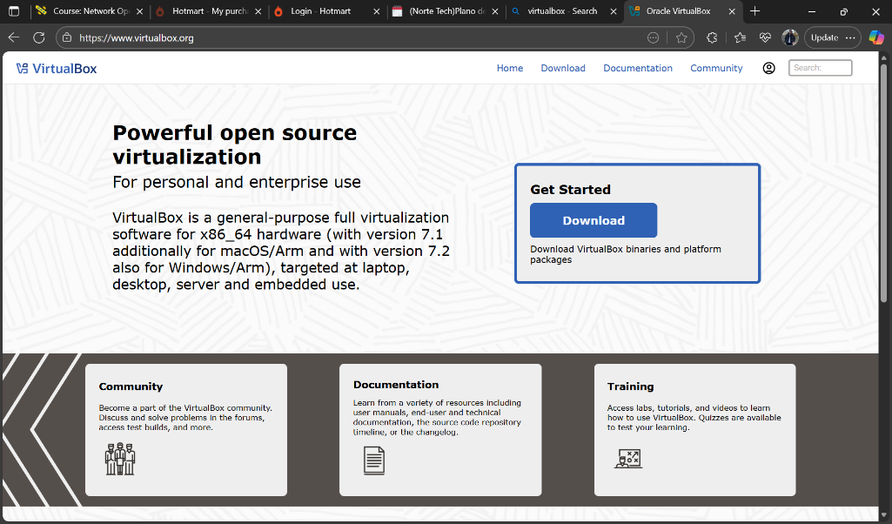
2.2.1 Evidence of Download and installation.
Creation of Virtual machine windows 1 and 2 (1 screenshot)
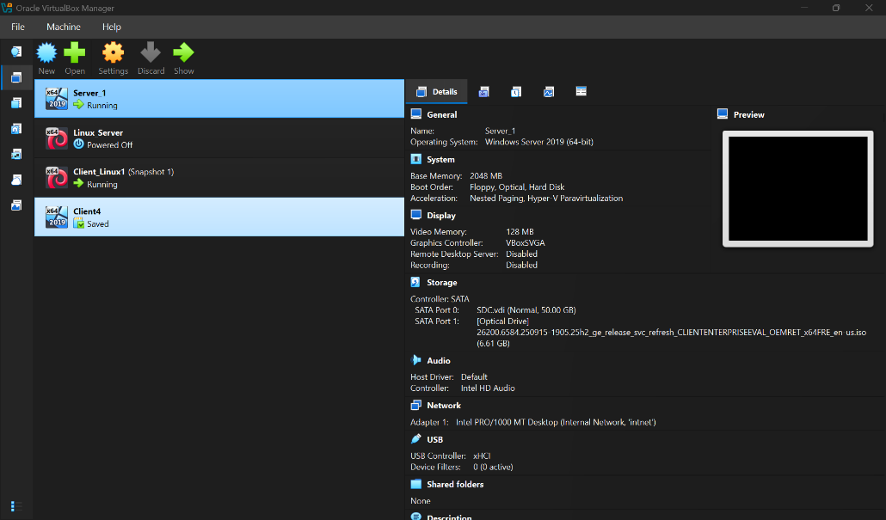
Creation of Virtual machine Linux Devian 1 and 2(1 screenshot)
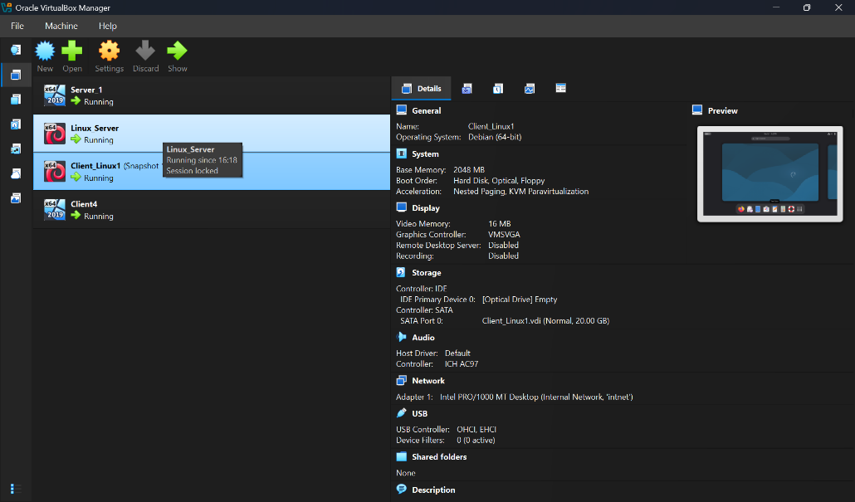

Installation of windows and Linux OS (Start 4 Machines and take desktop screenshots) (4 screenshots)
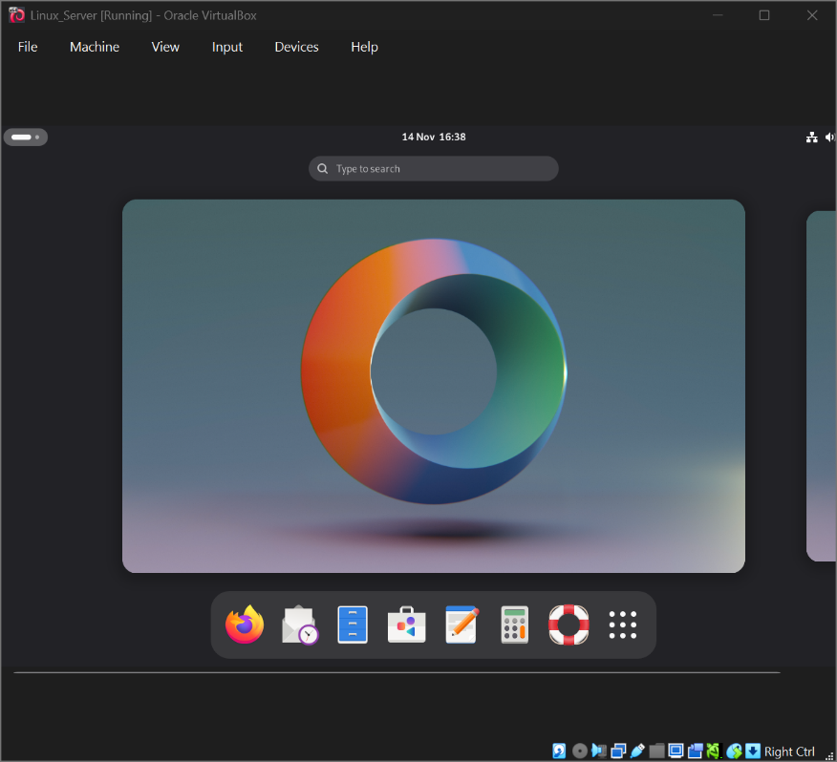
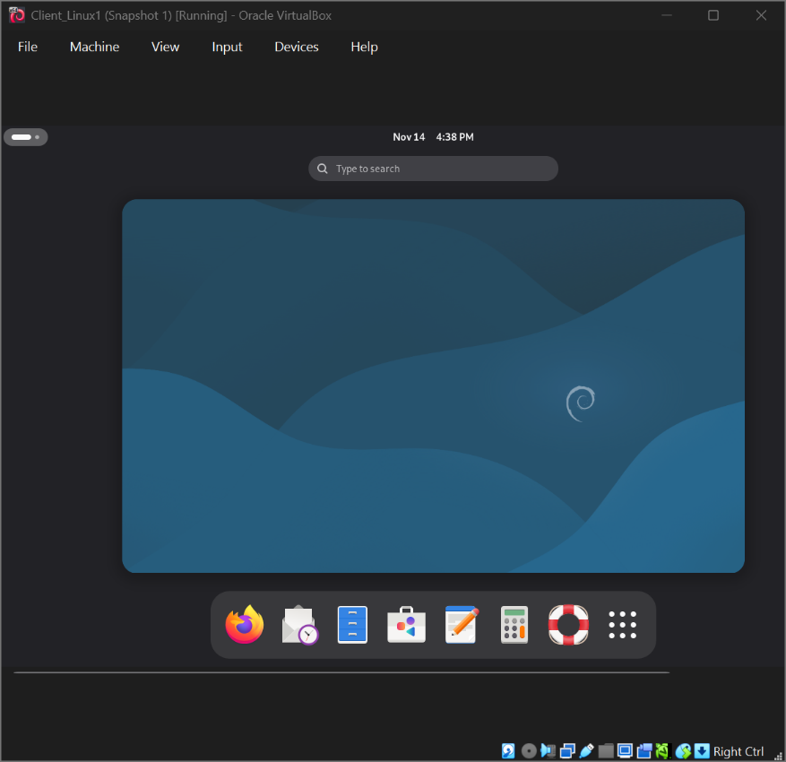

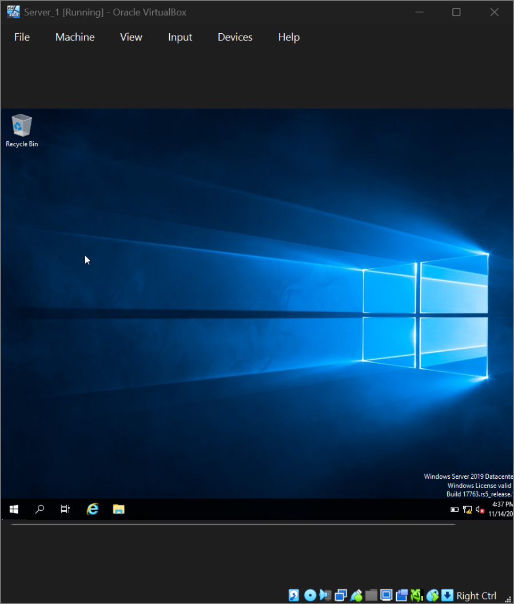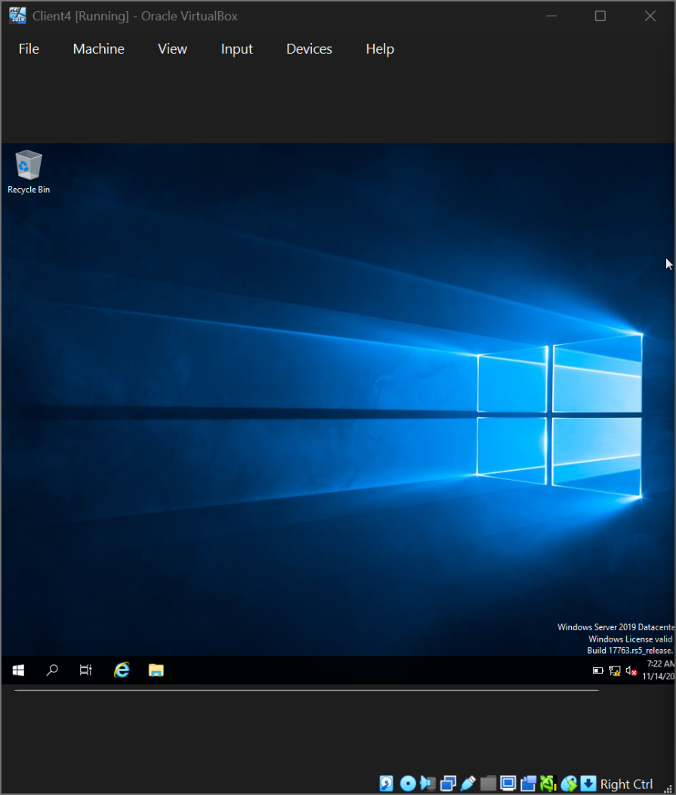
2.2.2 Deploy your network as per the given topology:
Creation of Network with Internal Network for windows (1 screenshot)
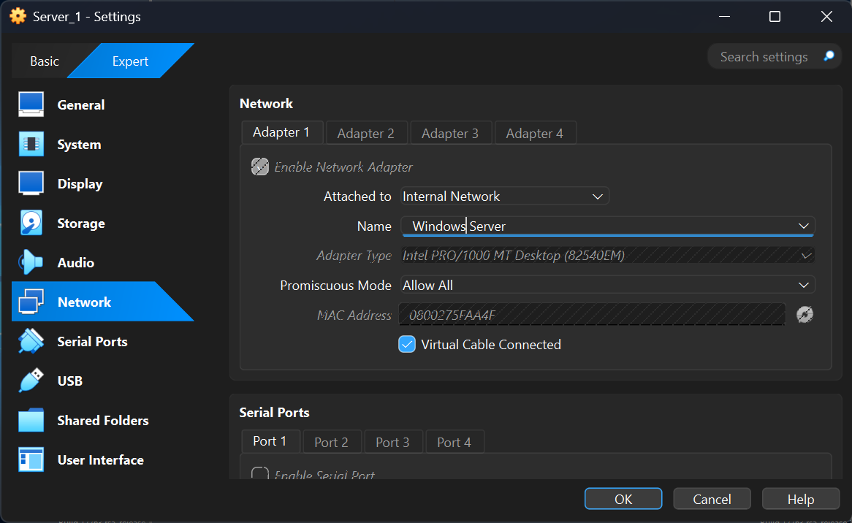
Creation of Network with Internal Network 2 for Linux (1 screenshot)
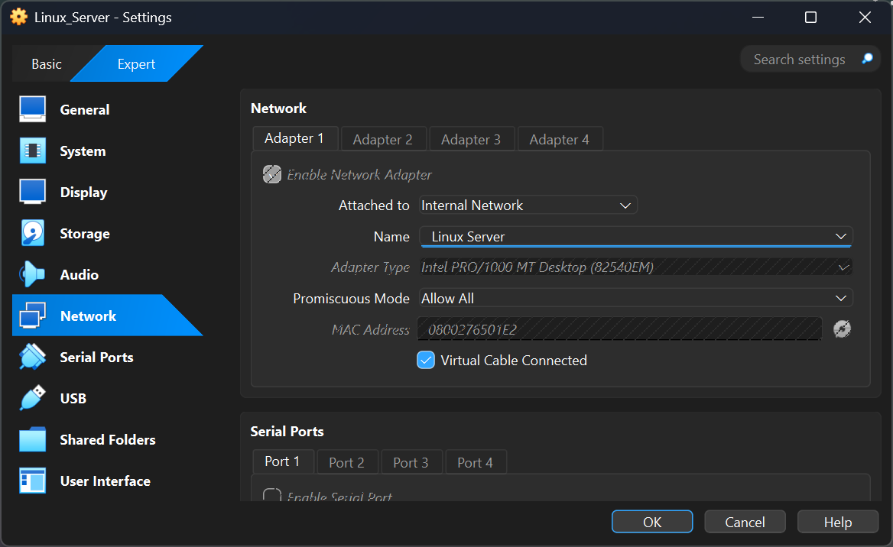

Evidence of 2 Windows PCs are connected with Internal Network (2 screenshot)
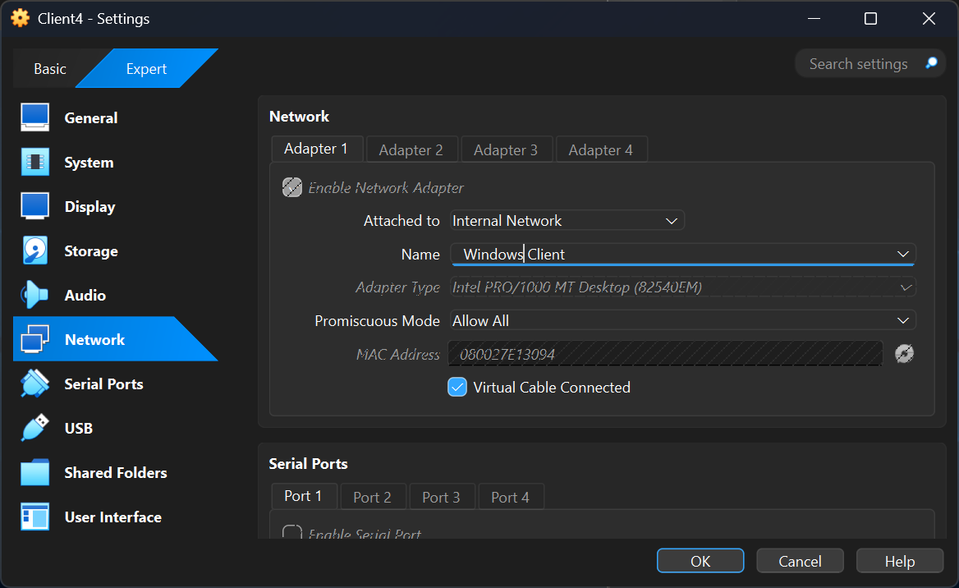

Evidence of 2 Linux PCs are connected with Internal Network2 (2 screenshot)
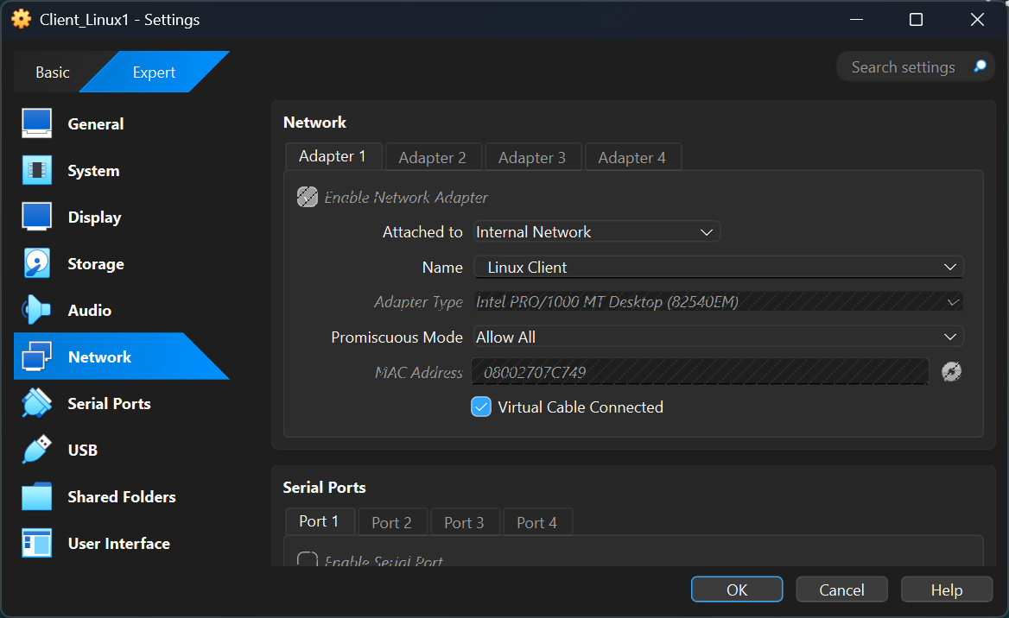

2.2.3 IP addressing :
2.3.1. Use appropriate IP addresses to configure your network.
Evidence of IP addresses set up in 2 Windows and 2 Linux machine(for windows command is ipconfig and for Linux use the command ip add show ( 4 screenshots)
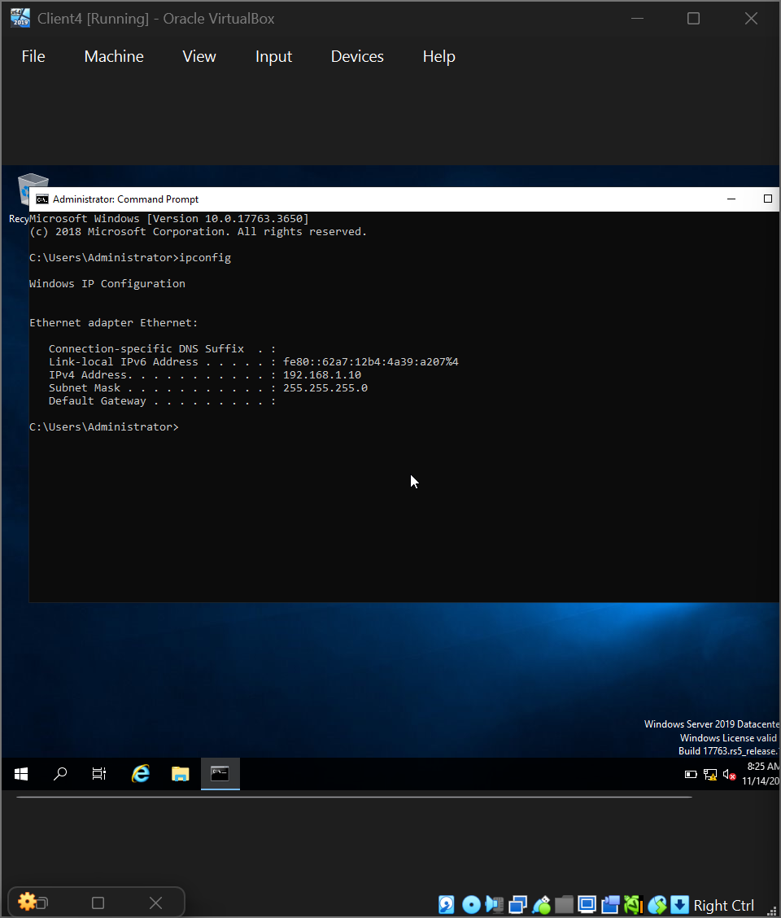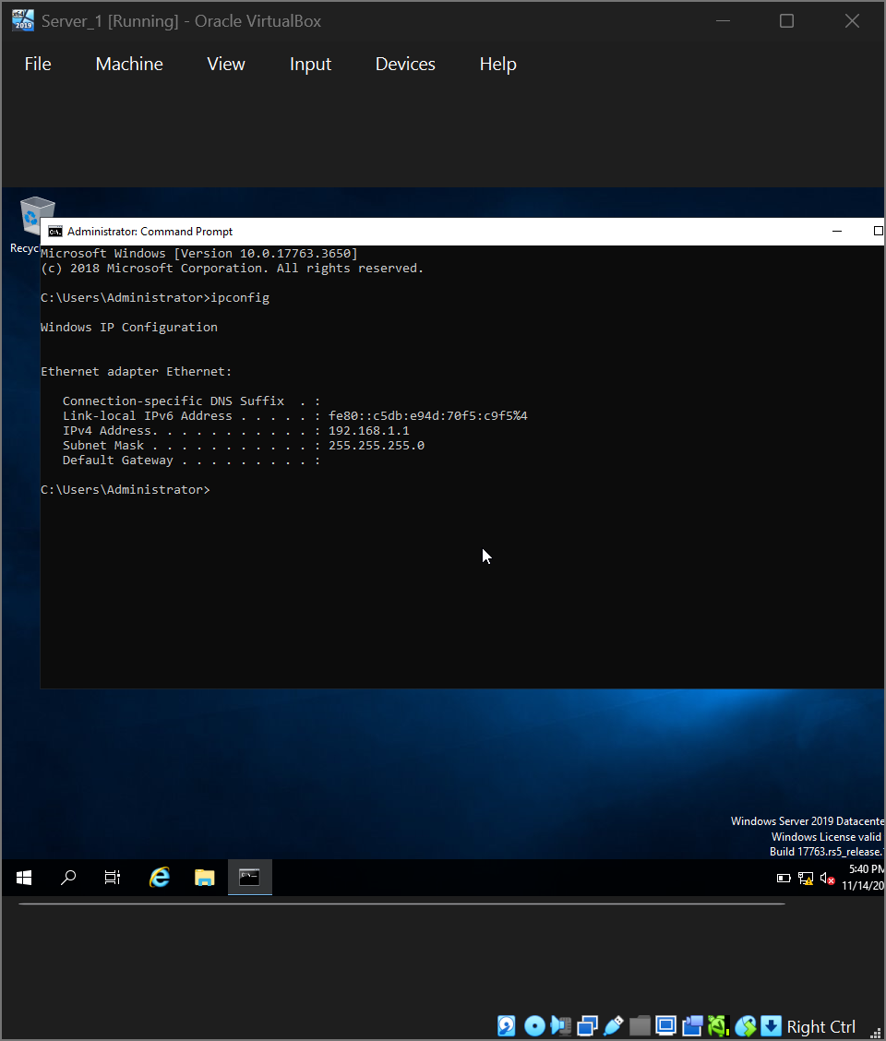
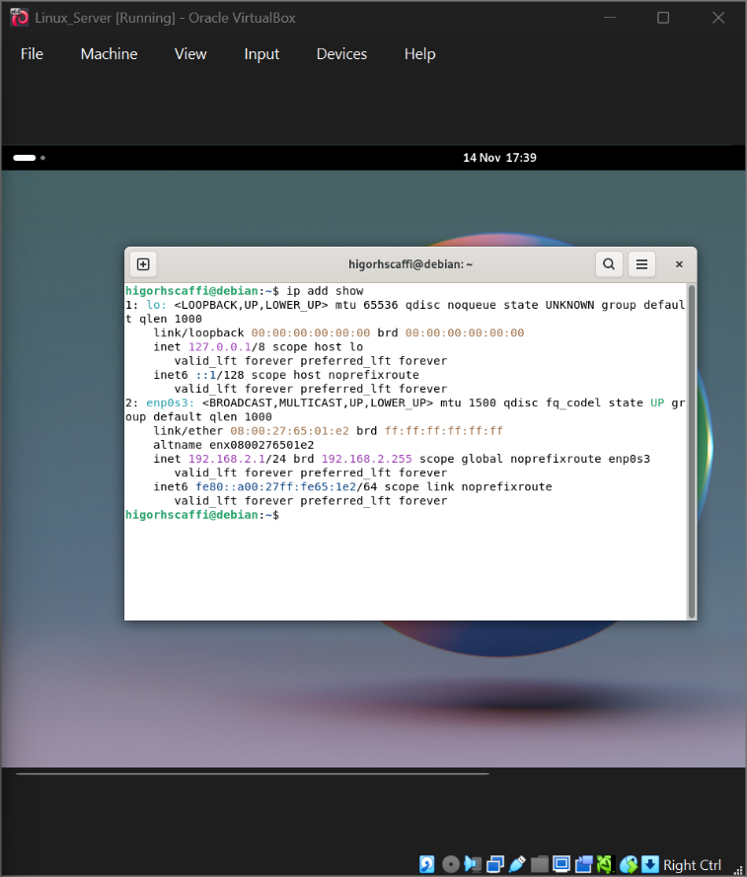
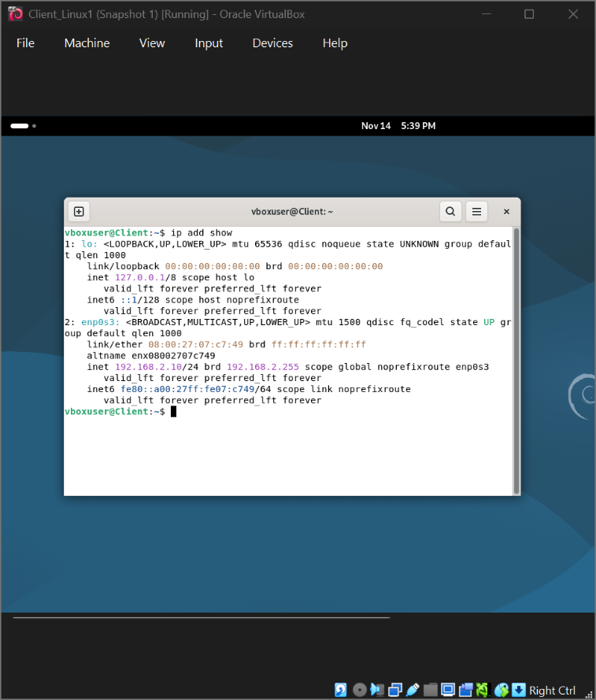

2.3.2. The above topology gives network address for the networks
Network IP address from Internal Network1 for windows (1 screenshot)
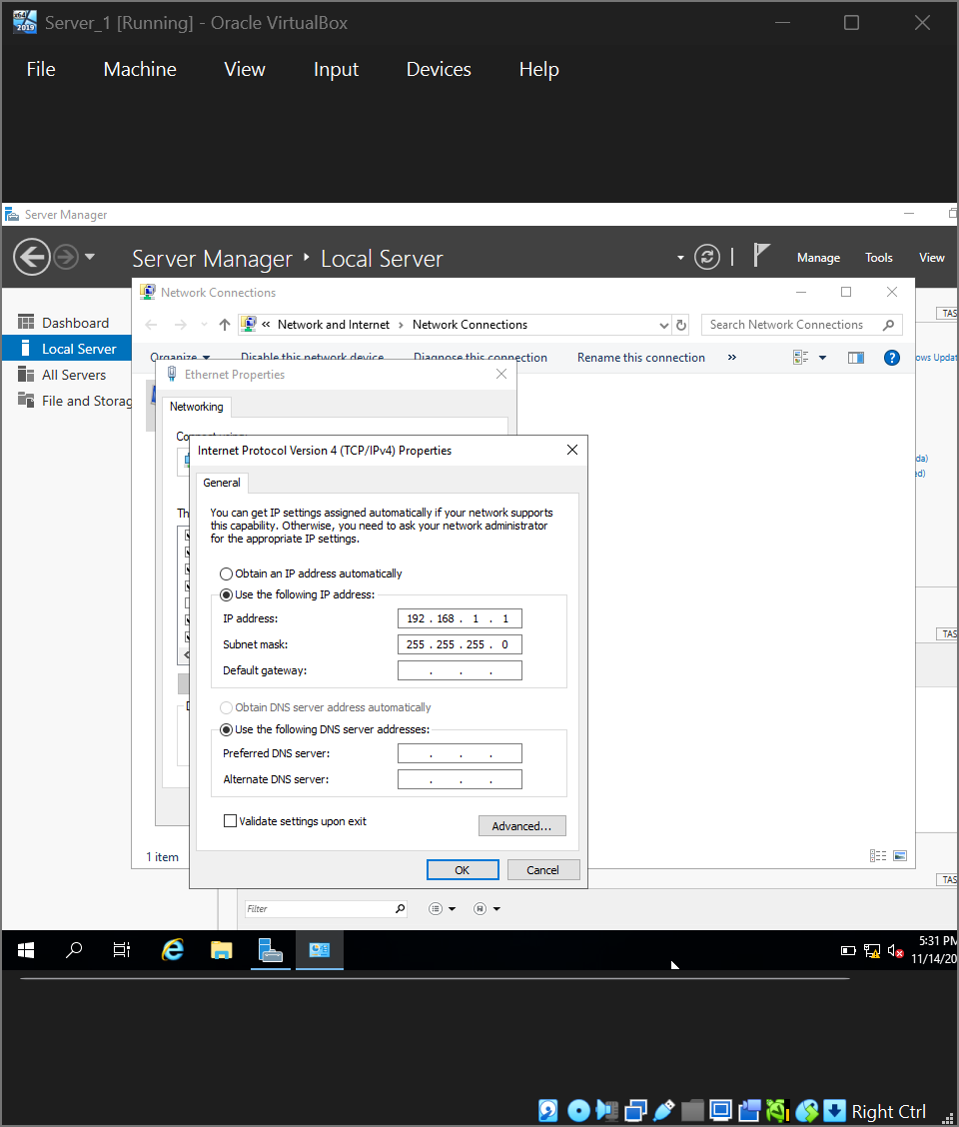
Network IP address from Internal Network 2 for Linux (1 screenshot)
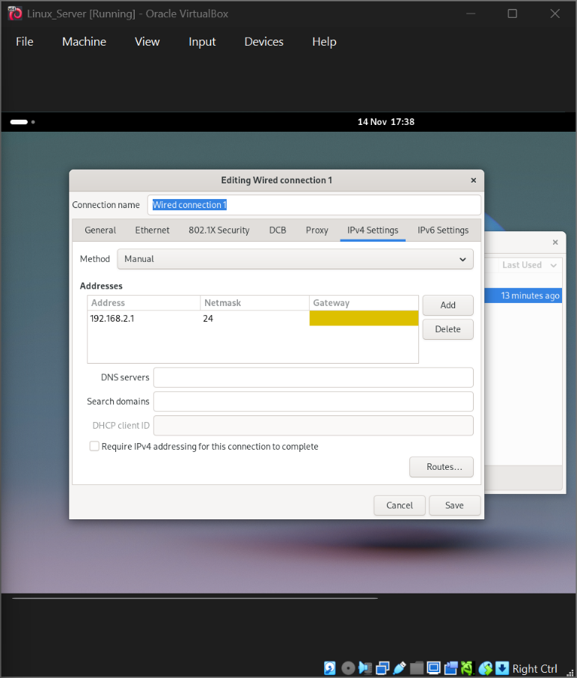

2.4. Test and Troubleshoot You need to achieve the following:
2.4.1. Perform Connectivity tests
Outcome 1: Successful connectivity within linux network. (2 screenshots)
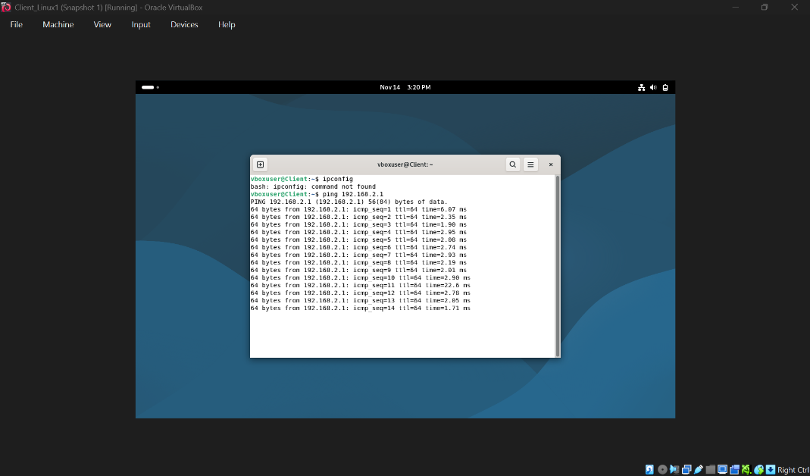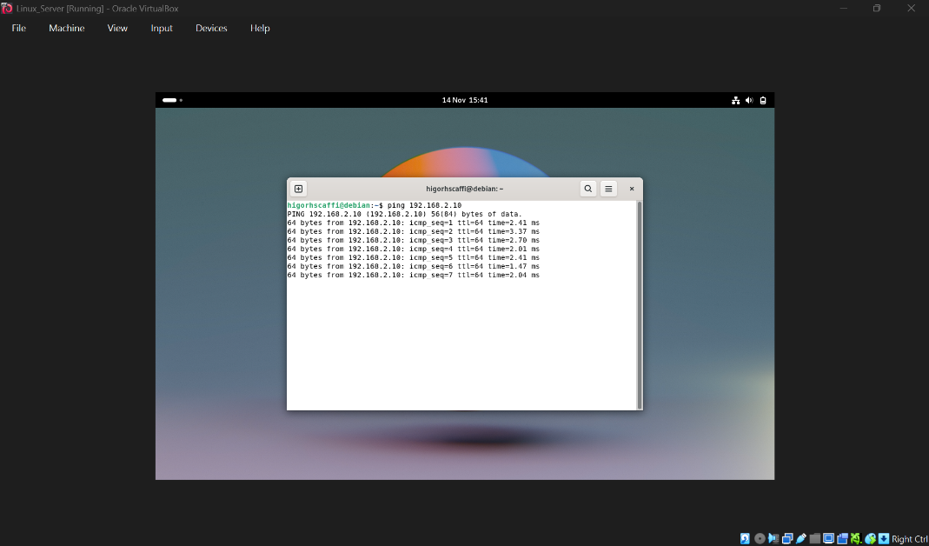

Successful connectivity within windows network. (2 screenshots) 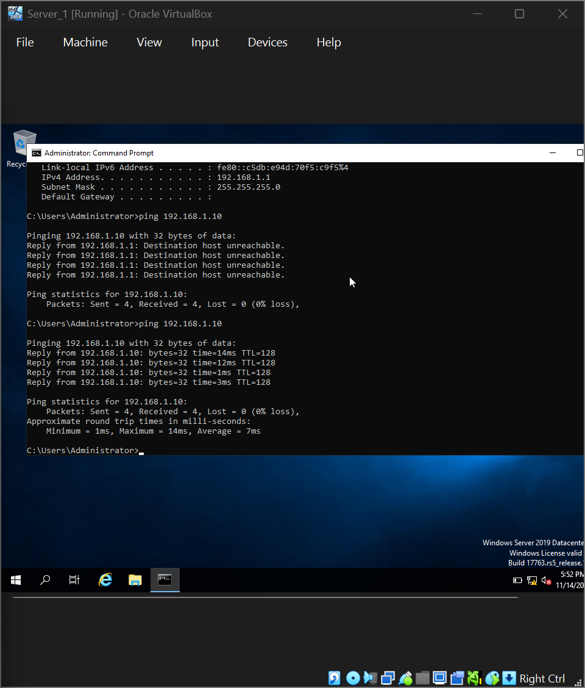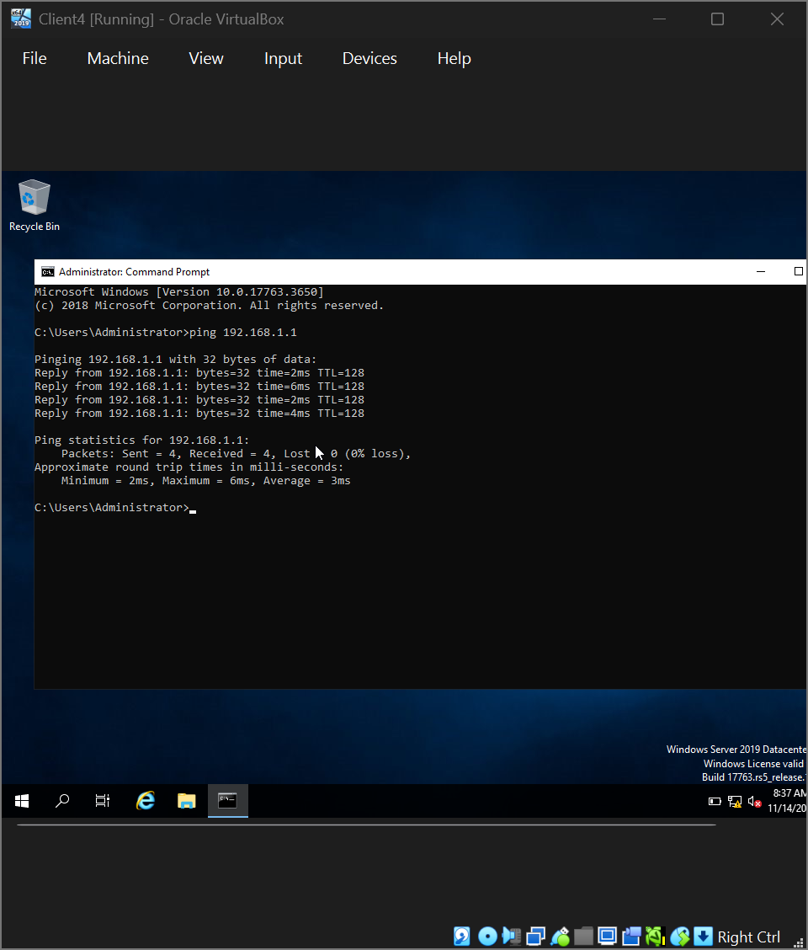

Outcome 2: Unsuccessful connectivity between Linux and windows networks (2 screenshots).
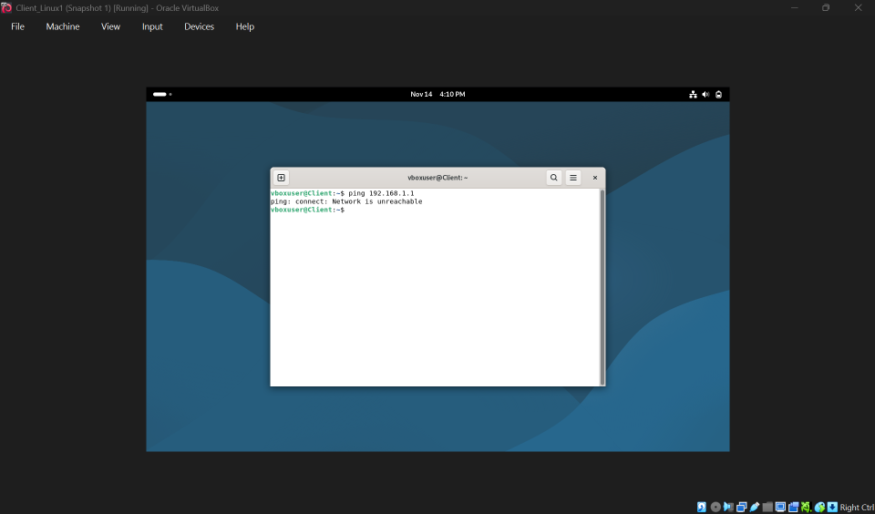

Task 2: Create Virtual Machine – Server 1 (Windows Server 2019)
Steps Performed:
- Created new VM named Server 1.
- Installed Windows Server 2019 (64-bit).
- Allocated 4 GB RAM and 60 GB hard drive.
- Configured NAT Network Adapter to connect to SWAN.
Network Configuration:
Setting | Value
IP Address | 192.168.1.1
Subnet Mask | 255.255.255.0
Gateway | 192.168.1.1
DNS | 8.8.8.8
Screenshot:
(Inserted screenshot showing Server 1 desktop and network settings or ipconfig output)

Task 3: Create Virtual Machine – Client 1 (Windows 10 or Server 2019)
Steps Performed:
- Created new VM named Client 1.
- Installed Windows 10 (64-bit) or Server 2019.
- Allocated 4 GB RAM and 60 GB hard drive.
- Configured NAT Network Adapter to connect to SWAN.
Network Configuration:
Setting | Value
IP Address | 192.168.1.10
Subnet Mask | 255.255.255.0
Gateway | 192.168.1.1
DNS | 8.8.8.8
Screenshot:
(Inserted screenshot showing Client 1 desktop and ipconfig output)

Task 4: Create NAT Network – SWAN
Steps Performed:
- Opened Network Manager in VirtualBox.
- Created a new NAT Network named SWAN.
- Set Network CIDR to 192.168.1.0/24.
- Enabled DHCP (optional).
Screenshot:
(Insert screenshot of VirtualBox Network Manager showing SWAN configuration)

Task 5: Test Connectivity Between Server 1 and Client 1
Steps Performed:
- Disabled Windows Firewall on both VMs.
- From Server 1, pinged Client 1 at 192.168.1.10.
- From Client 1, pinged Server 1 at 192.168.1.1.
- Verified successful replies.
Command Prompt Outputs:
ping 192.168.1.10
ping 192.168.1.1
Screenshot:
(Insert screenshot showing successful ping results from both machines)

2.1 Hypervision: Oracle Virtualbox Manager
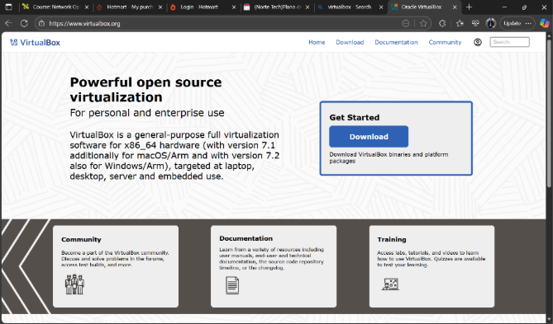
2.2.1 Evidence of Download and installation.
Creation of Virtual machine windows 1 and 2 (1 screenshot)
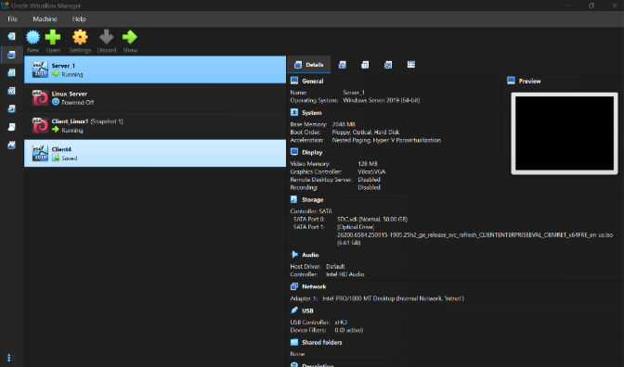
Creation of Virtual machine Linux Devian 1 and 2(1 screenshot)
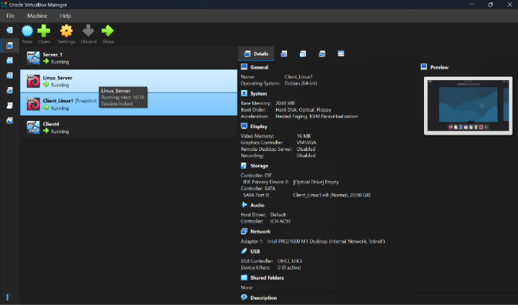

Installation of windows and Linux OS (Start 4 Machines and take desktop screenshots) (4 screenshots)
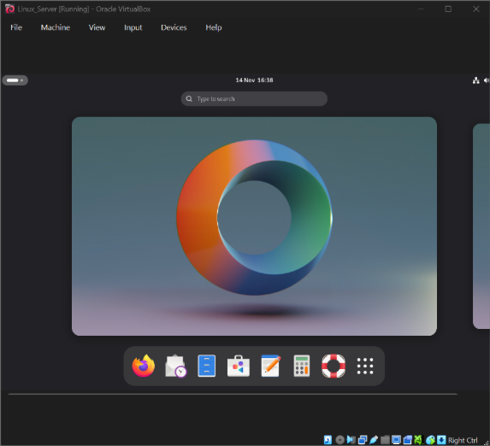
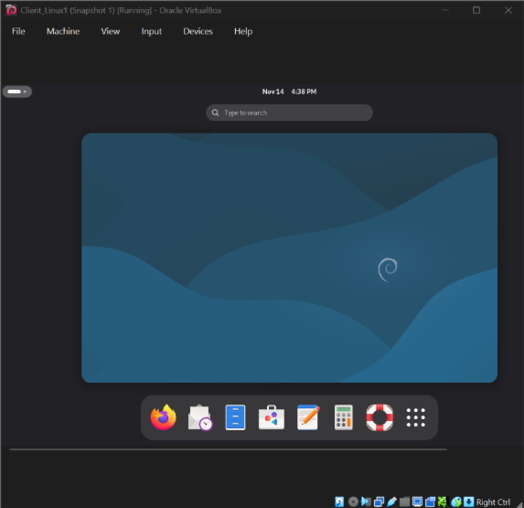

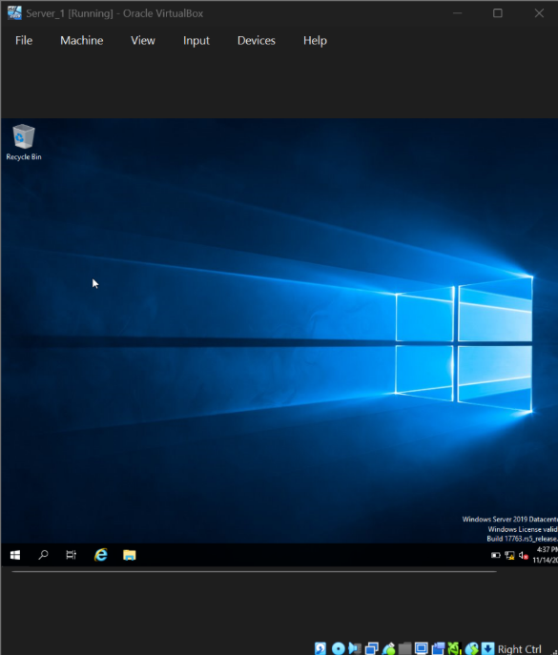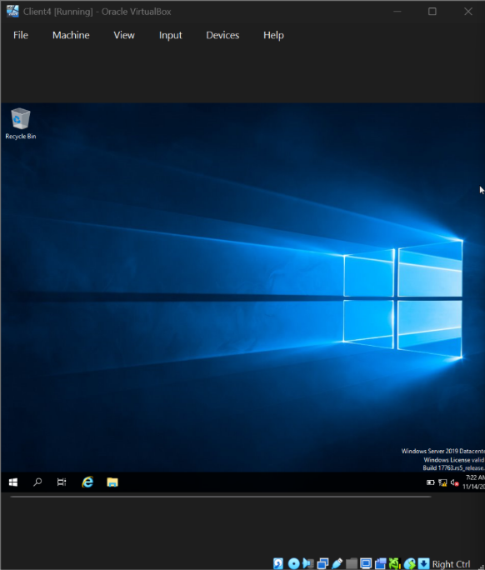
2.2.2 Deploy your network as per the given topology:
Creation of Network with Internal Network for windows (1 screenshot)
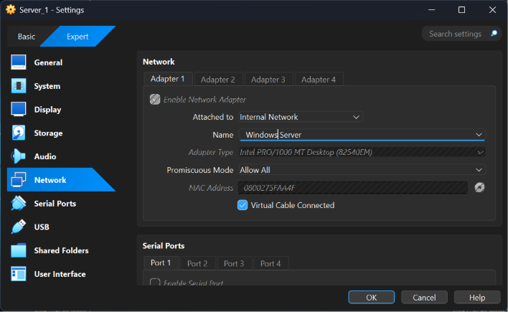
Creation of Network with Internal Network 2 for Linux (1 screenshot)
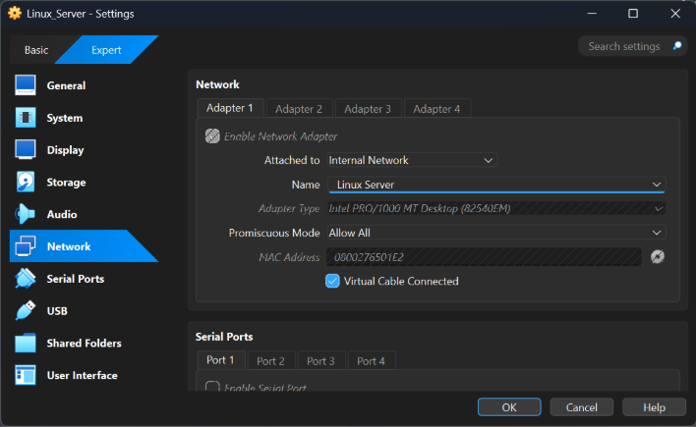

Evidence of 2 Windows PCs are connected with Internal Network (2 screenshot)
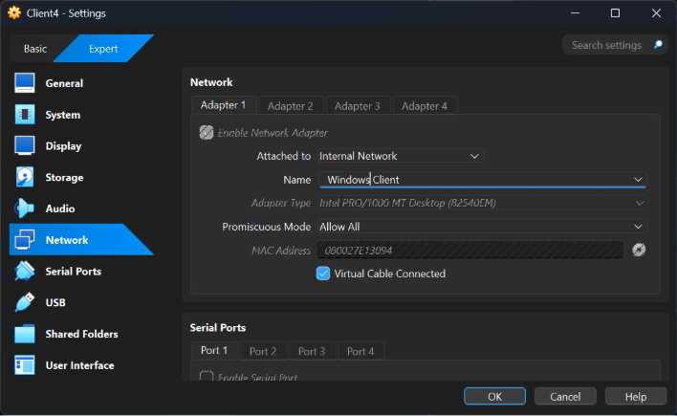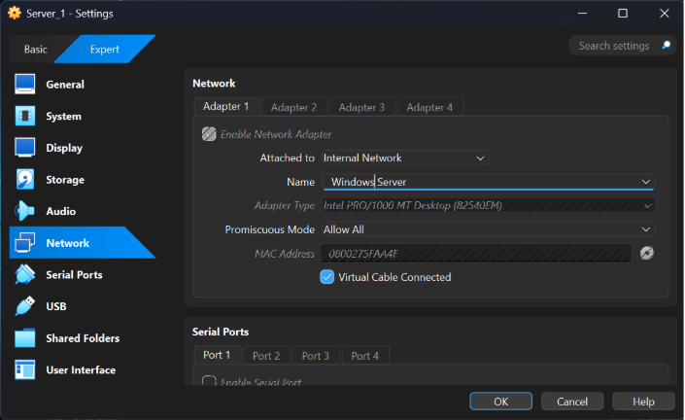

Evidence of 2 Linux PCs are connected with Internal Network2 (2 screenshot)
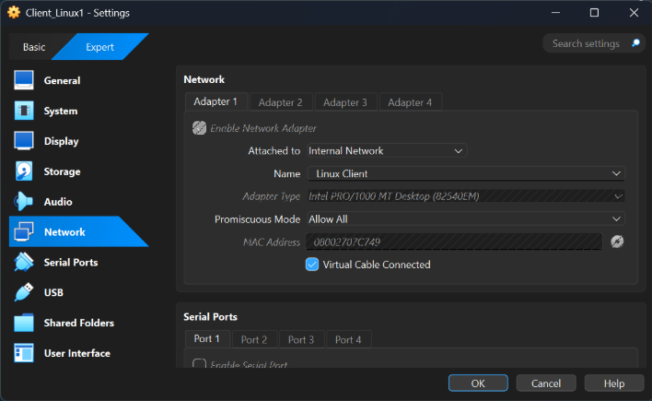
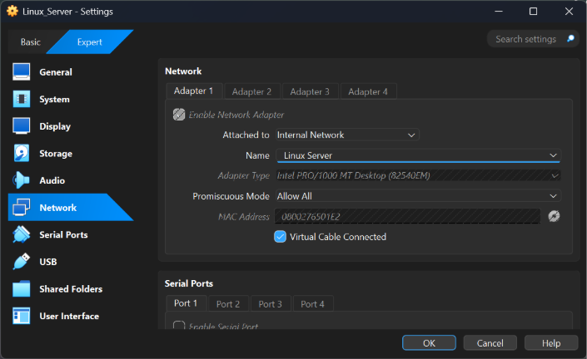

2.2.3 IP addressing :
2.3.1. Use appropriate IP addresses to configure your network.
Evidence of IP addresses set up in 2 Windows and 2 Linux machine(for windows command is ipconfig and for Linux use the command ip add show ( 4 screenshots)
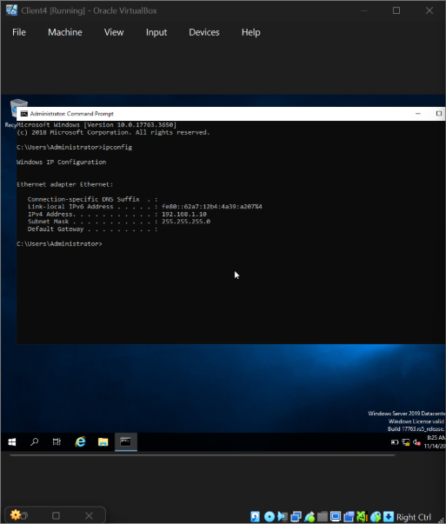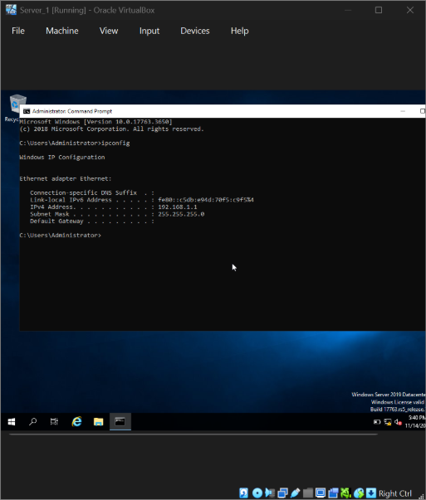
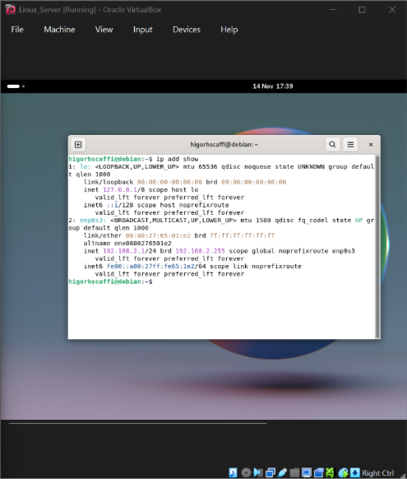
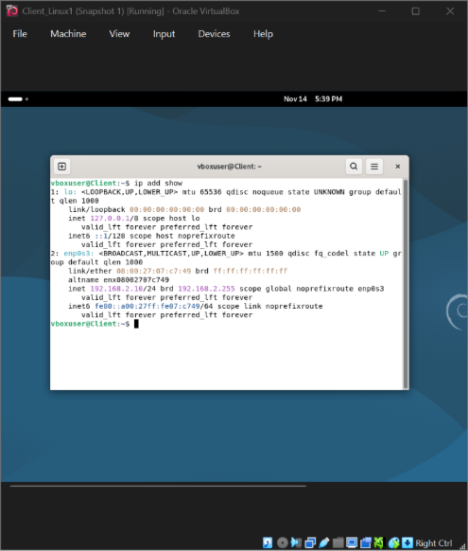

2.3.2. The above topology gives network address for the networks
Network IP address from Internal Network1 for windows (1 screenshot)
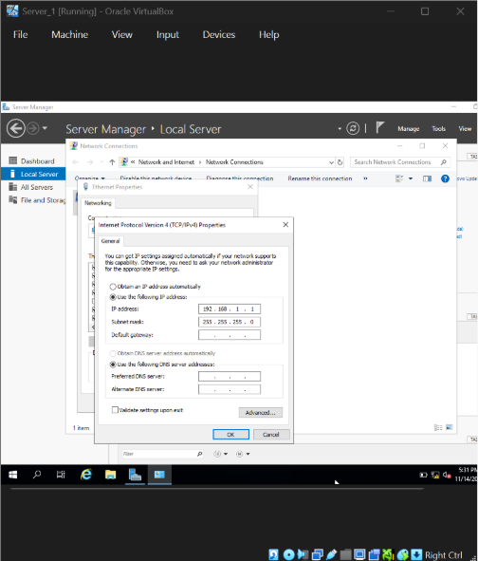
Network IP address from Internal Network 2 for Linux (1 screenshot)
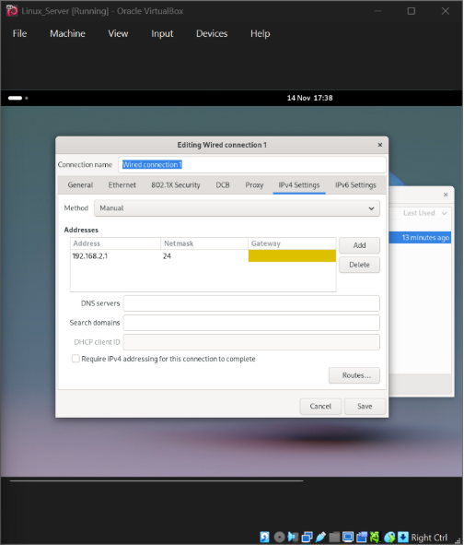

2.4. Test and Troubleshoot You need to achieve the following:
2.4.1. Perform Connectivity tests
Outcome 1: Successful connectivity within linux network. (2 screenshots)
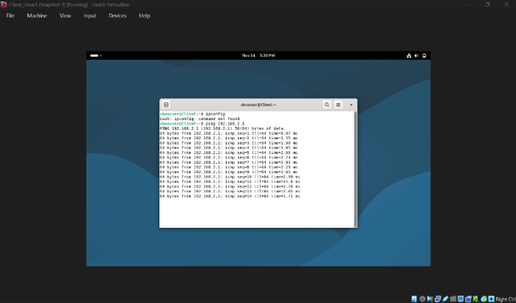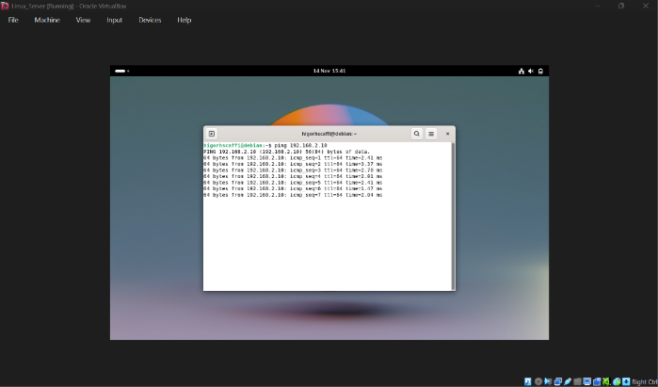

Successful connectivity within windows network. (2 screenshots) 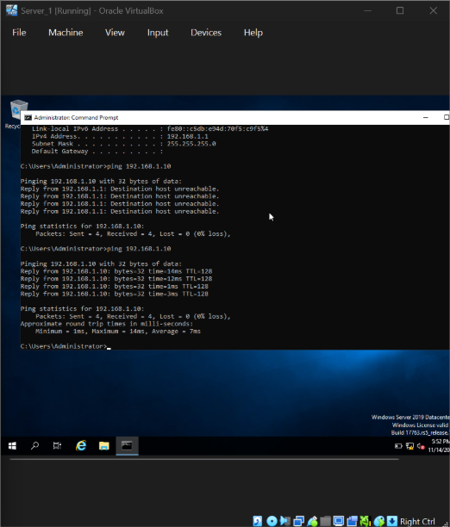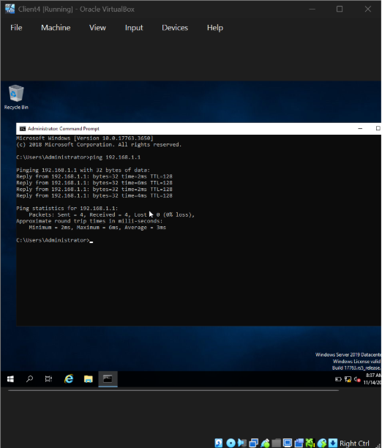

Outcome 2: Unsuccessful connectivity between Linux and windows networks (2 screenshots).
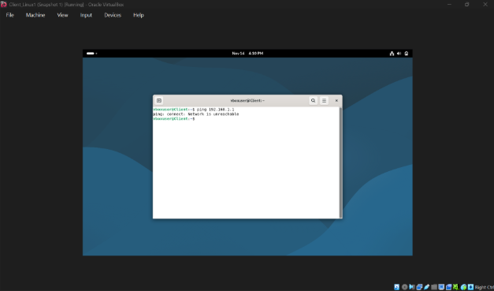
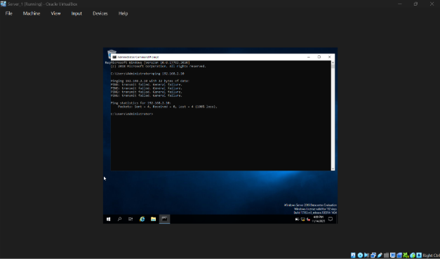

Conclusion
Successfully created and configured two virtual machines (Server and Client) in a NAT network named SWAN.
Both machines communicated successfully using static IPs, verifying correct network setup and VirtualBox configuration.

References
- Oracle VirtualBox Documentation: https://www.virtualbox.org/wiki/Documentation
- Microsoft Windows Server 2019 Installation Guide
- Microsoft Windows 10 Network Configuration Documentation.

TASK 3: Reflection Report (250 words)

Technical Reflection
During the deployment and testing stages of the network, several issues arose that required systematic troubleshooting. One recurring challenge involved IP address conflicts, caused by overlapping DHCP scopes during initial configuration. I diagnosed this using ipconfig /all on Windows and ip a on Debian, which revealed duplicate leases. The issue was resolved by redefining DHCP scope boundaries and applying reservations for server interfaces.
Another challenge was DNS resolution failures, particularly when clients attempted to join the SWANSEA.ACCA domain. Using NSlookup and dig, I confirmed that the Windows Server DNS zone lacked proper A and PTR records. Rebuilding the forward lookup zone and enabling secure dynamic updates resolved domain-join failures.
Firewall configurations also caused service disruptions, especially for DHCP relay traffic on the Debian server. DHCP requests were not forwarded across subnets until I inspected firewall logs and allowed UDP ports 67–68. Once the rules were adjusted, DHCP traffic passed correctly and client addressing stabilised.
End-to-end testing—such as ping tests, domain logins, certificate requests, and VPN connectivity—confirmed that the network behaved as expected after these adjustments.
Personal Reflection
This project strengthened both my technical confidence and my ability to approach problems methodically. I learned the importance of documenting each configuration step, as small mistakes—such as a mis-typed DNS address—can create larger failures later. I also became more comfortable using diagnostic tools like ping, tracert, nslookup, and system logs to guide troubleshooting. Beyond technical skills, I improved my patience, resilience, and ability to break complex issues into manageable tasks, which I believe will be valuable in real industry environments.

References
Forouzan, B.A., 2017. Data Communications and Networking. 5th ed. New York: McGraw-Hill.
Kurose, J.F. and Ross, K.W., 2021. Computer Networking: A Top-Down Approach. 8th ed. Boston: Pearson.
Microsoft, 2022. Active Directory Domain Services Documentation. Microsoft Learn.
NIST, 2020. Zero Trust Architecture (NIST Special Publication 800-207). Washington: National Institute of Standards and Technology.
Stallings, W., 2021. Foundations of Modern Networking. 2nd ed. London: Pearson.
Tanenbaum, A.S. and Bos, H., 2015. Modern Operating Systems. 4th ed. Boston: Pearson.
Tanenbaum, A.S. and Wetherall, D., 2021. Computer Networks. 6th ed. London: Pearson.

