Drama and Theatre in Education Module Process Workbook

Nicole Evans

2303744
Approx. 1942 words (excluding brackets, quotations, bibliography, appendix, AI acknowledgement, and headings).
2546 words altogether.

Early childhood experiences create a foundation for development; significantly impacting social and behavioural skills. Through education, children are exposed to subjects such as science, English, and maths and it is proven that these subjects provide skills and guidance for later in life; however, combining core subjects with the use of drama, exploring techniques that encourage teamwork, critical thinking, and communication, how much more can children learn both actively and subconsciously? This has been explored through the Drama and Theatre in Education Module.

Divergent Thinking
To begin educating using drama, it is important to first understand the difference between ‘Convergent Thinking’ and ‘Divergent Thinking’, and how it is beneficial to facilitators. As defined by Divergent Thinking UK, Convergent Thinking is “the systematic narrowing down of ideas into one core solution” whereas Divergent Thinking is “the spontaneous generation of numerous ideas that are all possible solutions” (Divergent Thinking UK, n.d).
By facilitating a drama-based workshop, children are supported in their ability to think divergently, explore perspectives and build empathy. In a talk given by Sir Ken Robinson, he discusses divergent thinking by saying “we all have this capacity” but “it mostly deteriorates” due to the standard education system (Robinson, quoted in RSA Animate, 2010). To combat this, drama workshops centre themselves around the exploration of nuance – encouraging the understanding of ‘no right or wrong’ and allowing children and young people to build on their own experiences. This is achieved through a strong workshop structure, often student-led, using various techniques proven to be beneficial in children’s development.

Storytelling
Children are familiar with the habit of being read to and so structuring a workshop around a story that is new or recognisable can be effective. Facilitators may also find it useful to establish a set of activities to complete within this workshop, which Jonothan Neelands labels as ‘conventions’ – “The list of conventions is like the list of ingredients for a recipe. It is only when the ‘ingredients’ are combined and subtly blended that they become a satisfying meal” (Neelands, 1998). Each convention aims to engage its users in a number of ways, for example, a workshop centred around the story of ‘Kensuke’s Kingdom’ by Michael Morpurgo may lead the facilitator into choosing the ‘meetings’ convention, putting themselves and students ‘in-role’ with a proposed question that gathers the group to address a situation, influenced by the circumstances in the story, and the status of their chosen characters. “Engaging with the challenges and conflicts that arise help children understand, consider and reflect on their own feelings and decisions” (Dubiel, n.d).
Neelands has created a reliable source for creating drama work for children, his conventions are easily applicable and can blend into one another for context and learning purposes without any set pattern or requirements. Incorporating conventions into a shared story is useful for a facilitator who aims to help children make their own discoveries and observations through physicality and discussion. Using storytelling as a method for teaching is useful for children of a certain age, but it may be deemed more engaging to allow older children to build their own world and characters using information that they find, such as the discovery of props, to further encourage a ‘student-led’ environment as previously mentioned.

Working with a Prop
Beginning a drama workshop with a mysterious prop immediately creates curiosity and interest for children; asking children one-by-one to enter the space to examine or reveal another item pushes them to become involved, begin their critical thinking development, and ask questions and make decisions about the props they see. Whilst telling a story creates a world for children to build around, having props that are connected means that children can create the world themselves using communication and decision-making skills.
Looking at the example of an old wooden box filled with items such as written letters giving context clues, an old photo frame with a specific date, a teddy bear, and an evacuee tag, the children quickly decipher that this box contains items from World War 2, belonging to a child around their age who was evacuated for safety – they work together to create details about the child beyond the props, creating their own story and the world it lives in. Using conventions, such as ‘soundtrack’, the children can discover the sounds in a busy city such as London in comparison to a safer, quieter farm in Carmarthen, influencing the understanding of the perspective of a child in the war.
Whilst drama in education does advocate enjoyment, it can be crucial to note that it is an opportunity for children to learn in a unique way, so education is a priority in these instances. This workshop offers children the chance to learn about a serious topic in a sensitive manner through practical exploration, helping them understand perspectives and feel empathy in an embodied way. As well as his conventions, Neelands advocates the need for reflection for children both as themselves, and as a character they choose to represent throughout a workshop – “Theatre provides a ‘mirror’ for actors and spectators to consider themselves and their relationships to others” (Neelands and Goode, 2000, p.7).

Mantle of the Expert
During her university education, Dorothy Heathcote developed a method that allowed non-drama specialists to incorporate drama through learning into their teaching work, creating a more engaging and immersive learning experience for children, she called it ‘Mantle of the Expert’. Its name stems from the idea that facilitators and teachers will apply a figurative mantle around their students that can only expand their leadership, knowledge, and understanding skills throughout their learning. As demonstrated through a Venn diagram (see Appendix A), for Mantle of the Expert to succeed, a teacher must be aware of and proficient in all three areas of the diagram (Aitken, 2013, p.36).
‘Expert Framing’ is vital in workshops of this kind, as it allows facilitators to step ‘in-role’, but bring the children into that role with them, framing them as ‘experts’ of their field – it allows facilitators to once again host new perspectives through learning, and by placing a teacher in-role at a varied level to their students, it influences the relationship between them. Looking at ‘A Dragon’s Place’ workshop as an example (Winter, n.d), the children are called into the space as a magical animal assistance team, aiming to help to fictional town ‘Ignis’ with its dragon infestation problem. Using the core components of the approach to Mantle of the Expert, children become a ‘Company’ of experts with an important job, or ‘Commission’ to carry out for a ‘Client’ through which they encounter obstacles or ‘Tensions’ to work through as a team. Each task set for the children is purposeful, and can be applied to real-life situations, creating what is known as ‘Metaxis’ – where children understand the fictionality of their world building and company, but are able to apply it and understand it in real world contexts.
Having a structure such as Mantle of the Expert is invaluable for facilitators, Jonothan Neelands discusses how “endowing pupils with expertise is in itself extremely powerful, motivating, and empowering” (Neelands, 1998, p.96) and it is important to note that Mantle of the Expert can incorporate curriculum-based learning also, Heathcote and Bolton mentioning how cross-curricular features are known as ‘dimensions’, and “looking at a part of a subject in terms of the whole, is built into the heart of the method” (Heathcote and Bolton, 1995, p.31), which is later pointed out as something that schools often resist.

Workshop Plan: The Lady of the Lake
With 3 examples of ways to structure drama work for children, a school may wish to provide a brief for facilitators, in which it will be decided which of these methods is best suited for the brief and demographic of its participants.
The Lady of the Lake is a Welsh myth set in Brecon that follows the story of a young farmer wishing to marry a lady who lives in ‘Llyn y Fan Fach’, the lake next to his farm (Fotaneg, 2016). Exploring themes of magic, herbology, community, and environmental impacts, taking a Mantle of the Expert approach, with some inclusions from Jonothan Neelands’ structuring work, is fitting.
As stated in a workshop plan (see Appendix B), having the children enter the space and placing them in-role gains their attention and excitement, they are introduced to ‘Farmer John’, in which, the children undergo the ‘hot seating’ convention. This establishes what Neelands refers to as the “context-building action: conventions that either ‘set the scene’ or add information to the context of the drama as it unfolds” (Neelands and Goode, 2000, p.6). The children are given creative freedom by being asked to consider what questions they would like to ask their client, but parameters are also established by being told that the questions should link to the themes of the Welsh myth. With context clues provided through a thorough script, the children are then involved in a world building task, physically creating the lake using resources provided by the facilitators, their artistic creativity is largely encouraged by being asked to draw animals and plants that may live in and around the lake.
Involvement in the ‘Tableau’ convention means that children are expected to think ‘outside of the box’ using communication and teamwork skills to create inanimate objects such as a loaf of bread with their bodies. Performing these tableaus means that children are supporting each other and the facilitator may wish to prompt them to think critically, asking them to explain what they interpret from each image.
A tension is suddenly added, as ‘CEO Chad Jones’ enters the space, subconsciously engaging the children in the ‘Overheard Conversations’ convention, igniting the “narrative action: conventions which tend to emphasize the ‘story’ or ‘what-happens-next’ dimension of the drama” (Neelands and Goode, 2000, p.6). The children involve their decision-making skills by deciding to talk to CEO Chad prior to the phone call. It is through a similar hot-seating task that they discover Chad’s morals, and they must now begin to explore the main line of inquiry ‘are people more important than the environment?’. In combination with the ‘Meetings’ convention, where the children become the jury of a court case, they start to explore the “poetic action: conventions which emphasize or create the symbolic potential of the drama through highly selective use of language and gesture” (Neelands and Goode, 2000, p.6). The acting jury are asked to present ideas surrounding the theme of ‘compromise’, where the two characters are able to work together; it is through this that children aim to understand the need for people’s health care, but also the destruction of an environment to do so, which blends into the final “reflective action: conventions which emphasize ‘soliloquy’ or ‘inner-thinking’ in the drama, or allow groups to review the drama from within the dramatic context” (Neelands and Goode, 2000, p.6). In role, the children are asked to reflect on the previous tasks and each character’s argument to create and present a justified decision on what to do with the lake. As a closing task afterwards, the children and facilitators step out of the roles they have been adopting and begin to discuss key points that stood out to them during the workshop, and their personal answers to the main line of inquiry. This action is arguably the most important of the workshop, as facilitators advocate for fun in a classroom environment with the main objective to educate and inspire children to experiment with the boundaries of ‘no right or wrong’.

Evaluation
In the 1980s, psychologist Howard Gardner proposed the concept of ‘multiple intelligences’, the idea that “every human being possesses a basic set of intelligences in a particular blend unique to each person”, influenced by regional, cultural, and environmental circumstances (Van Der Water, et al., 2015, p.11). Knowing this, facilitators can utilise drama’s performative and collaborative nature to explore multiple intelligences and discuss contemporary issues through highly considered workshops, something that is necessary in modern-day education.
Based on their blend of intelligence, children will respond to and behave differently in a workshop environment; traditional ‘verbal/linguistic’ classrooms may follow a reading, writing, speaking pattern, but a dramatic approach suggests a linguistic learning space could incorporate stories, narratives, and reflections. Similarly, a ‘bodily/kinaesthetic’ classroom that is accustomed to gesturing and moving the body, could be adapted into tableaus, puppetry, and choreography (Van Der Water, et al., 2015, p.12-13). It is about fine-tuning workshops to take pre-established learning and converting it into creativity and development.
Employing ‘Mantle of the Expert’ has proven itself beneficial, however Neelands’ structuring and drama conventions in combination with this, further enhance the quality of a workshop of this kind. As a first-time facilitator, guiding a room requires confidence, patience, and projection and, like children, these skills require development. It can be overwhelming to experience a workshop environment for the first time, student-led experiences cannot always be fully planned for, but that opens up opportunities for new discoveries and enjoyment. Reflection and feedback sessions from peers means that workshops can be developed to suit what is needed to gain the most out of them, feedback such as the courtroom task being further developed by providing a short recess in small groups to share ideas before presenting them back is one example, considering the staging around the room by creating a map (see Appendix C), is another. The effort that facilitators put into their workshops is deemed worthy when observing the positive impact it has on children’s learning both actively and subconsciously. All tools, feedback, and experiences gained throughout this module are transferrable for professional practice and open up new pathways for actors and creatives.

Bibliography
Divergent Thinking UK (No date). Why Think Divergently? Available at: https://www.divergentthinking.uk/why-think-divergently (Accessed 3rd May 2025).
Dubiel, J (No date). The Crucial Role of Storytelling in Early Childhood Education. Available at: https://www.booktrust.org.uk/resources/find-resources/the-crucial-role-of-storytelling-in-early-childhood-education/ (Accessed 3rd May 2025).
Fotaneg, A (2016). The Legend of the Lady of the Lake Demystified. Available at: https://botanicgarden.wales/2016/10/legend-lady-lake-demystified/ (Accessed 13th May).
Fraser, D, Aitken, V, and Whyte, B (2013). Dorothy Heathcote’s mantle of the expert approach to teaching and Learning: A Brief introduction. Available at: https://www.mantleoftheexpert.com/wp-content/uploads/2018/01/MOTE-Chapter-3_Aitken_Pages-from-Connecting-Curriculum-Fraser-v3-220213.pdf (Accessed 13th May 2025).
Heathcote, D and Bolton, G (1995). Drama for Learning: Dorothy Heathcote’s Mantle of the Expert Approach to Education. Portsmouth, NH: Heinemann.
Neelands, J (1998). Beginning Drama 11-14. London: David Fulton.
Neelands, J and Goode, T (2000). Structuring Drama Work: A Handbook of Available Forms in Theatre and Drama. Cambridge: Cambridge University Press.
RSA (2012). RSA ANIMATE: Changing Education Paradigms. Available at: https://www.youtube.com/watch?v=zDZFcDGpL4U&ab_channel=RSA (Accessed 3rd May 2025).
Van Der Water, M. McAvoy, M. and Hunt, K (2015). Drama and Education: Performance Methodologies for Teaching and Learning. London: Routledge.
Winter, N (No Date). A Dragon’s Place. Available at: https://www.mantleoftheexpert.com/resources/planning-units/context/a-dragons-place/ (Accessed 13th May 2025).

Appendix A
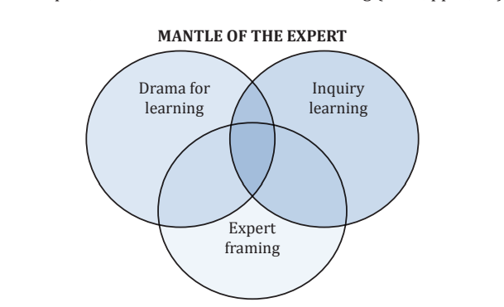

Appendix B
Lady of the Lake.docx

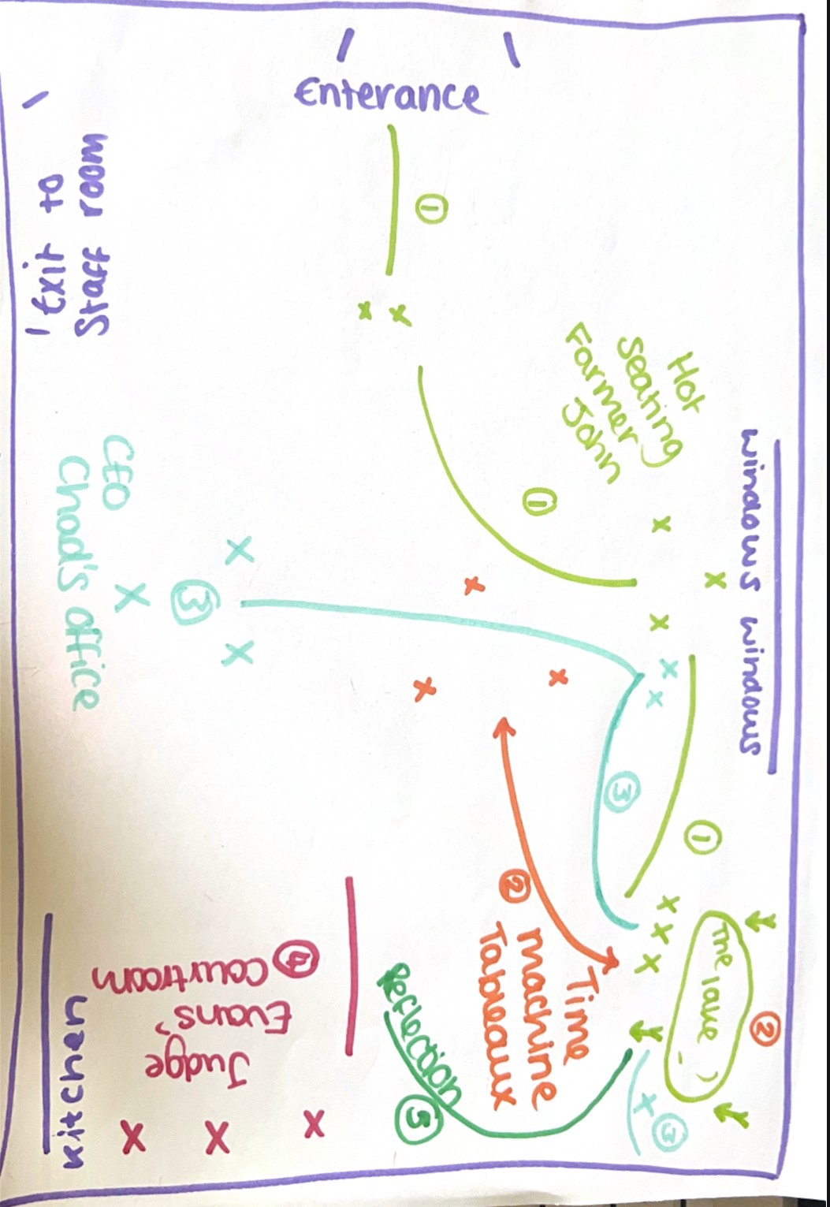
Appendix C

AI Acknowledgment
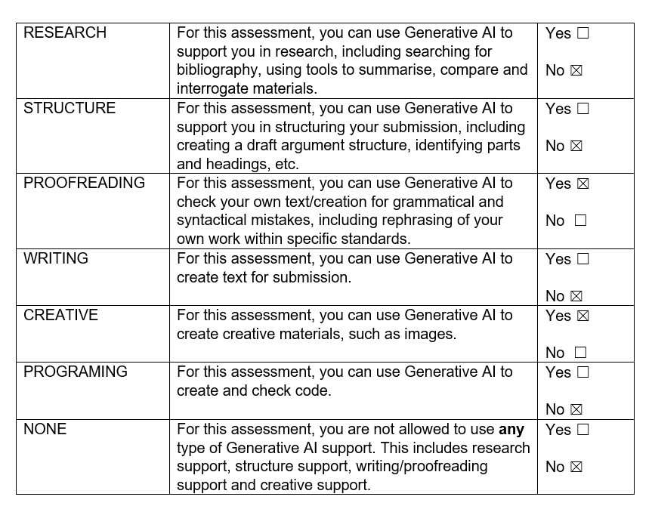

I confirm that I have not used any AI tools in the research and creation of this assignment. I confirm that I have not presented any AI generated materials as my own work. I confirm I have copies of my drafts, notes, and other resources I used, which I may be asked to provide in evidence.

