The Impact of Housekeeping Operations on Guest Satisfaction: A Case Study of DoubleTree by Hilton Southampton

Name: Victoria Prodan
Student ID number: 2245322
The module title: Hotel Placement Research Project
Module code: BMIH6008
Project supervisor name: Kathryn Flynn
Date: 26.02.2026
Institution: University of Wales Trinity Saint David
Department name: BA International Hotel Management

Declaration
I confirm that I have not presented any AI generated text as my own work. I confirm I have copies of my drafts, notes, and other resources I used before, and after the use of AI tools which I may be asked to provide in evidence.
Acknowledgement
I would like to thank my project supervisor Kathryn Flynn for the guidance and support throughout the completion of this research project. I am also thankful to the management and staff of my placement organisation. Besides this, I am highly grateful to my family and parents who have guided me throughout and motivated me.

Abstract
The report has stated how the housekeeping operations shape guest satisfaction by focusing on the case study organisation of DoubleTree by Hilton Southampton. Housekeeping is the most important part of a hotel stay as it directly impacts cleanliness and comfort. While booking, the main factor that helps a guest to book a hotel is cleanliness and good housekeeping services. This shows how strongly hotel businesses should focus on such services. The main purpose of this study is to understand the way housekeeping performance influences guest experiences and identify several areas where operational improvements might increase satisfaction. The research has adopted three main objectives and those are to critically examine the perceptions of cleanliness and understand the current housekeeping practices. It would also suggest practical action for the company to be better at enhancing consumer experiences within their hotel. Besides this, the study has used a secondary data collection method where online reviews of guests have been analysed here in detail. The method has allowed the researcher to not collect any new primary data that might have been time consuming. Therefore, relying only on the secondary research has allowed the researcher to compare various hospitality theories with that of the real experiences of consumers. To organise the findings into themes and common patterns, a thematic analysis method has been applied to identify the common patterns within guest feedback. These are linked to housekeeping practices to ensure the findings discussed are as per the topic and its objectives. Thus, another benefit of using this approach was to reveal the strengths and weaknesses of the organisation's operations and improve them in future.
Additionally, the findings of the report have shown that housekeeping performance has a strong impact on the way guests judge their entire stay within a hotel. Majority of the clients have been seen to prioritise cleanliness standards and hygiene to be maintained whenever they check-in any hotel. It was found that a room that is well-prepared and clean automatically results in good views among consumers that makes them happier. These foster feelings of trust and professionalism among the guests as compared to the operational failures like incomplete cleaned rooms and other issues that lead to customer dissatisfaction and frustration. Consumers usually link these failures as nothing but a symbol of weak management when the upper management body does not care for the mistakes their employees make and think customers would tolerate such things. All of these showcase the information that consistency and reliability are highly important like visible cleaning practices. Whenever guests think a gap exists between what they have expected and what they are experiencing in real life is not the same, they become disappointed. This research has offered some actionable recommendations at the end like to improve communication between housekeeping and the maintenance departments and to even offer realistic workload to employees. Employees should not feel burdened with the workload as that might give rise to employee turnover which is quite a common issue within the hospitality industry of the UK. Staff training has also been recommended.

Table of Contents
Chapter 1 Introduction 7
Overview of the case study 7
Hotel brand and location 9
Key theme 12
Aim 13
Objectives 13
Questions 14
Chapter 2 Literature Review 15
The Impact service quality has on customer satisfaction 15
Impact of Housekeeping reliability on Guest trust 17
Effect of operational failure on Guest experiences 19
Theoretical framework 21
Literature gap 21
Chapter 3 Methods 22
Chapter 4 Findings and Discussion 25
4.1 Findings 25
Finding 1: Perceived Cleanliness as a Determinant for Emotional Comfort 25
Finding 2: The effect on perceived operational competence on the inconsistent readiness of room 26
Finding 3: The influence of responsiveness on the perceived recovery of services 28
Finding 4: The influence of workforce stability on the consistency of services 29
Finding 5: The influence of housekeeping performance on the market positioning 29
Discussion 30
Theme 1: Cleanliness as a fundamental driver of satisfaction for DoubleTree by Hilton Southampton 30
Theme 2: The readiness of rooms as a systematic integration for DoubleTree by Hilton Southampton 31
Theme 3: The affiliation of the brand with the gap of performance expectations 32
Theme 4: The instability in workforce erodes the consistency of services for DoubleTree by Hilton Southampton 32
Theme 5: The perceived loss of sensitivity within a competitive market condition 33
Chapter 5 Conclusion and Recommendations 33
Conclusion 34
Recommendations and Practical Strategies 36
References 41

Chapter 1 Introduction

Overview of the case study
Housekeeping involves a department that looks after cleaning of rooms to public spaces of the property (Sianipar and Cicilia, 2023). This Case study aims to study the way housekeeping operations shape guest satisfaction within this popular hotel named DoubleTree by Hilton Southampton. However, on reviewing the online reviews by Tripadvisor (2025), it was seen that there were many negative reviews found on room readiness, cleanliness and maintenance issues. It is reported that over 75% of the hotel complaints within the UK were found on room condition (Which, 2020). This shows how strongly clients prefer housekeeping. Additionally, it is also seen that over 80% of the guests within the UK link proper cleanliness directly with their intention to return more to the hotel (ECJ, 2016). When housekeeping quality is inconsistent, guests would feel highly uncomfortable and have trust issues. This must be taken care of by this hotel premises otherwise it would be extremely risky for their brand reputation and promise to offer safety and comfort to guests.
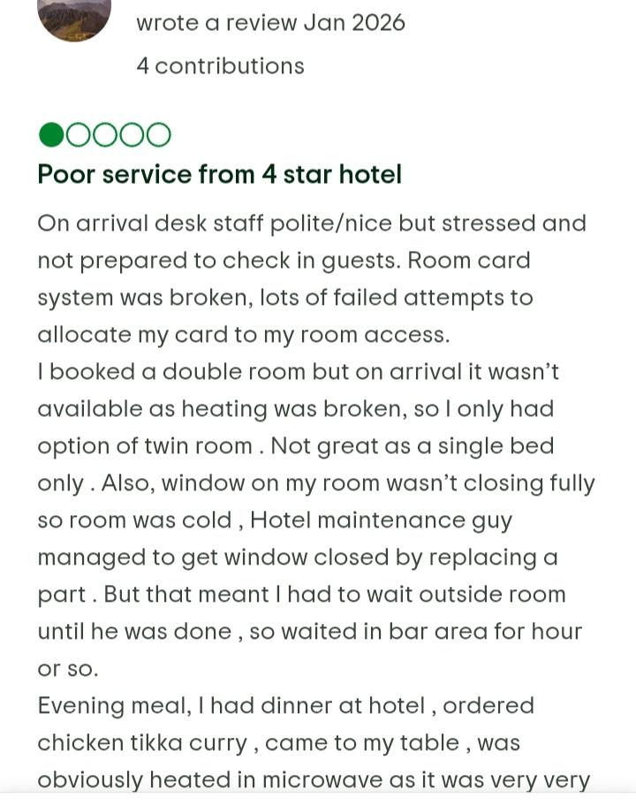
Figure 1: Guest reviews
(Source: Tripadvisor, 2025)

Hotel brand and location
DoubleTree by Hilton Southampton is a part of the famous global brand-named Hilton Worldwide (Hilton, 2025). Hilton Worldwide is known throughout the world for their cleanliness standards and aim to offer high quality services to clients (SFH, 2020). It is due to their constant positive reviews that guests expect their services to be comfortable and friendly. This hotel is situated within Southampton, which is a very busy coastal city within southern England (TW, 2025). This makes a very convenient location for both leisure and business travellers. Their location offers easy access to shopping areas and other major tourist attractions. Guests generally choose this hotel for their recognised brand quality along with modern facilities and a warm environment. They aim to offer consistent quality services to customers like clean rooms and helpful staff however the reviews speak differently of their services.

Figure 2: Hotel: DoubleTree by Hilton Southampton
(Source: ConferencesUK, 2025)

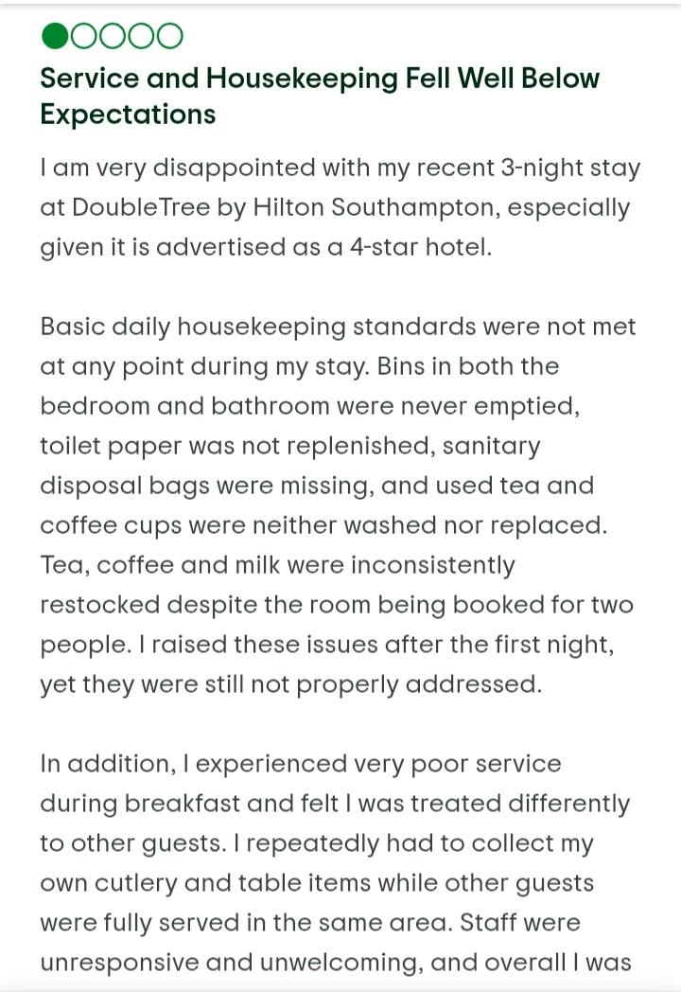
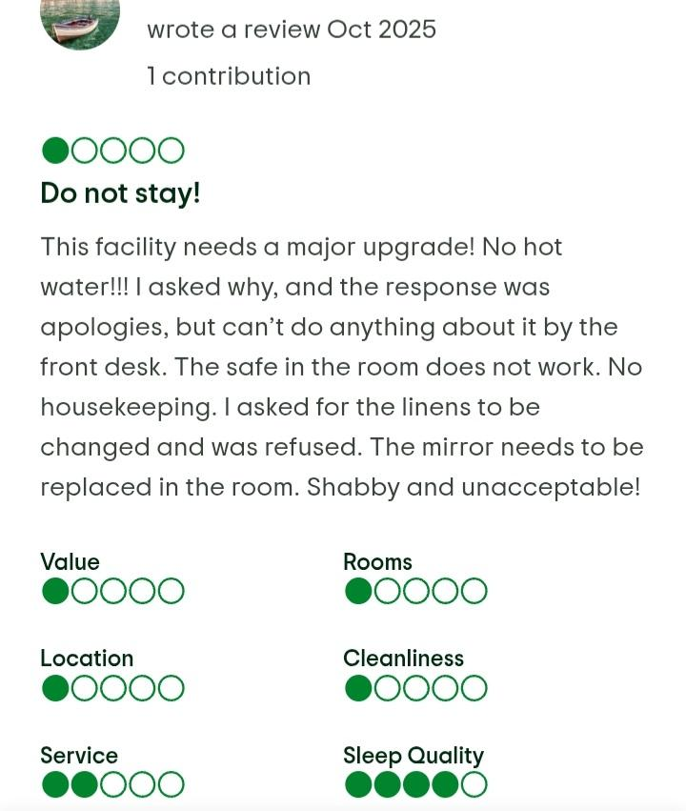
Figure 3: Guest negative reviews
(Source: Tripadvisor, 2025)

Key theme
The main theme is to study how housekeeping services affect guest satisfaction and their trust and comfort within a hotel. According to Jokiperä (2025), housekeeping is not only about cleaning rooms but ensuring how guests can feel safer and more cared for. Whenever rooms are ready and properly cleaned, guests tend to be happier and intend to return more to the hotel property (Singgalen, 2024). Considering the hospitality sector of the UK, guest expectations around cleanliness are high. It is shown by Faiq and Supriyanto (2023) that cleanliness is the main factor that makes guests feel satisfied within their stay. This would explain how good housekeeping services would improve customer experience whereas poor standards might result in disappointment or complaints.
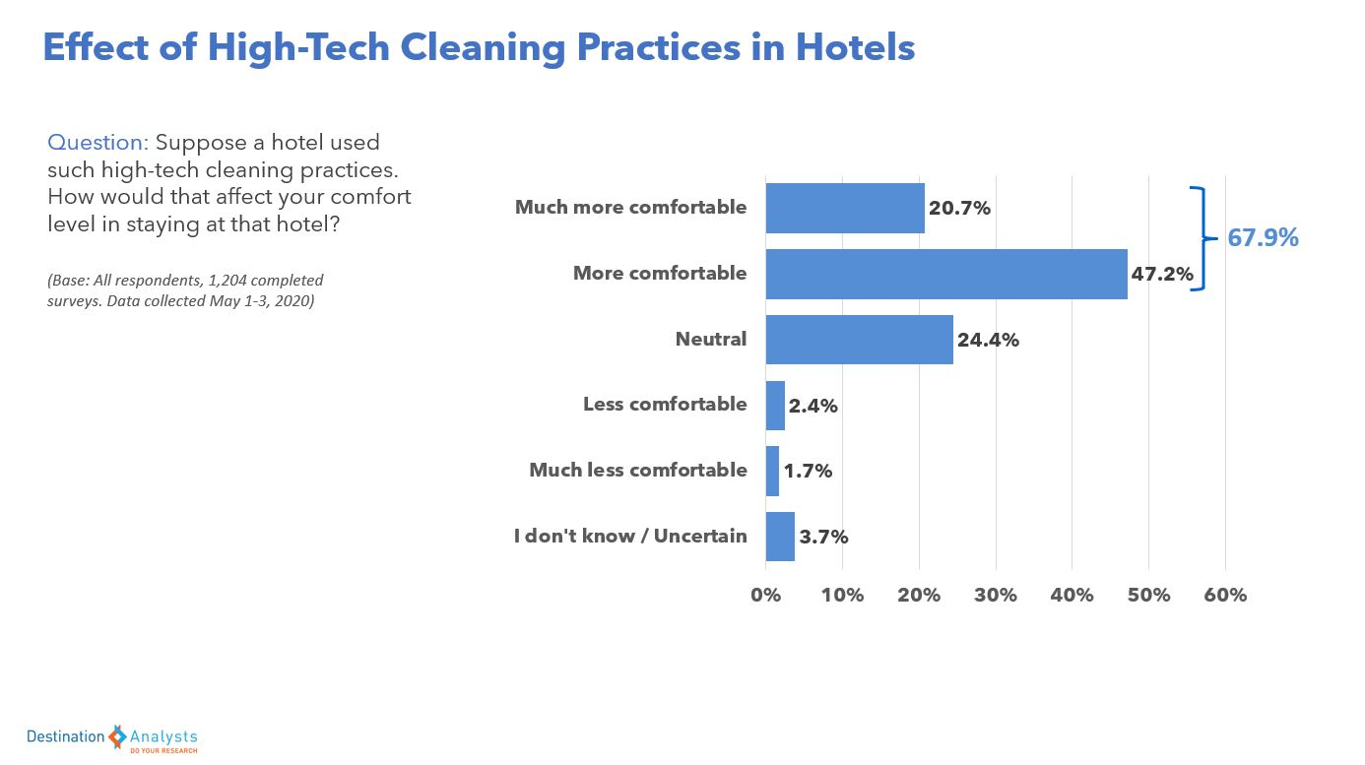
Figure 4: Consumers get more comfortable after high-tech cleaning practices within hotels
(Source: DA, 2025)

Aim
This research will aim to evaluate how the operations of housekeeping tend to influence the satisfaction of guests at DoubleTree by Hilton to identify the opportunities of improvement

Objectives
- To examine current housekeeping practices affecting guest satisfaction.
- To assess guest perceptions of cleanliness and quality.
- To recommend operational improvements enhancing satisfaction levels overall

Questions
- How does quality housekeeping services impact customer satisfaction and comfort?
- How do customers feel about room cleanliness and quality services?
- What are some improvements needed within housekeeping aspects to increase guest satisfaction?

Chapter 2 Literature Review

The Impact service quality has on customer satisfaction
Maintaining proper service quality is an important aspect. This must not be overlooked by any housekeeping department. The first and the foremost aspect that consumers look at before booking any hotel is cleanliness which is the responsibility of the housekeeping team (Lintot and Siniguian, 2025). Even Ndulango (2025) has stated a room that is not properly maintained or clean would never have a strong impression upon guests as they prioritise cleanliness. Such rooms which have incomplete cleaning done and have operational failures give rise to feelings of doubt and dissatisfaction among clients. This automatically gives rise to customer turnover who would never return to the property. Hotel brands feel that cleanliness is something that can be compromised, however guests have strictly been more focused on this aspect right after the Covid-19 pandemic. They have the opinion that a room that is properly done and well maintained is a symbol of professionalism and care of the holistic hotel. Additionally, Panditharatne (2025) has stated that conducting inspection rounds would bear some costs. So, to avoid this cost and focus more on speed, the majority of the hotels refrain from implementing. This is something that cannot be overlooked at all as inspection is one of the ways that might help to address such inefficiencies. While quick turnaround times tend to increase the availability of rooms, rushed preparation also gives rise to hygiene issues or some other defects that are overlooked (Browne-Farrell, 2025). However, this can be analysed with the help of a theory called the SERVQUAL model. According to Rexhepi (2022), this is a tool that was mainly formed to measure the perceptions of customers regarding service quality. It also argues that the satisfaction of guests depends highly on the gap between expectations along with perceived delivery of services. Room readiness shows the tangible dimension of quality services. Whenever a client enters a room that is clean and properly maintained, it reinforces trust (Bagnera et al. 2022). However visible faults or issues widens the expectation gap, thus leading to complaints and customer dissatisfaction. There must be systematic inspections done to ensure the housekeeping services are done carefully and management of workload should also be maintained. It is reported that staff turnover rate within the hospitality industry is 30%, double the average of the UK (KSB, 2025). Staff shortage might be a factor due to which the existing staff are being overburdened with work, thus making them feel fatigued [Refer to figure 5].
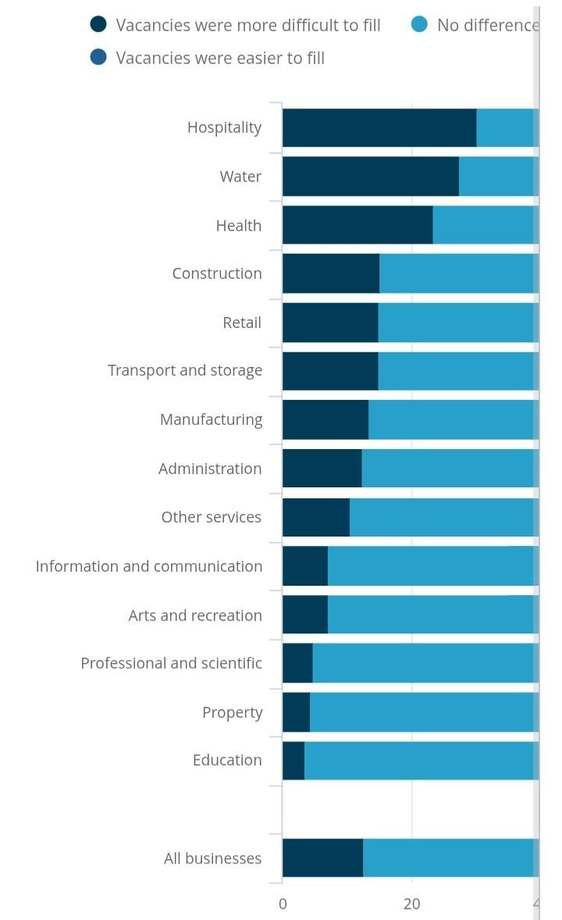
Figure 5: Staff shortage
(Source: ONS GOV, 2021)
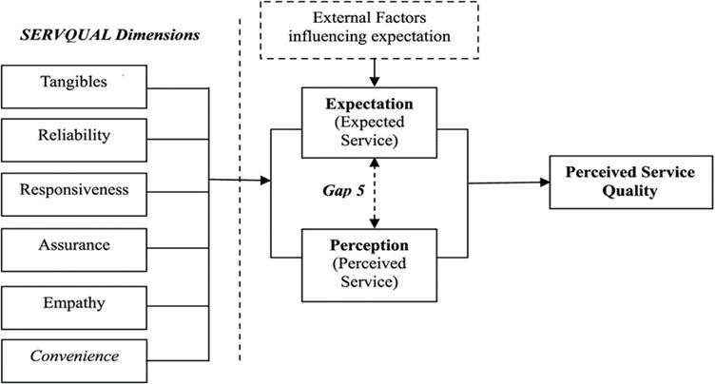
Figure 6: SERVQUAL model
(Source: AlOmari, 2021)

Impact of Housekeeping reliability on Guest trust
Housekeeping reliability plays an active role in fostering trust among guests however it happens behind the presence of guests. The room cleanliness is so important as it can be understood from a survey result that found that lack of cleanliness keeps guests awake at night and over 78% guests said they sleep better within an impeccably clean room (CM, 2019). This shows how clean rooms are not just effective for guests to have a positive stay experience but for hotels to keep up their positive reputation. Around 84% of guests claimed how they wouldn't return to a hotel second if they found it unclean. When cleaning is consistently done among all rooms and they are inspected carefully and guest belongings are also ethically handed over, guests feel safe and valued. However, whenever a housekeeping service is found unreliable like missed cleaning or lost items not being returned back to, as seen in Figure 8, guests lose confidence. Such issues simply showcase how weak their leadership or management is that they do not even inspect if everything is maintained properly. Many hotels within the UK force their employees to work way fast for not just reducing their costs but increasing room turnover also. While efficiency is significant, putting too much pressure on employees might lead them to adopt shortcuts. Not conducting inspections or rushing with tasks can save time but it would risk guest satisfaction (Au-Yong et al. 2024). Trust is way harder to repair than keeping proper maintenance of their hotels, which suggests that unreliable housekeeping might damage the entire reputation of the hotel. Here, this aligns with the Expectation–Confirmation Theory that states that consumers compare what they expect from hotels to what they actually experience (Yuan and Marzuki, 2024). Whenever housekeeping is reliable and customers find all their expectations to be met, it automatically fosters loyalty and satisfaction unlike while standards fail and lead to disappointment.
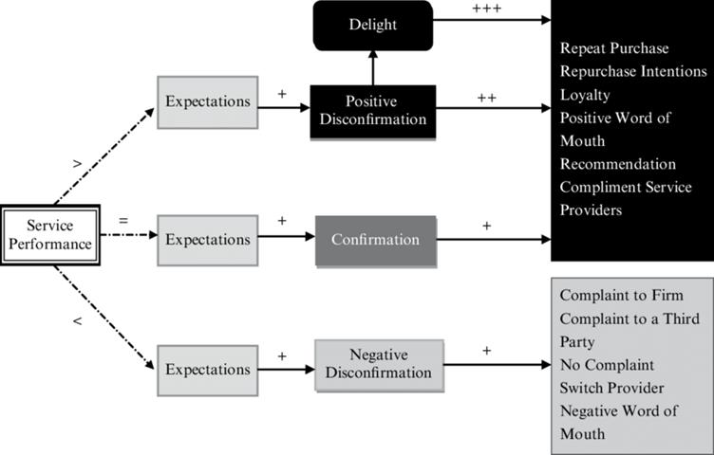
Figure 7: Expectancy-Confirmation Theory
(Source: Chen et al. 2022)
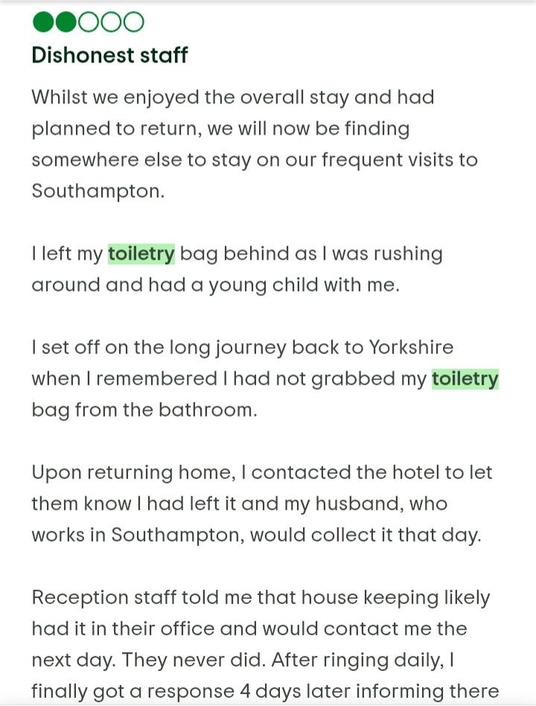
Figure 8: Guest reviews
(Source: Tripadvisor, 2025)

Effect of operational failure on Guest experiences
Operational failures are not any simple inconveniences, but they shape the way guests would judge their entire stay within the hotel. There might be some issues, but the housekeeping department must take full ownership of it and solve it at the earliest. According to Emeafor et al. (2025), guests have negative feelings like frustration whenever their allotted rooms have some problems like delayed maintenance or any other housekeeping issues arising. Whenever a client has to wait for the cleanliness works to be done, like in the review of this case study hotel here, it leads to discomfort among consumers. These are some problems that are not any mere housekeeping issue but a mistake of the entire management. Some hotels are there that tend to feel that consumers would accept such occasional delays however this is not the truth. This not just gives rise to consumer disappointment but causes a major loss to their sales and return consumers level. Thus, it is by this time quite evident from the above analysis that all clients want is a comfortable stay without any hassle and that too cleaned rooms. Here the service failure theory can be used. This states that any issues within services shape poor satisfaction levels as hospitality experiences are not personal but directly experienced by customers themselves (Zou and Migacz, 2022). When such failures are not corrected or prevented properly, negative impressions might follow. Hotels should focus more on inspection processes within hotels and ensure to adopt rapid response systems to reduce any risks.
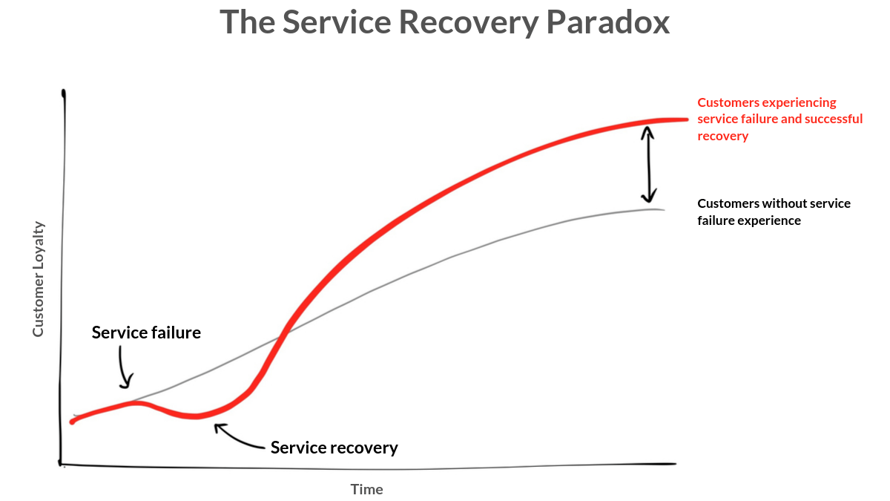
Figure 9: Service Failure Theory
(Source: Linkedin, 2024)

Theoretical framework
Under this section, a relevant theoretical framework can be applied, and the one is the SERVQUAL model. This model suggests that guests usually judge the services by comparing what they have been expecting with that of what they got to experience. Considering housekeeping, this comprises cleanliness of room, safety, readiness and reliability of staff members. It is suggested that when the performance meets expectations, it would automatically make them feel satisfied. However, when there is any gap noted like poor cleaning or faults that could not be rapidly solved, dissatisfaction occurs. It is reported from the UK Hospitality Impact Study of 2023 that 48% of the respondents said they rebooked a hotel or resort as they got exceptional experience right from booking to check-in, dining and other activities to check out. This illustrates how all consumers expect to get high quality services when they book hotels with so many charges. However, hotels should focus more on improving guest retention by 5% as it is estimated that by doing it, their profits will increase by 25% (HN, 2024). On the other hand, this model showcases that guest satisfaction is not about physical results but also on trust and consistency. Hotels tend to focus on cost savings and speed by assuming that guests only care about visible cleanliness. However, guests usually examine their overall experience that includes how well their services are offered. This means that any operational shortcuts might broaden this gap between expectation and reality.

Literature gap
Many studies tend to have focused mainly on hotel service quality and its impact on guest satisfaction but there are hardly any studies that specifically showcase how housekeeping services impact on guest satisfaction. Researchers have focused mainly on the entire service without examining room readiness or inspections in detail. This somehow forms a gap in understanding how housekeeping services shape comfort and trust among consumers. This study would address this gap by intricately exploring the concept of housekeeping performance and the way it acts as the main driver to promote positive guest satisfaction.

Chapter 3 Methods
The research has used a case study methodology for being able to examine the ways housekeeping operations shape guest satisfaction. A case study approach has been considered to be suitable for it allows a researcher to examine a real world and existing hotel rather than studying some generic hospitality trends (Kim et al. 2023). A study becomes even more reliable and high quality when a specific case study organisation is included. This not just makes the study more useful and makes it strong, backed with evidence. Here the study has focused on DoubleTree by Hilton Southampton as it has focused on providing a clear setting where such housekeeping practices are facing challenges and finding relevant ways to improve it. Another major advantage of using case study research is that it enables detailed understanding over just broad measurement (ANNAMALAH, 2024). Here using this case study method has enabled the researcher to capture some operational realities and real-life guest expectations during the same time. Housekeeping is not any different or separate function, but it interacts effectively with other departments like service, maintenance and front office culture. However, according to Kasim et al. (2023), it was found that using case studies is not always beneficial as the findings cannot be generalised to all hotels of the industry as they are specific to a proper context. There is one risk attached to it and that is interpretation of the findings collected from this method might showcase some personal judgements or opinions of the researcher (Lim, 2025). This might appear biased to some readers. To address this, the research usually focuses more on collecting secondary data and not any personal opinion. On this premise, it can be reliably stated that a secondary data collection method has been used here where all information has been collected from existing sources like academic journals, articles, company websites, online reviews platforms like Tripadvisor and other industry reports. Besides being a cost-effective method, the secondary data collection method is a very time-effective method unlike primary methods where a lot of time is required for conducting surveys or interviews (Suraj et al. 2024). Considering this study, secondary research is suitable as hospitality service quality has been studied in greater detail previously also. Thus, it would provide effective theoretical foundations. The guest reviews that have been collected have offered huge insight into the way housekeeping performance is usually perceived by them and the way it impacts the overall business too. However, this also has its limitations as there might be a probability of bias, especially for the fact that consumers usually express their extreme views on their online reviews. In order to reduce such risks, the research has attempted to organise the findings as per proper patterns and not comments which are somewhat isolated.
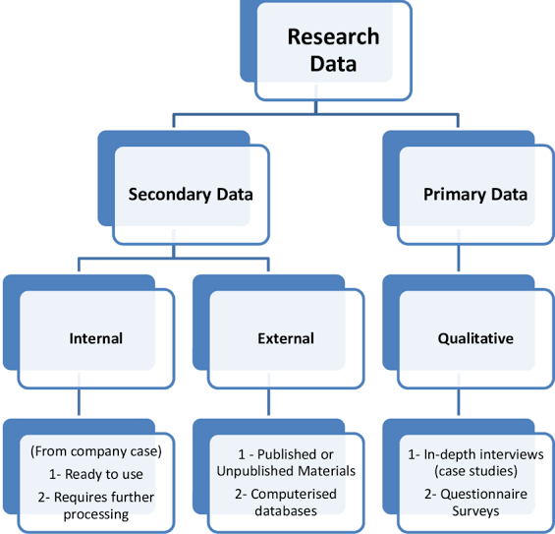
Figure 10: Primary and secondary collection methods
(Source: ZIDANE, 2012)
Considering the data analysis method used within this research, it has used a thematic analysis. According to Ahmed et al. (2025), thematic analysis is an effective and the most common method for qualitative research. This method enables the researchers to identify, analyse and interpret common themes or patterns in qualitative data. This helped to form themes related to housekeeping practices like reliability of services, room readiness and so on. Thematic analysis is useful as it helps to organise huge qualitative information into useful categories. While this relies on the judgment of the researcher, systematic coding along with comparison with relevant theory might help to enhance the consistency and reliability of research. Some other methods used within this study are comparing various literatures and critically evaluating them with respect to this topic. It also helped the researcher to use various models of service quality as the main interpretative tool to understand the root causes behind the failure of housekeeping services and its impact on guest satisfaction. This enhances the analytical depth of the study and prevents it from turning out to be too descriptive.
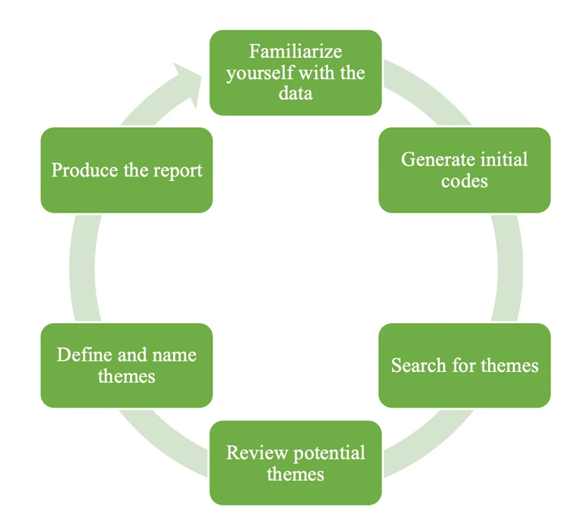
Figure 11: Thematic analysis method
(Source: LinkedIn, 2023)

Chapter 4 Findings and Discussion

4.1 Findings

Finding 1: Perceived Cleanliness as a Determinant for Emotional Comfort
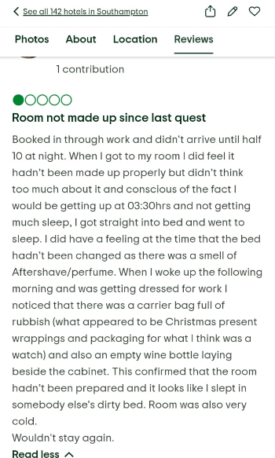
Figure 12: Customer Review
(Source: Tripadvisor, 2025)
It could be stated that a perceived cleanliness within a hospitality environment helps in shaping how satisfied guests feel during their stay (Siggalen, 2024). Considering this, it was observed that DoubleTree by Hilton Southampton had received a cleanliness score of 8.2 based on 1980 verified guests (Expedia, 2025). This is significantly higher than the overall guest rating of 79% which has demonstrated that the guests have cleanliness as a strength for the organisation (Marc Global, 2022). In a similar vein, various guests had praised cleanliness of the hotel along with the services of staffs [Refer to Figure 12]. This indicates that cleanliness contributes to guest satisfaction but does not compensate with other concerns of operations (Singgalen, 2024). It was further observed that the cleanliness score from Tripadvisor has showcased a rating of 4.5 out of 5 (TripAdvisor, 2025). However, the negative feedback demonstrated criticisms in detail in which the lapse in housekeeping had led to undermining the comfort of the guests. These findings have showcased that an individual lapse reported within the hospitality sector exerts an influence on the perceived experiences of the guests. This can be further evaluated using the Servicescape Theory which posits that a physical environment within a service setting have an influence on the behaviour of a customer (Yin et al. 2023). For the context of Hotel Hilton Southampton, the environmental cues act as a trigger through which the guests evaluates if their stays are comfortable. When there is a consistency in positive cues, guests have a relaxed feeling that reinforces their emotional comfort. This further aligns with the sensory impression of the Servicescape Theory that shapes their perception the quality of services offered. On the other hand, the average rating on cleanliness is not alone sufficient to ensure emotional satisfaction. A specific lapse in guest satisfaction has a disproportionate impact on how comfort could be perceived. This implies that DoubleTree should focus on mitigating the negative experiences of housekeeping which is important to ensure that the guests feel satisfied on entering their rooms.

Finding 2: The effect on perceived operational competence on the inconsistent readiness of room
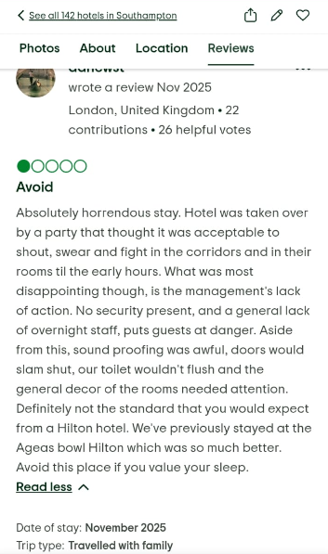
Figure 13: Guest Review
(Source: Tripadvisor, 2025)
Hotels having inconsistency in readiness of room helps an organization to influence how guests evaluate their operational reliability. Considering this, it has been observed that DoubleTree by Hilton Southampton has an overall rating of 3.5 which is based on over 2200 reviews by guests (Tripadvisor, 2025). With the positive review of the brand positively stating about the friendliness of staffs, there were reported concerns regarding the experiences of rooms requiring more attention upon guest arrival [Refer to Figure 13]. This demonstrates that the inconsistency in readiness affects the perception of guests even if the other elements of services are maintained adequately. These issues can be contextualized from the sector-wide instances. It has been observed that the hospitality sector of the UK employs more than 3 million workforces (UK Hospitality, 2025). However, it has continued to face shortage of labour after the recovery from the COVID-19 pandemic. Moreover, the vacancy rates within accommodation activities have remained over the national average. It was observed that there were over 100000 positions open through this sector in the UK (BBC, 2025). The higher vacancy levels have introduced a strain in operation specifically within the housekeeping departments in which the time of room turnaround affects the efficiency of check-ins (Thompson, 2024). Considering these pressures, the variability in standards of preparations have become likely. This can further help in demonstrating the inconsistencies that were observed in the feedback of the guests for DoubleTree by Hilton Southampton. The overall findings can be evaluated using the Attribution Theory which demonstrates how the customers interpret responsibility for the outcomes of services (Ji et al. 2025). When the guests are allocated a room which is not prepared completely, they are unlikely to align this issue with the challenges of internal staffing. Relating this case with DoubleTree by Hilton Southampton, the lapses in readiness of rooms could be considered as an insufficient quality control.

Finding 3: The influence of responsiveness on the perceived recovery of services
The responsiveness of housekeeping staffs plays an important role to shape the perception of guest satisfaction when there is an issue in services. For DoubleTree by Hilton Southampton, the staff rating for the hotel is marked at 8.4 which is higher than the rating on value-for-money being 7.6 (Agoda, 2025). This demonstrates that staff interaction with the guests are evaluated positively despite guests questioning on the facilities provided. Moreover, there were a proportion of guests comment where they stated that they gained a quick response upon request in situation where corrective cleaning was required. The importance of staff responsiveness could be further demonstrated from the sector-wide evaluation. It has been observed that over 78% of the guests in the hotels of the UK have stated that resolving problems rapidly influences their overall satisfaction despite the problem being a minor one (News By Wire, 2025). Moreover, it was observed that 32% of the customers in the UK have stated that they would stop engaging with brands after having a single negative experience unless being handled effectively (Vision Pont, 2025). This demonstrates how addressing a problem can be an influential factor for guest satisfaction. The overall finding can be evaluated using the Justice Theory which posits how customers evaluate fairness during the recovery of services (Sidhu et al. 2023). Within the context of DoubleTree by Hilton Southampton, when the workforce responds for correcting the issues, the guests perceive a higher interactional fairness. If the requests are handled without empathy, the guests interpret an unfair situation that leads to a negative evaluation. Moreover, the findings suggests that the responsiveness in housekeeping acts as a set of recovery mechanism which helps in protecting the perception of a brand. The speed of response helps in determining if the dissatisfaction increases. Within the hotel sector of the UK, the expectation of services helps in strengthening skills in communication which enhances the overall outcome of satisfaction.

Finding 4: The influence of workforce stability on the consistency of services
The stability of workforce within the housekeeping operations affects the consistency of services within the hospitality sector (Hsieh et al. 2025). For DoubleTree by Hilton Southampton, it was observed that the brand operates over 135 guest rooms (Hotels, 2025). This helps the organisation position it as a mid-sized hotels within the area of Southampton. This operational scale requires the housekeeping team to coordinate on the demand of business travel within the city. It was observed that the South East region of the UK had hosted over 16 million overnight domestic trips in which Southampton is a part of (Parliament UK, 2020). This has led to sustaining an additional pressure on the hotels during the peak periods. Within the hotel sector of the UK, it has been observed that the average rates of occupancy within the region have reached at over 73%. For DoubleTree by Hilton Southampton, operating at a similar level of occupancy would require them to prepare 100 rooms every day which would exclude additional request of services during their stays. The intensity of workload within a hotel increases the complexity to maintain the quality within the operations of housekeeping (Putri et al. 2025). The overall findings can be evaluated using the Operations Management Theory which focuses on the optimisation of process as the determinant for a service performance (Agatz et al. 2025). Within the housekeeping area, the efficiency in operations depends on the effectiveness of supervision. When the processes are streamlined, the rooms can be available for the guests without having to compromise with the cleaning standards. On the other hand, when the design of workflow is inconsistent, there is a deterioration of timelessness in services (Adhikari, 2025). This makes the guests interpret the availability of rooms as an inefficiency which reduces the overall reliability. Strengthening the management of workflow with a strategized communication system helps an organisation to preserve their standard of quality.

Finding 5: The influence of housekeeping performance on the market positioning
The performance of housekeeping services plays an important role to shape the competitive positioning of hotels within the hospitality sector (Tiwari et al. 2023). DoubleTree by Hilton Southampton has been considered as a 4-star property which is located at 4 miles from the city centre of Southampton (Hilton, 2025). This helps in positioning the brand outside the prime terminal zone. However, it has been observed that Southampton generates over 1 billion Pounds in annual expenditure of visitors (ABPorts, 2025). This demonstrates their strong economic importance of tourism among the accommodation providers. Within this sector, hotels that are located outside the city centres should rely on the quality of operations to maintain its competitiveness. It has further been observed that the average daily rates of a four-star hotel within the South-East regions of the UK have reached at 124 Pounds with RevPAR rates being averaged at 86 Pounds (MMU, 2020). These suggests that the pricing power are aligned with the perceived quality of services within the regional markets. For an organisation maintaining the confidence of room for room standards becomes important for justifying a comparable pricing (Sakinala, 2025). For DoubleTree by Hilton Southampton, these findings demonstrated how their housekeeping performance influences their ability to defend their market positioning. Hence, maintaining a prominent housekeeping standard is important for sustaining a competitive relevance within their regional market.

Discussion

Theme 1: Cleanliness as a fundamental driver of satisfaction for DoubleTree by Hilton Southampton
The overall analysis has demonstrated that cleanliness at DoubleTree by Hilton Southampton is considered as a strategic determinant for satisfaction. This could be interpreted beyond the discussion of descriptive service quality using the literary analysis. It was observed that that cleanliness rates of the hotel were 8.6 out of 10 (Tripadvisor, 2025). This suggests that the rating of a hotel is positively perceived on the operational performance of their workforce (Khalil et al. 2024). It further demonstrates that a small negative review of an organisation could lead to dominating the narratives of dissatisfaction among their stakeholders. Considering the wider industrial perspective, it was stated that over 80% of the guests in the UK has associated cleanliness of a hotel as a driver for their intentions to return (ECJ, 2016). This suggests the importance of cleanliness within the retention behaviour of guests within a hotel. This can be demonstrated using the Herzberg’s Two-Factor Theory which helps in differentiating among the motivators along with the hygiene factors offered by an organisation (Bhatt et al. 2022). The factors of cleanliness acts as a key hygiene factor which can be offered by hotels. For instance, guests express a higher delight due to the cleanliness of rooms. However, cleanliness is assumed as an offering for minimum expectations (Zinn et al. 2024). When it goes below the standards expected, dissatisfaction becomes disproportionate. This demonstrates why cleanliness prominently appears in negative rating despite having a strong rating average being a requirement for threshold. This tends to challenge the traditional literature within the hospitality sector treating housekeeping as an important part of service excellence. As per the views of Hossain (2023), cleanliness does not differentiate the hotels positively unless it is flawless consistently. On the other hand, it prevents hotels to maintain reputational damage which creates a managerial paradox. Investing in housekeeping services might necessarily not increase the scores of satisfactions. However, an insufficient investment could negate the intention of guests to return. Considering DoubleTree by Hilton Southampton, this makes cleanliness to be treated as a condition which is embedded within the operational culture. Moreover, the improvement above the expected standards can reduce it significantly. This strategic focus has shifted the sentiments of businesses to mitigate variability (Iriani et al. 2024). Within a highly competitive hospitality market, hotels failing to optimise their hygiene factors can lead to weakening the credibility of the brand before evaluating their service attributes.

Theme 2: The readiness of rooms as a systematic integration for DoubleTree by Hilton Southampton
The findings of the overall research have demonstrated that the issues in the readiness of rooms for the organisation are interpreted as the indicators of a broad operational weakness. It was observed that the hotel has an overall rating of 3.5 out of 5 on the basis of over 2200 guest reviews (Trpadvisor, 2025). This has suggested that the hotel has a moderate performance in comparison to their direct competitors. Considering this review, the guests had stated a delayed availability of rooms along with an incomplete preparation of rooms at check-ins with the triggers of recurring dissatisfaction. These issues should be evaluated within the wider context of the sector in which the hospitality industry in the UK have continued to experiencing over 100000 vacancies which has led to increasing the operational strain within the departments (BBC, 2025). However, the guests tend to judge the overall outcomes within the contextual complexity. The overall findings can be interpreted using the Systems Theory which posits that organisations typically act as an interconnected systems rather than departments which are independent (Emadi, 2023). Relating to this, it can be stated that organisations failing on a particular subsystem helps them reflect the breakdown in their overall structure. Within the case of DoubleTree by Hilton Southampton, the readiness of the room depends on the commitment among the oversight of supervision. When the guests face delays, they tend to perceive dysfunction rather than inefficiencies in tasks. Hence, the Systems Theory demonstrates why the lapses of readiness have an impact beyond the scale of operations. However, the finding of the overall research has demonstrated reliability is a significant outcome of quality integration (Aini et al. 2025). Although the cleaning standards are effective, the poor conditions can lead to a visible gap in services. The overall implication of DoubleTree by Hilton Southampton is significantly structural within the region. Improving the standards of housekeeping will not resolve the dissatisfaction of readiness unless the alignment is strengthened throughout the department.

Theme 3: The affiliation of the brand with the gap of performance expectations
The dissatisfaction of guests at DoubleTree by Hilton Southampton has been increased through the associated expectations of the brand. Considering this, the properties of Hilton in the UK have reported an average score of customer satisfaction by 79% (Marc Global, 2022). This has exceeded hospitality benchmarks in accordance to the Customer Satisfaction Index of the UK. This has led to establishing point of reference which shapes the expectations of guests prior to their arrival. When the service delivery within an organisation does not align with the brand standards, there is a perceived gap which are significant then the failure of objectives. The overall pattern can be demonstrated using the Expectation-Confirmation Theory. This theory posits that dissatisfaction within an organisation could be determined by the degree in which the experiences confirm the expectations. For the case of DoubleTree by Hilton Southampton, the affiliation of the brand has elevated the expectations of service quality. The guests evaluate a hotel based on the popularity of a brand. Hence, a moderate inconsistency in operation can lead to a strong negative effect of disconfirmation in comparison to other non-branded hotels (Seo and Shulga, 2025). However, the findings have led to complicating the interpretations of traditional quality of services. The improvements in operations for a hotel can be sufficient, but can they fail to match the expectations of customers for the brand. This demonstrates that performance should align with the corporate positioning of the brand instead of meeting the industrial average. Moreover, the leverage of the brand can lead to increasing the risk of reputation of the brand. Failing to provide a consistent experience could lead to eroding the brand equity even if it is acceptable by the standards of the sector.

Theme 4: The instability in workforce erodes the consistency of services for DoubleTree by Hilton Southampton
It could be stated that inconsistency in operations should be evaluated within the structured labour conditions of the hospitality sector (Bullock et al. 2024). Considering this, the employee turnover within the accommodation services have reached to a higher level in the UK. This demonstrates a structural instability within the frontline roles in which the reliability of performance is dependent on the familiarity of experiences gained. The overall situation can be evaluated using the Resource Based View Theory which posits that organisations achieve a sustained competitive advantage through their valuable internal resources (Lubis, 2022). Within a hospitality environment, the experienced housekeeping employees represents an important human capital. Moreover, the higher turnovers tend to disrupt the development of their capability which increases the variability of execution. These further challenges the assumption that the standards of operational procedure ensure a consistency in quality for a brand. Frequently replacing the staff leads to reducing the depth of operational competence. Considering this, the guests experience the consequences of turnover rates through the inconsistencies in the precision of services. The stability of the workforce by DoubleTree by Hilton Southampton should be positioned as a strategic priority rather than the variables of cost-control. Investing in retaining the workforce helps an organisation to strengthen their internal capability which supports the consistency of services.

Theme 5: The perceived loss of sensitivity within a competitive market condition
The findings of the research have demonstrated that the dissatisfaction of guests should be interpreted within the financial expectations of DoubleTree by Hilton Southampton. Considering this, the hotels in the UK have recorded an average occupancy rate of 76%. This has demonstrated a strong recovery of demand for travel after the onset of COVID-19 pandemic. Considering these conditions, guests are paying premium rates for staying at a hotel which increases the expectations of values (Rady et al. 2023). Hence, dissatisfaction reflects on the imbalance perceived within the experience of service provided by a brand. This can be demonstrated using the Prospect Theory which posits that an individual is sensitive to the losses rather than an equivalent gain (Lin et al. 2024). Within the context of the hospitality sector, guests typically evaluate their stays based on the prices they have paid. When the readiness of a room does not align with the standards of the brand, the psychological impact for a brand can be experienced as a loss rather than disappointment. Hence, maintaining consistency in operations for DoubleTree by Hilton Southampton will be important for protecting their perceived value.

Chapter 5 Conclusion and Recommendations

Conclusion
The research has been conducted on the main topic of “The Impact of Housekeeping Operations on Guest Satisfaction: A Case Study of DoubleTree by Hilton Southampton”. This clearly illustrates the idea of how this study has been conducted to provide insights on the ways housekeeping cleanliness and smooth operations give rise to guest satisfaction. The report has first started with focusing on the main overview of the topic covered and the case study hotel. This offered some valuable insights on how the hotel named DoubleTree by Hilton Southampton comes under the brand of Hilton Worldwide and is revered for their mission to offer high quality and comfortable services to customers. The hotel stands tall as compared to other hotels for their strategic location that helps guests to travel to local tourist attractions along with other nearby shopping locations. However, despite such strengths in their location and offerings to leisure as well as business travellers, the hotel brand is failing to keep up with smooth housekeeping operations. Some reviews have been collected from Tripadvisor which is a reputed platform, and it was found that there were many customers who provided negative reviews on their dishonest staff, improper housekeeping services, uncleaned rooms and bathrooms and other issues. A review was found from this similar platform called Tripadvisor where a guest has highlighted how they received poor service from such a 4-star hotel. Some also showcased how the basic regular housekeeping standards failed to be met by such a high standard hotel and this reflects their weak leadership and poor inspections. All this link of poor housekeeping services on guest satisfaction has been later examined in detail within the chapter 2 which is the literature review section. Various themes have been made that showcased how reliable and trustworthy cleaning services give rise to customer satisfaction. Whenever clients book any hotel, the first thing that they consider is how well the cleanliness standards are met. This is the sole responsibility of the housekeeping department to ensure the rooms and bathrooms are properly maintained and that their laundries and public spaces are properly done. Hygiene protocols are maintained as well. However, as seen through this case, how the hotel management overlooked the entire case of cleaning and hygiene. This was also analysed critically with the help of Expectancy-Confirmation Theory that suggests that clients have the tendency to compare their expectations to that of the things they have experienced in real life. Whenever clients see that their expectations regarding cleanliness and maintenance are not met properly, this gives rise to a negative perception about the hotel premises. They not just prefer to never return to that particular hotel but even recommend others, their friends and families to also do it. It was also seen how some hotels make it their habit to overlook room inspections as it might be time consuming. However, they do not understand the main idea that it is better to allocate some more time for the inspection processes rather than making customers feel disappointed with their services. This automatically gives rise to failed hospitality reputation along with loss in sales and profits. On the other hand, various statistics have been used within the study to showcase how strongly housekeeping operations impact guest satisfaction within the hospitality industry, focusing on the DoubleTree by Hilton Southampton. It was found by a study that over 48% of the respondents claimed to have rebooked a hotel or resort after they got an exceptional experience, starting from booking hotel to check-in, experiencing clean rooms and value for money dining till check out. This showcases how housekeeping services not just revolves around physical or visible cleaning but the entire hotel experience. This research has been conducted with the help of a secondary data collection method that has enabled the researcher to collect valuable information from reliable secondary sources only. This has reduced the pressure to collect any new primary data but instead analyse the existing data and critically apply it here. Furthermore, the research has also provided information over collecting valuable information in chapter 3. It has stated how for analysing the insights, thematic analysis was used. This was done by making relevant themes or patterns that made analysing the vast data easier, thus making the entire study appear organised. Additionally, it was also suggested within the study of how staff shortage is a persistent issue, as identified from figure 2 and this also might be an important factor behind such shortcuts applied within the housekeeping departments. The housekeeping operations are not being able to function effectively due to the staff shortage and lack of experienced staff. The existing employees are being highly pressured to carry various duties altogether due to which they are not giving much effort, giving rise to severe cleanliness issues for clients. Therefore, the hotels, especially this case study organisation, must stay more vigilant towards addressing this significant area of smooth hotel operations. This might be done by offering structured training to employees along with conducting daily room inspections so that not a single area remains uncovered. Gaining profits is a sole motive among hotel businesses but this must not overshadow their main aim which is to offer personalised and high-quality cleanliness services for guests. It is only after taking care of guest’s needs and hygiene standards that a hotel can be competitive and successful in the long run. Therefore, the findings and discussion have also reiterated these findings in the form of themes to ensure the hotel to improve their services.
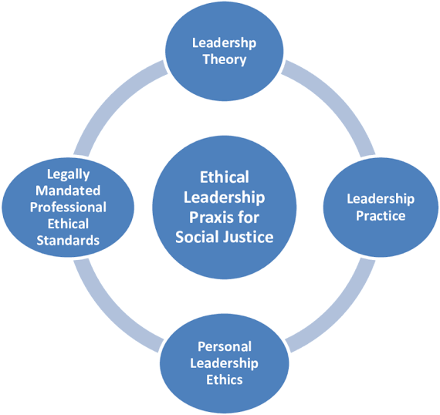
Figure 14: Ethical leadership principles
(Source: Gardiner and Tenuto, 2015)

Recommendations and Practical Strategies
Recommendation | Specific | Measurable | Achievable | Relevant | Timebound
Strengthen room inspection routines | The hotel should introduce a two-stage room inspection process led by a supervisor using a digital checklist before releasing rooms for guest arrival. | This action should reduce room related complaints by 25% and achieve 95% inspection compliance. | This can be achieved using the existing supervisory structure and current property management system. | This directly addresses cleanliness gaps and readiness inconsistencies identified in the findings. | The process should be implemented within 3 months and evaluated after 6 months.
Improve communication between housekeeping and maintenance | The hotel should implement a shared digital maintenance reporting system with real time updates accessible to both departments. | This should reduce maintenance related check in delays by 30%. | This is achievable through minor system adjustments and short staff training sessions. | This will prevent operational breakdown and improve service reliability. | The system should be piloted within 2 months and fully implemented within 4 months.
Introduce realistic workload allocation | The hotel should adjust daily room assignments based on occupancy levels and room condition complexity. | This should reduce staff reported workload pressure by 20% based on internal surveys. | This can be managed through revised scheduling practices without additional staffing. | This supports service consistency and reduces operational errors. | The revised allocation should be applied within 1 month and reviewed quarterly.
Provide structured training programme | The hotel should deliver quarterly refresher training on brand standards and quality expectations for housekeeping staff. | This should achieve 100% annual training completion for all housekeeping employees. | This is achievable using existing Hilton corporate training materials. | This aligns property level service delivery with brand expectations. | The programme should begin within 3 months and continue every quarter.
Strengthen ethical guest property handling | The hotel should formalise a documented lost property handling procedure supported by tracking records. | This should result in zero unresolved guest property complaints. | This can be implemented using existing front office processes. | This reinforces guest trust and professionalism. | The procedure should be introduced within 2 months with monthly monitoring.
Develop service performance dashboard | The hotel should create a monthly monitoring dashboard tracking cleanliness scores, complaint rates and turnaround times. | This should improve overall guest satisfaction scores by 10%. | This can be achieved using available internal and online review data. | This supports data driven decision making and long-term reputation management. | The dashboard should be designed within 2 months and fully operational within 5 months.
Table 1: Strategic Recommendations
Analysis:
The recommendations proposed for the organisation can be demonstrated using the Goal Setting Theory which will help in providing a structured foundation for operational improvement. This theory states that the performance within an organisation improves when the have measurable objectives (Jeong et al. 2023). Considering this, the proposed targets of reducing room related complaints by 25% will help the workforce with the hotel to gain clarity. Within an operation dynamic where the delivery of services is driven by routine, setting measurable targets will reduce the variability in performance. Moreover, completing a structured training process through the use of dashboard monitoring mechanism could lead to translating the strategic objectives into the behavioural standards of the organisation (Umana et al. 2022). On the other hand, the Goal Setting Theory focuses that goals levied by an organisation should be realistic. For instance, if the targets are considered as unachievable, the motivation of employees can decline rapidly. This is important within the hospitality sector which is characterised due to their high rates of employee turnover. Considering this, recommendation for the introduction of a workload allocation would help in preventing the performance goals to be counterproductive. It will help in balancing the expectations of productivity while protecting the consistency of services. In a similar vein, the Contingency Theory can be used to strengthen the value of these recommendations strategically. As per this theory, there are no management solutions available universally which can be applicable for all the contexts (Abedin, 2022). Considering this, it has been recommended that the organisation should ensure that their operational systems should align with the situational variables related to the instability in the market. The hospitality sector in the UK is operational amidst structural pressures related to the shortage of labour. Hence, it has been recommended for the organisation to implement a shared reporting system which reflects on the overall relation of contingency. Moreover, introducing a structured training program will help the organisation to respond to the contextual gaps in skills related to addressing the increased sensitivity around accountability within the work environment.

References
Abedin, B. (2022). Managing the tension between opposing effects of explainability of artificial intelligence: a contingency theory perspective. Internet Research, 32(2), 425-453.
ABPorts, (2025). Over £1 billion generated for Southampton. Available at: https://www.abports.co.uk/news-and-media/latest-news/2025/over-1-billion-generated-for-southampton-from-its-booming-cruise-industry/ (Accessed on: 16 February 2026)
Adhikari, Y. (2025). Optimising Workflow Efficiency of End-to-End Service Delivery Process: A constructive case study in a larger corporation.
Agatz, N., Fransoo, J.C., Rabinovich, E. and Sousa, R., (2025). Innovations, technologies, and the economics of last-mile operations: a call for research in operations management. Journal of Operations Management, 71(2), pp.166-175.
Agoda, (2025). DoubleTree by Hilton Southampton. Available at: https://www.agoda.com/doubletree-by-hilton-southampton/hotel/chilworth-gb.html (Accessed on: 15 February 2026)
Ahmed, S.K., Mohammed, R.A., Nashwan, A.J., Ibrahim, R.H., Abdalla, A.Q., Ameen, B.M.M. and Khdhir, R.M., (2025). Using thematic analysis in qualitative research. Journal of Medicine, Surgery, and Public Health, 6, p.100198.
Aini, Q., Manongga, D., Rahardja, U., Sembiring, I. and Li, Y.M., (2025). Understanding behavioral intention to use of air quality monitoring solutions with emphasis on technology readiness. International Journal of Human–Computer Interaction, 41(8), pp.5079-5099.
AlOmari, F., (2021). Measuring gaps in healthcare quality using SERVQUAL model: challenges and opportunities in developing countries. Measuring Business Excellence, 25(4), pp.407-420.
ANNAMALAH, S., (2024). The value of case study research in practice: A methodological review with practical insights from organisational studies. Journal of Applied Economic Sciences (JAES), 19(4 (86)), pp.485-498.
Au-Yong, C.P., Hoh, P.K. and Amos, D., (2024). Enhancing the Maintenance Practice to Improve Guests’ Satisfaction in the Hotels Industry. Built Environment Journal, 21(1), pp.18-29.
Bagnera, S., Dalton, A.N., Szende, P. and Legg, M., (2022). The Perception of Clean: Consumer Trust in Hotels Amidst COVID-19. International Journal of Gaming, Hospitality and Tourism, 2(1).
BBC, (2025). Half of UK job losses in hospitality, say bosses. Available at: https://www.bbc.com/news/articles/c05ey2ypp92o (Accessed on: 15 February 2026)
Bhatt, N., Chitranshi, J. and Mehta, M., (2022). Testing Herzberg's two factor theory on millennials. Cardiometry, (22), pp.231-236.
Browne-Farrell, G.D., (2025). Strategies to Reduce Waiting Times in a Hospital Emergency Department.
Bullock, K., Di Domenico, M., Miller, G., Shirgholami, Z. and Wong, Y., (2024). Under the radar? Modern slavery and labour exploitation risks for the hotel industry. Tourism Management, 102, p.104857.
Chen, W., Dong, B., Hsieh, C.W., Lee, M.J., Liu, N., Walker, R.M., Wang, Y., Wen, B., Wen, W., Wu, P. and Wu, X., (2022). A replication of “an experimental test of the expectancy‐disconfirmation theory of citizen satisfaction”. Public Administration, 100(3), pp.778-791.
CM, (2019). Dirty hotel rooms keep guests up at night – survey. Available at: https://cleaningmag.com/news/dirty-hotel-rooms-keep-guests-up-at-night-survey (Accessed on: 2 February 2026).
ConferencesUK, (2025). Double Tree by Hilton Hotel Southampton. Available at: https://www.conferences-uk.org.uk/venue/double-tree-by-hilton-hotel-southampton (Accessed on: 5 February 2026).
DA, (2025). Hotels - Destination Analysts. Available at: https://www.destinationanalysts.com/hotels/ (Accessed on: 2 February 2026).
ECJ, (2016). 80 Per Cent Of Britons Would Leave A Hotel If It Wasn't Clean Enough - ECJ. Available at: https://www.europeancleaningjournal.com/magazine/articles/latest-news/80-per-cent-of-britons-would-leave-a-hotel-if-it-wasnt-clean-enough (Accessed on: 4 February 2026).
Emadi, J. (2023). The Development of a Design Theory for Web Based Information Systems. Journal of Robotics Spectrum, 1, 013-023.
Emeafor, O.F., Anunobi, N.H. and Eyisi, A.P., (2025). Service Failure Dynamics in the Hospitality Industry. Nsukka Journal of the Humanities, 33(1).
Expedia, (2025). The Best Business Hotels in Southampton from $58 in 2026. Available at: https://www.expedia.com/Southampton-Hotels-Business-Hotel.0-0-d3245-tBusinessHotel.Travel-Guide-Filter-Hotels (Accessed on: 14 February 2026)
Faiq, N. and Supriyanto, S., (2023), December. The Influence Of Sanitation, Cleanliness, And Facilities On Customer Satisfaction During Overnight Stays With Service Quality As A Mediating Variable At Hotel Grasia Semarang. In International Conference On Digital Advanced Tourism Management And Technology (Vol. 1, No. 2, pp. 663-673).
Gardiner, M.E. and Tenuto, P.L., (2015). Reflections of practicing school principals on ethical leadership and decision-making: Confronting social injustice. The Journal of Values-Based Leadership, 8(2), p.6.
Hilton, (2025). DoubleTree by Hilton Southampton. Available at: https://www.hilton.com/en/hotels/souhndi-doubletree-southampton/ (Accessed on: 5 February, 2026).
HN, (2024). Just 27% of UK travellers have rebooked the same hotel due to the cost-of-living crisis. Available at: https://www.hospitalitynet.org/news/4119990.html (Accessed on: 3 February, 2026).
Hossain, M. (2023). The impact of hygiene practices in the management of restaurants and hotels.
Hotels, (2025). DoubleTree by Hilton Southampton. Available at: https://www.hotels.com/ho125464/doubletree-by-hilton-hotel-southampton-southampton-united-kingdom/ (Accessed on: 15 February 2026)
Hsieh, Y., Hirudayaraj, M. and Hsieh, W.C., (2025). Rethinking housekeeping job quality: insights from hotel housekeepers and managers. Current Issues in Tourism, pp.1-15.
Iriani, N., Agustianti, A., Sucianti, R., Rahman, A. and Putera, W., (2024). Understanding risk and uncertainty management: A qualitative inquiry into developing business strategies amidst global economic shifts, government policies, and market volatility. Golden Ratio of Finance Management, 4(2), pp.62-77.
Jeong, Y.H., Healy, L.C. and McEwan, D., (2023). The application of goal setting theory to goal setting interventions in sport: A systematic review. International review of sport and exercise psychology, 16(1), pp.474-499.
Ji, Y., Tao, W. and Wan, C., (2025). A systematic review of attribution theory applied to crisis events in communication journals: Integration and advancing insights. Communication research, p.00936502251319843.
Jokiperä, A., (2025). Planning housekeeping for a guesthouse accommodation business.
Kasim, A., Jailani, S.N., Mokhtar, M.F., Radha, J.Z.R.R.R., Khuadthong, B. and Fong, M.L.S., (2023). Community perceptions on the critical success factors of hotels’ community-based corporate social responsibility. Sustainability, 15(12), p.9842.
Khalil, N., Che Abdullah, S.N., Haron, S.N. and Hamid, M.Y., (2024). A review of green practices and initiatives from stakeholder’s perspectives towards sustainable hotel operations and performance impact. Journal of Facilities Management, 22(4), pp.653-682.
Kim, J., Kim, S., Jhang, J., Kwon, Y. and Baah, N.G., (2023). Experimental design studies in hospitality and tourism research: constructive recommendations. International Journal of Contemporary Hospitality Management, 35(10), pp.3570-3591.
KSB, (2025). High Staff Turnover in Hospitality. Available at: https://ksbrecruitment.co.uk/high-staff-turnover-in-hospitality/ (Accessed on 2 February, 2026).
Lim, W.M., (2025). What is qualitative research? An overview and guidelines. Australasian marketing journal, 33(2), pp.199-229.
Lin, G., Lin, M.S. and Song, H., (2024). An assessment of prospect theory in tourism decision-making research. Journal of Travel Research, 63(2), pp.275-297.
LinkedIn, (2023). Thematic analysis. Available at: https://www.linkedin.com/pulse/thematic-analysis-what-how-do-doreen-kanario-5tyvf?utm_source=share&utm_medium=member_android&utm_campaign=share_via (Accessed on: 3 February 2026).
Linkedin, (2024). The Service Recovery Paradox: Turning Failures into Opportunities. Available at: https://www.linkedin.com/pulse/service-recovery-paradox-turning-failures-danny-peters-3qrve?utm_source=share&utm_medium=member_android&utm_campaign=share_via (Accessed on: 4 February 2026).
Lintot, R.D. and Siniguian, M.M., (2025). Psychological Issues and Challenges of Hotel as Quarantine Facility: Policy and Guidelines.
Lubis, N. W. (2022). Resource based view (RBV) in improving company strategic capacity. Research Horizon, 2(6), 587-596.
Marc Global, (2022). UK-Hospitality-report.pdf. Available at: https://www.marcglocal.com/wp-content/uploads/2022/06/UK-Hospitality-report.pdf (Accessed on: 14 February 2026)
MMU, (2020). critical success factors in uk four and five star hotels. Available at: https://e-space.mmu.ac.uk/580119/1/PhD%20Dario%20tom%20Dieck.pdf (Accessed on: 16 February 2026)
Ndulango, J., (2025). Resources Optimization in a Facility Management: A case company in the Service Industry.
News By Wire, (2025). UK hotels face reputational risks if IT isn't modernised. Available at: https://newsbywire.com/uk-hotels-face-reputational-risks-if-it-isnt-modernised/ (Accessed on: 15 February 2026)
ONS GOV, (2021). Hospitality businesses are most likely to be struggling to fill vacancies. Available at: https://www.ons.gov.uk/employmentandlabourmarket/peopleinwork/employmentandemployeetypes/articles/hospitalitybusinessesaremostlikelytobestrugglingtofillvacancies/2021-09-16 (Accessed on: 3 February 2026).
Panditharatne, U., (2025). Enhancing Hotel Cost Efficiency and Sustainability-Evaluating the Impact of Durable, Cost-Efficient, and Energy-Saving Bath Linen in Hotel Laundry Operations.
Parliament UK, (2020). Home sweet home: How popular is domestic tourism in Great Britain. Available at: https://commonslibrary.parliament.uk/home-sweet-home-how-popular-is-domestic-tourism-in-great-britain/ (Accessed on: 15 February 2026)
Putri, N.M.K.E., Putra, I.K.M., Wajdi, M. and Mazher, M.A., (2025). An operational assessment of housekeeping services in fulfilling guest requests: A case study of Rby Bali. Kajian Pendidikan, Seni, Budaya, Sosial dan Lingkungan, 2(2), pp.88-101.
Rady, A., Abdelaziz, M. and Touni, R.D., (2023). The impact of price fairness on the perceived value and customer satisfaction under the exchange rate change in hotels in Egypt. Journal of Association of Arab Universities for Tourism and Hospitality, 25(2), pp.68-104.
Rexhepi, I., (2022). Measuring the perception of quality management primary healthcare services through SERVQUAL model. Corporate Governance and Organizational Behavior Review.
Sakinala, K. (2025). Mastering cost optimization in AWS: A comprehensive guide. International Research Journal of Education and Technology, 7(3).
Seo, K. and Shulga, L., (2025). Mapping Tourists’ Evaluations of a Hotel: An Analysis of Branded Versus Non-Branded Hotels. Cornell Hospitality Quarterly, 66(3), pp.294-303.
SFH, (2020). Hilton Defining a New Standard of Hotel Cleanliness, Working With RB/Lysol and Mayo Clinic to Elevate Hygiene Practices From Check‑In to Check‑Out. Available at: https://stories.hilton.com/releases/hilton-defining-new-standard-of-cleanliness (Accessed on: 5 February 2026).
Sianipar, R. and Cicilia, R.L., (2023). Procedure Housekeeping. Penerbit NEM
Sidhu, S.K., Ong, F.S. and Balaji, M.S., (2023). Impact of failure severity levels on satisfaction and behavior: from the perspectives of justice theory and regulatory focus theory. Journal of Consumer Marketing, 40(4), pp.535-547.
Singgalen, Y. A. (2024). Hotel customer satisfaction: A comprehensive analysis of perceived cleanliness, location, service, and value. Journal of Business and Economics Research (JBE), 5(3), 352-369.
Suraj, E.S., Kumar, B.S., Priyamathi, T., Tamilchudar, R. and Putra, H.D., (2024), March. The technology of advanced big data analytics favours growth of contemporary organisations. In AIP Conference Proceedings (Vol. 2816, No. 1, p. 110008). AIP Publishing LLC.
Thompson, S. (2024). Full House, Short Staff: Strategies for Restaurant Success. eBookIt. com.
Tiwari, A., Singh, M. and Dahiya, A., (2023). The impact of outsourcing of Hotel Housekeeping services on Hotel performance: a study on 5-Star Hotels of Delhi NCR. International Journal of Professional Business Review: Int. J. Prof. Bus. Rev., 8(1), p.4.
Tripadvisor, (2025). Awful, please read - Review of DoubleTree by Hilton. Available at: https://www.tripadvisor.com/ShowUserReviews-g186299-d192589-r1026367839-DoubleTree_by_Hilton_Southampton-Southampton_Hampshire_England.html (Accessed on: 15 February 2026)
Tripadvisor, (2025). Reviews. Available at: https://www.tripadvisor.in/Hotel_Review-g186299-d192589-Reviews-DoubleTree_by_Hilton_Southampton-Southampton_Hampshire_England.html (Accessed on: 2 February 2026).
TW, (2025). DoubleTree by Hilton Hotel Southampton. Available at: https://www.travelweekly.com/Hotels/Southampton-England/DoubleTree-by-Hilton-Hotel-Southampton-p51245395 (Accessed on: 5 February 2026).
Umana, A.U., Afrihyia, E., Appoh, M., Frempong, D., Akinboboye, O., Okoli, I., Umar, M.O. and Omolayo, O., (2022). Data-driven project monitoring: Leveraging dashboards and KPIs to track performance in technology implementation projects. Journal of Frontiers in Multidisciplinary Research, 3(2), pp.35-48.
UK Hospitality, (2025). Facts and stats. Available at: https://www.ukhospitality.org.uk/media-centre/facts-and-stats/ (Accessed on: 15 February 2026)
Vision Point, (2025). 32% of customers will walk away from a brand they love after a single bad experience. Available at: https://visionpoint.systems/statistic/32-of-customers-will-walk-away-from-a-brand-they-love-after-a-single-bad-experience/ (Accessed on: 15 February 2026)
Which, (2020). Some hotels found to have not cleaned rooms properly despite coronavirus risk. Available at: https://www.which.co.uk/news/article/hotels-not-properly-cleaning-despite-coronavirus-risk-azqUI4k8KgjT (Accessed on: 4 February 2026).
Yin, D., Li, M., Qiu, H., Bai, B. and Zhou, L., (2023). When the servicescape becomes intelligent: Conceptualization, assessment, and implications for hospitableness. Journal of Hospitality and Tourism Management, 54, pp.290-299.
Yuan, L. and Marzuki, A., (2024). What keeps historical theme park visitors coming? Research based on expectation confirmation theory. Frontiers in psychology, 15, p.1293638.
ZIDANE, Y., (2012). Project Change in Large Scale Engineering Projects. Master, Norwegian University of Science and Technology.
Zinn, A.K., Greene, D. and Dolnicar, S., (2024). Communicating default changes to hotel room cleaning without reducing guest satisfaction. Journal of Cleaner Production, 483, p.144266.
Zou, S. and Migacz, S.J., (2022). Why service recovery fails? Examining the roles of restaurant type and failure severity in double deviation with justice theory. Cornell Hospitality Quarterly, 63(2), pp.169-181.

