M5X01177
Manufacturing and Quality Systems

Lewis Christopher

Applying the Define and Measure Stages of the DMAIC Methodology to the Repeated Seal Failure on the 277 Bottom Discharge Mixer – Dow Silicones.

Contents Page

Introduction 3

Define stage 4

Problem Statement 4

SIPOC Diagram and Process Mapping 4

Customer identification 5

Critical to Quality Requirements 5

Measure stage 7

Data Collection Plan 7

Measurement system analysis 8

Conclusion 9

References 10

Figure 1 11

Figure 2 12

Introduction

The aim of this report will be to carry out an investigation into the define and measure aspects of the DMAIC methodology, with reference to the repeated seal failure, on the 500-gallon 277 Bottom Discharge Mixer (BDM) for Dow Silicones in Barry. The DMAIC methodology, part of the six-sigma model, is used as a tool for improving the quality of results which are achieved by a company for a given process or procedure (The Lean Six Sixma Company, n.d.).

The process that is being investigated is the seal failure on a mixer, used for producing Silicone rubber, through mixing of a range of different base products. These products will either be sold directly to the customer or used in another part of the area, as a base to be mixed further to produce higher grade silicones.

The reason for choosing this seal failure as the focus for this investigation is due to its repeated failure over the past year. The failure of the seal is evident when a black streak throughout the normally white or translucent discharged product is noticed by the operator. The presence of this black streak caused by the failure is responsible for failures in the lab tests carried out on site, as part of quality control procedures. These failures result in the need to scrap the product, and therefore loss of production time remaking what has been lost. The cost of materials and man hours, along with the loss in production during the replacement of the seal are other factors which are impacted. Due to high demand, this lost production time can cause direct impact to customers, who are then able to implement fines for not meeting deadlines for delivery.

Define stage

Problem Statement

A problem statement should be able to clearly describe to a reader, the undesirable difference between the current level of performance and the desired state at the end of a successful project (Morgan, n.d.). The below problem statement is what my investigation will be based around. The statement clearly highlights the current level of performance and in stating the expected life cycle of the seal, shows what I will be aiming to achieve by the end of the project.

‘There are currently numerous unplanned outages caused by the head seal failure on the 277 BDM, causing production loss and customer dissatisfaction due to the late delivery of product. The current time between failures of the seal is well below what expected in the planned maintenance schedule. In the past year the seal has only lasted its full 12 week planned cycle on 1 occasion.’

SIPOC Diagram and Process Mapping

SIPOC diagrams are used as a tool for documenting the process of a business (Amit, 2016). The acronym stands for supplier, input, process, output and customer and these are the 4 columns that make up the diagram and should be able to clearly show the process from beginning to end, making it clear for anyone unfamiliar with the process to understand (Amit, 2016). Process mapping is an extension to this SIPOC diagram and is used to further visualise the steps involved in the process (Figure 1).

Supplier | Input | Process | Output | Customer
Who supplies the input to the process? | What inputs are required? | What are the major process steps? | What are the process outputs? | Who is the output supplied to?
Cabot | Silica | Operator receives and reads recipe | 10kg logs of silicone rubber packaged in 500kg boxes | External vendors (eg. motor industry)
W115 Gumrig | Gum | Operator manually adds gum to mixer |  | W205 for further work to improve grade before sale
W307 | Fluids | KV valves allow for addition of given amount of fluids
 |  | Butterfly valve allows addition of silica
 |  | Mixer discharges product as logs of silicone
 |  | Automated unit packages locks into 500kg boxes

Customer identification

The failure of this seal is having an impact on customers both internally and externally to the business. Externally, the customers are being impacted because when the mixer is left down for prolonged periods of time and is not able to continue producing the product in line with the plan, the customers deliveries may then not arrive as previously agreed. Internally this failure also has an impact as many of the products that are made by this machine are moved to another area in the business and are mixed further with other additives to produce other products. If the product is not supplied to the other area within given time parameters, then this will also impact their scheduling and their ability to produce the required products within the given time constraints.

The area most impacted and therefore the key customer is the product that is moved internally, to be processed further within Dow, into the production of Fluorosilicone rubber. This is because the products which are reworked there are being sold with much higher profit margins but are made in smaller batches. As a result, there is very minimal stock piling of these batches, therefore only a very short period between stopping production and stocks being depleted. This is in contrast to the base product that is shipped straight from the 277 mixer, to the customer, as this is a much lower grade of silicone, that is produced to a very high level. This high production level and low cost means that the business is not as reluctant to have a base level of product stockpiled for situations such as extended periods of production loss.

Critical to Quality Requirements

Critical to Quality requirements (CTQs) are defined as a handful of elements which are considered critical in determining the success of a project or process (Master of Project Academy, n.d.). In order to establish what is critical to the customer you must listen to the voice of the customer and one way to do this would be using a Quality Function Deployment (QFD) along with other tools and dialog with all customers (6Sigma, 2018).

The critical quality requirements for the customer can fall into three different categories, based on the Kano model which measures not only how good a product is but also takes into account the emotions of the customer and how the product or service will make them feel (McGough, 2018). The basic quality requirements of the product in question are that the customer receives the correct product that is specified from Dow Silicones, this product should arrive within a given time frame and must have passed quality control testing in the labs. The performance requirements of this product are that the product is available to be produced in a wide range of moulds and colours with a wide range of packaging options are available to the customer. The customer should also be able to track all deliveries and receive updates alerting them of all stages of the production and transportation process of their order.

Project Charter
Project Name |  | Redesign of 277 head seal
Project Leader |  | Lewis Christopher
Project Sponsor |  | Elastomers Team Leader
Date |  | 20/11/2020
Problem Statement |  | There are currently numerous unplanned outages being caused by the head seal on the 277 BDM, causing production loss and customer dissatisfaction due to the late delivery of product. The current time between failures of the seal is well below what expected in the planned maintenance schedule. In the past year the seal has only lasted its full 12 week planned cycle on 1 occasion.
Scope |  | To redesign and install a new seal on the 277 BDM head. This will improve the lifespan of the gland to the 12-week planned shutdown, hence reducing lost production time.
Business Case |  | The number of seal replacements carried out in the past year is more than twice what is planned for this unit. These additional outages have led to total costs of approximately $1M in the past year in unplanned downtime, lost batches and maintenance.
Constrains | Time | 6 months.
 | Budget | TBC
 | Quality | Zero quality control failures as a result of seal failure between planned outages.
Measurable Benefits (per annum)
 |  | KPI | Baseline | Desired
 |  | Unplanned outages | 12 | 0
 |  | Batches scrapped | 20 | <3
 |  | Maintenance hours including planned outage | ~200 | <100
Team Members |  | Project Manager
 |  | Maintenance Technician
 |  | Maintenance Engineer
 |  | Project Sponsor
Risks |  | As there is no way of testing the new seal design without using it in the machine, there may be some adaptations needed after first installations which could impact production.

Measure stage

Data Collection Plan

The data collection plan is a key part of the measure phase. Without the plan of how you are going to gather the data, it is easy to overlook key metrics and not fully understand what the information is giving you. The collection plan below highlights the exact steps and the sequence which will be followed in the gathering of data for the project (Juneja, 2015).

What? | The data that needs to be collected as a metric for measuring this project will be the number of quality control failures of the product produced by this machine. There are other failures that could be possible within the quality control testing, but only those failures that could have been caused by this seal failure will be taken into consideration for the purpose of gathering data.
Why? | This is a key metric for determining the success of the project because the quality control failures are a certain way of determining whether the product is successful or not. Although the aim of the project is to reduce the downtime and improve customer satisfaction through ability to deliver all products on time, both issues will be eradicated if the machine is not failing quality control procedures. Speaking to customers about their satisfaction levels is another method that could be explored but this could have other mitigations and external factors impacting the results, making them harder to measure accurately and gather quantitative data from.
Who? | The responsibility for taking the sample would be with the operator, as they are present at each discharge. The quality control testing would be carried out by trained lab technicians, who would be able to identify any failures. The maintenance engineer or project manager would then be able to analyse the data and look at any trends.
How? | The recordings from the testing must be entered into SAP by the lab technicians so that engineers can look at the trends and see when any failures that have occurred. This historical data from before and after the replacement will give a clear indication of whether the implementation of the project has been a success.
When? | In order to ensure the highest accuracy, the operators should take a sample of each discharge and each should be taken from at the same point of the discharge. This will eradicate any deviations that may occur throughout the process. The machine can produce approximately six discharges in a 24-hour period, so taking a sample from each will give a large amount of data from which to draw conclusions when looking at the trends.
Where? | The product can be taken from the mixer head at the end of the discharge and packaged easily to be taken to the lab. The analysis carried out on the recordings for this collection plan would only be those showing the failure that has occurred specifically through the seal.

Measurement system analysis

In all measurement systems, there is a possibility of variation in the way in which results are taken and in the tools that are being used to take measurements. This variation will then contribute directly to the overall variability of the process and could impact the outcomes of the whole data collection process (Quality One, n.d.).

Operational definitions in data collection are used as a concise definition of a measure, to ensure that there is no ambiguity around decision making, such as deciding what constitutes a passed or failed sample (Quality Advisor, n.d.). To ensure that there is no variation in the way that different operators are taking samples from the product, or the way that they are being tested, strict procedures will be written which must be followed at all times for the testing process. This will eradicate any discrepancies which would be caused by human error that could impact the integrity of the testing process.

Along with procedures, ‘walking the process’ is another technique which will be implemented before the testing starts. This is another way of making sure that there is not any variation in the techniques being used to evaluate the findings from the lab testing. This will allow the engineer to look at the data in a clear manner and enable easier reading of the collected data.

Conclusion

Throughout the first two stages of this project following the DMAIC approach, it is apparent that the structure of the framework is very helpful in ensuring that all aspects of the project are investigated in an efficient manner.

Through following the DMAIC structure I feel I have managed to produce a clear definition of the project through my problem statement and then identified the customers and their concerns. This is all highlighted in the project charter, giving all the information about the project in a concise manner. The measure stage is also now clearly mapped so everyone can see what data is required and how that should be gathered in order to carry out the most meaningful analysis and draw conclusions about the success or failure of the project.

References

6Sigma, 2018. Critical to Quality (CTQ) is in the Six Sigma DNA. [Online]
Available at: https://www.6sigma.us/six-sigma-articles/critical-quality-six-sigma-dna/

Amit, 2016. SIPOC Diagrams : Definitions and steps. [Online]
Available at: https://tallyfy.com/sipoc-diagram/#:~:text=SIPOC%20diagram%20is%20a%20Six,process%20from%20beginning%20to%20end.

Juneja, P., 2015. Data Collection Plan. [Online]
Available at: https://www.managementstudyguide.com/data-collection-plan.htm

Master of Project Academy, n.d. Six Sigma Critical to Quality: 7 Steps to Produce CTQ Tree. s.l.:s.n.

McGough, O., 2018. Kano Analysis. [Online]
Available at: https://sapioresearch.com/kano-analysis

Morgan, R., n.d. How to write an effective problem statement. [Online]
Available at: https://www.isixsigma.com/new-to-six-sigma/getting-started/how-to-write-an-effective-problem-statement/
[Accessed 2020].

Quality Advisor, n.d. Opertional Definition. [Online]
Available at: https://www.pqsystems.com/qualityadvisor/DataCollectionTools/operational_definition.php

Quality One, n.d. Measurement System Analysis (MSA). [Online]
Available at: https://quality-one.com/msa/
[Accessed 2020].

The Lean Six Sixma Company, n.d. DMAIC Model. [Online]
Available at: https://www.theleansixsigmacompany.co.uk/dmaic-model/
[Accessed 2020].

Figure 1
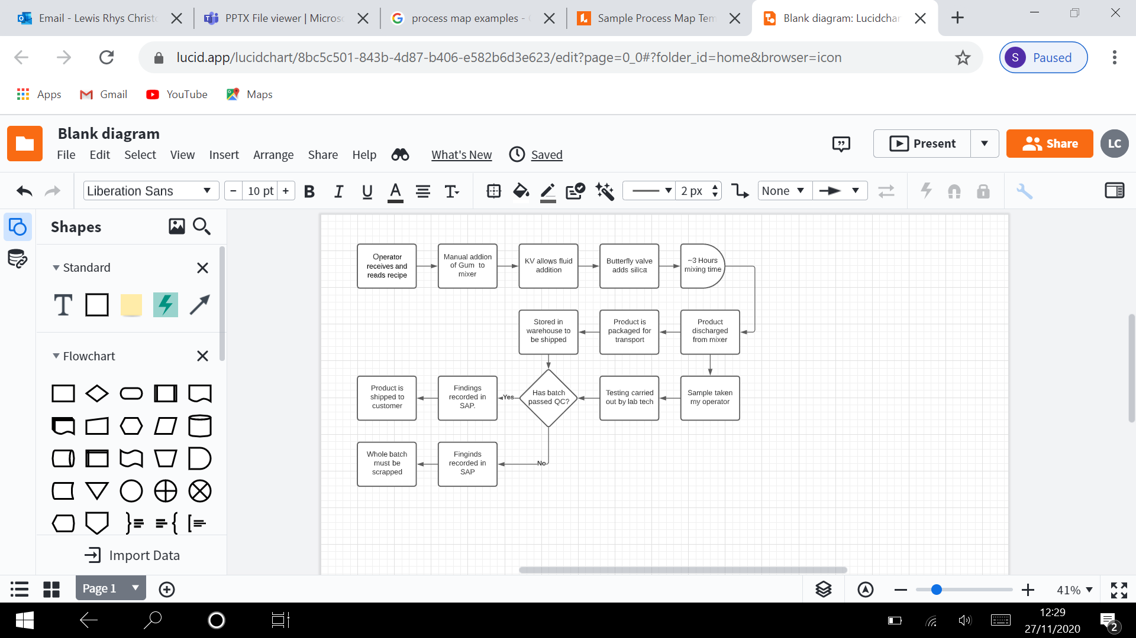

Figure 2


