
A study looking at the effect of technological advances upon crime statistics and a decreasing number of burglaries, theft from and of a motor vehicle and theft from a shop offence in England and Wales from 1980 to current time period.

School: UWTSD Swansea
Degree: Professional Police Practice
Student: Geraint O’Donovan
Student number: 1910632
Due Date: 27th June 2022
Word Count: 9,057

Declaration
This work has not previously been accepted in substance for any degree and is not being concurrently submitted in candidature for any degree.
Signed: G.O’Donovan
Date: 27/06/2022

Statement 1:
This dissertation is being submitted in partial fulfilment of the requirements for the degree of BSc Professional Policing Practice.
Signed: G.O’Donovan
Date: 27/06/2022

Statement 2:
This dissertation is the result of my own independent work/investigation, except where otherwise stated.
Other sources are acknowledged by footnotes giving explicit references. A bibliography is appended.
Signed: G.O’Donovan
Date: 27/06/2022

Statement 3:
I hereby give consent for my dissertation, if accepted, to be available for photocopying and for interlibrary loan, and for the title and summary to be made available to outside organisations.
Signed: G.O’Donovan
Date: 27/06/2022

Statement 4:
I hereby give consent for my dissertation, if accepted, to be available on the university’s IT system to those who have consent to use the system.
Signed: G.O’Donovan
Date: 27/06/2022

Acknowledgements
I would like to thank my family, especially my Father, Mother, Brother, Sister, and my girlfriend and friends for their support and patience through this difficult and stressful time. The support and kindness you have shown to me throughout this University process has allowed me to complete this process alongside working full time, I could not have done it without you.

Abstract
The aim of this dissertation is to identify what impact technological advancements have upon theft from and of a motor vehicle, domestic and non-domestic burglary and theft from a shop in England and Wales from 1980 to the current time period.
The researcher has undertaken analysis of the Home Office police recorded data for those five nominated theft offences, plotted the statistics in a linear graph along with dates of the introduction of a technological advancement. The graphs, therefore, helping to identify if there is any correlation in between those advancements and the theft crime statistics. If any correlation is identified this is to be backed up with further explorative research in this field.

Table of contents
Contents
Table of contents 6
Table of figures 8
Chapter 1: Introduction 9
1.1 Introduction 9
1.2 Background 9
1.2 Research Rationale 11
1.3 Aims and Objectives 11
1.4 Structure 11
1.5 Conclusion 12
Chapter 2 - Literature review 13
2.1 Introduction 13
2.2 Car theft 16
2.3 Burglary 18
2.4 Theft from a shop 20
2.5 General information relating to technological advancements 21
2.6 Conclusion 22
Chapter 3 – Research Methodology and Planning 23
3.1 Introduction 23
3.2 Research types 23
3.3 Research Strategy 24
3.4 Data collection and analysis 27
3.5 Benefits and limitations 28
3.6 Conclusion 28
Chapter 4: Dissertation – Analysis and results 30
4.1 Introduction 30
4.2 Data analysis 30
4.3 Analysis method 30
4.4 Conclusion 36
Chapter 5 – Findings and Conclusion 38
5.1: Introduction 38
5.2: Main findings 38
5.3 Recommendations 40
5.4 Limitations 41
5.5 Further Research 42
5.6 The achievements of Objectives 42
5.7 Conclusion 43
Bibliography: 45

Table of figures

Graph 1.2: Total recorded crime statistics plotted alongside total recorded theft crime statistics and total theft as a % of total crime
Graph 3.3.1 Comparison between CSEW and Home Office police recorded crime
Graph 3.3.2 : Home Office police recorded theft offences
Graph 3.4: Comparison between Home Office total recorded crime and theft crime
Graph 4.3.1: Theft of a motor vehicle and theft from a vehicle crime statistics plotted alongside the date of a technological advancement
Graph 4.3.2: Domestic burglary and non-domestic burglary crime statistics plotted alongside the dates of a technological advancement
Graph 4.3.3: Theft from a shop crime statistics plotted alongside the dates of a technological advancement

Chapter 1: Introduction

1.1 Introduction
The purpose of this dissertation is to investigate if technological advancements have a positive impact upon theft related crime statistics, this dissertation focus being purely on burglary (domestic and non-domestic), theft from a shop, theft of and from a vehicle. As the volume of data is too vast to compare all theft offences. These 5 different theft offences have been identified as being the most likely theft offences to have been affected by a technological improvement. Whist Government data goes as far back as 1898 this dissertation look at data from 1980, as not only is it too much data to consider, but also it is expected that a number of the most significant technological improvements will have occurred since 1980.

1.2 Background

The Government have recorded statistics of the levels of crime and crime types since 1898, and in 1898 this value stood at 82,426 total crimes. 68,541 of these being theft offences which as a percentage is 83%. (Home Office, 2012) Theft offences peaked in 1992 at 4,158,138 crimes, since then theft has generally been decreasing, and in 2020 the value of theft offences stood at 1,360,845 and 25% of total crime was related to theft offences. (Home Office, 2013)
Graph 1.2 shows that since 1992 the total number theft offences have generally been decreasing. However, there were slight increases in 2004 and 2016. Since 1972, the % of total crime being theft related offences has also generally been decreasing.

Graph 1.2: Total recorded crime statistics plotted alongside total recorded theft crime statistics and total theft as a % of total crime (Home Office, 2012) and (Home Office, 2013)

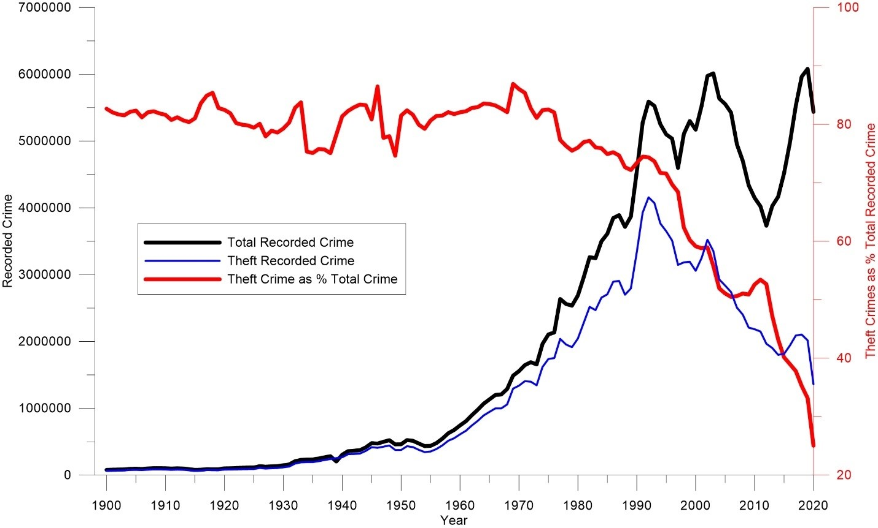

Technology is constantly improving and especially within the last 40-50 years. For example, in 1993 vehicle thefts stood at 597,519 which has now fallen to 93,653 in 2020. (Home Office, 2013) Since 2000 vehicle security has massively improved with the introduction of electronic alarms and immobilisers, and central locking. (Home Office, 2016, pp.4-5) This is likely to have had a significant impact on crime statistics as the vehicles became much harder to steal with the introduction of a capable guardian. Hollis-Peel et al., (2011, pp.53-70) state that for a crime to occur there must be a motivated offender, a lack of a capable guardian, and a target. Therefore, with these technological improvements in 2000 it introduced a capable guardian making the offence harder to complete, and possibly also making the offender less motivated to commit the crime.
This dissertation will therefore attempt to identify if technological advancements such as the use of CCTV have had a positive impact upon theft crime statistics.

1.2 Research Rationale
The researcher’s rationale for undertaking this project is due to their interest within the theories of criminology and the best practices that can be implemented to reduce crime. Having grown up in a period of rapid technological improvements, the researchers interest lies with how the technology can be used positively to reduce crime, by making the crime harder to commit and by taking away the motivation of an offender.

1.3 Aims and Objectives
The first objective of this dissertation is to correlate Government crime statistics for theft offences against significant technological advances to identify if improvements in technology have resulted in a reduction in theft crime. The results of this study may hopefully provide recommendations to those within the manufacturing market, to continue to focus upon developing their products, with the consideration of security at the forefront of their product development.

1.4 Structure
This study will be split into five chapters to help ensure that the objectives of this dissertation are achieved.
Chapter two of this dissertation will depict some of the available literature that will be used to help solidify the research topic.
Chapter three will identify the different techniques used to complete the research into the topic question.
Chapter four will analyse the results of the research and identify what sort of relationship exists between the theft crime statistics and technological improvements.
Chapter 5 will conclude this study and provide recommendations of the findings of the research that has been completed.

1.5 Conclusion
To conclude, chapter one has provided a background of the research topic and provided an explanation as to why the researcher has undertake this study. The objectives of this study have been provided, along with how this study will be structured, in order so that this project is completed successfully.

Chapter 2 - Literature review

2.1 Introduction
The purpose of this dissertation is to highlight to manufacturers and those working within the security department, that technological advances are essential in not only improving a product, but also in that they can act as a deterrent by taking away the means to those motivated to commit a theft offence. By removing the means or motivation of an offender by the introduction of technological improvements, it should reflect in the theft crime statistics. This dissertation will endeavour to display the correlation between theft statistics and technological improvements. Furthermore, highlighting the benefits and effects of technological improvements and to try identify that they have a positive impact upon theft crime, to encourage manufacturers to continue to develop such technology.
The purpose of this literature review is to identify the reliability of the available sources that have been used to conduct the research that has already been completed in this field. The strength of the literature is that this dissertation is largely based from sources that have researched evidence of how effective certain technological advances are, and that the online statistics of theft offences are readily available. However, there is a weakness in the literature in that none of the sources identified, have been able to conclusively identify that a certain factor is the primary cause of a reduction in theft offences.
The reasons that people become involved in criminal activity is such a varied, diverse topic that draws upon social factors, economic, drug and alcohol, a person’s upbringing and their varying motives. However, this dissertation may not be able to pinpoint a reduction of crime upon a specific technological factor. Ultimately the reason for the reduction in theft offences is likely to be as a result of several of the factors mentioned above. Moreover, this dissertation will look to prove that technological advancements are likely to have had a significant impact upon the statistics of theft offences.
Crime statistics have been downloaded and interrogated from the Government Crime Statistics website, which is in the public domain. These statistics have been plotted in a graphical format to help show a trend in these figures. The data has been thinned out to only display statistics relating to burglaries, theft from and of a motor vehicle and theft from a shop. These offences have been identified as being the most likely offences to have been affected by an improvement in technology, also the data is too vast to have considered all theft offences.
Research into total crime statistics show that crime levels peaked in 1992, before falling dramatically. (Home Office, 2012) Data produced by the Office for National Statistics show that theft offences peaked in 1995 with 11,615,000 total theft offences, 2,342,000 being domestic burglaries and 4,304,000 being vehicle related thefts. A steady year on year decline has been shown in the ONS statistics with latest figures in March 2020 standing at 3,299,000 total theft offences, 582,000 being domestic burglaries and 886,000 being vehicle related thefts. (Home Office, 2013) However, since 2013 the figures show a slight rise in theft of a motor vehicle, which is possibly due to the introduction of the keyless technology, and offenders using these technological advancements to their advantage to be able to steal a vehicle. West Midlands Police and Crime Commissioner states that nearly 3 times as many vehicles were stolen in 2018 compared to 2015. With experts believing that keyless technology is partly to blame for his increase. (Jamieson, 2018)
Furthermore, there is evidence from statistics that shows that overall theft from a shop has not seen any significant changes to its levels. In 1977 when theft from a shop statistics stood at 217,276 and in 2020 the figure rose slightly to 227,980, with a peak in 2017 of 382,659. Home Office, 2013) Therefore, it is likely that technological improvements have not had a dramatic impact upon theft from a shop. (Office for National Statistics, 2021, pp.1-23)
Routine Activity Theory is one of the most common theories used within criminology to depict why a crime has occurred. The theory states that in order for a crime to occur there must be a motivated offender, a lack of a capable guardian and a target. Therefore, without one of these factors the likelihood of a crime being committed is significantly less. (Miró, 2014, pp.1-7)
The Routine Activity Theory is also interlinked with the Twenty-five Situational Prevention Techniques that have been identified as factors that can impact upon the Routine Activity Theory. For example target hardening techniques such as strong locks on doors, immobilizers on cars act as a capable guardian which not only make it more difficult for the offender to commit the crime, but may also decrease their motivation due to the increased perceived effort to be successful in their attempt. Cornish and Clarke., (2003, pp.41-96) suggest that such prevention techniques may have a greater impact on those offenders whose motivation to commit a crime is weak, where as those offenders that are highly motivated may simply move on somewhere else to commit the crime. This journal has helped raise a potential weakness in all similar studies, as data is unlikely to capture the situations where a motivated offender does not complete a crime at their intended location. Due to a technological advancement in terms of the availability of a capable guardian such as strong door locks or immobilizers, meaning they are put off from even attempting the crime. Instead, they complete or attempt a crime at a different location. These situations may not be fully captured within government statistics and further studies. Moreover, these situations highlight the benefit of such an advancement in technology as they have been successful in deterring an offender resulting in a positive outcome upon crime statistics. Therefore, as previously mentioned it is difficult to quantify the number of and benefits of situations where an offender has been deterred by committing a crime by a technological advancement. This also identifies a gap in the literature where future research could be completed in order to try capture data in such situations, in order to further quantify the benefits of technological improvements upon crime statistics.

2.2 Car theft
Farrell et al., (2011, pp.147-175) state that further research is required to fully understand how security improvements affect all other types of crime types, and into how security improvements affect the mindset of an offender to further identify if this is another reason why crime has reduced. However, evidence within a report produced by the Home Office show that crime prevention techniques do have a impact upon crime, and especially regarding improvements in vehicle security it has shown to be very effective in reducing car theft especially the use of immobilizers. Moreover, vehicles that had an immobiliser, central locking and an alarm were identified as being around 25 times less likely to be stolen in comparison with those vehicles without such security. (Morgan, Shaw, Feist and Byron, 2016,pp.1-30)
For approximately 45 years Ford has been the most popular car brand within the United Kingdom and they have identified a concern for Ford owners who may park their vehicle out on their street overnight or out of sight all together. To try combat this Ford have introduced a new security feature called SecuriAlert which will notify the car owner if someone tries to gain access to the car with a key or attempts to open the car doors. (Brown, 2021) Ford are therefore showing their commitment to using technology to try reduce the risk of car theft as they believe this safety feature will benefit consumers and limit crime.
Several car and motoring experts regularly review car performance, value and the best safety features available to the consumer to try stop people stealing their car. The most well-known of these experts include Auto Express and The Drive and both carry out regular research, reviews and hands on testing. Reviews completed by The Drive suggest that some of the most effective, value for money products are steering wheel locks, brake locks and wheel locks. (Prince, 2021) Therefore it maybe beneficial for manufacturers to continue to develop products such as steering wheel locks as these have shown to be effective.
Advertising programme That’s Nerdalicious who have links with Amazon, Biotech Find and Life Science World further provide reviews of the most recent technology available to consumers in relation to vehicle security. That’s Nerdalicious highlight that there are a number of mechanical products such as wheel locks etc, however there are also products out there that allow you to monitor your vehicle in real time and also track its exact location. (Goodell, 2022) Whilst mechanical products have shown to be effective, continuing to develop other products such as vehicle tracking will allow for the police to have more information to try track down stolen vehicles and locate offenders. Meaning that whilst vehicle tracking may not help directly reduce the risk of cars being stolen, it may improve the chances of a vehicle being safely returned. However, offenders that know that a certain type of vehicle has a tracking system may be deterred from committing a theft offence as the risk to them is greater.
Ahmed, Marhoon and Nuri., (2018, pp.5261-5265) found that the use of leading technology such as vibration sensors, GSM and Bluetooth, all combined as part of an anti-theft security system have proved to be effective in reducing car theft. This technology requires the car user to enter a four-digit password to start the vehicle and if the number is entered incorrectly on two occasions, it will not only start but will alert the car owner. The results state that the use of such technology will be effective in reducing car theft.
West Midlands Police and Crime Commissioner David Jamieson wrote a letter to car manufacturers with concerns over the safety features of new vehicles, as offenders can use specialised equipment to open car doors and steal them. Furthermore, Jamieson stated that some car manufacturers are ignoring security loopholes that the police have informed them about, and that criminals are currently outsmarting manufacturers. (Jamieson, 2019) This may require the law having to change to force manufacturers to improve vehicle security. (Wiltshire, 2019) These comments made by David Jamieson further show the purpose of this dissertation, to highlight the need of manufacturers, the police and other security departments to work together to ensure that technology is being used in the most beneficial way to stop crime being committed.

2.3 Burglary
Tilley, Farrell and Clarke., (2015, pp.59-75) state that security improvements have become a major factor in the reduction of crime. This being especially apparent in car thefts; with improved vehicle security reducing the likelihood of successfully stealing a car, hence reducing an offender’s motivation to do so. Studies within the United Kingdom, United States, Australia and Netherlands highlighting that the introduction of central locking and immobilizers resulted in dramatic crime drops. (Tilley, Farrell and Clarke, 2015, pp.59-75) Furthermore from 1993 to 2011, completed burglaries have significantly fallen year on year, from 85 per 1000 households to 32 per 1000 households, whilst attempted burglary has seen a more modest decline from 35 per 1000 households in 1993 to 12 per 1000 households in 2011. (Tilley, Farrell and Clarke, 2015, pp.59-75) Improvement in security mean that there is a lower burglary risk that those without security. (Tilley, Farrell and Clarke, 2015, pp.59-75)
However (Hodges, 2021, pp.1-12) implies that the effect of CCTV upon crime prevention is difficult to quantify, burglars will often attempt to enter a property at the rear to avoid cameras that are more commonly placed at the front of the property. Hodges further recommends that conventual security in purchasing a good locking system on windows and secure doors maybe more beneficial than any smart security.
Further reducing the number of burglaries appears to be a priority for the Government with the introduction of a new multi-agency burglary taskforce aimed at reducing residential burglary. Moreover, the aims of the Government are to improve home security, and design products that will make burglary a harder crime to commit. The willingness of the Government to invest in such a taskforce and with their aims being to improve technology, further suggests that technological advancements do have a positive impact on crime statistics. (Home Office, 2019)
Miller., (2015) identifies that there are several technological improvements that are in the process of being rolled out to help secure people’s homes. The current way of thinking is that homes are moving towards a more smart and digital automated system. These improvements include; smart door locks and garage systems, with the smart systems linking to the Bluetooth on your mobile phone to lock/unlock the door, home sensors to identify any unusual motion, remote monitoring such as smart cameras and fingerprint scanners to unlock doors.
In addition, an article posted by Best Reviews., (2022) states that home security systems are incredibly popular with customers trying to prevent break ins and burglaries. Devices such as vacuum robots can now take photos and send them to the owner when they identify any unusual movement. Facial recognition and artificial intelligence are also becoming a big technological advancement with cameras being able to identify family members, friends that live at the address therefore helping to identify burglars or any unwanted persons at the address and then alerting the relevant persons.

2.4 Theft from a shop
As previously mentioned, theft from a shop has not seen any dramatic change upon the recorded statistics which suggests that technological improvements have not had any real impact. There are a number of social, economic factors that are likely to have caused this. Theft from a shop is commonly identified as being a trigger offence with subjects using theft as a means to fund a drug or alcohol addiction. The Gateway Foundation states that just under 20% of people in prison admit to stealing in order to fund a drug addiction. (Gateway Foundation, 2021) It can also be regarded as a summary only offence, so offenders maybe less concerned about the risks of being caught in comparison with a burglary offence, hence it may be the easiest and less risky theft to commit.
Moreover, the College of Policing states that overall retail tagging has not had a significant impact on theft from a shop but does advise that visible tags are found to be more effective in deterring offenders. (College of Policing, 2017) This therefore suggesting that whilst it is advised to tag items, there is little evidence to conclusively say that the technological improvement in the tagging of items has done much to reduce theft from a shop statistics.

2.5 General information relating to technological advancements
The College of Policing states that the evidence suggests that CCTV does reduce crime with the most effective areas being in car parks and residential area. CCTV also appears to have a bigger effect on vehicle crime and property crime. (College of Policing, 2021)
The Modern Crime Prevention Strategy produced by the Home Office states that the use of technology could be better used by the Police, to help deter criminals by being more effective in prosecuting them. (Home Office, 2016, pp.1-43) For example, the use of transmit and location data can be used to create a digital footprint that can effectively place an offender at the crime scene, along with the ever-improving forensic science. Moreover, technology can be used by the Police to allow for proactive policing and use the data available to find crime hotspots within their area. Therefore, allowing the police to allocate resources effectively, targeting certain times within certain areas to try and apprehend offenders, this is shown to be effective tool in reducing crimes such as burglaries. This strategy further stresses the need for the police to work alongside manufacturers with concerns over keyless theft of vehicles to try and come up with a solution to this problem. (Home Office, 2016, pp.1-43) By partner agencies working more together and sharing information it should allow for better decisions to be made about which technological advancements are beneficial for security, so that theft offences are less likely to occur and theft crime statistics reducing.
There has also been a discrepancy found in the way that data is recorded by the Office for National Statistics which falls under the Crime Survey for England and Wales, when compared with the Police Recorded Crime Statistics. The recorded numbers of theft offences are quite different when compared between both data sets, however the trends of the statistics are largely the same. (Elkin, 2022) To ensure that this dissertation remains consistent, only data from the Police Recorded Crime Statistics will be used going forwards. Crime Survey for England and Wales provides good indicators for long term crime trends, however police recorded crime gives a better understanding of lower volume crime. (Elkin, 2022)

2.6 Conclusion
To conclude there is evidence from government statistics and other sources to suggest that technology advancements do have a positive impact upon crime statistics, this is especially shown in theft of a motor vehicle and burglary. However, it has not been possible to identify any specific technological advancement that has had an impact upon theft from a shop. To ensure that positive technological advancements are continued to be made it will require both the police and manufacturers to work together to ensure that this happens. As shown with the introduction of vehicle keyless technology it has likely to have had a negative impact and has actually resulted in a rise in vehicle theft since it began to be widely used. Moreover, a gap in the literature has been identified where statistics and data will not cover situations where an offender has been deterred from committing a crime, due to a technological advancement and has hence moved onto a different location to complete the crime. In situations like this, the technological advancement would prove to be successful in deterring crime, however it will not be possible to quantify how many situations would fall into this category. This has identified a scope for future research as research into this particular area will help provide more conclusive results into the question of how technological advancements can affect theft offences.

Chapter 3 – Research Methodology and Planning

3.1 Introduction
This chapter of the dissertation will look to identify what research methods have been used whilst exploring the topic of the effect of technological advances upon crime statistics and a decreasing number of burglaries, theft from and of a motor vehicle and theft from a shop offence’ in England and Wales to current time period. Furthermore, the type of methodology used for further research will be highlighted and a review will be provided as to how the analysis of the dissertation will be portrayed. The benefits and limitations of using this style of research will also be identified.

3.2 Research types
This study looking at the effect of technological advances upon crime statistics and a decreasing number of burglaries, theft from and of a motor vehicle, theft from a shop offence’ in England and Wales from 1980 to current period, has used several different research methods. Quantitative research is defined as being the use of statistics to help identify trends within the research topic and to easily display information. (DeFranzo, n.d.) Qualitive research is defined as being exploratory research to try gain an understanding people’s opinions to allow for the user to develop ideas for their research. (DeFranzo, n.d.) Inductive research is defined as being the gathering of data to search for patterns within that data to allow for conclusions to be made. (Bhandari, 2022) Exploratory research is used when there is little knowledge around the topic and used to help the understanding of that topic. (George, 2021) To complete this dissertation, quantitative research will initially be used to gather the statistics of existing crime data, inductive and explorative research will then be used to try identify patterns in the crime data, and exploring different theories to see if technology improvements have decreased theft crime.

3.3 Research Strategy
This dissertation initially relied solely on secondary existing data that has been produced by The Office for National Statistics (ONS) through the Crime Survey of England and Wales (CSEW) and The Home Office police recorded crime. However, one important factor needed to be taken into consideration is how the existing crime data has been collected and reported. To ensure that this dissertation is ethical and accurate, it is therefore essential that the data has been reported and gathered in the same way. Golebiewski and Boyd (2019, pp. 1-51) imply that data can be manipulated, resulting in the person using the information can be easily misled. The ONS states that the benefits of police recorded crime is that it covers a wider range of the population and a wider range of crimes including lower volume crime. Moreover, the ONS states police recorded crime provides a good indication into the demands placed upon police, and for well reported crimes it can provide a good insight into that trend in crime. (Office for National Statistics, 2021) However, a negative is that it only covers crimes reported to the police and then recorded afterwards, furthermore across the United Kingdom police forces record crimes in different ways. (Office for National Statistics, 2021) Furthermore, as a result of the differing ways of how the police record crimes and its reliance upon a victim wanting to report an incident, the ONS do not class police recorded crime as a national statistic. (Office for National Statistics, 2021) The CSEW provide an estimate of crime statistics for England and Wales based upon a sample size of 34,500 interviews, with samples taken from each people in each police force area. (Crime Survey for England and Wales, 2019) However, as a result of the COVID 19 pandemic this survey as of 2020 has now changed to become telephone operated, highlighting another change in the process of collecting data. (Office for National Statistics, 2021)
Data comparison between both the CSEW and the Home Office police recorded crime is vastly different. CSEW data only available since 1980 and is consistently higher than police recorded crime which is available since 1898 and police recorded crime also provide a full breakdown of crime types. The historical comparison between CSEW and Home Office statistics is clearly displayed in Graph 3.3.1, moreover, since 2015 statistics show that the statistics are becoming more similar.
Graph 3.3.1 Comparison between CSEW and Home Office police recorded crime (Home Office, 2012) and (Home Office, 2013)
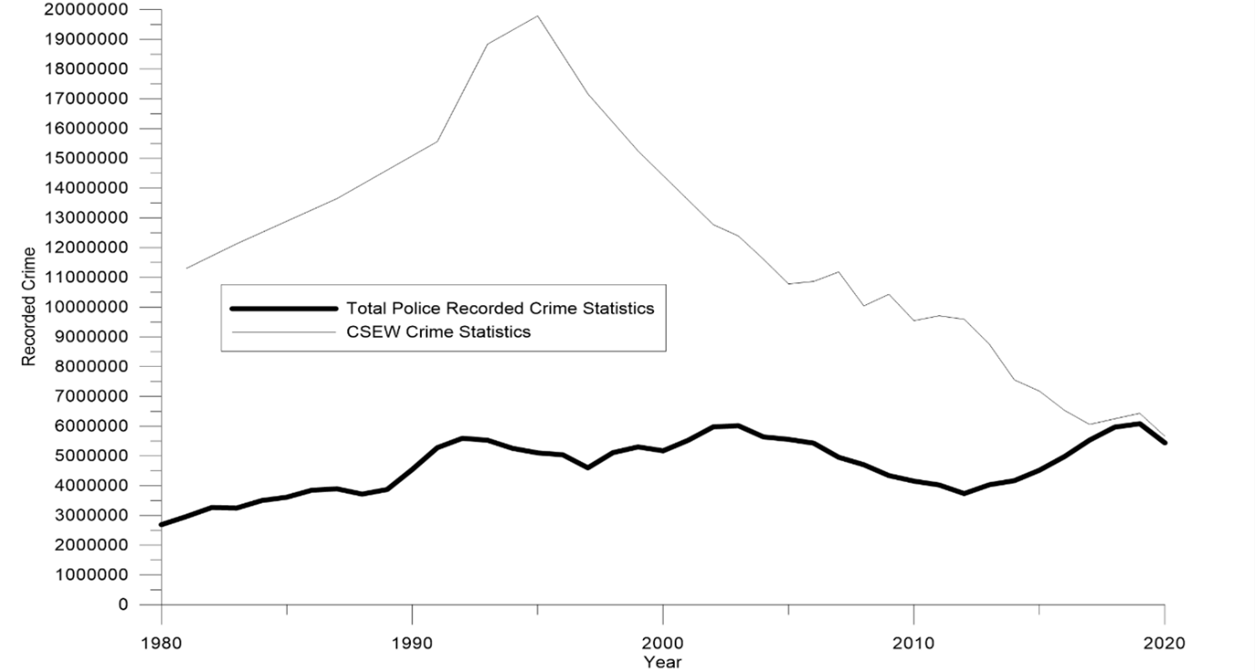
This dissertation will only focus on the Home Office police recorded crime to make the analysis of the data as accurate as possible. As police recorded crime provides an indication to the demands on police, this will provide an interesting comparison to see how technological advancements have impacted theft offences and potentially demand placed on the police.
Inductive quantitative research was initially completed using both The Home Office and CSEW data sets to help identify the trend of theft offences since 1980 to the current time period. Moreover, attention was specifically paid to burglaries, theft from and of a motor vehicle, and theft from a shop as these offences were identified as being the most likely offences to have been affected by a technological improvement. The police recorded crime data show that total recorded crime has increased from a level of 82,426 total crimes in 1898 to a peak of 6,013,759 total crimes in 2004, before decreasing to 5,437,337 total crimes in 2020. (Home Office,2013)
Graph 3.3.2 : Home Office police recorded theft offences (Home Office, 2012) and (Home Office, 2013)
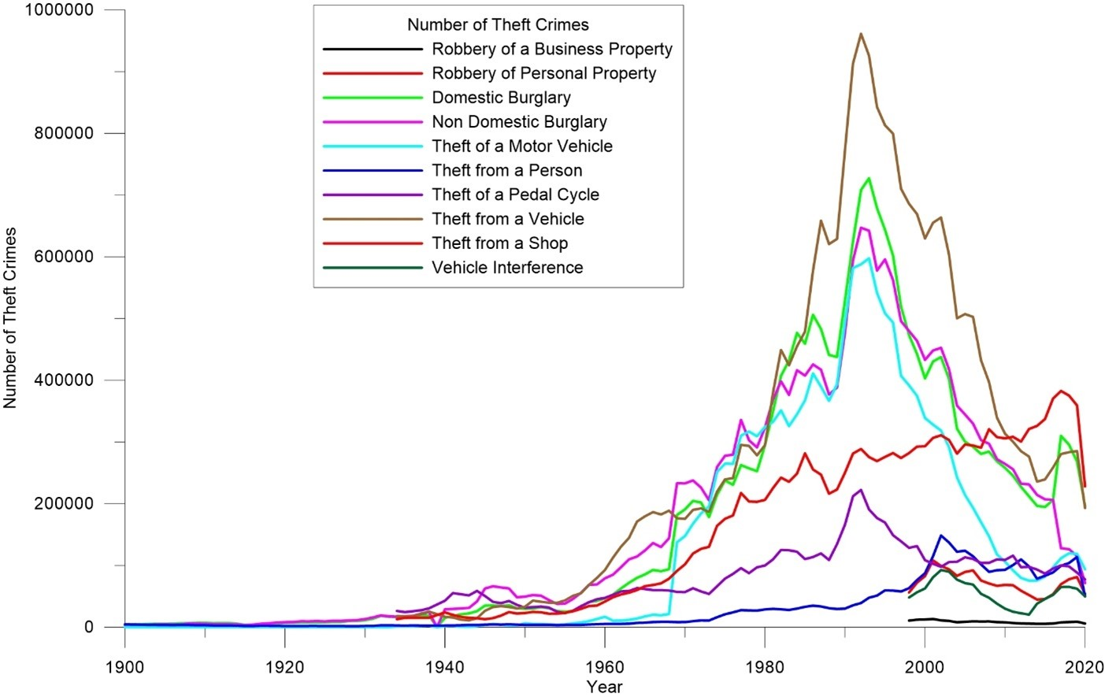
Graph 3.3.2 displays a historical linear graph of all recordable theft offences. Robbery of a business property, robbery of personal property and vehicle interference have been disregarded from this dissertation as they have only been recorded as separate offences since 1998. Furthermore, theft from a person and bicycle theft are also being disregarded because these are some of the lowest recorded theft offences and because it is expected that these offences will be the least likely offences to be affected by an improvement in technology.
The initial quantitative research of the Home Office data sets was then further backed up by inductive and exploratory research into sources and publications to try understand why the statistics show a decreasing trend, and if these trends could be corroborated to a technological improvement.

3.4 Data collection and analysis
Police crime recorded data has already been downloaded from the Home Office website and plotted in a graphical format against the time period. This data only displays burglaries, theft from and of a motor vehicle and theft from a shop. The benefits of having this data in a linear graph is that it clearly identifies the crime pattern for these offences and makes it easier to understand rather than having a long numerical list. Graph 3.4 displays a decreasing trend in theft offences since 1992 but a decreasing theft crime as a percentage of total crime since 1980.
Graph 3.4: Comparison between Home Office total recorded crime and theft crime (Home Office, 2012) and (Home Office, 2013)
Moreover, it also allows for the year a significant technological advancement was introduced, to be plotted on the same graph to give a visual timeline of these technological advancements versus the crime trend. Furthermore, once a correlation has been identified between a technological advancement and a change in the crime statistics, this dissertation will attempt to further back up this analysis with other publications and sources.

3.5 Benefits and limitations
The benefits of the methodology of this research is that it relies on existing quantitative secondary data that is already available to the public. Therefore, consent was not required from any source as to how the data was collected, making the research, less time consuming and entirely ethical. However, the negative of this methodology is that this exploratory research may not produce the conclusive results to depict that technological advancements do have a positive impact upon the stated theft offences. Due to the researchers timescales it may not be possible to overcome this barrier, but it does allow for future researchers to use this dissertation to aid them in their research.

3.6 Conclusion
To conclude this chapter has identified that the inductive quantitative research of existing data produced by the Home Office will form the bedrock and basic methodology of this dissertation. Inductive and exploratory research via publications and other sources will then look to further back up any analysis, to help depict the reasons why a technological advancement has had a positive impact upon the statistics of the nominated theft offences. The limitations of this research is that the inductive and exploratory research may not provide conclusive results to depict the exact reasoning as to why theft offences have decreased. As criminology is such a varied topic it is likely that there are several social, economic, policing factors along with technology advancements that may have had an effect.

Chapter 4: Dissertation – Analysis and results

4.1 Introduction
This chapter of the dissertation will focus upon the results and findings that have been discovered as part of the initial inductive quantitative research, and the inductive explorative research that has been completed, as explained in the previous chapter. Concerning, the effect of technological advances upon crime statistics and a decreasing number of burglaries, theft from and of a motor vehicle and theft from a shop offences since 1980. The crime statistical data obtained from quantitative research will be displayed in a graphical format, to help identify trends in the data to allow for thorough data analysis to occur.

4.2 Data analysis
Data analysis is defined as being the process of examining data to help form decision making and to identify trends or patterns within the data set. (Calzon, 2022) The analysis of the crime statistical data will allow for any trends in theft crime statistics to be identified, to see if any significant technological advancements have had an impact upon these statistics.

4.3 Analysis method
The police recorded crime statistics obtained from the Home Office will be displayed in a linear graph. Moreover, on the same graph, the date of significant technological advancements will be plotted to help identify if there is any correlation between these dates and the crime statistics. To make reviewing the data easier, three separate graphs will be produced to display these findings. Graph 4.3.1 will display theft of a and from a motor vehicle, graph 4.3.2 will display burglary and non-domestic burglary, graph 4.3.3 will display theft from a shop.
However, whilst several technological advancements have been displayed within the graphs, it is important to note that there will be several other technological advancements that will have occurred within the relevant time frame, that are not possible to include within this analysis due to the sheer volume of them. Hence, what is believed to be the most significant of advancements have been included within this dissertation.
Graph 4.3.1: Theft of a motor vehicle and theft from a vehicle crime statistics plotted alongside the date of a technological advancement (Home Office, 2012) and (Home Office, 2013)

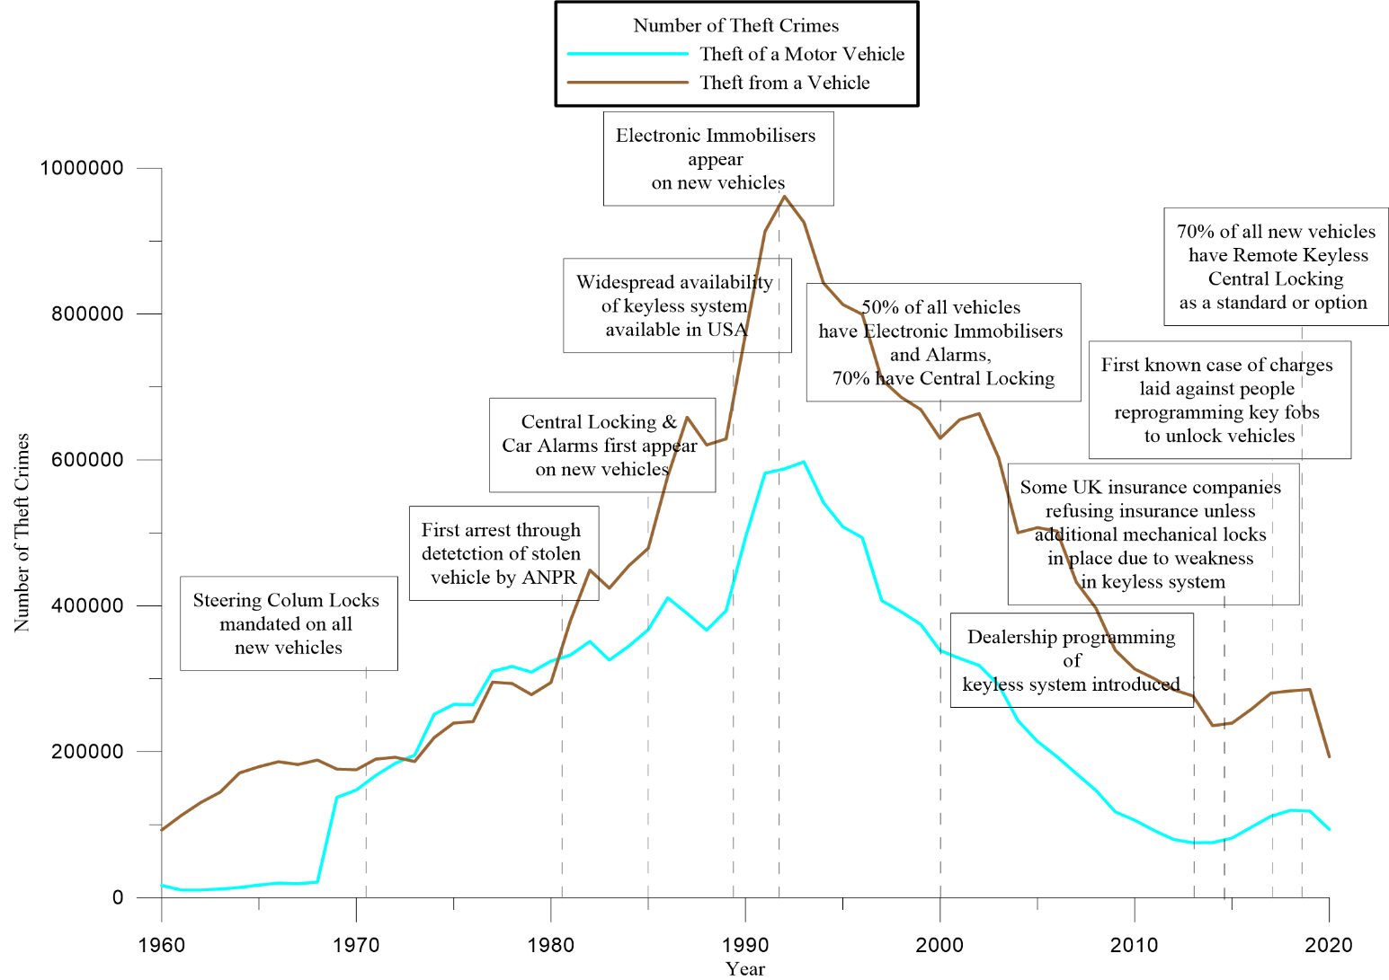
The above data has been collected from 3 data sets produced by the Home Office. 2 of the data sets have been collected from the Home Office historical data set. (Home Office, 2012) Whilst the last data set came from the Home Office (Home Office, 2013)
In 1960 there were 16,840 theft of a motor vehicle offences, in 1992 this had risen to 587,856. (Home Office, 2013) In 1960 there were 1960 92,704 theft from a motor vehicle offences, in 1992 this had risen to 961,340 offences. (Home Office, 2013) This shows a general rise year on year in the number of theft offences. The general rise in these offences between this period have occurred even with the introduction of steering column locks in 1971, the first arrest of a person through the use of Automatic Number Plate Recognition (ANPR) in 1981, the introduction of central locking and car alarms on new vehicles in 1985, and the more widespread use of keyless technology in 1989. Therefore, this trend suggests that these technological advancements during this time period have not been successful in reducing theft from and of a motor vehicle as the theft statistics have continued to rise.
However, it is also important to note that these technological advancements may take time to take effect and impact upon crime statistics, as it would take time for the general public to be more widely using and purchasing newer vehicles that have central locking and car alarms for example. Therefore, whilst theft of and from a vehicle statistics do not correlate with the technological advancements between the years of 1960 – 1992. It needs to be considered that these technological advancements may have actually had an impact in the years post 1992 where the crime statistics in both theft of and from a motor vehicle declined. This is therefore a gap in this research as it is not possible to specifically say what impact those technological advancements have had.
Both theft of and from a motor vehicle peaked in 1992/93, however since then both offences show a general decline in the number of offences. Theft of a motor vehicle peaked in 1993 with 597, 519 offences whilst theft from a motor vehicle peaked in 1992 with 961,340 offences. (Home Office, 2013) In 2020 theft of a motor vehicle offences stood at 93,653 and in 2020 theft from a motor vehicle stood at 193,119 offences. (Home Office, 2013) Both theft of and from a motor vehicle rose slightly in 2013 however there is no clear evidence as to why this rise occurred, before eventually decreasing again in 2018. There have been several significant technological advancements since 1992 and these include; the introduction of electronic immobilizers in 1992, in 2000 50% of all vehicles were known to have electronic immobilizers and alarms with a further 70% having central locking, in 2013 dealerships improved programming of the keyless system, in 2014 insurance companies began to refuse to insure vehicles without mechanical locks due to issues with the keyless system, in 2017, the first known case of charges given to people found to be reprogramming key fobs to vehicles. In 2019, 70% of all new vehicles have remote keyless central locking. It appears that these technological advancements have had a positive impact upon reducing theft offences relating to vehicles as the crime statistics during this period have reduced. However, this again is theoretical as it has not been possible to directly correlate a reduction in the crime statistics to a specific technological advancement.

Graph 4.3.2: Domestic burglary and non-domestic burglary crime statistics plotted alongside the dates of a technological advancement (Home Office, 2012) and (Home Office, 2013)
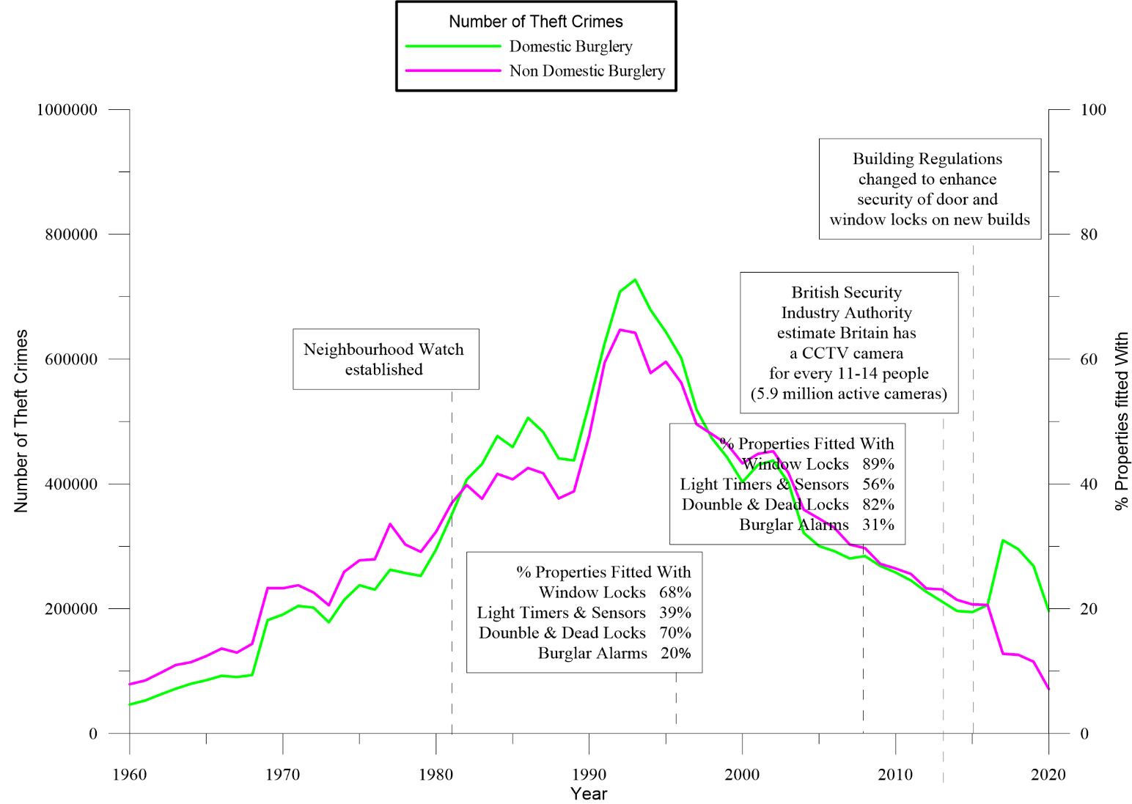
The above data has been collected from 3 data sets produced by the Home Office. 2 of the data sets have been collected from the Home Office historical data set. (Home Office, 2012) Whilst the last data set came from the Home Office (Home Office, 2013)
In 1960 domestic burglary offences stood at 46,591 and rose to its peak in 1993 where there were 727,276 domestic burglary offences. (Home Office, 2013) In 1960 non domestic burglary stood at 79,167 and rose until its peak in 1992 where 647,043 non domestic burglaries occurred. (Home Office, 2013) Both domestic and non-domestic burglary saw a generic gradual rise in the number of burglaries between 1960 and 1988, however in 1988 – 1992 both offences saw a sharper increase in the number of offences. In 1988 there were 441,020 domestic burglaries and it rose sharply to 727,276 domestic burgalries in 1993. (Home Office, 2013) In 1998 there were 376,772 non domestic burglaries and rose sharply to its peak in 1992 of 647,043 non domestic burglaries. (Home Office, 2013)
In 1982 the neighbourhood watch was established; however, it appears that this did not have significant impact upon statistics as the number of burglaries continued to rise even with the introduction of neighbourhood watch.
From its peak in 1992/93 both non domestic and domestic burglary offences have seen a generic decrease, and interestingly both follow a very similar linear curve, and both lines are tight too each other highlighting that the number of domestic and non-domestic burglaries were also very similar. In 2016, non-domestic burglaries continued its gradual decrease, however domestic burglary sharply increased till 2017 before again falling. In 2015 domestic burglaries offences stood at 194,700 and non-domestic burglaries stood at 207,057. (Home Office, 2013)
In 1995 only 68% of properties had window locks, 39% had light sensors, 70% had double and dead locks, 20% had burglar alarms. However, by 2008 these numbers had increased with 89% of properties having window locks, 56% with light sensors, 82% double and dead locks, 31% with burglar alarms. Also, by 2013 it was estimated that there was a CCTV camera for every 11-14 people, and in 2015 door and window locks were improved om all new build properties. These technological advancements suggest that the introduction of them has had a positive impact upon reducing burglaries as the crime statistics have reduced.

Graph 4.3.3: Theft from a shop crime statistics plotted alongside the dates of a technological advancement (Home Office, 2012) and (Home Office, 2013)
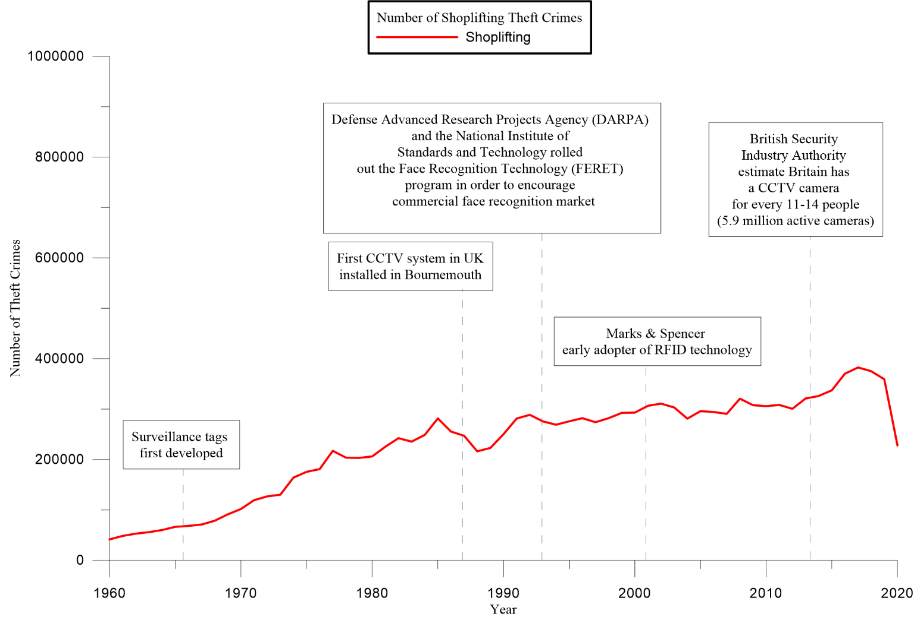
The above data has been collected from 3 data sets produced by the Home Office. 2 of the data sets have been collected from the Home Office historical data set. (Home Office, 2012) Whilst the last data set came from the Home Office (Home Office, 2013)
Since 1960 to 2018 crime statistics show that there has been a gradual increase in the number of thefts from a shop. In 1960 the number of theft from a shop offences stood at 41,535 and in 2017 this value peaked at 382,659 offences. (Home Office, 2013) From 1985 – 1988 this figure did decrease slightly before again rising. From 2018- 2020 the statistics show a significant decrease in the number of theft offences. In 2018 the number of theft from a shop offences was 375,159 and continued decreasing till 2020 where the value stood at 227, 980. (Home Office, 2013) However, it is important to note that this is undoubtably related to the COVID 19 pandemic with the majority of shops and businesses having to close in March 2019. The COVID 19 pandemic therefore, having a significant impact upon the falling of theft offences from a shop during this time period.
In 1966 surveillance tags were developed, in 1987 the first CCTV system was installed within the UK, in 1993 facial recognition was first introduced, in 2001 Marks and Spencer began using radio frequency identification with the tagging of items, in 2013 it was estimated that there was a CCTV camera for every 11-14 people within the UK. It would appear that none of these technological advancements have had a positive impact upon the number of theft offences from a shop as the crime statistics continued to rise during this period.

4.4 Conclusion
To conclude, this chapter of the dissertation has displayed the trends in theft of and from a motor vehicle, domestic and non-domestic burglary, and theft from a shop offences from 1960-2020 in England and Wales in a linear graphical format. Also plotted alongside the crime statistics, are significant technological advancements that have been considered to have an impact upon these statistics. At first glance it appears that some of these advancements have had a positive impact upon these statistics, whilst some appear to have had little impact. However, further work will be required to identify if a sole technological advancement is responsible for affecting a change in the crime patterns. Moreover, it is also important to consider that the introduction of a technological advancement will take time to impact upon crime statistics, as for example it will take time for the general public to purchase newer vehicles with better security. Likewise, other factors such as the COVID 19 pandemic need to be considered with the widespread closure of shops and businesses from March 2019 which will especially have impacted upon theft statistics relating to shops.

Chapter 5 – Findings and Conclusion

5.1: Introduction
The previous chapter of this dissertation focused upon the analysis of the results and findings that have been discovered as part of the research that has been completed within this project. Looking into the effect of technological advances upon crime statistics and a decreasing number of burglaries, theft from and of a motor vehicle and theft from a shop offences since 1980. This chapter will look to provide a conclusion regarding the research question and the research results that have been found, as well as highlighting the limitations of the project and identify where further work can be completed to help provide further evidence into the research question.

5.2: Main findings
As stated in the previous section of this dissertation, police recorded crime statistics produced by the Home Office show that from 1960- 1992 the number of theft of a motor vehicle and from a motor vehicle offences generally rose year on year. From 1992 – current time period the number of motor vehicle related theft offences generally decreased year on year. From 1960 – 1992 domestic and non domestic burglary saw a gradual rise in the number of offences, before again gradually decreasing from 1992 to current time period. In relation to theft from a shop, the results show a gradual rise from 1960-2018, before decreasing sharply in 2018-2020. Further exploratory research has found that a number of the technological advancements are likely to have had an impact upon crime statistics, however there is a lack of conclusiveness in the literature available. For example, the introduction of improved locks on doors and windows will undoubtably improve the target hardening of a premises, moreover, it may also take away the motivation of an offender to commit a burglary. But the literature does not conclusively say that this technological advancement has resulted in a decrease in burglaries. Graphs 4.3.1 and 4.3.2 provided previously in Chapter 4 do show a timeline and positive correlation between some of the introductions of a technological advancements and the crime statistics. However, this reduction in theft crime statistics is not seen throughout all the technological improvements. This lack of conclusive results is also shown throughout the other technological advancements that have been identified as potentially causing a change in crime statistics. Conclusive literature has been found, within a report published by the Home Office stating that steering locks and electronic immobilisers have driven down theft of vehicles, because they have made the theft more difficult to complete. (Home Office, 2016, pp.1-12) Crime statistics show that from a peak of theft of a vehicle in 1993 with 597,519 this value continued to gradually decrease till 2013 where the number of theft of a vehicle offences was 75,308. (Home Office, 2013) In 1992 electronic immobilisers were installed on new vehicles and in 2000 50% of all vehicles were identified as having immobilisers and alarms. The dates of the introduction of immobilisers in 1992, the decline in theft of a motor vehicle began in 1993, this positive correlation indicates that the use of immobilisers have had a positive impact upon theft of a motor vehicle. This is further backed up by the reference previously made by the Home Office stating that immobilisers have driven down the number of thefts of a vehicle. Moreover, in 1995 the percentage of properties fitted with window locks was 68%, 70% double and dead locks and only 20% had burglar alarms. In 2008, 89% of properties were fitted with window locks, 82% double and dead locks, 31% had burglar alarms. In 1993 domestic burglary peaked at 727,276 offences and continued to decrease till 2015 where the number of domestic burglaries was 194,700. (Home Office, 2013) In 1992 non domestic burglary peaked at 647,043 and decreased till 2020 where the number of non domestic burglaries was 71,366. (Home Office, 2013) Therefore, between the years of 1995- 2008 more properties were identified as having better security, suggesting that this has helped reduce the number of burglary offences during this time. This is further backed up by Tilley, Farrell and Clarke (2015, pp.59-75) stating that improvements in security mean that the risk of burglary is lower than those properties without it.
However, it is important to consider that whilst the literature currently does not provide conclusive results regarding the research question, the reality is that it may have had some impact upon the statistics, it is however too varied a topic to quantify how much of an impact the technological advancements have had.
It could be argued that theft of a shop is the easiest theft to commit as the products are all widely available to the public, they are generally of lower cost, hence the target hardening of these products is less. As retailers continue to weigh up the balance between the cost of their product, the cost of target hardening and of their profits made.
Moreover, the type of theft offences considered within this dissertation are all considered to be acquisitive volume trigger crimes, where offenders addictions drive their need to commit theft offences in order to fund an addiction. A study into drug users and criminal offences found that of 27,000 acquisitive crimes, shop lifting was found to be the most common offence. (Stewart, Gossop, Marsden and Rolfe, 2000, pp.10-20) This is possibly why theft from a shop does not see any significant decline in its recording, due to its more minor sentencing and the ease of which the crime can be completed. However, the statistics do show a sharp decrease in 2019-2021, however this will undoubtably be due to the COVID 19 pandemic and the widespread closure of shops during this time.

5.3 Recommendations
Having completed this research there are two recommendations that could be used with further research to improve this study and make it more conclusive. One of the key recommendations would be to analysis whether the properties that were burglaries had any security measures in place and compare this to the number of burglaries occurring at locations with security measures in place. This same recommendation would be applied to theft of a motor vehicle to compare both data sets. The researcher has been unable to find this data within the data sets that have been researched. Another recommendation would be for interviewing offenders who have committed theft offences to identify what security measures act as a deterrent for them.

5.4 Limitations
The biggest limitation of this project has been the sheer volume of the scope of work and the volume of available literature, this having been underestimated. This project has researched 5 different theft offences; theft of a motor vehicle, theft from a motor vehicle, domestic burglary, non-domestic burglary and theft from a shop. There is a significant amount of data available, related to each of these offences that could not be considered due to time constraints. Therefore, whilst this dissertation has helped to raise awareness that there is potential for technological advancements to have a positive impact upon crime statistics, there is a lack of conclusiveness in the results. Moreover, due to the volume of literacy available, more conclusive results may have been obtained by focusing on one or two similar offences, such as theft of and from a motor vehicle etc. By narrowing down the scope of work, it would have allowed freed up more time to allow for further research to have been completed to try come to a more conclusive result. There has also been a gap in the literature in that there is limited conclusive data nor literature that clearly identifies any particular technological advancement as having an impact upon crime statistics.

5.5 Further Research
This dissertation has tried to link crime statistics to an technological advancement to see if the technological improvement has had a positive impact upon the crime statistics, hence affecting the motivation and capability of an offender to carry out a theft offence. Therefore, further research could be done by either speaking to those who have committed multiple theft/burglary offences or initiating a survey to gather their opinions. This data could provide an invaluable insight, into not only the thought process of offenders, but to help identify what products/technological advancements take away the means/motivation of offenders to commit one of the nominated theft offences. Routine activity theory states that in order for a crime to occur there must be three factors present; an offender motivated to commit a crime, a suitable target and the absence of a capable guardian. (Bryant and Bryant, 2019, pp.46-50) Therefore, a technological advancement may not only increase the target hardening but also reduce the motivation and means of the offender to commit a crime.
Moreover, as criminology is such a wide and varied topic, other political, economic, social, personal upbringing, drug and alcohol abuse factors have not been considered during this dissertation. However, it is important that they are considered within any further research as ultimately changes within crime statistics could be as a result of several of the above factors. Rosenfeld (2009, pp.287-306) states that crime rates fall during times of a booming economy and crime rates increase during a economy down turn. Therefore, it is important to consider such factors in any further analysis to ensure that the scope of work is correct and ethical.

5.6 The achievements of Objectives
The primary objective of this study was to identify a correlation between technological advancements and the crime statistics of domestic and non domestic burglary, theft of and from a motor vehicle and theft from a shop.
This objective has been achieved as per the graphical displays within Chapters 3 and 4. There does appear to be a relationship between technological advances and theft related crime statistics. However, this study could have been more thorough had there been better information available to identify what specific technological advancements present a deterrent to offenders. This has clearly been a limitation in this scope of work. This information could be obtained through further research and interviews of offenders which would allow the second objective to achieved. The second objective was for this report to be used by manufacturers to assess the success of technological advancements so that they continue to put security at the forefront of their technology improvements. This objective could be achieved with further research that brings about more conclusive results.

5.7 Conclusion
To conclude, this dissertation has set out to establish the effect of technological advancements upon police recorded crime statistics for theft of and from a motor vehicle, domestic and non domestic burglary and theft from a shop. The limitations of this dissertation have been the sheer volume of the scope of work and available literature, which may have had an impact upon the lack of conclusive results found within this research. However, due to the complex nature of criminology it is also possible that it is not possible to come to a conclusive result regarding what technological advancements have impact crime recordings. Further potential research around this topic area have also been identified, with the requirement to look into other social, economic and political factors for example. Moreover, an insight into the views of offenders of technological advancements would also help further develop this topic. The further research identified could be used to further qualify the work already done within this dissertation, and to come to a more conclusive result about what technological advancements have had a positive impact upon the level of theft offences. Any further conclusive evidence gathered, can then be used to reach out to manufactures to ensure that they continue to invest in technological advancements that provide better security and target hardening to their products. As ultimately if the harder a product is to steal, the motivation and means of an offender to commit a theft offence will decrease.

Bibliography:

Home Office, 2012. Historical crime data. London: Home Office.
Home Office, 2013. Historical crime data. London: Home Office.
Home Office, 2012. Historical crime data. London: Home Office.
Home Office, 2013. Historical crime data. London: Home Office.
Home Office, 2013. Historical crime data. London: Home Office.
Home Office, 2016. Reducing criminal opportunity: vehicle security and vehicle crime. London: Home Office, pp.4-5.
Hollis-Peel, M., Reynald, D., van Bavel, M., Elffers, H. and Welsh, B., 2011. Guardianship for crime prevention: a critical review of the literature. Crime, Law and Social Change, [online] 56(1), pp.53-70. Available at: <https://link.springer.com/article/10.1007/s10611-011-9309-2>.
Home Office, 2012. Historical crime data. London: Home Office.
Home Office, 2013. Historical crime data. London: Home Office.
Jamieson, D., 2018. Car thefts nearly triple - West Midlands Police & Crime Commissioner. [online] West Midlands Police & Crime Commissioner. Available at: <https://www.westmidlands-pcc.gov.uk/car-thefts-nearly-triple/> [Accessed 27 June 2022].
Home Office, 2013. Historical crime data. London: Home Office.
Office for National Statistics, 2021. Crime in England and Wales: year ending June 2021. Office for National Statistics, pp.1-23.
Miró, F., 2014. Routine Activity Theory. The Encyclopedia of Theoretical Criminology, [online] pp.1-7. Available at: <https://onlinelibrary.wiley.com/doi/full/10.1002/9781118517390.wbetc198> [Accessed 19 January 2022].
Cornish, D.B. and Clarke, R.V., 2003. Opportunities, precipitators and criminal decisions: A reply to Wortley's critique of situational crime prevention. Crime prevention studies, 16, pp.41-96.
Farrell, G., Tseloni, A., Mailley, J. and Tilley, N., 2011. The Crime Drop and the Security Hypothesis. Journal of Research in Crime and Delinquency, [online] 48(2), pp.147-175. Available at: <https://journals.sagepub.com/doi/abs/10.1177/0022427810391539> [Accessed 19 January 2022].
Morgan, N., Shaw, O., Feist, A. and Byron, C., 2016. Reducing criminal opportunity: vehicle security and vehicle crime. [ebook] Home Office, pp.1-30. Available at: <https://assets.publishing.service.gov.uk/government/uploads/system/uploads/attachment_data/file/489097/horr87.pdf> [Accessed 27 June 2022].
Brown, C., 2021. NOW YOUR CAR CAN LET YOU KNOW IF IT’S BEING BROKEN INTO – VIA YOUR SMARTPHONE. [online] https://media.ford.com/. Available at: <https://media.ford.com/content/fordmedia/feu/gb/en/news/2021/06/10/now-your-car-can-let-you-know-if-its-being-broken-into--via-your.html> [Accessed 21 January 2022].
Prince, R., 2021. Best Car Anti-Theft Devices: Give Your Vehicle an Extra Layer of Security. [online] www.thedrive.com. Available at: <https://www.thedrive.com/reviews/27431/best-car-anti-theft-device> [Accessed 21 January 2022].
Goodell, J., 2022. Top 10 Best Car Anti-Theft Devices in 2022 Reviews. [online] That's Nerdalicious. Available at: <https://thatsnerdalicious.com/best-car-anti-theft-devices/> [Accessed 21 January 2022].
Ahmed, S., Marhoon, H. and Nuri, O., 2018. Implementation of smart anti-theft car security system based on GSM. International Journal of Engineering & Technology, [online] 7(4), pp.5261-5265. Available at: <http://www.sciencepubco.com/index.php/IJET> [Accessed 21 January 2022].
Jamieson, D., 2019. PCC calls on voice of the UK motor industry to tackle vehicle theft – open letter from David Jamieson - West Midlands Police & Crime Commissioner. [online] West Midlands Police & Crime Commissioner. Available at: <https://www.westmidlands-pcc.gov.uk/pcc-calls-on-voice-of-the-uk-motor-industry-to-tackle-vehicle-theft-open-letter-from-david-jamieson/> [Accessed 27 June 2022].
Wiltshire, T., 2019. Law ‘may need changing to force improvements in car security’. [online] https://uk.sports.yahoo.com/news. Available at: <https://uk.sports.yahoo.com/news/law-may-changing-force-improvements-131011519.html> [Accessed 21 January 2022].
Tilley, N., Farrell, G. and Clarke, R., 2015. Target Suitability and the Crime Drop. [ebook] London: Palgrave Macmillan, pp. 59-75. Available at: <https://library.oapen.org/viewer/web/viewer.html?file=/bitstream/handle/20.500.12657/22833/1007328.pdf?sequence=1&isAllowed=y> [Accessed 19 January 2022].
Tilley, N., Farrell, G. and Clarke, R., 2015. Target Suitability and the Crime Drop. [ebook] London: Palgrave Macmillan, pp. 59-75. Available at: <https://library.oapen.org/viewer/web/viewer.html?file=/bitstream/handle/20.500.12657/22833/1007328.pdf?sequence=1&isAllowed=y> [Accessed 19 January 2022].
Tilley, N., Farrell, G. and Clarke, R., 2015. Target Suitability and the Crime Drop. [ebook] London: Palgrave Macmillan, pp. 59-75. Available at: <https://library.oapen.org/viewer/web/viewer.html?file=/bitstream/handle/20.500.12657/22833/1007328.pdf?sequence=1&isAllowed=y> [Accessed 19 January 2022].
Tilley, N., Farrell, G. and Clarke, R., 2015. Target Suitability and the Crime Drop. [ebook] London: Palgrave Macmillan, pp.59-75. Available at: <https://library.oapen.org/viewer/web/viewer.html?file=/bitstream/handle/20.500.12657/22833/1007328.pdf?sequence=1&isAllowed=y> [Accessed 19 January 2022].
Hodges, D., 2021. Cyber-enabled burglary of smart homes. Computers & Security, [online] 110, pp.1-12. Available at: <https://www.sciencedirect.com/science/article/pii/S016740482100242X#sec0026> [Accessed 12 January 2022].
Home Office, 2019. Burglary taskforce will drive work to combat house break-ins. [online] GOV.UK. Available at: <https://www.gov.uk/government/news/burglary-taskforce-will-drive-work-to-combat-house-break-ins> [Accessed 20 January 2022].
Miller, J., 2015. 7 Ways Technology is Changing Home Security. [Blog] The Blog, Available at: <https://www.huffpost.com/entry/7-ways-technology-is-changing-home-security_b_8324548> [Accessed 21 January 2022].
Best Reviews, 2022. The Latest Home Security Technology To Watch in 2021 - Home Security Systems Reviews. [online] Home Security Systems Reviews. Available at: <https://home-security-systems.bestreviews.net/the-latest-home-security-technology-to-watch-in-2021/> [Accessed 21 January 2022].
Gateway Foundation, 2021. Stealing to Fund Addiction. [Blog] Addiction Blog, Available at: <https://www.gatewayfoundation.org/addiction-blog/stealing-to-fund-addiction/> [Accessed 27 June 2022].
College of Policing, 2017. Retail tagging. [online] Whatworks.college.police.uk. Available at: <https://whatworks.college.police.uk/toolkit/Pages/Intervention.aspx?InterventionID=45> [Accessed 21 January 2022].
College of Policing, 2021. Closed-circuit television (CCTV). [online] Whatworks.college.police.uk. Available at: <https://whatworks.college.police.uk/toolkit/Pages/Intervention.aspx?InterventionID=1> [Accessed 21 January 2022].
Home Office, 2016. Modern Crime Prevention Strategy. [ebook] London: Home Office, pp.1-43. Available at: <https://assets.publishing.service.gov.uk/government/uploads/system/uploads/attachment_data/file/509831/6.1770_Modern_Crime_Prevention_Strategy_final_WEB_version.pdf> [Accessed 21 January 2022].
Home Office, 2016. Modern Crime Prevention Strategy. [ebook] London: Home Office, pp.1-43. Available at: <https://assets.publishing.service.gov.uk/government/uploads/system/uploads/attachment_data/file/509831/6.1770_Modern_Crime_Prevention_Strategy_final_WEB_version.pdf> [Accessed 21 January 2022].
Elkin, M., 2022. Crime in England and Wales - Office for National Statistics. [online] Ons.gov.uk. Available at: <https://www.ons.gov.uk/peoplepopulationandcommunity/crimeandjustice/bulletins/crimeinenglandandwales/latest> [Accessed 27 June 2022].
Elkin, M., 2022. Crime in England and Wales - Office for National Statistics. [online] Ons.gov.uk. Available at: <https://www.ons.gov.uk/peoplepopulationandcommunity/crimeandjustice/bulletins/crimeinenglandandwales/latest> [Accessed 27 June 2022].
DeFranzo, S., n.d. Difference between qualitative and quantitative research.. [online] Snap Surveys Blog. Available at: <https://www.snapsurveys.com/blog/qualitative-vs-quantitative-research/> [Accessed 7 March 2022].
DeFranzo, S., n.d. Difference between qualitative and quantitative research.. [online] Snap Surveys Blog. Available at: <https://www.snapsurveys.com/blog/qualitative-vs-quantitative-research/> [Accessed 7 March 2022].
Bhandari, P., 2022. Inductive Reasoning | Types, Examples, Explanation. [online] Scribbr. Available at: <https://www.scribbr.com/methodology/inductive-reasoning/> [Accessed 7 March 2022].
George, T., 2021. Exploratory Research | Definition, Guide, & Examples. [online] Scribbr. Available at: <https://www.scribbr.com/methodology/exploratory-research/> [Accessed 7 March 2022].
Golebiewski, M. and Boyd, D., 2019. Data voids: where missing data can easily be exploited. Data and Society. [online] Data & Society Research Institute, pp.1-51. Available at: <https://apo.org.au/sites/default/files/resource-files/2019-10/apo-nid265631.pdf> [Accessed 6 March 2022].
Office for National Statistics, 2021. Crime in England and Wales QMI - Office for National Statistics. [online] Ons.gov.uk. Available at: <https://www.ons.gov.uk/peoplepopulationandcommunity/crimeandjustice/methodologies/crimeinenglandandwalesqmi#:~:text=victims%20to%20report.-,Because%20of%20concerns%20over%20the%20quality%20and%20consistency%20of%20crime,designation%20as%20National%20Statistics1.> [Accessed 6 March 2022].
Office for National Statistics, 2021. Crime in England and Wales - Office for National Statistics. [online] Ons.gov.uk. Available at: <https://www.ons.gov.uk/peoplepopulationandcommunity/crimeandjustice/bulletins/crimeinenglandandwales/yearendingmarch2021> [Accessed 6 March 2022].
Office for National Statistics, 2021. Crime in England and Wales QMI - Office for National Statistics. [online] Ons.gov.uk. Available at: <https://www.ons.gov.uk/peoplepopulationandcommunity/crimeandjustice/methodologies/crimeinenglandandwalesqmi#:~:text=victims%20to%20report.-,Because%20of%20concerns%20over%20the%20quality%20and%20consistency%20of%20crime,designation%20as%20National%20Statistics1.> [Accessed 6 March 2022].
Crime Survey for England and Wales, 2019. Crime Survey for England and Wales. Crime Survey for England and Wales, pp.1-10.
Office for National Statistics, 2021. Crime in England and Wales QMI - Office for National Statistics. [online] Ons.gov.uk. Available at: <https://www.ons.gov.uk/peoplepopulationandcommunity/crimeandjustice/methodologies/crimeinenglandandwalesqmi#:~:text=victims%20to%20report.-,Because%20of%20concerns%20over%20the%20quality%20and%20consistency%20of%20crime,designation%20as%20National%20Statistics1.> [Accessed 6 March 2022].
Home Office, 2012. Historical crime data. London: Home Office.
Home Office, 2013. Historical crime data. London: Home Office.
Home Office, 2013. Historical crime data. London: Home Office.
Home Office, 2012. Historical crime data. London: Home Office.
Home Office, 2013. Historical crime data. London: Home Office.
Home Office, 2012. Historical crime data. London: Home Office.
Home Office, 2013. Historical crime data. London: Home Office.
Calzon, B., 2022. Your Modern Business Guide To Data Analysis Methods And Techniques. [Blog] The datapine Blog, Available at: <https://www.datapine.com/blog/data-analysis-methods-and-techniques/> [Accessed 25 April 2022].
Home Office, 2012. Historical crime data. [online] GOV.UK. Available at: <https://www.gov.uk/government/statistics/historical-crime-data> [Accessed 25 April 2022].
Home Office, 2013. Police recorded crime and outcomes open data tables. [online] GOV.UK. Available at: <https://www.gov.uk/government/statistics/police-recorded-crime-open-data-tables> [Accessed 25 April 2022].
Home Office, 2012. Historical crime data. [online] GOV.UK. Available at: <https://www.gov.uk/government/statistics/historical-crime-data> [Accessed 25 April 2022].
Home Office, 2013. Police recorded crime and outcomes open data tables. [online] GOV.UK. Available at: <https://www.gov.uk/government/statistics/police-recorded-crime-open-data-tables> [Accessed 25 April 2022].
Home Office, 2013. Historical crime data. London: Home Office.
Home Office, 2013. Historical crime data. London: Home Office.
Home Office, 2013. Historical crime data. London: Home Office.
Home Office, 2013. Historical crime data. London: Home Office.
Home Office, 2012. Historical crime data. [online] GOV.UK. Available at: <https://www.gov.uk/government/statistics/historical-crime-data> [Accessed 25 April 2022].
Home Office, 2013. Police recorded crime and outcomes open data tables. [online] GOV.UK. Available at: <https://www.gov.uk/government/statistics/police-recorded-crime-open-data-tables> [Accessed 25 April 2022].
Home Office, 2012. Historical crime data. London: Home Office.
Home Office, 2013. Historical crime data. London: Home Office.
Home Office, 2013. Historical crime data. London: Home Office.
Home Office, 2013. Historical crime data. London: Home Office.
Home Office, 2013. Historical crime data. London: Home Office.
Home Office, 2013. Historical crime data. London: Home Office.
Home Office, 2013. Historical crime data. London: Home Office.
Home Office, 2012. Historical crime data. London: Home Office.
Home Office, 2013. Historical crime data. London: Home Office.
Home Office, 2012. Historical crime data. London: Home Office.
Home Office, 2013. Historical crime data. London: Home Office.
Home Office, 2013. Historical crime data. London: Home Office.
Home Office, 2013. Historical crime data. London: Home Office.
Home Office, 2016. Reducing criminal opportunity: vehicle security and vehicle crime. Research Report 87. Home Office, pp.1-12.
Home Office, 2013. Historical crime data. London: Home Office.
Home Office, 2013. Historical crime data. London: Home Office.
Home Office, 2013. Historical crime data. London: Home Office.
Tilley, N., Farrell, G. and Clarke, R., 2015. Target Suitability and the Crime Drop. [ebook] London: Palgrave Macmillan, pp. 59-75. Available at: <https://library.oapen.org/viewer/web/viewer.html?file=/bitstream/handle/20.500.12657/22833/1007328.pdf?sequence=1&isAllowed=y> [Accessed 19 January 2022].
Stewart, D., Gossop, M., Marsden, J. and Rolfe, A., 2000. Drug misuse and acquisitive crime among clients recruited to the National Treatment Outcome Research Study (NTORS). Criminal Behaviour and Mental Health, 10(1), pp.10-20.
Bryant, R. and Bryant, S., 2019. Blackstone's Handbook for Policing Students 2020. 14th ed. New York: Oxford University Press, pp.46-50.
Rosenfeld, R., 2009. Crime is the Problem: Homicide, Acquisitive Crime, and Economic Conditions. Journal of Quantitative Criminology, 25(3), pp.287-306.

