Data Centre Management Assignment Student number: P147535
Module Code: ACCA6001
Module Tutor: Dr. Carlene Campbell

Evaluation of Infrastructure as a Service (IaaS) within the confines of Network & Data Centre Management.
Abstract—This report describes the design and implementation of a functional/working enterprise Network & Data Centre to support the University of Wales Trinity St David (UWTSD)’s campuses and partner colleges globally in order to centralise UWTSD’s IT operation and equipment as well as to manage and support the day-to-day operations. The connection is tested fully to ensure that it is operational and that all links are well interconnected. A research is then carried out in the Network & Data Centre management field. The research includes a review and proposal to optimise the network & data centre to support the company's future growth. Some areas of future growth focused upon include the use of Internet of Things (IoT), Cloud services and Machine2Machine (M2M) communication in enterprise environments. All of these areas are fully analysed to understand their security risks and the benefits related to them.

Keywords:
IaaS: Infrastructure as a Service, IoT: Internet of Things, M2M: Machine2Machine, DMZ: Demilitarised zone, APIs: Application Programming Interfaces, WAN: Wide Area Network, VPN: Virtual Private Network, IDC: Internet Data Centre, VLAN: Virtual Local Area Network, SAN: Storage Area Network.

List of Figures:
Figure 1 Network model of UWTSD (Source: Author) 3
Figure 2 IoT Security System (Source: Author) 3
Figure 3 Internet Server Farm within Google IDC (Source: Author) 3

Introduction

Network management is the process of governing and controlling a given network to reduce faults and improve the network performance using a variety of tools and methodologies to keep up with the changing technologies and meet the business requirements. Network management aims at achieving a secure network. It involves a variety of concepts such as security, performance, and reliability [1]. Some of the key areas that network management focuses on are network operation, network administration, network maintenance, and network provisioning. Network administration is the following and maintenance of an inventory of network assets such as transmission lines, switches, servers, routers, and hubs by monitoring their performance, updating and upgrading the related software. Network operation ensures the smooth running of a network by closely monitoring problems, finding the problems and fixing them before they occur. Network maintenance is the timeliness of repair and upgrade of all network resources. Network provisioning is the configuration of network resources in order to support the requirements of a particular application or service such as increasing more broadband to support more users. The data centre is a centralised location where computers and network equipment are placed in order to collect, store, process, distribute or allow access to a large number of data ports. Data centres are often referred to as server farms because of the large concentration of servers which are stacked into rows. These server farms offer services such as data storage, backup, and recovery. Data centre management is the management of the operations in a data centre by a group of skilled individuals who maintain and oversee the IT and technical issues that may arise [2]. This report describes the design and implementation of a functional/working enterprise Network & Data Centre to support the UWTSD’s campuses and partner colleges globally in order to centralise UWTSD's IT operation and equipment as well as to manage and support the day-to-day operations. It also contains the results of a research that aims at reviewing and proposing an optimised network and data centre to support a company’s future growth by observing how part of the future growth such as Internet of Things (IoT), cloud services and machine to machine communication will benefit the company and what the security risks involved will be [1].

Related work

Machine2Machine communication in enterprise environments
Machine to machine (M2M) is a future technology in businesses that enables any networked devices to share information and perform tasks or operations without the need or presence of a human and to direct the actions. It was the basis upon which the Internet of Things was developed. It is made up of sensors, a wireless network and a computer preferably one which is connected to the internet. In M2M, a remote acquires data and sends it directly to a network wirelessly, where it gets routed usually through the internet and then to a server which can be a personal computer; the data is then analysed through the laid instructions [3].
Some of the benefits of M2M include: M2M reduces costs by reducing the need for physical human visits in order to monitor network resources. It also optimises network operations and processes to promote faster operations. M2M ensures continuous communication. Since M2M is always available, it ensures that the network data is available in real-time capacity. Storing this data in a cloud-based platform allows the data to be accessed anytime and anywhere through the use of either a smartphone, tablet or computer. M2M is scalable, and this allows a business to be able to support an increasing number of customers or services that it provides. M2M improves the quality of services since monitoring and management have been automated. It also promotes security through the use of encryption and authentication to secure information [3].
Machine to machine communication leads to security concerns in a given network through compromise of devices in the network, data flowing in the network, communication within the network and end to end user security concerns. Devices in a network are subject to unauthorised access and theft. Therefore, there is a need for locks to be placed on the devices and alert systems to be developed in server rooms for when unauthorised access to those rooms occurs. Data in a network can be accessed in an unauthorised way through two major ways: data stored in a device within the network and data that is being transferred from one point to another. To ensure the security of data, data has to be strongly encrypted. All the data has to be encrypted including configuration information, network settings, and ownership data. Data is transferred from one point to another once encrypted, which ensures security. However, to increase the level of security it is advisable to encrypt both the data and the communication. The endpoints in a communication need to be secured in order to promote the security of both data and communication [3].

Cloud Services
Cloud services are where remote servers are used to deliver services, both hardware and software, without the need for any physical hardware or software, in order to process, store and manage data over the internet. The data that is stored on the remote servers is maintained and controlled by a cloud computing provider, such as Google. In regard to Google Drive, cloud providers make sure that the data stored or being accessed is always secure, that it can be accessed anywhere and at any time, and in case of any disasters, they ensure that the data is backed up successfully. Cloud services involve the following functions: Infrastructure as a Service (IaaS), Platform as a Service (PaaS), public, private and hybrid clouds, test and development, big data analysis, data storage, data recovery, and backup [4].
Cloud services are important nowadays. They promote worldwide access to information from anywhere and at any time as long as one has internet access; they increase the amount of storage so that one does not run out of hard drive storage; they are synonymous with easy set-up that can take place in only a few minutes, as well as automatic updates where cloud providers such as Apple are responsible for ensuring that updates are readily available; they reduce costs thanks to the use of inexpensive software which are already installed while other software such as Dropbox are free. Companies acquire cloud services by purchasing software like iCloud, Google Drive, Dropbox from cloud providers such as Google, Apple, IBM and many others. The companies specify the storage and type of cloud computing service they require. These types could be private, public or hybrid [4].
Some of the security issues and possible solutions associated with cloud computing include user access control, securing the data stored within the cloud provider, securing the interfaces and securing channels. User access control is a risk since cloud computing does not have a proper authorisation system that will limit access to the data stored within a cloud. Since all the employees and customers can access information within the cloud, it is therefore advisable for any organisation to only store less critical information in the cloud. Securing the data stored within the cloud provider or the data being accessed from the remote servers is very critical and should be strongly encrypted to ensure their security. Securing the interfaces used is also a risk of cloud computing, and therefore companies should ensure that interfaces and APIs used to access data stored in the cloud are secure [4].

Internet of Things (IoT)
Internet of Things (IoT) refers to the physical devices that are connected to the internet to exchange and collect data from each other. For instance, IoT is capable of allowing an administrator to remotely monitor the operation of a network from the confines of his/her home. Internet of things in a network promotes communication such as machine to machine communication in a network. It also promotes automation and control of operations, adequate supply of information, monitoring of network resources, saving and proper utilisation of time, optimum utilisation of resources thus saving money, automation of daily tasks leading to better monitoring of tasks and better quality of life [5]. The threats associated with IoT are: insecure Web and APIs Interface, inefficient authentication and/or authorisation of systems, network services which are not properly secured, lack of encryption of transport, data, communication and channels of a network, promoting privacy in the network, insecure cloud and mobile interface and few security configurations within the network [6].

Data centre Design

We have built a functional/working enterprise Network & Data Centre to support the UWTSD’s campuses and partner colleges globally (as illustrated in Figure 1). This is a move to centralise UWTSD's IT operation and equipment as well as to manage and support the day-to-day operations. The main campus is located in the City of Swansea. Other campuses and/or partner colleges are based in Carmarthen, Lampeter, London and Malaysia.
The design includes four server farms:
- Internet server farm within the ISP, part of Google IDC.
- DMZ server farm.
- Extranet server farm to be accessed by partners only.
- Intranet server farm to be accessed by internal users only.
- Security system using IoT devices to protect server room from fire, humidity, temperature, and access security (as illustrated in Figure 2).
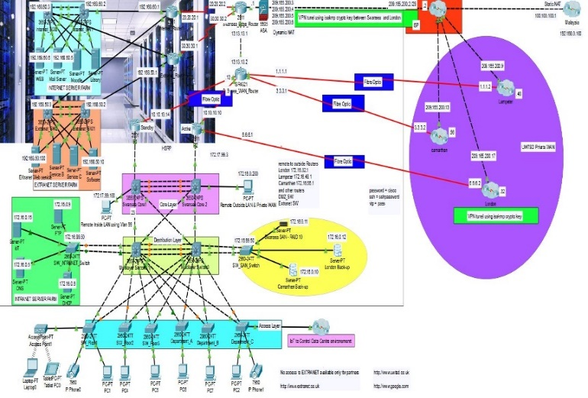
The Network and Data Centre designed consists of various categories of server farms: intranet, extranet, DMZ and dedicated internet server farm. Each of these server farms is a small data centre that is used to manage huge amounts of data within the network.

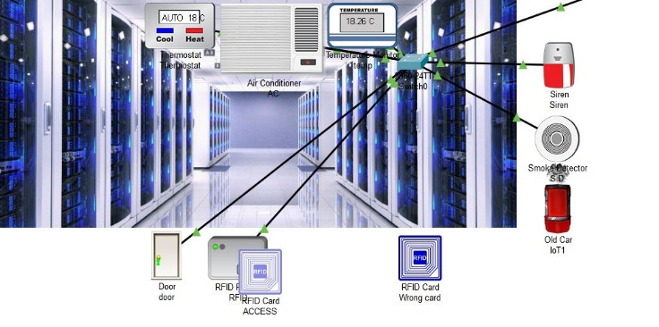
Figure 1 Network Model of UWTSD (Source: Author)
Figure 2 IoT Security System (Source: Author)

The DMZ Server Farm
The DMZ server farm consists of many servers, two DMZ switches, and one DMZ router. The four servers are two web servers, a Meraki server, and a back-up server. The main DMZ switch 1 is located adjacent to the DMZ router. The purpose of this switch is to facilitate the detection of network breaches before they occur. Thus, the DMZ switch is a perimeter defence switch. The placement of the DMZ switch is based on the assumption that all external network nodes attempting to gain access to the servers are controlled by malicious users, hence should be kept in the DMZ for evaluation [7].

The Intranet Server Farm
The Intranet is a local and restricted communication network that is used for communication among the internal stakeholders of an organisation such as employees and the management. Therefore, an intranet server farm is a group of server computers that specifically receive and execute requests within the local intranet network. The intranet server farm consists of four servers: IoT server, DNS server, DHCP server and an Intranet server.
The DHCP server continuously assigns IP addresses to client devices on the network, while the DNS server converts these addresses into names. The Intranet server processes and sends requested information to the client devices. The IoT server supports and manages all the IoT devices that control the access, room temperature and the fire alarm of the server room while Swansea distribution switches 1 and 2 serve the purpose of forwarding data packets to and from the servers in the intranet server farm.

The Extranet Server Farm
The extranet server farm has the same architecture as the DMZ server farm. Each of the two pairs of Server-PTs is connected to an extranet switch. The extranet switches are in turn connected to an extranet router, which is then connected to the Swansea Edge router.

The Internet Server Farm
The internet server farm is located in Google internet data centre (IDC) (as illustrated in Figure 3), running four dedicated internet servers to support the university web service (www.internetserver.com).
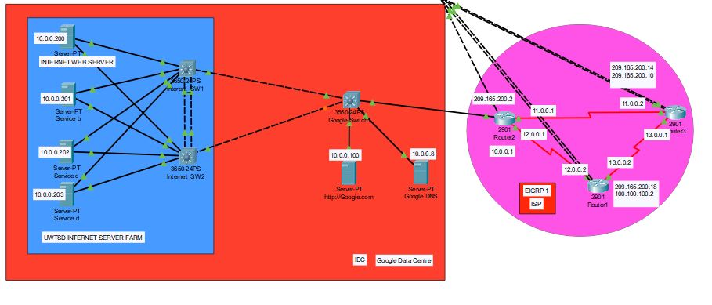
Figure 3 Internet Server Farm within Google IDC (Source: Author)

Remote Access
Since a cloud-based data centre has been designed in this case, data centre management in Malaysia will have to remotely access the data centre through a wider area network (WAN), which is probably the internet. Therefore, all the three main server farms – the DMZ, extranet, and internet server farms – are accessed remotely from Malaysia.

Virtual Private Network (VPN)
The Network & Data Centre designed includes a VPN that allows users in different sites to access the internet privately. A VPN is typically an encrypted connection to the internet. The main aim of including this VPN is to ensure that internet users on all sites can also use the Swansea network to privately and remotely connect to the internet.
Business Continuity Services
Other storage services that should be sought for during implementation include back up storages. Back-up storage is a risk management strategy that aims at ensuring business continuity in the event of a data breach or a data loss.

Implementation

- VLANs have been created for staff, students, admin, VoIP and management departments.
- VPN connection was created between our partners and the main branch on Swansea campus (one sample was configured between London and Swansea).
- OSPF Routing protocol was used to connect between partners and the main campus and to connect to the DMZ zone and the Extranet server farm.
- Security was applied to filter traffic to and from the servers’ rooms.
- Storage services SAN, disk arrays & secondary/backup location.
- One VTP switch server with many switches as client to ease the VLANs management.
- HSRP for redundancy.
- Spanning tree to avoid layer 2 loopbacks.
- EtherChannel has been configured across the core and distribution layers to increase bandwidth.
- Enabling SSH to remote securely and manage all the devices inside and outside Swansea LAN.
- Creating VoIP VLAN to handle voice data with a higher priority across the network.
- NAT to direct the traffic in and out using a pool of public IPs

IP Addressing using VLSM:

Swansea network: 172.16.0.0 /19 Mask 255.255.224.0 (with a total of 8190 IP addresses).
London network: 172.16.32.0 /20 Mask 255.255.240.0 (with a total of 4094 IP addresses).
Lampeter network: 172.16.48.0 /19 Mask 255.255.248.0 (with a total of 2046 IP addresses).
Carmarthen network: 172.16.56.0 /19 Mask 255.255.248.0 (with a total of 2046 IP addresses).

Results/Findings & discussions

To improve and effectively manage a data centre and network, the IT teams in a business need to come up with a well thought and smart network topology, be up to date with the most modern and latest standards and evaluate the impact of technology such as internet of things or cloud services [8]. Data centre and network management is a broad range of processes starting with a flexible topology that will allow for expansion and growth [9]. By coming up with such a topology, the network administrator is able to use any advanced networking features, emerging networking standards and so much more [10].
Network and data centre management can be improved by using a leaf-spine data centre architecture instead of the traditional hierarchical architecture. Leaf-spine design was originally developed to improve the performance when handling the east-west traffic by reducing the number of hops between any two networked devices to one since there is a direct connection to spine switch from each leaf switch [11]. The leaf-spine topology has more advantages such as improved redundancy, improved performance, improved scalability, and supports less expensive fixed-configuration switches and provides a large number of paths between two points. However, using leaf-spine architecture in UWTSD will bring the architecture under pressure because there is a large number of devices connecting at the access layer due to the effect of the internet of things being introduced to the network [12]. The users of the network will be able to connect one or more devices to the network; each device will be capable of generating a large quantity of traffic from tasks and applications such as streaming contents. Also, the use of cloud services will increase network traffic tremendously. To ensure this is controlled, the access layer needs to be properly managed and this can be accomplished by replacing the use of spanning tree protocol with multi-chassis link aggregation (MC-LAG) [2].
The network that has been designed and implemented for the UWTSD spans the main campus, located in the City of Swansea, as well as other campuses and/or partner colleges that are based in Carmarthen, Lampeter, London and Malaysia. As such, the network spans over a very large area. For instance, the distance between Swansea and London is 265 kilometres. To ensure high-speed connections, the IT team should strive to use fibre optic cables instead of copper [13]. This is because fibre cables can support ranges of about 700 feet as compared to copper which only supports a maximum of 330 feet. Moreover, fibre optic cables are still evolving through the use of digital diagnostic monitoring [14].
Network and data centre management can be further improved through the understanding and use of the latest and newest Institute of Electrical and Electronics Engineers (IEEE) networking standards [15]. Understanding the IEEE standards will help to know the type of protocols to follow, understand the media access parameters of control, the hardware specifications, software requirements and cables needed at each point in the network [16]. Once the network standards have been improved, managing workloads in the network and dividing network resources can easily be done by administrators [17]. To increase flexibility, efficiency, and resilience in a network, administrators can choose to use software-defined applications since they use infrastructural management and automated software to define and manage various areas of the network [18]. However, there are four critical aspects of a network management software that an administrator has to keep in mind: fault identification, performance management, network provisioning and maintaining the quality of service (QoS) [19].

Conclusion

Optimising a network and data centre is only possible from the initial stage of the logical and physical design of the network. Designing a network that is flexible and scalable allows for the development of a network that can be further improved through addition of technologies such as Internet of Things which promotes machine to machine communication. The use of readily available cloud services can also promote proper utilisation of the network resources and remote resources to manage less critical tasks and store less critical data. Each of the technologies mentioned above could bring great advantages to the network. However, if the security risks cannot be countered, then the technologies should be avoided [20].

References
[1] N. Kato, I. Bisio, and J. Liu, “Guest Editorial ‘Things’ as Intelligent Sensors and Actuators in the Users’ Context: Processing and Communications Issues,” IEEE Internet Things J., vol. 4, no. 2, pp. 297–298, 2017.
[2] A. Greenberg et al., “VL2: A Scalable and Flexible Data Center Network,” Commun. ACM, vol. 54, no. 3, p. 95, Mar. 2011.
[3] R. Beghdad, “Towards using eigenprofiles for intrusion detection in computer networks,” Comput. Networks, vol. 1286, no. October, 2003.
[4] S. U. Khan and A. Y. Zomaya, “Handbook on data centers,” Handb. Data Centers, pp. 1–1334, 2015.
[5] D. S. Linthicum, “Approaching Cloud Computing Performance,” IEEE Cloud Comput., vol. 5, no. 2, pp. 33–36, 2018.
[6] M. Chiang and T. Zhang, “Fog and IoT: An Overview of Research Opportunities,” IEEE Internet Things J., vol. 3, no. 6, pp. 854–864, 2016.
[7] “Call for Papers: IEEE Cloud Computing Special Issue on Cloud Security House Advertisement,” IEEE Cloud.
[8] "IEEE Internet of Things Journal publication information", IEEE Internet of Things Journal, vol. 2, no. 5, pp. C2-C2, 2015.
[9] "IEEE Cloud Computing Call for Papers: Special Issue on Cloud-Native Applications House Advertisement", IEEE Cloud Computing, vol. 3, no. 6, pp. 23-23, 2016.
[10] E. Elmroth, P. Leitner, S. Schulte, and S. Venugopal, “Connecting Fog and Cloud Computing,” IEEE Cloud Comput., vol. 4, no. 2, pp. 22–25, 2017.
[11] R. Sosan, • Choudhry, and F. Azim, “Mobile Cloud Computing: The Taxonomy and Comparison of Mobile Cloud Computing Application Models,” Wirel. Pers. Commun., vol. 89.
[12] H. Beard, Cloud computing best practices. Brisbane, Australia: The Art of Science, 2010.
[13] M. Khabbaz and C. M. Assi, “Modelling and Analysis of A Novel Deadline-Aware Scheduling Scheme for Cloud Computing Data Centers,” IEEE Trans. Cloud Comput., vol. 6, no. 1, pp. 141–155, 2018.
[14] "IEEE Cloud Computing Special Issue on Cloud Security", IEEE Cloud Computing, vol. 2, no. 5, pp. c2-c2, 2015.
[15] 21st Annual Computer Security Applications Conference. Los Alamitos, Calif.: IEEE Computer Society, 2005.
[16] R. Buyya, C. Vecchiola and S. Selvi, Mastering cloud computing. Waltham, MA: Morgan Kaufmann, 2013.
[17] M. Latapy and W. Willinger, "Complex computer and communication networks", Computer Networks, vol. 52, no. 15, pp. 2817-2818, 2008.
[18] S. Pearson and G. Yee, Privacy and security for cloud computing. Springer, 2013.
[19] B. Dwan, "Computer security", Computer Fraud & Security, vol. 1999, no. 10, p. 19, 1999.
[20] P. Kocovic, R. Behringer, M. Ramachandran and R. Mihajlovic, Emerging trends and applications of the Internet of things.

