

BMSK6001

Emergent Leadership Skills for the Workplace

Student name: Laurentiu Corodescu
Student Number: 2024420
Module Number: BMSK6001
Module Title: Emergent Leadership Skills for the Workplace

Table of Contents
Introduction 3
1. Critically Assessing the Transformational Leadership Theory's Impact on Individual Workplace Performance 4
Comparative Analysis 4
Alignment and Differences 5
Literature review 6
Real-World Examples 7
Strengths and Limitations 8
2. Evaluate your ability to use a range of leadership styles in different situations to fulfil the leadership role. 10
Questionnaire 1 10
Interpretation of the Scores 11
Administrative Skills 12
Interpersonal Skills 12
Conceptual Skills 13
Questionnaire 2 14
Interpretation of the Scores 15
3. Assessing Leadership Skills: Setting Direction, Motivation, Delegation and Empowerment in the Workplace 18
Transformational leadership 18
Application to Real-Life Workplace Situation 18
Situational Leadership - Delegation and Empowerment 19
Application to Real-Life Workplace Situation 19
Conclusion 21
References 22

Introduction
Leadership influences the performance and effectiveness of individuals and organisations in the workplace. Navigating the complexity of managing a diverse workforce and effecting change in the workplace as a leader necessitates a thorough awareness of many leadership models, philosophies and styles. This entails critically reviewing well-known leadership models and theories, assessing one's leadership style and skills and implementing applicable concepts and techniques to inspire and empower others. It is necessary to be capable. This work tests your leadership abilities and competencies in depth, focusing on four main areas: providing direction, inspiring, delegating and empowering. Examining the viewpoints of two important theorists, James McGregor Burns, Paul Hershey and Kenneth Blanchard, reveals how these ideas might influence and improve my leadership practice. James McGregor Burns' transformational leadership philosophy emphasises the significance of creating a compelling vision and encouraging followers to accomplish it. This idea assists me in evaluating my abilities to create direction, convey a clear aim to my team members and encourage them to work together towards a shared goal. The situational leadership theory established by Paul Hershey and Kenneth Blanchard, on the other hand, emphasises the significance of modifying leadership approaches based on followers' preparedness and competency. I will analyse my team member's skills, allocate work properly and assist their growth and development, this model gives insight into my delegation and empowering capabilities.

Critically Assessing the Transformational Leadership Theory's Impact on Individual Workplace Performance

Comparative Analysis
One of the fundamental contrasts between transformational leadership theory and transactional leadership theory is the emphasis and technique to inspire followers (Nawaz and Khan, 2016). Transactional leadership is based on an exchange relationship between the leader and the follower, with incentives and punishments utilised to motivate both parties (Wahyuni, Purwandari and Syah, 2020). This strategy is centred on exchanging prizes for satisfying specific performance requirements. Transformational leadership, on the other hand, is concerned with inspiring and motivating followers via visionary leadership, intellectual stimulation, personal attention and ideal influence. Transformational leadership focuses on developing a common vision, setting high standards and pushing followers to go beyond self-interest and towards the organization's collective goals (Hawkins, 2021). It promotes a feeling of purpose and meaning in followers, encouraging them to build strong commitment and intrinsic drive. Transformational leaders may build a supportive and inspiring work environment that improves individual performance in the workplace by appealing to their followers' higher ideas and beliefs. Transactional leadership, on the other hand, operates on a contingent reward system, in which followers are driven by the promise of a reward or punishment dependent on their performance. This method is transactional since it focuses on establishing expectations, creating goals and rewarding or punishing depending on performance results. While interactive leadership is excellent at keeping day-to-day operations running smoothly and ensuring compliance, it does not allow individuals to go above and beyond job requirements to attain their full potential.
The focus changes to the adaptability and flexibility of leadership techniques when comparing transformational and situational leadership. According to situational leadership, effective leadership is dependent on changing the leadership style to the unique scenario and level of preparedness of the followers (ISAAC, 2019). This emphasises the significance of aligning leadership behaviour to individual followers' developmental needs and capacities. Transformational leadership, on the other hand, is distinguished by a consistent leadership style that focuses on inspiring and encouraging followers to attain better levels of performance.

Alignment and Differences
Understanding the compatibility and contrasts between transformational leadership and other approaches is critical to understanding transformational leadership's influence on workplace performance. Transformational leadership is concerned with inspiring and motivating followers via a variety of means. One of the pillars of transformational leadership is visionary leadership, which conveys a compelling vision and encourages people to strive for it (Manu, 2022). This supports the notion that people who have a strong sense of purpose and direction are more likely to be engaged and perform well.
Intellectual stimulation is another part of transformative leadership. Leaders that engage in thought stimulation boost their followers' creativity, critical thinking and problem-solving. Leaders drive innovation and growth by encouraging employees to think outside the box and experiment with new ideas. This correlation between transformative leadership and individual performance is visible in the workplace, where intellectually stimulated people are more likely to provide new solutions and achieve great outcomes.
Individual attention is also an important component of transformative leadership. Leaders who pay attention to their followers' needs, interests and professional growth demonstrate a genuine interest in their followers' needs, interests and professional development. Leaders can build a supportive and inspiring work atmosphere by recognising and respecting each person's unique skills and objectives. Employees who feel appreciated and supported exhibit higher levels of job satisfaction, dedication and loyalty as a result of this connection between transformative leadership and workplace performance.
Transactional leadership, on the other hand, is based on active management through dependent incentives and exclusions (Khan and Nawaz, 2016). Setting explicit expectations, rewarding or punishing depending on performance and acting only when deviations occur are all part of this method. Interactional leadership is useful in some contexts, but it may not encourage as much engagement and commitment as transformational leadership. While transactional approaches primarily emphasise extrinsic motivation through rewards, transformational leadership encourages employees to connect with greater aims and embrace personal growth.
These distinctions have important practical ramifications. Transformational leadership has been shown to have a more profound and long-term influence on workplace performance than transactional leadership (Afsar et al, 2017). A transformational strategy enables employees to be self-motivated, take ownership of their job and contribute to the organization's success. In contrast, transactional techniques focus mostly on extrinsic rewards, which may result in short-term compliance but not long-term performance increases.
Understanding the similarities and contrasts between transformational leadership and other methods may assist organisations in making educated judgements regarding leadership practises and strategies. Transformational leadership provides a more complete and empowering approach to leadership, resulting in enhanced individual performance in the workplace, higher levels of employee engagement and ultimately, organisational success.

Literature review
The literature on transformational leadership and workplace performance sheds light on the influence of this leadership style on individual performance. Some research on the link between transformational leadership and employee factors such as work happiness, organisational commitment and performance has been done.
According to Abelha, Carneiro and Cavazotte, (2018), there is a positive relationship between transformational leadership and work happiness. Employees who consider themselves transformational leaders have greater levels of job satisfaction because transformational leaders create supportive and exciting work environments that encourage employee well-being and contentment. These data imply that transformative leadership increases overall employee work satisfaction, which can improve employee engagement and performance.
Another key consequence explored in connection to transformative leadership is organisational commitment. As per the journal of Cilek (2019), transformational leaders have a major influence on enhancing staff loyalty to the organisation. Loyalty, congruence with the organization's values and aims, and a desire to go the additional mile to achieve shared goals characterise this commitment. Transformational leaders build a feeling of purpose in their people, create a vision that resonates with them and leads to a better connection and dedication to the organisation.
According to the author Crowley (2022), the impact of transformative leadership on employee performance has received much attention. Individual success is regularly linked to transformative leadership. Transformational leaders encourage and motivate their employees to go above and beyond their assigned duties, to strive for perfection and to constantly improve their performance. Transformational leaders foster an environment that encourages better levels of employee performance via personal attention, intellectual stimulation and high standards.

Real-World Examples
Real-life examples are critical in assessing the influence of transformational leadership theory on workplace performance. It may gain tangible proof of the theory's usefulness and learn how it leads to practical benefits by reviewing case studies of leaders who have successfully utilised it effectively.
Steve Jobs, the founder of Apple is one such persuasive example. Jobs, known for his visionary leadership style, embrace the ideals of transformational leadership. He had a clear vision for Apple goods and was able to inspire and encourage the team to bring that vision to reality. He established a culture of innovation and quality at Apple, producing ground-breaking devices such as the iPhone and iPad, thanks to his charismatic and visionary leadership (Bloom and Rhodes, 2018). Jobs' capacity to inspire individuals and help them attain their full potential highlights the influence of transformational leadership on individual performance in the workplace.
Indra Nooyi, the former CEO of Pepsi, is another noteworthy example. Nooyi's leadership style was distinguished by his ability to motivate and encourage his subordinates. He advocated for diversity and an inclusive work atmosphere and he pushed his team members to take chances and question the status quo (Hallenbeck, 2017). Pepsi has enjoyed great development and success during his leadership. Nooyi's transformational leadership style inspires people to think creatively, take responsibility for their job and contribute to the organization's overall success.
These examples demonstrate how transformational leadership may improve workplace performance by motivating colleagues, encouraging creativity and establishing a sense of purpose and shared vision. Individuals may link to their own job experiences and judge the relevance and applicability of the theory to their conditions by analysing these real-world scenarios.
While these instances highlight transformational leadership's success, it is crucial to emphasise that it is not a one-size-fits-all strategy. Many elements influence the effectiveness of this leadership style, including organisational culture and the leader's capacity to communicate, motivate and accept followers. Individuals must thus analyse their workplace dynamics thoroughly and determine how to apply transformational leadership ideas to increase individual performance and achieve beneficial organisational outcomes.

Strengths and Limitations
Strengths
- Increased employee motivation: One of transformational leadership theory's primary assets is its capacity to inspire and encourage people (Arif and Akram, 2018). Transformational leaders are adept at developing a compelling vision and communicating it in ways that are appealing to their followers. This shared vision connects employees' work to a larger purpose, which increases motivation and commitment.
- Enhanced employee commitment: Transformational leaders foster in their employees a sense of trust, respect and appreciation (KHAN and ISMAIL, 2017). Establish deep bonds with team members by exhibiting high levels of integrity and ethical behaviour. This fosters loyalty and devotion in leaders and organisations.
- Encouragement of innovation and creativity: Transformational leaders foster an innovative culture by encouraging workers to think creatively, question the status quo and strive for continual progress. It encourages critical thinking and seeks out varied viewpoints to stimulate cognition, resulting in new ideas and enhanced production.
Limitations
- Dependency on leader attributes: The efficacy of transformational leadership is heavily dependent on the characteristics of the leader such as personality and vision (Buil, Martínez and Matute, 2019). These attributes are not innate in all leaders and cultivating them can require time and effort. Because of this constraint, the theory's influence on workplace performance may vary depending on the skills of the leader.
- Contextual influences: Transformational leadership efficacy may be impacted by a variety of situational elements, including organisational culture, industry standards and country culture (Crede, Jong and Harms, 2019). Cultural variations, for example, might impact followers' adoption of transformative leadership techniques.
- Potential for burnout: Transformational leaders frequently devote a significant amount of time and energy to engaging and motivating their followers. This degree of commitment may result in increased effort and fatigue for leaders. Furthermore, followers may become overly reliant on leaders for advice and decision-making, stifling their growth and independence.

Evaluate your ability to use a range of leadership styles in different situations to fulfil the leadership role.

Questionnaire 1
Leadership Skills Questionnaire
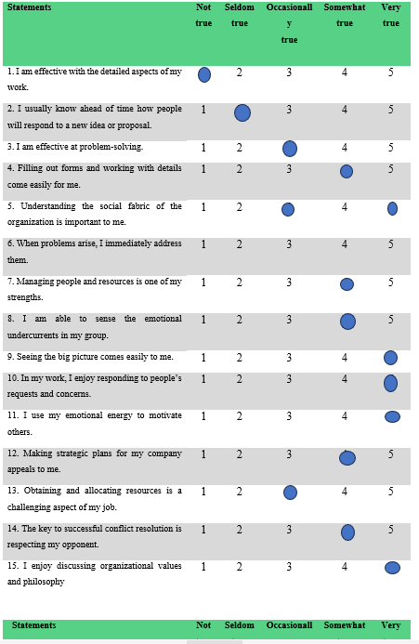
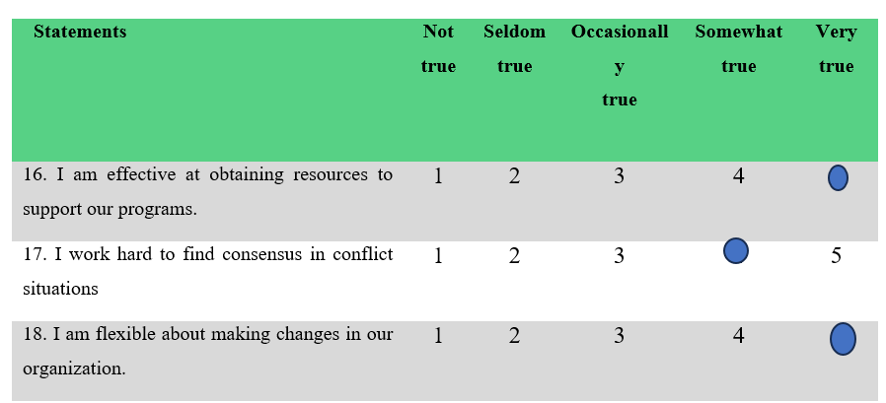
Total Scores
Administrative skill: _______22___________
Interpersonal skill: _________24___________
Conceptual skill: ____________25_________

Interpretation of the Scores
The analysis of the leadership skills questionnaire scores reveals that I have high leadership abilities in management, interpersonal interactions and conceptual thinking. A high score in all three categories suggests the capacity to efficiently manage tasks, resources and professional relationships. This also implies that they are adept at comprehending the larger organisational picture and establishing strategic strategies. These scores show that I have acquired a well-rounded skill set that allows me to flourish in several leadership roles. A strong management skills score demonstrates your ability to deal with details, handle issues and successfully manage resources. Interpersonal skills that are strong exhibit the capacity to grasp social dynamics, recognise emotions and effectively respond to individual needs and concerns. Finally, my strong conceptual skills score demonstrates my talent for big-picture thinking, strategic planning and behavioural alignment with organisational principles. These interpretations emphasise my leadership abilities and give me a solid basis upon which to grow. Using these abilities enables us to continue assisting our team and organisation in their success while concentrating on additional growth in areas that require it.
Now, I will critically reflect on my questionnaire answers and compare them with my real-life experiences in the workplace to gain deeper insights into my leadership styles.

Administrative Skills
According to the questionnaire results, I have excellent administrative abilities, notably in dealing with job details and managing people and resources. These findings are consistent with my experience in leadership jobs where I have been competent in project management, paying attention to detail and completing assignments. Effective detail work indicates my ability to focus on specific tasks, rigorously follow processes and maintain a high level of precision. This ability is required to guarantee that have all of the knowledge I need and that I do jobs efficiently. It also assists me in keeping my team or organisation organised and structured (Sarla, 2020). Furthermore, it exhibits proficiency in managing people and resources, as well as the capacity to efficiently organise and distribute resources, assign responsibilities and assure team member productivity. I excel at coordinating efforts, inspiring others and maximising my team's combined potential. This capacity to manage people and resources efficiently helps to project success and the attainment of organisational goals. It is crucial to remember, however, that there is always opportunity for development. While I am excellent at handling details and managing my personnel, I am aware that I need to increase my ability to acquire and allocate resources. This part of managerial skills necessitates a deliberate strategy to find and secure the program's resources. By concentrating on this specific talent, I improve my capacity to obtain the proper resources, optimise their usage and assure the success of my projects and efforts. Look for training and professional development options in resource management, financial planning and budgeting to help me to enhance my management abilities. Participating in collaborative initiatives and seeking advice from experienced mentors and peers may also give useful insights and ideas for optimal resource allocation.

Interpersonal Skills
According to the questionnaire's findings, I have strong interpersonal skills that help me develop good relationships at work. Understanding an organization's social structure is crucial to me since it helps me to efficiently traverse dynamics and cultures (De Janasz, Dowd and Schneider, 2019). We may address underlying problems and help team members on a personal and professional level by recognising emotional fluxes within the group. Responding to people's wants and worries is my speciality and I like being around and assisting others. This empathy and support skill helps to a peaceful and helpful work atmosphere. Furthermore, appreciating multiple points of view and keeping open communication helps to build an inclusive and active participation culture. The questionnaire does, however, demonstrate that there is potential for development when it comes to reaching a consensus in contentious circumstances. While I place a premium on courteous dispute resolution, I also value the development of skills for compromising and reaching mutually beneficial solutions. This entails attentively listening to all sides, looking for common ground and employing good negotiating skills. It may contribute to a harmonious and productive work environment by improving my capacity to resolve disputes and establish a compromise. Look for training and workshop programmes that focus on dispute resolution and negotiation to help me improve my interpersonal skills. Participating in role-playing exercises and soliciting feedback from coworkers and superiors can also give useful information about areas for growth.

Conceptual Skills
Leaders must have conceptual talents, which include the capacity to think strategically, analyse difficult circumstances and anticipate an organization's future path. My questionnaire result indicates that I have an exceptional ability for conceptual thinking and strategic planning. I have a natural desire to view the broad picture and like establishing a long-term business strategy. In my professional experience, I have been involved in the analysis of market trends, the conduct of industry research and the identification of growth possibilities (Ravitch and Carl, 2019). I can now see the full picture and make educated decisions that match the aims of my organisation. Our conceptual thinking capacity also allows us to foresee prospective obstacles and proactively change our techniques to traverse a changing environment. Furthermore, I enjoy sharing the organization's beliefs and principles since they serve as a firm basis for decision-making and drive the team's activities. Aligning our actions with common values produces a strong feeling of purpose and organisational togetherness. However, it is critical to recognise that conceptual skills extend beyond individual thinking and planning. Effective leaders must also include people in the conceptualization process and consider many points of view. Collaboration and inclusive decision-making result in more imaginative ideas and a sense of belonging among team members. It is critical to foster an environment in which individuals feel safe sharing their views and questioning the status quo. I can actively seek chances for cooperation to further improve conceptual abilities, such as including important stakeholders in strategy conversations and asking for input from team members.

Questionnaire 2
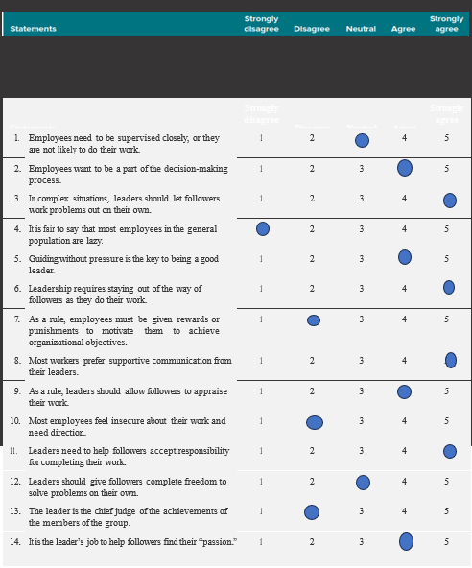
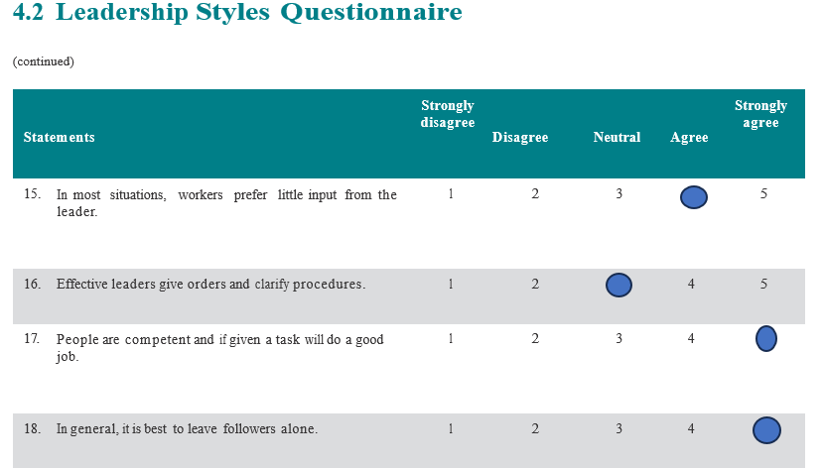
Total Scores
Authoritarian Leadership 11
Democratic Leadership 27
Laissez-Faire Leadership 26

Interpretation of the Scores
Authoritarian Leadership: 11 falls in the low range (11-15).
Democratic Leadership: 27 falls in the high range (21-25).
Laissez-Faire Leadership: 26 falls in the high range (21-25).
According to the questionnaire findings, my leadership style goes towards a mix of democratic and free methods, with less emphasis on authoritarian leadership. This demonstrates a desire for incorporating team members in decision-making, offering non-obligatory direction and encouraging open communication (Parés, Ospina and Subirats, 2017). Adopting these techniques can help to empower and motivate individuals, stimulate active involvement and foster a healthy work atmosphere. To effectively adjust my approach to new settings, it is critical to continuously refine my leadership abilities by seeking feedback and exploring alternative theories.
The findings from the questionnaire show that I have a significant preference for democratic leadership, as seen by my score of 27 in the democratic leadership category. This style corresponds to my idea that workers want to be involved in decision-making and that their thoughts and opinions are vital in accomplishing organisational goals. As a democratic leader, I understand the significance of fostering a friendly and inclusive work atmosphere. I value my team members' ideas and opinions and I promote open communication and active engagement in decision-making. Employee participation in decision-making exhibits trust in their skill and experience, as well as encourages ownership and commitment among team members. One of the most significant advantages of democratic leadership is that it increases employee involvement and motivation. Employees are more likely to be optimistic and interested in their job when they believe their opinions are heard and their ideas are respected. I utilise their creativity and problem-solving talents by actively including them in decision-making, which leads to unique solutions and increased performance. Furthermore, democratic leadership contributes to the development of strong relationships and great work culture. It creates an environment where individuals feel safe to speak their thoughts, seek feedback and work together towards common goals by encouraging open communication and cooperation. It encourages collaboration, trust and mutual respect among team members, which boosts morale and job satisfaction. It is crucial to highlight, however, that democratic leadership is not suited to every context. A more prescriptive approach may be necessary when speedy decision-making or clear direction is required. As a leader, I must analyse each circumstance and adjust my leadership style accordingly. This adaptability enables us to embrace the benefits of democratic leadership while also acknowledging the necessity for alternate ways when they are required. To build my democratic leadership style, I may continue to improve my communication and facilitation abilities. Actively listening to and soliciting ideas from team members, as well as generating chances for cooperation are critical components of democratic leadership. Furthermore, soliciting input from team members and reflecting on their experiences gives useful insights for improving leadership effectiveness.
A Laissez-Faire leadership style score of 26 suggests that I tend to allow my team members freedom and independence. This approach demonstrates faith in the talents and capacities of team members, as well as belief in their capacity to make decisions and handle problems on their own (Ahsan and Khalid, 2023). I seek to empower team members and create an atmosphere that supports creativity, innovation and personal growth by taking a hands-off approach. One of the advantages of laissez-faire leadership is that it encourages individual liberty and autonomy. Giving team members the flexibility to experiment with their ideas and techniques increases their sense of ownership and responsibility for their job. As individuals feel trusted and respected in their roles, this may lead to improved motivation, work satisfaction and engagement. Furthermore, a laissez-faire attitude fosters creativity and innovation in the team. Giving individuals the freedom to think outside the box and experiment with new ideas opens up possibilities for new views and solutions. This can help to strengthen problem-solving skills and provide novel alternatives that might not have evolved under a more restricted leadership style. However, it is crucial to recognise that the laissez-faire approach has potential drawbacks. Independence is vital, but it risks causing uncertainty and a lack of direction in the team. People may feel unsure about their tasks and responsibilities if they are not given clear advice and assistance, resulting in decreased productivity and cohesiveness. As a leader, I must find a balance between granting independence and ensuring that team members have the resources, direction and support they require to fulfil their jobs effectively. Furthermore, the laissez-faire approach is not applicable in all settings and team dynamics. Some people, particularly those working on high-risk or difficult projects, require more structure and guidance to function best. Assessing team members' strengths and requirements and altering leadership styles accordingly, is critical to ensuring team member success and achieving organisational goals.
According to the questionnaire's findings, I have a low authoritarian leadership score, suggesting a desire for a more collaborative and inclusive style. While some situations necessitate explicit leadership, I believe in empowering team members and encouraging individuality and responsibility. Authoritarian leaders tend to have greater control over decision-making and close monitoring of their subordinates (Tang and Tang, 2019). They give clear directions, establish strong rules and expect team members to adhere to them. While this attitude might be useful in some instances, such as dealing with crises or inexperienced team members, it can limit your ability to be creative, collaborate and innovate. However, because I have a less authoritarian personality, I prioritise developing collaborative work settings in which employees are encouraged to voice their opinions, explore ideas and participate in decision-making. I embrace varied opinions and feel that including team members in decision-making leads to better outcomes and a deeper sense of responsibility. We hope to foster an atmosphere of trust, mutual respect and open communication by adopting a more democratic leadership style. This strategy promotes a sense of empowerment in team members, allowing them to actively share their skills and contribute to the team's overall success. I believe in offering advice and assistance without exerting unnecessary control, allowing individuals to grow their talents, make autonomous decisions and take ownership of their work.
It is vital to remember that effective leadership necessitates the capacity to change styles dependent on the scenario and the demands of the team. In my approach, a democratic and free-flowing leadership style is more typical, but there are occasions when a more dominating or authoritative approach is required, such as during a crisis or when a specialised direction is required. Looking back on my own work experiences, I saw that my leadership style corresponded well with the survey replies. I've discovered that incorporating teams in decision-making, offering non-pressure advice and encouraging open and collaborative communication all produce excellent results. Implementing democratic and open leadership practices has resulted in greater employee engagement, motivation and innovation. Seeking input from team members, peers and superiors can help me improve my leadership abilities. Their insight into the efficacy of my leadership style and areas for growth is invaluable. Exploring various leadership theories and models, such as situational leadership and servant leadership, will further widen my understanding and help me to adapt the style to different situations and individuals more successfully.

Assessing Leadership Skills: Setting Direction, Motivation, Delegation and Empowerment in the Workplace

Transformational leadership
The transformational leadership theory of James McGregor Burns emphasises the significance of having a clear direction for the team. Transformational leaders comprehend their organization's mission, values and long-term ambitions (Omar, 2017). They develop a captivating vision that inspires and encourages their followers to strive towards making it a reality. Transformational leaders foster a feeling of shared purpose and dedication by effectively expressing this vision and aligning teams with it. In my leadership capacity, I have attempted to define a clear course for the team. When faced with a challenging project, for example, I develop explicit goals and milestones to explain the intended outcome and plan. I conveyed my vision and discussed the significance of the project and its synergy with our organization's larger objective. This aided in the formation of a shared understanding and commitment among team members.

Application to Real-Life Workplace Situation
I can evaluate my capacity to manage various job situations. For example, I oversaw the implementation of a new customer relationship management system with a cross-functional team. The system's goals and advantages were specified and the system's path was determined, with an emphasis on boosting customer happiness and simplifying operations. I inspired the team to accept change and actively contribute to its success by successfully expressing the vision.
I arranged a series of meetings and workshops to discuss the aims, benefits and potential problems of deploying a new CRM system to set the path for this project. To be competitive in the market, I emphasised the significance of boosting customer satisfaction and optimising operations. I encouraged team members to realise the importance of their participation in reaching the intended goal by expressing a clear vision. Furthermore, I promoted open communication, requested input from team members and ensured that their perspectives and ideas were taken into account when setting direction. The team felt a feeling of ownership and dedication as a result of this collaborative approach. I ensured that everyone was on the same page about the project and knew how their efforts fit into the overall picture through regular communication and updates.
Reflecting on this experience, I realised that establishing clear direction required not only a thorough grasp of the organization's objectives but also good communication and interaction with team members. It is critical to develop a common vision and motivate people to actively engage in its realisation. This experience demonstrated the value of clarity, inclusivity and good communication in guiding and encouraging teams towards common goals. I was able to provide a compelling direction for my team and drive them to attain the necessary outcomes by utilising the transformational leadership concepts outlined by James McGregor Burns. We also recognise the need for continual growth and learning in this area, because effective direction-setting is a dynamic process that necessitates flexibility and responsiveness to changing conditions.

Situational Leadership - Delegation and Empowerment
The situational leadership theory developed by Paul Hershey and Kenneth Blanchard gives great insight into delegation and empowerment. According to this theory, effective leaders should tailor their leadership style to their subordinates' preparedness and talents. Rather than using a rigid approach, leaders should analyse their team members' competency and trustworthiness and distribute work accordingly (Alaimo, 2022). Leaders may empower individuals in this way to create growth and development. I believe in situational leadership concepts and recognise that various team members have varying levels of competency and preparation. Rather than approaching delegation in a one-size-fits-all manner, I thoroughly examine each team member's talents before allocating a job. Delegate more complicated work to employees with experience and aptitude and provide them with autonomy and growth possibilities. This helps people to take ownership of their work and add their knowledge to the project.

Application to Real-Life Workplace Situation
I may use concrete instances from my company to evaluate my delegating and authorisation skills. I just recruited a new team member who had no prior experience in a certain area. Rather than monitoring technicalities or avoiding delegation, I selected a supportive leadership approach that was suited to their developmental requirements. In this case, I offered clear directions, training, and resources and I regularly watched their development. I was always accessible to answer inquiries and offer advice as necessary. My objective was to gradually increase their confidence and competence by offering help and reassurance. I steadily raised my team members' duties as they acquired experience and developed their talents. This enabled them to engage freely and complete activities requiring a greater degree of ability and competence. They were able to enhance their skills and contribute to the project's success because of this step-by-step authorisation. Reflecting on this experience, I realised that effective delegation needs not just an awareness of a person's talents, but also a commitment to encourage and create a safe environment for growth. By integrating my board approach with the situational leadership model, I was able to create an atmosphere that supported team members' growth and made them feel empowered and respected.

Conclusion
Finally, the assessment of my leadership skills, such as creating direction, inspiring people, delegating and empowering, offered significant insight into my leadership effectiveness. I discovered the main ideas and frameworks that underpin these leadership talents by critically reviewing the theories of James McGregor Burns on transformational leadership and Paul Hershey and Kenneth Blanchard on situational leadership. A questionnaire assessment of my leadership style revealed a significant predisposition towards a democratic and free approach, with a comparatively low tendency towards authoritarian leadership. This demonstrates a preference for encouraging cooperation, inclusivity and autonomy among team members, as well as an emphasis on member trust and empowerment. I was able to apply these ideas to real-world settings and analyse the influence of my leadership skills in making a change in the workplace by reflecting on real-life workplace instances. Setting a compelling vision, inspiring and encouraging team members, allocating work effectively and empowering employees have all resulted in great outcomes in terms of improved engagement, performance and team growth. However, as a leader, I must always strive to develop and adapt. Knowing your strengths and areas for development allows me to effectively advise, encourage, delegate and empower others to effect significant change in your workplace.

References
Abelha, D.M., Carneiro, P.C.D.C. and Cavazotte, F.D.S.C.N., (2018). Transformational leadership and job satisfaction: Assessing the influence of organizational contextual factors and individual characteristics. Revista Brasileira de Gestão de Negócios, 20, pp.516-532.
Afsar, B., Badir, Y.F., Saeed, B.B. and Hafeez, S., (2017). Transformational and transactional leadership and employee’s entrepreneurial behaviour in knowledge–intensive industries. The International Journal of Human Resource Management, 28(2), pp.307-332.
Ahsan, M.J. and Khalid, M.H., (2023). Laissez-Faire Leadership. In Leadership Approaches in Global Hospitality and Tourism (pp. 61-72). IGI Global.
Alaimo, C.J., (2022). Bold Leadership. In HR Leadership During Bankruptcy and Organizational Change: A Practical Guide (pp. 55-62). Cham: Springer International Publishing.
Arif, S. and Akram, A., (2018). Transformational leadership and organizational performance: the mediating role of organizational innovation. SEISENSE Journal of Management, 1(3), pp.59-75.
Bloom, P. and Rhodes, C., (2018). CEO society: The corporate takeover of everyday life. Bloomsbury Publishing.
Buil, I., Martínez, E. and Matute, J., (2019). Transformational leadership and employee performance: The role of identification, engagement and proactive personality. International journal of hospitality management, 77, pp.64-75.
Cilek, A., (2019). The Effect of Leadership on Organisational Commitment: A Meta-Analysis. Cypriot Journal of Educational Sciences, 14(4), pp.554-564.
Crede, M., Jong, J. and Harms, P., (2019). The generalizability of transformational leadership across cultures: A meta-analysis. Journal of Managerial Psychology.
Crowley, M.C., (2022). Lead from the heart: Transformational leadership for the 21st century. Hay House, Inc.
De Janasz, S., Dowd, K. and Schneider, B., (2019). Interpersonal Skills in Organizations, 6e.
Hallenbeck, G., (2017). Lead 4 Success: Learn the essentials of true leadership. Center for Creative Leadership.
Hawkins, P., (2021). Leadership team coaching: Developing collective transformational leadership. Kogan Page Publishers.
ISAAC, M.L., (2019). SITUATIONAL LEADERSHIP IN THE BOOK OF SAMUEL. Journal of Biblical Perspectives in Leadership, 9(1), pp.168-177.
Khan, I. and Nawaz, A., (2016). The leadership styles and the employees performance: A review. Gomal University Journal of Research, 32(2), pp.144-150.
KHAN, S.A. and ISMAIL, W.K.W., (2017). To evaluate the impact of transformational leadership on organizational learning. CLEAR International Journal of Research in Commerce & Management, 8(9).
Manu, A., (2022). Transformational Leadership. In The Philosophy of Disruption (pp. 67-77). Emerald Publishing Limited.
Nawaz, Z.A.K.D.A. and Khan, I., (2016). Leadership theories and styles: A literature review. Leadership, 16(1), pp.1-7.
Omar, H.O., (2017). Transformational leadership in quality management. University of Montana.
Parés, M., Ospina, S.M. and Subirats, J. eds., (2017). Social innovation and democratic leadership: communities and social change from below. Edward Elgar Publishing.
Ravitch, S.M. and Carl, N.M., (2019). Qualitative research: Bridging the conceptual, theoretical, and methodological. Sage Publications.
Sarla, G.S., (2020). Leadership Lessons. NOLEGEIN-Journal of Leadership & Strategic Management, 3(2), pp.1-5.
Tang, K.N. and Tang, K.N., (2019). Leadership styles and organizational effectiveness. Leadership and change management, pp.11-25.
Wahyuni, N.P.D., Purwandari, D.A. and Syah, T.Y.R., (2020). Transactional leadership, motivation and employee performance. Journal of Multidisciplinary Academic, 3(5), pp.156-161.

