
Skills for the Workplace
Module Assignment Submission
Student Name: | Kirsty Alison Matthews
Student Number: | 2105827
Module No: | BMSK4005
Module Title: | Professional Career Development

Statement of Confirmation of Authenticity
By the act of making this submission, the student declares that this is the work of the student named above. The work has not, in whole or in part, been knowingly presented elsewhere for assessment, or where assessment has been built on a previous assessment, this has been identified. Where materials have been used from other sources it has been properly acknowledged. If this statement is untrue, the student acknowledges that an assessment offence has been committed.
Attention is drawn to the plagiarism and unfair practice policies of both the University and of ILM.

Table of Contents
Section 1: Know how to identify development needs 3
1.1 Identify learning styles for self and another 3
1.2 Use a simple technique for identifying development needs for self & another 4
1.3 Identify potential barriers to learning for self and another. 5
1.4 Explain how these barriers to learning can be overcome. 6
Section 2: Know how to develop self & others to achieve organisational objectives 6
2.1 Analyse learning/development options to meet needs of self & another. 6
2.2 Identify support mechanisms for the development of self & another 6
2.3 Prepare development plans for yourself and another person 7
2.4 Method used to monitor the development of self & another. 8
Section 3: Know how to prepare for the recruitment process 8
Reflection on the recruitment process 8
3.1 Description 8
3.2 Feelings 9
3.3 Evaluation 9
3.4 Analysis 9
3.5 Conclusion 9
3.6 Action Plan 9
References 10
Appendix A 10
Appendix B 10
Appendix C 10
Appendix D 10

Section 1: Know how to identify development needs

Throughout this assignment I will be identifying and discussing various methods to identify my own and other peoples learning styles and abilities, I will also be looking at how other people identify their own strengths, weaknesses, opportunities, and threats when it comes to there own personal development once all these have been identified I will look at how weaknesses can be overcome and turn these into a strength. I will also be looking at how people plan their career future development and aspects. Finally, I will find an application form for my self to fill in which I believe is well suited to me. I will then analyse the application form and discuss any improvements in which I think there may be. Hopefully this will help me in the future with any job applications I have to work with.

1.1 Identify learning styles for self and another

There are number of different ways that have been developed that we can use to identify our learning styles, this can be done by using numerous of self-assessment questionnaires for example: - VARK of VARK fleming (1987). And Honey, P. and Mumford, A. (1986b) Learning Styles Questionnaire, Peter Honey Publications Ltd. both of these can identify a person learning styles, needs, strengths and weaknesses, I have used both these methods on my self and another to identify our learning styles and needs, and our strengths and weaknesses.
I have used two simple techniques to identify learning styles for myself and another the first is the VARK questionnaire.
These are the vark questionnaire learning styles where you can understand the different types of learning styles of people. VARK - A Guide to Learning Styles. 2021. VARK Learning Style Questionnaire. [online] Available at: <https://vark-learn.com/the-vark-questionnaire/> [Accessed 23 November 2021]. (VARK Learning Style Questionnaire, 2021)
TDTC. 2021. Honey and Mumford Learning styles. [online] Available at: <https://tdtc.co.uk/honey-and-mumford-learning-styles/> [Accessed 1 December 2021].
- Learning styles | - Factors
- Visual | - Where people find it easier to learn through pictures, graphs, videos ect
- Aural | - Where people find it that they learn best by listening
- Read/write | - Where people find it best to learn if they read and write things down.
- Kinaesthetic | Where they are active learners where they prefer to be physical/hands on

My results from this questionnaire were:
- Visual 3
- Read/Write 11
- Kinaesthetic 11
- Aural 11
Which suggest I learn best by reading things and writing them down/taking notes, listening and being active and hands on.
The second one is the honey and mumford questionnaire.
The results from the honey & mumford learning styles suggest that iam a
Theorists’ strengths are in building a concept or theory on the basis of their analysis.
They are good at integrating different pieces of information and building models on the way things operate. They may choose to start their learning by reading around a topic. Theorists will see their role as strongest at the ‘REVIEW and EVALUATION’ stage of the learning cycle
lMy score was 42.

For Beck I have also used the same techniques to identify her learning styles first Is the Vark questionnaire where becky’s results were she is best at aural learning.
And on the honey and mumford questionnaire she was a
Reflector:- are much better at listening and observing. They are effective at reflecting on their own and others’ experience and good at analysing what happened and why. In terms of the learning cycle, reflectors are seen as those who perform well in the ‘MONITOR’ role above all else.

1.2 Use a simple technique for identifying development needs for self & another
SWOT Person 1

STRENGTHS  - I am a people person  - I have good customer skills  - I learn best by asking lots of questions and discussing things.  - I am good at time keeping / managing  - I am currently multi skilled so I am good at multitasking.  - I am good at working alone or as part of a team. | WEAKNESSES  - I don’t like public speaking  - I get anxious presenting in front of small or large groups  - Visual learning, I get board quite quickly while watching videos unless they are interesting.  - I always doubt myself and don’t have the confidence that I am doing things right
OPPORTUNITIES  - I am currently employed by TSB bank I would like to try and over come my weaknesses and be able to apply for a managers roll in managing a small team at the contact centre but not having the confidence or knowledge to be able to apply for this role.  - Public speaking  - Enjoy visual learning | THREATS  - I get easily distracted and don’t have enough confidence in myself that I have the knowledge that everyone else has in the same role.  - Competition with other co workers  - Child care issues  - Health anxiety and type 1 diabetic.

SWOT Person 2

STRENGTHS  - I like to be organised be on time  - I am a good listener  - I like to discuss and talk things through  - I am a quick learner and like to make sure I complete all tasks that are given to me to meet the dead line.  - I have got 10 years experience in retail so I am good at working on my own and as part of a team  - Rearly jump to conclusions  - Transferable skills | WEAKNESSES  - I tend to be too cautious and not take risks  - I can be quite hard on my self and stress and get myself worked up about the situation  - Not the best at multi tasking, I would rather get one thing done then move on to the next.
OPPORTUNITIES  I am currently working as a cleaner for Swansea city council. I wiukd kike ti see my self in 2 to 3 years as being a supervisor or manager for Swansea city council being in charge of the office side of things and having the confidence to do so.  Great support from friends and family  Underserved markets and specific products | THREATS  Competition from other people applying foe the same job role as you and being too cautious and not taking enough riskd and having the confidence to just jump straight in to it.  Family commitments.

1.3 Identify potential barriers to learning for self and another.

First i have identified potential learning barriers for my self by using the vark questionnaire and off what I feel my weaknesses are and what will potentially stop me from being where I want to be in the next 12 months to 5 years.
Secondly I have used the SWOT analysis to determine what my strengths and weaknesses are and make a plan on how I can turn my weaknesses into strengths for me be able to progress in the future. I feel that my potential barriers to learning are
- Being anxious and not being able to do public speaking or presentation.
- I always doubt myself and don’t have enough confidence to just go for it.
- Visual learning as I get easily distracted while carrying out this style of learning.
- Another potential barrier for myself could be child care with being a single mum too two young children with one being in full time school and the other only being 2 especially when trying find the time to work study and be a parent.
- Work and study life balance
- Being a type 1 diabetic, this will mean I need to take extra breaks through out the day make sure I am in control of my sugars and health and could lead to taking extra days off if not manageable.

Here is where I found some useful information which helped me
Your Bibliography: TalentLMS. 2021. Barriers to Learning & How to Overcome Them With Engagement. [online] Available at: <https://www.talentlms.com/ebook/learner-engagement/learning-barriers> [Accessed 28 November 2021].

I have identified potential learning barriers for becky by using the same method as my self she has under gone a SWOT analysis so we have gathered what she is best as doing and what she is not so good at doing or what will stop her from learning or being where she wants to be in the next 12 months to 5 years
- One of her barriers is mum guilt she is a single mother and is always beating herself up if she is not spending enough time being a motherand having enough time to do so while working and studying and even doing house hold chores, she always finds herself rushing around a lot and overthinking a lot.
- Child care is another one of her barriers it can be difficult for her having to depend on friends and family and not to feel a burden to others
- She is also very cautious and doe4s not like to take risks she would rather sit back and observe, listen and not get involved too much.

1.4 Explain how these barriers to learning can be overcome.

For myself I believe that I can over come my first barrier which is public speaking I can start off by speaking and presenting in front of friends and family then once I feel confident enough in myself to do it in front of colleges and managers.
Same for my second barrier which is doing presentations in front of people again I will be more confident in over coming this by firstly starting off with family and friends and then small groups until I am confident in presenting in front of large groups.
My third potential barrier is visual learning as I prefer to read / write or ask questions I believe I can over come this by looking at more graphs charts and maps to get myself familiar to this type of learning style.
My forth barrier could be childcare that could stop me from learning or being where I want to be, some times this can not be overcome and would need to take time out if unwell but always have someone to take care of them if needs be.
My Fifth potential barrier to learning is work and study/life balance I currently work for part time for TSB and I am struggling to fit everything in with looking after my 2 children under 5 working and studying, I can over come this by getting one thing done at a time I have also spoke to my manager who is willing to help me out with some time off if needs be to study she has been really understanding with me wanting to finish the course and better my knowledge. Also my family are being very supportive with childcare.
And also being a type one diabetic this would mean taking extra breaks to be able to monitor my blood sugars and take insulin. To ensure it is staying in control as if not managed well could lead to time off work and studying.
For Becky’s first barrier which is mom quilt this won’t happen over night but over time she will bounce back and it wont hurt as much she could set aside expectations based on her own personal circumstances. Reserve self-judgement as working mother hood is a very big role in both her and her sons life Becky works to give her son a better life.
Verywell Family
https://www.verywellfamily.com/overcome-working-mom-guilt-4145348

Section 2: Know how to develop self & others to achieve organisational objectives

2.1 Analyse learning/development options to meet needs of self & another.
To analyse learning/ development needs for my self I have undertaken a swot analysis to identify my core strengths, weaknesses, opportunities and threats which leads to fact based analysis, fresh perspectives and fresh ideas. I have undertaken the VARK questionnaire and also the honey and mumford questionnaire to determine how I learn best and what I can improve on and how I can over come my barriers to learning which are stated above in 1.4
As seen in swot analysis above the first option to meet needs for my self is always doubting my self and not having enough confidence, to meet these needs I have agreed with my line manager to do weekly training and quiz’s to answer which she will mark and let me know how I did this will give me more confidence in knowing that I do have the knowledge.
Public speaking and presentation to meet these needs I can practice in front of family and friends and line manager at work and make sure I practice the topic this will give me more confidence to do so.

For becky I have also undertaken a swot analysis, taken the honey and mumford and vark questionnaire to determine what she is best at and what her weak points are and also so see what she can improve on and what learning styles she learns best with and how she can over come her barriesr to learning which are stated above in 1.4.
Lack In confidence to meet beckys needs she can ask for feed back appraisal and rewards as work to left her know she is doing a good job.
Becky also tends to avoid direct participation to meet beckys needs with this she could participate in small groups with family and friends for her to get more confident with the surroundings.
Verywell Family. 2021. 5 Ways to Overcome Working Mom Guilt. [online] Available at: <https://www.verywellfamily.com/overcome-working-mom-guilt-4145348> [Accessed 30 November 2021].

2.2 Identify support mechanisms for the development of self & another
So following on from barriers above in 1.4 to Identify support mechanisms for the development for myself first of all I have under taken swot to determine what I can improve on I have also asked my line manager for regular feed back from customer calls and also a managers perspective for me to be able to keep a chart on how I am developing and what I can do to improve and be the best version of myself., which will mean developing my self as an employee and helping the company growth so we have started doing a, start, stop, continue chart which means start to do things that I am not already doing, stop doing things that don’t sound to great or done work that good and continue doing what I am good at this will happen every 2 weeks to see how I am getting along with it. We have also arranged time out every week for core training and quick quiz time to make sure my knowledge is fresh and up to date in order for me to progress to where I want and need to be. This will also give me the confidence I need as I continuously doubt my self that I don’t know what I am doing.
Another support mechanism I can use for public speaking and presentation so I can develop with this is practice Infront of people I feel comfortable with I must give my self enough time to practice any public speaking or presentation to also feel comfortable with it there is also a free online course that I have found and taken witch I found very helpful the course is designed for both new and professional public speakers who want to eliminate their fear of public speaking and improve on communication skills. Your Bibliography: Play.google.com. 2021. [online] Available at: <https://play.google.com/store/apps/details?id=com.alison.mobile.flutter&hl=en_US&gl=US> [Accessed 30 November 2021].
Hall-Flavin, D. (2011, March 24). How can I overcome my fear of public speaking?. Retrieved from http://www.mayoclinic.org/diseases-conditions/phobias/expert-answers/fear-of-public-speaking/faq-20058416
My last support mechanism is for my anxiety I am a very anxious person and have suffered with anxiety for years and it is not easy to control on a daily basis you have good days and you have bad but I have been reading up and there are some methods I can try to over come this with already being on controlled medication for it. Other ways to over coming it are acceptance, An acceptance-based approach means that you observe the thought you're having without the urgency you might normally feel to address it, fix it, argue with it, or believe it. You are letting it come and go without focusing on it.

Questioning

strategy that can help you change the way you perceive situations and lessen your anxiety. This technique is a cornerstone of a treatment approach called cognitive behavioral therapy (CBT).
Cognitive restructuring offers a way to critically evaluate potentially distorted thoughts.

Exposure

The basic concept of exposure is to lean into anxiety by confronting, rather than avoiding, You learn that nothing terrible will happen, or that bad outcomes are manageable.

Nutrition
Research shows that anxiety levels can be impacted by the kinds of food and drinks you consume. One study observed that participants who consumed more saturated fats and added sugars had higher anxiety levels than those who consumed fewer fats and less sugar

Physical Exercise
Find a way to move your body that feels good—it doesn’t have to be a full work out Taking a long walk for even 10 minutes can help improve your mood

Mindfulness
Other coping strategies you can try to help ease anxiety include practicing techniques such as mindfulness, meditation, deap breathing, and muscle relaxation.
How to snap out f the anxiety cycle and overcome worry verywell minded
https:/www.verywellminnded.com/breaking-the-anxiety-cycle-139298

Learning mechanisms / development for becky is that she has asked for regular feed back on her development from her line manager. Is going to keep completing her core training to make sure she is always up to date with her knowledge around the role. She is going to do this on a monthly basis.

2.3 Prepare development plans for yourself and another person

Part 1: Personal Analysis
See SWOT Analysis in 1.2

Part 2: Setting Goals

What do I want to learn? | What do I have to do? | What support and resources will I need? | How will I measure success? | Target Date for Review
Greater depth of knowledge in managing a team | Attend and Complete higher education for the work skills course | Attend uni every Tuesday | By completing and passing the higher education course | 12 months
Take learning quizzes and core training to learn more depth in the banking industry and managing a team within the banking sector | Make sure my managber agrees time off the phone for me to complete | I will need my manager to give me feed back on how I have done | By completing these every week | This will go on for the next 12 months
Be able to apply and have the confidence to go for a managing roll | Make sure I am completing all learning giving to me keeping up to date with knowledge and changes happing in the banking indistry | My line manager and SME will provide support in helping me be able to do this by letting me practice infront of them | By completing the above and taking on board all good and bad feed back | 12 to 3 years

Part 3: Personal Objectives

Short Term Goals (next 12 months)
In the next 12 months I want to be able to be in a position where I feel confident and have enough knowledge where I can apply to be a team manager at TSB bank contact centre. And to complete and pass the higher education for the work skills course.
Medium Term Goals (2-3 years)
In the next 2-3 years I want to able to manage a team at the contact centre and be given the responsibility to manage both from home and at the office.

Long Terxm Goals (3-5 years)
My long term goal is to be a Senior manager this would give me the responsibility of managing large teams account the telephone banking sites.

2.4 Method used to monitor the development of self & another.
To monitor, record and evaluate my development this will allow me to see how efficient my approach is and gives me data that can help my future development , with work related development I have a number of strategies arranged with my line manager see above in 2.2 these are going to be reviewed every week to two weeks to help monitor my development. To monitor my anxiety I have monthly check ins with the mental health nurse and keep taking my medication provided by the GP and also keep on top of over coming anxiety mechanisms I will monitor this in my monthly review with the mental health nurse.
Public speaking and presentation to monitor my development for this I will practice in front of family friends and my line manager make sure I know what I am taking about when presenting and make my self familiar with the topic, so to manage and monitor all I will keep a development log for each topic and review on a weekly to monthly basis to see how I am progressing.
For becky she is going to have regular feed back from her line manager.

Section 3: Know how to prepare for the recruitment process

Reflection on the recruitment process
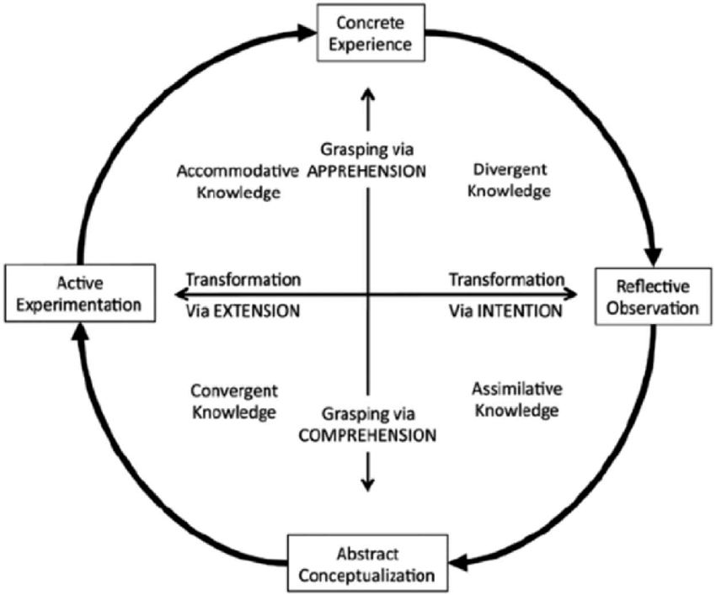 Growth Engineering. 2021. What Is Kolb's Experiential Learning Theory?. [online] Available at: <https://www.growthengineering.co.uk/kolb-experiential-learning-theory/> [Accessed 1 December 2021].
Choose the Refection model you are using and reference it – providing a diagram/image would be a nice touch here

3.1 Description

So the job I applied for was assistant relationship manager in private banking they are a global asset management firm with a strong presence based across Europe Europe with funds in excess of 10 billion with a focus on Equities, Fixed Income, Asset Allocation & Private Banking.
This particular role sits within a small inclusive team in Private Banking reporting into the Head of Private Banking who are looking to recruit a CRM Private Client Assistant with a focused background in Wealth Management.
Day to Day responsibilities include:
- Inputting payments and trades into the system
- Preparing and delivering client packs to relationship managers
- Working closely with the Central File team to ensure a smooth onboarding process
- Assisting the Private client team in assessing suitability for all Private Clients
- Running daily reports and reporting back to the Private Client Team
- Occasional diary management & travel arrangement
Skills/Experience:
- Minimum of 3 years' experience within a client relationship role
- Must have experience supporting teams
- Strong understanding of compliance and AML procedures
- Excellent relationship building skills
- Good communication

3.2 Feelings

When applying for this role I felt very nervous and anxious that I may not be the right candidate for the role.

3.3 Evaluation

I enjoyed creating my cv and cover letter and putting my mind to work to find the right job for me.
As nervous and anxious as I was I am looking forward to the response I have for them weather I get the job or not I now have a little more confidence in being able to come out of my comfort zone.

3.4 Analysis

To analysis this I have applied for a role that I already have a lot of knowledge about but bettering my self at the same time where this is a managers job and a better pay salary which will be a better future for me and my children.

3.5 Conclusion

My conclusion to this piece of work is that Iam now able to write a cv and cover letter without panicking i can come out of my comfort zone and apply for jobs that I want to be able to better myself. I know how I learn best so checking job descriptions to make sure they are going to be the right one for me.

3.6 Action Plan
To keep pushing my self to get my weaknesses and threats to strengths.
To keep updating my cv for any course task I think will improve this.
To keep on top of my development plan and make sure this happens within the time scales.

References

Your Bibliography: Play.google.com. 2021. [online] Available at: <https://play.google.com/store/apps/details?id=com.alison.mobile.flutter&hl=en_US&gl=US> [Accessed 30 November 2021].

Hall-Flavin, D. (2011, March 24). How can I overcome my fear of public speaking?. Retrieved from http://www.mayoclinic.org/diseases-conditions/phobias/expert-answers/fear-of-public-speaking/faq-20058416
Verywell Family. 2021. 5 Ways to Overcome Working Mom Guilt. [online] Available at: <https://www.verywellfamily.com/overcome-working-mom-guilt-4145348> [Accessed 30 November 2021].
VARK - A Guide to Learning Styles. 2021. VARK Learning Style Questionnaire. [online] Available at: <https://vark-learn.com/the-vark-questionnaire/> [Accessed 23 November 2021]. (VARK Learning Style Questionnaire, 2021)
TDTC. 2021. Honey and Mumford Learning styles. [online] Available at: <https://tdtc.co.uk/honey-and-mumford-learning-styles/> [Accessed 1 December 2021].
CIPD. 2021. SWOT Analysis | Factsheets | CIPD. [online] Available at: <https://www.cipd.co.uk/knowledge/strategy/organisational-development/swot-analysis-factsheet> [Accessed 1 December 2021].
Your Bibliography: TalentLMS. 2021. Barriers to Learning & How to Overcome Them With Engagement. [online] Available at: <https://www.talentlms.com/ebook/learner-engagement/learning-barriers> [Accessed 28 November 2021].
Verywell Family. 2021. 5 Ways to Overcome Working Mom Guilt. [online] Available at: <https://www.verywellfamily.com/overcome-working-mom-guilt-4145348> [Accessed 30 November 2021].

How to snap out f the anxiety cycle and overcome worry verywell minded
https:/www.verywellminnded.com/breaking-the-anxiety-cycle-139298
Growth Engineering. 2021. What Is Kolb's Experiential Learning Theory?. [online] Available at: <https://www.growthengineering.co.uk/kolb-experiential-learning-theory/> [Accessed 1 December 2021].

Appendix A

Learning styles results go here
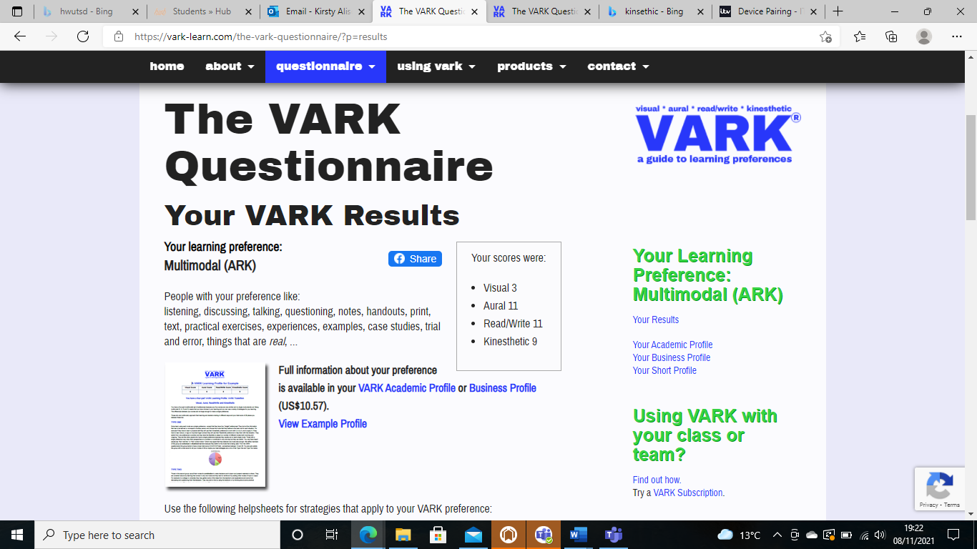

Honey & Mumford’s Learning Styles Questionnaire

No. | Statements | Put Y or N
1 | I have strong beliefs about what is right and wrong, good and bad. | Y
2 | I often ‘throw caution to the wind’. | N
3 | I tend to solve problems using a step-by-step approach, avoiding any ‘flights of fancy’. | N
4 | I believe that formal procedures and policies cramp people’s style. | N
5 | I have a reputation for having a no-nonsense, ‘call a spade a spade’ style. | N
6 | I often find that actions based on ‘gut feeling’ are as sound as those based on careful thought and analysis. | N
7 | I like to do the sort of work where I have time to ‘leave no stone unturned’. | Y
8 | I regularly question people about their basic assumptions. | N
9 | What matters most is whether something works in practice. | Y
10 | I actively seek out new experiences. | N
11 | When I hear about a new idea or approach I immediately start working out how to apply it in practice. | Y
12 | I am keen on self-discipline such as watching my diet, taking regular exercise, sticking to a fixed routine etc. | Y
13 | I take pride in doing a thorough job. | Y
14 | I get on best with logical, analytical people and less well with spontaneous, ‘irrational’ people. | N
15 | I take care over the interpretation of data available to me and avoid jumping to conclusions. | N
16 | I like to reach a decision carefully after weighing up many alternatives. | Y
17 | I’m attracted to novel, unusual ideas than to practical ones. | N
18 | I don’t like ‘loose-ends’ and prefer to fit things into a coherent pattern. | Y
19 | I accept and stick to laid down procedures and policies so long as I regard them as an efficient way of getting the job done. | Y
20 | I like to relate my actions to a general principle. | Y
21 | In discussions, I like to get straight to the point. | Y
22 | I tend to have distant, rather formal relationships with people at work. | Y
23 | I thrive on the challenge of tackling something new and different. | N
24 | I enjoy fun-loving spontaneous people. | Y
25 | I pay meticulous attention to detail before coming to a conclusion. | Y
26 | I find it difficult to come up with wild, ‘off-the-top-of-the-head’ ideas. | Y
27 | I don’t believe in wasting time by ‘beating about the bush’. | Y
28 | I am careful not to jump to conclusions too quickly. | Y
29 | I prefer to have as many sources of information as possible, the more data to mull over the better. | Y
30 | Flippant people who don’t take things seriously enough usually irritate me. | N
31 | I listen to other people’s point of view before putting my own forward. | Y
32 | I tend to be open about how I’m feeling. | Y
33 | In discussions, I enjoy watching the manoeuverings of the other participants. | N
34 | I prefer to respond to events on a spontaneous, flexible basis rather than plan things out in advance. | N
35 | I tend to be attracted to techniques such as network analysis, flow charts, branching programmes, contingency planning etc. | N
36 | It worries me if I have to rush out a piece of work to meet a tight deadline. | Y
37 | I tend to judge people’s ideas on their practical merits. | N
38 | Quiet, thoughtful people tend to make me feel uneasy. | N
39 | I often get irritated by people who want to rush headlong into things. | N
40 | It is more important to enjoy the present moment than to think about the past or the future. | Y
41 | I think that decisions based on a thorough analysis of all information are sounder than those based on intuition. | Y
42 | I tend to be a perfectionist. | N
43 | In discussions, I usually pitch in with lots of ‘off the top of the head’ ideas. | N
44 | In meetings, I put forward practical realistic ideas. | N
45 | More often than not, rules are there to be broken. | N
46 | I prefer to stand back from a situation and consider all the perspectives. | Y
47 | I can often see inconsistencies and weaknesses in other people’s arguments. | N
48 | On balance, I talk more than I listen. | Y
49 | I can often see better, more practical ways to get things done. | Y
50 | I think written reports should be short, punchy and to the point. | Y
51 | I believe that rational, logical thinking should win the day. | N
52 | I tend to discuss specific things with people rather than engaging in ‘small talk’. | N
53 | I like people who have both feet firmly on the ground. | Y
54 | In discussions, I get impatient with irrelevancies and ‘red herrings’. | N
55 | If I have a report to write I tend to produce lots of drafts before settling on the final version. | N
56 | I am keen to try things out to see if they work in practice. | Y
57 | I am keen to reach answers via a logical approach. | Y
58 | I enjoy being the one that talks a lot. | Y
59 | In discussions, I often find I am the realist, keeping people to the point and avoiding ‘cloud nine’ speculations. | N
60 | I like to ponder many alternatives before making up my mind. | Y
61 | In discussions with people I often find I am the most dispassionate and objective. | N
62 | In discussions I’m more likely to adopt a ‘low profile’ than to take the lead and do most of the talking. | Y
63 | I like to be able to relate current actions to a longer-term bigger picture. | Y
64 | When things go wrong I am happy to shrug it off and ‘put it down to experience’. | Y
65 | I tend to reject wild, ‘off-the-top-of-the-head’ ideas as being impractical. | N
66 | It’s best to ‘look before you leap’. | Y
67 | On balance, I do the listening rather than the talking. | Y
68 | I tend to be tough on people who find it difficult to adopt a logical approach. | N
69 | Most times I believe the end justifies the means. | N
70 | I don’t mind hurting people’s feelings so long as the job gets done. | N
71 | I find the formality of having specific objectives and plans stifling. | N
72 | I’m usually the ‘life and soul’ of the party. | Y
73 | I do whatever is expected to get the job done. | Y
74 | I quickly get bored with methodical, detailed work. | Y
75 | I am keen on exploring the basic assumptions, principles and theories underpinning things and events. | Y
76 | I’m always interested to find out what other people think. | Y
77 | I like meetings to be run methodically, sticking to the agenda etc. | N
78 | I steer clear of subjective or ambiguous topics. | N
79 | I enjoy the drama and excitement of a crisis situation. | N
80 | People often find me insensitive to their feelings. | N

Scoring and Plotting Results

You score one point for each item that you ticked. There are no points for items that you crossed. Simply indicate on the grid below which items were ticked by putting an Y next to the relevant statement number. The column with the highest total of Y numbers indicates your preferred learning style.

2 | 7 | 1 | 5
4 | 13 | 3 | 9
6 | 15 | 8 | 11
10 | 16 | 12 | 19
17 | 25 | 14 | 21
23 | 28 | 18 | 27
24 | 29 | 20 | 35
32 | 31 | 22 | 37
34 | 33 | 26 | 44
38 | 36 | 30 | 49
40 | 39 | 42 | 50
43 | 41 | 47 | 53
45 | 46 | 51 | 54
48 | 52 | 57 | 56
58 | 55 | 61 | 59
64 | 60 | 63 | 65
71 | 62 | 68 | 69
72 | 66 | 75 | 70
74 | 67 | 77 | 73
79 | 76 | 78 | 80
Total: | Total: | Total:42 | Total:
ACTIVIST | REFLECTOR | THEORIST | PRAGMATIST

Becky’s results for the honey & Mumford she was a reflector and on the vark she was Aural.

Appendix B

Job application goes here
Top of Form

Work experience
Customer Service Advisor
TSB
May 2012 - Present • 9 yrs 7 mos
i am currently i customer service advisor for the telephone banking side of TSB bank, i deal with anything from a account balance to money transfers uk and international to online banking help desk and conversational banking always trying my best to help customers at first point of contact by going above and beyond on each call. I am looking to better my self and currently under taking a course at university witch is higher education for the work skills which i attend every Tuesday.

Add another work experience

Personal statement
StatementNeed help?

Your details
Name
Preferred contact number
Country of residence
Postcode
Highest level of education
Education history:
Current/most recent salary
AnnualDailyHourlyNone
Send application
Bottom of Form
- About us
- Contact us
- Cookies
- Terms and conditions
- Privacy policy
© Copyright and database rights Totaljobs Group Ltd 2021

Appendix C

CV goes here
Kirsty Matthews.
07599434534| Kirsty-alison-matthews@hotmail.co.uk | Swansea Sa5 9ah

SUMMARY
I am a Personable and dedicated Customer Service Representative with extensive experience in the banking industry with 9 years’ experience. I am still currently employed by TSB bank were I am a multi skilled advisor including every day banking, online banking, international money transfers and conversational banking. I work well as part of a team also alone enjoy sharing best practice.
I am very passionate person with a upbeat and positive attitude motivated to maintain customer satisfaction with excellent skills in building rapport with customers to meet any needs and contribute to company success.

EXPERIENCE
Customer service advisor, TSB Bank , May 2013-Current
Swansea West Glamorgan
Responded and resolved all customer queries within assigned deadlines.
Greeted customers with a warm friendly welcome when answering phone calls
Stayed up to date on the latest company updates and training to knowledgably respond to all customer queries.
Used live chat to answer a wide range of customer queries, often communicating up to 6 chats at once.
Effectively and efficiently solved a wide range of customer complaints to maintain customer satisfaction.
Kept abreast of rapidly evolving technology to provide knowledgeable customer support.

Used fast typing speed of to respond to customers efficiently.

Manage UK and international money transfers.

SKILLS
- Cross-selling
- Product troubleshooting
- Order processing
- Complaint handling
- Telephone switchboard operation
- Script following
- Live chat operation
- Customer account management
- Regulatory compliance
- Customer Needs Assessment
- Call centre experience
- Multi-tasking
- Committed to team success
- Professional and friendly
- Problem-solving abilities
- Energetic work attitude
Careful and active listener

EDUCATION
GCSE’s
Daniel James comprehensive, Swansea 2000

Appendix D

Covering Letter goes here
Kirsty Matthews
Kirsty-alison-matthews@hotmail.co.uk
R.E Customer service advisor
Dear TSB
As an experienced customer service banking, the posting for customer service banking with TSB piqued my interest. While reviewing the job requirements and your website, I was excited to see that my qualifications and personal traits are aligned with your requirements.
I bring a set of talents that I believe will be valuable to TSB. In my customer service banking role, I honed my abilities in everyday banking, online and mobile banking and international money transfers providing a solid foundation for the customer service banking position. My customer service, people-centric nature and eagerness to please have afforded me excellent teamwork skills. I am excited to contribute my strengths and proficiency in time management towards your team efforts. my focus on building strong professional relationships has been a valuable asset throughout my career.
I am excited to contribute my strengths and proficiency in time management towards your team efforts. my focus on building strong professional relationships has been a valuable asset throughout my career.
Please review my CV for an in-depth view of my work history and accomplishments. I'm hoping to discuss how my personality and work history fit the customer service banking role. Thank you for your time and consideration.
Thankyou for your time and consideration
Yours’s sincerely
Kirsty Matthews

