A Zero Trust Security Framework for Financial Services: Mitigating Modern Cyber Threats at Vigilant Trust & Asset Management

Abstract — Vigilant Trust & Asset Management (VTAM) works in a threat environment in which ransomware-as-a-service, supply chain compromise, AI-enabled social engineering cloud misconfiguration are targeting financial institution consistently. The current research developed a modern cyber security framework for VTAM that is completely based on the Zero Trust principles and it is aligned with standards including ISO 27001 and NIST Cybersecurity Framework. Internal and external threats are emerging and developing that are assessed and evaluated in terms of their potential operational, reputational and financial impact on the organization. The research on framework then proposes the feasible and administrative controls, security policies, network segmentation, multi-factor authentication, immutable backup strategies and continuous patch management. Further, 24/7 monitoring and incident response approach is elaborated based on SIEM and SOAR technologies that are also represented through process and architectural diagrams. The study also recommends a role based and continuous training and awareness programs including vishing simulations and realistic phishing for a strong security culture management across VTAM.
Keywords — Zero Trust architecture; NIST Cybersecurity Framework; ISO 27001; Ransomware-as-a-Service; AI-powered social engineering; Financial Services Cyber Security

Introduction
Financial institutions are consistently targeted by cybercriminals because they regularly process huge volumes of sensitive financial information that is based on a continuously available digital services [1]. VTAM is medium-sized financial services company operating in environment and also adopt the hybrid working practices and cloud services that increase surface for attacks [2]. Current security incident at VTAM including attempted ransomware infection, and sophisticated phishing campaign shows the issues in the traditional perimeter-based defences and a requirement for a modern and holistic security approach [3].
Cyber threats are also emerging through models like ransomware-as-a-service (RaaS), supply chain compromise, AI-assisted vishing and cloud misconfiguration that can result into huge financial losses, reputational damages and regulatory penalties [4, 5]. In this regard, industry guidance is promoting Zero Trust architecture where no device, user of service is trusted automatically and a consistently verified access division is present [6]. The frameworks like ISO 27001 and NIST Cybersecurity Framework introduce the structures ways to find, protect, detect and respond to and get recovery from such threats.
The purpose of the current research paper is to create a modern security framework for VTAM that is follows the Zero Trust principles and it is aligned with recognized standards and intelligence of recent threats. It will also find main internal and external threats, design appropriate security policies and proposes feasible administrative and technical controls that suits the medium-sized financial organizations. It also creates a 24/7 active monitoring and incident response ability through tools like Automation and Response (SOAR), Security Information and Event Management (SIEM) and Security Orchestration that are supported with clear diagrams [7]. Ultimately, the report recommends a consistent training and awareness programme fir building security conscious culture at organization.

Identification of Modern Threats
VTAM is operating in a threat landscape where cybercriminals are using highly specialized services and automation to increase attack on financial organizations. A significant external threat is RaaS in which criminal groups are creating ransomware platforms and lease or sell them to affiliates. The model reduces the requirement for technical skills to launch attacks and capable targeted, frequent companies against VTAM. These attacks can be successful and leading to ransomware attacks that can encrypt financial systems disrupt client services and trading and results in data exfiltration, regulatory investigations and extortions.
AI powered social engineering is another prominent threat that include voice phishing that applies realistic synthetic audio to imitate trusted partners and senior staff [8]. These methods can bypass the traditional email-based controls and exploit human trust. These methods can directly bypass traditional and email based controls and exploit human trust by deceiving employees regarding their revealing credentials, approval of fraudulent payments and restricting security checks [9]. Furthermoe, VTAM staff was working under time pressure like facing customers and finance roles were particularly vulnerable to these manipulations [10].
The compromise on the software supply chain also lead to serious risks [11]. Attackers target third party vendors and manage service providers or components that are widely used to insert backdoor and malware within legitimate updates. Furthermore, incidents related to current high-profile supply chain breaches shows that compromise to one supplier can proliferate in short time within various organizations [12]. Cloud-based SaaS, compromised trading platform and remote management tools can bypass perimeter defense and lead to advantages of opponents like access to internal system for VTAM.
The adoption of cloud services and hybrid work further expands VTAM’s attack surface. Misconfigured cloud storage, weak identity and access management, and unmanaged personal devices connecting from home networks can expose sensitive data or provide initial entry points for attackers [13]. Threats such as credential theft, session hijacking and abuse of legitimate remote access tools are amplified when staff regularly work outside the traditional office network.
Internal threats must also be considered. Malicious insiders may misuse authorised access for financial gain or in response to grievance, while careless or poorly trained staff can unintentionally cause incidents by clicking phishing links, using weak passwords or mishandling data [14]. Overall, these combined internal and external threats require VTAM to implement a modern, Zero Trust‑aligned security framework that does not rely on a single perimeter but continuously verifies users, devices and transactions.

Zero Trust Security Policies
Zero Trust security policies for VTAM must translate the principle of “never trust, always verify” into clear, enforceable rules that apply to users, devices, networks, applications and data [15]. These policies should explicitly align with recognised frameworks such as the NIST Cybersecurity Framework and ISO 27001, supporting the Identify, Protect, Detect, Respond and Recover functions while reflecting VTAM’s regulatory obligations as a financial institution [16].​
At the identity and access management level, policies should require strong authentication, centralised identity management and least‑privilege access. All users, including contractors and third‑party suppliers, should authenticate using multi‑factor authentication (MFA) and be authorised based on role‑based access control and just‑in‑time elevation where necessary [17]. Access decisions should consider contextual signals such as device health, location and behaviour, with regular recertification of high‑risk privileges [18].
Endpoint and network policies should focus on segmentation and continuous validation of device security posture [19]. VTAM should define standards for managed devices, including mandatory endpoint protection, encryption and up‑to‑date patching, and restrict access from non‑compliant or unmanaged endpoints. Network access policies should implement micro‑segmentation between critical financial systems, user subnets and externally facing services, using firewall and software‑defined networking rules to limit lateral movement. Remote access must pass through secure VPN or Zero Trust Network Access (ZTNA) solutions with strong logging and monitoring. The following diagram (Figure 1) illustrates how these Zero Trust principles are applied across VTAM's environment.
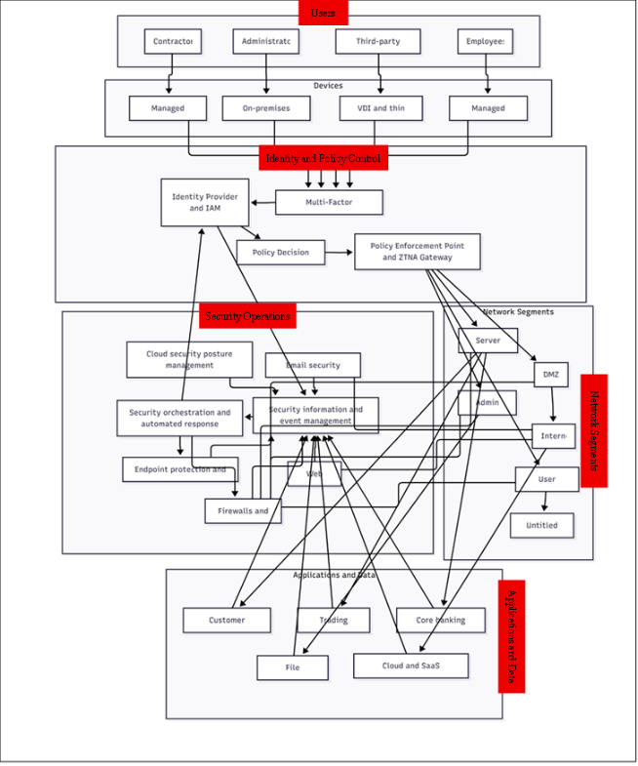
Fig. 1 1Zero Trust architecture for VTAM, showing users, devices, central identity and policy control, segmented networks,
Application and data policies should protect sensitive client and trading information throughout its lifecycle. Data classification rules should distinguish between public, internal, confidential and highly confidential information and specify appropriate controls such as encryption at rest and in transit, data loss prevention and strict sharing restrictions [20]. Application access policies should require secure development practices, regular vulnerability assessments and documented third‑party risk management, particularly for SaaS and supply chain dependencies.​
Finally, governance policies should mandate centralised logging, periodic risk assessments and continuous improvement. VTAM should formally map its policies to NIST CSF categories and ISO 27001 controls, review them after incidents or major business changes, and ensure staff understand their responsibilities through regular communication and training [16].

Technical and Administrative Mitigations
Technical and administrative mitigations for VTAM must convert Zero Trust policies into practical controls that are feasible for a medium‑sized financial organisation. These measures should directly address the identified threats, such as ransomware‑as‑a‑service, AI‑driven social engineering, supply chain compromise and cloud misconfiguration, while aligning with recognised good practice from frameworks like the NIST Cybersecurity Framework and ISO 27001 [16].​
A core set of technical controls should focus on hardening identity, endpoints, networks and data. Strong identity and access management can be implemented through MFA for all remote and sensitive access, centralised directory services and role‑based access control [21]. Endpoint protection should include next‑generation anti‑malware, host‑based firewalls, device encryption and application control to limit the execution of unauthorised software [22]. Network security should use layered firewalls, secure configuration of routers and switches, intrusion detection or prevention systems, and micro‑segmentation to reduce lateral movement between critical financial systems and user networks. For cloud services, Cloud Security Posture Management (CSPM) tools can help detect misconfigurations, enforce encryption and monitor access [23].​
Table 1. Mapping of VTAM security controls to NIST CSF functions
Control | Identify | Protect | Detect | Respond | Recover
Multi-factor authentication (MFA) | – | X | – | – | –
Network segmentation / firewalls | – | X | – | – | –
Endpoint protection and EDR | – | X | X | – | –
SIEM with log correlation | – | – | X | X | –
SOAR playbooks | – | – | – | X | –
Immutable/offline backups | – | – | – | – | X
Patch management (CISA KEV-driven) | X | X | – | – | –
Security awareness training | X | X | – | – | –

Resilience against ransomware and exploited vulnerabilities requires robust backup and patch management strategies. VTAM should implement regular, automated backups of critical systems using immutable or write‑once‑read‑many storage, with copies stored offline or in logically separate environments and tested through periodic recovery exercises. Patch management processes should prioritise remediation of weaknesses listed in the CISA Known Exploited Vulnerabilities catalogue and apply security updates to operating systems, applications and network devices within defined timeframes [24]. Email security controls like advanced spam filtering, URL rewriting, and attachment sandboxing as well as application whistling can minimize the chances of malware delivery and successful phishing.
Furthermore, administrative phishing is a source of governance and sources required to support such technologies [25]. The organization need to establish document security policies and standard operating procedures that covers the access requests, incident handling, change management and supplier risk management. Furthermore formal risk assessments, security clauses in contracts, and checks of supplier due diligence can assists to manage supply chain threats. Moreover, internal reviews, regular audits and management reporting on key security metrics can indicate support and oversights for continuous improvement.

Monitoring and Incident Response
An incident response ability with modern monitoring is important for VTAM to assess and include advanced threats like ransomware-as-a-service, supply chain intrusion and account compromise. The monitoring approach should also follow the Detect and Respond functions of the NIST Cybersecurity Framework through continuous visibility of endpoints, network traffic, identity events and cloud workloads.
VTAM should deploy a Security Information and Event Management (SIEM) platform to aggregate and correlate logs from firewalls, servers, endpoints, databases, cloud services and authentication systems. Use‑case rules and behavioural analytics can then generate alerts for suspicious activities, such as unusual login locations, privilege escalation, repeated failed authentication or mass file encryption. Integration with a Security Orchestration, Automation and Response (SOAR) tool would enable automated or semi‑automated actions, for example isolating an endpoint, disabling an account or blocking a malicious IP address when defined conditions are met [26].
Incident response should be documented as a structured process and illustrated in a flow diagram showing the stages of preparation, detection and analysis, containment, eradication, recovery and post‑incident review. For ransomware scenarios, runbooks should specify how to quickly identify affected systems, disconnect them from the network, switch to clean backups and communicate with stakeholders, including regulators where required. Clear roles and responsibilities are needed for the incident response team, along with defined escalation paths to senior management and the board [14]. Consistent testing through simulated attacks and tabletop exercises like phishing campaigns that are provided to the monitoring dashboards will assist VTAM to refine its procedures and improve time of response.
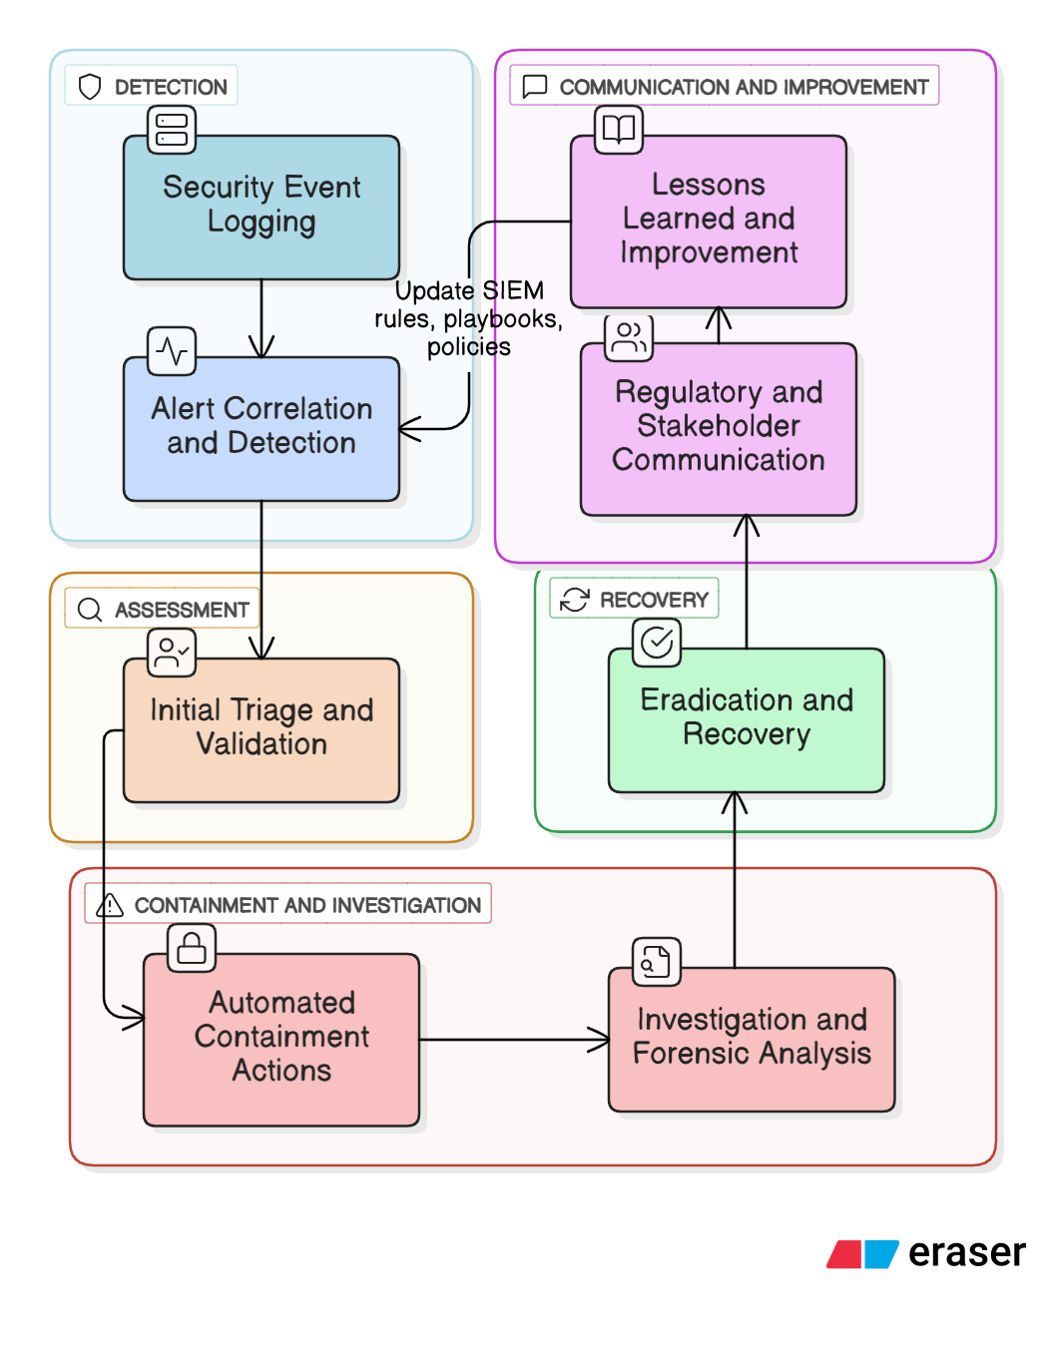
Fig. 2 SIEM/SOAR‑based incident response workflow for ransomware incidents at VTAM.

Traini ng and Security Culture
An efficient security and training culture programme is required for VTAM to address unintentional and malicious insider threats and support the technical control in the Zero Trust framework. The marketing criteria indicates training should go beyond annual videos and it should promote a culture that is security-conscious with the help of engaging activities, consistent and role specific content.
VTAM should adopt an ongoing, structured awareness programme that is based on short e-learning modules, regular communication, workshops on existing threats like vishing phishing, supply chain compromise and ransomware. Furthermore, AI-assisted voice phishing and simulated phishing campaigns can be applied for testing staff behavior, give immediate feedback and find roles or department that need additional support [22]. Furthermore, training should narrate the way employees can use to assess suspicious messages and call, verify payment requests or about data and approve reporting channels for escalating concerns in short time. Role-based training is important to reflect the risk exposures and various responsibilities. Front office staff need to focus on the protection of client data and they verify instructions from customers [12]. On the other hand, finance team have to provide in-depth guidance regarding fraud detection like authorization control and indicators. Security and IT personnel need an advanced technical training regarding secure configuration; process of incident response and obligations related to regulatory measures. Board members and senior managers should have focused briefings about cyber risk, governance responsibilities and business impact that can assist them for sponsor and model good practice. For a strong security culture, VTAM need to define the metrics like incident reporting levels, phishing click rates and completion of training and use such aspects for tracking improvement over time. It can further include positive reinforcement like recognition of teams having strong positive behaviour and clear consequences for serious policy breaches. It can assist to indicate that security is a shared responsibility in the entire organization.

Conclusion
The purpose of the paper was to examine the modern threat landscape faced by VTAM including RaaS, supply chain compromise, AI-enabled social engineering and weaknesses due to the hybrid working and cloud adoption. The study has proposed a security framework on the basis of Zero Trust principles and it is aligned with recognized standards like ISO 27001 and the NIST Cybersecurity Framework. The proposed measures including micro segmentation, strong identity management, immutable backups, CSPM and risk-based patch management are created to increase feasibility for medium sized financial organizations that cab minimizes the impact and further chances of cyber-attacks.

‘#

References

[  1] | A. Adejumo and C. Ogburie, " Strengthening finance with cybersecurity: Ensuring safer digital transactions.," World Journal of Advanced Research and Reviews, 25(3), pp. 1527-1541, 2025.
[2] | S. Satish, " A quantitative study on adoption of public cloud in financial services (Doctoral dissertation, University of the Cumberlands)," 2024.
[3] | T. Jabid, M. R. A. Rashid, M. H. Ferdaus, M. S. Ali, M. M. Islam, M. .. Hasan and M. Islam, Ransomware prevention strategies: Building robust cyber defenses. In Ransomware Evolution (pp. 144-171), CRC Press, 2024.
[4] | J. Simola and T. Leppänen, "Identification of the Emerging Sources of Cybersecurity Threats. In Proceedings of the European Conference on Cyber Warfare and Security," Academic Conferences International, p. 2025.
[5] | B. Pratap and V. Singh, "The Evolving Cyber Threat Landscape: Navigating the Intersection of Cybercrime and Cybersecurity," Wordsswiggle publication, 2025.
[6] | N. F. Syed, S. W. Shah, A. Shaghaghi, A. Anwar, Z. Baig and R. Doss, "Zero trust architecture (zta): A comprehensive survey," IEEE access, 10, pp. 57143-57179, 2022.
[7] | P. G. Perez, "Information security event management (SIEM) systems and AI for enhancing policy deployment effectiveness in intrusion detection," 2023.
[8] | M. Chawki, Social Engineering in the Era of AI: Unmasking the Changing Face of Cyber Threats. In Cybercrime Unveiled: Technologies for Analysing Legal Complexity (pp. 1-24), Cham: Springer Nature Switzerland, 2025, p. Cham: Springer Nature Switzerland.
[9] | N. Taavitsainen, Trust to Exploitation: The Legal and Societal Implications of Payment Fraud and the Path Toward Stronger Protections, 2025.
[10] | J. I. Samuels, Unraveling the Dynamics and Impacts of Financial Sabotage: A Comprehensive Analysis, 2024.
[11] | J. Martínez and J. M. Durán, "Software supply chain attacks, a threat to global cybersecurity: SolarWinds’ case study," International Journal of Safety and Security Engineering, 11(5), pp. 537-545, 2021.
[12] | H. Singh, Understanding and Implementing Effective Mitigation Strategies for Cybersecurity Risks in Supply Chains., Available at SSRN 5267866, 2025.
[13] | B. S. Rawal, G. Manogaran and A. Peter, Cybersecurity and identity access management, Singapore: Springer, 2023.
[14] | A. E. Maseko, Remedies to reduce user susceptibility to phishing attacks (Doctoral dissertation, University of the Western Cape), 2023.
[15] | P. C. Shekhar, Never Trust, Always Verify: Zero Trust Security Testing Framework, 2022.
[16] | J. Edwards, A comprehensive guide to the NIST cybersecurity framework 2.0: Strategies, implementation, and best practice, John Wiley & Sons, 2024.
[17] | S. H. Kendyala, The Role of Multi Factor Authentication in Securing Cloud Based Enterprise Applications, Available at SSRN 5074876, 2020.
[18] | B. Shebaro, O. Oluwatimi and E. Bertino, " Context-based access control systems for mobile devices," IEEE Transactions on Dependable and Secure Computing, 12(2), pp. 150-163, 2014.
[19] | H. Singh, Strengthening Endpoint Security to Reduce Attack Vectors in Distributed Work Environments, Available at SSRN 5267844, 2025.
[20] | H. N. Nguyen and L. Cuong, "Overview Of Data Classification And Applications In Data Security," International Journal of Environmental Sciences, pp. 31-39, 2025.
[21] | Volkova, A., Niedermeier, M., Basmadjian, R., de Meer and H., " Security challenges in control network protocols: A survey," IEEE Communications Surveys & Tutorials, 21(1), pp. 619-639, 2018.
[22] | S. Alvi, "8 Endpoint Security and. Handbook of AI-Driven Threat Detection and Prevention: A Holistic Approach to Security, 130," 2025.
[23] | P. Garg, "Cloud security posture management: Tools and techniques," p. Available at SSRN 5357921, 2025.
[24] | C. M. Osborne and D. S. Boone, "Effective Patch Management and Government Systems," 2023.
[25] | M. M. Ali and N. F. Mohd Zaharon, "Phishing—A cyber fraud: The types, implications and governance," International Journal of Educational Reform, 33(1), pp. 101-121, 2024.
[26] | P. Enberg, "Behavior Analytics in Cyber Security," 2024.

Appendices

Presenttation
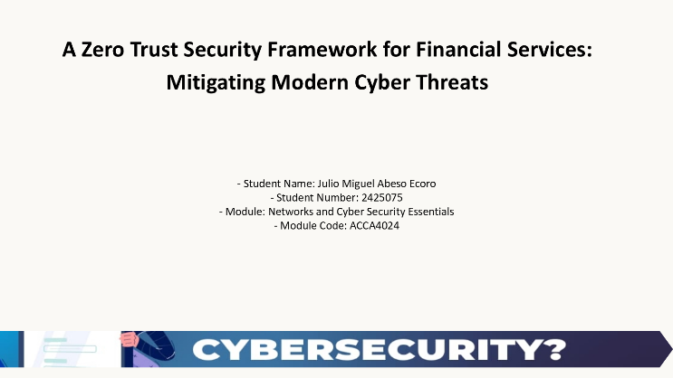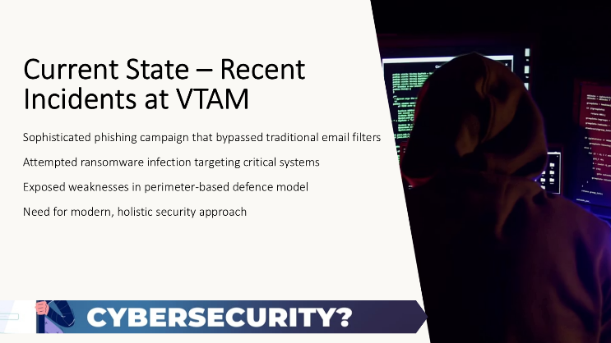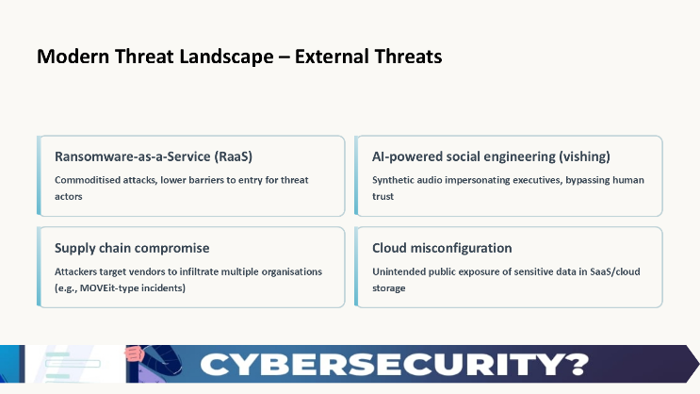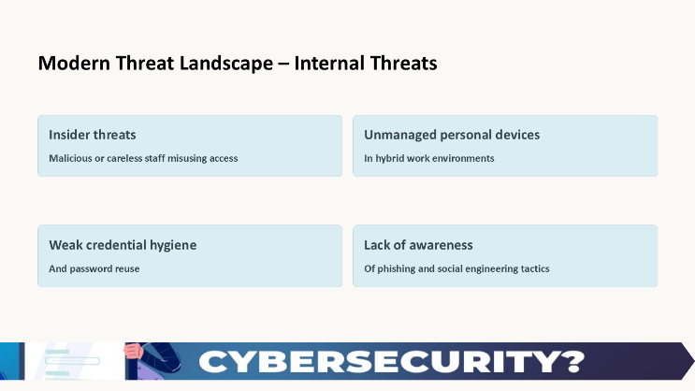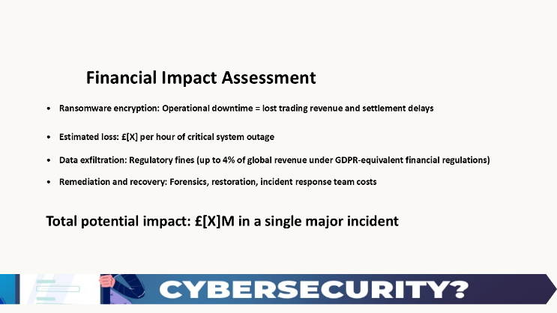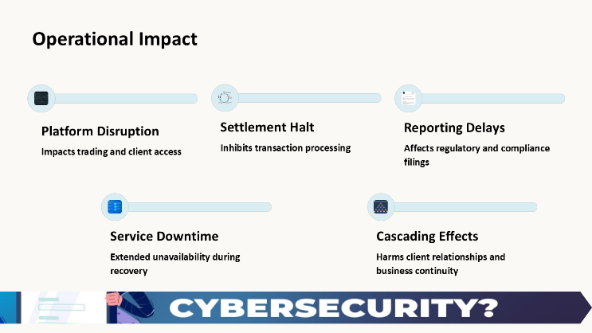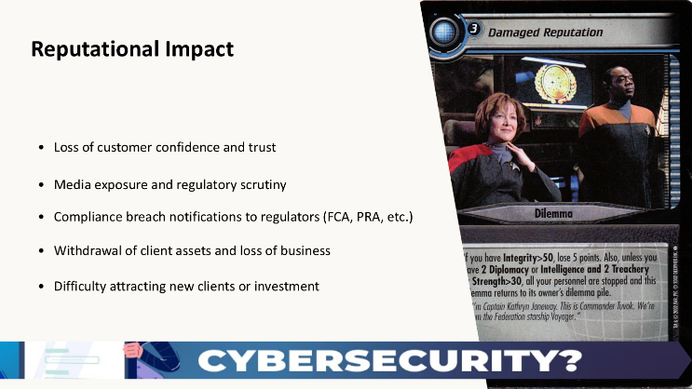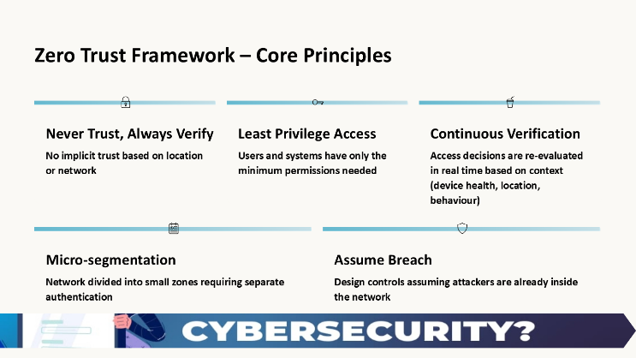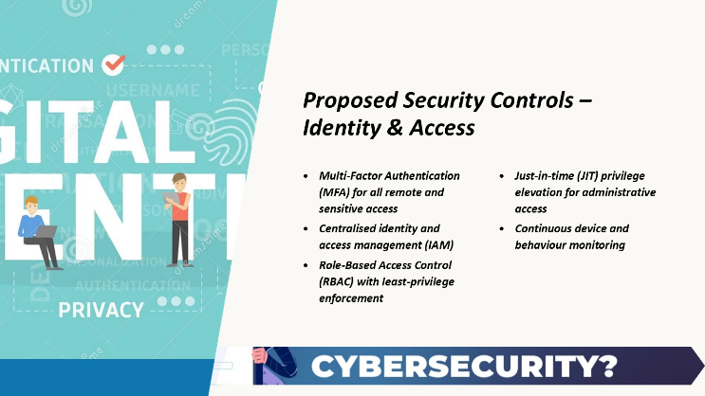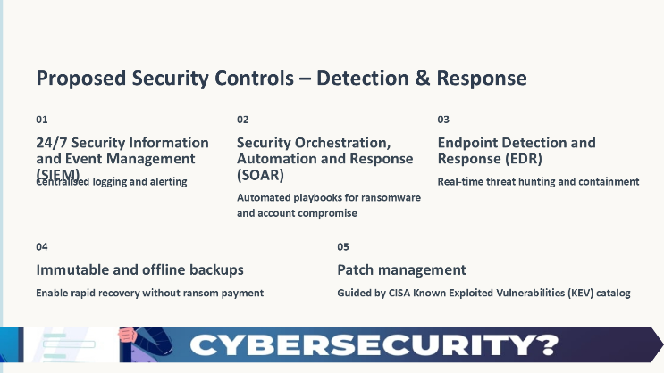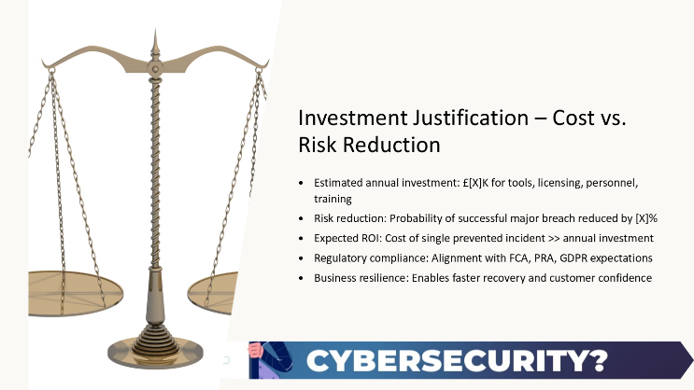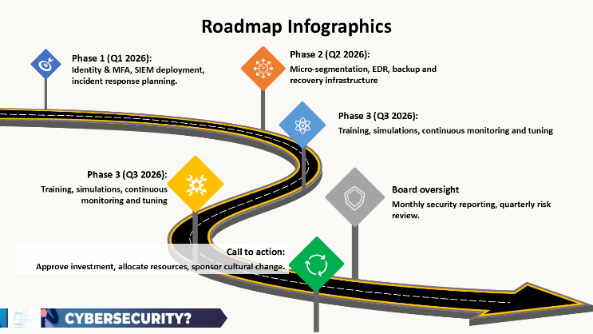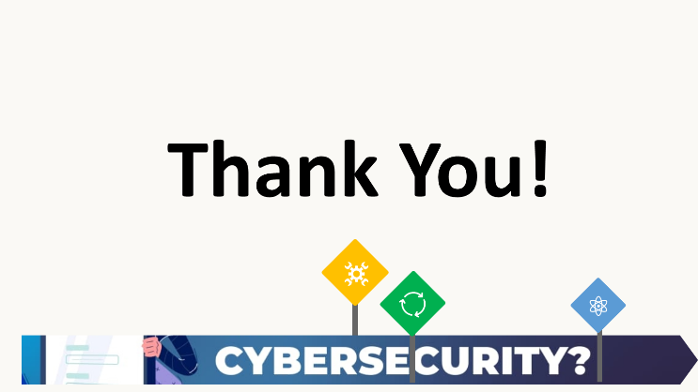

Certificate


