Module: ACCA5026 Databases and Application Development
Assignment Title: Database Design & Implementation
PART A
Student name: Andrew Ross Pullin
Student ID: 0851963
Email: 0851963@student.uwtsd.ac.uk
Course Title: Computing (Data and Information Systems)

Table of Contents
Introduction 2
Database Design 3
Stored Procedures and Transactional Scenario 7
Performance Tuning Enhancement 8
Conclusion and Reflection 9
References 10
Appendices 11

Introduction
The Student’s Union is responsible for supporting and coordinating a diverse range of clubs, including academic, cultural, sporting, and special-interest groups. However, the current reliance on paper-based records and disconnected spreadsheet systems has resulted in unorganised data management, administration errors, and limited visibility of student participation and engagement.
This assignment addresses the need for a centralised and structured database system to support the effective management of club operations within the Student’s Union. The proposed solution aims to integrate club records, student memberships, event management, participation tracking, and official communications into a single, database. By doing so, the system seeks to improve data accuracy, reduce errors, and enhance operational efficiency.
The report presents the design and implementation of the database that meets the requirements. It begins with the identification of key entities and relationships, followed by the development of an Entity Relationship Diagram (ERD) and a fully normalised database schema to Third Normal Form (3NF). The implementation phase demonstrates the creation of tables, constraints, stored procedures, triggers, and transactional scenarios, supported by realistic test data.
The overall aim is to demonstrate a robust, secure, and efficient database solution that supports the Student’s Union’s club management activities while adhering to best practices in database design and implementation. [1]

Database Design
The ERD shows the structure and relationships of the Student Club Database:
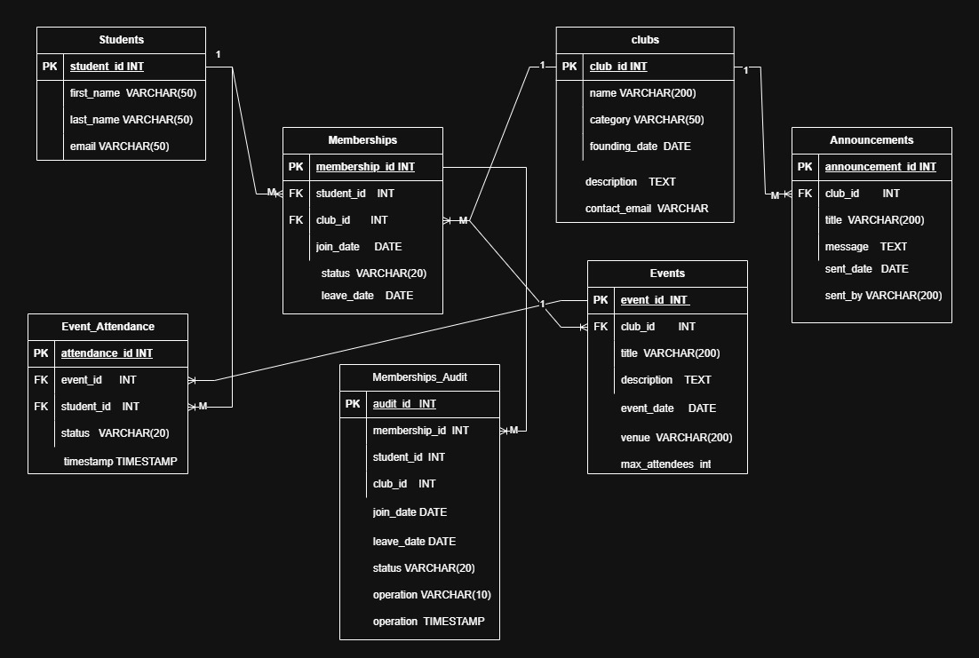
The Student Club Database has been designed to efficiently manage club operations, including student memberships, events, announcements, and auditing of membership changes. The database is implemented as a relational database and normalised to Third Normal Form to ensure data integrity and minimise redundancy. [2]

Entities and Attributes:

Students

- Primary Key (PK): student_id uniquely identifies each student.
- Attributes: first_name, last_name, email store student details.
- Design decision: Each student can participate in multiple clubs, establishing a many-to-many relationship with Clubs.

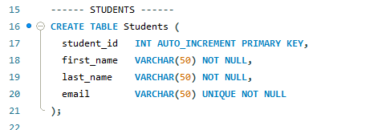

Clubs

- Primary Key (PK): club_id.
- Attributes: name, category, founding_date, description, contact_email.
- Design decision: Clubs act as a central entity, linking to memberships, events, and announcements. This ensures all club-related operations are centralized.

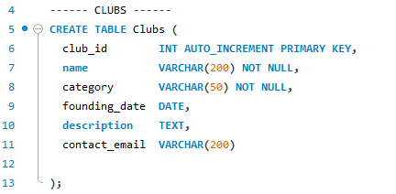

Memberships

- Primary Key (PK): membership_id.
- Foreign Keys (FK): student_id, club_id.
- Attributes: join_date, leave_date, status.
- Design decision: Memberships resolve the many-to-many relationship between Students and Clubs. A unique constraint on (student_id, club_id) prevents duplicate memberships.

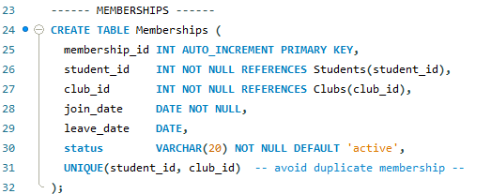

Events

- Primary Key (PK): event_id.
- Foreign Key (FK): club_id.
- Attributes: title, description, event_date, venue, max_attendees.
- Design decision: Each event belongs to one club, establishing a one-to-many relationship. Events are tracked for attendance and reporting.

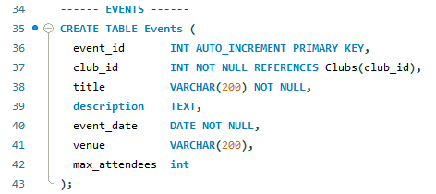

Event_Attendance

- Primary Key (PK): attendance_id.
- Foreign Keys (FK): student_id, event_id.
- Attributes: status, timestamp.
- Design decision: Resolves the many-to-many relationship between Students and Events. A unique constraint on (event_id, student_id) prevents duplicate attendance records.

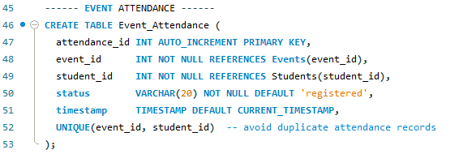

Announcements
- Primary Key (PK): announcement_id.
- Foreign Key (FK): club_id.
- Attributes: title, message, sent_date, sent_by.
- Design decision: Each club can send multiple announcements, forming a one-to-many relationship.

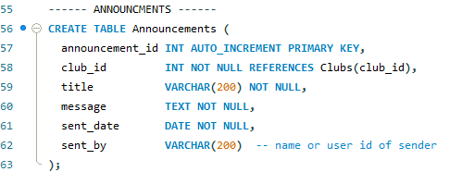

Memberships_Audit

- Primary Key (PK): audit_id.
- Tracks changes to Memberships including inserts, updates, and deletions.
- Design decision: Supports auditing and ensures accountability. Each audit record references the membership_id it relates to, forming a one-to-many relationship with Memberships.

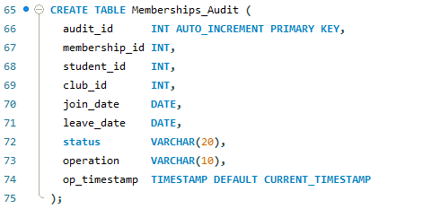

Key Relationships:

Students, Memberships, and Clubs: Many to many relationships through Memberships.

Students, Event_Attendance, and Events: Many to many relationships through Event_Attendance.

Clubs and Events: One to many; each club can /could hosts multiple events.

Clubs and Announcements: One to many; each club can issue multiple announcements.

Memberships and Memberships_Audit: One to many; audit table tracks changes to memberships.

Stored Procedures and Transactional Scenario
To make sure data in the system is stored correctly and consistently, stored procedures were used to carry out important database tasks. A stored procedure is a set of SQL instructions saved inside the database. This helps keep the code organised, makes it easier to reuse, and reduces mistakes when working with data. [3]

One main stored procedure, RegisterStudentToClub, was created to register a student as a member of a club. This procedure uses a transaction, meaning several steps are treated as one single action. The transaction starts, then the procedure ensures that either all changes are successfully applied or none, this ensures the data integrity.

An exception handler was included to look for errors while the procedure runs. If an error happens, such as trying to add a student to a club they already belong to, the transaction is cancelled and no changes are saved. The data is only saved when all steps finish without any problems.

Another stored procedure, RegisterEventAttendance, handles a more detailed situation. Before adding a student to an event, it first checks whether the student is already registered. This check helps prevent the same student from being added twice. If the student is not already registered, the attendance record is added and saved. If they are already registered, no changes are made.

These examples show how transactions, along with saving (COMMIT) and cancelling (ROLLBACK) changes, help keep the database reliable. They ensure that data remains correct, even when many users are using the system at the same time or when rules must be enforced.

Audit and Trigger Implementation

To support accountability and traceability within the database system, an auditing mechanism was implemented using database triggers. Auditing is essential for monitoring changes to critical data, particularly membership records that reflect student participation within clubs. [4]

A dedicated audit table, Memberships_Audit, was created to store historical records of membership changes. This table captures key details including the membership identifier, associated student and club, membership status, the type of operation performed, and a timestamp indicating when the change occurred.

An AFTER INSERT trigger was implemented on the Memberships table to automatically log new membership records into the audit table. This trigger executes immediately after a membership is successfully created and inserts the relevant details into the audit log without requiring manual intervention.

The use of a trigger ensures that all membership insert operations are consistently recorded, improving data reliability and supporting potential audit or review requirements. By automating the auditing process at the database level, the system reduces human error, enforces consistent logging, and enhances transparency in club membership management.

Performance Tuning Enhancement

Database performance is important, especially when the system needs to run many searches and combine data from different tables. To help the Student Club Management System run faster, indexes were added to certain database columns that are often searched or used to link tables together. [5]

An index works like the index in a book; it helps the database find information more quickly without searching through every row. Indexes were added to important columns such as student email addresses, club memberships, and event details. For example, adding an index to the Students.email column allows the system to quickly find a student using their email address, which is a common task.

Indexes were also added to the Memberships.student_id and Memberships.club_id columns. These help the database work faster when showing which students belong to which clubs. In addition, indexes on Events.club_id and Event_Attendance.event_id make it quicker to find events and attendance records for a specific club.

Overall, the indexing strategy improves query execution speed and system scalability while maintaining minimal storage. This approach ensures that the database can efficiently support reporting, engagement analysis, and day-to-day operational queries as the volume of data grows.

Conclusion and Reflection
This project successfully designed and implemented a relational database system to support the management of student clubs and societies within the Students’ Union. The solution addressed the limitations of existing paper-based and spreadsheet systems by providing a centralised database capable of managing clubs, student memberships, events, attendance, and official communications efficiently and reliably.

The database was designed using sound relational principles and normalised to Third Normal Form (3NF), ensuring data integrity and minimising redundancy. Key database features, including stored procedures, transaction handling, triggers, and indexing, were implemented to demonstrate robust data management, consistency, and performance optimisation. Transactional logic ensured that critical operations were executed safely using commit and rollback mechanisms, while triggers provided automated auditing of membership changes.

Overall, the system meets the functional requirements outlined in the case study and demonstrates a strong understanding of relational database concepts. Future improvements could include, additional sample data, enhanced security controls, expanded auditing to further support Students’ Union operations.

References

[1] | T. Connolly, Database Systems: A Practical Approach to Design, Implementation, and Management, Pearson Education, 2015.
[2] | M.-I. C. T. T. a. G. T. M. Fotache, “The effects of database normalization on decision support system performance,” Information systems (Oxford), vol. 136, p. 102636, 2024.
[3] | W3Schools, “W3Schools,” [Online]. Available: https://www.w3schools.com/sql/sql_stored_procedures.asp. [Accessed 16 12 2024].
[4] | D. Fabbari, “ResearchGate,” 01 04 2013. [Online]. Available: https://www.researchgate.net/publication/261347463_SELECT_triggers_for_data_auditing. [Accessed 06 01 2026].
[5] | C. K. W. a. R. Nayak, “Adaptive Database's Performance Tuning Based on Reinforcement Learning,” Semantic Scholar, 26 08 2019. [Online]. Available: https://www.semanticscholar.org/paper/Adaptive-Database's-Performance-Tuning-Based-on-Wee-Nayak/24594ae733e0c3851e5031d17f31e0f3a4d87f06#cited-papers. [Accessed 06 01 2026].

Appendices
SQL:

CREATE DATABASE newstudentclubDB;
USE newstudentclubDB;

------ CLUBS ------
CREATE TABLE Clubs (
club_id INT AUTO_INCREMENT PRIMARY KEY,
name VARCHAR(200) NOT NULL,
category VARCHAR(50) NOT NULL,
founding_date DATE,
description TEXT,
contact_email VARCHAR(200)

);

------ STUDENTS ------
CREATE TABLE Students (
student_id INT AUTO_INCREMENT PRIMARY KEY,
first_name VARCHAR(50) NOT NULL,
last_name VARCHAR(50) NOT NULL,
email VARCHAR(50) UNIQUE NOT NULL
);

------ MEMBERSHIPS ------
CREATE TABLE Memberships (
membership_id INT AUTO_INCREMENT PRIMARY KEY,
student_id INT NOT NULL REFERENCES Students(student_id),
club_id INT NOT NULL REFERENCES Clubs(club_id),
join_date DATE NOT NULL,
leave_date DATE,
status VARCHAR(20) NOT NULL DEFAULT 'active',
UNIQUE(student_id, club_id) -- avoid duplicate membership --
);

------ EVENTS ------
CREATE TABLE Events (
event_id INT AUTO_INCREMENT PRIMARY KEY,
club_id INT NOT NULL REFERENCES Clubs(club_id),
title VARCHAR(200) NOT NULL,
description TEXT,
event_date DATE NOT NULL,
venue VARCHAR(200),
max_attendees int
);
------ EVENT ATTENDANCE ------
CREATE TABLE Event_Attendance (
attendance_id INT AUTO_INCREMENT PRIMARY KEY,
event_id INT NOT NULL REFERENCES Events(event_id),
student_id INT NOT NULL REFERENCES Students(student_id),
status VARCHAR(20) NOT NULL DEFAULT 'registered',
timestamp TIMESTAMP DEFAULT CURRENT_TIMESTAMP,
UNIQUE(event_id, student_id) -- avoid duplicate attendance records
);

------ ANNOUNCMENTS ------
CREATE TABLE Announcements (
announcement_id INT AUTO_INCREMENT PRIMARY KEY,
club_id INT NOT NULL REFERENCES Clubs(club_id),
title VARCHAR(200) NOT NULL,
message TEXT NOT NULL,
sent_date DATE NOT NULL,
sent_by VARCHAR(200) -- name or user id of sender
);

CREATE TABLE Memberships_Audit (
audit_id INT AUTO_INCREMENT PRIMARY KEY,
membership_id INT,
student_id INT,
club_id INT,
join_date DATE,
leave_date DATE,
status VARCHAR(20),
operation VARCHAR(10),
op_timestamp TIMESTAMP DEFAULT CURRENT_TIMESTAMP
);

------ CLUB_INFO ------
INSERT INTO Clubs (name, category, founding_date, description, contact_email)
VALUES
('Math 4 Fun Club','academic','2016-10-01','A club for mathematics enthusiasts','math4fun@uni.edu'),
('Drama Club','cultural','2018-02-01','Theatre and drama group','drama@uni.edu'),
('Football Team','sports','2000-09-01','University football team','football@uni.edu');

------ STUDENT_INFO ------
INSERT INTO Students (first_name, last_name, email)
VALUES
('Alice','Wong','alice.wong@uni.edu'),
('Bob','Smith','bob.smith@uni.edu'),
('Charlie','Doe','charlie.doe@uni.edu');

------ MEMBERSHIP_INFO ------
INSERT INTO Memberships (student_id, club_id, join_date)
VALUES
(1, 1, '2024-09-01'), -- Alice joined the Math 4 Fun
(1, 2, '2025-10-01'), -- Alice also joined the Drama Club
(2, 3, '2023-09-01'), -- Bob has joined the Football Team
(3, 1, '2025-09-01'); -- Charlie has joined Math 4 Fun

------ EVENT_INFO ------
INSERT INTO Events (club_id, title, description, event_date, venue, max_attendees)
VALUES
(1, 'Math 4 Fun Club', 'Quick maths revision session', '2025-10-15', 'Room 101', 30),
(2, 'Drama Club', 'Rehearsal for upcoming play', '2025-11-10', 'Drama Hall', 50),
(3, 'Football Practice', 'Practice for the new season', '2025-08-10', 'Main Field', 40);

------ EVENT_ATTENDANCE_INFO ------
INSERT INTO Event_Attendance (event_id, student_id, status)
VALUES
(1, 1, 'attended'), -- Alice attended Math 4 Fun Club
(2, 1, 'registered'), -- Alice registered for Drama Club
(3, 2, 'attended'); -- Bob attended Football Practice

------ ANNOUNCEMENT_INFO ------
INSERT INTO Announcements (club_id, title, message, sent_date, sent_by)
VALUES
(1, 'Welcome to Math 4 Fun', 'Welcome all new members!', '2025-09-05', 'Union Officer'),
(3, 'Football Practice Reminder', 'Don’t forget practice this Friday has been moved indoors.', '2025-08-18', 'Coach John');

------ AUDIT_TABLE_FOR_CHANGES ------
CREATE TABLE Memberships_Audit (
audit_id INT AUTO_INCREMENT PRIMARY KEY,
membership_id INT,
student_id INT,
club_id INT,
join_date DATE,
leave_date DATE,
status VARCHAR(20),
operation VARCHAR(10), -- 'INSERT', 'UPDATE', 'DELETE'
op_timestamp TIMESTAMP DEFAULT CURRENT_TIMESTAMP
);

------ CLUB_INFO_RETRIEVE ------
SELECT club_id, name, category, founding_date
FROM Clubs;

------ STUDENT_RETRIEVE ------
SELECT student_id, first_name, last_name, email
FROM Students;

------ EVENT_ATT_RETRIEVE ------
SELECT event_id, student_id, status
FROM Event_Attendance;

------ JOIN_TABLES ------
SELECT
c.name AS club_name,
s.first_name,
s.last_name,
m.join_date
FROM Clubs AS c
JOIN Memberships AS m
ON c.club_id = m.club_id
JOIN Students AS s
ON m.student_id = s.student_id;

------ ADD_STUDENT_AND_AUDIT ------
START TRANSACTION;
INSERT INTO Memberships (student_id, club_id, join_date)
VALUES (1, 3, CURDATE());
INSERT INTO Memberships_Audit (membership_id, student_id, club_id, join_date, status, operation)
VALUES (LAST_INSERT_ID(), 1, 3, CURDATE(), 'active', 'INSERT');
COMMIT;

DELIMITER $$

CREATE PROCEDURE RegisterEventAttendance (
IN p_event_id INT,
IN p_student_id INT
)
BEGIN
DECLARE record_count INT;

START TRANSACTION;

SELECT COUNT(*) INTO record_count
FROM Event_Attendance
WHERE event_id = p_event_id
AND student_id = p_student_id
FOR UPDATE;

IF record_count = 0 THEN
INSERT INTO Event_Attendance (event_id, student_id, status)
VALUES (p_event_id, p_student_id, 'registered');
END IF;

COMMIT;
END$$

DELIMITER ;
;

------ Frequent lookup columns ------
CREATE INDEX idx_student_email ON Students(email);
CREATE INDEX idx_membership_student ON Memberships(student_id);
CREATE INDEX idx_membership_club ON Memberships(club_id);
CREATE INDEX idx_event_club ON Events(club_id);
CREATE INDEX idx_attendance_event ON Event_Attendance(event_id);

------ View all clubs ------
SELECT * FROM Clubs;

------ View students and their clubs ------
SELECT
s.first_name,
s.last_name,
c.name AS club_name,
m.join_date
FROM Students s
JOIN Memberships m ON s.student_id = m.student_id
JOIN Clubs c ON m.club_id = c.club_id;

------ View audit log ------
SELECT * FROM Memberships_Audit;

