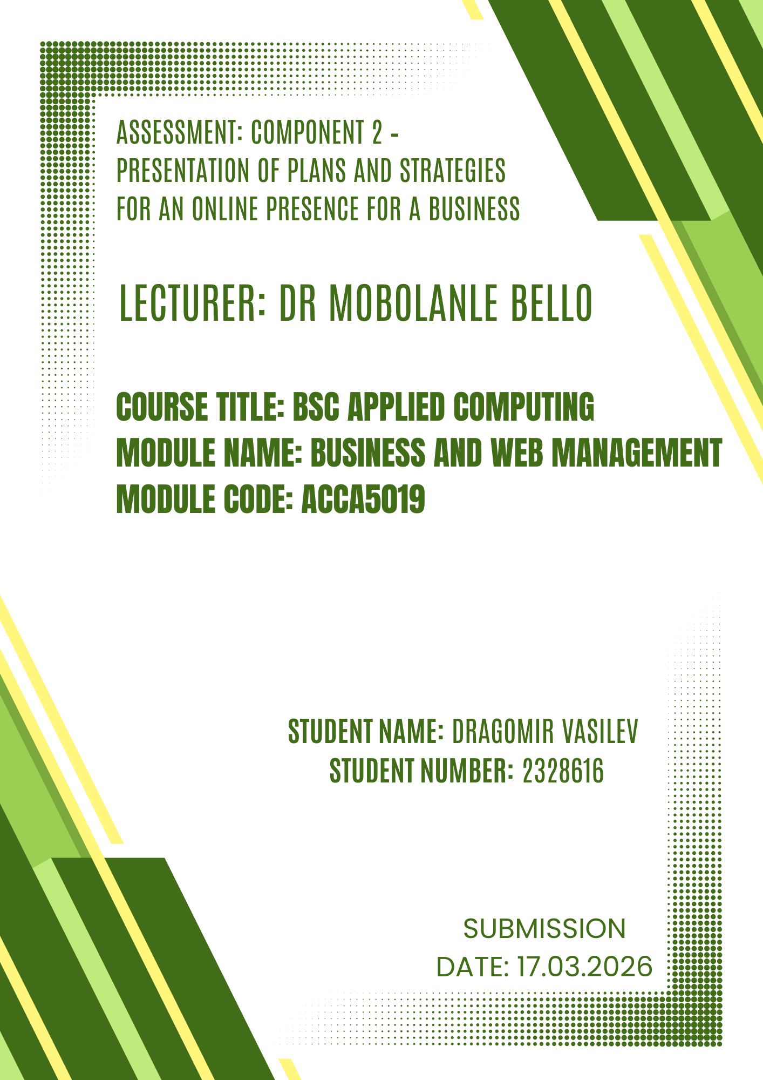

Google sites Urban Green Café portfolio link
https://sites.google.com/view/urban-green-caffe-portfolio

Urban Green Café Inkscape created Logo link
https://uowtsd-my.sharepoint.com/:u:/g/personal/2328616_student_uwtsd_ac_uk/IQDguLTw8y2gSrhNGLNxcf9kAbHHQ-YorUgnYiiQYZzvalY?e=mSrkub

