HTML & CSS Web Development

Internet Technology and Security – ACCA4018
  - Samuel Richards

Networking & Cyber Security
1901717
Submitted:

Contents
1. Introduction 2
2. Requirements 2
2.1 Logo 2
2.2 Images 3
3. Implementation 3
3.1 screenshots 3
3.2 Validation 9
4. Evaluation 10
4.1 Usability 10
4.2 Accessibility 10
4.3 Search engine optimisation 11
5. Website Evaluation 11
5.1 Usability 11
5.2 Accessibility 11
5.3 Search engine optimisation 12
6. References 13

1. Introduction
This report is based on a website which was created by Samuel Richards, and he built this website on a business which is like other animal rehoming business such as RSPCA, Many tears. This website will consist of much text, pages and images of various animals which will be taking care of these animals, and hopefully will be rehomed. The target audience for this website will be various people such as families which want pets, as well as couples and other which need of a new family member.
In this report it will mention the requirements of this website, it will also show images which are used, the pages themselves. Also, in this report there will be a validator test which will be done and will show the results of that test, this will be done on the HTML and CSS of the website to see if there are any errors, and if so, it will be show how the errors were fixed. There will be a section showing about “SEO”

2. Requirements

The Name of the Website is SAT Which stands for (Samuel Animal Trust) the reason for this is website is because, Samuel’s love for animals and thought that would be a great topic for the website, the target audience for this website is quite obvious, it would be families, couples and elderly, anyone who likes animals in general. It is kind of like “RSPCA and Dogs Trust” But it would be more of a family business kind of vibe.

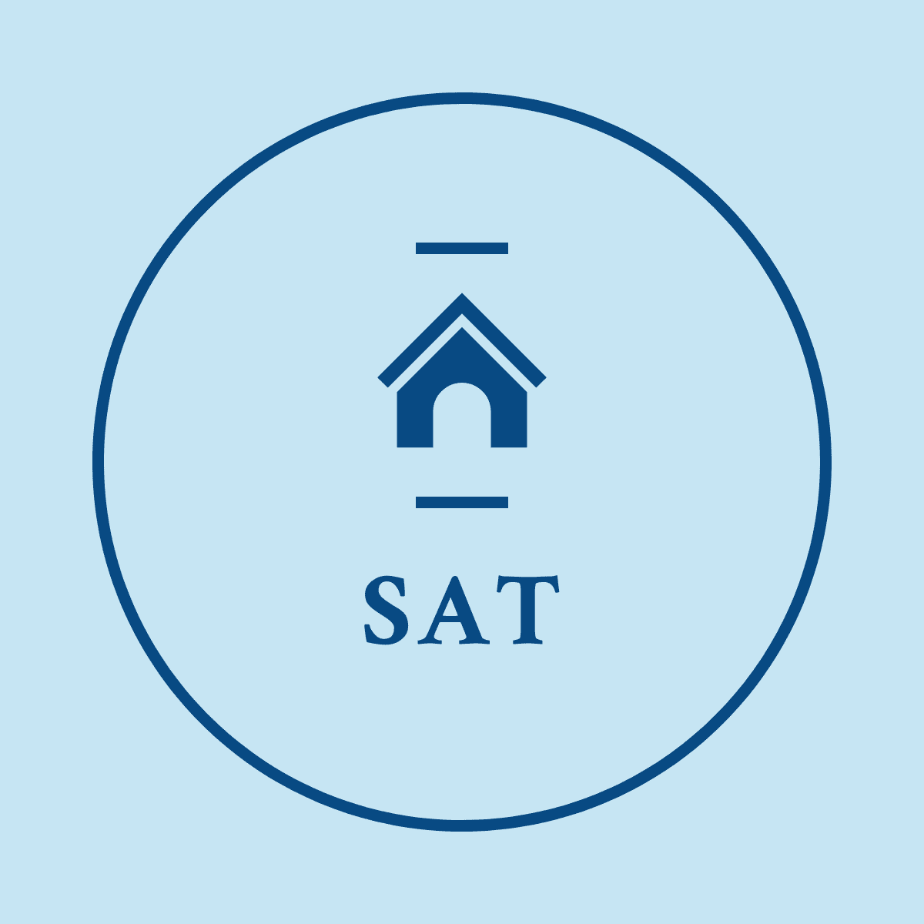
2.1 Logo

This is the logo which was made and used in the website which was created, I found it was perfect to be used because it resembles the meaning for the business, there will be many different animals which need a new home, such as dogs, cats, rabbits and many more. It is a simple logo which is used, but I wanted nothing to complicated.

2.2 Images
The images that were used in this website were used from online sources, such as website called “Freeimages.com” this website has millions of images on there which are free to use, all that was done was select the images which you would want to click on it and download. Very useful website to get free images from

3. Implementation

3.1 screenshots
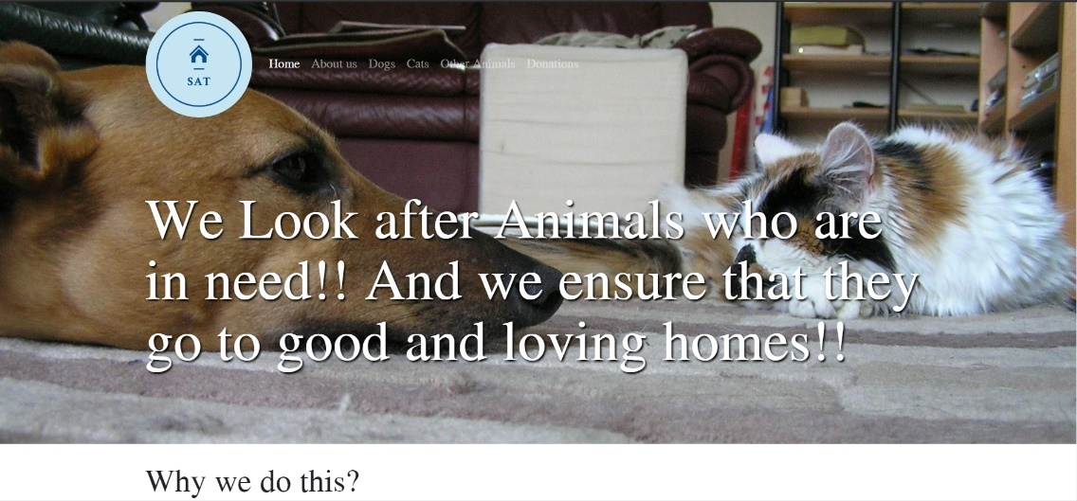
- Home Page

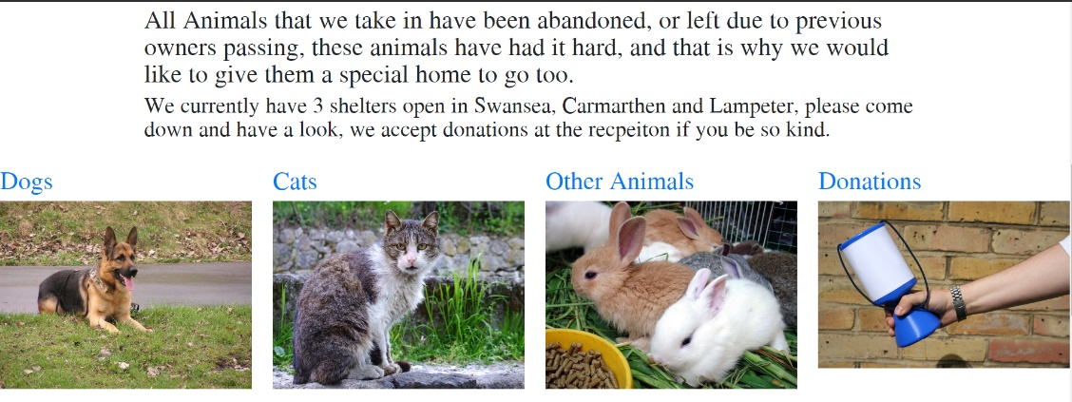

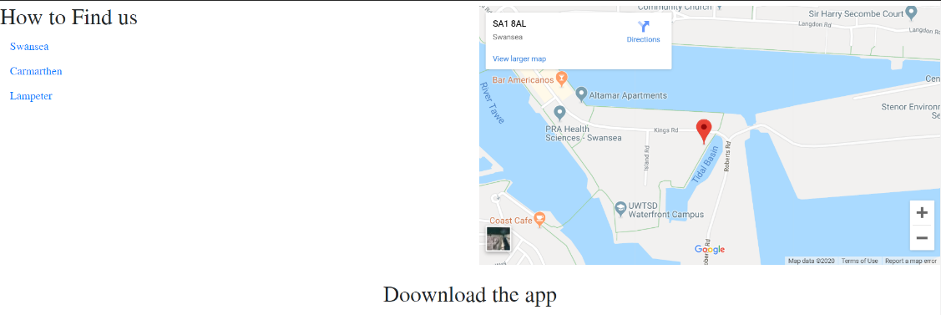

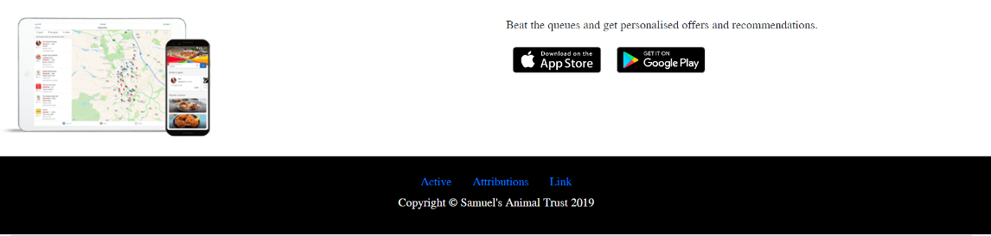

- About us Page
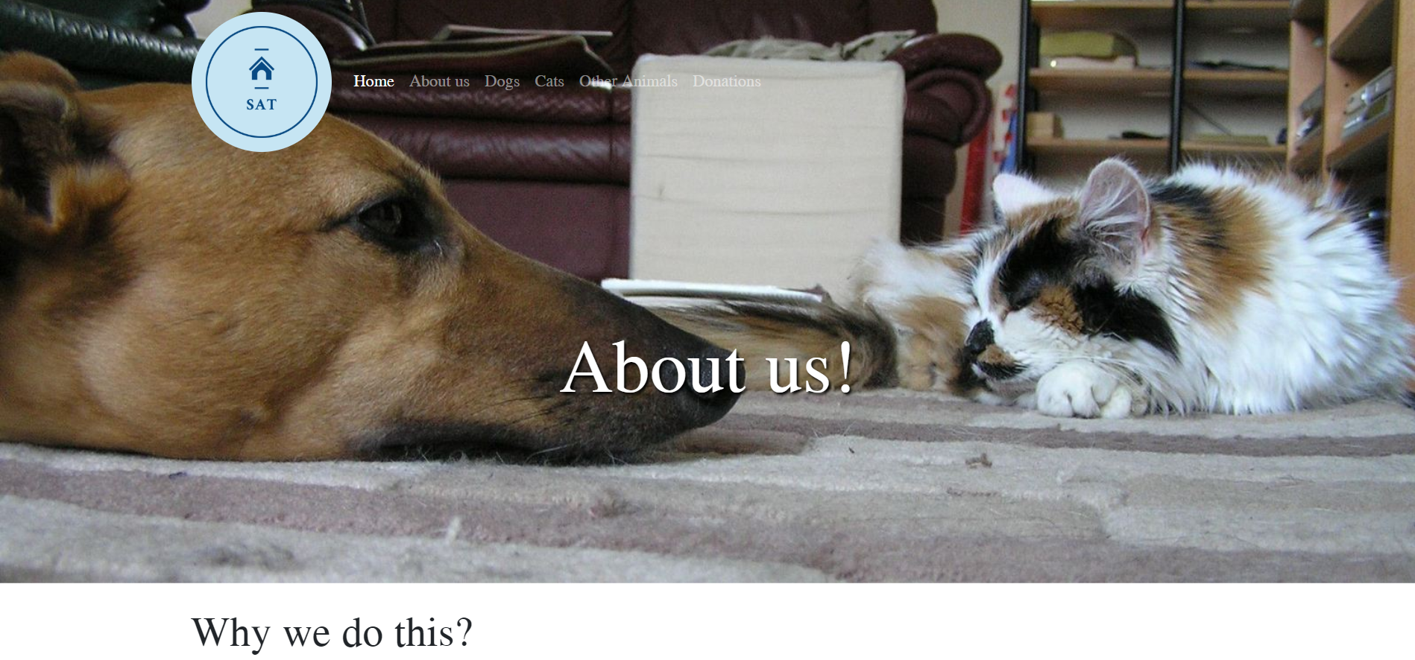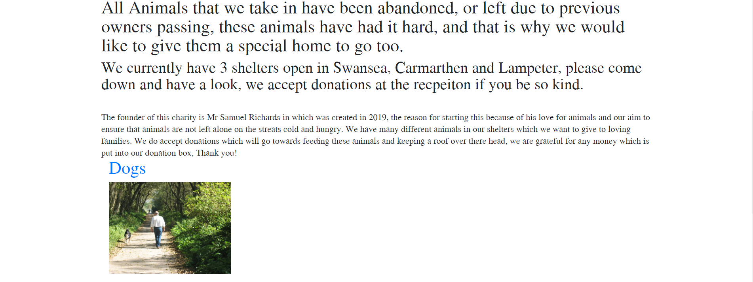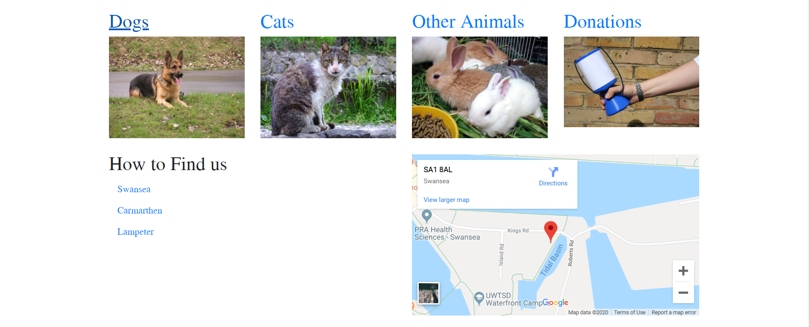

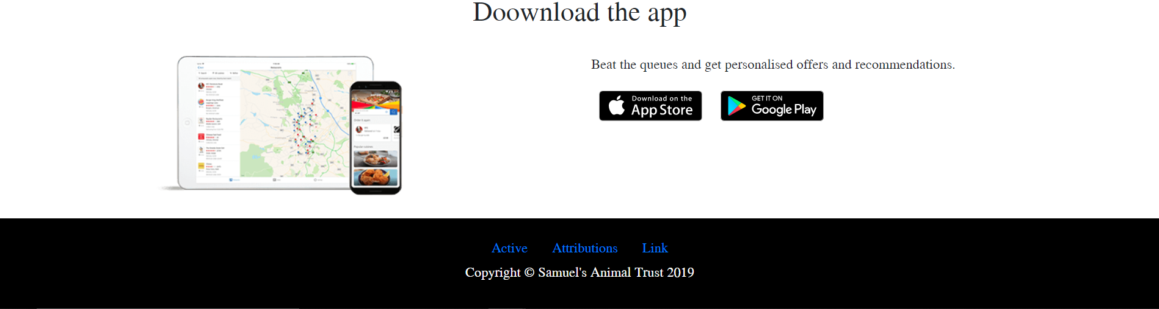

- Dogs Page
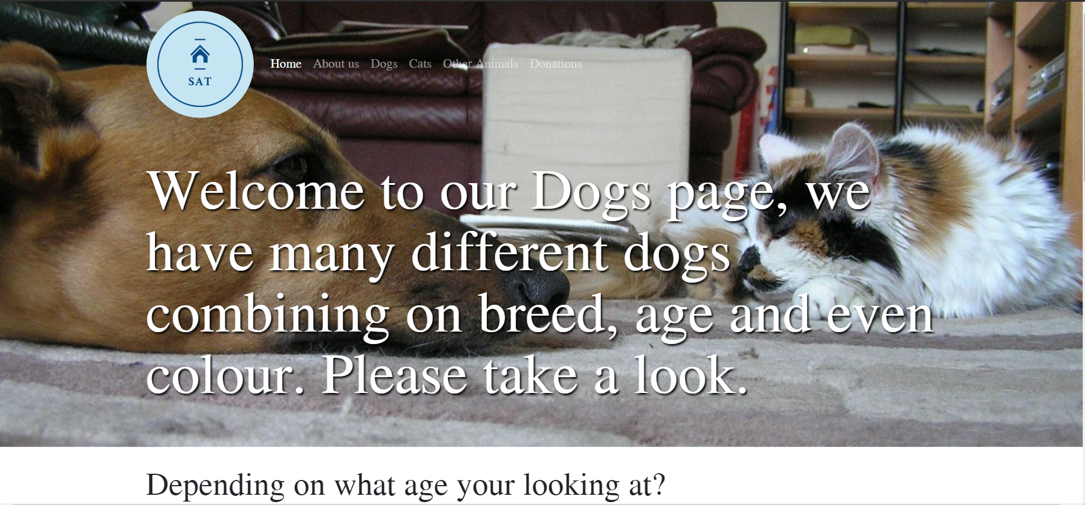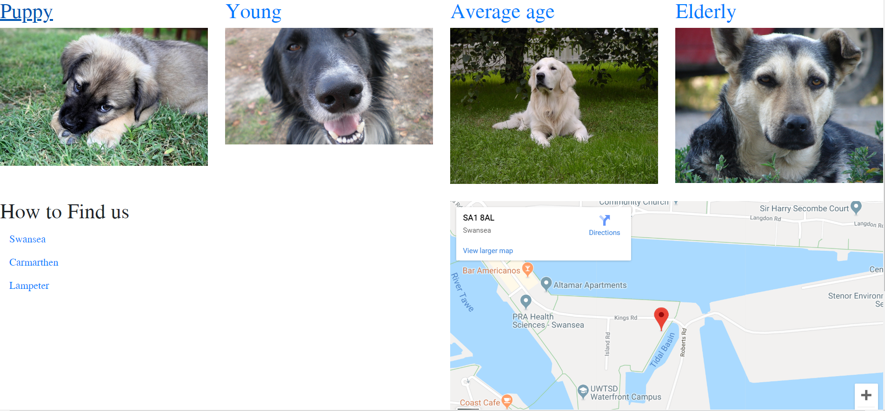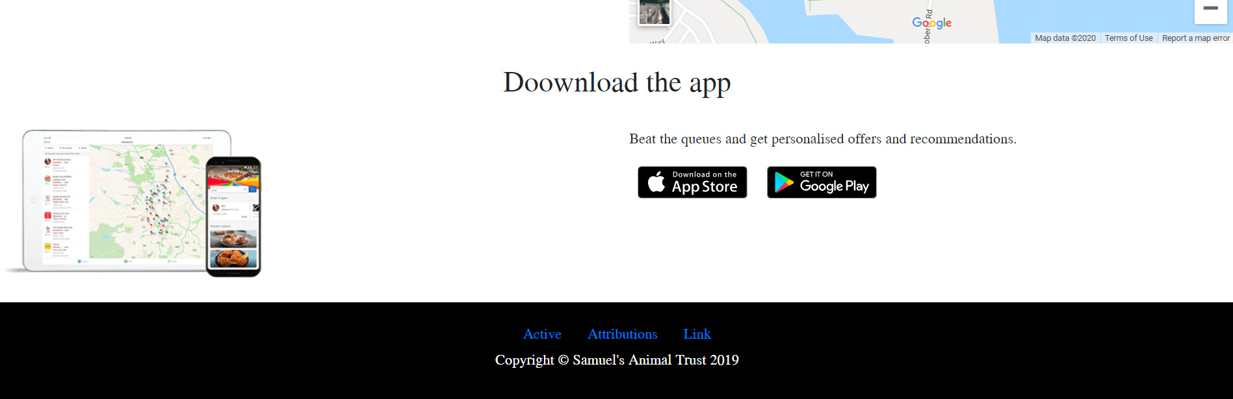

- Cats Page
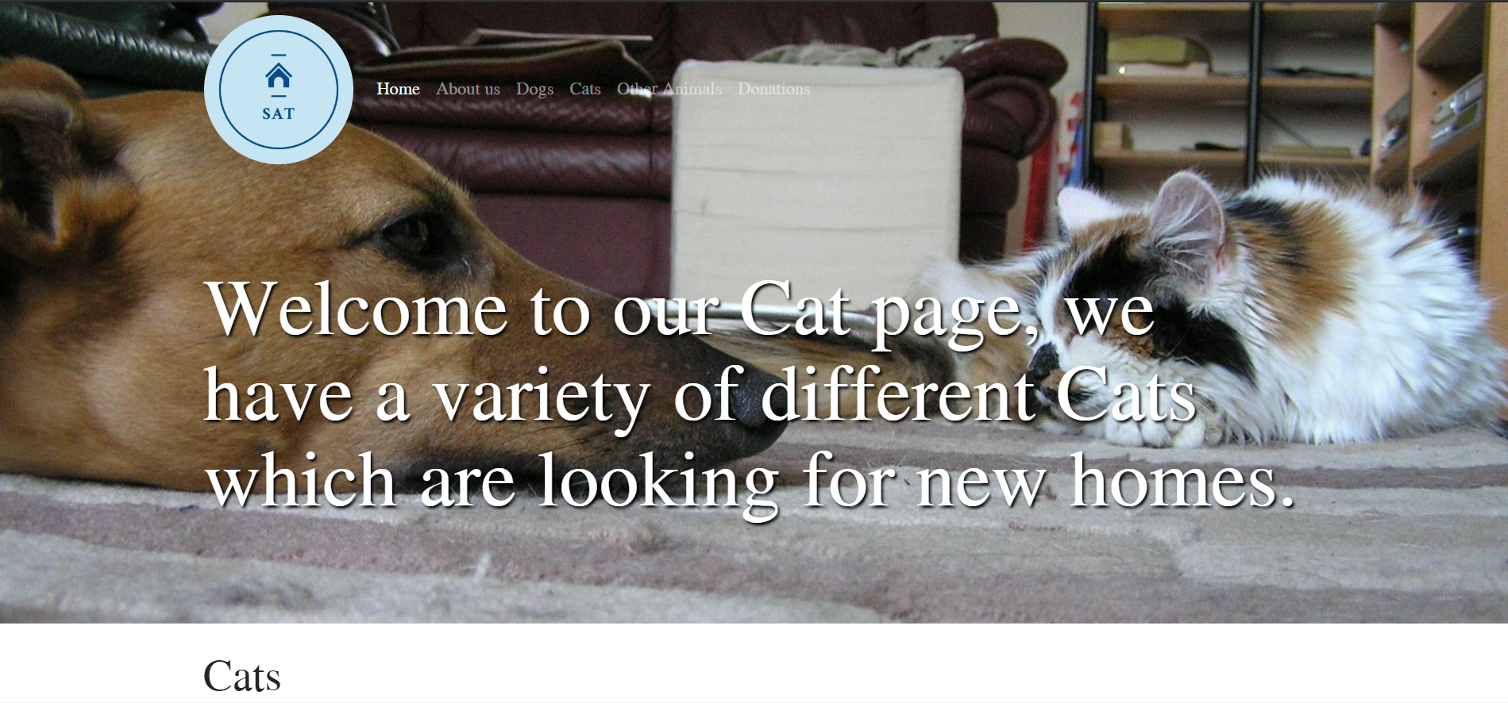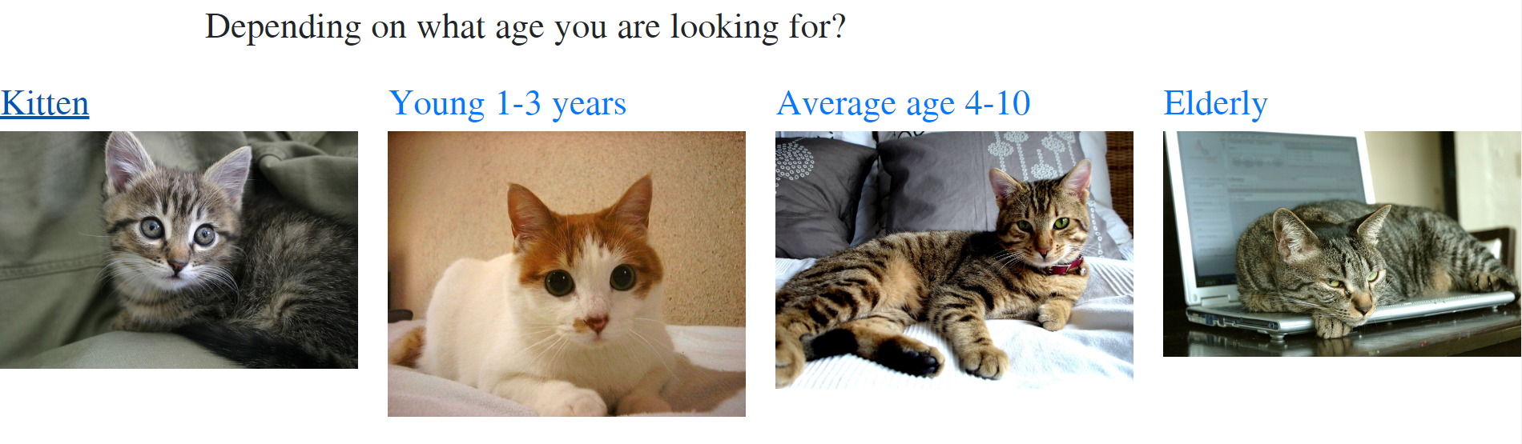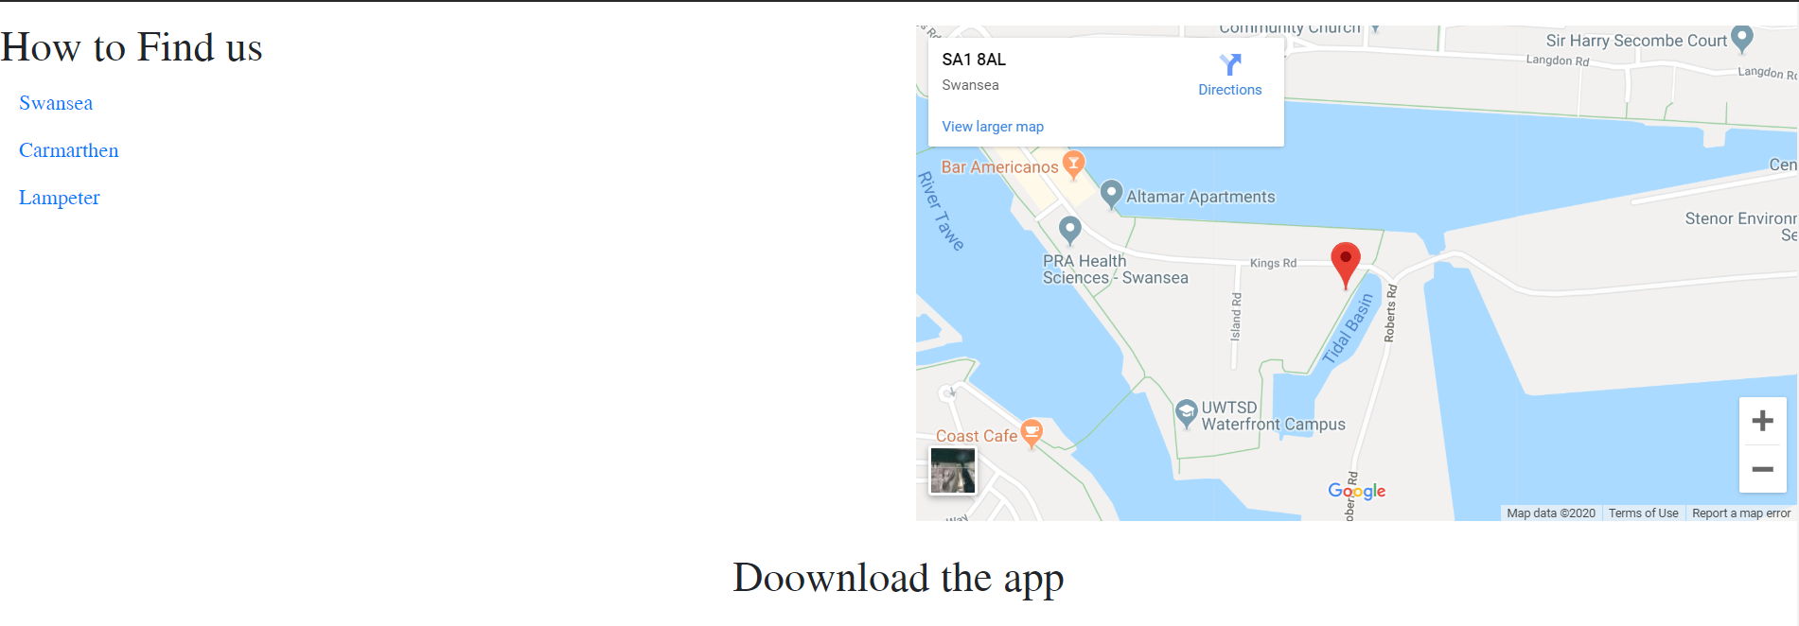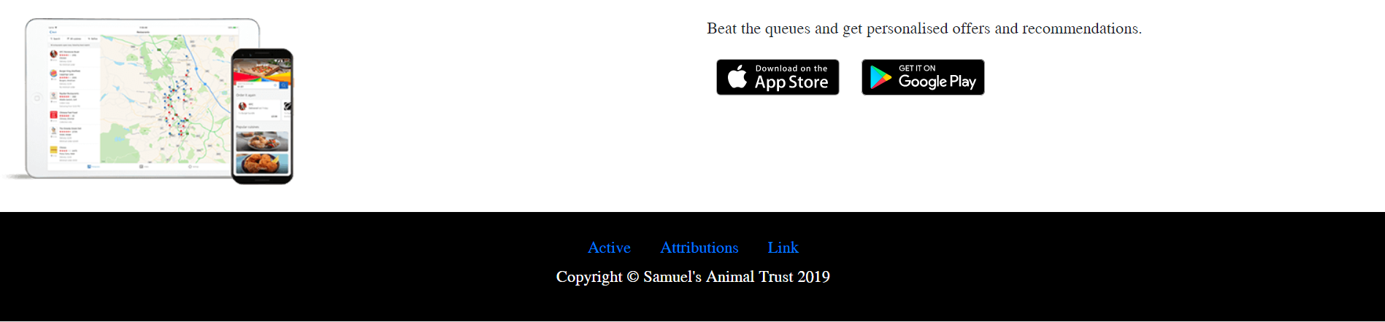

- Other Animals Page
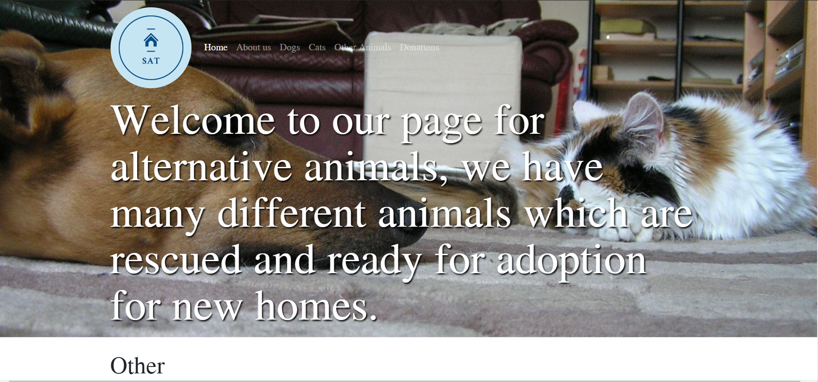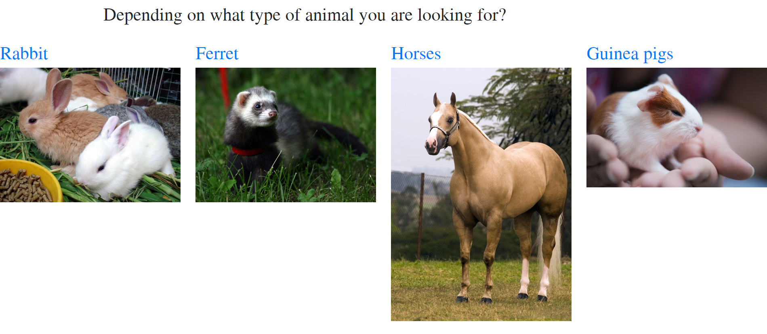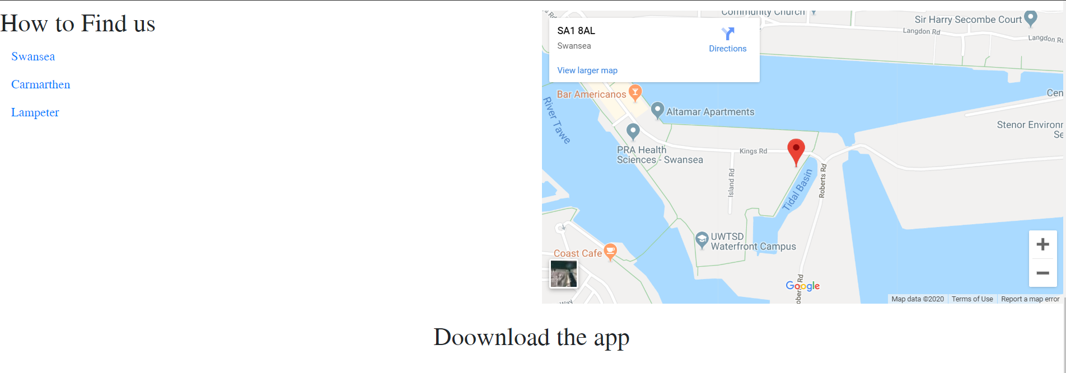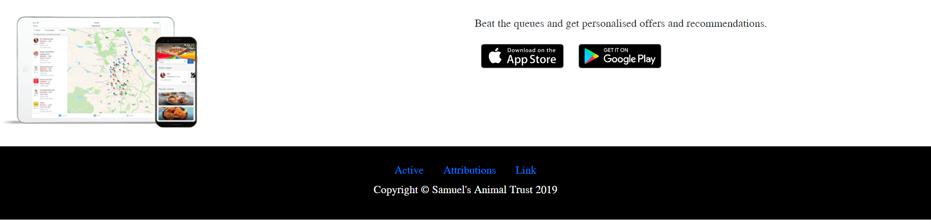

- Donation Page
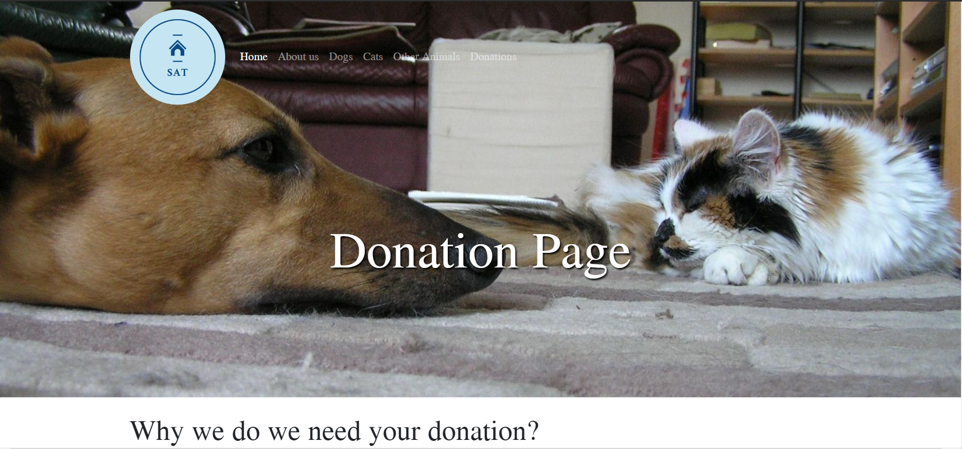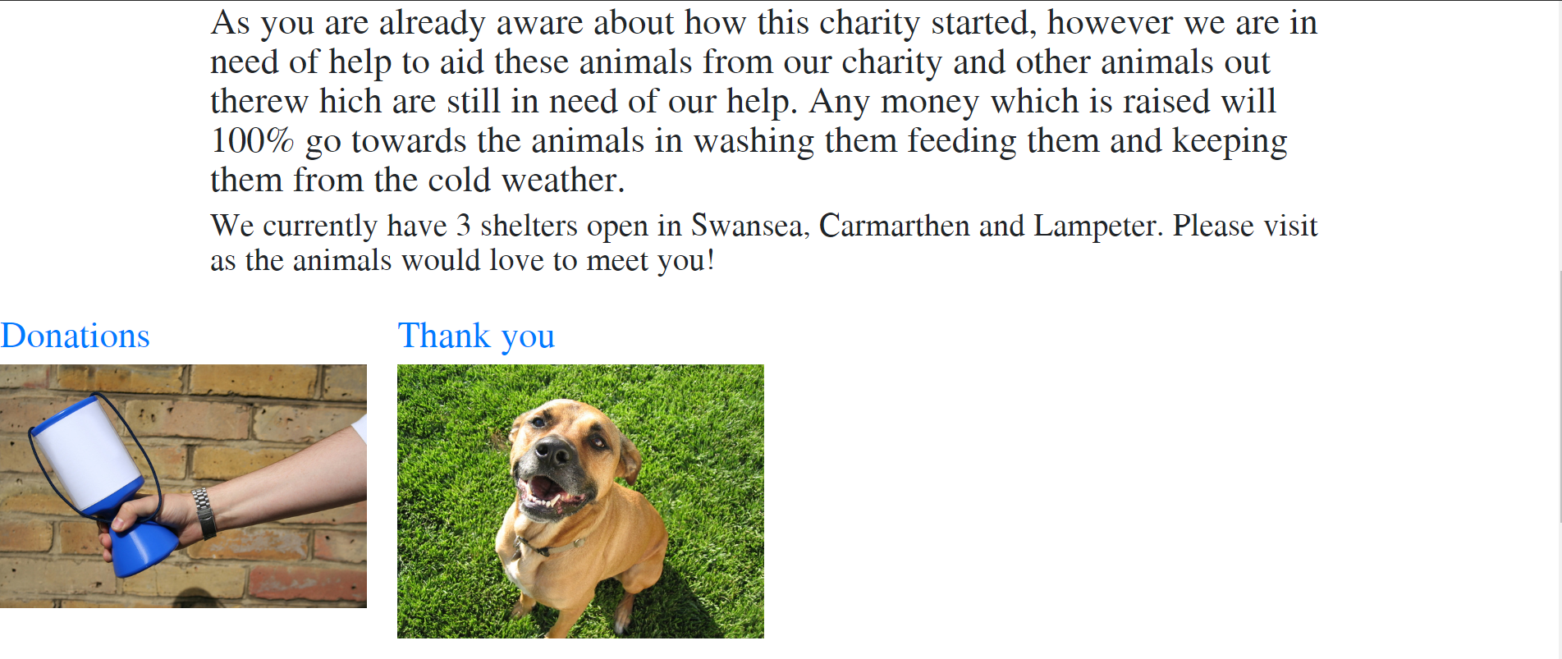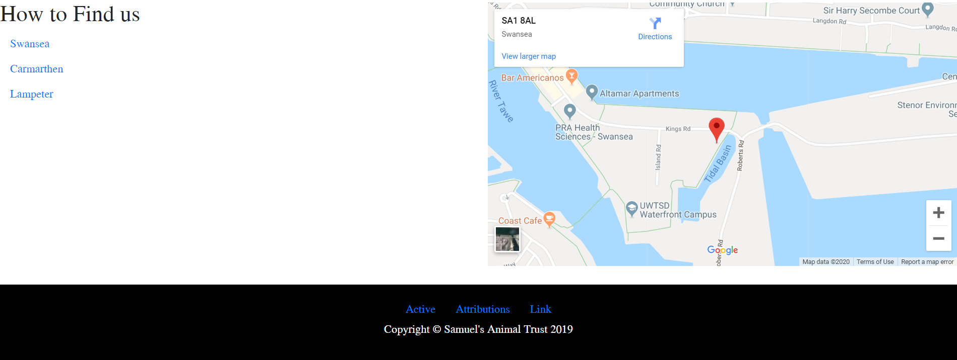

3.2 Validation

First I tackled my HTML code with the validator supplied on moodle, this is what came back and only a few errors came back which were simple fixes:-
- The first error that I encountered was in the header of the code, the meta tag was entered as name instead of meta, and this caused a number of issues within my code, once the error was fixed the other errors disappeared.
- My Second error was within a url, a special character was entered within the url which the validator did not like, simple fix was take it out, did that and error code went away.
- My third error was within a image code, in the file name there was a space between two words which is not accepted, I had to go in my assets file in images and change the name from “Other Animals” to “OtherAnimals” and then change the code to the same, so it did not mess up my website, again another simple fix
- My fourth error was again within the image code, but was different error code turns out I was missing the “alt=”” “ from my code, added it in and the error code went.
- My final error was because I had a “Div” which wasn’t linked anywhere, it was a stray, simple fix was delete it. Fixed the code.
Those were the only errors which showed up and all were fixed, very simple.

With my Style.CSS page I had –
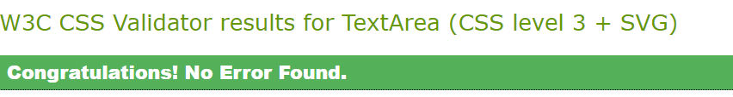
Which I was quite surprised about.

4. Evaluation

4.1 Usability
Usability is a term which is used quite a lot in web design, the term “Usability” is used to describe how easy the website is to use for users, how they interact with it [1]. This means in terms of if the user is trying to look for something specific from your website, it needs to be easy to find for them, if it isn’t then the usability of the website is poor, as this will cause the user to be agitated/ frustrated, and by having this will cause the website to fail because if the user is frustrated with the website then that is a guarantee that these user will not come back to this website causing it to fail by having 0 viewers for the site, this is why the website must be easy to use and fun, the better looking, and easier to use will make the website ratings much better and popular which is what you want when designing a website. The only way of having good usability is by having a well designed website, and the only way to do this is by designing it in the correct way, having a good structure in place, make sure everything is tidy looking and well built, make sure the site has clear navigation this is basically saying don’t overcomplicate things make it easier to go from page to page, make sure they know where they’re going, Finally make sure your website responds well to all devices, its very common that the user is using a computer, but also in todays society a lot people are using mobile devices as well which is a lot smaller, so you need to make sure that your website responds to different sizes. The last thing you want is a messed-up website when it doesn’t load up on a small screen, your website will have severe criticism from that.

4.2 Accessibility
Accessibility is another term which is thrown round in the web design world, this tackles the ability for people to be able to read and understand your website, some people would say its easy these days because of all the tools we have while building websites and that is why, when you are designing a website you have to make it “Accessible” for everyone, and when I mean everyone I literally mean everyone, such as people with disabilities, the website needs to be easy for them to use it. The reason for this is because not all websites are developed like they should be, and when people with disabilities access them, they can not use them because they find it hard or near impossible to use. It’s the same case for the elderly, when creating a website, you need to take everyone into account, even people in developing countries [2]. Some people would think making websites accessible is major work when it isn’t, its simple things like hoovering over a button and making it highlight a different colour, just that alone helps people realise where there cursor is, if you don’t do this then you are going to hit some serious consequences, like your website visitor rating isn’t as good as it could be, reading online “In 2017 there were 814 website accessibility lawsuits filed” all because they weren’t accessible [3].

4.3 Search engine optimisation
Search Engine Optimisation which is also known as (SEO) is used to ensure that your website is seen/found by people who are searching through the internet for specific things. SEO works through search engines which has a certain algorithm, that will search for keywords which is associated with websites. For example searching for dogs, any website like SAT will have keywords like dogs, animals adoption, these keywords will link with the user who is searching for dogs, the search engine will pull up my website with others in a list and the user then can pick from various amounts of websites that have linked her search with the keywords associated with those websites.
There are many other ways that SEO works, that will show your website to users who are searching for certain specific websites, another way they do this is the text that supplied on your website, just by having relevant information which matches with what the user is looking for is enough to get your website linked to those users, Also the title of your page within the code will help the search engine get your website to appear to the users, the search engine do look for things within your code of the website. Also if your website is well connected to others, then that will boost your rating higher making it a higher priority for the SEO [4], because if your website is associated with others then they know your are well linked and will be mentioned in other places meaning your website is doing well and has potential to grow, and by that happening the search engine will have you higher up the scale putting you before others.

5. Website Evaluation

5.1 Usability
The Usability of SAT is very good, the reason for this is because the website is well structured, its not over done because it has a simple structure to it, which makes it basic not over done and very easy to use for users, which makes it easy for the users to use and navigate through. The page names of the website are very clear on what are on them which makes it easy to select. The look of the website is fairly good because it has plenty of pictures which makes it look nice and colourful, and another plus point for the website is that it doesn’t have too much text as well which wouldn’t bore the users too much, because of this I believe the users would be happy to come back to this website because it wouldn’t bore them or frustrate them. It’s a good website which is easy to use.

5.2 Accessibility
The Accessibility of the website ok too good, many people could use it because it very straightforward to use, there are 2 different ways to get to different pages, for example to get to the dog page, you either click the name of the page and when you hover over it will the text will go darker which identifies where your cursor is and that will redirect you to the page or go down the page and click on the dog image which will also take you the dog page, which I find helps some users with disabilities. I would find because the website is straightforward that would help the elderly as well because the website is clear and simple to use.

5.3 Search engine optimisation

With the SEO the website should be very easily found by the search engines because the keywords within the code, there has been a fair few put in which should help the users find the website. Also, because there is a bit of text on each pages of the website which should also help the search engine pick up the website when ever animals are being searched by the users. At the very minute the website isn’t linked with any other websites but if the business was to go well then it could easily link with other animal shelters within its proximity to help publicize the business.

6. References

[1] | “interaction-design.org/literature/topics/usability,” Interaction Design Foundation, [Online]. Available: https://www.interaction-design.org/literature/topics/usability. [Accessed 18 12 2019].
[2] | “Introduction to Web Accessibility,” W3 - Web Accessibility Initiative , 05 06 2019. [Online]. Available: https://www.w3.org/WAI/fundamentals/accessibility-intro/. [Accessed 18 12 2019].
[3] | “Designing for accessibility is not that hard,” UX Collective, 27 06 2018. [Online]. Available: https://uxdesign.cc/designing-for-accessibility-is-not-that-hard-c04cc4779d94. [Accessed 18 12 2019].
[4] | “Web Design Practices That Frustrate SEO Pros,” Search Engine Journal, 10 07 2019. [Online]. Available: https://www.searchenginejournal.com/web-design-practices-that-frustrate-seo-pros/315671/#close. [Accessed 18 12 2019].

